How You Can Reduce and Eliminate Nutrients and Bacteria
- Plant vegetation around driveways, shorelines, and on slopes. The vegetation will absorb nutrients, filter out pollutants and trap sediment.
- Keep yard waste such as grass clippings and leaves out of the lake, storm drains, and off streets. Although yard waste is natural, when it decomposes it becomes high in nutrients.
- Reduce or eliminate fertilizer application; use organic, “no phosphorus” or slow–release fertilizers. Massachusetts state law was changed in 2012 to reduce the phosphorus content in fertilizers. And most established landscaping does not need any additional phosphorus.
- To determine the phosphorus content in a fertilizer, look at the middle number in the formula on the package (e.g., 16-0-8).
- You can have your soil tested (call the UMASS Extension Soil Testing Lab at 413-545-2311 or download a soil test order form at https://soiltest.umass.edu/ordering-information). You may not need to add fertilizer.
- Use phosphate-free or low-phosphate (less than 1%) automatic dishwashing detergents. Phosphate content in various dishwashing detergents sold in Massachusetts ranges from 0% up to 8.7% by weight. Gel detergents tend to have less phosphorus than powder detergents.

Brought to You by MassDEP

and

the Town of _______

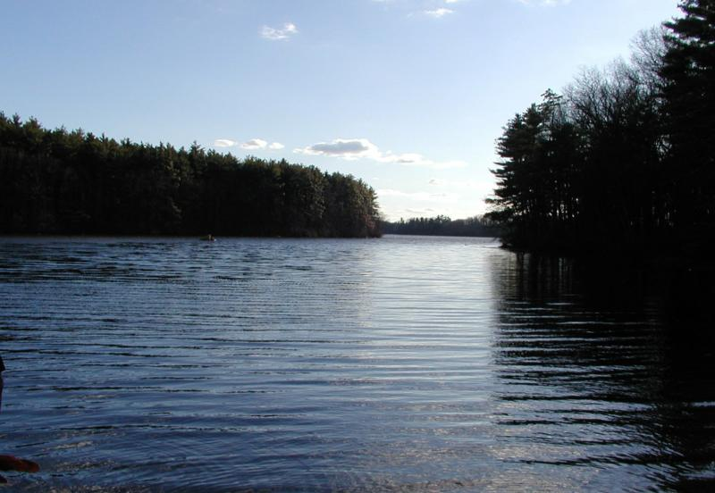


Be a Beneficial Lake Effect: Protecting Your Lake or Pond From Stormwater Pollution

Lake Water Quality, Watersheds, and Stormwater Pollution
A lake's water quality reflects what is happening in its surrounding watershed.
A watershed includes all the land that drains into a stream, lake or other waterbody.

Why Is Stormwater a Problem?
When stormwater flows throughout the watershed, it picks up pollutants and deposits them into water resources.
Common types of stormwater pollutants include phosphorus and bacteria from septic systems; oil and grease from parking lots; phosphorus and nitrogen from lawn and garden fertilizers; pet waste; and sediment from construction activities and soil erosion.
Stormwater pollution does not observe property lines. It flows wherever water takes it - typically to storm drains and then, without any treatment, into nearby streams and lakes.

How Does Stormwater Pollution Affect Lake Water Quality?
- Excessive nutrients such as phosphorus stimulate algal and plant growth, limiting the recreational use of the lake (fishing, swimming and boating) and degrading wildlife habitat.
- Sediment can cause serious damage to lakes and ponds by increasing turbidity and filling in sensitive habitat that is needed for aquatic life. It also transports phosphorus.
- Bacteria from failing or substandard septic systems, pet waste, and waterfowl often cause beach closures.

What Can We Do To Help Reduce Stormwater Pollution?
Cumulatively, people who live near lakes and ponds can have the greatest impact on the health of a lake. Steps to prevent or reduce stormwater pollution can be simple and inexpensive. Preventing and reducing stormwater pollution is the key to improving lake water quality. Every little bit helps!
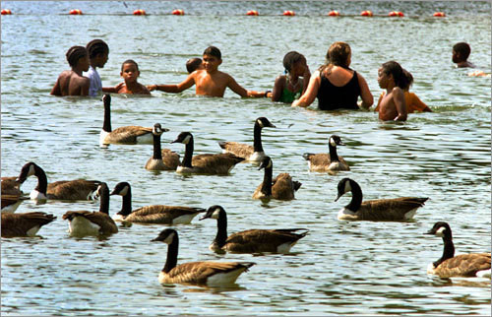
Best Management Practices
Best Management Practices (BMPs) are activities that prevent pollution or reduce the effects of stormwater pollution. It is easier and more cost- effective to prevent pollution than to restore degraded lakes and ponds. BMPs can be “structural”, such as planting a buffer strip, or “non-structural”, such as analyzing lawn soils prior to applying fertilizer. Listed below are simple and cost-effective BMPs that can be used to reduce pollution from stormwater.

Encourage Infiltration and Control Sedimentation
- Minimize impervious surfaces such as driveways and parking lots to encourage infiltration.
- Slow or divert stormwater runoff toward vegetated areas where water can seep into the ground.
- Mulch and seed exposed soils to eliminate erosion.
- Wash cars over pervious surfaces, such as lawns, not over driveways; and wash undercarriages at a commercial car wash facility.

How You Can Reduce and Eliminate Nutrients and Bacteria
- Maintain septic tanks with regular pumping and inspection at least every 3-5 years.
- Pick up pet waste and dispose of it in the trash.
- Establish a vegetated buffer strip along shorelines to discourage waterfowl, such as geese, and avoid feeding them. The average goose will produce one pound of droppings a day!

