Social Media Action Plan

#BeaNutritionNeighbor
You can help people understand why it’s so important to #BeaNutritionNeighbor!
During Malnutrition Awareness Week®, people throughout the U.S. will unite to raise awareness about the importance of ensuing access to proper nutrition for our most vulnerable populations. Up to one out of two seniors are at risk for malnutrition in the US.
The ongoing COVID-19 pandemic has only underscored how vital our elderly nutrition programs are, with requests rising by 50 percent in Massachusetts. Even though 99 percent of seniors over 65 have received at least one dose of the COVID-19 vaccine¹, seniors are struggling being homebound, quarantined, and fearful of illness. Now more than ever, they need people to step up and #BeaNutritionNeighbor.

More than 3.7 million older Americans suffer from malnutrition.
50% of older adults in Massachusetts are at risk of malnutrition.

#BeaNutritionNeighbor is a social media campaign designed to educate and engage people about malnutrition in older adults. Digital tools to share with the online community include:
- #BeaNutritionNeighbor memes that start social media conversations about malnutrition in older adults. These memes highlight common scenarios of people living with often invisible nutrition deficiencies.
- #BeaNutritionNeighbor social media frames for customization on Facebook.
- #BeaNutritionNeighbor memes that center on incidence, prevalence, warning signs, and risk factors of malnutrition in older adults.
- #BeaNutritionNeighbor infographic.
- #BeaNutritionNeighbor explanation/call-to-action graphic.
Please consider sharing #BeaNutritionNeighbor messaging during October 4-8, 2021, to put the spotlight on malnutrition in older adults during Malnutrition Awareness Week®. There are several digital tools to blanket your social media pages with #BeaNutritionNeighbor.
¹ Centers for Disease Control

Together, we can heighten awareness of malnutrition in older adults and share resources that will help educate patients, caregivers, the media, policy makers, the public, and the greater nutrition community.

Memes:

Hyperlink for all memes: www.mass.gov/nutrition-program-for-seniors
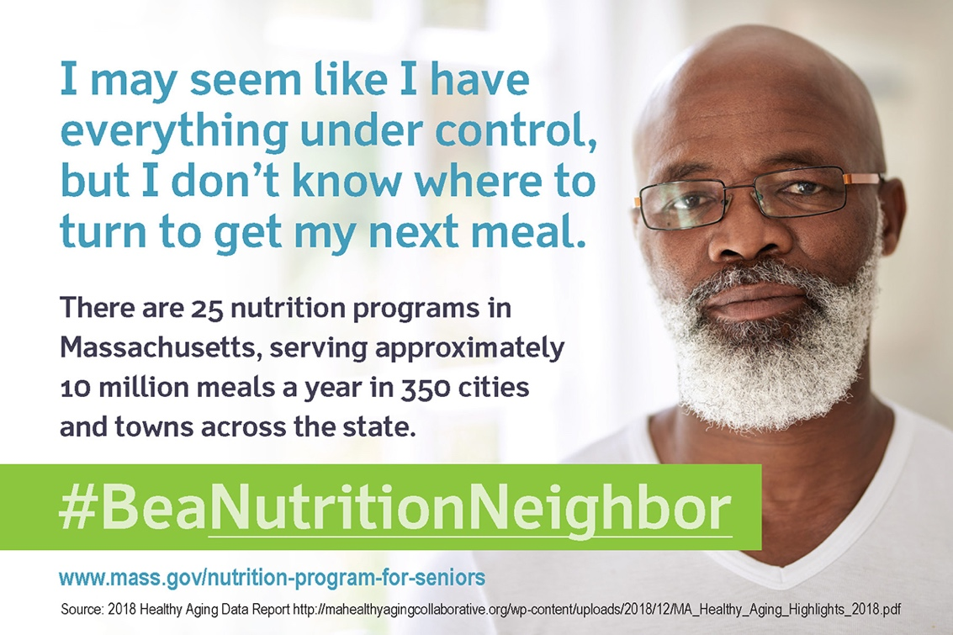

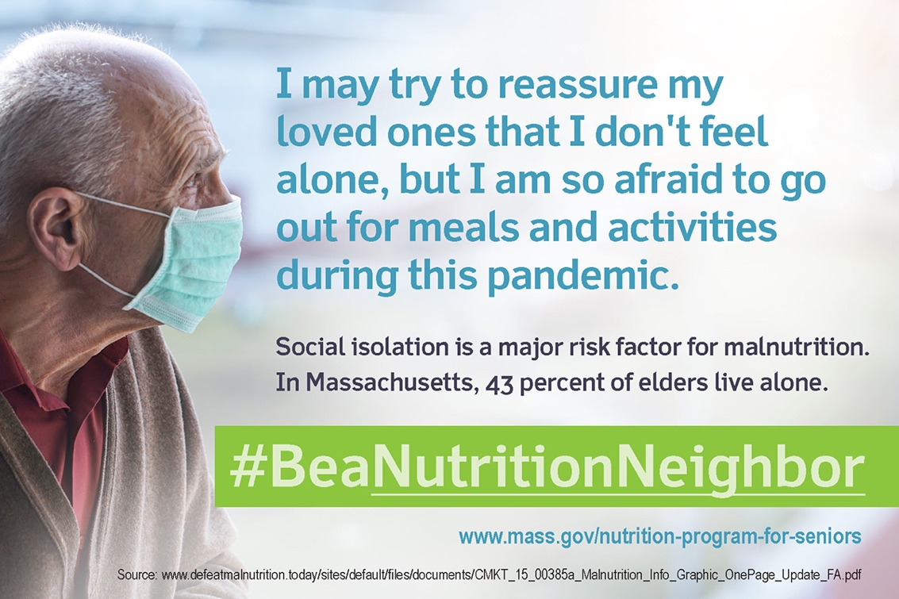

Memes:

Hyperlink for all memes: www.mass.gov/nutrition-program-for-seniors
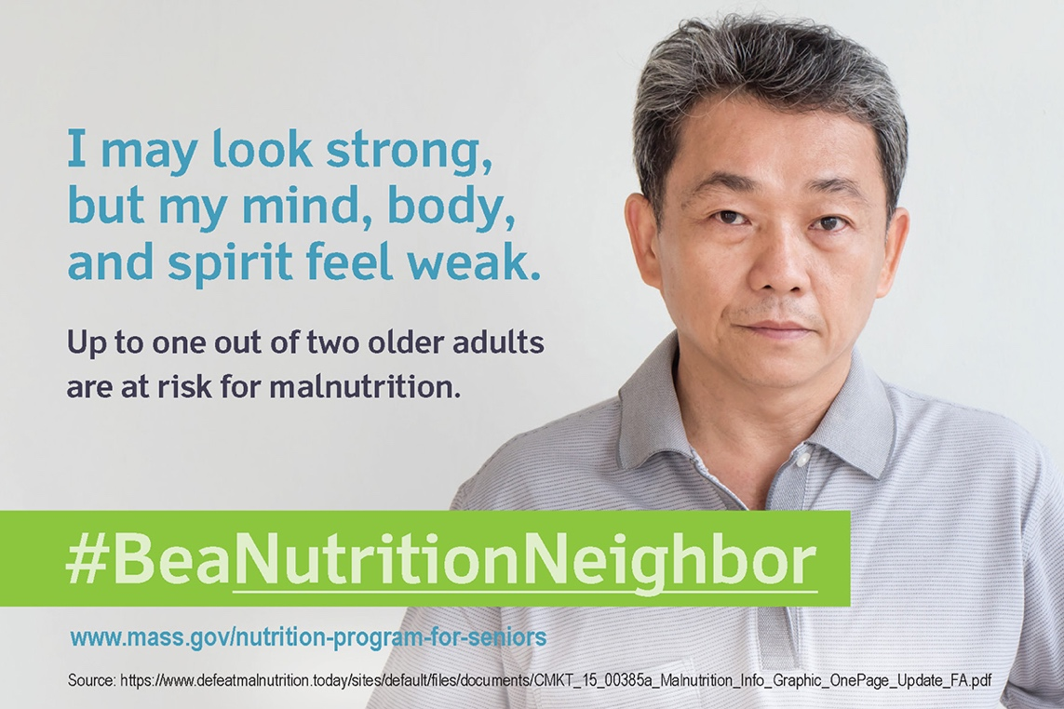
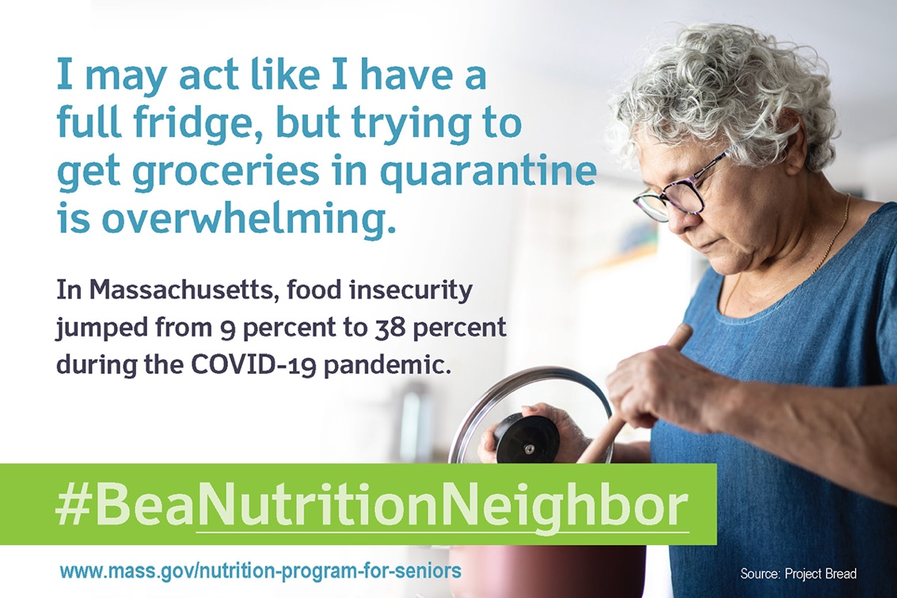

Memes:

All memes can link to: www.mass.gov/nutrition-program-for-seniors

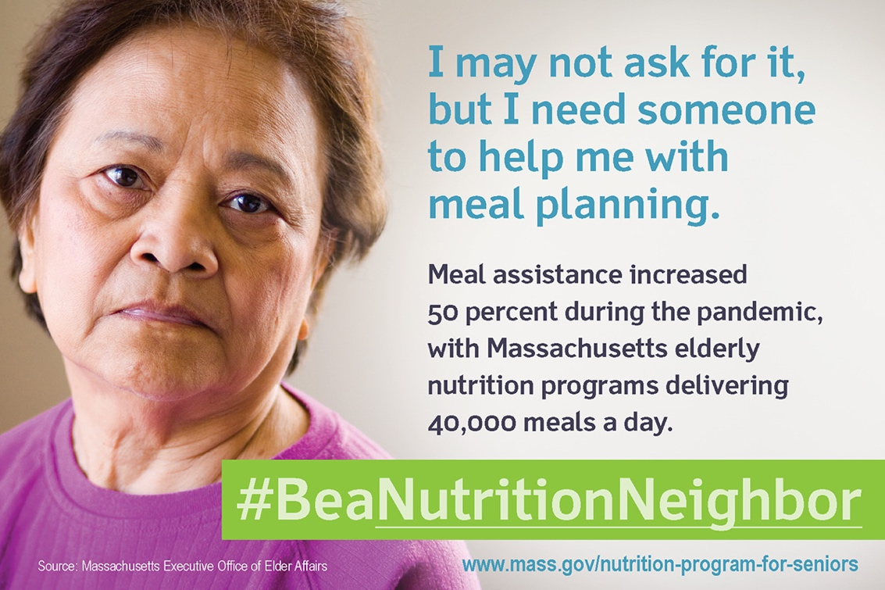

Social Media Frames:

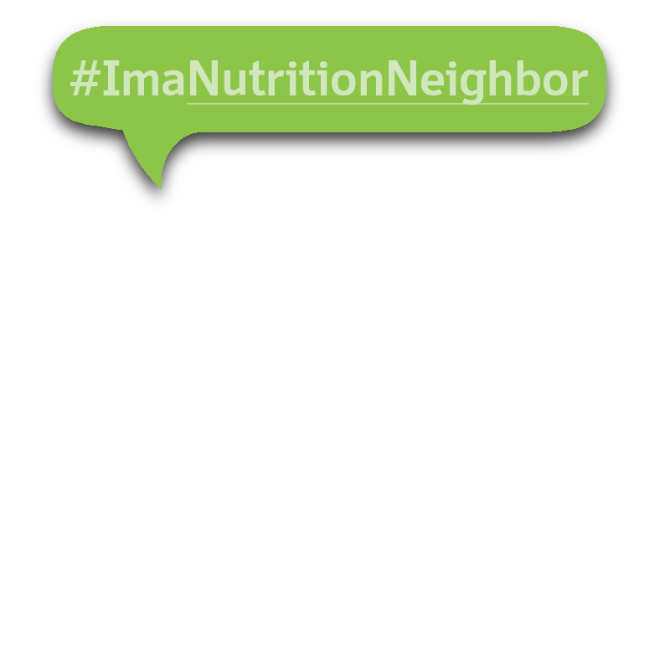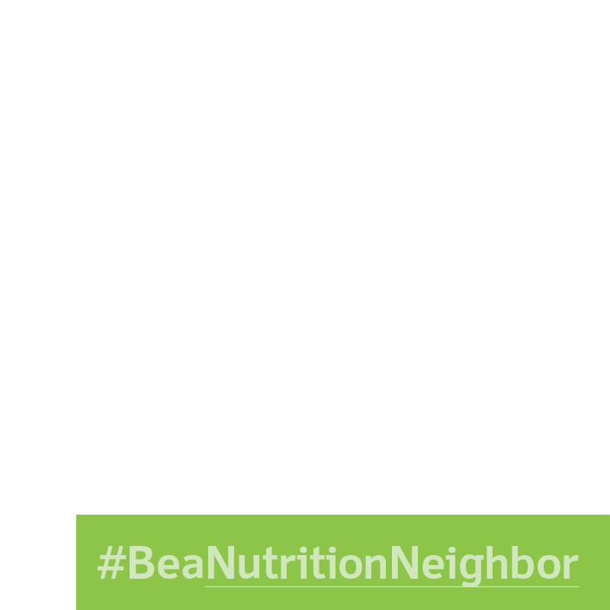

Combined Infographic:

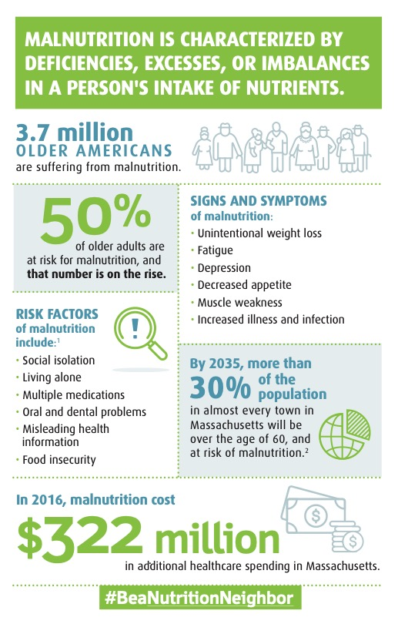

¹ Fávaro-Moreira NC, Krausch-Hofmann S, Matthys C, et al. Risk Factors for Malnutrition in Older Adults: A Systematic Review of the Literature Based on
Longitudinal Data. Adv Nutr. 2016;7(3):507–522. Published 2016 May 16. doi:10.3945/an.115.011254 https://www.ncbi.nlm.nih.gov/pmc/articles/PMC4863272/
² http://pep.donahue-institute.org/downloads/2015/new/UMDI_LongTermPopulationProjectionsReport_2015 04 _29.pdf
Memes:

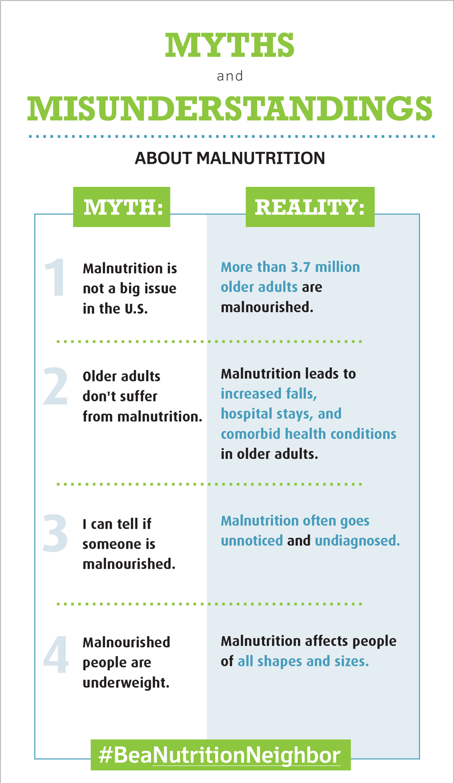

Memes:

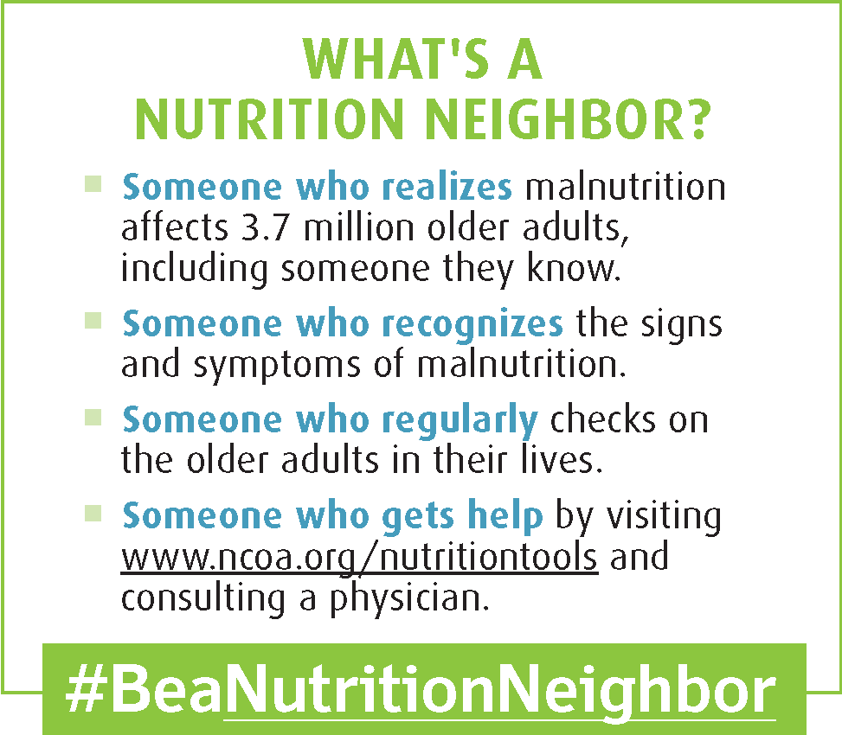

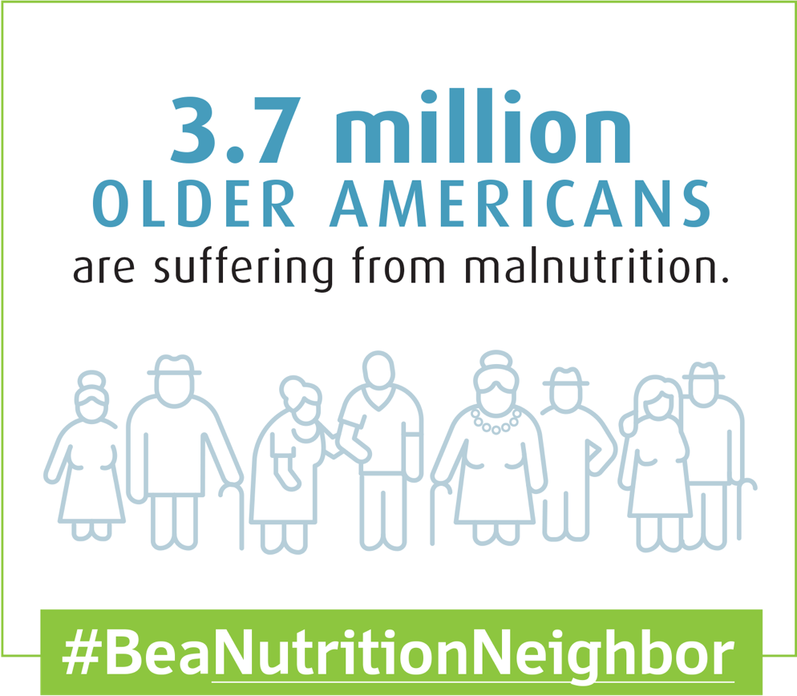

Memes:

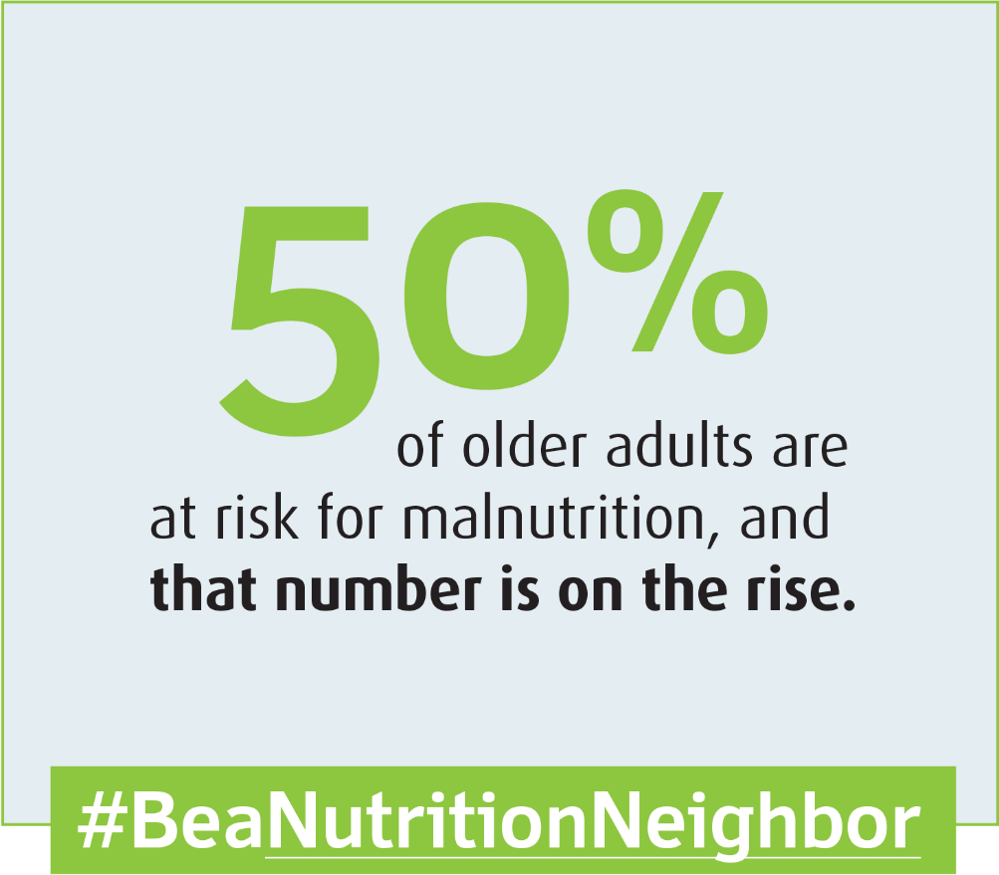

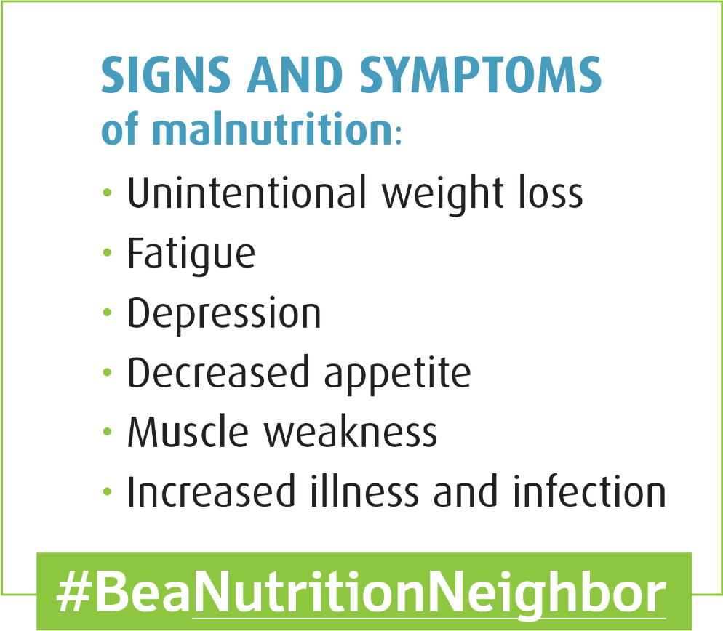

Memes:

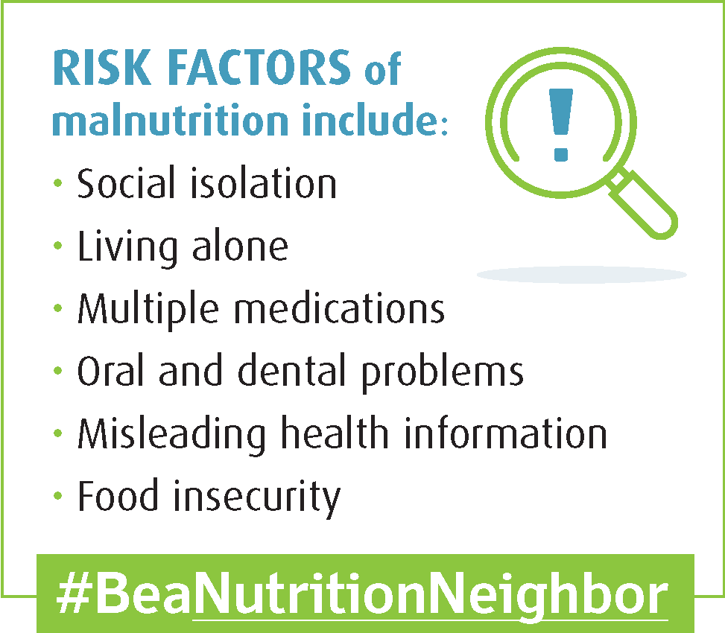

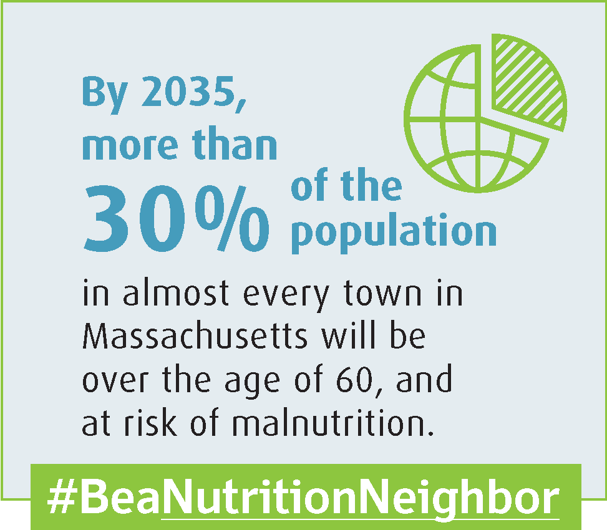

Memes:

