Complete this form by typing responses in the fields provided and clicking in applicable boxes. Click to see additional information, including sample photos. Save the form, adding the name of the beach in the filename. | 
Alternatively: Print out pages 1-5 of the form and complete it manually, referencing additional information and sample photos on pages 6-14. Then, scan the form and save it, including the name of the beach in the filename.

Map
- Please send a topographic map of the beach and its surrounding area with this application.
Click on the icon for a sample. | 
- What is the approximate length of the beach? |  |  | (specify feet or miles)

Water Circulation
- Water currents: |  |  | ☐ | Weak | ☐ | Medium | ☐ | Strong
- Prevailing Winds:  A wind that consistently blows from one direction more than from any other. | ☐ | N | ☐ | E | ☐ | S | ☐ | W
- Bounding structures (see diagram):  Landforms or structures that impact  the flow and movement of water. |  |  | ☐ | None | ☐ | 1 side | ☐ | 2 sides
Jetty
Landform
Pier
Types of Bounding Structures
- Horizontal distance between high and low tide (ft):
- Water depth: | ☐ |  | Shallow | ☐ | Medium | ☐ | Deep
- Beach slope: | ☐ |  | Low | ☐ | Medium | ☐ | Steep

Additional comments:

Natural or Artificial Physical Hazards
- Natural or artificial physical hazards present? |  | ☐ | Yes | ☐ | No

- If yes, please specify hazard(s):

Additional comments:

Potential Wastewater and Stormwater Impacts
- Does all of the watershed have municipal sewer? |  |  |  |  |  |  | ☐ | Yes | ☐ | No
- Prevalence of subsurface sewage disposal within watershed:
Title 5: |  | ☐ | 0 | ☐ | 1-5 |  | ☐ | 6-20 | ☐ | >20
Non-Title 5: |  | ☐ | 0 | ☐ | 1-5 |  | ☐ | 6-20 | ☐ | >20
- Combined sewer overflow discharge location potentially impacting beach?  Some older sewer systems carry both sewage and stormwater in the same pipe. After heavy rainfall, the amount of stormwater in these pipes can increase significantly, overload the system, and lead to discharges directly into waterways. These discharges occur at specific pipes in the system and are called combined sewer overflows (CSOs). |  |  |  |  |  |  | ☐ | Yes | ☐ | No
- Sanitary sewer overflow discharge location potentially impacting beach?  Sanitary sewer overflows (SSOs) are discharges of untreated sewage from sewer systems. These can occur after water infiltrates the sewer pipes after heavy rainfall or periods of high groundwater. SSOs can release sewage directly into waterways. |  |  |  |  |  |  | ☐ | Yes | ☐ | No
- Industrial wastewater discharge location potentially impacting beach?  Wastewater from a commercial or industrial facility. |  |  |  |  |  |  | ☐ | Yes | ☐ | No
- Stormwater pipe/runoff discharge potentially impacting beach? |  |  |  |  |  |  | ☐ | Yes | ☐ | No

Additional comments:

Potential Animal Waste Impacts
- Are birds or other wild animals commonly seen on or near to the beach? |  | ☐ | Yes | ☐ | No
- Are dogs allowed on the beach during the bathing season? |  | ☐ | Yes | ☐ | No
- Even if not allowed, are dogs on the beach during the bathing season? |  | ☐ | Yes | ☐ | No
- Is wrack (seaweed) commonly seen on the beach? |  | ☐ | Yes | ☐ | No
- Is any of the land adjacent to the beach used for agriculture?  Potential runoff from agricultural areas. |  | ☐ | Yes | ☐ | No

Additional comments:

Potential Bather Impacts
- Are there sanitary facilities at the beach during the swimming season? |  |  |  |  |  | ☐ | Yes | ☐ | No
- What is the average number of people in the water during the swimming season?
 |  | ☐ | 1-20 | ☐ | 21-50 | ☐ | 51-100 | ☐ | >100
- What is the maximum number of people in the water during the swimming season?
 |  | ☐ | 1-20 | ☐ | 21-50 | ☐ | 51-100 | ☐ | >100

Additional comments:

Water Quality
- Please supply the information below for the three most recent (full) beach seasons’ bacterial test results.

Year | Number of Samples | Number of Exceedances  (both single sample and geometric mean)* | Exceedance Levels
*Beaches are ineligible for a variance if they have had an exceedance or lack weekly sample results from the most recent two bathing seasons.

- Please list any other bathing beaches (public or semi-public) within half a mile of the beach being inspected and provide the number of samples that exceeded from each within the past three years.

Beach Name | Number of Exceeding Samples within previous 3 years | Exceedance Levels

- Are there tributaries discharging onto or near the beach? |  |  |  |  |  |  |  |  |  | ☐ | Yes | ☐ |  | No
- If yes, please specify distance from beach (feet): |  | ☐ |  | 0 |  |  | ☐ | 1-100 |  | ☐ | 101-500 | ☐ |  | >500
- Does the tributary water quality negatively impact the beach water quality?
 |  |  | ☐ |  |  | Always |  |  | ☐ | Sometimes |  | ☐ |  | Never
- Please specify any other potential sources of water quality contamination:

Additional comments:

Summary of Potential Pollution Sources
The purpose of this section is to highlight potential pollution sources identified in the sanitary survey. This summary can be used as a guide to assist the LBOH in determining 1) whether to grant a variance and 2) if granted, the new sampling frequency. This summary is not intended to capture all of the information contained in the survey.

Potential Pollution Sources Present

Type of Source | Yes or No
Subsurface Sewage Disposal | ☐ | Yes | ☐ | No
Combined Sewer Overflow | ☐ | Yes | ☐ | No
Sanitary Sewer Overflow | ☐ | Yes | ☐ | No
Industrial Wastewater | ☐ | Yes | ☐ | No
Stormwater | ☐ | Yes | ☐ | No
Animal/Pet Waste | ☐ | Yes | ☐ | No
Lack of Sanitary Facilities | ☐ | Yes | ☐ | No
High Average Number of Swimmers | ☐ | Yes | ☐ | No
Exceedances at Nearby Beaches | ☐ | Yes | ☐ | No
Water Quality Concerns in Nearby Tributaries | ☐ | Yes | ☐ | No

Additional comments:

Question 1: Please send a topographic map of the beach and its surrounding area.

 | Return to survey

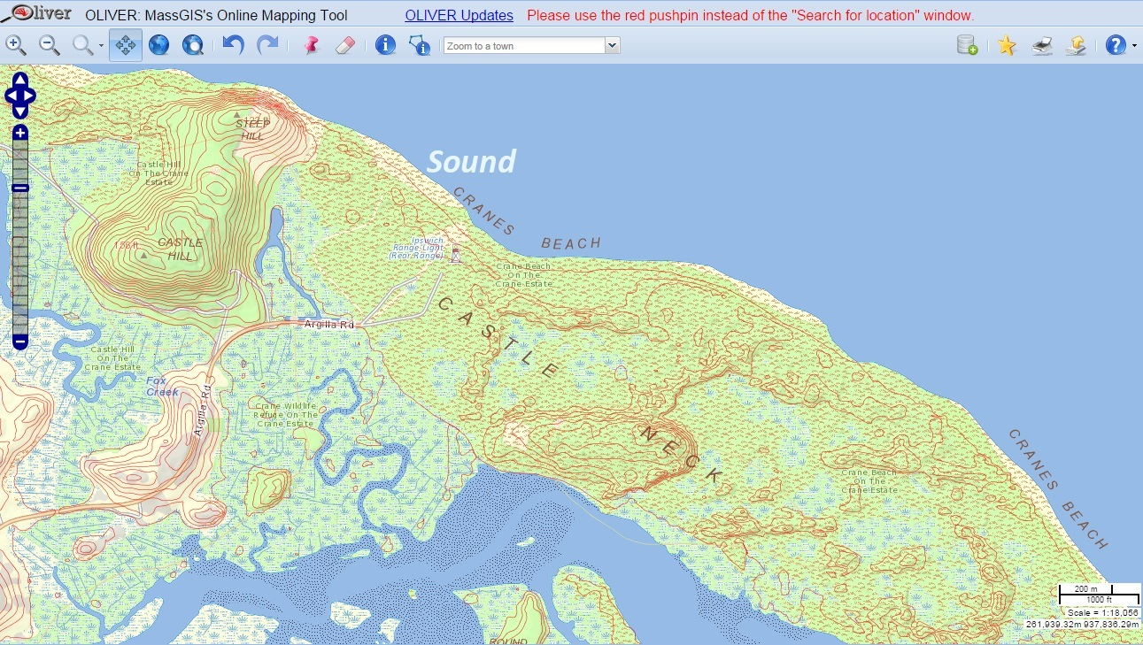
Question 5: Bounding structures
Landforms or structures that impact the flow and movement of water.

Return to survey

Jetty
Landform
Pier
Types of Bounding Structures

Jetty: A structure extending into a sea, lake, or river to influence the current or tide or to protect a harbor. | Pier: A structure built on posts extending from land out over water, used as a landing place for ships, an entertainment area, a strolling place, etc.
Sandy Point Beach, Beverly  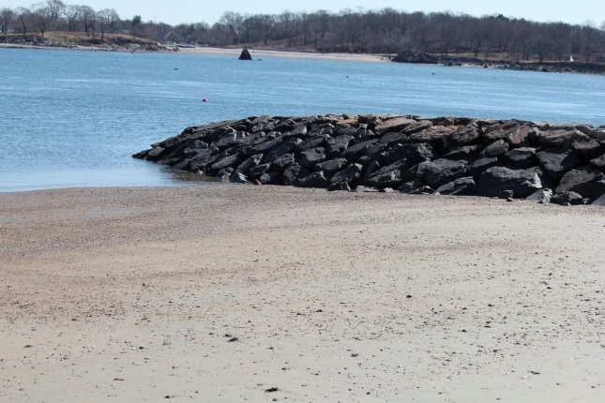 | Spectacle Island, Boston  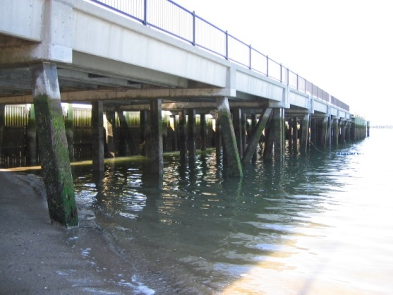

Question 9: Natural or artificial physical hazards present?
Return to survey

Natural Hazards: Naturally occurring physical phenomena that may pose a health and safety risk, such as steep grade and undertow. Shown below are cliff, rocky beach, and algae. | Artificial Hazards: Man-made physical phenomena that may pose a health and safety risk, such as broken glass and watercraft. Shown below are dam, oyster beds, and permanent structures.
Cliff: Moshup Beach, Aquinnah  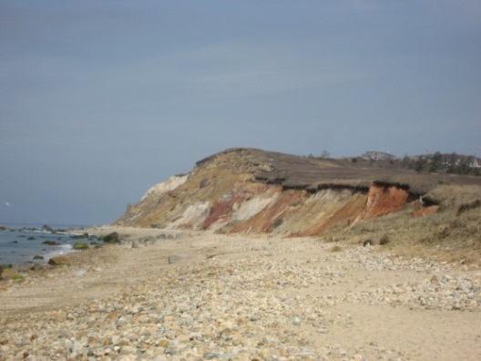 | Dam: Lake Gardner, Amesbury 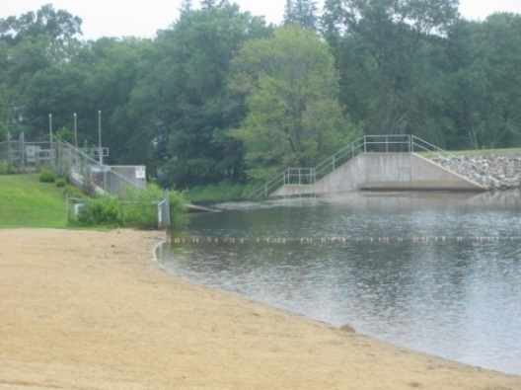
Rocky Beach: Lobsterville Beach 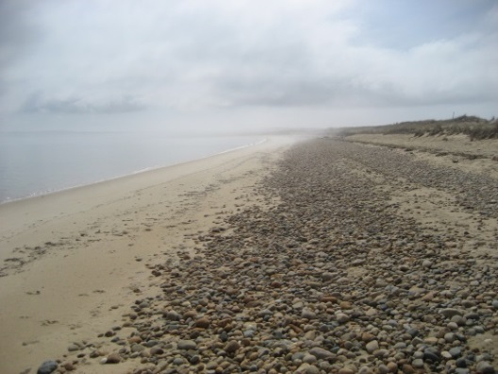 | Oyster Beds: Red Beach, Aquinnah 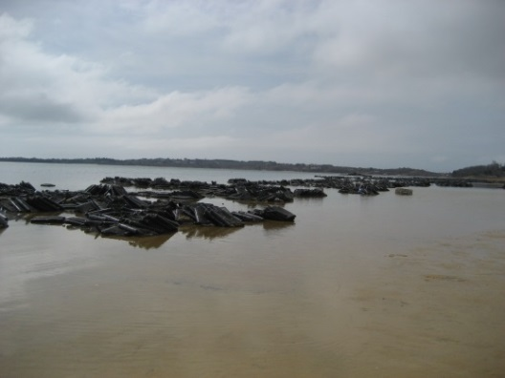
Algae: West Beach, Beverly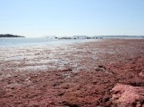 | Permanent Structures: Spectacle Island, Boston 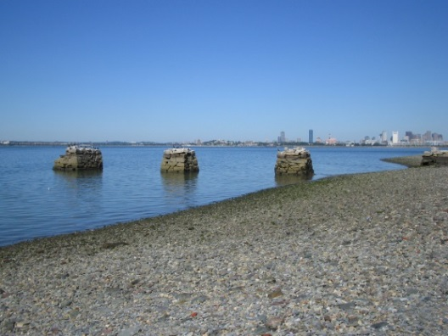
Question 12: Prevalence of subsurface sewage disposal within watershed:

Return to survey

Title 5 type: Title 5 = On-site sewage disposal systems governed by Title 5 of the Massachusetts State Environmental Code (310 CMR 15.000).

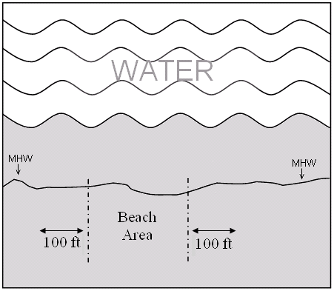

Non-title 5 type: AKA non conforming system. Any system which is not in full compliance with the standards and requirements of 310 CMR 15.000 and for which a variance or local upgrade approval has not
been obtained. Nonconforming systems include, but are not limited to, cesspools, privies, failed systems, and systems with a design flow above 10,000 gpd.

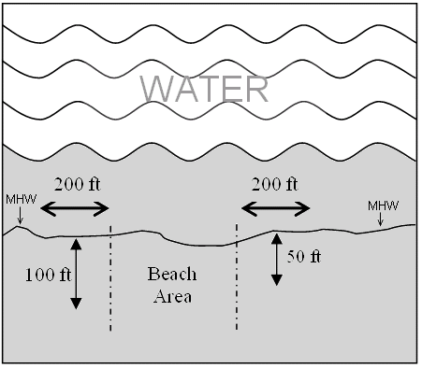
Question 16: Stormwater pipe/runoff discharge potentially impacting beach?
Stormwater is the water that runs off surfaces such as rooftops, paved streets, highways, and parking lots. It can also come from hard grassy surfaces like lawns, play fields, and from graveled roads and parking lots.
Stormwater may discharge directly into area lakes, rivers, and streams without any (or limited) treatment.

Return to survey

Pipe: Mingo Beach, Beverly  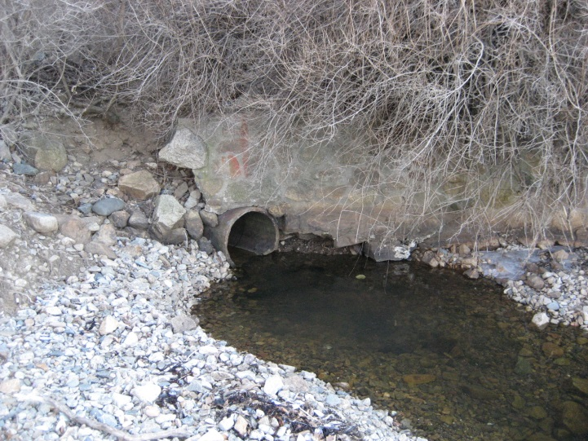 | Pipe: Island Grove Beach, Abington  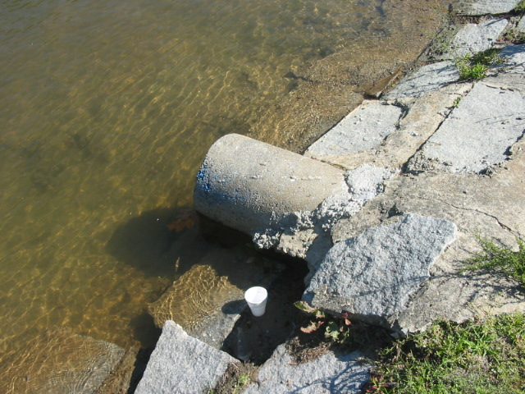
Drainage Holes: King’s Beach, Lynn
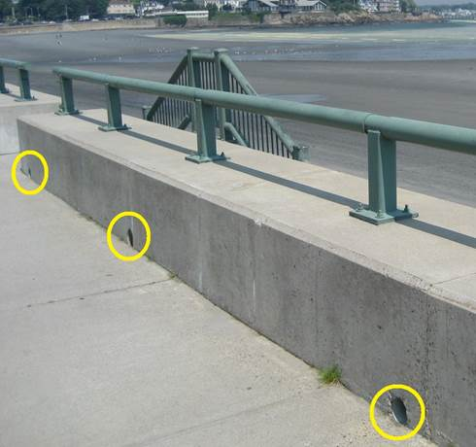

Question 17: Are birds or other wild animals commonly seen on or near to the beach?

Return to survey

Seagulls: Spectacle Island, Boston  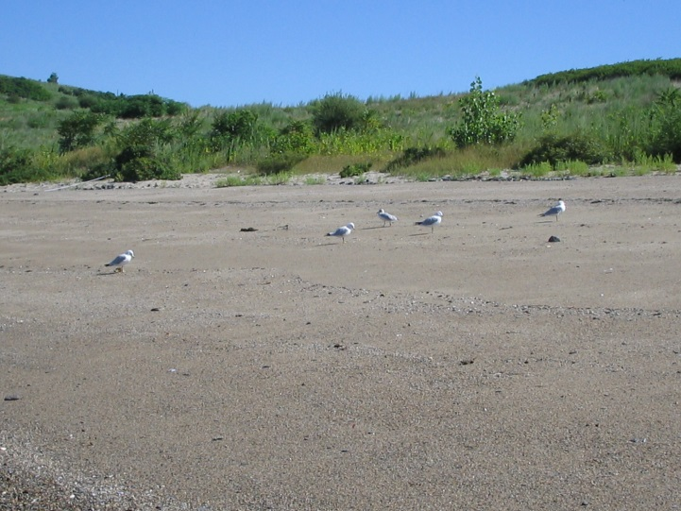 | Geese: Woodbury Beach, Beverly  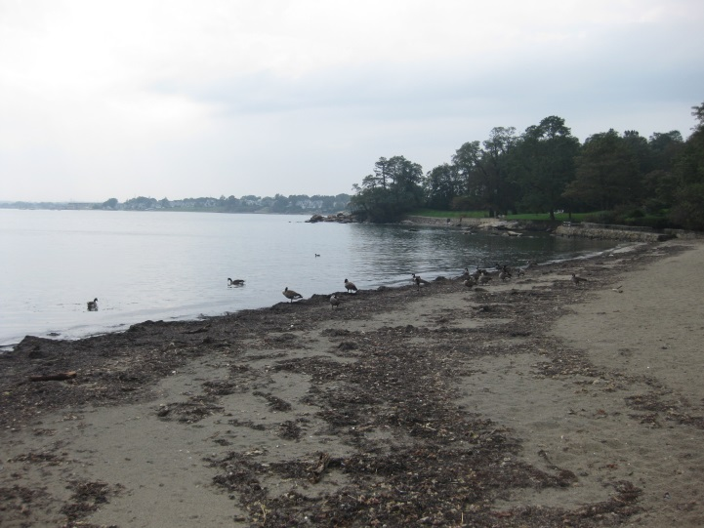

Question 20: Is wrack (seaweed) commonly seen on the beach?
The wrack line or strand line is a line of debris that often runs parallel to the water's edge and marks the high tide line. This wrack line is made up of a mixture of manmade materials that have washed up onto the beach and decaying marsh grasses.

Return to survey

Light Wrack Line: Smith Beach, Braintree  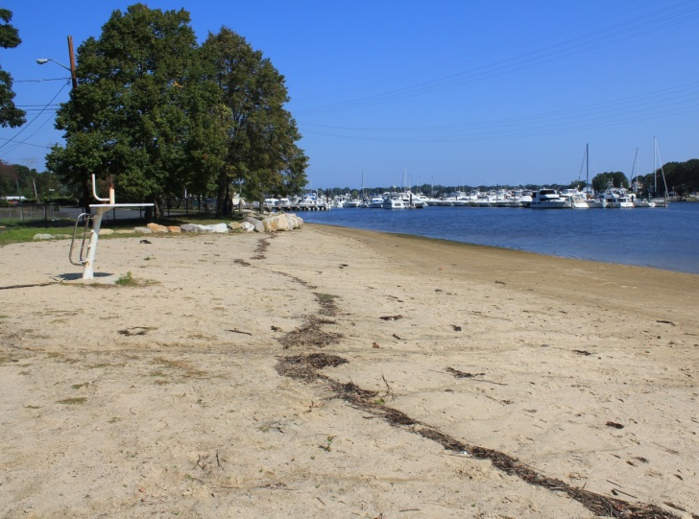 | Heavy Wrack Line: Red River Beach, Harwich  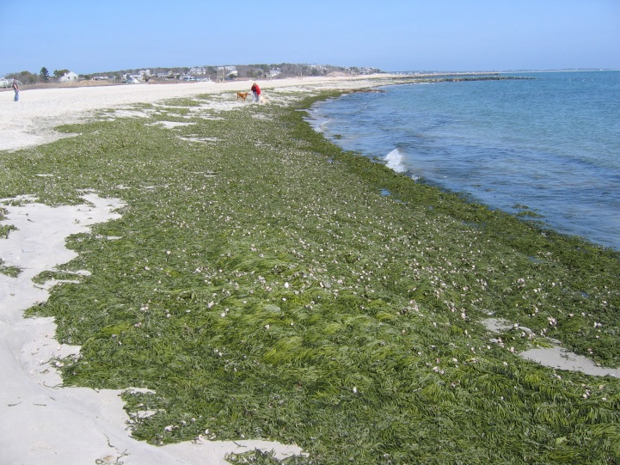

Question 22: Are there sanitary facilities at the beach during the swimming season?
Temporary or permanent facilities for sanitary use.

Return to survey

Permanent Sanitary Facilities  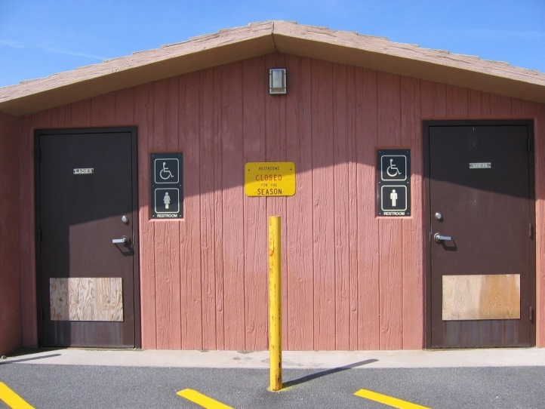 | Temporary Sanitary Facilities  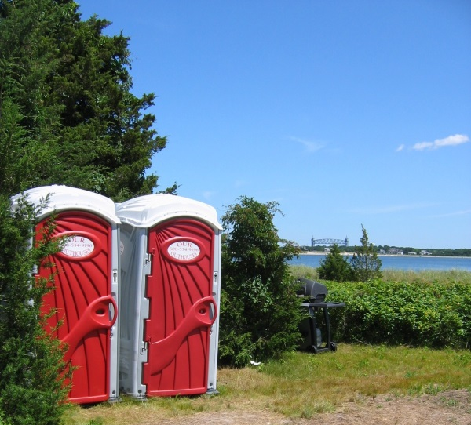

Question 27: Are there tributaries discharging onto or near the beach?
A stream that flows to a larger stream or other body of water.

Return to survey

Tributary Discharge: Red Beach, Aquinnah
