Beaches are an important natural resource and good water quality is essential to having a safe and enjoyable beach visit. Boards of Health have an important role in ensuring that required water testing and notification are conducted.

Massachusetts Department of Public Health | Bureau of Environmental Health

Marine and Freshwater Beaches
Information for Boards of Health

BEACHES
There are three types of beaches:
- Public ― open to the general public regardless of whether a fee is charged.
- Semi-public ― open to individuals through a common access and/or use, such as hotels, condo associations, and camps.
- Private ― all others.

The MA Department of Public Health (DPH) and local boards of health (BOHs) regulate public and semi-public beaches under 105 CMR 445.000. The regulations do not apply to private beaches.
BEach testing
To minimize the risk of illness from contaminated water, beaches are required to be tested for “indicator” bacteria ― bacteria that indicate the presence of fecal contamination. Marine water must be tested for Enterococci bacteria, while freshwater can be tested for Enterococci or E. coli.
The BOH oversees all water testing within its jurisdiction at approved sampling locations. Operators of semi-public beaches pay for their own sample collection and analysis.
Beaches must be sampled within 5 days prior to opening and at least weekly thereafter during operation.

PERMITTING & SIGNAGE
BOHs are required to issue permits for beaches to operate. Beaches are required to have permanent signs located near entrances. Signs must include:

- Dates of operation and a statement that the waters are not tested for bacteria outside these dates
- Operator contact information
- Permit number
SAMPLE COLLECTION & ANALYSIS
Samples should be taken within the area of greatest usage, remain consistent (sampled from the same location each week), and be collected in the following manner:
- Wade to a depth of 3 feet and wait for debris to settle.
- Remove cap of sterile sample bottle and plunge the bottle 12 inches under the surface, filling it in one downward sweeping motion, moving away from your body. Discard a few millimeters to allow air space.
- Place bottle in cooler with ice packs.
Field data must be recorded at time of collection on a form provided by DPH.
Samples should be delivered within six hours to a laboratory certified by the MA Department of Environmental Protection to conduct the analysis. Find laboratories here: www.mass.gov/certified-laboratories

WATER QUALITY STANDARDS
There are two types of water quality standards: single sample and geometric mean (geomean). The geomean is calculated using the five most recent samples and is intended to reflect typical conditions.
Beach Type | Indicator  Organism | Standards (cfu/100 mL)
 |  | Single Sample | Geomean
Marine | Enterococci | 104 | 35
Freshwater | Enterococci | 61 | 33
 | E. coli | 235 | 126
DPH beach water quality criteria

PUBLIC NOTIFICATION
Signs warning of high bacteria levels are required when:
- Two samples collected on consecutive days both exceed the single sample water quality standard, or one sample exceeds it and a re-test is not collected the following day.
- One sample exceeds the water quality standard at beaches where, in two or more of the last four full seasons, samples collected on consecutive days exceeded the water quality standard.
- The geomean standard is exceeded.

Signs must be posted at all entrances to the beach and parking lots, stating:
WARNING! NO SWIMMING
SWIMMING MAY CAUSE ILLNESS
The signs shall also contain the following:

- A graphic of a swimmer in a red circle with a diagonal hatch mark
- The reason for warning
- The date the warning was issued
- BOH contact information
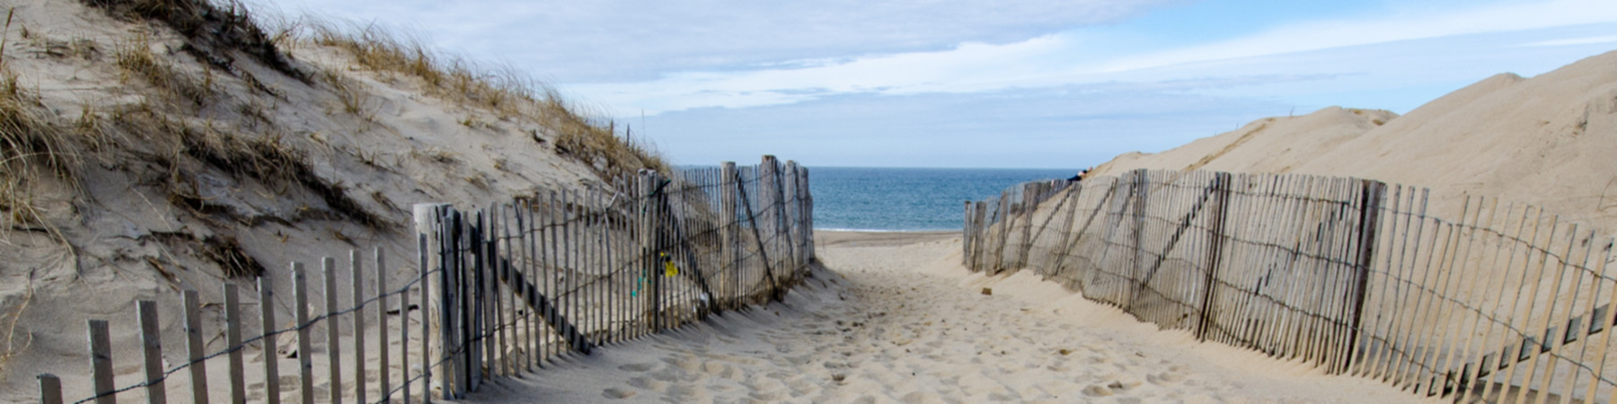

OTHER REASONS FOR POSTING A BEACH
- Preemptive: Assumption of bacterial exceedance after rainfall/storm event based on historical data.
- Physical quality: Presence of solid refuse, floating waste solids, oils, grease, scum, or hazardous materials.
- Safety hazards: Presence of dangerous conditions, including fast currents, sharp drop-offs, water clarity/visibility issues, or sharks.

TESTING VARIANCES
Beach operators may request a variance from the BOH if they believe weekly testing is not warranted. To be eligible for a variance, the operator must provide the BOH with a sanitary survey of the beach and test results showing that there were no exceedances during the previous two bathing seasons.

If the BOH approves the variance, it must be submitted to DPH with all the required documents for review and approval. Sanitary survey forms can be obtained at: http://www.mass.gov/dph/beaches

Reporting
Laboratories must report results to the BOH within 5 days, except for exceedances which require immediate notification.
BOHs must immediately notify DPH of any beach postings and subsequent re-openings.
BOHs must provide all test results and field data to DPH by October 31st each year. Electronic reporting of these data is encouraged.
For More Information:
Environmental Toxicology Program
Bureau of Environmental Health
MA Department of Public Health
Phone: 617-624-5757 | Fax: 617-624-5183 |
TTY: 617-624-5286
Email: dph-beach@mass.gov
Website: http://www.mass.gov/dph/beaches

March 2022

