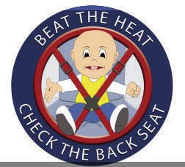

**Tips for Transportation Safety**

# Did you know…

* A child’s body warms 3 to 5 times faster than an adult’s.
* The temperature inside a car can rise 30º in twenty minutes, and 43º in one hour, even with the windows left open a bit.
* Heat stroke occurs when the body temperature exceeds 104º. A body temperature of 107º is usually fatal.

# What you can do…

* Never leave a child unattended in a vehicle…not even for a minute!
* When placing a young child in a car seat, place your purse, cell phone or other belongings on the floor of the back seat. Put the child’s belongings on the front seat.
* Call your child care provider if your child will be late or absent from care.
* If you see a young child alone in a vehicle, report it to the police.

**You could save a life!**