**Massachusetts Department of Public Health | Bureau of Climate and Environmental Health**

# Frequently Asked Questions About Bed Bugs

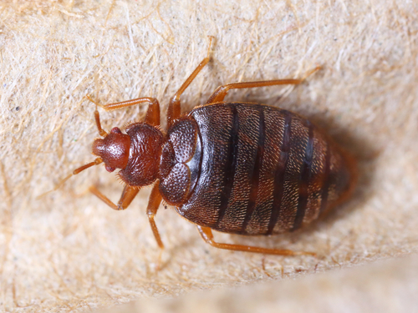

What are bed bugs?

Bed bugs are insects that feed on the blood of people and animals. They are small, flat, brown, and oval. They do not have wings.

What do bed bugs look like?

• Bed bug eggs are white and pear-shaped. When they first hatch, bed bugs are clear and lighter in color. As they get older, they become browner.

• Adult bed bugs are reddish-brown, flat, and oval. If you look closely, you can see short, golden-colored hairs. Bed bugs do not have wings. They give off a musty, sweetish odor. After they eat, they become swollen and dark red.

Why are bed bugs a problem?

Bed bugs are becoming an increasing problem in many cities and towns. This may be because more people are traveling out of the country to places where bed bugs are a problem. It may also be because certain pesticides for bed bug infestations have been banned.

How do bed bugs get in people’s homes?

Bed bugs usually get into your home through luggage, clothing, or other personal items during travel. Sometimes hotels have bed bugs. Bed bugs can crawl into your luggage and get carried back to your home. It only takes one bed bug to get an infestation started in your home.

Bed bugs may also get into your house by crawling onto your clothes, but this is not likely. A more common way to bring bed bugs into your home is if you buy and wear used clothes or used furniture that have bed bugs in them.

Are there steps I can take to avoid bringing bed bugs into my home?

Yes, you should look closely at used furniture before you bring it home.

Check apartments and dorm rooms. Living in close quarters can make it easier to get bed bugs. They often live in the spaces between walls. If an apartment next to yours has bed bugs, you might also have them. It is hard to fix bed bug problems until all apartments within the building have taken steps to get rid of them.

Check vacant apartments for bed bugs before moving in. Bed bugs can survive for months without feeding.

Where do bed bugs hide?

• Beds (seams, tufts, and crevices of mattresses and box springs), bed frames, headboards, and in clutter under beds

• Carpets and baseboards

• Behind loose wallpaper

• Folds of curtains and drapes

• Clocks, radios, or phones near a bed or on a nightstand

• Inside and underneath drawers

• Picture frames

What are the signs of a bed   
bug infestation?

Signs of bed bug infestation may be:

• Darker (reddish or brownish) spots or smears  
on bed sheets, pillowcases, or mattresses, or  
in nearby areas from bed bug feces

• A distinct musty odor

• Small, itchy red bumps on your skin from  
bed bug bites

What happens if a bed bug bites me?

Bed bugs are not known to transmit any infectious diseases. Their bite looks like the bite of most blood-sucking insects and may cause some skin irritation. Some bites might not be noticed, while others turn into larger sores.

How can I treat bed bug bites?

Wash the area of the bite with an antiseptic soap  
to reduce infection, and resist the urge to scratch. Contact your health provider if the bite becomes infected.

How do I get rid of bed bugs?

If you see the signs of bed bug infestation, you should look closely in all areas of your home to find out if you have bed bugs.

• Identify the source.

• Use a vacuum cleaner (preferably HEPA-filtered) to remove the bugs and their cast skins from all areas where you see them or think they might be. Do this during your initial inspection and at least every week afterwards.

• Discard or scrub and vacuum mattresses; then enclose the mattress in a zippered mattress cover. Wash headboards and bed frames.

• Use a high-quality silicone-based sealant. Seal shut all cracks, crevices, and entry points in walls, especially within 20 feet of any spot where bed bug bites happened.

• Do not use any insect killer on your own. It will only spread infestation.

• Contact a licensed pest control operator.

• Once clothes (e.g., bed linens, clothing, etc.) are laundered, place them in large plastic bags or tightly closed bins to prevent any re-infestation.

• Isolate the cleaned (bed bug-free) items until bed bugs are gone.

Who is responsible for the removal of bed bugs?

In most cases, a landlord or property manager is required by law to “maintain the dwelling and premises free from infestation and shall be responsible for pest elimination” (MA: 105 CMR 410.550). It is the landlord’s responsibility to respond to any complaints of bed bugs.

If someone is renting a residence containing one dwelling unit, the owner may not be responsible for extermination as long as they maintain upkeep of the home. In these cases the occupant may be required to pay.

If you are a tenant, contact your landlord so that they can hire a licensed exterminator to identify the insect and develop an extermination plan or IPM (Integrated Pest Management) Plan to eliminate them.

Landlord or property owner responsibilities

Encourage tenants to report bed bugs. Respond quickly to complaints with inspection and intervention.

Resident responsibilities

• Follow guidelines for reporting bed bugs.

• Cooperate with staff in controlling bed bugs.



Whom can I contact for additional information?

Your local board of health or:

Bureau of Climate and Environmental Health   
MA Department of Public Health   
250 Washington Street, 7th Floor, Boston, MA 02108   
Phone: 617-624-5757 | Fax: 617-624-5777 | TTY: 617-624-5286   
[www.mass.gov/dph/environmental_health](http://www.mass.gov/dph/environmental_health)

October 2023

