INDOOR AIR QUALITY ASSESSMENT

Bedford Town Hall
10 Mudge Way
Bedford, Massachusetts

Prepared by:
Massachusetts Department of Public Health
Bureau of Environmental Health
Indoor Air Quality Program
May 2015

Background/Introduction
In response to a request from an employee, the Massachusetts Department of Public Health (MDPH), Bureau of Environmental Health (BEH) provided assistance and consultation regarding indoor air quality (IAQ) at the Bedford Town Hall (BTH) 10 Mudge Way, Bedford, Massachusetts. The request was prompted by general IAQ concerns in the building, including issues relating to musty odors and reports of allergy symptoms among BTH staff. On April 1, 2015, the BTH was visited by Jason Dustin, Environmental Analyst/Inspector in BEH’s IAQ Program to conduct an IAQ assessment. Heidi Porter, Director, Bedford Health Department, accompanied Mr. Dustin throughout the assessment.
The BTH is a two-story brick building that was constructed in the 1930’s. The building has a peaked roof with asphalt shingles and was last renovated in 1988. The building houses administrative offices for town departments as well as meeting rooms, a break room and record storage areas. Windows are openable throughout the building, although some are sealed. The building is heated by forced hot water radiators and has an air handling unit (AHU) for ventilation and air conditioning.

Methods
Air tests for carbon monoxide, carbon dioxide, temperature and relative humidity were conducted with the TSI, Q-Trak, IAQ Monitor, Model 7565. Air tests for airborne particle matter with a diameter less than 2.5 micrometers were taken with the TSI, DUSTTRAK™ Aerosol Monitor Model 8532. BEH/IAQ staff also performed a visual inspection of building materials for water damage and/or microbial growth.

Results
The BTH has an employee population of approximately 40 with the public visiting to conduct business daily. The tests were taken during normal operations and results appear in Table 1.

Discussion

Ventilation
It can be seen from Table 1 that carbon dioxide levels were below 800 parts per million (ppm) in all areas tested, indicating adequate air exchange at the time of the assessment (Table 1). It is also important to note that a number of areas were sparsely populated or unoccupied at the time measurements were taken, which can greatly reduce carbon dioxide levels. Carbon dioxide levels would be expected to be higher with full occupancy.
Fresh air provided by the AHU is ducted to ceiling-mounted supply diffusers (Picture 1). Return air is drawn back into vents (Picture 2) and returned to the AHU. Note that in a few areas, supply vents were diverted or blocked off, which reduces the ability of the system to supply fresh air to that space. Without continuous operation of supply/exhaust ventilation, indoor air pollutants can build up and lead to IAQ/comfort complaints.
BTH staff reported that the pneumatic thermostat controls for the system have been problematic. It was also reported that installation of a new heating system with new temperature and ventilation controls is scheduled in July 2015.
Minimum design ventilation rates are mandated by the Massachusetts State Building Code (MSBC). Until 2011, the minimum ventilation rate in Massachusetts was higher for both occupied office spaces and general classrooms, with similar requirements for other occupied spaces (BOCA, 1993). The current version of the MSBC, promulgated in 2011 by the State Board of Building Regulations and Standards (SBBRS), adopted the 2009 International Mechanical Code (IMC) to set minimum ventilation rates. Please note that the MSBC is a minimum standard that is not health-based. At lower rates of cubic feet per minute (cfm) per occupant of fresh air, carbon dioxide levels would be expected to rise significantly. A ventilation rate of 20 cfm per occupant of fresh air provides optimal air exchange resulting in carbon dioxide levels at or below 800 ppm in the indoor environment in each area measured. MDPH recommends that carbon dioxide levels be maintained at 800 ppm or below. This is because most environmental and occupational health scientists involved with research on IAQ and health effects have documented significant increases in indoor air quality complaints and/or health effects when carbon dioxide levels rise above the MDPH guidelines of 800 ppm for schools, office buildings and other occupied spaces (Sundell et al., 2011). The ventilation must be on at all times that the room is occupied. Providing adequate fresh air ventilation with open windows and maintaining the temperature in the comfort range during the cold weather season is impractical. Mechanical ventilation is usually required to provide adequate fresh air ventilation.
Carbon dioxide is not a problem in and of itself. It is used as an indicator of the adequacy of the fresh air ventilation. As carbon dioxide levels rise, it indicates that the ventilating system is malfunctioning or the design occupancy of the room is being exceeded. When this happens, a buildup of common indoor air pollutants can occur, leading to discomfort or health complaints. The Occupational Safety and Health Administration (OSHA) standard for carbon dioxide is 5,000 parts per million of air (ppm). Workers may be exposed to this level for 40 hours/week, based on a time-weighted average (OSHA, 1997).
The MDPH uses a guideline of 800 ppm for publicly occupied buildings. A guideline of 600 ppm or less is preferred in schools due to the fact that the majority of occupants are young and considered to be a more sensitive population in the evaluation of environmental health status. Inadequate ventilation and/or elevated temperatures are major causes of complaints such as respiratory, eye, nose and throat irritation, lethargy and headaches. For more information concerning carbon dioxide, please see Appendix A.
Indoor temperature readings during the assessment ranged from 68ºF to 80ºF, the majority of which were within the MDPH recommended comfort guidelines (Table 1). The MDPH recommends that indoor air temperatures be maintained in a range of 70ºF to 78ºF in order to provide for the comfort of building occupants. In many cases concerning indoor air quality, fluctuations of temperature in occupied spaces are typically experienced, even in a building with an adequate fresh air supply.
Several BTH staff members complained of overheating in office spaces, particularly on the south side of the BTH which is likely due to direct sunlight exposure on windows. Use of adjustable blinds and shades and/or the application of tinted window film should help to prevent heat complaints due to solar gain.
It was reported that staff in some areas of the BTH experience discomfort due to direct air flow from supply diffusers or drafts from nearby windows. Changing diffuser style to direct airflow away from office personnel can help alleviate the sensation of drafts. Windows and walls should be examined to determine if further weatherization methods are needed to improve temperature control.
The relative humidity measured in the building during the assessment ranged from 12 to 22 percent (Table 1), which was below the MDPH recommended comfort range. The MDPH recommends a comfort range of 40 to 60 percent for indoor air relative humidity. Relative humidity levels in the building would be expected to drop during the winter months due to heating. The sensation of dryness and irritation is common in a low relative humidity environment. Low relative humidity is a very common problem during the heating season in the northeast part of the United States.

Microbial/Moisture Concerns
At the time of the assessment, BEH/IAQ staff detected a musty odor in the Planning Director’s office, as well as a slight musty odor in the copy area of the Planning Department. Both of these rooms are located on the first floor (main level) and have stored plans/records that have historic water damage (Picture 3) which is the likely source of musty odors.
BEH/IAQ staff did not find any active leaks or water-damaged building materials in either of these locations. It is likely that odor complaints are due to excess humidity moistening porous items stored (papers, plans, clothing, etc.) or odors from items that were water-damaged prior to being brought into the space. All items in this space should be examined to find any water-damaged, mold-colonized or odorous materials. Any porous materials found to be mold-colonized should be discarded. Necessary documents could be scanned prior to discarding. Items of historical significance could be professionally restored if original copies are required.
Some occupants in these two areas have blocked ventilation ducts/vents (Pictures 4 and 5) and opened windows to alleviate musty odors. It should be noted that blocking exhaust vents would prevent the ventilation system from removing moisture and odors from the rooms, thereby enhancing odors. Also, blocking supply vents would prevent adequate fresh air supply from entering the space to dilute any common indoor pollutants. Further, when windows are left open during hot/humid weather, condensation may moisten surfaces/porous materials that are cooled below the dew point temperature.
BTH staff reported that due to excess humidity in some lower level locations, portable dehumidifiers (Picture 6) are utilized. Improperly maintained dehumidifiers can also be a source for water damage and microbial growth. The manufacturer’s recommendations should be followed regarding cleaning and proper maintenance procedures to avoid spills, stagnant water and associated odors.
The US EPA and the American Conference of Governmental Industrial Hygienists (ACGIH) recommend that porous materials be dried with fans and heating within 24 to 48 hours of becoming wet (US EPA, 2001; ACGIH, 1989). If porous materials are not dried within this time frame, mold growth may occur. Once mold has colonized porous materials, they are difficult to clean and should be removed and discarded.
The fresh air intake vent for the AHU appeared to have a subterranean pit directly beneath it. Also noted were piles of accumulated leaves/debris in the immediate vicinity of the vent (Pictures 7 and 8). These conditions have the potential of drawing odors/mold from standing water or decomposing leaves into occupied areas. This area should be regularly maintained to remove any standing water and accumulated debris from beneath the fresh air intake.
A refrigerator was observed on top of carpeting in the break room. Spills or leaks from this equipment can moisten carpet and lead to microbial growth and degradation of the carpet. It is recommended to install tile in this area or place a rubber/plastic tray beneath this equipment to protect the carpet from leaks.
Plants were observed in some areas (Picture 9). Plants can be a source of pollen and mold, which can serve as respiratory irritants for some sensitive individuals. Plants should be properly maintained and equipped with drip pans to prevent water damage to porous building materials and be located away from ventilation sources to prevent the aerosolization of dirt, pollen or mold.

Other IAQ Evaluations
Indoor air quality can be negatively influenced by the presence of respiratory irritants, such as products of combustion. The process of combustion produces a number of pollutants. Common combustion emissions include carbon monoxide, carbon dioxide, water vapor, and smoke (fine airborne particle material). Of these materials, exposure to carbon monoxide and particulate matter with a diameter of 2.5 micrometers (μm) or less (PM2.5) can produce immediate, acute health effects upon exposure. To determine whether combustion products were present in the indoor environment, BEH/IAQ staff obtained measurements for carbon monoxide and PM2.5.

Carbon Monoxide
Carbon monoxide is a by-product of incomplete combustion of organic matter (e.g., gasoline, wood and tobacco). Exposure to carbon monoxide can produce immediate and acute health effects. Several air quality standards have been established to address carbon monoxide and prevent symptoms from exposure to these substances. The MDPH established a corrective action level concerning carbon monoxide in ice skating rinks that use fossil-fueled ice resurfacing equipment. If an operator of an indoor ice rink measures a carbon monoxide level over 30 ppm, taken 20 minutes after resurfacing within a rink, that operator must take actions to reduce carbon monoxide levels (MDPH, 1997).
The American Society of Heating Refrigeration and Air-Conditioning Engineers (ASHRAE) has adopted the National Ambient Air Quality Standards (NAAQS) as one set of criteria for assessing indoor air quality and monitoring of fresh air introduced by HVAC systems (ASHRAE, 1989). The NAAQS are standards established by the US EPA to protect the public health from six criteria pollutants, including carbon monoxide and particulate matter (US EPA, 2006). As recommended by ASHRAE, pollutant levels of fresh air introduced to a building should not exceed the NAAQS levels (ASHRAE, 1989). The NAAQS were adopted by reference in the Building Officials & Code Administrators (BOCA) National Mechanical Code of 1993 (BOCA, 1993), which is now an HVAC standard included in the Massachusetts State Building Code (SBBRS, 2011). According to the NAAQS, carbon monoxide levels in outdoor air should not exceed 9 ppm in an eight-hour average (US EPA, 2006).
Carbon monoxide should not be present in a typical, indoor environment. If it is present, indoor carbon monoxide levels should be less than or equal to outdoor levels. On the day of the assessment, outdoor carbon monoxide concentrations were non-detect (ND) (Table 1). No measureable levels of carbon monoxide were detected in the building during the assessment (Table 1).

Particulate Matter
The US EPA has established NAAQS limits for exposure to particulate matter. Particulate matter includes airborne solids that can be irritating to the eyes, nose and throat. The NAAQS originally established exposure limits to PM with a diameter of 10 μm or less (PM10). In 1997, US EPA established a more protective standard for fine airborne particulate matter with a diameter of 2.5 μm or less (PM2.5). This more stringent PM2.5 standard requires outdoor air particle levels be maintained below 35 μg/m³ over a 24-hour average (US EPA, 2006). Although both the ASHRAE standard and BOCA Code adopted the PM10 standard for evaluating air quality, MDPH uses the more protective PM2.5 standard for evaluating airborne PM concentrations in the indoor environment.
Outdoor PM2.5 concentrations were measured at 9 μg/m³ (Table 1). PM2.5 levels indoors ranged from 1 to 7 μg/m³ (Table 1), which were below the NAAQS PM2.5 level of 35 μg/m³. Frequently, indoor air levels of particulate matter (including PM2.5) can be at higher levels than those measured outdoors. A number of activities that occur indoors and/or mechanical devices can generate particulate matter during normal operations. Sources of indoor airborne particulate matter may include but are not limited to particles generated during the operation of fan belts in the HVAC system, use of stoves and/or microwave ovens in kitchen areas; use of photocopiers, fax machines and computer printing devices; operation of an ordinary vacuum cleaner and heavy foot traffic indoors.

Volatile Organic Compounds
Indoor air concentrations can be greatly impacted by the use of products containing volatile organic compounds (VOCs). VOCs are carbon-containing substances that have the ability to evaporate at room temperature. Total volatile organic compounds (TVOCs) can result in eye and respiratory irritation if exposure occurs. For example, chemicals evaporating from a paint can stored at room temperature would most likely contain VOCs. In an effort to identify materials that can potentially increase indoor VOC concentrations, BEH/IAQ staff examined rooms for products containing these respiratory irritants.
Several areas contained dry erase marker (DEM) boards and related materials. Materials such as dry erase markers and dry erase board cleaners may contain VOCs, such as methyl isobutyl ketone, n-butyl acetate and butyl-cellusolve (Sanford, 1999), which can be irritating to the eyes, nose and throat.
There are several photocopiers located throughout the BTH. Photocopiers can be sources of pollutants such as VOCs, ozone, heat and odors, particularly if the equipment is older and in frequent use. Both VOCs and ozone are respiratory irritants (Schmidt Etkin, 1992). Photocopiers should be kept in well ventilated rooms, and should be located near windows or exhaust vents.
Hand sanitizers were found in some offices and common areas (Table 1). Hand sanitizer products may contain ethyl alcohol and/or isopropyl alcohol, which are highly volatile and may be irritating to the eyes and nose and may contain fragrances to which some people may be sensitive.
Air fresheners and cleaners with deodorizing materials were observed in some areas (Picture 10). Air deodorizers contain chemicals that can be irritating to the eyes, nose and throat of sensitive individuals. Many air fresheners contain 1,4-dichlorobenzene, a VOC which may cause reductions in lung function (NIH, 2006). Furthermore, deodorizing agents do not remove materials causing odors, but rather mask odors that may be present in the area. Cleaning products contain chemicals that can be irritating to the eyes, nose and throat of sensitive individuals. These products should be properly labeled. Consideration should be given to working with building management to provide staff with compatible cleaning products and supplies to prevent any potential for adverse chemical interactions.

Other Conditions
Other conditions that can affect IAQ were observed during the assessment. Dusty vents, personal fans and drapes were observed throughout BTH. Dust can be irritating to the eyes, nose and respiratory tract. These items should be cleaned periodically in order to prevent them from serving as a source of aerosolized particulate matter.
There were a number of items that had gathered a considerable amount of dust and debris in the Planning Director’s office and Planning area (Picture 11). This dust/debris can cause irritation when aerosolized due to air movement or movement of items. The dust/debris can also serve as a substrate for mold colonization if sufficient moistening occurs.
Most occupied areas had wall-to-wall carpeting (Table 1). The Institute of Inspection, Cleaning and Restoration Certification (IICRC), recommends that carpeting be cleaned annually (or semi-annually in soiled high traffic areas) (IICRC, 2012).
In some areas, accumulation of items, including papers, boxes and personal items were found stored on desks, tables and counters (Picture 12). Large numbers of items provide a source for dusts to accumulate. These items make it difficult for custodial staff to clean. Items should be relocated and/or cleaned periodically to avoid excessive dust build up.

Conclusions/Recommendations
In view of the findings at the time of the visit, the following recommendations are made:
- Operate all ventilation systems throughout the building continuously during periods of occupancy to maximize air exchange. This would include leaving thermostat fan settings in the “on” mode (not auto) for continuous airflow.
- Continue with plans to upgrade heating system and ventilation controls.
- Remove any obstructions or materials blocking supply and/or exhaust vents.
- To avoid comfort complaints, consider adjusting or replacing supply diffusers to direct airflow away from personnel.
- Drafty windows/walls should be examined to determine if further weatherization methods are needed to improve temperature issues. Long term plans to upgrade window efficiency should be considered.
- Consider using adjustable blinds and shades and/or the application of additional window tinting film to prevent heat complaints due to solar gain.
- It is recommended that the Planning/Planning Director offices be thoroughly cleaned. Use of a High Efficiency Particulate Arrestance (HEPA) vacuum cleaner and/or damp cloths will help remove dust/debris rather than aerosolizing it.
- For buildings in New England, periods of low relative humidity during the winter are often unavoidable. Therefore, scrupulous cleaning practices should be adopted to minimize common indoor air contaminants whose irritant effects can be enhanced when the relative humidity is low. To control for dusts, a HEPA filter equipped vacuum cleaner in conjunction with wet wiping of all surfaces is recommended. Avoid the use of feather dusters. Drinking water during the day can help ease some symptoms associated with a dry environment (throat and sinus irritations).
- Perform a thorough search for any water-damaged or mold-colonized porous items in the Planning Department Copy Area and the Planning Director’s office. This would include items brought into the space (clothing, drapes, papers, boxes, food, etc.).
- Remove and discard any porous items found to have visible mold colonization or odors. Items of importance such as plans or important legal documents could be scanned or copied prior to discarding.
- Clean and disinfect any mold-colonized nonporous surfaces with a mild detergent or antimicrobial agent according to EPA guidelines (US EPA, 2001).
- Consult “Mold Remediation in Schools and Commercial Buildings” published by the US Environmental Protection Agency (US EPA, 2001) for more information on mold. This document can be downloaded from the US EPA website at: http://www.epa.gov/mold/mold_remediation.html.
- Continue to use dehumidifiers in lower level to reduce humidity. Manufacturer’s recommendations concerning cleaning and regular maintenance should be followed to avoid water damage and microbial growth.
- The area near the fresh air intake vent shown in Pictures 7 and 8 should be maintained to remove any standing water and accumulated debris.
- Avoid storing porous items in areas subject to chronic moisture. In particular, do not store cardboard/paper items in direct contact with floors or walls where condensation may occur during humid conditions.
- Carpeting is generally not recommended in blow-grade areas or areas subject to chronic high humidity. When replacing flooring on the lower level, consider replacing any carpet with tile or other non-porous flooring.
- Consider placing rubber or plastic trays beneath refrigerators to protect the carpet from water damage and microbial growth.
- Plants should be properly maintained and equipped with drip pans to prevent water damage to porous building materials and be located away from ventilation sources to prevent the aerosolization of dirt, pollen or mold.
- To reduce exposure to VOC’s: locate photocopiers in well ventilated rooms and reduce or eliminate the use of dry erase boards, hand sanitizers, air fresheners and cleaners with high VOC content.
- Avoid the use of air deodorizers and other scented products in the office to reduce exposure to VOCs.
- Consider supplying staff with compatible cleaning products.
- Large amounts of accumulated items on flat surfaces should be relocated and/or cleaned periodically to avoid excessive dust build up.
- Clean carpeting annually (or semi-annually in soiled high traffic areas) as per the recommendations of the Institute of Inspection, Cleaning and Restoration Certification (IICRC, 2012). Copies of the IICRC fact sheet are available at: http://www.iicrc.org/consumers/care/carpet-cleaning/#faq.
- Refer to resource manuals and other related indoor air quality documents for further building-wide evaluations and advice on maintaining public buildings. Copies of these materials are located on the MDPH’s website: http://mass.gov/dph/iaq.

References
ACGIH. 1989. Guidelines for the Assessment of Bioaerosols in the Indoor Environment. American Conference of Governmental Industrial Hygienists, Cincinnati, OH.
ASHRAE. 1989. Ventilation for Acceptable Indoor Air Quality. American Society of Heating, Refrigeration and Air Conditioning Engineers. ANSI/ASHRAE 62-1989.
BOCA. 1993. The BOCA National Mechanical Code/1993. 8th ed. Building Officials & Code Administrators International, Inc., Country Club Hills, IL.
IICRC. 2012. Institute of Inspection, Cleaning and Restoration Certification. Carpet Cleaning: FAQ. Retrieved from http://www.iicrc.org/consumers/care/carpet-cleaning/#faq.
MDPH. 1997. Requirements to Maintain Air Quality in Indoor Skating Rinks (State Sanitary Code, Chapter XI). 105 CMR 675.000. Massachusetts Department of Public Health, Boston, MA.
NIH. 2006. Chemical in Many Air Fresheners May Reduce Lung Function. NIH News. National Institute of Health. July 27, 2006. http://www.nih.gov/news/pr/jul2006/niehs-27.htm
OSHA. 1997. Limits for Air Contaminants. Occupational Safety and Health Administration. Code of Federal Regulations. 29 C.F.R 1910.1000 Table Z-1-A.
Sanford. 1999. Material Safety Data Sheet (MSDS No: 198-17). Expo® Dry Erase Markers Bullet, Chisel, and Ultra Fine Tip. Sanford Corporation. Bellwood, IL.
SBBRS. 2011. Mechanical Ventilation. State Board of Building Regulations and Standards. Code of Massachusetts Regulations, 8th edition. 780 CMR 1209.0.
Schmidt Etkin, D. 1992. Office Furnishings/Equipment & IAQ Health Impacts, Prevention & Mitigation. Cutter Information Corporation, Indoor Air Quality Update, Arlington, MA.
Sundell. 2011. Sundell, J., H. Levin, W. W. Nazaroff, W. S. Cain, W. J. Fisk, D. T. Grimsrud, F. Gyntelberg, Y. Li, A. K. Persily, A. C. Pickering, J. M. Samet, J. D. Spengler, S. T. Taylor, and C. J. Weschler. Ventilation rates and health: multidisciplinary review of the scientific literature. Indoor Air, Volume 21: pp 191–204.
US EPA. 2001. “Mold Remediation in Schools and Commercial Buildings”. Office of Air and Radiation, Indoor Environments Division, Washington, DC. EPA 402-K-01-001. March 2001. Available at: http://www.epa.gov/iaq/mold/mold_remediation.html.
US EPA. 2006. National Ambient Air Quality Standards (NAAQS). US Environmental Protection Agency, Office of Air Quality Planning and Standards, Washington, DC. http://www.epa.gov/air/criteria.html.
Picture

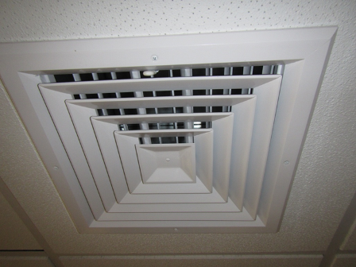

Ceiling-mounted supply diffuser

Picture

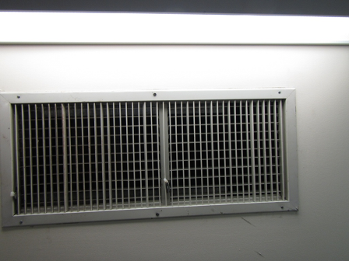

Wall-mounted return vent
Picture

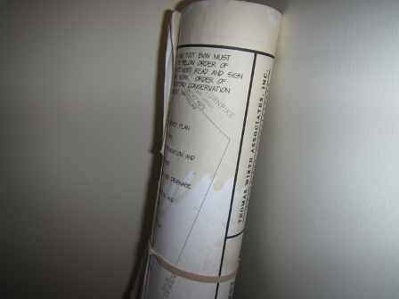

Water-damaged plans in Planning Department Copy Area

Picture

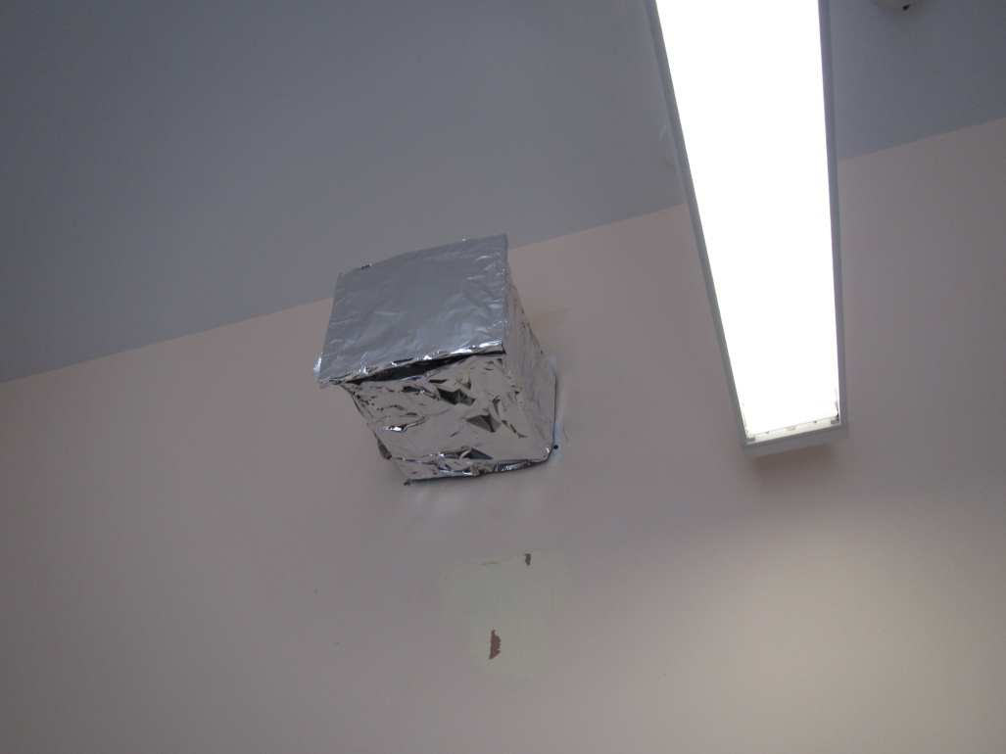

Blocked supply vent

Picture

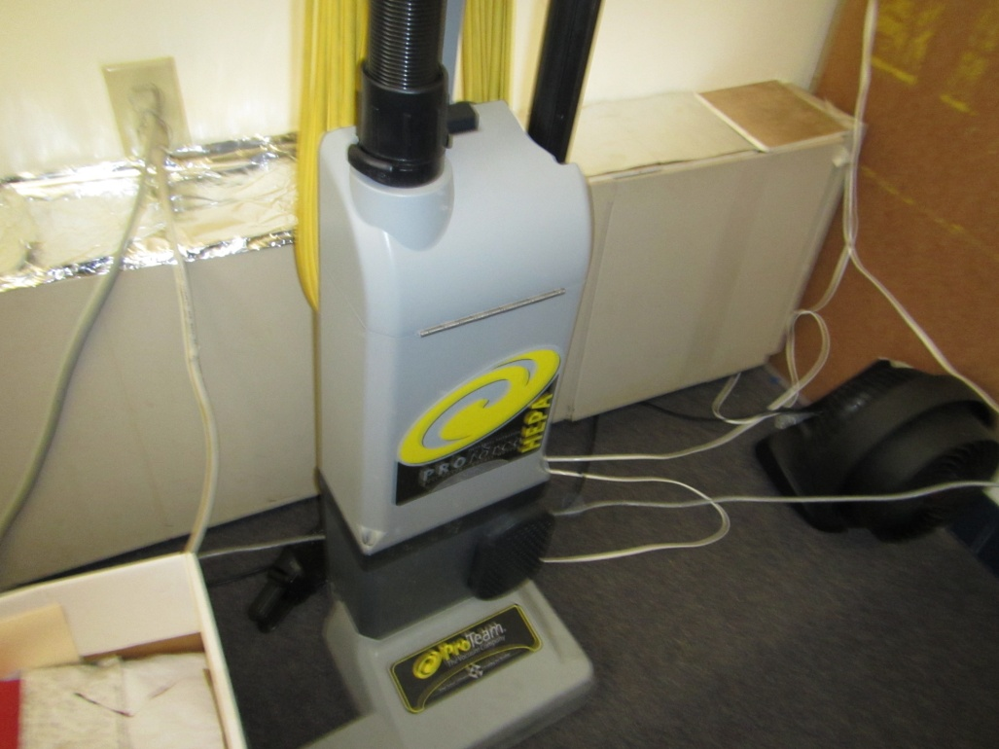

Blocked heating unit (arrows)

Picture

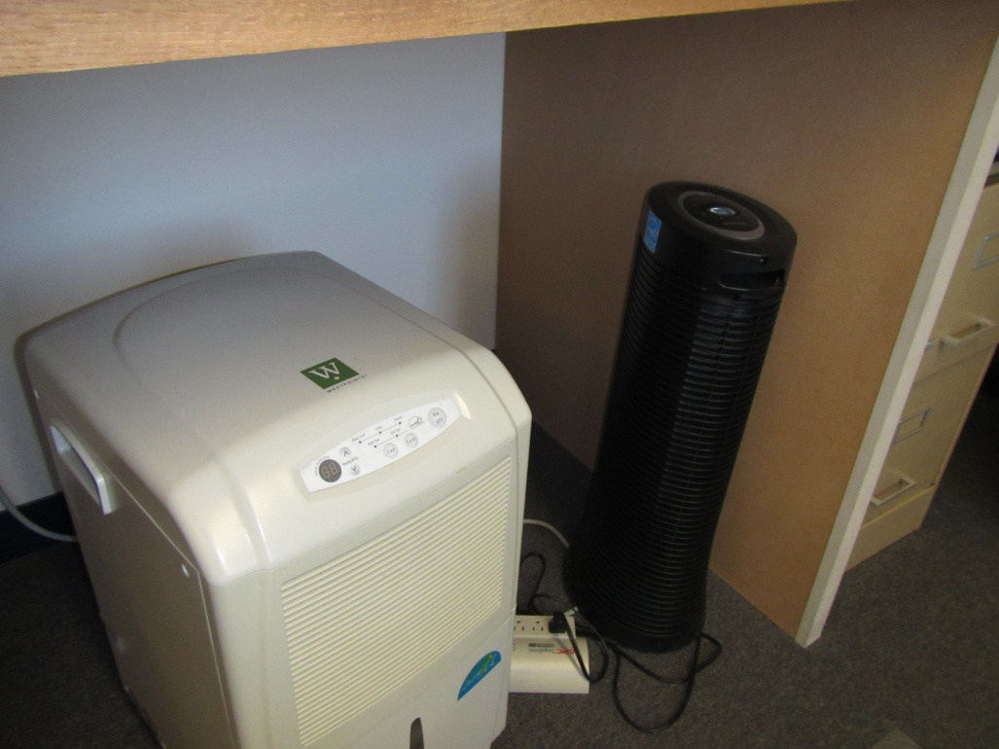

Dehumidifier in lower level (arrow)

Picture

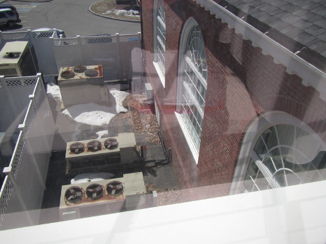

Location of fresh air intake showing leaves/debris (arrow)

Picture

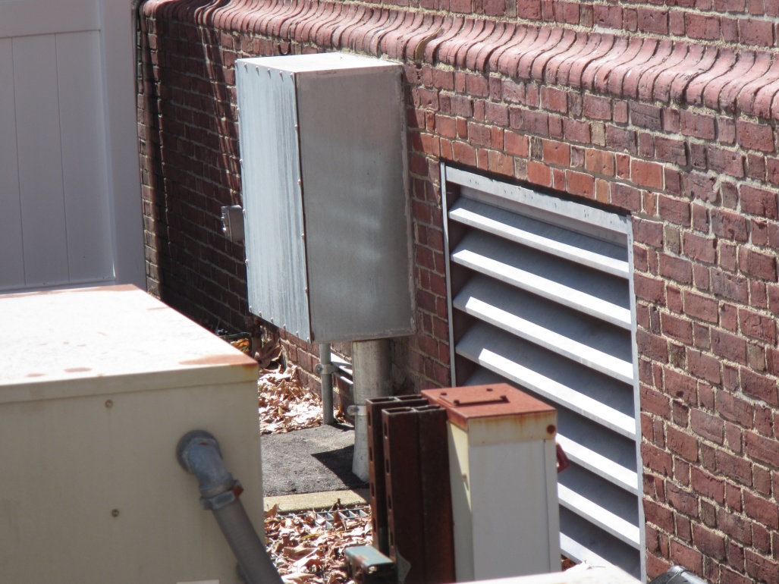
Leaves/debris on pit grate
Fresh air intake vent

Fresh air intake vent with leaves on grate of pit

Picture 9

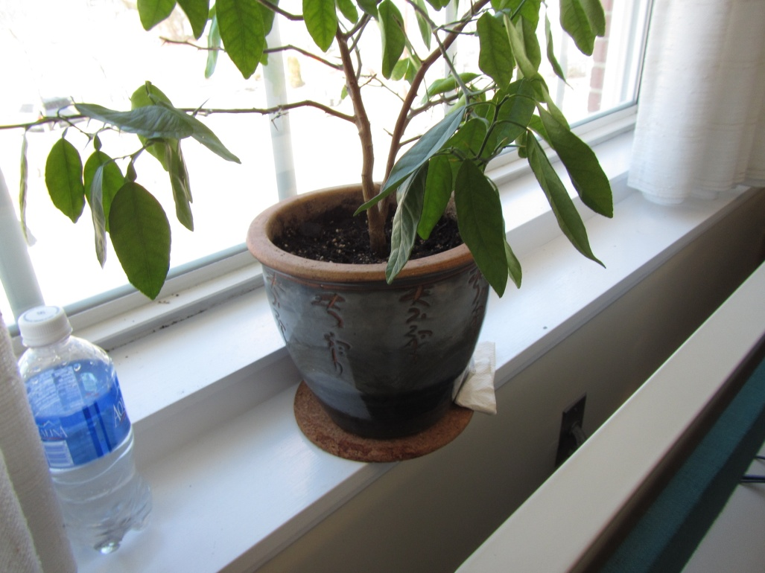

Plant on top of porous materials

Picture 10

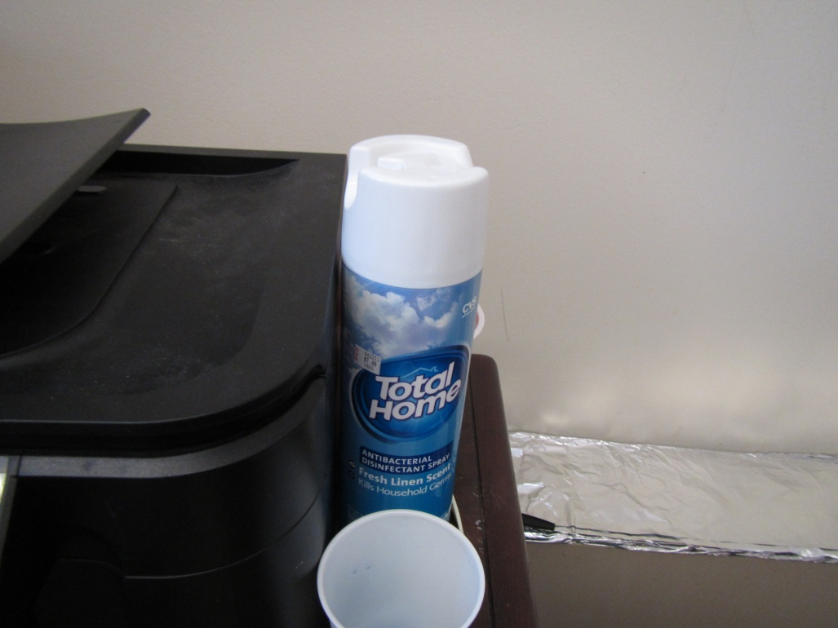
Disinfectant/deodorizing spray

Picture 11

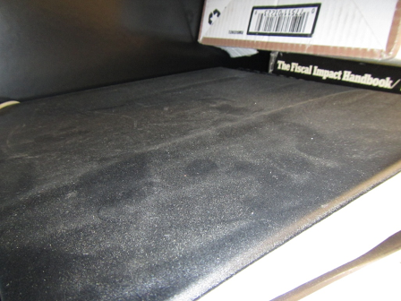

Items with dust/debris accumulation (Planning Director Office)

Picture 12

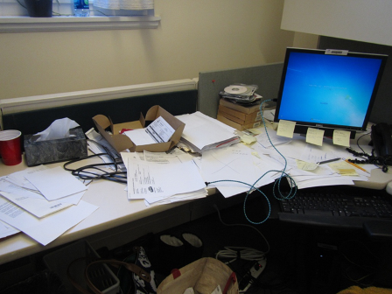

Accumulated items on surfaces
Location | Carbon  Dioxide  (ppm) | Carbon Monoxide  (ppm) | Temp  (°F) | Relative  Humidity  (%) | PM2.5  (µg/m³) | Occupants  in Room | Windows  Openable | Ventilation |  | Remarks
 |  |  |  |  |  |  |  | Supply | Exhaust
Background | 394 | ND | 53 | 10 | 9 |  |  |  |  | Clear, steady wind
LL Conference | 512 | ND | 68 | 22 | 1 | 3 | Y | Y | Y
Kitchen | 480 | ND | 70 | 22 | 2 | 1 | Y | Y | Y | Fridge on carpet, crumbs in toasters
Assessors –open area | 502 | ND | 72 | 22 | 2 | 4 | Y | Y | Y | Plants, PC, printer
Assessors-file room | 473 | ND | 74 | 13 | 2 | 1 | N | N | Y | Carpet, strong exhaust flow (negative pressure)
Assoc. Assessor | 489 | ND | 74 | 13 | 2 | 1 | Y | Y | N | Plants
Asst. Assessor | 479 | ND | 74 | 12 | 2 | 0 | N | Y | N
Janitor closet/office | 460 | ND | 73 | 13 | 3 | 0 | N | Y | Y | HS, cleaning chemicals
Main level
Town Clerk reception | 511 | ND | 71 | 14 | 3 | 2 | Y | Y | Y | PC, DEM, AF
Clerk office foyer | 513 | ND | 75 | 14 | 3 | 2 | N | Y off | Y off | Temp. complaints, pneumatic control problems, south side
Conference room | 523 | ND | 74 | 13 | 3 | 1 | Y | Y off | Y off | PF
Archivist | 510 | ND | 80 | 14 | 4 | 0 | Y | Y off | Y off | No airflow, AI, file boxes, hot- south side (solar gain)
Town Clerk office | 533 | ND | 78 | 20 | 3 | 1 | Y | Y | N | HS, passive door vent
Selectmen’s room | 487 | ND | 75 | 13 | 3 | 2 | Y | Y | Y
Auditorium | 412 | ND | 72 | 15 | 5 | 0 | Y | Y | Y | Slight musty odor, historic water damage to plaster ceiling, over boiler room
Code enforcement | 503 | ND | 73 | 13 | 4 | 4 | Y | Y | Y | Cleaning products, plants
Local bldg. inspector | 512 | ND | 73 | 20 | 3 | 0 | Y | Y off | Y off
Conservation Adm. | 515 | ND | 74 | 20 | 5 | 1 | Y | Y off | Y off | Dusty drapes, reported temp. control issues-cold in winter
Code enforcement director | 520 | ND | 73 | 21 | 4 | 3 | Y | Y | Y
Planning reception | 540 | ND | 73 | 19 | 4 | 3 | Y | Y | Y
Asst. Planner | 512 | ND | 73 | 20 | 4 | 1 | Y | Y | Y | Drafts/temp. control issues, personal heater
Planning director | 700 | ND | 72 | 20 | 7 | 1 | Y open | Y  Blocked | Y  Blocked | HEPA vacuum, blocked ducts, musty odor; possible WD records or items
Planning copy area | 527 | ND | 72 | 20 | 2 | 0 | N | Y | Y | Half wall, WD records
Town manager reception | 560 | ND | 72 | 22 | 2 | 2 | N | Y | Y | HS, AF, plants
Asst. town mgr | 527 | ND | 73 | 19 | 2 | 0 | N | Y | Y
Town Manager | 504 | ND | 74 | 21 | 2 | 1 | Y | Y | Y | Solar gain; south facing
Finance Open area -left side | 508 | ND | 74 | 12 | 2 | 2 | N | Y | Y
Finance-center | 520 | ND | 74 | 13 | 3 | 2 | N | Y | Y | Plants
Finance-right side | 517 | ND | 73 | 13 | 3 | 2 | N | Y | Y | Dusty exhaust vent, plants
Economic Coordinator | 501 | ND | 73 | 13 | 2 | 0 | N | Y | Y
Town Accountant | 548 | ND | 73 | 13 | 2 | 1 | N | Y | Y | Lysol wipes, plants
Finance Director | 527 | ND | 74 | 12 | 2 | 0 | N | Y | Y
IT area | 500 | ND | 74 | 12 | 2 | 0 | N | Y | Y | AI
IT director | 730 | ND | 74 | 12 | 2 | 0 | Y | Y | Y
Human Resources | 583 | ND | 74 | 12 | 3 | 1 | Y | Y | Y | DEM, dead plant
2nd levelConference Room | 484 | ND | 74 | 19 | 3 | 0 | Y | Y | Y
Mail Room | 530 | ND | 73 | 13 | 3 | 0 | Y | Y | Y

