INDOOR AIR QUALITY ASSESSMENT

Beebe School
401 Pleasant Street
Malden, Massachusetts

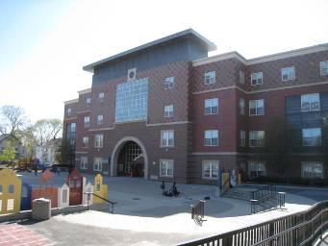

Prepared by:
Massachusetts Department of Public Health
Bureau of Environmental Health
Indoor Air Quality Program
June 2010

Background/Introduction
At the request of a parent, the Massachusetts Department of Public Health (MDPH), Bureau of Environmental Health (BEH) provided assistance and consultation regarding indoor air quality (IAQ) at the Beebe School (BS) located at 401 Pleasant St, Malden, Massachusetts. The assessment was coordinated through the Malden Health Department (MHD) and Malden Public Schools (MPS). Concerns about general IAQ conditions and reports of exacerbation of asthma, prompted the request. On April 13, 2010, Cory Holmes, Environmental Analyst/Regional Inspector from BEH’s Indoor Air Quality (IAQ) Program, made a visit to the BS to conduct an assessment. During the assessment, BEH staff were accompanied by Christopher Webb, Director, MHD and for portions of the assessment by Steve Melanson, Director of Facilities, MPS.
The BS is a four-story modern brick building that was constructed in 1999. The building contains general classrooms, science classrooms, art room, music rooms, computer labs, kitchen, cafeteria, auditorium, gymnasium, faculty workrooms and office space. Windows are openable throughout the building.

Methods
Air tests for carbon monoxide, carbon dioxide, temperature and relative humidity were conducted with the TSI, Q-Trak, IAQ Monitor, Model 7565. Air tests for airborne particle matter with a diameter less than 2.5 micrometers were taken with the TSI, DUSTTRAK™ Aerosol Monitor Model 8520. BEH staff also performed visual inspection of building materials for water damage and/or microbial growth. Moisture content of porous building materials was measured with a Delmhorst, BD-2000 Model, Moisture Detector equipped with a Delmhorst Standard Probe.

Results
The school houses 888 children in grades K through 8 and has a staff of approximately 80. Tests were taken during normal operations at the school and results appear in Table 1.

Discussion

Ventilation
It can be seen from Table 1 that carbon dioxide levels were above 800 parts per million (ppm) in 8 of 25 areas surveyed, indicating poor air exchange in roughly a third of the areas surveyed during the assessment. It is also important to note that several classrooms had open windows and/or were empty/sparsely populated at the time of the assessment, which can greatly reduce carbon dioxide levels. Carbon dioxide levels would be expected to be higher with full occupancy and with windows closed.
Rooftop air-handling units (AHUs) provide mechanical ventilation to interior areas (Picture 1). AHUs draw in fresh, outside air through a set of intake louvers and then through a bank of pleated filters (Picture 2). Air is then distributed to interior areas via ceiling-mounted air diffusers (Picture 3). The air intake for AHU-6 was shut during the assessment, which would limit the introduction of fresh, outside air for areas supplied by this unit (Picture 4). Loud squeaking noises were heard from AHU-5, which suggest either a loose belt or issues with the fly wheel. BEH staff examined the interior of the unit and found substantial debris from belt-wear (Picture 5). Inside the building a loud “hissing” noise was detected in classroom 425. BEH staff removed ceiling tiles toward the rear of the room and discovered a breach in the supply duct, which was pressurizing the ceiling plenum and resulting in little airflow into the classroom. In subsequent correspondence with Mr. Webb, he reported that the duct was repaired and airflow re-established to classrooms supplied by this duct-line.
Exhaust ventilation is provided by ceiling-mounted vents ducted to rooftop motors (Picture 6). The exhaust ventilation system is designed to continuously remove moisture, odors, and pollutants from the indoor environment. Exhaust vents were not functioning in the majority of areas surveyed at the time of the assessment. BEH staff examined the rooftop exhaust vents and found a number of them not functioning/in disrepair (Picture 7). In subsequent correspondence with Mr. Webb he reported that exhaust vents were either repaired or are on a list awaiting repair. In a number of classrooms, the exhaust vents were located above the hallway door which can limit exhaust efficiency (Picture 8). When a classroom door is open, exhaust vents tend to draw air from both the hallway and the classroom. The open hallway door reduces the effectiveness of the exhaust vent to remove common environmental pollutants from classrooms.
Fan coil units (FCUs) in each classroom facilitate airflow and temperature control. FCUs do not provide fresh air to rooms; rather, FCUs re-circulate air and provide auxiliary heating and cooling. Conditioned air is filtered and provided to the classroom by a diffuser atop the unit. Air is then drawn into a return vent at the base of the unit (Figure 1). Each classroom has two FCUs and is controlled by a switch with settings for “low”, “high” and “off”. In a number of areas, FCUs were found deactivated and/or obstructed by furniture, books and other stored materials (Picture 9). In order for FCUs to facilitate airflow as designed, air diffusers and return vents must remain free of obstructions. Importantly, these units must remain “on” and be allowed to operate while rooms are occupied. The occupant of classroom 172 reported that the motor of one of the FCUs was broken and that the other was making “noise”, which may indicate mechanical problems.
To maximize air exchange, the MDPH recommends that both supply and exhaust ventilation operate continuously during periods of occupancy. In order to have proper ventilation with a mechanical supply and exhaust system, the systems must be balanced to provide an adequate amount of fresh air to the interior of a room while removing stale air from the room. It is recommended that HVAC systems be re-balanced every five years to ensure adequate air systems function (SMACNA, 1994).
The Massachusetts Building Code requires that each room have a minimum ventilation rate of 15 cubic feet per minute (cfm) per occupant of fresh outside air or openable windows (SBBRS, 1997; BOCA, 1993). The ventilation must be on at all times that the room is occupied. Providing adequate fresh air ventilation with open windows and maintaining the temperature in the comfort range during the cold weather season is impractical. Mechanical ventilation is usually required to provide adequate fresh air ventilation.
Carbon dioxide is not a problem in and of itself. It is used as an indicator of the adequacy of the fresh air ventilation. As carbon dioxide levels rise, it indicates that the ventilating system is malfunctioning or the design occupancy of the room is being exceeded. When this happens, a buildup of common indoor air pollutants can occur, leading to discomfort or health complaints. The Occupational Safety and Health Administration (OSHA) standard for carbon dioxide is 5,000 parts per million parts of air (ppm). Workers may be exposed to this level for 40 hours/week, based on a time-weighted average (OSHA, 1997).
The MDPH uses a guideline of 800 ppm for publicly occupied buildings. A guideline of 600 ppm or less is preferred in schools due to the fact that the majority of occupants are young and considered to be a more sensitive population in the evaluation of environmental health status. Inadequate ventilation and/or elevated temperatures are major causes of complaints such as respiratory, eye, nose and throat irritation, lethargy and headaches. For more information concerning carbon dioxide, consult Appendix A.
Indoor temperature measurements ranged from 70º F to 75º F, which were within the MDPH recommended comfort range on the day of the assessment (Table 1). The MDPH recommends that indoor air temperatures be maintained in a range of 70º F to 78º F in order to provide for the comfort of building occupants. In many cases concerning indoor air quality, fluctuations of temperature in occupied spaces are typically experienced, even in a building with an adequate fresh air supply. In addition, it is difficult to control temperature and maintain comfort without operating the ventilation equipment as designed (e.g., FCUs/exhaust vents deactivated/inoperable/obstructed).
The relative humidity measured in the building ranged from 23 to 31 percent, which was below the MDPH recommended comfort range in all areas surveyed during the assessment (Table 1). The MDPH recommends a comfort range of 40 to 60 percent for indoor air relative humidity. Relative humidity levels in the building would be expected to drop during the winter months due to heating. The sensation of dryness and irritation is common in a low relative humidity environment. Low relative humidity is a very common problem during the heating season in the northeast part of the United States.

Microbial/Moisture Concerns
Water-damaged ceiling tiles were observed in a few areas, which indicate current/historic plumbing and/or roof leaks (Table 1). Water-damaged ceiling tiles can provide a source of mold and should be replaced after a water leak is discovered and repaired. Chronic leaks were reported by the occupant in room 140 along windows. Water-damaged gypsum wallboard (GW) that was possibly colonized by mold was observed on the ceiling in the hallway outside of classroom 151 (Picture 10). At the time of the assessment, BEH recommended that the damaged/mold colonized section of GW be removed.
Leaks in the nurse’s office were also reported, which most likely are resulting from condensation on metal fixtures associated with the air conditioning system above ceiling tiles. The school maintenance department and/or their HVAC vendor should examine conditions above the ceiling in this area to ensure metal components are properly insulated and that no leaks in the ductwork are detected, to help prevent/reduce condensation.
The auditorium is carpeted and is the lowest point of the school. It was reported that the carpet along the front of the stage is chronically wet during heavy rains that result in high water table conditions (Picture 11). BEH staff conducted moisture measurements of the carpet and found that the carpet and GW along the stairs at stage left (Picture 12) had elevated moisture measurements. At the time of the assessment, BEH staff recommended that the wet carpeting and GW be removed in this area, with a long-term recommendation to replace carpeting along the lower floor of the auditorium with a non-porous material such as tile.
The US Environmental Protection Agency (US EPA) and the American Conference of Governmental Industrial Hygienists (ACGIH) recommend that porous materials (e.g., GW, carpeting) be dried with fans and heating within 24 to 48 hours of becoming wet (US EPA, 2001; ACGIH, 1989). If not dried within this time frame, mold growth may occur. Once mold has colonized porous materials, they are difficult to clean and should be removed and discarded.
Plants were noted in several classrooms. Plants can be a source of pollen and mold which can be respiratory irritants to some individuals. Plants should be properly maintained and equipped with drip pans and should be located away from univents to prevent the aerosolization of dirt, pollen and mold.
Breaches were observed between countertops and sink backsplashes in a number of classrooms (Table 1). If not watertight, water can penetrate through these seams. Water penetration and chronic exposure of porous and wood-based materials can cause these materials to swell and show signs of water damage. As discussed, moistened materials that are not dried within 24 to 48 hours can become potential sources for mold growth.
Water-damaged/mold colonized equipment manuals were found inside of rooftop AHUs (Picture 13). These documents should be removed to prevent a source of mold spores/odors inside the units that can be distributed to occupied areas via the HVAC system.

Other IAQ Evaluations
Indoor air quality can be negatively influenced by the presence of respiratory irritants, such as products of combustion. The process of combustion produces a number of pollutants. Common combustion emissions include carbon monoxide, carbon dioxide, water vapor, and smoke (fine airborne particle material). Of these materials, exposure to carbon monoxide and particulate matter with a diameter of 2.5 micrometers (μm) or less (PM2.5) can produce immediate, acute health effects upon exposure. To determine whether combustion products were present in the indoor environment, BEH staff obtained measurements for carbon monoxide and PM2.5.

Carbon Monoxide
Carbon monoxide is a by-product of incomplete combustion of organic matter (e.g., gasoline, wood and tobacco). Exposure to carbon monoxide can produce immediate and acute health effects. Several air quality standards have been established to address carbon monoxide and prevent symptoms from exposure to these substances. The MDPH established a corrective action level concerning carbon monoxide in ice skating rinks that use fossil-fueled ice resurfacing equipment. If an operator of an indoor ice rink measures a carbon monoxide level over 30 ppm, taken 20 minutes after resurfacing within a rink, that operator must take actions to reduce carbon monoxide levels (MDPH, 1997).
The American Society of Heating Refrigeration and Air-Conditioning Engineers (ASHRAE) has adopted the National Ambient Air Quality Standards (NAAQS) as one set of criteria for assessing indoor air quality and monitoring of fresh air introduced by HVAC systems (ASHRAE, 1989). The NAAQS are standards established by the US EPA to protect the public health from six criteria pollutants, including carbon monoxide and particulate matter (US EPA, 2006). As recommended by ASHRAE, pollutant levels of fresh air introduced to a building should not exceed the NAAQS levels (ASHRAE, 1989). The NAAQS were adopted by reference in the Building Officials & Code Administrators (BOCA) National Mechanical Code of 1993 (BOCA, 1993), which is now an HVAC standard included in the Massachusetts State Building Code (SBBRS, 1997). According to the NAAQS, carbon monoxide levels in outdoor air should not exceed 9 ppm in an eight-hour average (US EPA, 2006).
Carbon monoxide should not be present in a typical, indoor environment. If it is present, indoor carbon monoxide levels should be less than or equal to outdoor levels. Outdoor carbon monoxide concentrations were non-detect (ND) the day of the assessment (Table 1). No measureable levels of carbon monoxide were detected in the building during the assessment (Table 1).

Particulate Matter
The US EPA has established NAAQS limits for exposure to particulate matter. Particulate matter is airborne solids that can be irritating to the eyes, nose and throat. The NAAQS originally established exposure limits to particulate matter with a diameter of 10 μm or less (PM10). According to the NAAQS, PM10 levels should not exceed 150 microgram per cubic meter (μg/m³) in a 24-hour average (US EPA, 2006). These standards were adopted by both ASHRAE and BOCA. Since the issuance of the ASHRAE standard and BOCA Code, US EPA established a more protective standard for fine airborne particles. This more stringent PM2.5 standard requires outdoor air particle levels be maintained below 35 μg/m³ over a 24-hour average (US EPA, 2006). Although both the ASHRAE standard and BOCA Code adopted the PM10 standard for evaluating air quality, MDPH uses the more protective PM2.5 standard for evaluating airborne particulate matter concentrations in the indoor environment.
Outdoor PM2.5 concentration was measured at 6 μg/m³ (Table 1). PM2.5 levels measured indoors ranged from 4 to 10 μg/m³ (Table 1), which were below the NAAQS PM2.5 level of 35 μg/m³. Frequently, indoor air levels of particulates (including PM2.5) can be at higher levels than those measured outdoors. A number of mechanical devices and/or activities that occur indoors can generate particulate during normal operations. Sources of indoor airborne particulates may include but are not limited to particles generated during the operation of fan belts in the HVAC system, cooking in the cafeteria stoves and microwave ovens; use of photocopiers, fax machines and computer printing devices; operation of an ordinary vacuum cleaner and heavy foot traffic indoors.

Volatile Organic Compounds
Indoor air concentrations can be greatly impacted by the use of products containing volatile organic compounds (VOCs). VOCs are carbon-containing substances that have the ability to evaporate at room temperature. Frequently, exposure to low levels of total VOCs (TVOCs) may produce eye, nose, throat and/or respiratory irritation in some sensitive individuals. For example, chemicals evaporating from a paint can stored at room temperature would most likely contain VOCs. In an effort to identify materials that can potentially increase indoor VOC concentrations, BEH staff examined classrooms for products containing these respiratory irritants.
A strong chemical odor was detected in room 429, which was traced to two plug-in air fresheners. Air deodorizers contain chemicals that can be irritating to the eyes, nose and throat of sensitive individuals. Many air fresheners contain 1,4-dichlorobenzene, a VOC which may cause reductions in lung function (NIH, 2006). Furthermore, deodorizing agents do not remove materials causing odors, but rather mask odors that may be present in the area.
Several classrooms contained dry erase boards and markers. Materials such as permanent markers, dry erase markers and dry erase board cleaners may contain VOCs, such as methyl isobutyl ketone, n-butyl acetate and butyl-cellusolve (Sanford, 1999), which can be irritating to the eyes, nose and throat. Cleaning products were also observed on countertops in classrooms during the assessment. Like dry erase materials, cleaning products contain VOCs and other chemicals. These chemicals can be irritating to the eyes, nose and throat and should be kept out of reach of students. Furthermore, a Material Safety Data Sheet (MSDS) should be available at a central location for each product in the event of an emergency. Consideration should be given to providing teaching staff with school issued cleaning products and supplies to ensure that MSDS information is available for all products used at the school.

Other Conditions
Other conditions that can affect indoor air quality were observed during the assessment. Upholstered furniture, cushions and pillows were observed in several classrooms. Upholstered furniture pillows and cushions are covered with fabric that comes in contact with human skin. This type of contact can leave oils, perspiration, hair and skin cells. Dust mites feed upon human skin cells and excrete waste products that contain allergens. In addition, if relative humidity levels increase above 60 percent, dust mites tend to proliferate (US EPA, 1992). In order to remove dust mites and other pollutants, frequent vacuuming of upholstered furniture is recommended (Berry, M.A., 1994). It is also recommended that upholstered furniture (if present in schools), be professionally cleaned on an annual basis. If an excessively dusty environment exists due to outdoor conditions or indoor activities (e.g., renovations), cleaning frequency should be increased (every six months) (IICRC, 2000).
In several classrooms, items were observed on the floor, windowsills, tabletops, counters, bookcases and desks. The large number of items stored in classrooms provides a source for dusts to accumulate. These items (e.g., books, papers, folders, boxes) make it difficult for custodial staff to clean. Items should be relocated and/or be cleaned periodically to avoid excessive dust build up. In addition, these materials can accumulate on flat surfaces (e.g., desktops, shelving and carpets) in occupied areas and can subsequently be re-aerosolized causing further irritation.
Several bathroom fans were not functioning at the time of the assessment. This condition prevents the continuous removal of moisture and restroom odors. On windy days, air can be forced down the exhaust ducts “pressurizing” the rooms. If exhaust vents are not functioning, back-drafting can occur, which can re-aerosolize accumulated dirt and dust particles and force restroom odors into adjacent areas.
A number of personal fans, exhaust vents, air diffusers and flat surfaces in classrooms and hallways (e.g., windowsills, lockers, TVs) were observed to have accumulated dust/debris (Pictures 3 and 6). Accumulated dust/debris was also noted inside AHUs and FCUs (Pictures 5, 14 through 16). Re-activated FCUs, AHUs, vents or fans can aerosolize accumulated dust. If exhaust vents are not functioning, backdrafting can occur, which can re-aerosolize dust particles.
Finally, filters for the FCUs were observed to be ill-filling, with many of them resting on the floor (Picture 17). In many cases the filters were occluded with dust/debris (Picture 18). Once a filter is saturated it can actually serve as a source of particulates to be re-aerosolized into the airstream by the FCUs. In addition, it can accelerate the degradation of HVAC equipment by making the equipment work harder to draw air through clogged filters.

Asthma Prevalence
In 2003 the Massachusetts Department of Public Health began tracking the prevalence of pediatric asthma in public and private schools statewide. This initiative is part of the MDPH Environmental Public Health Tracking (EPHT) Program funded by the United States Centers for Disease Control and Prevention, the EPHT portal contains a variety of health and environmental information specific to Massachusetts communities (http://matracking.ehs.state.ma.us). The statewide prevalence rate of pediatric asthma is 10.85. For the city of Malden as a whole the rate is 11.94. The rate of asthma in Malden is statistically significantly higher than the statewide pediatric asthma prevalence rates. However, the pediatric asthma prevalence rate for the Beebe School is 6.1, which is statistically significantly lower than the statewide prevalence rate for pediatric asthma.

Conclusions/Recommendations
In view of the findings at the time of the visit, the following recommendations are provided:
- Contact an HVAC engineering firm to evaluate fresh air intake louvers/pneumatics for AHU 6, belt/flywheel function for AHU-5, and that repairs to the breach in the ductwork in classroom 425 were adequate to restore airflow.
- Continue with plans to restore general exhaust ventilation throughout the building. Periodically inspect motors and belts for proper function; perform repairs and adjustments as necessary.
- Restore exhaust ventilation in bathroom areas; make repairs as necessary.
- Close classroom doors to facilitate exhaust ventilation.
- Remove all blockages from FCUs to ensure adequate airflow.
- Operate FCUs as designed to facilitate airflow and temperature control. Inspect FCUs in classroom 172, make repairs as needed.
- Change filters for air-handling equipment (e.g., AHUs, and FCU) as per the manufacturers’ instructions or more frequently if needed. Vacuum interior of units prior to activation to prevent the aerosolization of dirt, dust and particulate matter. Ensure filters fit flush in their racks with no spaces in between allowing bypass of unfiltered air into the unit.
- Consider adopting a balancing schedule of every 5 years for all mechanical ventilation systems, as recommended by ventilation industrial standards (SMACNA, 1994).
- Use openable windows to facilitate air exchange. Care should be taken to ensure windows are properly closed at night and weekends to avoid the freezing of pipes and potential flooding.
- Improve cleaning/dust control measures. For buildings in New England, periods of low relative humidity during the winter are often unavoidable. Therefore, scrupulous cleaning practices should be adopted to minimize common indoor air contaminants whose irritant effects can be enhanced when the relative humidity is low. To control dusts, a high efficiency particulate arrestance (HEPA) filter equipped vacuum cleaner in conjunction with wet wiping of all surfaces is recommended. Avoid the use of feather dusters. Drinking water during the day can help ease some symptoms associated with a dry environment (throat and sinus irritations).
- Develop a clear line of communication between the central maintenance department and school personnel for prompt remediation of temperature/ventilation concerns/complaints, leaks or other building related issues. This can be done by establishing a written request/e-mail work order system with a log kept in the main office. Classroom occupants should report temperature extremes immediately to school administration/maintenance and refrain from deactivating/obstructing HVAC equipment.
- Repair any existing water leaks (e.g., area along windows of room 140) and replace any remaining water-damaged ceiling tiles. Examine the area above these tiles for mold growth. Disinfect areas of water leaks with an appropriate antimicrobial, as needed.
- Remove water damaged/mold colonized section of GW ceiling in hallway outside of classroom 151. Determine the source of water leaks and make repairs as needed.
- Inspect HVAC system for proper insulation and/or breaches in ductwork above ceiling in nurse’s office in areas where chronic leaks are reported; make repairs as necessary.
- Remove carpeting from lower level of auditorium in front of stage. Consider replacing with non-porous flooring material (e.g., tile).
- Remove water-damaged GW at base of stairs near wet carpeting in auditorium stage left. Consider replacing with a non-porous/water resistant material.
- Consider contacting a building engineering firm, public works and/or building envelope specialist to determine methods of preventing chronic water infiltration in the auditorium.
- Remove water-damaged/mold colonized manuals from inside AHUs, clean flat surfaces with an antimicrobial as necessary.
- Seal breaches, seams and spaces between sink countertops and backsplashes to prevent water damage.
- Ensure plants are equipped with drip pans. Examine drip pans periodically for mold growth and disinfect with an appropriate antimicrobial, as needed.
- Routinely clean dry erase board trays of accumulated particulate.
- Store cleaning products properly and out of reach of students. All cleaning products used at the facility should be approved by the school department with MSDS’ available at a central location.
- Refrain from using strongly scented materials (e.g., air fresheners) in classrooms.
- Relocate or consider reducing the amount of materials stored in classrooms to allow for more thorough cleaning of classrooms. Clean items regularly with a wet cloth or sponge to prevent excessive dust build-up.
- Clean upholstered furniture/pillows/cushions annually or more frequently if needed. If not feasible, consider removal.
- Clean air diffusers, exhaust vents, FCUs and personal fans periodically of accumulated dust. If stained ceiling tiles cannot be cleaned, replace.
- Consider adopting the US EPA (2000) document, “Tools for Schools”, as an instrument for maintaining a good indoor air quality environment in the building. This document is available at: http://www.epa.gov/iaq/schools/index.html.
- Refer to resource manual and other related indoor air quality documents located on the MDPH’s website for further building-wide evaluations and advice on maintaining public buildings. These documents are available at: http://mass.gov/dph/iaq.

References
ACGIH. 1989. Guidelines for the Assessment of Bioaerosols in the Indoor Environment. American Conference of Governmental Industrial Hygienists, Cincinnati, OH.
ASHRAE. 1989. Ventilation for Acceptable Indoor Air Quality. American Society of Heating, Refrigeration and Air Conditioning Engineers. ANSI/ASHRAE 62-1989.
Berry, M.A. 1994. Protecting the Built Environment: Cleaning for Health, Michael A. Berry, Chapel Hill, NC.
BOCA. 1993. The BOCA National Mechanical Code/1993. 8th ed. Building Officials and Code Administrators International, Inc., Country Club Hill, IL.
IICRC. 2000. IICRC S001 Reference Guideline for Professional On-Location Cleaning of Textile Floor Covering Materials Institute of Inspection, Cleaning and Restoration Certification. Institute of Inspection Cleaning and Restoration, Vancouver, WA.

MDPH. 1997. Requirements to Maintain Air Quality in Indoor Skating Rinks (State Sanitary Code, Chapter XI). 105 CMR 675.000. Massachusetts Department of Public Health, Boston, MA.
NIH. 2006. Chemical in Many Air Fresheners May Reduce Lung Function. NIH News. National Institute of Health. July 27, 2006. http://www.nih.gov/news/pr/jul2006/niehs-27.htm
OSHA. 1997. Limits for Air Contaminants. Occupational Safety and Health Administration. Code of Federal Regulations. 29 C.F.R 1910.1000 Table Z-1-A.

Sanford. 1999. Material Safety Data Sheet (MSDS No: 198-17). Expo® Dry Erase Markers Bullet, Chisel, and Ultra Fine Tip. Sanford Corporation. Bellwood, IL.
SBBRS. 1997. Mechanical Ventilation. State Board of Building Regulations and Standards. Code of Massachusetts Regulations. 780 CMR 1209.0.
SMACNA. 1994. HVAC Systems Commissioning Manual. First Edition. Sheet Metal and Air Conditioning Contractors’ National Association, Inc., Chantilly, VA.
US EPA. 1992. Indoor Biological Pollutants. US Environmental Protection Agency, Environmental Criteria and Assessment Office, Office of Health and Environmental Assessment, research Triangle Park, NC. EPA 600/8-91/202 January 1992.
US EPA. 2000. Tools for Schools. Office of Air and Radiation, Office of Radiation and Indoor Air, Indoor Environments Division (6609J). EPA 402-K-95-001, Second Edition. http://www.epa.gov/iaq/schools/tools4s2.html
US EPA. 2001. Mold Remediation in Schools and Commercial Buildings. Office of Air and Radiation, Indoor Environments Division, Washington, DC. EPA 402-K-01-001. March 2001. Available at: http://www.epa.gov/iaq/molds/mold_remediation.html
US EPA. 2006. National Ambient Air Quality Standards (NAAQS). US Environmental Protection Agency, Office of Air Quality Planning and Standards, Washington, DC. http://www.epa.gov/air/criteria.html
Picture 1

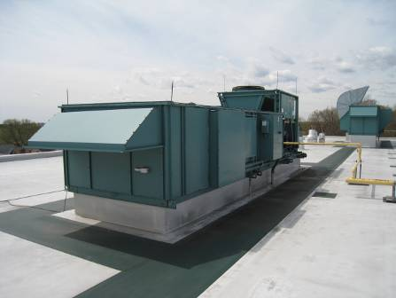

Rooftop Air Handling Units (AHUs)

Picture 2

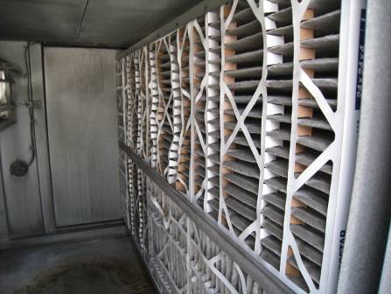

Bank of Pleated Air Filters in Rooftop AHU

Picture 3

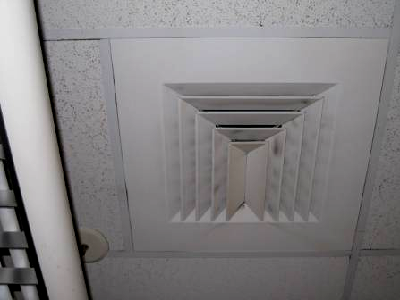

Ceiling-Mounted Air Diffuser, Note Dust/Debris Accumulation on Louvers

Picture 4

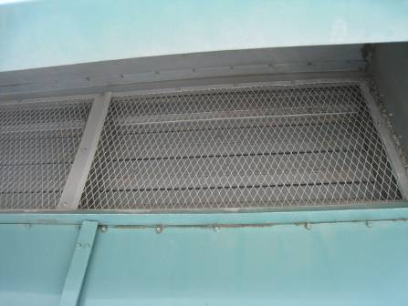

Air Intake Shut on Rooftop AHU 6

Picture 5

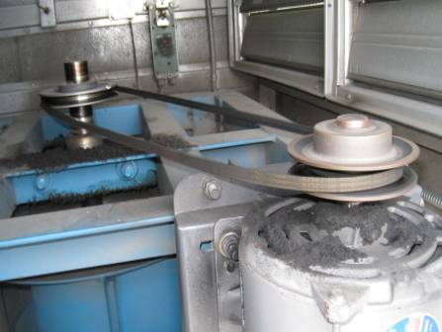

Interior of AHU-5, Note Piles of Debris From Belt-Wear

Picture 6

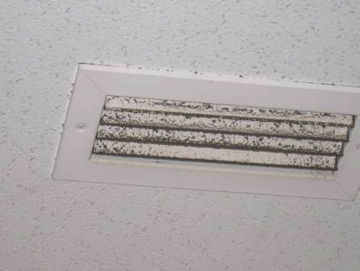

Ceiling-Mounted Exhaust Vent, Note Dust/Debris Accumulation on Louvers

Picture 7

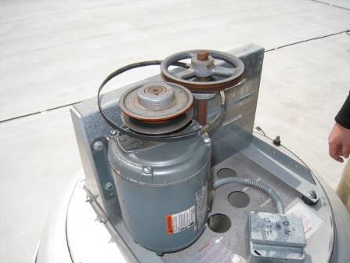

Rooftop Exhaust Vent, Note Damaged Fan Belt

Picture 8

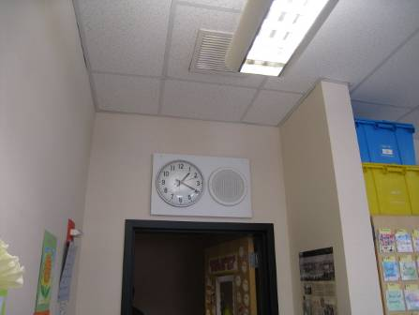

Proximity of Exhaust Vent to Open Classroom Door

Picture 9

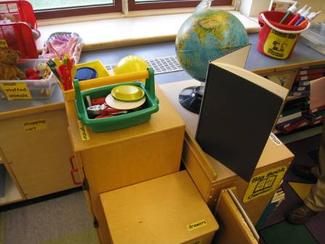

Fan Coil Unit (FCU) Return Vent (Bottom Front) Obstructed by Classroom Furniture

Picture 10

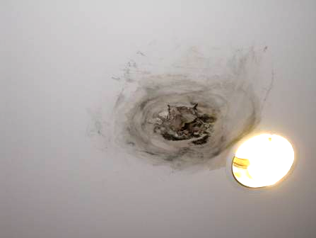

Water Damaged/Mold Colonized section of Gypsum Wallboard Ceiling
In Hallway Near Classroom 151
Picture 11

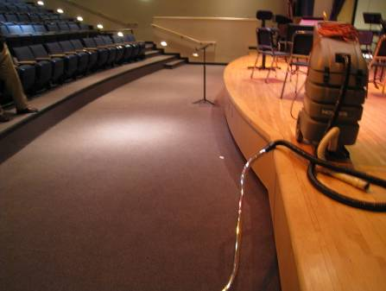

Auditorium Floor Chronically Moistened, Arrow Indicates Wet Carpet and GW at Base of Stairs

Picture 12

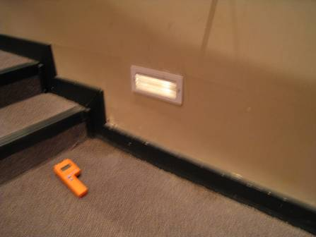

Wet Carpet and GW at Base of Stairs Auditorium Stage Left

Picture 13

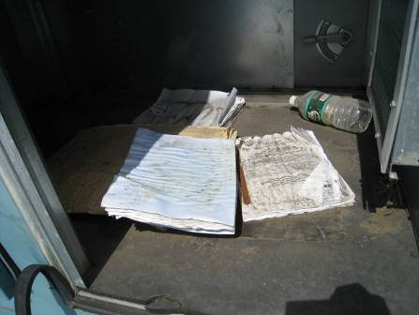

Water-Damaged/Mold Colonized Manuals Inside AHU Chambers

Picture 14

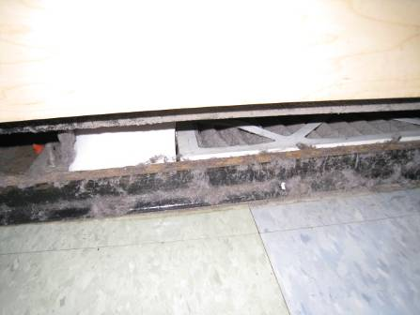

Accumulated Dust/Debris Along Front of FCU, Note Filter on Floor
Picture 15

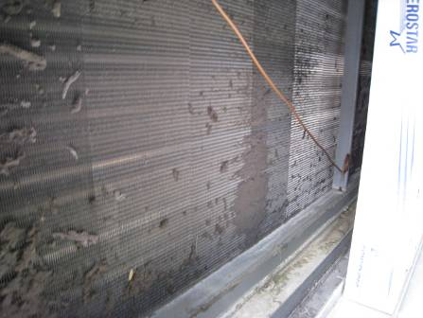

Accumulated Dust/Debris in Rooftop AHU

Picture 16

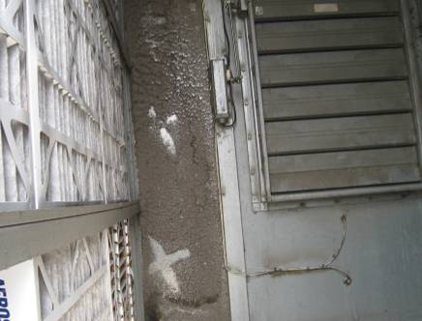

Accumulated Dust/Debris in Rooftop AHU

Picture 17

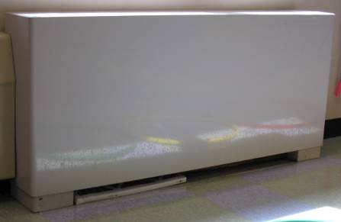

Air Filter for FCU on Floor

Picture 18

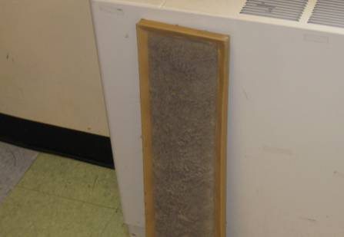

Air Filter for FCU Occluded With Dust/Debris
Location/ Room | Occupants  in Room | Temp  (°F) | Relative  Humidity  (%) | Carbon  Dioxide  (ppm) | Carbon Monoxide  (ppm) | PM2.5  (µg/m3) | Windows  Openable |  | Ventilation |  |  |  | Remarks
 |  |  |  |  |  |  |  |  |  | Supply |  | Exhaust
background |  | 63 | 24 | 330 | ND | 6 |  |  |  |  |  |  | Scattered clouds, mostly sunny, winds East 9-17 mph, gusts up to 21 mph
174 | 21 | 70 | 29 | 830 | ND | 7 | Y |  | Y |  | Y |  | Exhaust weak/off, tile floor, accumulated items
173 | 25 | 73 | 27 | 975 | ND | 8 | Y |  | Y |  | Y |  | Exhaust weak/off, FCU-filter on ground, DO, dirt/dust accumulation-supply/return vents/flat surfaces, dust/debris accumulation on vents
172 | 25 | 73 | 27 | 1103 | ND | 9 | Y |  | Y |  | Y |  | Accumulated items, plants, 1 FCU reportedly has broken motor, 1 reported to have-noise, plants
1st Floor Boy’s Restroom |  |  |  |  |  |  | N |  | N |  | Y |  | No draw from exhaust vent
154 | 0 | 72 | 26 | 598 | ND | 6 | N |  | Y |  | Y
151 | 26 | 75 | 27 | 938 | ND | 7 | N |  | Y |  | Y |  | FCU-vent occluded with dust/debris, spaces between sink/backsplash
 | Hallway outside room 151 |  |  |  |  |  |  |  |  |  |  |  | WD GW ceiling, possible mold growth, leak/hole in GW
149 | 26 | 73 | 27 | 940 | ND | 5 | Y |  | Y |  | Y |  | FCU obstructed, 1 WD CT, dust/debris on vents, spaces between sink/backsplash
142 | 23 | 73 | 28 | 973 | ND | 10 | Y |  | Y |  | Y |  | Dirt/dust/debris accumulation on vents, FCU filter on floor, 4 area rugs, spaces sink/countertop
40 | 27 | 73 | 25 | 686 | ND | 7 | Y |  | Y |  | Y |  | Window open, FCU obstructed dust/debris accumulation, plants/nests on FCU, DO, spaces between sink/countertop, UF/pillows/chair, FCU filter on floor, chronic leaks reported along window
Music Room 180 | 26 | 74 | 26 | 582 | ND | 7 | N |  | Y |  | Y |  | Spaces between sink/backsplash, wall to wall carpeting
136 | 3 | 75 | 24 | 592 | ND | 7 | Y |  | Y |  | Y |  | FCU-filter dirty
137 OT/PT | 0 | 70 | 23 | 470 | ND | 8 | Y |  | Y |  | Y
Health Services | 4 | 72 | 27 | 514 | ND | 10 | Y |  | Y |  | Y |  | Debris/sediment from vents reported, dust/debris accumulation on vents, occupant reports chronic condensation/leaks from AC system
Auditorium | 0 | 70 | 25 | 378 | ND | 7 | N |  | Y |  | Y |  | Lowest point of building, chronic water pooling, carpeted, Carpet-wet, GW-wet-recommend removal along stairs
218 | 0 | 74 | 31 | 890 | ND | 9 | Y |  | Y |  | Y |  | Spaces between sink/backsplash
213 | 0 | 75 | 27 | 683 | ND | 10 | Y |  | Y |  | Y |  | Window open, cleaning products on sink, spaces between sink/backsplash, FCU-obstructed, dust/cobwebs
322 | 26 | 75 | 28 | 569 | ND | 10 | Y |  | Y |  | Y |  | Windows open, spaces between sink/backsplash, cleaning products
337 | 0 | 75 | 25 | 442 | ND | 9 | Y |  | Y |  | Y
341 | 25 | 74 | 25 | 512 | ND | 7 | Y |  | Y |  | Y |  | Window open
410 | 20 | 74 | 31 | 810 | ND | 4 | Y |  | Y |  | Y |  | DO, spaces between sink/backsplash, exhaust vent-weak
Hallway outside 410 |  |  |  |  |  |  |  |  |  |  |  |  | WD CT-dry
416 | 0 | 74 | 25 | 452 | ND | 7 | Y |  | Y |  | Y |  | FCU obstructed, accumulated items on flat surfaces, dust control issues
425 | 25 | 74 | 27 | 589 | ND | 8 | Y |  | Y |  | Y |  | Noise from HVAC-breach in duct above ceiling-pressurizing ceiling plenum, FCU-off/obstructed, windows open, accumulated items,
427 | 1 | 74 | 27 | 570 | ND | 9 | Y |  | Y |  | N |  | DO
429 | 1 | 71 | 25 | 440 | ND | 10 | Y |  | Y |  | Y |  | 2 plug-in air fresheners, space between sink/backsplash, FCUs-off, filters on ground
417 | 6 | 74 | 25 | 551 | ND | 9 | Y |  | Y |  | Y |  | Accumulated items, space between sink/backsplash
407 | 20 | 74 | 26 | 503 | ND | 9 | Y |  | Y |  | Y |  | Windows open, DO, kiln-vented
`

