INDOOR AIR QUALITY ASSESSMENT

Belcher Elementary School
125 Montgomery Street
Chicopee, MA

March 2024

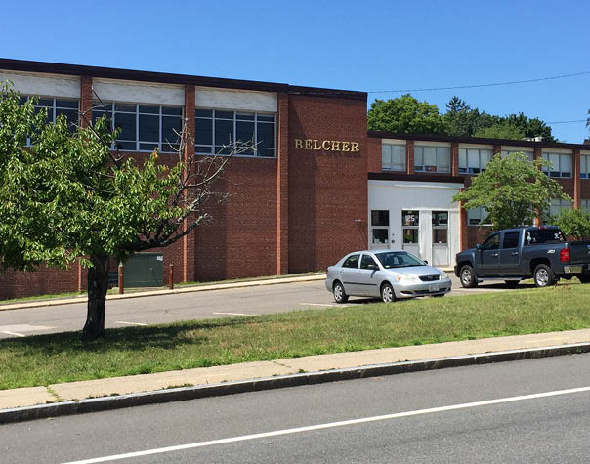

Prepared by:
Massachusetts Department of Public Health
Bureau of Climate and Environmental Health
Indoor Air Quality Program

Contents

EXECUTIVE SUMMARY 3
BACKGROUND 5
RESULTS AND DISCUSSION 5
Ventilation 5
HVAC System Maintenance 6
HVAC Types and Specific Conditions 6
Water Damage and Moisture Concerns 7
Sources of Respiratory Irritants/Possible Asthma Triggers 9
Other IAQ Issues 11
CONCLUSIONS AND RECOMMENDATIONS 11
REFERENCES 17
FIGURES 19
PICTURES 20
Table 1 34
Table 2A 34
Table 2B 35
Table 2C 36
Table 3 37
Table 4 39

R an EXECUTIVE SUMMARY

The Massachusetts Department of Public Health’s Indoor Air Quality Program (MADPH IAQ) conducted an IAQ walkthrough of the Belcher Elementary School located at 125 Montgomery Street in Chicopee on February 28, 2024. This walkthrough was in conjunction with the “Asthma in Schools: Data to Action Project”- a collaboration between Massachusetts Department of Public Health (DPH) programs, local health departments, and local school health and administration officials to support asthma prevention and intervention efforts in school settings.
Any building can have IAQ issues. These issues can be made worse through conditions common to marginalized communities (Environmental Justice communities or EJ) such as inequitable exposure to outdoor air pollution and a greater likelihood of poor building conditions leading to deterioration of IAQ resulting in higher asthma rates. The Belcher Elementary School is within an EJ community. In addition, the pediatric asthma rate for this school as of 2018 is 22.5% compared to the statewide pediatric prevalence rate of 11.8%.
The assessment was conducted by evaluating several key elements within the school; a visual inspection of the heating, cooling, and ventilating (HVAC) systems, water/microbial damage, exterior building envelope evaluation, cleanliness, and point sources of respiratory irritants such as chemicals. Data is collected in this manner to identify potential asthma triggers, allergens, and other environmental factors that can cause indoor air quality symptoms. Please refer to the Indoor Air Quality Manual on the MDPH website for methods, sampling procedures, and interpretation of results.
As a result of this walkthrough, there are several findings: conditions in this school are typical of elementary schools of this age and type, univents and other heating, ventilation, and air conditioning (HVAC) components may be beyond their lifespan, some water-stained ceiling tiles were observed, and there are occupant induced issues such as clutter and blockage of HVAC units. (Results and Discussion)
Upon review of these findings, a number of recommendations are made to optimize existing HVAC systems and improve air exchange. It is a testament to the Facilities/Maintenance staff that the original HVAC units in the building are still operating (> 50 years old). However, the age of univents and other HVAC components make maintenance increasingly difficult. Issues regarding the presence of point sources of irritation such as clutter can be addressed to reduce dust and odors. (Conclusions)
Based on the results of the assessment, the following primary recommendations are made:
- Operate supply and exhaust ventilation continuously when the building is occupied. Check univents and exhaust vents during occupied periods to ensure they are on and operating.
- Educate teachers and staff on the operation of univents and exhaust vents so they can avoid blocking units and can report off or inoperable units to facility staff. If not already in use, consider using a tracking program to collect and administer work orders for mechanical systems such as classroom univents.
- Consider reducing the number of items stored in rooms to make cleaning easier. Scrupulous cleaning practices should be adopted to minimize common indoor air contaminants whose irritant effects can be enhanced when the relative humidity is low. To control dusts, a high efficiency particulate arrestance (HEPA) filter equipped vacuum cleaner in conjunction with wet wiping of all surfaces is recommended. Avoid the use of feather dusters.
(Conclusions and Recommendations)
Please note: this report contains a series of recommendations that should serve as Best Practices that apply to most public-school buildings across the Commonwealth and should be shared amongst other buildings in the school district.

R an BACKGROUND
Building: | Belcher Elementary School
Address: | 125 Montgomery Street  Chicopee, Massachusetts
Coordinated Via: | Chicopee school administration, board of health, and nursing leaders
Reason for Request: | Pediatric Asthma Pilot Project and General IAQ
Date of Assessment: | February 28, 2024
Massachusetts Department of Public Health/Bureau of Climate and Environmental Health (MDPH/BCEH) Staff Conducting Assessment: | Cory Holmes, Assistant Director, IAQ Program  Stefanie Santora, Inspector, IAQ Program
Building Description: | The Belcher Elementary School is a brick-faced two-story school with occupied basement, originally constructed in 1969 as a catholic school. Some interior renovations were made in 2010 along with the addition of a 4-classroom modular wing. The school contains general classrooms, offices, and accessory rooms including a combination gym/cafeteria/auditorium.
Windows: | Most windows in the building are openable.

R an RESULTS AND DISCUSSION
The following is a summary of conditions observed during the indoor air quality walkthrough (Table 1)

Ventilation
Ventilation refers to both the supply of fresh air and the removal of stale air from a room. The introduction of fresh air into an occupied space will dilute normally occurring pollutants that are generated by occupancy and other activities. In addition, an HVAC system will remove pollutants from a building if operating appropriately. All ventilation systems throughout the building should operate continuously during periods of occupancy.

The Belcher Elementary School has a combination of unit ventilators (univents, Picture 1) and rooftop air handing units (for the modular wing, Picture 2). Univents bring in fresh air from a vent on the outside of the building (Picture 3), filter it, heat it, and supply the air through a vent on the top. Some room air is recirculated along with the fresh air through a vent at the bottom (Figure 1). The air handling units bring in fresh air from the roof, filter it, heat it, and bring it into classrooms and offices through ceiling-mounted supply vents (Pictures 4 and 5). Classrooms are also equipped with exhaust vents that remove stale air from rooms; they are located in the top of coat closets (Picture 6) in most classrooms, while the modular classrooms have ceiling vents (Picture 7) (Table 2B).

The various types of ventilation components as well as devices that can move/redirect airflow are listed in Table 2A, Table 2B and Table 2C.

HVAC System Maintenance
- Univents, Fan Coil Units (FCU), and other HVAC components may be beyond their service life According to the American Society of Heating, Refrigeration, and Air-Conditioning Engineering (ASHRAE), the service life of this type of unit is 15-20 years, assuming routine maintenance of the equipment (ASHRAE, 1991).

HVAC Types and Specific Conditions
Balancing
To have proper ventilation with a mechanical supply and exhaust system, a system must be balanced to provide an adequate amount of fresh air to the interior of a room while also removing stale air from the room.
It is recommended that HVAC systems be re-balanced every five years to ensure adequate air systems function (SMACNA, 1994).

(see HVAC pictures)

Classroom Unit ventilators:
- Some univents were blocked with furniture or items (Pictures 8 and 9; Table 1).

- Most univents were set to fan “off” (Table 1), so although they were radiating heat, no fresh air was being provided during the walkthrough.

- Univents are reported to have filters with a minimum efficiency reporting value (MERV) of 4-5. The MDPH IAQ program recommends that filters of at least MERV 8 be used if the equipment can handle without a degradation in airflow, as these are adequate to filter out pollen, mold, and similar particulates.

Classroom Exhaust vents:
- A few exhaust vents were blocked with items (Picture 10; Table 1).

- Some exhaust vents were not operating, as judged by a lack of air draw (Table 1). Either these have been turned off or the rooftop fans are not functional.

- It should also be noted that coat closet doors were removed, which changes how the exhaust vents were designed to operate (by pulling air beneath doors), see Picture 11 as an example.

Additional HVAC Conditions:
- Some areas had fan coil units (FCUs) which are similar to univents but are not ducted to the outside, therefore they do not introduce fresh air but heat, cool, and recirculate only. It was noted in several of the FCUs that filters were not fitted properly, allowing for filter bypass (Picture 12).

- Most classrooms have openable windows (Table 1). These can be used for additional fresh air during temperate weather. Windows should be kept closed during wet weather, when air conditioning is operating in the room to prevent condensation and mold growth during elevated relative humidity, and at the end of the school day to prevent frozen pipes during the winter.

- Wall-mounted mini-splits/air conditioners were seen in a few areas (Table 1). Mini-splits do not supply fresh air while operating, however window mounted air conditioners do supply some fresh air while in operation. They are both equipped with filters that need to be cleaned periodically (Picture 13). When these and other air conditioners (e.g., portable or window-mounted) are operating, windows should be closed, and the room door should be kept closed.

- A number of classrooms contain an AC unit in the coat closet. It is important to ensure that the units are not obstructed by items that would prevent airflow (Picture 14) and that filters are cleaned/changed as per the manufacturer’s recommendation, or more frequently if needed.

- Thermostats for modular classrooms were set to “Fan Auto” position (Picture 15) which will only activate air circulation when heating or cooling is called for by the system. The MDPH IAQ Program recommends that the fan is set to “Fan On” rather than “Auto”. This is especially important during temperate weather in spring and fall where heating or cooling may not be called for frequently. Intermittent fresh air supply will likely increase IAQ/comfort complaints.

Water Damage and Moisture Concerns
Please note that the IAQ Program does not recommend conducting mold testing in a typical water damage remediation. For details, please consult Guidance Regarding Testing for Mold in Water-Damaged Public Buildings | Mass.gov
The application of a mildewcide to moldy porous materials is not recommended.

Molds are found naturally in our environment both indoors and outdoors. Inside, mold growth may occur when items, particularly porous products such as paper or gypsum wallboard, are exposed to moisture. Typical water sources include leaks, floods, and condensation. To avoid mold growth, dry all water-damaged items and affected areas within 24-48 hours and reduce indoor humidity. Some people with chronic respiratory conditions, such as asthma, are more likely to experience health symptoms associated with molds, including allergic reactions and respiratory irritation. Controlling moisture is the key to preventing mold growth and potential health symptoms.

Hot humid summers are becoming more frequent due to climate change. Massachusetts has experienced hot, humid, and rainy summers in 2018, 2021, and 2023. July of 2021 was the wettest ever recorded in Massachusetts, and the three-month period from June through August, known as the meteorological summer, was the fourth wettest on record, according to the National Oceanic and Atmospheric Administration’s (NOAA) Centers for Environmental Information (NOAA, 2021). The summer of 2023 was also hot, and wet, being measured as the second rainiest on record (WBUR, 2023). These conditions are challenging for buildings, particularly those without air conditioning.

During these hot and wet summers, extended periods of outdoor relative humidity above 70% occurred. Under these weather periods, public buildings experienced extended periods of water vapor exposure from high relative humidity. When exposed to these conditions, porous materials such as gypsum wallboard, cardboard, and other materials may become prone to developing mold colonization, particularly if located in areas that are prone to developing condensation on floors and walls (e.g., below grade space).
- Water-damaged ceiling tiles were found in a few locations (Table 1), which can indicate current/historic roof/plumbing leaks or other water infiltration. Water-damaged ceiling tiles can provide a source of mold and should be replaced after a water leak is discovered and repaired.

- Shrubbery was noted in close proximity to fresh air intakes (Picture 16), which can draw in moisture, mold spores, and pollen.

- Spaces were noted beneath/around exterior doors (Picture 17), which can allow drafts, moisture, and pests into the building.

- Plants were noted in some classrooms and offices. Plants can be a source of pollen or mold especially if overwatered or not well maintained.

- Bowed or sagging ceiling tiles were noted in some areas (Table 1).
This is an indication that these rooms have been subject to an extended period of
high humidity.

- Most porous materials in the basement storeroom were elevated, but some cardboard boxes were directly on the floor (Picture 18). Porous items should be elevated on shelves or pallets, etc. to prevent getting wet from condensation on the cool surface of the floor.

A list of water damage issues identified inside and outside the building s were identified which can contribute to water issues, is included as Table 3.
(see Water Damage and Moisture Concern Pictures)

Mold Growth
Porous materials (e.g., gypsum wallboard, ceiling tiles and carpeting) can be dried with fans and heating within 24 to 48 hours of becoming wet (US EPA, 2008).
If porous materials are not dried within this time frame, mold growth may occur.

Sources of Respiratory Irritants/Possible Asthma Triggers

Asthma is a lung disease that can make breathing difficult. Without careful management of asthma, some people can have symptoms, like a tight feeling in the chest, shortness of breath, coughing, or wheezing. Although there is no cure for asthma, people with asthma can live healthy, active lives. A safe and healthy environment helps to reduce asthma symptoms.

Comparison of Local and State-wide Asthma Rates
17.0% of children
have asthma
<Chicopee >
11.8% of children
have asthma
Massachusetts
22.5% of children
have asthma
Belcher School

- Sometimes, learning tools and personal items in a classroom can be a source of irritants. For example, a bird or insect nest is a great learning tool for students but may harbor microbes and allergens. Similarly, food-based projects can attract pests that carry disease or trigger allergies.

- Personal products, particularly those with volatile organic compounds (VOCs) including scents, can also be a source of respiratory irritation. VOCs are carbon-containing substances that have the ability to evaporate at room temperature. Frequently, exposure to low levels of total VOCs (TVOCs) may produce eye, nose, throat and/or respiratory irritation in some sensitive individuals.

- Dust, a common respiratory and eye irritant, can collect on surfaces and items. Although janitorial and maintenance staff perform routine cleaning in classrooms, they may not be able to clean as effectively if classroom items are not picked up or surfaces are cluttered.

- Even with a properly functioning ventilation system, it is necessary to either eliminate or reduce the use of materials that can be a source of respiratory irritants to prevent symptoms in individuals who have sensitivity to such pollutants.

For guidance on maintaining an asthma-friendly healthy school environment, please consult the MDPH Asthma Prevention and Control Program’s Clearing the Air: An Asthma Toolkit for Healthy Schools.
Possible asthma triggers and/or airborne pollutants exist in the building. These are listed below as well as in (Table 4).
(see Sources of Respiratory Irritant Pictures)

- Staff work room 19 contained a copier and laminator.
Photocopiers produce heat and ozone, and laminators melt plastic and produce
odors when in use. No exhaust vent for this room was found.

- Some classrooms and storage rooms had an excess of items such as books, craft materials, papers, and other materials (Picture 8).
Items need to be stored neatly so that effective cleaning can be performed.

- Many classrooms were equipped with area rugs (Table 1).
These need to be cleaned regularly to remove dust, debris, and odors. Area rugs
should be stored off the floor in a climate-controlled area during the summer to
prevent moistening by condensation. Used area rugs should not be brought into the
school as they may harbor allergens such as pet dander.

- Air purifiers were noted in many classrooms (Table 1; Picture 19).
These appear to be units which use high efficiency particulate arrestance (HEPA)
filters, and, in some cases, an additional carbon filter. These are good choices for use
in occupied areas. Air purifiers that may produce ozone should not be used (EPA,
2003) All air purifiers should be cleaned and maintained in accordance with
manufacturer’s instructions.

- Exposure to low levels of total volatile organic compounds (TVOCs) may produce eye, nose, throat, and/or respiratory irritation in some sensitive individuals. BCEH/IAQ staff examined rooms for products containing VOCs. BCEH/IAQ staff noted hand sanitizers, cleaners, dry erase materials, and a variety of scented products/air fresheners (Picture 20; Table 1) in use within the building. These products have the potential to be irritants to the eyes, nose, throat, and respiratory system of sensitive individuals. Consult “Clean Air Is Odor Free” for more information on fragrances in schools and other building.

- Tennis balls had been sliced open and placed on table/chair footings to reduce noise in a few areas (Picture 21). Tennis balls are made of a number of materials that are a source of respiratory irritants. Constant wearing of tennis balls can produce fibers and lead to off-gassing of VOCs. Tennis balls are made with a natural rubber latex bladder, which becomes abraded when used as a chair leg pad. Use of tennis balls in this manner may introduce latex dust into the school environment. Some individuals are highly allergic to latex (e.g., spina bifida patients) (SBAA, 2001). It is recommended that the use of materials containing latex be limited in buildings to reduce the likelihood of symptoms in sensitive individuals (NIOSH, 1997).

- In some areas supply/exhaust vents and personal fans were dusty (Table 1; Pictures 4 and 6). This dust can be aerosolized under certain conditions and can also be a medium for mold growth. Univent cabinets can also accumulate dust and debris; these are reportedly cleaned when the filters are changed and appeared clean during the walkthrough.

Other IAQ Issues

Radon

Radon is a naturally occurring radioactive gas that seeps into buildings from the surrounding soil and at elevated levels can increase the risk of lung cancer.

The Environmental Protection Agency (EPA) conducted a National School Radon Survey “in which it discovered nearly one in five schools has at least one schoolroom with a short-term radon level above the action level of 4pCi/L (picocuries per liter) – the level at which the EPA recommends that schools take action to reduce the level” (US EPA, 1993).

The BCEH/IAQ Program therefore recommends that every school be tested for radon, and that this testing be conducted during the heating season while school is in session in a manner consistent with USEPA radon testing guidelines. Radon measurement specialists and other information can be found at www.nrsb.org and http://aarst-nrpp.com/wp, with additional information at: https://www.mass.gov/radon.

R an CONCLUSIONS AND RECOMMENDATIONS

Please note: this report contains a series of recommendations that should serve as Best Practices that apply to most public-school buildings across the Commonwealth and should be shared amongst other buildings in the School District.

Issues typical to many schools were found in this building. The age of the HVAC equipment will make controlling temperature and airflow more difficult as time goes on. Drainage issues and water infiltration issues particularly at the seam between the older part of the building and the newer are likely responsible for the musty odors described in the hallway between the two areas. Other issues described can be mitigated with repairs to the exhaust systems, and with changes to occupant behaviors to reduce blockages of univents and clutter.
Short-term recommendations can be implemented as soon as practicable, however long-term measures are more complex and will require planning and resources to adequately address overall indoor air quality concerns within the building.

Short-term Recommendations
HVAC System |  |  | Helpful Links
 | Ensure all univents are on and operating continuously during occupied periods. If univent fan operation is linked to thermostat, work with HVAC vendor to operate independently as to not “cycle” off/on during the school day.
 | Remove blockages from AC units in classroom closets, exhaust vents, and the top/front of univents, including furniture and items.
 | Periodically check the function of all classroom and restroom exhaust vents and repair as needed.
 | Close classroom doors for improved exhaust vent function and air exchange.
 | Continue with regular filter changes for HVAC equipment using a minimum efficiency rating value (MERV) 8 or the best quality/highest MERV-rated filter that can be used without effecting airflow.  Ensure filters fit flush within their racks to prevent filter bypass. |  | ANSI/ASHRAE Standard 52.2-2017
 | During filter changes, clean dust and debris from the inside of univent and HVAC system cabinets.
 | Use openable windows for additional fresh air during temperate weather. Tightly close windows at the end of the day and avoid opening windows when air conditioning is in use or during extreme cold to prevent freezing of pipes.
 | Clean and maintain window, mini-split, and portable air conditioners in accordance with manufacturer’s instructions. Keep windows closed in rooms where air conditioners are operating to avoid condensation.
Water Damage Sources
 | Replace water-damaged ceiling tiles. Repeated water damage to ceiling tiles indicates leaks from the roof or plumbing/HVAC system which should be repaired. |  | http://www.epa.gov/mold/mold-remediation-schools-and-commercial-buildings-guide
 | Do not store cardboard or other porous items directly on floors to prevent mold growth due to condensation on cool surfaces, Elevate items with pallets or store on shelving.
 | Seal spaces around exterior doors with weatherstripping, to prevent drafts, moisture, and pest entry.
 | Properly maintain plants to avoid mold and odors. Keep plants away from airflow of HVAC equipment.
 | Trim plants/shrubbery at least 5 feet away from the building, particularly near fresh air intakes.
 | Use these guidelines to control for moisture and increase comfort in a non-air-conditioned school especially during heatwaves. |  | - Mold Growth Prevention During Hot, Humid Weather https://www.mass.gov/service-details/preventing-mold-growth-in-massachusetts-schools-during-hot-humid-weather  - Remediation and Prevention of Mold Growth and Water Damage in Public Schools https://www.mass.gov/service-details/remediation-and-prevention-of-mold-growth-and-water-damage-in-public-schools-and  - Methods for Increasing Comfort in Non-air-conditioned Schools https://www.mass.gov/doc/methods-for-increasing-comfort-in-non-air-conditioned-schools/download
 | While bowed/sagging ceiling tiles are not a source of mold, this indicates extended exposure to high humidity. Therefore, care should be taken with storage of materials in these areas during hot, humid weather and over the summer.
 | During summer months, pull furniture away (1 to 2 inches) from walls to prevent mold growth due to lack of airflow and remove impermeable wall coverings that can trap moisture such as laminated posters.
Respiratory Irritants/Possible Asthma Triggers
 | Avoid using latex-containing tennis balls as chair or table glides. Replace with latex-free glides or other materials. |  | https://www.cdc.gov/niosh/docs/97-135/default.html  https://www.spinabifidaassociation.org/wp-content/uploads/latex-in-the-home-and-community-eng.pdf
 | Clean personal fans, supply, and exhaust/return vents periodically to remove dust and debris.
 | Reduce use of products and equipment that create irritating volatile organic compounds (VOCs) and only use in well-ventilated areas. Minimize the use of air fresheners (e.g., plug-ins), deodorizers and scented products. |  | https://www.mass.gov/cleaner-greener-healthier-schools
 | Use only District-approved cleaning products. Keep spray bottles properly labeled and out of the reach of children.
 | Move copiers and laminators to a well-ventilated area with an exhaust vent.
 | Periodically sort classroom and stored items to remove unwanted items. Store remaining items neatly and off the floor. Where rooms have a history of moisture issues, consider storing items in waterproof totes
 | Clean area rugs frequently using a HEPA-equipped vacuum cleaner. Avoid bringing used area rugs into the school.
 | Clean and maintain air purifiers in accordance with manufacturer’s instructions. Avoid the use of air purifiers that may product ozone. |  | https://www.epa.gov/indoor-air-quality-iaq/ozone-generators-are-sold-air-cleaners
 | Seal open utility holes/breaches in floors, walls, and ceilings.
Other Recommendations to Improve Air Quality Conditions
 | Test the school for radon by a certified radon measurement specialist during the heating season when school is in session. | Radon measurement specialists and other information can be found at: www.nrsb.org, and http://aarst-nrpp.com/wp
 | To learn more about radon, review the MDPH’s Radon in Schools and Child Care Programs factsheet. | https://www.mass.gov/radon.
 | Utilize the US EPA’s (2000), “Tools for Schools”, as an instrument for maintaining a good IAQ environment in the building available at: | https://www.epa.gov/iaq-schools.
 | For guidance on maintaining an asthma-friendly healthy school environment, please consult the MDPH Asthma Prevention and Control Program’s Clearing the Air: An Asthma Toolkit for Healthy Schools. | https://www.maasthma.org/schooltoolkit
 | Include an IAQ component in the school’s Wellness Advisory Committee program. An IAQ plan should have an IAQ liaison/teacher representative, a member of maintenance/facilities and administration that conduct regular walk-throughs to identify on-going and/or potential environmental issues.
Long-term Recommendations
Since the HVAC system is likely beyond its service life contact an HVAC engineering firm for advice regarding conditions noted, including a building-wide HVAC equipment assessment to determine:
- Whether the existing HVAC system can be balanced as recommended.
- The operability and feasibility repairing the existing equipment.
- If the equipment should be replaced due to age, physical deterioration, and availability of parts for ventilation components.
 | Consider installing sensor technology in classrooms to provide continuous monitoring of the following indoor air parameters (particularly temperature and relative humidity). Sensors should be re-calibrated quarterly or according to manufacturer’s specifications and building management software updated as per manufactures instructions, industrial standards, and/or change in operating systems. As an example, the link to the right illustrates how this technology is serving Boston Public Schools to improve air quality (i.e carbon dioxide, temperature, relative humidity, carbon monoxide, and particulate matter). | COVID-19 Health & Safety Information / Indoor Air Quality Sensor Dashboard (bostonpublicschools.org)

REFERENCES
ASHRAE. 1991. ASHRAE Applications Handbook, Chapter 33 “Owning and Operating Costs”. American Society of Heating, Refrigeration and Air Conditioning Engineers, Atlanta, GA.
ASHRAE. 2012. American Society of Heating, Refrigeration and Air Conditioning Engineers (ASHRAE) Standard 52.2-2012 -- Method of Testing General Ventilation Air-Cleaning Devices for Removal Efficiency by Particle Size (ANSI Approved).
MDPH. 2015. Massachusetts Department of Public Health. Indoor Air Quality Manual: Chapters I-III. Available at: https://www.mass.gov/lists/indoor-air-quality-manual-and-appendices.
NIOSH. 1997. NIOSH Alert Preventing Allergic Reactions to Natural Rubber latex in the Workplace. National Institute for Occupational Safety and Health, Atlanta, GA.
NOAA. 2021. Summer 2021 neck and neck with Dust Bowl summer for hottest on record. National Oceanic and Atmospheric Administration, 1401 Constitution Avenue NW, Room 5128, Washington, DC 20230 https://www.noaa.gov/news/summer-2021-neck-and-neck-with-dust-bowl-summer-for-hottest-on-record
SBAA. 2001. Latex In the Home And Community Updated Spring 2001. Spina Bifida Association of America, Washington, DC.
SMACNA. 1994. HVAC Systems Commissioning Manual. 1st ed. Sheet Metal and Air Conditioning Contractors’ National Association, Inc., Chantilly, VA.
US EPA. 1993. Radon Measurement in Schools, Revised Edition. Office of Air and Radiation, Office of Radiation and Indoor Air, Indoor Environments Division (6609J). EPA 402-R-92-014.
US EPA. 2000. Tools for Schools. Office of Air and Radiation, Office of Radiation and Indoor Air, Indoor Environments Division (6609J). EPA 402-K-95-001, Second Edition. http://www.epa.gov/iaq/schools/index.html.
US EPA. 2003. “Ozone Generators that are Sold as Air Cleaners: An Assessment of Effectiveness and Health Consequences”. United States Environmental Protection Agency, Office of Air and Radiation, Indoor Environments Division, Washington, DC. Last updated September, 2018. https://www.epa.gov/indoor-air-quality-iaq/ozone-generators-are-sold-air-cleaners
US EPA. 2008. Mold Remediation in Schools and Commercial Buildings. US Environmental Protection Agency, Office of Air and Radiation, Indoor Environments Division, Washington, D.C. EPA 402-K-01-001. http://www.epa.gov/mold/mold-remediation-schools-and-commercial-buildings-guide.
US EPA. 2023. Indoor Air Quality (IAQ), https://www.epa.gov/indoor-air-quality-iaq
WBUR. 2023. “It's been a summer of rain and flooding misery in Mass.” WBUR local news. September 12, 2023. https://www.wbur.org/news/2023/09/12/summer-flooding-rain-massachusetts.

R an FIGURES
Figure 1

Unit Ventilator (Univent)

Mixed Air

Air Diffuser

Outdoors Indoors

Fan

Heating/Cooling Coil

Air Mixing Plenum

Filter

Outdoor Return
Air Air

Air
Flow
Control
Louvers

Air Flow

= Fresh Air/Return Air

= Mixed Air

R an PICTURES
(Click to link back to report)
HVAC pictures
Picture 1
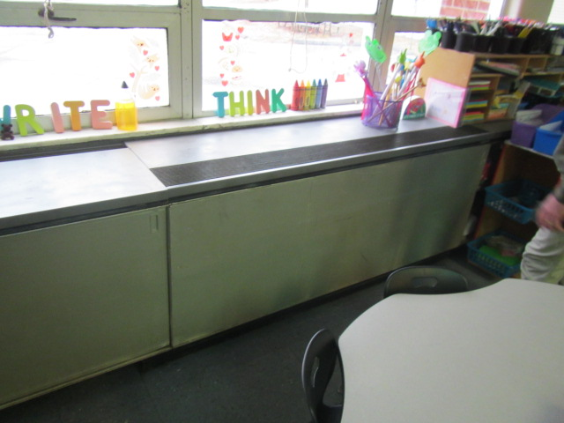
Unit ventilator (univent) and openable window
Picture 2
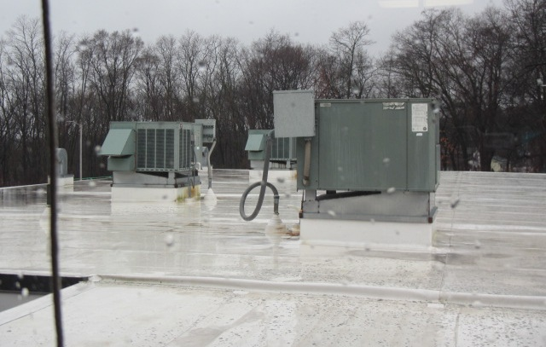
Rooftop air handling units (AHUs) for modular wing
Picture 3
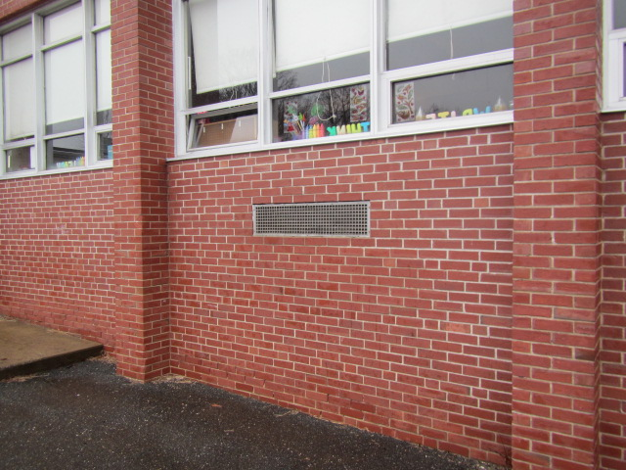
Univent air intake under windows
Picture 4
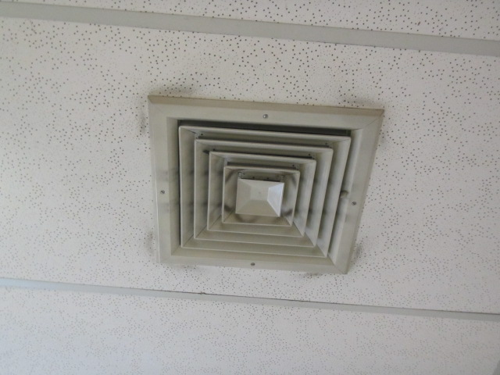
Supply vent from rooftop AHU, note dust and debris on/around vent
Picture 5
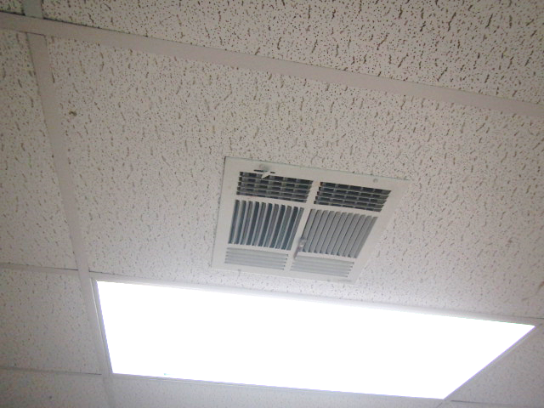
Ceiling-mounted supply vent in modular classroom
Picture 6
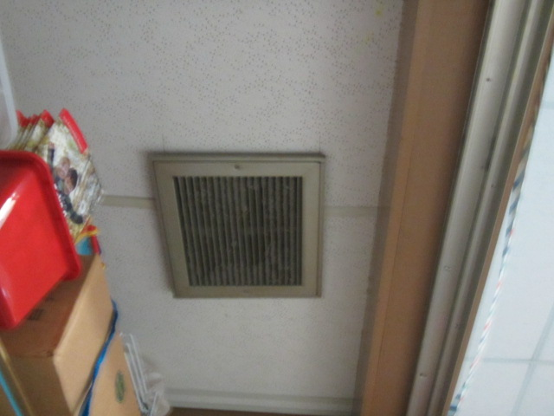
Exhaust vent in the ceiling of coat closets, note dust and debris on vent
Picture 7
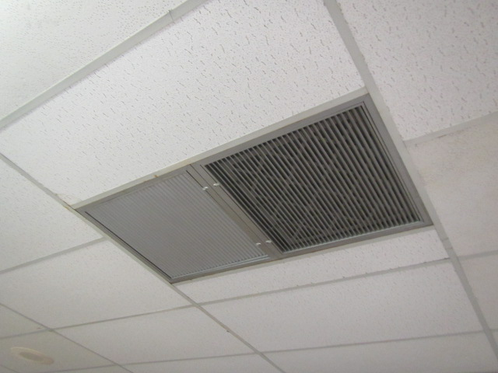
Ceiling-mounted return vents in modular classroom
Picture 8
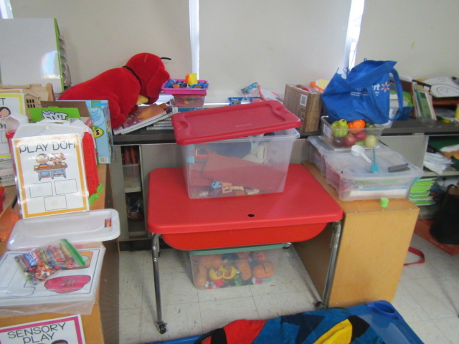
Univent obstructed by items on top (supply vent) and along front (return vent)
Picture 9
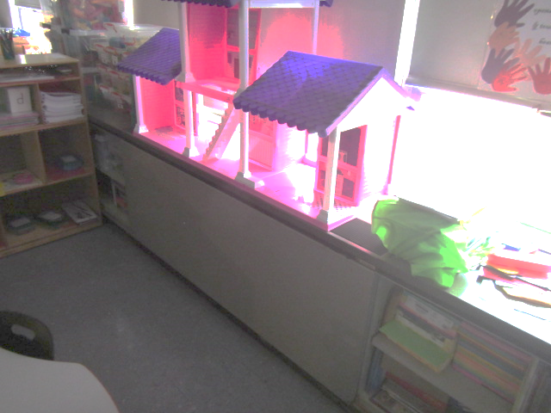
Univent obstructed by items on top (supply vent)
Picture 10
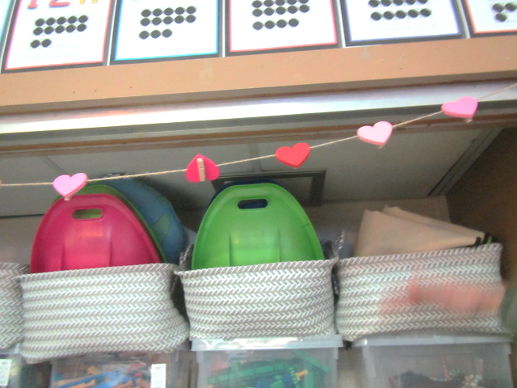
Coat closet exhaust vent in classroom (arrow) obstructed by items
Picture 11
Example of undercut coat closet exhaust vent doors (Picture taken by IAQ staff from Jacobs Elementary School, Hull, MA)
Picture 12
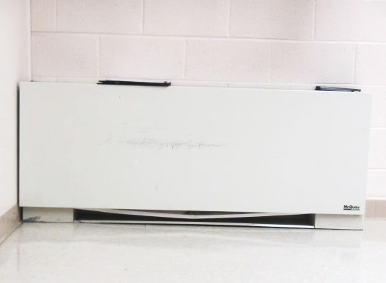
Fan coil unit (FCU), note bowed filter (arrow), allowing for bypass
Picture 13
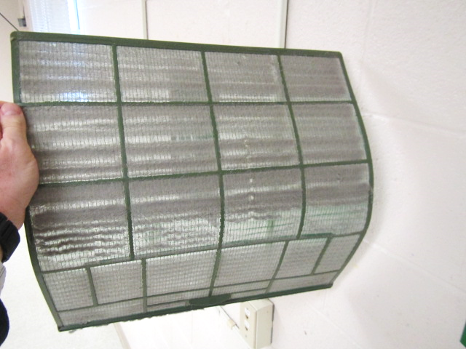
Mesh mini-split filter with accumulated dust/debris
Picture 14
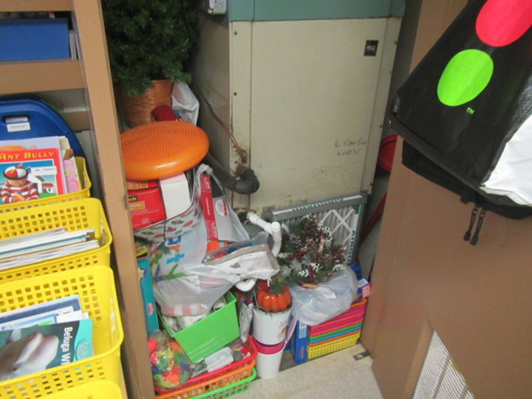
AC unit in classroom coat closet, note items obstructing filter/airflow (arrow)
Picture 15
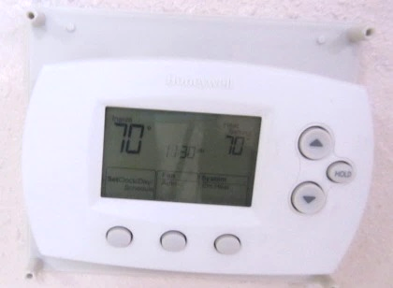
Digital thermostat for modular classroom, note Fan set to “Auto” (arrow)
Water Damage and Moisture Concern Pictures
(click to link back to report)
Picture 16
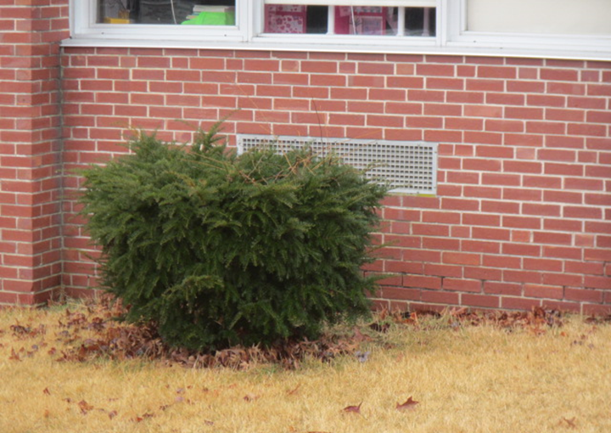
Shrubbery in front of univent air intake
Picture 17
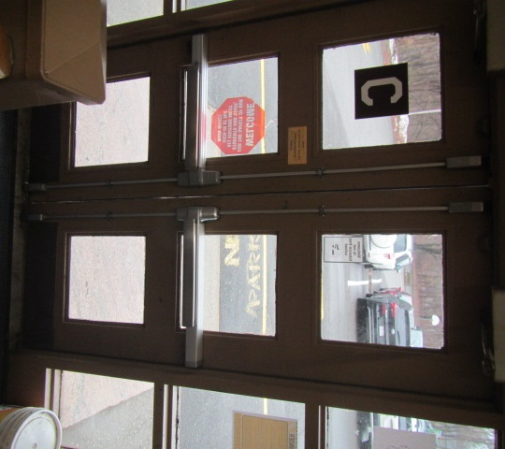
Space between exterior doors (light visible)
Picture 18
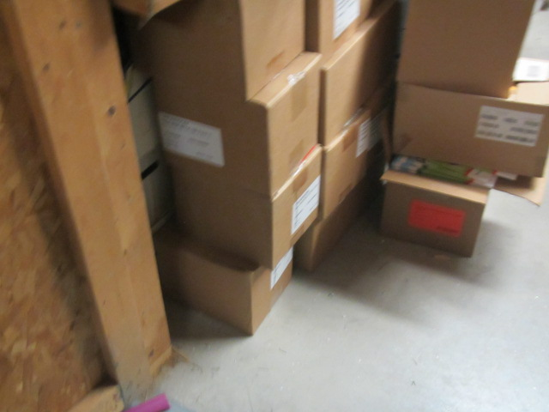
Cardboard boxes directly on basement floor

Sources of Respiratory Irritant Pictures
(Click to link back to report)
Picture 19
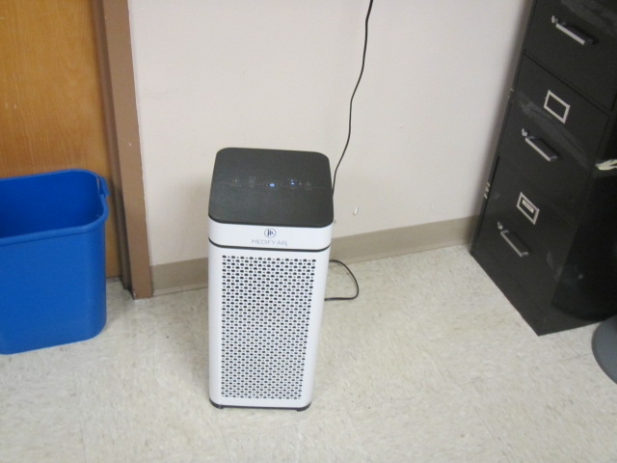
Air purifier in classroom
Picture 20
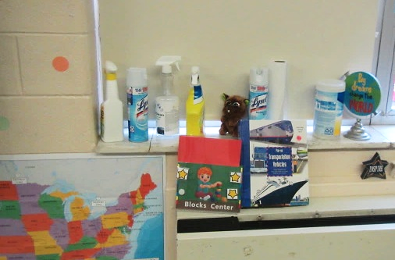
Spray cleaners on windowsill
Picture 21
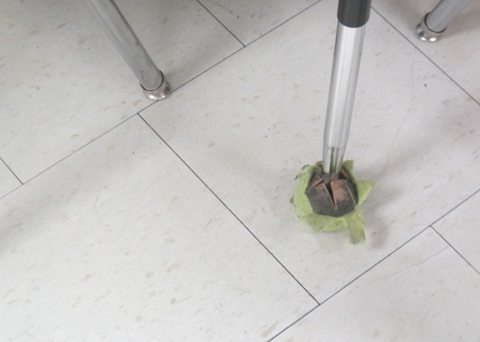
Tennis ball on chair leg
Picture 22
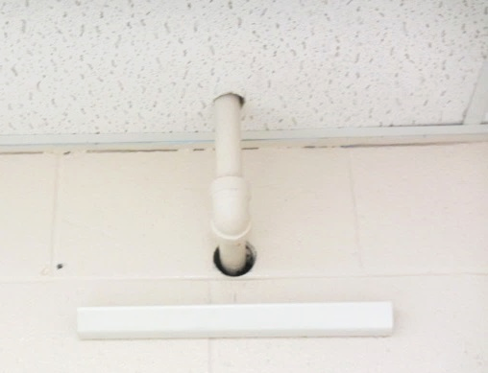
Open holes around utilities in basement room 15
Picture 23
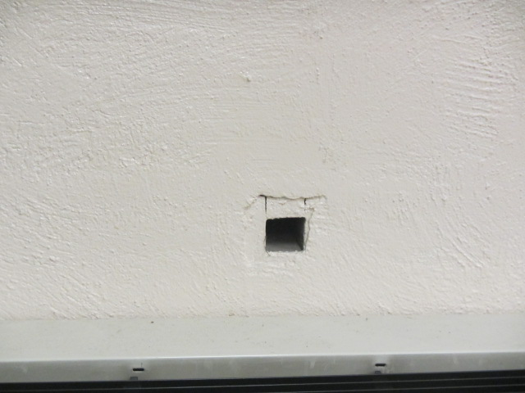
Open hole in wall above FCU in basement Library room 16

Click to link back to report

Table 1
Room | Openable Windows | HVAC | Ventilation |  | Ceiling Tiles/Staining (Y or N)  Bowed = B | Comments
 |  |  | Intake | Exhaust
Basement
Room 15 - Dance | Y | Y | Y | Y (Industrial) | Y-1, B | FCU filter bowed, mini-split, mini-split filter d/d, no regular exhaust, open area around pipe in wall, air purifier
Room 16 – Library | Y | Y | Y |  | Y-1, B | Area rug, staining around light in ceiling, square hole in wall above FCU, bathroom exhaust vent – d/d and running
Room 19 – Staff | N/A | N/A | Y | N | Y-2, B | Copier, laminator, no exhaust
Room 20 – Speech | N/A | N/A |  |  | Y-2, B | Air purifier
Storage | N/A |  |  |  |  | Cardboard boxes on floor
Room 17 – Computer Lab | N/A | Y |  |  |  | FCU filter bowed, mini-split, area rug, open area around pipe in wall
Room 10 -Preschool | Y | Y (off) | Y | Y | Y-2, B | Multiple area rugs, AHU blocked with objects on top, AHU does not vent outside, FCU units not running, radiator blocked by bookcase, ceiling fans, air purifier
Gym | Y | Y | Y | Y | Y-1, B | Air purifier
Nurses Office | N/A | Y |  |  |  | Air purifier
Main Floor
Room 3-Kindegarten | Y | Y | Y (off) | Y (off) | Y-1, B | Area rug, AHU deactivated, air purifier in corner of room, vented closet door w/AHU blocked by objects
Room 2 – Preschool | Y (open) | Y (off) | Y (off) | Y (1 on) |  | Exhaust vent d/d, FCU blocked by objects
Room 1 – Kindergarten | Y | Y | Y | Y | Y-3, B | FCU blocked by objects, exhaust vents d/d,
Room 4 | Y | Y | Y | Y (off) |  | AC, FCU blocked at bottom
Room 12 | Y (open) | Y | Y | Y | Y, B | Thermostat on “Auto”
Room 14 – Gr. 1 | Y | Y | Y | Y | Y, B | Air purifier running
Room 11 – Gr. 1 | Y | Y | Y | Y | Y, B
Room 13 | Y | Y | Y | Y | Y-2, B | Tennis balls on chairs
Room 5 – Preschool | Y | Y | Y | Y | Y, B
Room 8 | Y (open) | Y (off) | Y | Y (off) | Y, B | Accumulated storage in closet w/individual AHU system
Room 6 – Gr. 2 | Y | Y | Y | Y | Y, B
Room 7 - office area | Y | Y | Y | Y (off) | Y, B | Plants with drip pans
Room 9 | Y | Y | Y | Y | Y, B | Plug-in air freshener next to air purifier, passive exhaust vent in wall of closet venting to adjacent room
Conference Room | Y | Y | Y | Y | Y, B
Office A – Science | Y | Y | Y | Y | Y, B | Window AC, air purifier
Office B | Y | Y | Y | Y off | Y, B | Window AC, ceiling fan, air purifier

(Click to link back to report)

Table 2A
Equipment Present in Building  (X = Yes) | Type of Heating/Cooling Ventilation  Equipment | Fresh  Air  Supply  (X = Yes) | Type of Location(s) | Air Filters Installed  MERV Rating  (1-15, U*)  (X = Yes) | Comments
Y | Univents | X | Classrooms | X 4-5
Y | Rooftop Air Handling Units | X | Modular classrooms | X 13
 | Outdoor, Ground-Installed Air Handling Units
 | Attic/Crawlspace Air Handling Units
Y | Ceiling-Mounted Air Handling Units (including inside plenum) | X | Cafetorium | X 13
 | Basement/Crawlspace-Installed Air Handling Units
 | Mechanical Room-installed Air Handling Units
Y | Fan Coil Units |  | Some classrooms | X 4-5
Y | Window-Mounted Air Conditioners | X | Classrooms, offices
 | Wall Louver-Controlled Gravity Air Supply
Y | Windows
 | Fan in window (blowing in)
Y | Built in wall fan (switched) |  | Basement, Dance Room
 | Heat recovery ventilator unit
 | Energy recovery ventilator unit
 | Chilled Beam
 | Passive combustion supply vent in basement/boiler room

*U = Filter Rating underdetermined due to inaccessibility during building visit

(Click to link back to report)

Table 2B
Equipment Present in Building  (X = Yes) | Type of Exhaust Ventilation  Equipment | Ducted  To Outdoors  (X = Yes) | Type of Location(s) | Comments
X | Rooftop Motors/Fans | X | Classroom coat closets
 | Unit Exhaust
X | Ceiling Return Vent | X | Modular classrooms
 | Ceiling Return Vent, Plenum
X | Wall Return Vent | X | Cafetorium
 | Kitchen Stove Hood
X | Restroom Exhaust Vent | X
 | Photocopier Exhaust Vent
 | Garage
 | Chemical Hood(s)
 | Locker Rooms
 | Showers
 | Clothes Dryers
 | Gas Water Heaters
 | Furnace-Flue to Chimney
 | Furnace/Boiler direct vent or power vent (no combustion air supply)
 | Kiln, Pottery
 | Dark Room
 | Generator Room
 | Wood Shop Dust Collector
 | Spray Paint Booths
 | Fan in window (blowing out)

Table 2C
Equipment Present in Building  (X = Yes) | Type of Equipment | Type of Location(s) | Comments
 | Floor Fans, pedestal
 | Floor Fans, portable
Y | Air Purifier (HEPA, other) | Classrooms, offices
 | Floor heaters, portable
Y | Refrigerators, Cold Beverage Vending Machines
 | Radiator, wall-mounted
 | Radiator, floor-mounted
 | Passive Vents (Wall/Door)

(Click to link back to report)

Table 3
Found in Building  X = Yes | Water-Damaged Materials, Building Components or Stored Materials | Location | Visible Microbial Growth?  X = Yes | Musty odor detected?  X = Yes | Comments
 | Books-other bound materials
 | Brick walls – broken, missing mortar
 | Brick walls – blocked weep holes
X | Cardboard boxes | Basement storeroom
 | Carpet tiles
 | Carpet - Area rugs
 | Carpet wall-to-wall
 | Ceiling tiles - affixed directly to ceiling surface
X | Ceiling tiles - bowing-in suspended ceiling
 | Ceiling tiles - water-stained in splined ceiling
X | Ceiling tiles - water-stained in suspended ceiling
 | Chairs - laminated
 | Cloth
 | Countertops (around sinks)
 | Curtains
 | Dust/debris within AHU, uninvent, HVAC, chilled beam units, etc. (WD through condensation, humidity, or leaks)
 | Efflorescence (i.e., mineral deposits)
 | Engineered woods - particleboard, plywood, Masonite
 | Flooring – loosened tiles
 | Flooring - wooden
 | Furniture - laminated
 | Furniture - upholstered
 | Gypsum wallboard - ceiling
 | Gypsum wallboard - restroom wall
 | Gypsum wallboard - interior wall
 | Gypsum wallboard – located on exterior wall
 | HVAC drain pan – lack of draining
 | HVAC filters
 | Insulation- attic (paper-backed)
 | Insulation - inside air handling unit
 | Insulation - on pipe(s) fiberglass
 | Insulation - on pipe(s) other/plaster-like material
 | Insulation - wall cavity
 | Insulation – ceiling plenum
 | Modular furniture – walls/cloth partitions
 | Musical instrument cases
 | Plaster ceilings
 | Records/files
 | Refrigerator - door gasket
 | Refrigerator - drip pan
 | Refrigerator - Interior surfaces
 | Room divider - ceiling-mounted, sliding
 | Sink backsplash
 | Tables – laminated
 | Wallpaper
 | Wood - attic/roof materials
 | Wood - floor joists in basement ceiling
 | Wood - wall framing
 | Wood - window sills
 | Wood - window-mounted air conditioner framing
 | OTHER

WHAT ARE ENVIRONMENTAL ASTHMA TRIGGERS?
Asthma triggers are any chemical, pollutant, or allergen that can make your asthma worse. Asthma triggers can also be strong chemical smells, dust, or pets. Your asthma triggers may be different from those of other people. Not all asthma triggers affect people the same way. Environmental asthma triggers are found both indoors and outdoors. DPH link: Asthma and Your Environment (mass.gov)

(click to link back to report)

Table 4
Condition Present  X = Yes | Possible asthma symptom-inducing environmental pollutant | Recommendation to reduce or eliminate the pollutant
X | Water Damage and/or Mold  (allergen) | Identify water source and repair to eliminate.  Clean non-porous materials.  Remove and replace porous materials susceptible to mold growth.  Perform regular water damage assessments as a tool to ensure timely mitigation as needed.  Use NIOSH water damage assessment protocol as a guide: NIOSH water damage assessment guideline.
 | Moistening of building components during hot, humid weather (>2 days in length) (mold, allergen) | Remove materials not dried in <2 days in a manner consistent with US EPA Mold Removal in Commercial Buildings guideline.  Use dehumidification in occupied basement areas and other areas with chronic dampness.
X | Vegetation against exterior of building (water damage-mold) | Remove all vegetation preventing building exterior drying.  Remove all vegetation capable of falling onto a building or depositing debris onto the roof.
 | Personal humidifiers (lack of proper maintenance)  (pollutant and allergen) | Clean and maintain properly.  Use distilled water to eliminate metal and water treatment odors.  Maintain hydration by increasing water consumption.
 | Drains: Floor drains, Sink drains (abandoned use)  Water bubblers (abandoned use) | If in use, pour water into drain at least twice a week.  If not in use, seal the drain with an appropriate material in accordance with Massachusetts Plumbing Code (248 CMR 10.00).
 | Live Animals (turtles, gerbils, birds, rabbits, etc.) | Ensure cleanliness or remove animals from the location.
 | Improperly maintained aquariums and terrariums (allergen) | Maintain such equipment properly to eliminate odor.  Discontinue use.
X | Plants and flowers  (allergen and mold) | Keep indoor plants well maintained and not overwatered. Monitor for signs of mold and pests.  Ensure water for cut flowers does not become stagnant.  Ensure dried plant material is free of odors, mold, and pests and handled carefully  If asthma risks are high, eliminate plants and flowers.
 | HVAC system moisture issues  (mold, allergen) | Consult ASHRAE’s minimum standards for HVAC maintenance and inspection of commercial HVAC systems (https://www.ashrae.org/technical-resources/bookstore/standards-180-and-211).
 | HVAC system contaminant issues (allergen) | Consult ASHRAE’s minimum standards for HVAC maintenance and inspection of commercial HVAC systems (https://www.ashrae.org/technical-resources/bookstore/standards-180-and-211).
 | Indoor swimming pool odors outside of swimming pool (mold, chemical) | Maintain and operate pool HVAC systems to vent odors from building.  Ensure locker room exhaust vents are operating during building hours.  All doors leading to pool should be rendered airtight and be closed.
 | Pollen (allergen) | Recommend installation of MERV 8 or better filters if HVAC engineer confirms HVAC system can be so equipped without adversely affecting function.  Cut grass after hours.  Cut grass in a pattern to direct clippings away from exterior wall.  Remove trees and shrubs from in front of windows and air intakes.
 | Dry air | Maintain hydration.  Avoid overheating of air.
 | Dust mites  (allergen) | Recommendation to remove non-official upholstered furniture, area rugs, pillows, cushions, etc.  Cleaning with use of HEPA-filtered vacuum cleaner.  Eliminating clutter, storing items in dust and moisture-proof containers, and regularly removing dust through wet wiping.
 | Pests, including rodents and cockroaches  (allergen) | Use of integrated pest management guidelines, including:  - Proper disposal of food containers  - Proper storage of food products in airtight containers  - Elimination of use of food as art projects  - Remove pest harborages/clutter  - Regular monitoring for pests  EPA IPM guideline link
X | Latex-containing materials | Remove tennis balls from furniture legs.
X | Fragrances  (chemical) | Eliminate point sources, such as:  - Plug-in air fresheners  - Aroma/oil reed diffusers  - Scented sprays  - Discontinue use of other scented materials  - Consult DPH fragrance guideline: Clean air is odor-free
 | Strong smells from /use of Chemicals (such as cleaning products)  (chemical) | Use building-issued cleaning products.  Use products in accordance with manufacturer’s instructions including dilution, application, and ventilation.  Avoid using products that are stronger than needed for the situation.
 | Strong odors from new building materials (carpeting/furniture)  (chemical) | Use low VOC-emitting materials.  Air out materials (outside or in unoccupied area) prior to installation.
 | Tobacco smoke  Secondhand Smoke  (pollutant) | Eliminate tobacco smoking.  Seal all shared wall penetrations.
X | Products with a strong odor such as paint, perfume, hairspray, air fresheners, bug-spray, laminators, candles, wax melters, dry erase markers and other VOC-containing products  (chemical) | If essential:  - Provide proper exhaust ventilation to eject aerosolized product directly outdoors.  - Avoid/reduce use during occupied hours.  If not necessary, remove and eliminate.
 | Vehicle exhaust  (pollutant) | Enforce anti-idling regulations and post signs to give notice.  Relocate vehicles away from fresh air intakes.  Require cars to park face-in at building walls.  MA anti-idling law FAQs
 | Vapors and or fumes from gas, oil, or kerosene stoves  (pollutant) | Operate stove hood when stove in use.  Install stove hood if not present.  Ensure equipment is in good working order.
 | Ozone (pollutant) | Eliminate use of ozone generating equipment.
X | Window Air Conditioners (if not properly maintained) (allergen) | Equip with proper filter and clean periodically.  Clean drip pans.  Install in window with weathertight, non-mold-growth sustaining material.
 | Pottery (pollutant) | Do not operate kiln during occupied hours.  Operate kiln with exhaust system activated.  Seal all seams and holes in kiln vent.  Ensure kiln exhaust discharge terminates outdoors.
 | Carpeting (allergen) | Clean carpeting in a manner consistent with IICRC standards, including regular vacuuming with a high efficiency particulate air (HEPA) filtered vacuum in combination with annual cleaning or semi-annual cleaning in soiled high traffic areas.
 | Sweeping/dusting vs HEPA vacuuming/wet wiping  (allergen or pollutant) | Refrain from using feather dusters or brooms.  Utilize HEPA vacuums and wet wiping to minimize aerosolizing particulate matter.
X | Lack of adequate air exchange/mechanical ventilation | Make repairs as necessary and ensure all HVAC system components are operating continuously when building is occupied.
 | Lack of local exhaust at source of pollution (vocational shop activities, kitchen exhaust hood) (all) | Recommend installation of exhaust ventilation to direct pollutants directly outdoors.
 | Renovating buildings while occupied  (chemical) | Use all SMACNA guidelines for Renovation While Buildings Are Occupied. For information, visit https://www.mass.gov/service-details/construction-and-renovation-generated-pollutants-in-occupied-buildings.
 | Chemistry program chemical storage  (chemical) | Repair (if needed) and operate chemical storeroom vents appropriately.  Reduce or eliminate unneeded or overstocked chemicals.  Store all chemicals in a manner to separate incompatible chemicals.  Keep chemical storerooms clean.
X | Photocopiers/duplicating machines | All machines should have dedicated exhaust vents.

