INDOOR AIR QUALITY ASSESSMENT

Belmont Hill School
Morse Hall
350 Prospect Street
Belmont, Massachusetts 02478

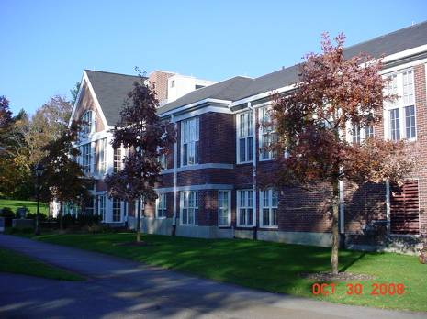

Prepared by:
Massachusetts Department of Public Health
Bureau of Environmental Health
Indoor Air Quality Program
April 2009

Background/Introduction
At the request of Linda Rudzinski, Assistant to the Director of Facilities for the Belmont Hill School, the Massachusetts Department of Public Health (MDPH), Bureau of Environmental Health (BEH) conducted a limited indoor air quality assessment in Morse Hall at the Belmont Hill School, 350 Prospect Street, Belmont, Massachusetts. The request for an indoor air assessment was prompted by concerns about odors on the first floor of the building during the heating season. The odor problem had existed since the renovation of the building in the mid-1990s. On October 30, 2008, Michael Feeney, Director of BEH’s Indoor Air Quality (IAQ) Program, visited the building to investigate the source of the odor.
The Morse Hall is a two-story brick building that contains classrooms, a lounge area and administrative offices. The building is heated with natural gas, and windows are openable. Odors in the building are reported to be prevalent during the heating season. Previous attempts of identifying the odor included an examination of the original plumbing system prior to the BEH visit.

Methods
A visual inspection of each area was conducted, with an examination of the offices, hallway and mechanical rooms within Morse Hall.

Discussion

Odor Evaluation
The heating, ventilating and air conditioning (HVAC) system at Morse Hall consists of two air-handling units (AHUs). AHUs draw in air through fresh air intakes, which filter, heat and/or cool the air, then distribute it to occupied areas via ceiling/wall-mounted air diffusers. Exhaust air is returned back to the AHUs via ceiling/wall-mounted return vents. An AHU in the attic provides mechanical ventilation to the second floor (Picture 1). The other AHU is in the basement, where the furnace for the building is located (Picture 2).
In order to ascertain whether a break in the plumbing drain system could be the source of the musty odor, a container of orange oil was poured into a drain in the attic mechanical room. After several minutes, no orange odor was detected by office occupants or in occupied areas of the first or second floors. The lack of orange oil odor indicates that the plumbing system was unlikely to be the source of the odor.
The basement AHU was found to have a hole in its casing that was drawing air from the basement mechanical room (Pictures 3 and 4). The basement AHU is also equipped with high efficiency particle arrestance (HEPA) filters (Picture 5). It is likely that the presence of the HEPA filters is increasing the draw of basement air into the AHU through breaches/holes in the cabinet since HEPA filters require significant energy expenditure to draw air through the filter. Removing the HEPA filters and installing appropriate pleated air filters require a decrease in fan speed, which should reduce the draw of odors via cabinet breaches.
In this configuration, the basement AHU is likely to draw air through the hole in Picture 3 rather than through the HEPA filter, since the hole is the path of least resistance for air to enter the cabinet. Any odors/pollutants in the basement will then be drawn into the AHU via this hole, which would then be distributed to occupied areas via the ductwork. Since a number of odor sources exist in the basement, this AHU cabinet hole must be sealed. The following odor sources were noted in the basement mechanical room:
- A breach in the furnace connection to the flue was noted in a location opposite the hole in the AHU (Picture 6). When the furnace was operating, a stream of air was noted emanating from this breach. The furnace combusts natural gas as its fuel. Since natural gas is odorless, a material containing sulfur called mercaptan is added to provide a odor in order to indentify gas leaks (Hess Corp., 2006). The odors reported by BHS staff were described as sulfur-like, which would be consistent with the odor of combusted gas.
- A breach between the flue and the chimney connection was also noted (Picture 7).
- Seams also exist in the flue pipe (Picture 8).
- Two unsealed pipes in the foundation wall were also identified (Pictures 9 and 10). These pipes may be connected to the school sewer system, which may also be a source of sulfurous odor.
The combination of the furnace flue breach with the breach of the AHU cabinet drawing air from the basement mechanical room are the most likely source of sulfur odor on the first floor. While a similar opening was found in the attic AHU (Pictures 11 and 12), no source of odor could be located.

Conclusions/Recommendations
In view of the findings at the time of this visit, the following measures should be considered:
- Seal all holes in AHU cabinets in the basement and attic.
- Repair the connection of the furnace to its flue to render this junction airtight.
- Repair the connection of the chimney to the flue to render this junction airtight.
- Remove HEPA filter banks from the AHU and replace with an appropriate pleated filter. Consult a ventilation engineers concerning filter selection and adjusting the fan speed of the basement AHU.
- Seal all flue joints with an appropriate, fire rated sealant.
- Seal all open pipes in the foundation wall.

References
Hess Corp. 2006. MATERIAL SAFETY DATA SHEET Natural Gas (odorized) MSDS No. 8010. Hess Corporation, Woodbridge, NJ. Revision Date: 7/1/2006. www.hess.com/ehs/msds/8010NaturalGasOdorized.pdf

Picture 1
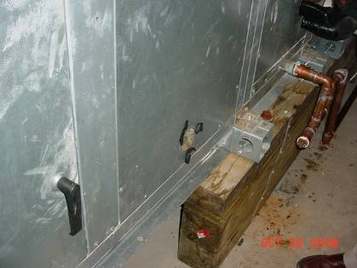

Attic AHU

Picture 2

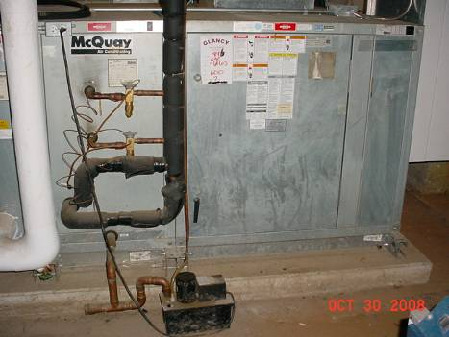

Basement AHU, Note Hole in Door

Picture 3

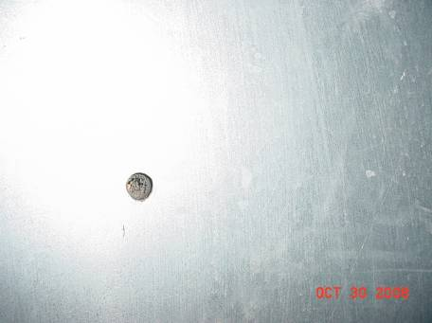

Close-Up of Hole in Door of Basement AHU

Picture 4

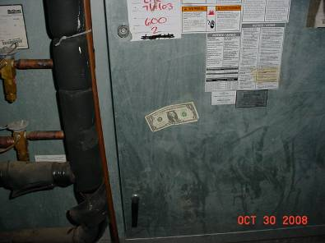

Draw Of Air of Hole in Door by Basement AHU Fan Strong Enough to Hold Dollar Bill in Place

Picture 5

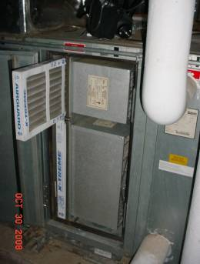

HEPA Filters Installed In Basement AHU

Picture 6

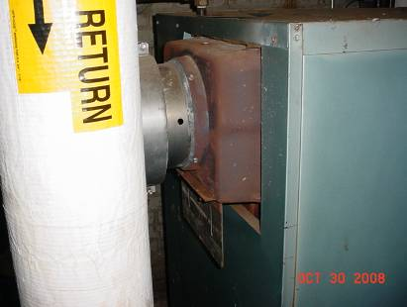

Hole in Furnace Flue

Picture 7

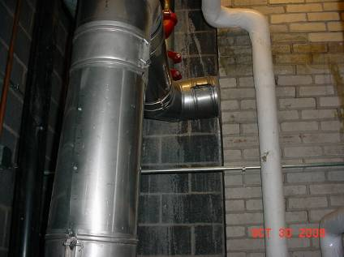

Breach in Flue/Chimney Connection, Note Flue Is Not Flush With Chimney

Picture 8

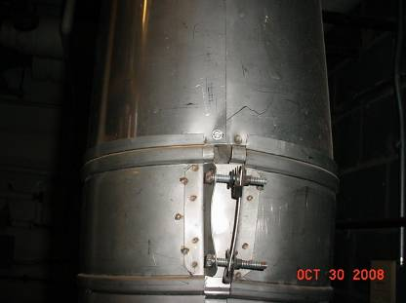

Unsealed Flue Seams

Picture 9

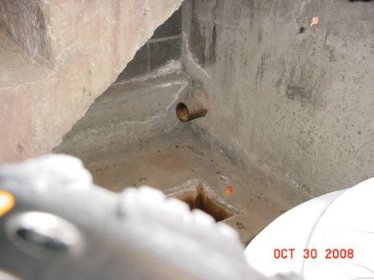

Open Pipe beneath Mechanical Room Stairs

Picture 10

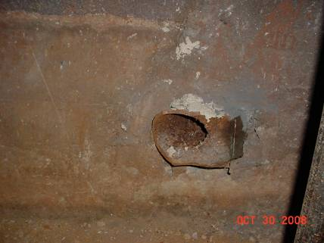

Unsealed Pipe in Foundation Wall

Picture 11

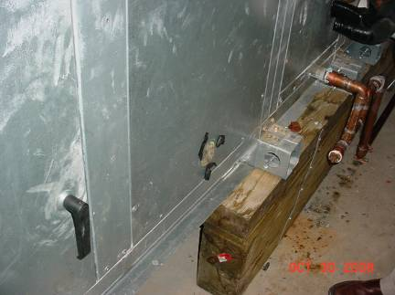
Hole in Cabinet of Attic AHU

Picture 12

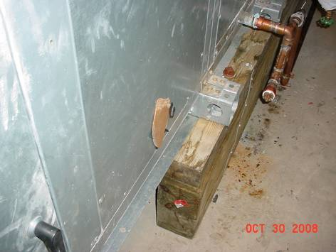

Hole in Cabinet of Attic AHU Seal with Cardboard and Electrical Tape

