INDOOR AIR QUALITY ASSESSMENT

Berkshire Arts and Technology Charter School
One Commercial Street
Adams, MA

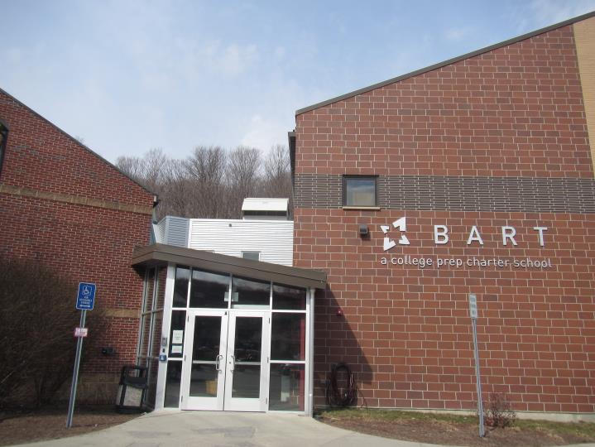

Prepared by:
Massachusetts Department of Public Health
Bureau of Environmental Health
Indoor Air Quality Program
August 2020

Background
Building: | Berkshire Arts and Technology Charter School (BART)
Address: | 1 Commercial Street, Adams
Requested by: | Julia Marko, Business Manager, BART
Reason for Request: | Concerns about indoor air quality (IAQ) in the school
Date of Assessment: | March 2, 2020
Massachusetts Department of Public Health/Bureau of Environmental Health (MDPH/BEH) Staff Conducting Assessment: | Ruth Alfasso, Environmental Engineer/Inspector IAQ Program
Building Description: | BART is a two-story school with several wings. The building was originally a restaurant built in the 1970s. The school has occupied this location for about 15 years, and conducted additions and renovations in 2015. Most of the building exterior is brick, and the building has a combination of peaked and flat roof sections.
Windows: | Windows are openable in some areas of the school, however most windows are original to the building and may be difficult to open.

Methods
Please refer to the IAQ Manual for methods, sampling procedures, and interpretation of results (MDPH, 2015).

Results
The following is a summary of indoor air testing results (Table 1).
- Carbon dioxide levels were above the MDPH recommended level of 800 parts per million (ppm) in about two thirds of the areas surveyed, indicating inadequate air exchange in most areas of the building.
- Temperature was within or close to the MDPH recommended range of 70°F to 78°F in occupied areas. Temperature control issues were frequently reported in the building.
- Relative humidity was below the lower end of the MDPH recommended range of 40 to 60% in all areas tested the day of assessment, which is typical of conditions during the heating season.
- Carbon monoxide levels were non-detectable (ND) in all areas tested.
- Particulate matter (PM2.5) concentrations measured were below the National Ambient Air Quality (NAAQS) level of 35 μg/m³ in all areas tested.

Discussion

Ventilation
A heating, ventilating, and air conditioning (HVAC) system has several functions. First it provides heating and, if equipped, cooling. Second, it is a source of fresh air. Finally, an HVAC system will dilute and remove normally occurring indoor environmental pollutants by not only introducing fresh air, but by filtering the airstream and ejecting stale air to the outdoors via exhaust ventilation. Even if an HVAC system is operating as designed, point sources of respiratory irritation may exist and cause symptoms in sensitive individuals.
Fresh air ventilation in the BART is supplied by air handing units (AHU) located in various utility rooms around the school. Fresh air is drawn in through vents on the exterior, heated or cooled, filtered and supplied to classrooms, offices and common areas via ceiling-mounted supply vents (Picture 1). Ceiling or wall-mounted exhaust vents remove stale air (Picture 2).
There are AHU of different types and ages from when each portion of the school was built. Some new AHU have been installed and more of the older AHU are planned to be replaced as funding becomes available. Based on the testing results, some of the AHU are not supplying sufficient fresh air for occupancy (Table 1). This may be due to damper settings on the exterior vents which are often adjusted to restrict outdoor air during very cold weather to protect air handling equipment and decrease operating costs. Or the computer controls for the HVAC settings may not direct the system to supply fresh air continuously, only turning systems on when temperature control is needed.
In addition, many exhaust/return vents were found not drawing air at the time of the assessment. Operating exhaust vents are necessary to remove stale air and associated odors, moisture and respiratory irritants from occupied areas. This is especially important in areas that may generate high levels of pollutants, odors and moisture. Such areas include restrooms, locker rooms, heavily occupied rooms, art and science rooms and similar areas.
Note that each AHU is equipped with filters to remove dust and other particulates from the airstream. The filters used on these units appeared to be of a pleated type with a Minimum Efficiency Rating (MERV) of 8, which are adequate in filtering out pollen and mold spores (ASHRAE, 2012). Filters should also be changed two to four times a year, or per the manufacturer’s recommendations. Facility staff report that filters are changed multiple times a year, and frequency is increased when the filters are found to be heavily soiled.
To maximize air exchange, the MDPH recommends that both supply and exhaust ventilation operate continuously during periods of occupancy. In order to have proper ventilation with a mechanical supply and exhaust system, the systems must be balanced to provide an adequate amount of fresh air to the interior of a room while removing stale air from the room. It is recommended that HVAC systems be re-balanced every five years to ensure adequate air systems function (SMACNA, 1994). Reportedly, parts of the system have been balanced recently, but not the building overall.

Microbial/Moisture Concerns
In order for building materials to support mold growth, a source of water exposure is necessary. Identification and elimination of the source of water moistening building materials is necessary to control mold growth. Water-damaged ceiling tiles were observed in a few areas (Table 1). Water-damaged ceiling tiles can provide a source of mold and should be replaced after a water leak is discovered and repaired. Reportedly, most of the roof was repaired recently and previously water-damaged tiles were removed and replaced.
There were refrigerators in staff rooms, classrooms, and offices. Refrigerators should be cleaned out regularly to prevent odors and microbial growth. Any stained gaskets should be cleaned with a mild antimicrobial solution; if they are too heavily stained/damaged, they should be replaced. Refrigerators should not be placed on carpet/porous materials to protect them from spills. Water dispensers and water fountains were also found with carpet underneath (Picture 3). Spills and leaks can moisten carpeting and lead to microbial growth.
Some classrooms and offices have sinks with cabinets underneath (Picture 4). The area under cabinets can be a moist environment, so no porous materials or large amounts of materials should be stored there.
Plants were present in some classrooms and other areas (Table 1). Plants should be well maintained, not overwatered, and not placed on porous materials or in the airstream of ventilation equipment.
Some classrooms and other areas are equipped with wall-mounted ductless air conditioners (Picture 5). These units create condensation that is drained with a small pump and tubing. The pump and tubing should be checked periodically for clogs and leaks.
The United States Environmental Protection Agency (US EPA) and the American Conference of Governmental Industrial Hygienists (ACGIH) recommend that porous materials be dried with fans and heating within 24 to 48 hours of becoming wet (US EPA, 2008; ACGIH, 1989). If porous materials are not dried within this time frame, they should be removed and discarded.
Door sweeps and weather stripping were worn out in some areas of the building. Doors should be made tight-fitting to prevent unconditioned outdoor air, moisture and pests from entering the building. In some areas, trees and shrubs are adjacent to or up against the building (Picture 6). These can hold moisture against the building and accelerate deterioration of brick and masonry. In addition, plant roots can damage the building foundation and increase the chance of water and pest infiltration. Trees overhanging the roof can also drop leaves that will clog rain gutters and roof drains. Trees near fresh air intakes and windows may be a source of pollen and odors to the inside of the building. It is recommended that trees and shrubs be trimmed at least 5 feet from the building.
A portion of the building has a basement level. Groundwater near the building is reported to be fairly high, as shown by the presence of the Hoosic River to the rear of the property. The basement is used for some storage and also contains mechanical equipment including the boilers. There is an active sump in the basement (Picture 7) with a pump that activates when the water level is high enough. This sump should be equipped with a tight-fitting cover to avoid evaporation of groundwater and associated odors into the basement. Another area of the basement near where the chimneys for the boiler equipment exit the building is reported to have a significant flow of water during heavy rain events. To prevent this contingency, a combination of regrading the exterior, installing gravel drains in the ground to remove water, and/or waterproofing the building envelope may be necessary. It may also be possible to install a trench drain in the basement floor to direct any water infiltration directly to the existing floor drains and remove it from the building more quickly. While these conditions continue to exist, it is not recommended to store mold growth-prone materials in the area of water infiltration. In addition, the floor should be kept clean and free of dust and debris that may become a mold growth medium if moistened. Any items stored in other areas of the basement should be kept off the floor using pallets, shelving or other means. All porous items highly susceptible to microbial growth (e.g., paper, leather, upholstered furniture) should be kept in waterproof containers or stored in a more climate-controlled area.
Note that in areas of the school without a basement, the first floor is directly on cement slab. Much of this floor is carpeted. Floors in contact with slab tend to be cooler than the surrounding air. During hot, humid weather, the floor may be subject to condensation, which would moisten carpeting and lead to odors and degradation of carpet fibers. Also, in general, carpeting is not recommended for schools, particularly in high traffic areas, due to the difficulty of keeping carpets clean in an active school environment.

Other Conditions
Exposure to low levels of total volatile organic compounds (TVOCs) may produce eye, nose, throat, and/or respiratory irritation in some sensitive individuals. BEH/IAQ staff examined rooms for products containing VOCs. BEH/IAQ staff noted hand sanitizers, home cleaning products, and dry erase materials in use within the building (Table 1). All of these products have the potential to be irritants to the eyes, nose, throat, and respiratory system of sensitive individuals.
Several of the science classrooms have laboratory hoods (Picture 8). These units are designed to draw pollutants up and out of the building during experiments. In order to ensure they are functioning properly, they need to be calibrated/certified periodically. In addition, no chemicals should be stored in the hoods. Some of the laboratory preparation rooms had storage cabinets for flammable and corrosive materials. These cabinets and other chemical storage should be kept clean and organized.
There is an art room including ceramics materials that is located in an area off the building atrium. The room is demarcated by low walls but shares ventilation with the rest of the atrium (Picture 9). A ceramics kiln is located in this room with no direct exhaust ventilation or containment (Picture 10). This configuration will allow excess heat, odors and other pollutants from operation of the kiln to migrate to many other areas of the school via the atrium. Kilns should be vented directly from the building and be separated from occupied areas.
Carpeting, including area rugs, should be vacuumed regularly with a high efficiency particulate arrestance (HEPA) filter equipped vacuum cleaner to avoid particulates from causing further irritation or serving as a reservoir for microbial colonization. Also, carpeting and rugs should be cleaned at least once per year according to Institute of Inspection Cleaning and Restoration Certification recommendations (IICRC, 2012). Area rugs too worn to be effectively cleaned should be replaced. Area rugs should be rolled up and stored in a clean, dry place when rooms are not occupied during the summer months to prevent moistening due to condensation.
In some classrooms and offices, large numbers of items were on floors, windowsills, tabletops, counters, bookcases and desks, which provide a source for dusts to accumulate (Picture 11). These items (e.g., papers, folders, boxes) make it difficult for custodial staff to clean. Items should be relocated and/or be cleaned periodically to avoid excessive dust build up. In addition, dust and debris can accumulate on flat surfaces (e.g., desktops, shelving and carpets) in occupied areas and subsequently be re-aerosolized causing further irritation. Items were seen hanging from the ceiling in a few areas. These items can be a source of dust/debris in the airstream of ventilation equipment. In addition, hanging items from the ceiling disturbs the ceiling tile system which can allow dust and debris into occupied areas.
Note that the Environmental Protection Agency (EPA) conducted a National School Radon Survey in which it discovered nearly one in five schools had “…at least one frequently occupied ground contact room with short-term radon levels above 4 [picocuries per liter] pCi/L” (US EPA, 1993). The BEH/IAQ Program therefore recommends that every school be tested for radon, and that this testing be conducted during the heating season while school is in session in a manner consistent with USEPA radon testing guidelines. Radon measurement specialists and other information can be found at www.nrsb.org and http://aarst-nrpp.com/wp, with additional information at: http://www.mass.gov/eohhs/gov/departments/dph/programs/environmental-health/exposure-topics/iaq/radon.

Conclusions/Recommendations
Based on the observations made during the visit, the following is recommended:
- Utilize a system to report and track maintenance issues so that concerns can be reported by staff and maintenance staff can indicate when issues have been resolved.
- Operate the HVAC system to provide for continuous fresh air ventilation during occupied hours. Check HVAC settings and supply air louvers for conditions that may restrict fresh air flow, particularly for units serving areas with elevated carbon dioxide levels.
- Ensure all exhaust vents are drawing air during occupied periods to remove stale air, odors, moisture, and irritants.
- Use openable windows to supplement fresh air during temperate weather where possible. Ensure all windows are closed tightly at the end of each day. Do not open windows while AC system is operating to prevent condensation/mold growth.
- Change filters in HVAC units at least twice a year. Continue to use MERV 8 or higher filters. Clean HVAC cabinets of debris and dust when filters are changed.
- Consider adopting a balancing schedule of every 5 years for all mechanical ventilation systems, as recommended by ventilation industrial standards (SMACNA, 1994).
- Replace water-damaged ceiling tiles once a leak is discovered and repaired.
- Keep classroom/office plants in good condition, avoid overwatering, and keep them away from the airstream of ventilation equipment.
- Ensure all refrigerators are kept clean to prevent microbial growth and odors. Clean gaskets and other surfaces with a mild antimicrobial solution to remove debris and mold. If they cannot be adequately cleaned-replace.
- Avoid storing porous items or large amounts of items under sinks.
- Periodically check the drain hoses and pumps for ductless air conditioners for clogs and other conditions that may leads to leaks.
- Replace worn out door sweeps. Check for light and drafts around doors.
- Trim trees and shrubs at least 5 feet from the building including any overhanging branches.
- Install a cover on the sump in the basement to reduce evaporation and odors. Periodically inspect the sump pump and associated piping for proper function.
- Consider working with a drainage consultant to reduce or control water inflow to the basement during wet weather. Until drainage issues have been resolved, do not store anything in the area where flooding occurs and keep the floor free of dust and debris that may become mold-colonized if moistened.
- Avoid storing any porous materials on the floor in the basement level, using pallets, or shelving to elevate materials above the floor. Materials highly susceptible to mold growth should be stored in waterproof containers or in a more climate-controlled area. Inspect items stored for a long time for any odors or microbial growth before moving them to occupied areas.
- Monitor conditions of carpeting in all areas of the school, but particularly in areas which are on slab and may be subject to condensation. If conditions such as odors or degradation are occurring, consider plans to replace with a non-porous flooring material.
- Reduce or eliminate the use of air fresheners, scented cleaners, hand sanitizers and dry erase materials to reduce irritation.
- Relocate kiln to an area with local exhaust capability separated from occupied areas. Use local exhaust continually while the kiln is in operation.
- Ensure exhaust hoods in science classrooms are maintained/calibrated in accordance with manufacturer’s instructions.
- Replace any missing or ajar ceiling tiles to avoid pathways to unconditioned areas. Avoid hanging items from the ceiling tile system.
- Clean supply/exhaust vents and personal fans regularly to remove accumulated dust/debris. Replace surrounding ceiling tiles that cannot be adequately cleaned.
- For buildings in New England, periods of low relative humidity during the winter are often unavoidable. Therefore, scrupulous cleaning practices should be adopted to minimize common indoor air contaminants whose irritant effects can be enhanced when the relative humidity is low. To control for dusts, a high efficiency particulate arrestance (HEPA) filter equipped vacuum cleaner in conjunction with wet wiping of all surfaces is recommended. Avoid the use of feather dusters. Drinking water during the day can help ease some symptoms associated with a dry environment (throat and sinus irritations).
- Clean carpeting and area rugs at least once per year according to IICRC recommendations (IICRC, 2012). Area carpets too worn to be effectively cleaned should be replaced. Roll up and store are rugs in a clean, dry place during the summer.
- Relocate or consider reducing the amount of materials stored in classrooms to allow for more thorough cleaning of classrooms. Clean items regularly with a wet cloth or sponge to prevent excessive dust build-up.
- Continue to utilize the US EPA’s (2000), “Tools for Schools”, as an instrument for maintaining a good IAQ environment in the building available at: http://www.epa.gov/iaq/schools/index.html.
- The school should be tested for radon by a certified radon measurement specialist during the heating season when school is in session. Radon measurement specialists and other information can be found at: www.nrsb.org, and http://aarst-nrpp.com/wp.
- Refer to resource manuals and other related IAQ documents for further building-wide evaluations and advice on maintaining public buildings. Copies of these materials are located on the MDPH’s website: http://mass.gov/dph/iaq.

References
ACGIH. 1989. Guidelines for the Assessment of Bioaerosols in the Indoor Environment. American Conference of Governmental Industrial Hygienists, Cincinnati, OH.
ASHRAE. 2012. American Society of Heating, Refrigeration and Air Conditioning Engineers (ASHRAE) Standard 52.2-2012 -- Method of Testing General Ventilation Air-Cleaning Devices for Removal Efficiency by Particle Size (ANSI Approved).
IICRC. 2012. Institute of Inspection Cleaning and Restoration Certification. Institute of Inspection, Cleaning and Restoration Certification. Carpet Cleaning: FAQ.
MDPH. 2015. Massachusetts Department of Public Health. “Indoor Air Quality Manual: Chapters I-III”. Available at: http://www.mass.gov/eohhs/gov/departments/dph/programs/environmental-health/exposure-topics/iaq/iaq-manual/.
SMACNA. 1994. HVAC Systems Commissioning Manual. 1st ed. Sheet Metal and Air Conditioning Contractors’ National Association, Inc., Chantilly, VA.
US EPA. 2000. Tools for Schools. Office of Air and Radiation, Office of Radiation and Indoor Air, Indoor Environments Division (6609J). EPA 402-K-95-001, Second Edition. http://www.epa.gov/iaq/schools/index.html.
US EPA. 1993. Radon Measurement in Schools, Revised Edition. Office of Air and Radiation, Office of Radiation and Indoor Air, Indoor Environments Division (6609J). EPA 402-R-92-014.
US EPA. 2008. “Mold Remediation in Schools and Commercial Buildings”. Office of Air and Radiation, Indoor Environments Division, Washington, DC. EPA 402-K-01-001. September 2008. Available at: http://www.epa.gov/mold/mold-remediation-schools-and-commercial-buildings-guide.
Picture 1
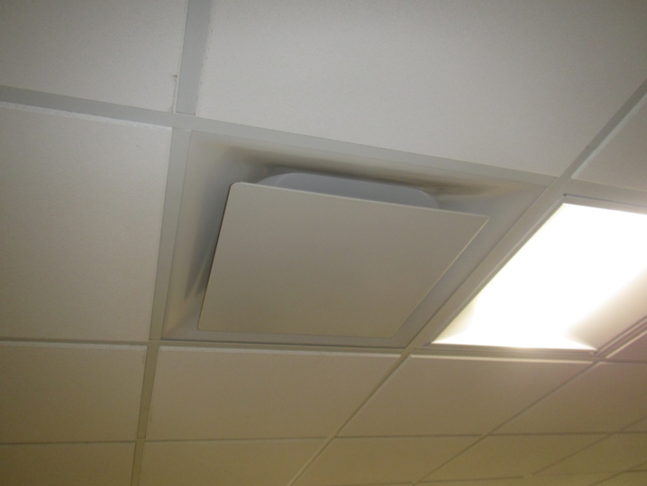
One style of supply vent
Picture 2
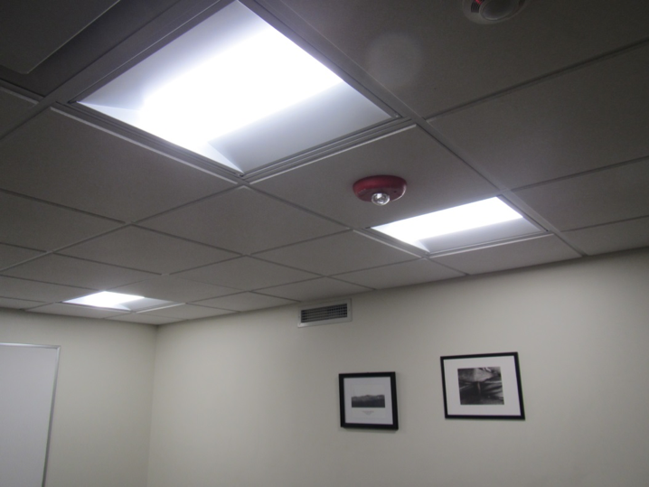
Wall-mounted exhaust vent
Picture 3
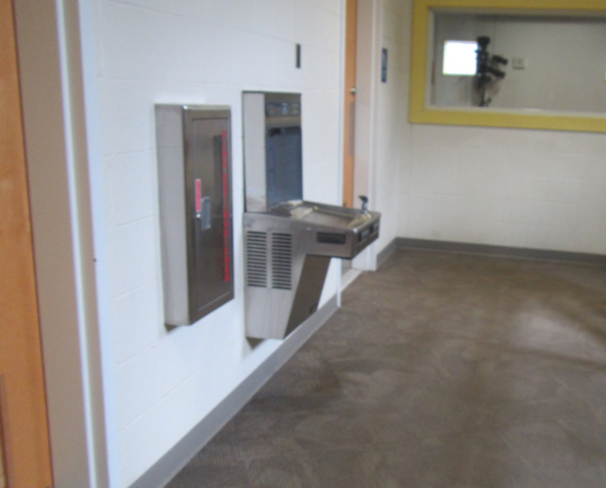
Water fountain on carpet
Picture 4
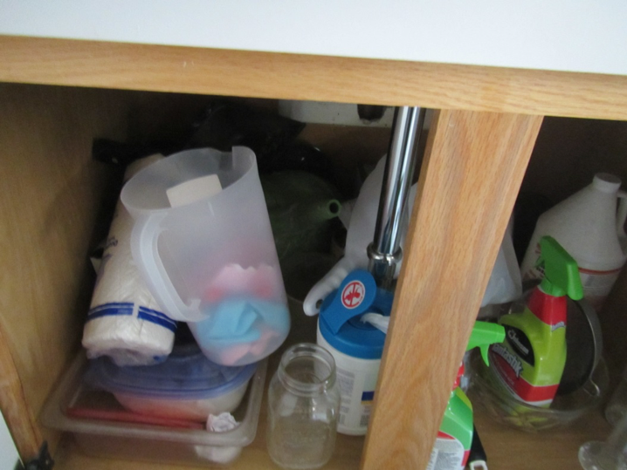
Large amount of items under sink in classroom
Picture 5
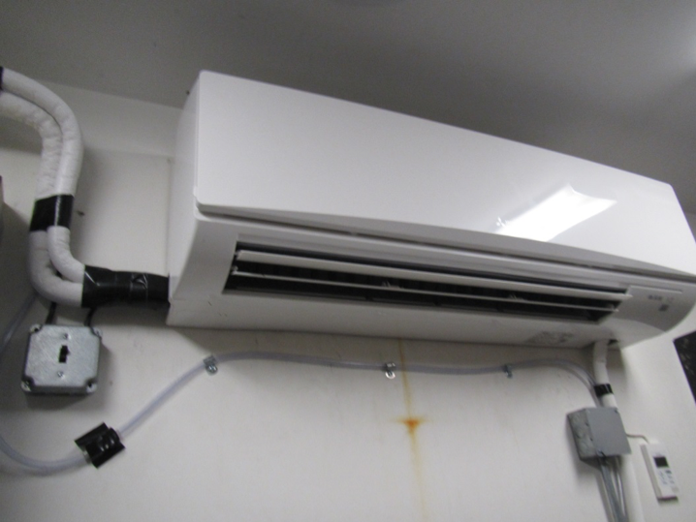
Ductless air conditioner with drainage hose
Picture 6
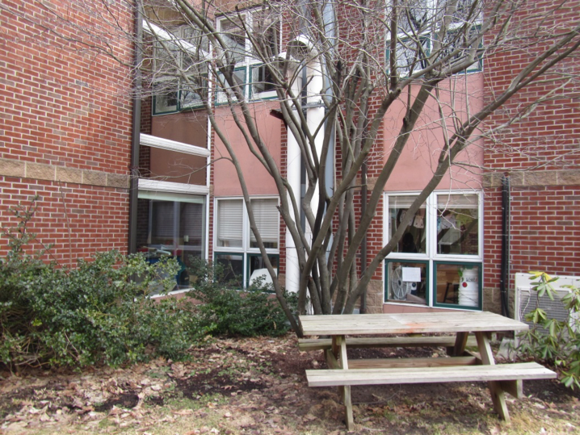
Trees and shrubbery next to the building
Picture 7
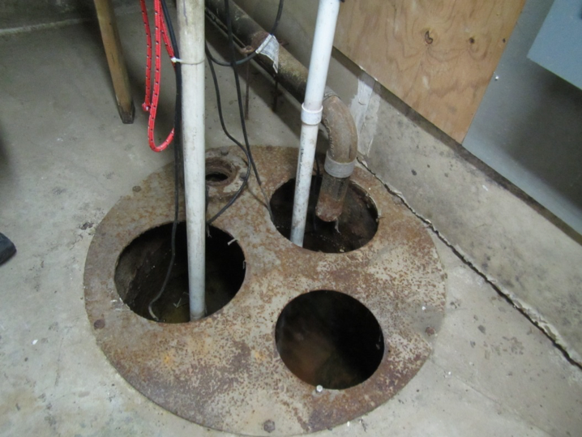
Sump with pump in basement
Picture 8
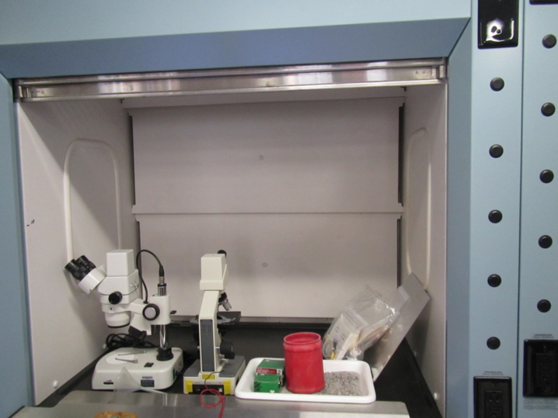
Laboratory hood in science classroom
Picture 9
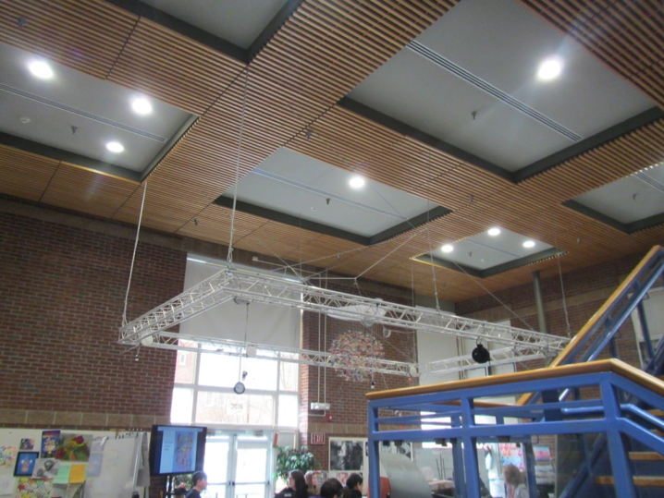
View into art classroom from main atrium
Picture 10
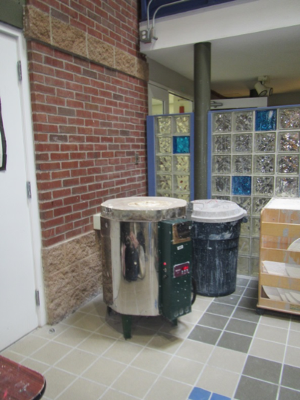
Kiln in art room, glass block wall separates art room from atrium
Picture 11
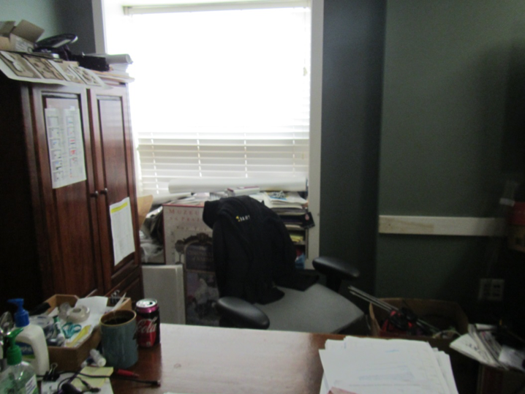
Paper and items on windowsill and desk

Location | Carbon  Dioxide  (ppm) | Carbon Monoxide  (ppm) | Temp  (°F) | Relative  Humidity  (%) | PM2.5  (µg/m³) | Occupants  in Room | Windows  Openable | Ventilation |  | Remarks
 |  |  |  |  |  |  |  | Supply | Exhaust
Background | 457 | ND | 49 | 20 | 10 |  |  |  |  | Cloudy
Business office conference room | 565 | ND | 66 | 20 | 9 | 0 | N | Y | Y off | Carpet squares
Business office cubes | 611 | ND | 68 | 19 | 7 | 0 | N | Y | Y | Carpet squares
317 | 564 | ND | 68 | 19 | 6 | 0 | N | Y | Y | Reportedly loud vents, carpet squares
Main office area | 606 | ND | 69 | 18 | 6 | 3 | Y | Y | Y | Carpet squares
Art area | 744 | ND | 69 | 19 | 5 | 20 | Y | Y | Y | Open area off atrium, plants and art supplies, kiln (no vent)
507 | 520 | ND | 71 | 16 | 7 | 0 | N door | Y | Y | Papers
508 | 546 | ND | 72 | 16 | 6 | 11 | N | Y | Y | Stage, plywood over floor
Women’s restroom in 500 wing |  |  |  |  |  | 0 | N | ? | Y | Vent has no flow, looks like supply vent but is reportedly exhaust
510 | 471 | ND | 70 | 15 | 7 | 0 | N | N | N | Concrete floor
121 | 701 | ND | 71 | 17 | 7 | 4 | Y | Y | Y | DEM, carpet, HS, heater-on
122 conference | 812 | ND | 72 | 17 | 6 | 0 | N | Y | Y | Carpet (slab underneath in this area)
123 | 891 | ND | 72 | 19 | 7 | 7 | N | Y | Y | Carpet, small room, DO
Restroom |  |  |  |  |  |  | N | Y | Y | Exhaust off, ajar ceiling tile (wire pulling)
Teachers area | 710 | ND | 71 | 16 | 6 | 2 | N | Y | Y | Carpet, AI, staff restroom attached
128 | 544 | ND | 71 | 14 | 8 | 0 | N | Y | Y | Carpet
124 | 792 | ND | 71 | 18 | 13 | 0 | N | Y | Y | Carpet, DEM
Nurse | 1339 | ND | 71 | 24 | 6 | 2 | Y | Y | Y | NC
108 | 1463 | ND | 71 | 23 | 4 | 12 | Y | Y | Y | Ductless AC, NC, HS
101 | 1444 | ND | 70 | 23 | 4 | 0 | Y | Y | Y | NC, DEM, sink
102 | 2090 | ND | 72 | 29 | 3 | 22 | Y | Y | Y | NC, DEM, HS
103 | 1693 | ND | 72 | 25 | 4 | 21 | Y | Y | Y | Chipped concrete floor, sink
104 | 1967 | ND | 73 | 26 | 3 | 8 | Y | Y | Y | NC (floor tile), DEM
105 | 2113 | ND | 73 | 27 | 3 | 18 | Y | Y | Y | DEM
309 | 1135 | ND | 71 | 20 | 5 | 16 | Y | Y | Y | NC (floor tile), HS, DEM, wall AC
303 | 1151 | ND | 72 | 21 | 5 | 7 | N | Y | Y | DEM, NC (floor tile)
Rachel Carson | 1170 | ND | 72 | 21 | 5 | 22 | Y | Y | Y | Sinks, science hoods, plants, ductless AC, NC (floor tile)
Buckminster Fuller | 1231 | ND | 72 | 21 | 7 | 20 | Y | Y | Y | Sinks, DEM
314 | 1338 | ND | 71 | 20 | 5 | 1 | Y | Y | Y | AI (floor, windowsills, desk), HS
2nd floor
410 | 1170 | ND | 68 | 22 | 4 | 14 | Y | Y | Y | Carpet, DEM
401 | 1407 | ND | 70 | 23 | 4 | 25 | Y | Y | Y | Carpet, DEM
402 | 1678 | ND | 72 | 27 | 4 | Class just left | Y | Y | Y | DEM, carpet
409 | 1248 | ND | 72 | 29 | 4 | 15 | Y | Y | Y | Carpet, DEM
408 | 1077 | ND | 71 | 16 | 4 | 1 | Y | Y | Y | Carpet, DEM
All gender RR |  |  |  |  |  |  | N |  | Y off | Bathroom odor
229 | 868 | ND | 72 | 18 | 3 | 1 | N | Y | Y | Carpet
228 | 864 | ND | 72 | 17 | 3 | 0 | N | Y | Y | HS odor, carpet, DEM
Principal’s office area | 861 | ND | 72 | 17 | 3 | 2 | N | Y | Y | Carpet
225 | 798 | ND | 73 | 15 | 4 | 1 | Y | Y | Y | Carpet, heater, food, large box of highlighters
218 library | 1064 | ND | 73 | 17 | 4 | 1 | N | Y | Y | Carpet, books
215 | 979 | ND | 74 | 18 | 4 | 1 | N | Y | Y | Area rug, HS
216 | 998 | ND | 76 | 17 | 6 | 2 | Y | Y | Y | NC (floor tile)
217 | 910 | ND | 74 | 15 | 2 | 0 | N | Y | Y | Ductless AC, MDF equipment
210 staff lunch | 960 | ND | 73 | 18 | 4 | 0 | Y | Y | Y | Old windows
203 | 1007 | ND | 72 | 20 | 5 | 20 | N | Y | Y | Carpet (old blue)
208 | 992 | ND | 72 | 19 | 4 | 13 | Y | Y | Y | Carpet (old blue), DEM, PF
207 | 925 | ND | 71 | 19 | 5 | 15 | Y | Y | Y | Carpet (old blue), DEM
204 | 1090 | ND | 72 | 20 | 3 | 19 | Y | Y | Y | Carpet, DEM, PS
206 | 1200 | ND | 71 | 19 | 3 | 18 | Y | Y | Y | Carpet, DEM, PF
205 | 1083 | ND | 71 | 20 | 4 | 13 | Y | Y | Y | Carpet, DEM
Stairwell |  |  |  |  |  |  |  |  |  | WD CT
412 staff room | 871 | ND | 71 | 19 | 3 | 7 | Y | Y | Y on | Carpet
Staff area kitchen |  |  |  |  |  |  |  |  |  | Sink, fridge, toaster (crumbs), microwave
Exit area office in staffroom | 880 | ND | 72 | 18 | 3 | 2 | N | Y | Y | DEM, carpet, attached restroom
601 fitness | 557 | ND | 69 | 14 | 6 | 0 | Y | Y | Y | Gym mat odor, DEM
602 fitness | 540 | ND | 69 | 15 | 7 | 0 | Y | Y | Y | Mats
503 lunch | 655 | ND | 71 | 19 | 7 | Full lunch | N | Y | Y
Boiler room | 492 | ND | 70 | 20 | 6 | 0

