INDOOR AIR QUALITY ASSESSMENT

Berkshire Community College
Hawthorne Hall
1350 West Street
Pittsfield, MA

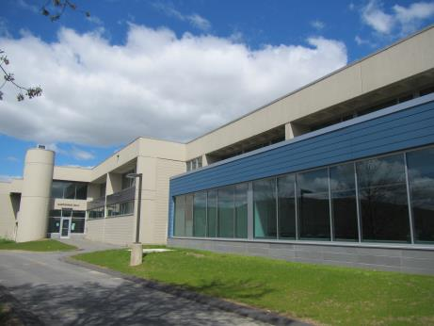

Prepared by:
Massachusetts Department of Public Health
Bureau of Environmental Health
Indoor Air Quality Program
August 2017

Background/Introduction
Building: | Hawthorne Hall (HH)
Address: | 1350 West Street, Pittsfield, MA
Assessment Requested by: | David Moran, Director of Facilities, Berkshire Community College (BCC)
Reason for Request: | General indoor air quality (IAQ)
Date of Assessment: | May 12, 2017
Massachusetts Department of Public Health/Bureau of Environmental Health (MDPH/BEH) Staff Conducting Assessment: | Jason Dustin Environmental Analyst/Inspector IAQ Program
Date of Building Construction: | 1970’s
Building Description: | Two-level concrete building consisting of classrooms, science rooms, and office space.
Building Population: | HH has approximately 26 employees with members of the student body visiting on a daily basis (~300-400).
Windows: | Openable

Methods
Please refer to the IAQ Manual and appendices for methods, sampling procedures, and interpretation of results (MDPH, 2015).

Results and Discussion
The following is a summary of indoor air testing results (Table 1).
- Carbon dioxide measurements were below the MDPH recommended level of 800 parts per million (ppm) in all areas surveyed indicating adequate fresh air exchange at the time of assessment.
- Temperature was within the MDPH recommended range of 70°F to 78°F in all areas visited.
- Relative humidity was below the MDPH recommended range of 40% to 60% in all areas assessed.
- Carbon monoxide levels were non-detectable (ND) in all areas tested.
- Particulate matter (PM2.5) concentrations measured were below the National Ambient Air Quality (NAAQS) level of 35 μg/m³ in all occupied areas surveyed.
- Total volatile organic compound (TVOC) levels were ND in all areas tested.

Ventilation
Fresh air ventilation is provided to HH by air handling units (AHU) which are located on the roof. The ventilation system utilizes a desiccant wheel, which recovers heat/energy from the exhausted air stream and transfers this energy to the incoming fresh air. It was reported by BCC facilities staff that the system does not direct bathroom or kitchen exhaust vents to the desiccant wheel. Restroom and kitchen vents eject these waste streams directly outside of the building as recommended by MDPH.
Space heating is supplemented by fan coil units (FCU) controlled by thermostats. These FCUs heat/cool the space on demand but the ventilation supplied by the AHUs is on continuously as recommended by MDPH.
Properly functioning supply and exhaust ventilation are important to dilute and remove many commonly-found indoor air pollutants. As mentioned above, all occupied areas tested appeared to have excellent air exchange.

Microbial/Moisture Concerns
HH has recently undergone an extensive renovation including new roofing, AHUs, carpet tile/flooring and interior furnishings. BEH did not observe any signs of water intrusion or any musty odors while performing this assessment.
Most areas are equipped with air conditioning from the AHUs. It is important to educate occupants to refrain from opening windows during the cooling season to avoid condensation on porous building materials.
BEH staff noted some exterior areas with bird nests around the BCC campus. Birds and bird wastes can be sources of allergens and microbial contamination. Birds/nesting materials in close proximity to air intakes or openable windows/doors should be removed to avoid entrainment of these allergens/irritants.

Other Concerns
Other conditions that can affect IAQ were observed during the assessment. Exposure to low levels of total volatile organic compounds (TVOCs) may produce eye, nose, throat, and/or respiratory irritation in some sensitive individuals. To determine if VOCs were present, BEH/IAQ staff used a photo ionization detector (PID) to measure TVOCs. No measurable TVOCs were detected at the time of the assessment. BEH/IAQ staff noted hand sanitizers, cleaners/wipes and air deodorizers in use within the building (Pictures 1 and 2). All of these products have the potential to be irritants to the eyes, nose, throat, and respiratory system of sensitive individuals. MDPH typically recommends limiting the use of these items to avoid irritant effects on occupants.
Construction activities were being performed outside of HH to connect it to Melville Hall at the time of this assessment (Picture 3). BCC staff should ensure that contractors continue to follow the MDPH guideline “Methods Used to Reduce/Prevent Exposure to Construction/Renovation Generated Pollutants in Occupied Buildings” (MDPH, 2006).
Some areas were noted to have boxes on the floor (Picture 4). Porous items such as cardboard, paper, clothing, etc. should be stored off of the ground especially on ground floor areas (on slab). This will decrease the likelihood of the items accumulating moisture due to condensation.
Some FCUs were noted to be dusty (Picture 5). FCUs should be cleaned regularly with a high efficiency particulate arrestance (HEPA) vacuum and wet-wiped to avoid aerosolizing accumulated dust/debris.
Many rooms have dry erase boards and materials (Picture 6). It is important to continue to avoid accumulations of dry erase residue in the trays. This residue may have irritant effects when aerosolized.
Although relative humidity was measured to be close to the MDPH guidelines during this assessment, it is very common to have extremely low relative humidity during the heating season in the Northeast. This can cause irritation of the eyes, nose and respiratory tract.

Conclusions/Recommendations
In view of the findings at the time of the assessment, the following is recommended:
- Continue to follow MDPH guidelines (MDPH, 2006) concerning renovations while building is occupied.
- Continue to perform regular HEPA vacuuming and wet-wiping of surfaces to reduce the risk of aerosolized dust/debris from construction activities. This should include regular FCU cleaning.
- Any birds/nesting materials in close proximity to air intakes or openable windows/doors should be removed to avoid entrainment of these allergens/irritants.
- Educate occupants to refrain from opening windows during the cooling season (while AC is operating) to avoid condensation on porous building materials.
- Eliminate the use of scented items, including air deodorizing sprays, reed diffusers and scented cleaners to prevent respiratory irritation. Consider adopting a “fragrance-free” policy campus-wide.
- Reduce the use of or eliminate products containing VOC’s in the building (harsh cleaners/wipes, hand sanitizers, etc.).
- Continue to keep dry erase board trays free from debris to avoid irritant effects.
- Porous items such as cardboard, paper, clothing, etc. should be stored off of the ground especially on ground floor areas (on slab) to decrease the likelihood of these items accumulating moisture due to condensation.
- For buildings in New England, periods of low relative humidity during the winter are unavoidable. Therefore, scrupulous cleaning practices should be adopted to minimize common indoor air contaminants whose irritant effects can be enhanced when the relative humidity is low. To control for dusts, use of a HEPA filter equipped vacuum cleaner in conjunction with wet wiping of all surfaces is recommended. Avoid the use of feather dusters. Drinking water during the day can help ease some symptoms associated with a dry environment (throat and sinus irritations).
- Consider adopting the US EPA (2000) document, “Tools for Schools”, as an instrument for maintaining a good IAQ environment in the building. This document is available at: http://www.epa.gov/iaq/schools/index.html.
- Refer to resource manual and other related IAQ documents located on the MDPH’s website for further building-wide evaluations and advice on maintaining public buildings. These documents are available at: http://mass.gov/dph/iaq.

References
MDPH. 2006. Massachusetts Department of Public Health. “Methods Used to Reduce/Prevent Exposure to Construction/Renovation Generated Pollutants in Occupied Buildings”. Available at: http://www.mass.gov/eohhs/docs/dph/environmental/iaq/appendices/renovation.pdf
MDPH. 2015. Massachusetts Department of Public Health. Indoor Air Quality Manual: Chapters I-III. Available at: http://www.mass.gov/eohhs/gov/departments/dph/programs/environmental-health/exposure-topics/iaq/iaq-manual/.
US EPA. 2000. Tools for Schools. Office of Air and Radiation, Office of Radiation and Indoor Air, Indoor Environments Division (6609J). EPA 402-K-95-001, Second Edition. https://www.epa.gov/iaq-schools.
Picture 1
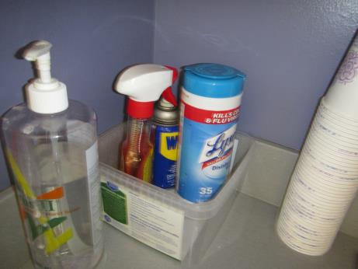
Assorted cleaners/wipes
Picture 2
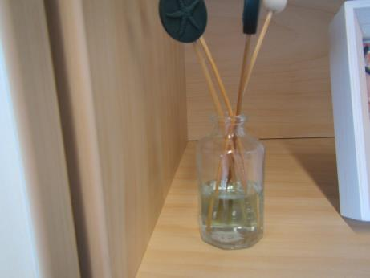
Reed diffuser air deodorizer in office area
Picture 3
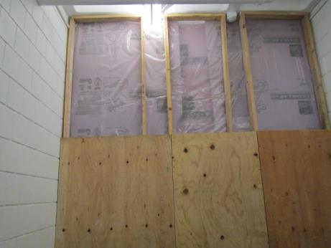
Barrier separating occupied area from active construction
Picture 4
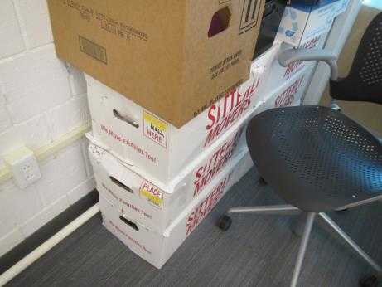
Boxes of items stored directly on the floor
Picture 5
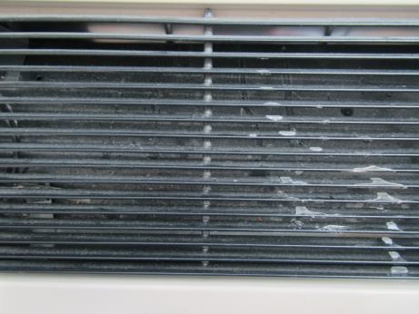
Fan coil unit (FCU) showing accumulated dust
Picture 6
Dry erase materials (DEM)
Location | Carbon  Dioxide  (ppm) | Carbon Monoxide  (ppm) | Temp  (°F) | Relative  Humidity  (%) | PM2.5  (µg/m³) | TVOCs  (ppm) | Occupants  in Room | Windows  Openable | Ventilation |  |  | Remarks
 |  |  |  |  |  |  |  |  | Intake | Exhaust
Background | 311 | ND | 64 | 35 | 8 | ND | - | - | - |  | - | Clear, light wind
1st floor hall | 450 | ND | 72 | 32 | 7 | ND | 2 | N | Y |  | Y | DEM
H105 | 449 | ND | 72 | 32 | 4 | ND | 3 | N | Y |  | Y | DEM
H201 faculty work space | 718 | ND | 72 | 32 | 8 | ND | 3 | Y | Y |  | Y | Photocopier, kitchen, carpet
H202 | 588 | ND | 72 | 31 | 6 | ND | 2 | N | Y |  | Y | DEM, carpet, boxes on floor
H203 | 488 | ND | 72 | 31 | 5 | ND | 3 | N | Y |  | Y | Sinks, biology equipment, DEM
Lab supply | 478 | ND | 72 | 33 | 5 | ND | 2 | N | Y |  | Y | Chemical hood, lab chemicals, eye shower, exhaust connected to return?
H205 | 426 | ND | 72 | 31 | 5 | ND | 3 | N | Y |  | Y | Sinks, anatomy props
H225 | 541 | ND | 72 | 32 | 4 | ND | 3 | N | Y |  | N | Plant
H228 | 418 | ND | 72 | 31 | 3 | ND | 2 | N | Y |  | N | Carpet, floor supply vent
H209 | 339 | ND | 71 | 30 | 2 | ND | 3 | N | Y |  | Y | Tile floor
H108 | 558 | ND | 72 | 34 | 4 | ND | 3 | N | Y |  | Y | DEM
H104 | 571 | ND | 71 | 33 | 5 | ND | 3 | N | Y |  | Y | Carpet, DEM
H103 | 531 | ND | 71 | 32 | 6 | ND | 6 | N | Y |  | Y | DEM, carpet
H102 | 379 | ND | 71 | 31 | 4 | ND | 2 | N | Y |  | Y | DEM, carpet
H233 | 440 | ND | 72 | 31 | 3 | ND | 0 | N | Y |  | N | Air freshener (reed diffuser), carpet, hand sanitizer w/fragrance
H235 | 467 | ND | 72 | 31 | 2 | ND | 1 | N | Y |  | N | DEM, carpet
H210 | 340 | ND | 71 | 31 | 4 | ND | 3 | N | Y |  | Y | Patient simulator mannequins
H211 | 437 | ND | 71 | 31 | 4 | ND | 3 | N | Y |  | Y | Patient simulator mannequins, maternity ward setup, hand sanitizer

