INDOOR AIR QUALITY ASSESSMENT

Berkshire Community College
Jonathan Edwards Library
1350 West Street
Pittsfield, Massachusetts

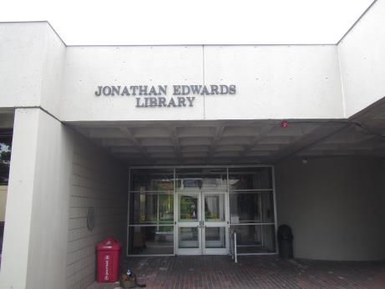

Prepared by:
Massachusetts Department of Public Health
Bureau of Environmental Health
Indoor Air Quality Program
November 2016

Background
Building: | Berkshire Community College (BCC) Jonathan Edwards Library (JEL)
Address: | 1350 West Street, Pittsfield, MA
Assessment Requested by: | David Moran, BCC Facilities Director
Reason for Request: | General indoor air quality (IAQ) assessment and employee concerns
Date of Assessment: | September 30, 2016
Massachusetts Department of Public Health/Bureau of Environmental Health (MDPH/BEH) Staff Conducting Assessment: | Jason Dustin, Environmental Analyst/Inspector, IAQ Program
Date of Building Construction: | 1970’s
Building Description: | Two-story concrete building with portions built into a hill
Building Population: | The JEL has approximately 9 employees with members of the student body visiting on a daily basis.
Windows: | Openable

Methods
Please refer to the IAQ Manual and appendices for methods, sampling procedures, and interpretation of results (MDPH, 2015).

Results and Discussion
The following is a summary of indoor air testing results (Table 1).
- Carbon dioxide measurements were below the MDPH recommended level of 800 parts per million (ppm) in all areas surveyed except for one location.
- Temperature was within or close to the MDPH recommended range of 70°F to 78°F at the time of assessment in most areas. A few areas where windows and doors were open were below this range.
- Relative humidity was within the MDPH recommended range of 40 to 60% in all areas tested.
- Carbon monoxide levels were non-detectable (ND) in all areas tested.
- Particulate matter (PM2.5) concentrations measured were below the National Ambient Air Quality (NAAQS) level of 35 μg/m³ in all areas tested.
- Total Volatile Organic Compounds (TVOCs) levels were ND in all areas tested.

Ventilation
A heating, ventilating, and air conditioning (HVAC) system has several functions. First it provides heating and, if equipped, cooling. Second, it is a source of fresh air. Finally, an HVAC system will dilute and remove normally occurring indoor environmental pollutants by not only introducing fresh air, but also filtering the airstream and ejecting stale air to the outdoors via exhaust ventilation. The act of cooling is two-fold; the system chills the air via cooling coils while also typically removing moisture from the air.
The HVAC system at the JEL consists of unit ventilators (univents) and some perimeter radiator units. The unit ventilators draw fresh air through a vent on the exterior wall (Pictures 1 and 2). Air is mixed with return air from the room, filtered, heated (if needed) and delivered back to the room (Figure 1). The unit ventilator units at the JEL do not provide air conditioning (AC). A window AC unit exists that is intended to cool an enclosed office space behind the circulation desk (Picture 3).
The unit ventilator in Room E10 was not operating properly at the time of assessment. In addition, all windows were closed in this room, which would account for the elevated carbon dioxide reading measured in this room. These unit ventilators should be in operation continuously during occupied hours and supplemented with open windows as needed. It should be noted that this room had a temporary sign labeling it as Room E11. To avoid confusion, all rooms were labeled according to the floor plan shown in Figure 2.

Microbial/Moisture Concerns
JEL staff reported that the deck/patio off of the main floor of the library experienced water infiltration at the interface of the patio surface and exterior wall of the reference area (Picture 4, Figure 2). The carpet in the reference area was reportedly wet occasionally by this leaking. BEH staff observed an older red section of carpeting which may indicate that furniture or shelving was once installed over it (Picture 5). JEL staff reported that fans were used to dry the carpet whenever leaks penetrated this area but the red section of carpeting may have been covered and prevented drying by the fans and should be replaced. This leak was eliminated by repairing the rubber membrane beneath the patio blocks. A slight musty odor was detected in the basement area below this leak which may indicate carpeting was chronically moistened.
Any water-damaged porous materials (e.g., carpeting, ceiling tiles) not dried within 48 hours should be discarded and replaced to avoid microbial colonization. Typically, carpeting is not recommended in below grade space. Mold resistant carpet tiles should be considered when replacing carpeting in below grade spaces.
JEL staff reported several areas of water infiltration through the concrete foundation in below-grade areas (Picture 6). It is important to note that concrete is unlikely to support mold growth even when exposed to periodic water leaks. BEH staff did note accumulations of powdery, white material in some areas (Pictures 7 and 8). The white material is called efflorescence; efflorescence is a characteristic sign of water damage to building materials such as brick, mortar, or plaster, but it is not mold growth. As moisture penetrates and works its way through mortar around brick, water-soluble compounds dissolve, creating a solution. As the solution moves to the surface of the brick or mortar, water evaporates, leaving behind white, powdery mineral deposits. This condition indicates that water from the exterior has penetrated into the building. Although concrete does not typically support mold growth, paint, items, or debris near the walls that are moistened may become mold-colonized. When present, efflorescence can be readily cleaned. According to BCC Facilities staff, they have been working to mitigate water infiltration in these areas.
Below grade spaces are typically subject to condensation/moisture so extra effort should be made to reduce the chance for water damage to porous items (e.g., books, carpeting). Consider using fans to accelerate evaporation of any collected moisture especially during humid weather. While temperature is mainly a comfort issue, relative humidity in excess of 70 percent for extended periods of time can provide an environment for mold and fungal growth (ASHRAE, 1989). Dehumidifiers can be used in conjunction with fans in below grade spaces to keep humidity at acceptable levels. Dehumidifiers should be cleaned/maintained according to manufacturer recommendations to avoid spills and microbial contamination.
JEL occupants reported that water infiltrates through the older, single pane windows especially during driving rains in areas such as Reference and the Reference office (Picture 9).
The JEL has acoustic ceiling tiles in some areas to dampen sound in the concrete space. Some of these tiles were noted to be water-damaged (Picture 10). As with carpeting and other porous water-damaged items, any water-damaged acoustic ceiling tiles should be discarded and replaced.
The window AC unit appears to be sized to only serve the office area behind the circulation desk. In general, AC units should never run in cooling mode while windows or doors are opened due to the possibility of moisture collecting on surfaces cooled below the dew point. The door to the circulation office (Room E103) should remain closed while operating the AC in this room. The JEL is a very large space that, as stated earlier, does not have building-wide cooling so that leaving this door open while the AC unit is operating would similarly increase the potential of condensation due to the large volume of unconditioned air in the JEL.
Plants were observed in a several areas, including on porous surfaces (e.g., carpet). Plants can be a source of pollen and mold, which are respiratory irritants to some individuals. Plants should be properly maintained and equipped with drip pans to prevent water damage to porous materials. Plants should also be located away from air diffusers to prevent the aerosolization of dirt, pollen, and mold. Due to the higher incidence of chronic dampness, consideration should be given to removing plants from below grade spaces.
Refrigerators and water coolers/fountains were noted to be placed over carpeting (Picture 11). Chronic leaks or spills from these items can cause carpet degradation and microbial colonization.

Other Conditions
Other conditions that can affect IAQ were observed during the assessment. Room E12 had an odor that may have been due to the trash/recycling bins in this area. Recycling bins and trash cans should be maintained and emptied daily to prevent the introduction of pests and leaking. Consideration should be given to installing tile in this area.
A metal fresh air intake vent cover was noted to be badly corroded outside of the entrance to the JEL (Picture 12). This vent cover should be repaired/replaced to avoid any pests from nesting inside the wall/univent cavity.
The Institute of Inspection, Cleaning, and Restoration Certification (IICRC) recommends that carpeting be cleaned annually (or semi-annually in soiled high traffic areas) (IICRC, 2012). Regular vacuuming with a high efficiency particulate air (HEPA) filtered vacuum in combination with an annual cleaning will help to reduce accumulation and potential aerosolization of materials from carpeting. Since the average lifespan of carpeting is approximately eleven years (Bishop, 2002), consideration should be given to the installation of new flooring.

Conclusions and Recommendations
In view of the findings at the time of the visit, the following recommendations are made:
- Operate all unit ventilators continuously during occupied hours and supplement fresh air with open windows as needed. Continue to clean and maintain these units regularly including filter changes per manufacturer recommendations.
- Make any necessary repairs to unit ventilator in room E10 (E11 temporary sign).
- Continue to mitigate any area of active water infiltration through the building envelope.
- Continue to monitor the area off of the patio that was previously leaking and take any necessary actions (e.g., fans, further repairs).
- Any water-damaged porous materials (e.g., carpeting, acoustic ceiling tiles, etc.) not dried within 48 hours should be discarded and replaced to avoid microbial colonization.
- Consider utilizing dehumidifiers in conjunction with fans in below grade spaces to keep humidity at acceptable levels and accelerate evaporation of any collected moisture. Dehumidifiers should be cleaned/maintained according to manufacturer recommendations to avoid spills and microbial contamination.
- The door to the circulation office (Room E103) should remain closed while operating the AC in this room to avoid condensation from the large volume of unconditioned air. Regularly maintain/clean this AC unit according to manufacturer recommendations.
- Repair/replace fresh air intake vent cover near JEL entrance to avoid any pests from nesting inside the wall/univent cavity.
- Empty trash/recycling daily to avoid the introduction of pests and spills. Consider installing tile in this area.
- Ensure that procedures are in place and encourage occupants to report HVAC/maintenance issues so that they can be logged and repaired promptly.
- Consider placing waterproof mats under water fountains/coolers and refrigerators to prevent chronic water damage to carpeting.
- Plants should be properly maintained and equipped with drip pans to prevent water damage to porous materials. Plants should also be located away from air diffusers to prevent the aerosolization of dirt, pollen, and mold. Consider removing plants from below grade spaces.
- Continue to clean carpeting annually or semi-annually in soiled high traffic areas as per the recommendations of the Institute of Inspection, Cleaning and Restoration Certification (IICRC, 2012).
- For buildings in New England, periods of low relative humidity during the winter are often unavoidable. Therefore, scrupulous cleaning practices should be adopted to minimize common indoor air contaminants whose irritant effects can be enhanced when the relative humidity is low. To control for dusts, a HEPA filter equipped vacuum cleaner in conjunction with wet wiping of all surfaces is recommended. Avoid the use of feather dusters. Drinking water during the day can help ease some symptoms associated with a dry environment (throat and sinus irritation).
- Refer to resource manual and other related indoor air quality documents located on the MDPH’s website for further building-wide evaluations and advice on maintaining public buildings. These documents are available at http://mass.gov/dph/iaq.

Long Term Recommendations
- Consider installing building-wide cooling for the JEL to more effectively control comfort and humidity.
- Replace any carpeting beyond its service life. Consider mold resistant carpet squares for new flooring.
- Consider upgrading the older single pane windows at the JEL to new, energy efficient windows that will eliminate water infiltration and improve comfort for occupants.

REFERENCES
American Society of Heating, Refrigerating, and Air-Conditioning Engineers (ASHRAE). 1989. Ventilation for Acceptable Indoor Air Quality. ANSI/ASHRAE 62-1989.
Bishop. 2002. Bishop, J. & Institute of Inspection, Cleaning and Restoration Certification. A Life Cycle Cost Analysis for Floor Coverings in School Facilities.
Institute of Inspection, Cleaning and Restoration Certification (IICRC). 2012. Carpet Cleaning: FAQ. Retrieved from http://www.iicrc.org/consumers/care/carpet-cleaning.
Massachusetts Department of Public Health (MDPH). 2015. Indoor Air Quality Manual: Chapters I-III. Available at: http://www.mass.gov/eohhs/gov/departments/dph/programs/environmental-health/exposure-topics/iaq/iaq-manual/.
Picture 1
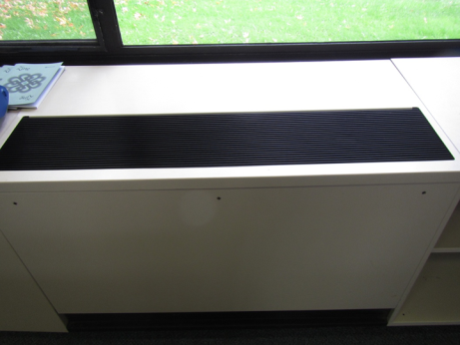
Unit ventilator
Picture 2
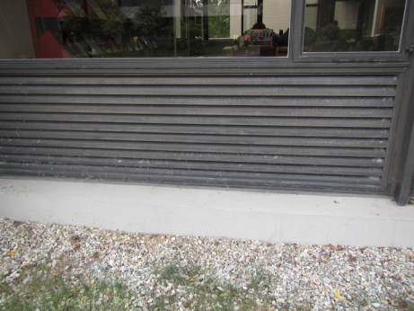
Fresh air intake for unit ventilator
Picture 3
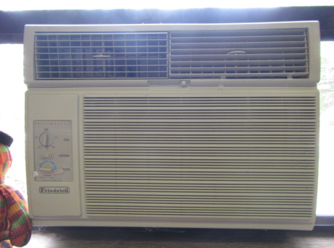
Window AC unit in office E103
Picture 4
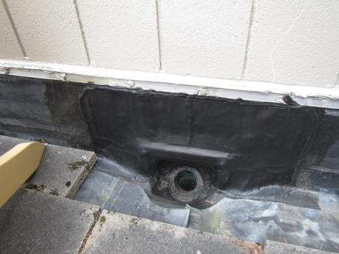
Patio area showing repairs made to rubber membrane where leaks occurred
Picture 5
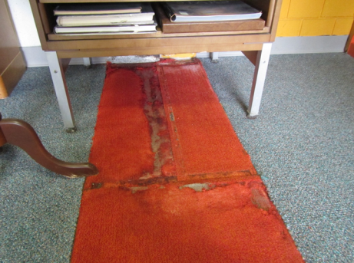
Older red carpeting in area of patio water intrusion
Picture 6
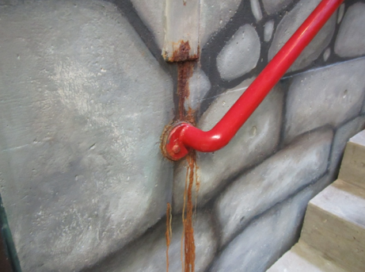
Area of active water infiltration in stairwell
Picture 7
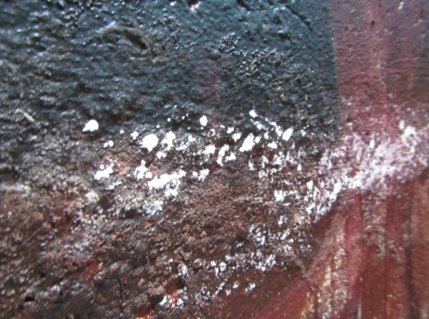
Efflorescence in stairwell
Picture 8
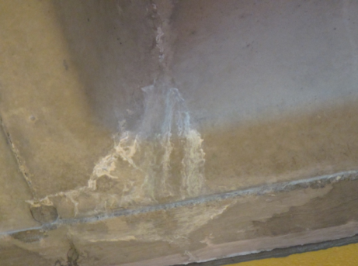
Efflorescence in concrete
Picture 9
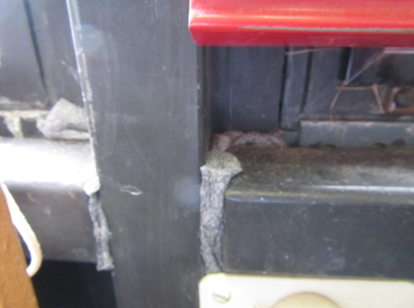
Reference area showing older windows where leaks occur
Picture 10
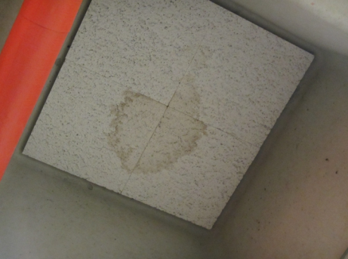
Water-damaged ceiling tiles
Picture 11
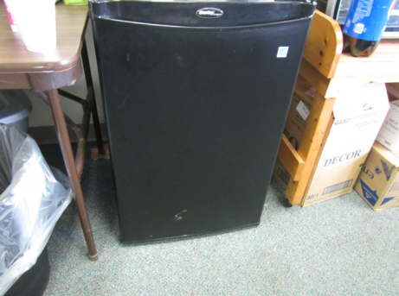
Refrigerator placed on carpeting
Picture 12
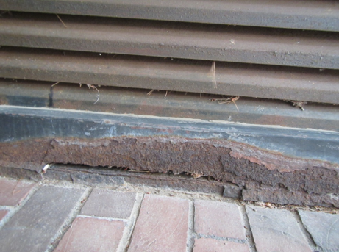
Badly corroded fresh air intake vent cover
Location | Carbon  Dioxide  (ppm) | Carbon Monoxide  (ppm) | Temp  (°F) | Relative  Humidity  (%) | PM2.5  (µg/m³) | TVOCs  (ppm) | Occupants  in Room | Windows  Openable | Ventilation |  | Remarks
 |  |  |  |  |  |  |  |  | Supply | Exhaust | Remarks
Background | 344 | ND | 54 | 55 | 7 | ND | - | - | - | -
First Floor
E105 | 523 | ND | 68 | 51 | 7 | ND | 4 | Y | Y | Y | Univents, HS, photo copier, plants, carpet
E106 | 364 | ND | 64 | 52 | 5 | ND | 1 | Y | Y | Y | Upholstered furniture, window open
E107 | 450 | ND | 66 | 53 | 6 | ND | 2 | Y | Y | Y | DEM, carpet
New Room | 478 | ND | 67 | 50 | 6 | ND | 2 | Y | Y | Y | New carpet tile, DEM, elevator, univent
Circulation Desk | 690 | ND | 67 | 49 | 6 | ND | 2 | Y | Y | Y | Door open to patio, plants, perimeter heat
Office E103 | 468 | ND | 70 | 44 | 3 | ND | 2 | Y | Y | Y | Window air conditioner, personal fans, plants
E102 | 470 | ND | 70 | 45 | 4 | ND | 2 | Y | Y | Y | Personal fans, solar gain, metal blinds
Reference E101 right side-desks | 417 | ND | 69 | 44 | 3 | ND | 3 | Y | Y | Y | DEM, reported water infiltration through window
Reference E101 left side-books | 413 | ND | 68 | 47 | 2 | ND | 1 | Y | Y | Y | WD carpet; repairs made to leaks through wall, efflorescence
Reference office- E108 | 464 | ND | 68 | 47 | 3 | ND | 1 | Y | Y | Y | WD carpet, reported window water infiltration
Basement
E9 | 581 | ND | 69 | 50 | 5 | ND | 1 | Y | Y | Y | Carpet, water fountain over carpet
E2 | 512 | ND | 70 | 49 | 5 | ND | 3 | Y | Y | Y | Book stacks, historic WD CTs, slight musty odor
E12 | 607 | ND | 70 | 48 | 6 | ND | 0 | Y | Y | Y | Recycling/trash odor
E11 (locked) | - | - | - | - | - | - | - | - | - | -
E10 (*temporary sign read E11) | 1326 | ND | 70 | 52 | 6 | ND | 2 | Y | Y | Y | Univent reportedly broken, windows closed, DEMs, CPs, refrigerator on carpet, plants
Stacks- middle | 515 | ND | 70 | 48 | 5 | ND | 2 | Y | Y | Y
Stacks- left side | 492 | ND | 70 | 48 | 5 | ND | 1 | Y | Y | Y | Slight musty odor, plant, WD carpet

