INDOOR AIR QUALITY ASSESSMENT

Berkshire Community College
Melville and Hawthorne Halls
1350 West Street
Pittsfield, MA

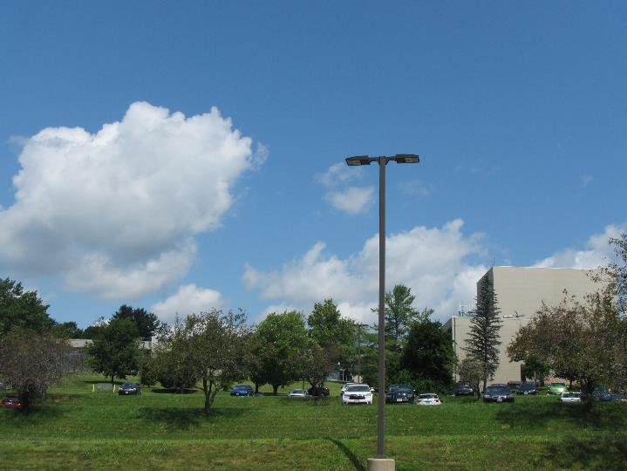

Prepared by:
Massachusetts Department of Public Health
Bureau of Environmental Health
Indoor Air Quality Program
August 2019

Background/Introduction
Building: | Berkshire Community College (BCC) Melville and Hawthorne Halls
Address: | 1350 West Street, Pittsfield, MA
Assessment Requested by: | Melissa Loiodice, Director of Human Resources, Berkshire Community College (BCC)
Reason for Request: | General indoor air quality (IAQ)
Date of Assessment: | August 8, 2019
Massachusetts Department of Public Health/Bureau of Environmental Health (MDPH/BEH) Staff Conducting Assessment: | Jason Dustin Environmental Analyst/Inspector IAQ Program
Date of Building Construction: | 1970’s
Building Description: | Two-level concrete building consisting of classrooms, science rooms, and office space.
Building Population: | These two buildings have approximately 50 employees with 200-300 members of the student body visiting daily.
Windows: | Openable

Methods
Please refer to the IAQ Manual and appendices for methods, sampling procedures, and interpretation of results (MDPH, 2015). Note that these buildings were visited in 2017 during extensive renovations; these reports are available at https://www.mass.gov/report/indoor-air-quality-reports.

Results and Discussion
The following is a summary of indoor air testing results (Table 1).
- Carbon dioxide measurements were below the MDPH recommended guideline of 800 parts per million (ppm) in all areas surveyed indicating adequate fresh air exchange at the time of assessment.
- Temperature was within the MDPH recommended range of 70°F to 78°F in all areas visited.
- Relative humidity was within the MDPH recommended range of 40% to 60% in all areas assessed.
- Carbon monoxide levels were non-detectable (ND) in all areas tested.
- Particulate matter (PM2.5) concentrations measured were below the National Ambient Air Quality (NAAQS) level of 35 μg/m³ in all occupied areas surveyed.
- Total Volatile Organic Compounds (TVOCs) levels were ND in all areas tested.

Ventilation
Fresh air ventilation is provided to Melville and Hawthorne Halls by large air handling units (AHU) which are located on the roof (Picture 1). The ventilation system uses a desiccant wheel which recovers heat/energy from the exhausted air stream and transfers this energy to the incoming fresh air. It was previously reported by BCC Facilities staff that the system does not direct bathroom or kitchen exhaust to the desiccant wheel and instead ejects these waste streams directly outside of the building as recommended by MDPH.
Space heating and cooling is supplemented by fan coil units (FCU) controlled by thermostats (Picture 2). These FCUs heat/cool the space on demand but fresh air ventilation supplied by the AHUs is on continuously as recommended by MDPH.
Properly functioning supply and exhaust ventilation are important to dilute and remove many commonly found indoor air pollutants. In order to have proper ventilation with a mechanical ventilation system, the systems must be balanced after installation to provide an adequate amount of fresh air to the interior of a room while removing stale air from the room. It is recommended that HVAC systems be re-balanced every five years to ensure adequate air systems function (SMACNA, 1994).

Microbial/Moisture Concerns
Extensive renovations including new roofing, AHUs, carpet tile/flooring and interior furnishings were performed in 2017. One room (M-301) was noted to have a water stain on a ceiling tile which was reported to be a historic leak (Picture 3). BEH/IAQ staff did not observe any other signs of water intrusion or any musty odors while performing this assessment.
Most areas are equipped with air conditioning from the AHUs. Occupants should be reminded not to open windows during the cooling season to avoid intrusion of hot humid air that may lead to condensation on porous building materials.
A refrigerator was noted to be located directly on carpeting in the Hawthorne Hall faculty lounge (Picture 4). Leaks or spills from this appliance may cause water damage to carpeting and allow microbial colonization if left unchecked for an extended duration.

Other Concerns
Exposure to low levels of total volatile organic compounds (TVOCs) may produce eye, nose, throat, and/or respiratory irritation in some sensitive individuals. To determine if VOCs were present, BEH/IAQ staff used a photo ionization detector (PID) to measure TVOCs. No measurable levels of VOCs were recorded during the assessment (Table 1). BEH/IAQ staff typically finds hand sanitizers, cleaners/wipes, air deodorizers, and dry erase materials in use within most buildings. All of these products have the potential to be irritants to the eyes, nose, throat, and respiratory system of sensitive individuals. MDPH recommends limiting the use of these items to avoid irritant effects on occupants.
Dry erase boards are used in many classrooms at the BCC (Picture 5). The trays of these boards should continue to be wiped regularly to reduce the likelihood of particulates having irritant effects on occupants.

Conclusions/Recommendations
In view of the findings at the time of the assessment, the following is recommended:
- Continue to operate all supply and exhaust ventilation in a continuous mode while buildings are occupied.
- Remove the water-damaged ceiling tile in room M-301 and replace new. Monitor the area for continued leaks and make repairs as necessary.
- Consider placing a waterproof tray/mat under the refrigerator in the Hawthorne Hall faculty lounge or relocate the appliance to a non-carpeted area.
- Educate occupants to refrain from opening windows during the cooling season (while AC is operating) to avoid condensation on porous building materials.
- Eliminate the use of scented items, including air deodorizing sprays, reed diffusers and scented cleaners to prevent respiratory irritation.
- Reduce the use of or eliminate products containing VOCs in the building (harsh cleaners/wipes, hand sanitizers, etc.).
- Continue to keep dry erase board trays free from debris to avoid irritant effects.
- For buildings in New England, periods of low relative humidity during the winter are unavoidable. Therefore, scrupulous cleaning practices should be adopted to minimize common indoor air contaminants whose irritant effects can be enhanced when the relative humidity is low. To control for dusts, a high efficiency particulate arrestance (HEPA) filter equipped vacuum cleaner in conjunction with wet wiping of all surfaces is recommended. Avoid the use of feather dusters. Drinking water during the day can help ease some symptoms associated with a dry environment (throat and sinus irritations).
- Ensure a balancing schedule of every five years for the HVAC equipment.
- Consider adopting the US EPA (2000) document, “Tools for Schools”, as an instrument for maintaining a good IAQ environment in the building. This document is available at: http://www.epa.gov/iaq/schools/index.html.
- Refer to resource manual and other related IAQ documents located on the MDPH’s website for further building-wide evaluations and advice on maintaining public buildings. These documents are available at: http://mass.gov/dph/iaq.

References
MDPH. 2015. Massachusetts Department of Public Health. Indoor Air Quality Manual: Chapters I-III. Available at: http://www.mass.gov/eohhs/gov/departments/dph/programs/environmental-health/exposure-topics/iaq/iaq-manual/.
SMACNA. 1994. HVAC Systems Commissioning Manual. 1st ed. Sheet Metal and Air Conditioning Contractors’ National Association, Inc., Chantilly, VA.
US EPA. 2000. Tools for Schools. Office of Air and Radiation, Office of Radiation and Indoor Air, Indoor Environments Division (6609J). EPA 402-K-95-001, Second Edition. https://www.epa.gov/iaq-schools.
Picture 1
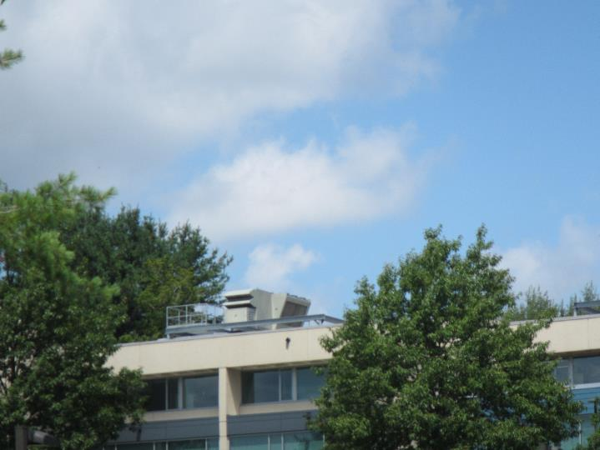
Roof-mounted AHU
Picture 2
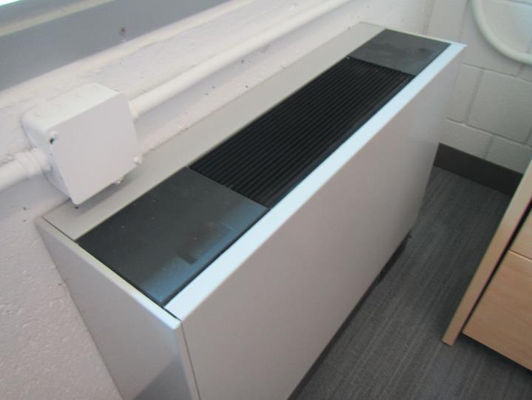
Supplemental Fan Coil Unit (FCU)
Picture 3
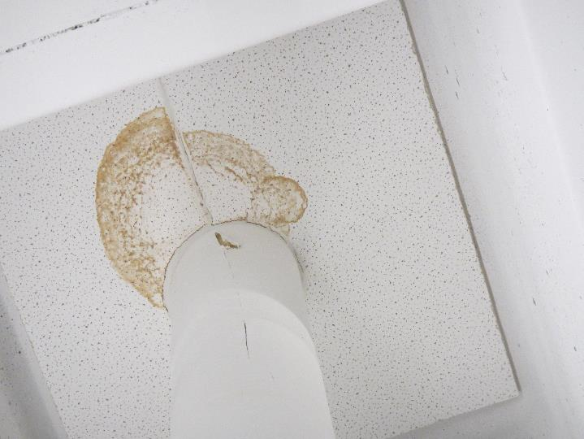
Water-stained ceiling tile
Picture 4
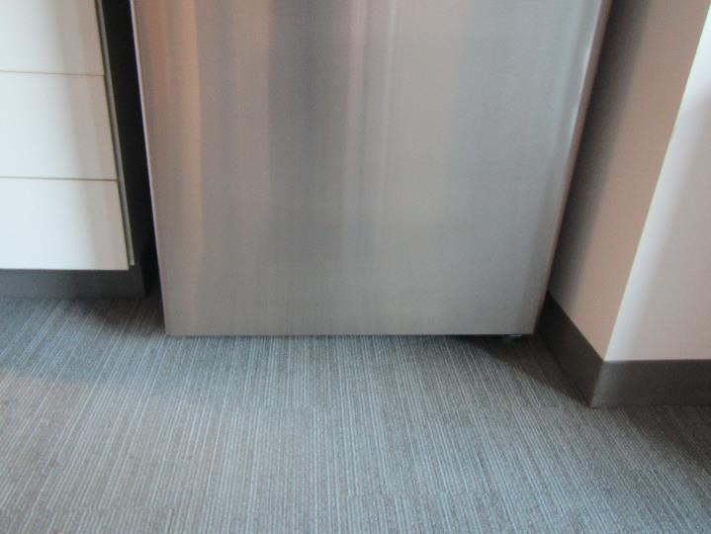
Refrigerator on carpeting in faculty lounge
Picture 5
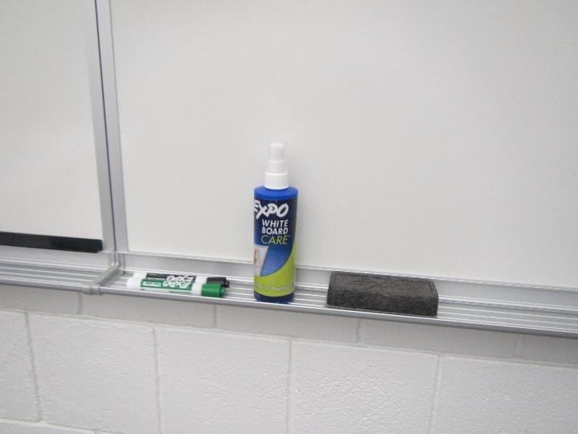
Dry erase board and materials

Location | Carbon  Dioxide  (ppm) | Carbon Monoxide  (ppm) | Temp  (°F) | Relative  Humidity  (%) | PM2.5  (µg/m³) | TVOCs  (ppm) | Occupants  in Room | Windows  Openable | Ventilation |  |  | Remarks
 |  |  |  |  |  |  |  |  | Intake | Exhaust
Background | 278 | ND | 84 | 61 | 11 | ND | - | - | - |  | - | Partly sunny, light wind
Melville Hall:
M-421 | 459 | ND | 74 | 58 | 11 | ND | 1 | Y | Y |  | Y | FCU, DEM
Hallway | 489 | ND | 73 | 59 | 9 | ND | 4 | N | Y |  | Y | Laminate flooring
M-301 | 355 | ND | 74 | 52 | 6 | ND | 4 | N | Y |  | Y | WD CT, carpet tile
M-302 | 391 | ND | 73 | 56 | 7 | ND | 6 | N | Y |  | Y | DEM, carpet tile
Hallway | 344 | ND | 74 | 54 | 5 | ND | 4 | N | Y |  | Y
M-211 | 339 | ND | 74 | 59 | 8 | ND | 4 | N | Y |  | Y | Carpet tile
Hallway | 321 | ND | 74 | 58 | 6 | ND | 4 | N | Y |  | Y | Laminate flooring
Hawthorne Hall:
Connector Lounge | 344 | ND | 73 | 55 | 3 | ND | 4 | N | Y |  | Y
Faculty Lounge | 324 | ND | 73 | 54 | 3 | ND | 4 | N | Y |  | Y | Fridge over carpet, FCU
Faculty H-431A | 311 | ND | 72 | 55 | 3 | ND | 3 | N | Y |  | Y
Hallway | 322 | ND | 73 | 56 | 3 | ND | 4 | N | Y |  | Y
H-409 | 342 | ND | 73 | 53 | 2 | ND | 2 | Y | Y |  | Y
Hallway | 351 | ND | 74 | 56 | 3 | ND | 4 | N | Y |  | Y
H-402 | 340 | ND | 72 | 56 | 4 | ND | 4 | N | Y |  | Y | FCU, carpet tile
Hallway | 370 | ND | 72 | 58 | 3 | ND | 4 | N | Y |  | Y
H-108 | 458 | ND | 73 | 57 | 2 | ND | 4 | N | Y |  | Y | FCU
Hallway | 331 | ND | 73 | 56 | 4 | ND | 4 | N | Y |  | Y

