INDOOR AIR QUALITY ASSESSMENT

Berkshire Community College
Melville Hall
1350 West Street
Pittsfield, MA

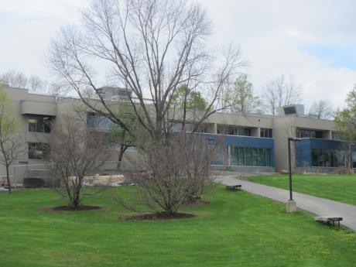

Prepared by:
Massachusetts Department of Public Health
Bureau of Environmental Health
Indoor Air Quality Program
June 2017

Background/Introduction
Building: | Melville Hall (MH)
Address: | 1350 West Street, Pittsfield, MA
Assessment Requested by: | David Moran, Director of Facilities, Berkshire Community College (BCC)
Reason for Request: | General indoor air quality (IAQ)
Date of Assessment: | May 3, 2017
Massachusetts Department of Public Health/Bureau of Environmental Health (MDPH/BEH) Staff Conducting Assessment: | Jason Dustin Environmental Analyst/Inspector IAQ Program
Date of Building Construction: | 1970’s
Building Description: | Two-level concrete building consisting of classrooms, science rooms, and office space.
Building Population: | MH has approximately 30 employees with 200-300 members of the student body visiting daily.
Windows: | Openable

Methods
Please refer to the IAQ Manual and appendices for methods, sampling procedures, and interpretation of results (MDPH, 2015).

Results and Discussion
The following is a summary of indoor air testing results (Table 1).
- Carbon dioxide measurements were below the MDPH recommended level of 800 parts per million (ppm) in all areas surveyed indicating adequate fresh air exchange at the time of assessment.
- Temperature was within the MDPH recommended range of 70°F to 78°F in all areas visited.
- Relative humidity was below the MDPH recommended range of 40% to 60% in most areas assessed.
- Carbon monoxide levels were non-detectable in all areas tested.
- Particulate matter (PM2.5) concentrations measured were below the National Ambient Air Quality (NAAQS) level of 35 μg/m³ in all occupied areas surveyed. The first floor South Hallway showed an elevated reading most likely due to construction vehicles.

Ventilation
Fresh air ventilation is provided to MH by three large air handling units (AHU) which are located on the roof (Picture 1). The ventilation system uses a desiccant wheel which recovers heat/energy from the exhausted air stream and transfers this energy to the incoming fresh air. It was reported by BCC Facilities staff that the system does not direct bathroom or kitchen exhaust to the desiccant wheel and instead ejects these waste streams directly outside of the building as recommended by MDPH.
Space heating is supplemented by fan coil units (FCU) controlled by thermostats (Picture 2). These FCUs heat/cool the space on demand but fresh air ventilation supplied by the AHUs is on continuously as recommended by MDPH.
Properly functioning supply and exhaust ventilation are important to dilute and remove many commonly found indoor air pollutants.

Microbial/Moisture Concerns
MH has just undergone an extensive renovation including new roofing, AHUs, carpet tile/flooring and interior furnishings. BEH/IAQ staff did not observe any signs of water intrusion or any musty odors while performing this assessment.
Most areas are equipped with air conditioning from the AHUs. Occupants should be reminded not to open windows during the cooling season to avoid intrusion of hot humid air that may lead to condensation on porous building materials.

Other Concerns
Other conditions that can affect IAQ were observed during the assessment. Exposure to low levels of total volatile organic compounds (TVOCs) may produce eye, nose, throat, and/or respiratory irritation in some sensitive individuals. To determine if VOCs were present, BEH/IAQ staff used a photo ionization detector (PID) to measure TVOCs. Although some occupied areas had slight new vinyl flooring odors (mainly unoccupied hallways), no measurable TVOCs were detected at the time of the assessment. Odors were strongest in enclosed foyers that lacked ventilation (Picture 3). BCC Facilities staff have been propping open doors to better ventilate the foyer areas until the odors of new vinyl flooring dissipate. BEH/IAQ staff typically finds hand sanitizers, cleaners/wipes, air deodorizers, and dry erase materials in use within most buildings. All of these products have the potential to be irritants to the eyes, nose, throat, and respiratory system of sensitive individuals. MDPH typically recommends limiting the use of these items to avoid irritant effects on occupants.
Construction activities were being performed outside of MH (Picture 4) at the time of this assessment. BEH staff noted one elevated particulate matter (PM 2.5) reading that was taken in an unoccupied hallway area immediately adjacent to the construction. It is likely that the idling of construction equipment in close proximity to the building may have caused this temporary increase in PM 2.5 in this isolated area. Efforts should be made to schedule particularly dusty/odorous construction activities during unoccupied hours, ensure that walls and other barriers between occupied areas and areas where construction are occurring are intact, and temporarily close the AHU nearest the construction if needed. Please consult Appendix A, “Methods Used to Reduce/Prevent Exposure to Construction/Renovation Generated Pollutants in Occupied Buildings” for more information.
Some doors leading to the construction outside were blocked for access but were noted to have dust/debris tracked in from construction personnel (Pictures 5 to 7). This dust/debris may have irritant effects if allowed to aerosolize within the building. Walk-off mats with an adhesive coating are one method used to prevent the tracking of this debris into occupied areas. Regular wet-wiping of surfaces, HEPA vacuuming, and wet-mopping tile floors will also help to reduce particulate matter in occupied areas.
Many rooms have dry erase boards and materials. Trays should be cleaned regularly using a damp cloth to remove debris before it is aerosolized.

Conclusions/Recommendations
In view of the findings at the time of the assessment, the following is recommended:
- Continue to follow MDPH guidelines (Appendix A) concerning renovations while building is occupied. This may include installing adhesive-style walk off mats in entrances leading to construction areas to avoid tracking dust/debris from construction side and scheduling dusty/odorous activities during unoccupied hours or temporarily closing AHU nearest construction.
- Continue to perform regular HEPA vacuuming and wet-wiping of surfaces to reduce the risk of aerosolized dust/debris from construction activities.
- Educate occupants to refrain from opening windows during the cooling season (while AC is operating) to avoid condensation on porous building materials.
- Eliminate the use of scented items, including air deodorizing sprays, reed diffusers and scented cleaners to prevent respiratory irritation.
- Reduce the use of or eliminate products containing VOCs in the building (harsh cleaners/wipes, hand sanitizers, etc.).
- Continue to keep dry erase board trays free from debris to avoid irritant effects.
- For buildings in New England, periods of low relative humidity during the winter are unavoidable. Therefore, scrupulous cleaning practices should be adopted to minimize common indoor air contaminants whose irritant effects can be enhanced when the relative humidity is low. To control for dusts, a high efficiency particulate arrestance (HEPA) filter equipped vacuum cleaner in conjunction with wet wiping of all surfaces is recommended. Avoid the use of feather dusters. Drinking water during the day can help ease some symptoms associated with a dry environment (throat and sinus irritations).
- Consider adopting the US EPA (2000) document, “Tools for Schools”, as an instrument for maintaining a good IAQ environment in the building. This document is available at: http://www.epa.gov/iaq/schools/index.html.
- Refer to resource manual and other related IAQ documents located on the MDPH’s website for further building-wide evaluations and advice on maintaining public buildings. These documents are available at: http://mass.gov/dph/iaq.

References
MDPH. 2006. Massachusetts Department of Public Health. “Methods Used to Reduce/Prevent Exposure to Construction/Renovation Generated Pollutants in Occupied Buildings”. Available at: http://www.mass.gov/eohhs/docs/dph/environmental/iaq/appendices/renovation.pdf
MDPH. 2015. Massachusetts Department of Public Health. Indoor Air Quality Manual: Chapters I-III. Available at: http://www.mass.gov/eohhs/gov/departments/dph/programs/environmental-health/exposure-topics/iaq/iaq-manual/.
US EPA. 2000. Tools for Schools. Office of Air and Radiation, Office of Radiation and Indoor Air, Indoor Environments Division (6609J). EPA 402-K-95-001, Second Edition. https://www.epa.gov/iaq-schools.

Picture 1
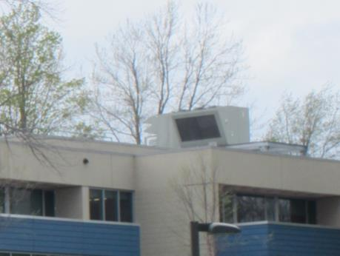
Air handling unit (AHU) on the roof of Melville Hall
Picture 2
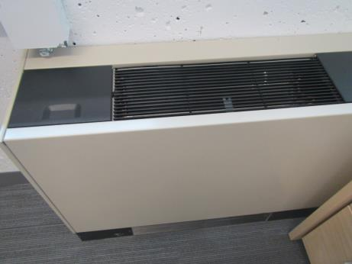
Thermostat-controlled fan coil unit (FCU)
Picture 3
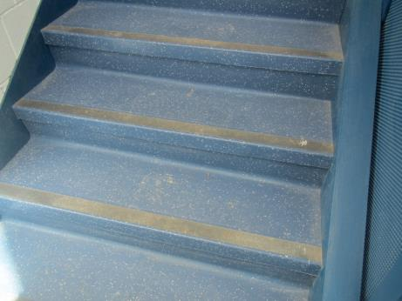
New vinyl flooring in stairwell area
Picture 4
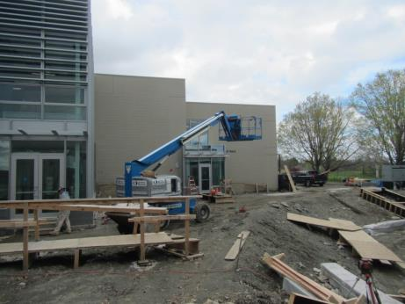
Construction activities outside of Melville Hall
Picture 5
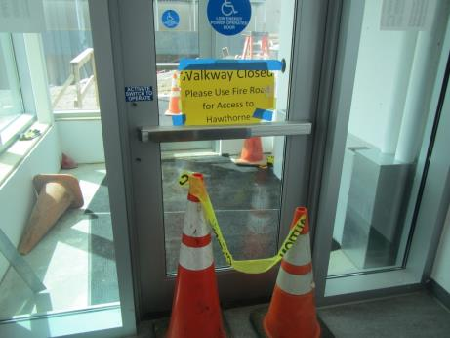
Door leading to construction outside
Picture 6
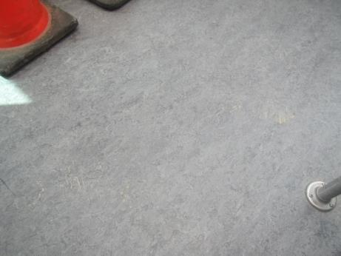
Dust/debris from construction area tracked into hall (no walk off mat inside)
Picture 7
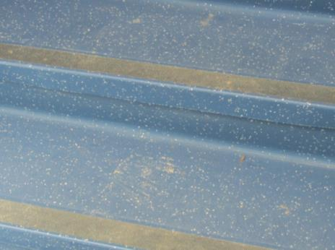
Dust/debris from construction access door leading upstairs

Location | Carbon  Dioxide  (ppm) | Carbon Monoxide  (ppm) | Temp  (°F) | Relative  Humidity  (%) | PM2.5  (µg/m³) | TVOCs  (ppm) | Occupants  in Room | Windows  Openable | Ventilation |  |  | Remarks
 |  |  |  |  |  |  |  |  | Intake | Exhaust
Background | 337 | ND | 53 | 39 | 5 | ND | - | - | - |  | - | Overcast
1st floor South Hallway | 528 | ND | 70 | 42 | 35 to 71 | ND | 0 | N | Y |  | Y | Construction vehicles outside window
M202 | 502 | ND | 70 | 36 | 7 | ND | 0 | N | Y |  | Y | Hoods, chemicals, DEM
M101 | 396 | ND | 70 | 34 | 3 | ND | 0 | N | Y |  | Y | DEM, computers, carpet tile
M102 | 783 | ND | 70 | 38 | 8 | ND | 23 | N | Y |  | Y | DEM, carpet tile
M103 | 463 | ND | 70 | 34 | 5 | ND | 3 | N | Y |  | Y | Water closet (neutralization system)
M106 | 525 | ND | 70 | 37 | 2 | ND | 0 | N | Y |  | Y
1st floor North Hallway | 637 | ND | 71 | 38 | 2 | ND | 0 | N | Y |  | Y
M109 | 370 | ND | 70 | 35 | 3 | ND | 3 | N | Y |  | Y | Door undercut
M240 suite | 621 | ND | 71 | 37 | 3 | ND | 6 | N | Y |  | Y | Carpet tile, DEM
M240D | 541 | ND | 71 | 37 | 2 | ND | 1 | N | Y |  | N
M240C | 657 | ND | 72 | 37 | 3 | ND | 1 | Y | Y |  | N
M207 | 371 | ND | 70 | 33 | 4 | ND | 3 | N | Y |  | Y
M206 | 352 | ND | 69 | 34 | 3 | ND | 2 | N | Y |  | Y
M205 | 542 | ND | 71 | 34 | 11 | ND | 2 | N | Y |  | Y
M204 | 378 | ND | 71 | 33 | 5 | ND | 2 | N | Y |  | Y | DEM, carpet tiles
Hallway floor 2 -level 3 | - | - | - | - | 29 | - | - | - | - |  | -
M218 | 411 | ND | 70 | 35 | 4 | ND | 2 | Y | Y |  | N | Dust on surfaces, floor vent is supply
M105 | 369 | ND | 70 | 32 | 5 | ND | 3 | N | Y |  | Y | DEM, stored boxes, very slight musty odor
Hawthorne H-228 | 471 | ND | 68 | 37 | 6 | ND | 0 | Y | Y |  | N | Floor vent supply, white board (no DEM)
Hallway outside of H-228 | 541 | ND | 72 | 33 | 7 | ND | 10 | N | Y |  | Y | DEM

