- Factor 6 Supplemental Documents

BHS 2022 Community Health Needs Assessment, available at: https://www.google.com/url?sa=t&rct=j&q=&esrc=s&source=web&cd=&cad=rja&uact=8&ved=2ahUKEwjxieubqoSAAxV7F1kFHUqNDlcQFnoECB0QAQ&url=https%3A%2F%2Fwww.berkshirehealthsystems.org%2Fassets%2Fdocuments%2Fcommunity-benefit-reports%2Fbhs_2022_chna_final.pdf&usg=AOvVaw16tXHZzjK3PmLSdmpNhbD5&opi=89978449

- Notice of Intent
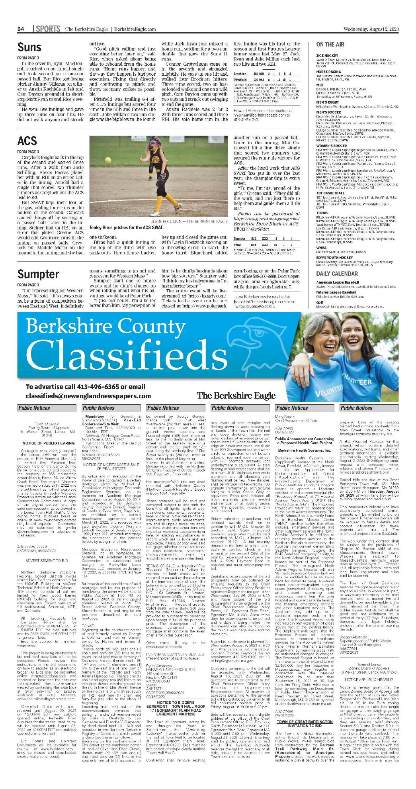
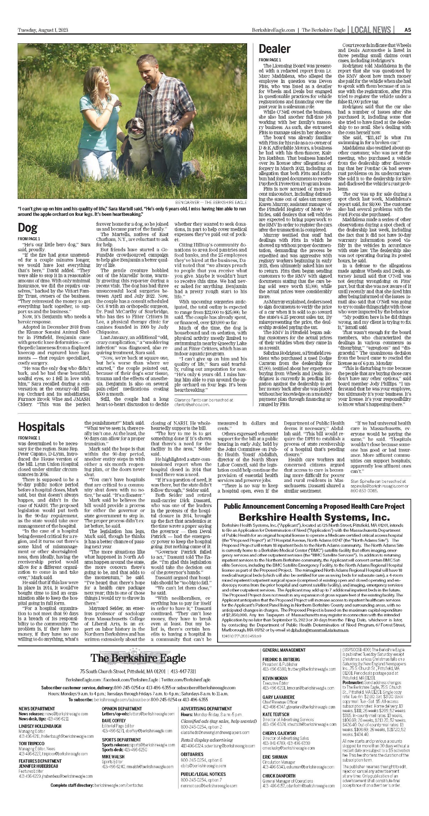

- ACO Letter
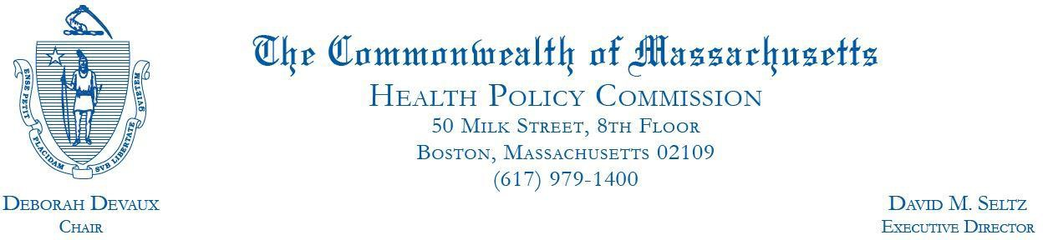

December 22, 2022

Mr. Scott St. George Berkshire Health Systems, Inc. 725 North Street
Pittsfield, MA 01201

RE: ACO LEAP Certification Dear Mr. St. George:
Congratulations! The Health Policy Commission (HPC) is pleased to inform you that Berkshire Health Systems, Inc. meets the requirements for ACO Certification under our Learning, Equity, and Patient-Centeredness (LEAP) standards. This certification is effective from January 1, 2023, through December 31, 2024.

The ACO Certification program, in alignment with other state agencies including MassHealth, is designed to accelerate care delivery transformation in Massachusetts and promote a high quality, efficient health system. ACOs participating in the program have met a set of objective criteria focused on core ACO capabilities demonstrating dedication to patient-centered care, use of evidence-based and data-driven strategies to improve care delivery, and commitment to addressing long-standing health inequities. Berkshire Health Systems, Inc. meets those criteria.

The HPC will promote Berkshire Health Systems, Inc. as a Certified ACO on our website and in our marketing and public materials. Enclosed you will find an ACO Certification logo for your organization to use in accordance with the attached Terms of Use. We hope you will use the logo on promotional materials when you highlight your ACO Certification to your patients, payers, and others.

The HPC looks forward to ongoing engagement with you over the next two years. We intend to follow up shortly to provide an overview and some reflections on what we saw in the Health Equity Responses, a new feature of the ACO Certification application starting in 2021, across the cohort of Certified ACOs. We hope your organization will find that information helpful as we all continue to explore ways to improve health equity in the Commonwealth.

Thank you for your dedication to providing accountable, coordinated health care to your patients, and to continued learning and improvement over time. If you have any questions about this letter or the ACO Certification program, please do not hesitate to contact Mike Stanek, Senior Manager, at HPC-Certification@mass.gov or (617) 757-1649.

Best wishes,

[signature on file]

David Seltz Executive Director

- Articles of Organization

Available at: https://corp.sec.state.ma.us/CorpWeb/CorpSearch/CorpSearchRedirector.aspx?Action=PDF&Path=CORP_DRIVE1/2022/0830/002289561/0001/202240229540_1.pdf
https://corp.sec.state.ma.us/CorpWeb/CorpSearch/CorpSearchRedirector.aspx?Action=PDF&Path=CORP_DRIVE1/2013/1121/000486410/0027/200982324880_1.pdf
https://corp.sec.state.ma.us/CorpWeb/CorpSearch/CorpSearchRedirector.aspx?Action=PDF&Path=CORP_DRIVE1/2013/1212/000486439/0072/200983362340_1.pdf

- Affidavit of Truthfulness & Compliance

Version: 7-6-17

Massachusetts Department of Public Health

Determination of Need

Affidavit of Truthfulness and Compliance with Law and Disclosure Form 100.405 (B)
Instructions: Complete Information below. When complete check the box "This document is ready to print:". This will date stamp and lock the form. Print Form. Each person must sign and date the form. When all signatures have been collected, scan the document and e-mail to: dph.don@state.ma.us Include all attachments as requested.
Application Number: BHS-23072710-OL
Original Application Date: August 15, 2023
Applicant Name: Berkshire Health Systems, Inc.
Application Type: Original License
Applicant's Business Type: Corporation
Is the Applicant the sole member or sole shareholder of the Health Facility(ies) that are the subject of this Application? Yes

The undersigned certifies under the pains and penalties of perjury:
- The Applicant is the sole corporate member or sole shareholder of the Health Facility(ies) that are the subject of this Application;
- I have read [been informed of the contents of] 105 CMR 100.000, the Massachusetts Determination of Need Regulation;
- I understand and agree to the expected and appropriate conduct of the Applicant pursuant to 105 CMR 100.800;
- I have read [been informed of the contents of] this application for Determination of Need including all exhibits and attachments, and certify that [have been informed that] all of the information contained herein is accurate and true;
- I have submitted the correct Filing Fee and understand it is nonrefundable pursuant to 105 CMR 100.405(B);
- I have submitted the required copies of this application to the Determination of Need Program, and, as applicable, to all Parties of Record and other parties as required pursuant to 105 CMR 100.405(B);
- I have caused, as required, notices of intent to be published and duplicate copies to be submitted to all Parties of Record, and all carriers or third-party administrators, public and commercial, for the payment of health care services with which the Applicant contracts, and with Medicare and Medicaid, as required by 105 CMR 100.405(C), et seq.;
- I have caused [have been informed that] proper notification and submissions to the Secretary of Environmental Affairs pursuant to 105 CMR 100.405(E) and 301 CMR 11.00; will be made, if applicable.
- If subject to M.G.L. c. 6D, § 13 and 958 CMR 7.00, I have submitted such Notice of Material Change to the HPC - in accordance with 105 CMR 100.405(G);
- Pursuant to 105 CMR 100.210(A)(3), I certify that both the Applicant and the Proposed Project are in material and substantial compliance and good standing with relevant federal, state, and local laws and regulations, as well as with all previously issued Notices of Determination of Need and the terms and Conditions attached therein [issued in compliance with 105 CMR 100.00, the Massachusetts Determination of Need Regulation effective January 27, 2017 and amended December 28, 2018];
- I have read and understand the limitations on solicitation of funding from the general public prior to receiving a Notice of Determination of Need as established in 105 CMR 100.415;
- I understand that, if Approved, the Applicant, as Holder of the DoN, shall become obligated to all Standard Conditions pursuant to 105 CMR 100.310, as well as any applicable Other Conditions as outlined within 105 CMR 100.000 or that otherwise become a part of the Final Action pursuant to 105 CMR 100.360;
- Pursuant to 105 CMR 100.705(A), I certify that the Applicant has Sufficient Interest in the Site or facility; and
- Pursuant to 105 CMR 100.705(A), I certify that the Proposed Project is authorized under applicable zoning by-laws or ordinances, whether or not a special permit is required; or,
  - If the Proposed Project is not authorized under applicable zoning by-laws or ordinances, a variance has been received to permit such Proposed Project; or,
  - The Proposed Project is exempt from zoning by-laws or ordinances.

Corporation
Attach a copy of Articles of Organization/Incorporation, as amended

Darlene Rodowicz, President & CEO <Signature on File> 8/8/2023
CEO for Corporation Name Signature: Date:

Barton D. Raser, Board Chair <Signature on File> 8/8/2023
Board Chair for Corporation Name Signature: Date:

Affidavit of Truthfulness Berkshire Health System Regulation effective January 27, 2017 and amended December 28, 2018

- Filing Fee
