August 3, 2023 Expanding Access to Care in North Adams
Community Meeting:

Opening a Critical Access Hospital in North County

August 3, 2023

Agenda
- Background
- What is a Critical Access Hospital (CAH)?
- Why is a CAH Designation Important?
- How Does It All Work?
- What Does a CAH Mean for Northern Berkshire County?
- Next Steps
- Questions?

*This meeting is being recorded*

2

Background

3

Background

On June 29, 2023, BHS Announced a New Plan for Access to Healthcare In Northern Berkshire County
- Re-open hospital facility with the name North Adams Regional Hospital
- Seek federal designation as a critical access hospital (CAH)
- Re-open up to 25 inpatient beds for medical/surgical care
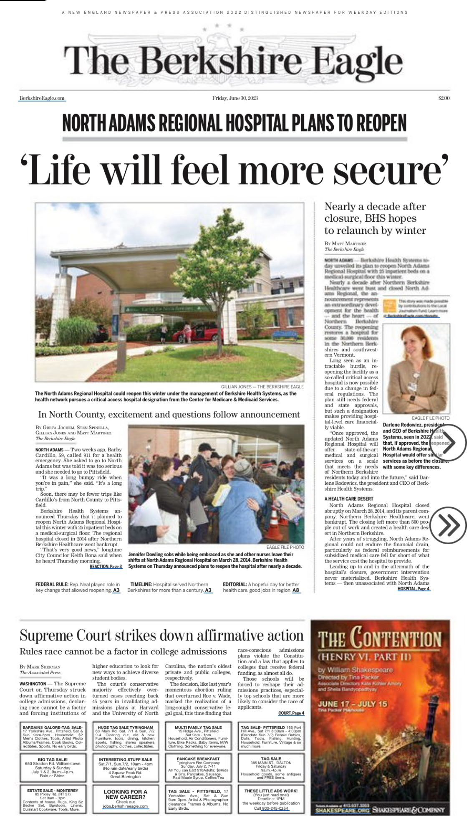
The Berkshire Eagle, June 30, 2023 (front page

4

Background

Our Mission
To advance health and wellness for everyone in our community in a welcoming, inclusive, and personalized environment

The New NARH is a Key Part of BHS’s Strategic Plan

- Since 2022, we have been engaged in a strategic plan to bring our organization’s mission to life, focused on three core areas: patients, people, and community.
- This is a unified effort spanning all 4,000+ members of the BHS team, working together to create a healthier Berkshire County.
- Re-establishing inpatient beds at North Adams Regional Hospital is a pivotal step within our strategic plan, as it strengthens our ability to serve patients in North County as part of a coordinated system of care.

5

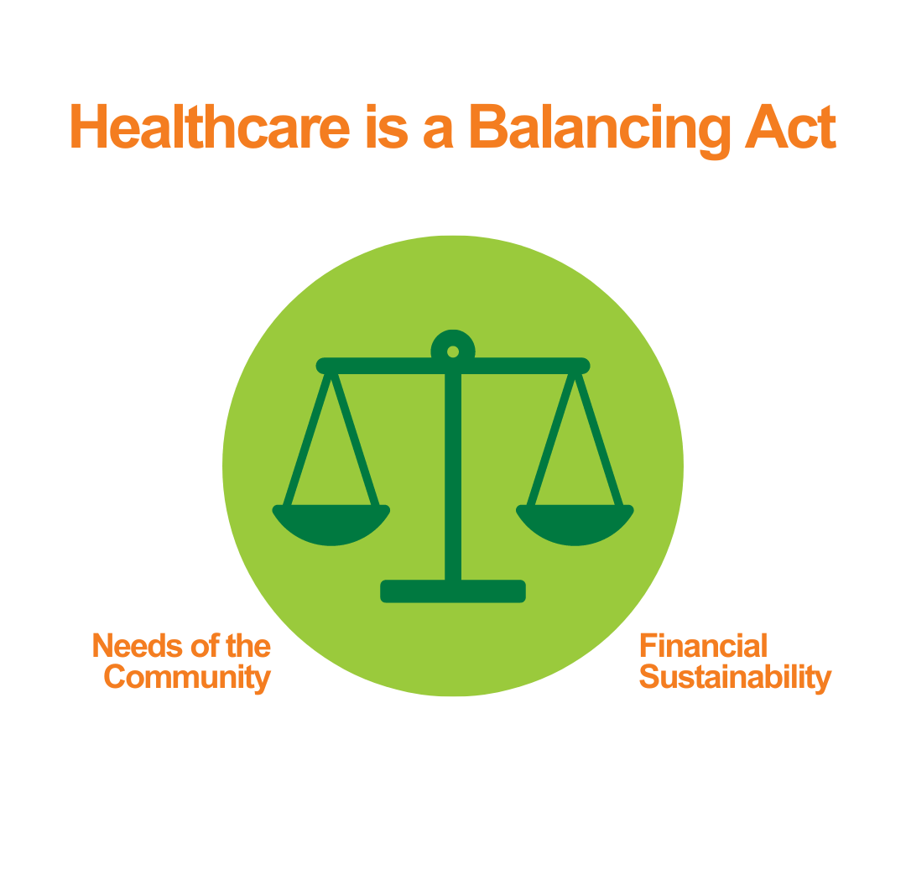
Background

We are always working to maintain this balance so that we can advance health and wellness for our whole community.

6

What is a
Critical Access Hospital? (CAH)

7

What is a CAH?

Critical Access Hospital Designation
(CAH)

A critical access hospital is small facility that has been specifically recognized by the federal government for its important role in providing healthcare services to people in a rural area.

A CAH designation is granted by the Center for Medicare and Medicaid Services (CMS) and it determines how hospitals are paid by government insurance for the care they provide.

Congress created the CAH designation in 1997 in response to over 400 rural hospital closures during the 1980s and early 1990s.

8

Why is a CAH Designation
Important?

9

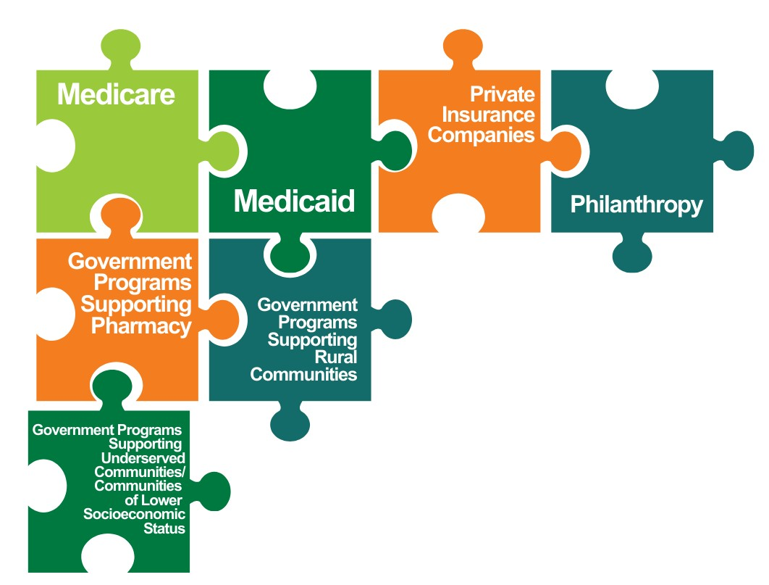
What is a CAH?

Ensuring financial sustainability of a health system is like a puzzle.

Critical Access Hospitals are one part of ensuring that we have a strong healthcare system in our community.
Critical Access Hospitals

10

How Does It All Work?

11

How Does It All Work?

Conditions To Obtain CAH
Designation

Location Requirements

- The hospital is located in rural area
- The hospital is more than a 15-mile drive from another hospital if the hospitals are connected by a federal highway with two lanes.

This highway requirement recently changed, which is what has now allowed BHS to seek a CAH designation at NARH.

12

How Does It All Work?

Conditions To Obtain CAH
Designation

Patient Care Requirements
- Must provide 24/7 emergency care services
- Must maintain 25 or fewer acute inpatient or observation beds
  - Beds can include swing beds (skilled nursing)
- Must have patients with average length of stay of 4 days or less
- Must be part of a system of care and have transfer agreements for higher levels of care

13

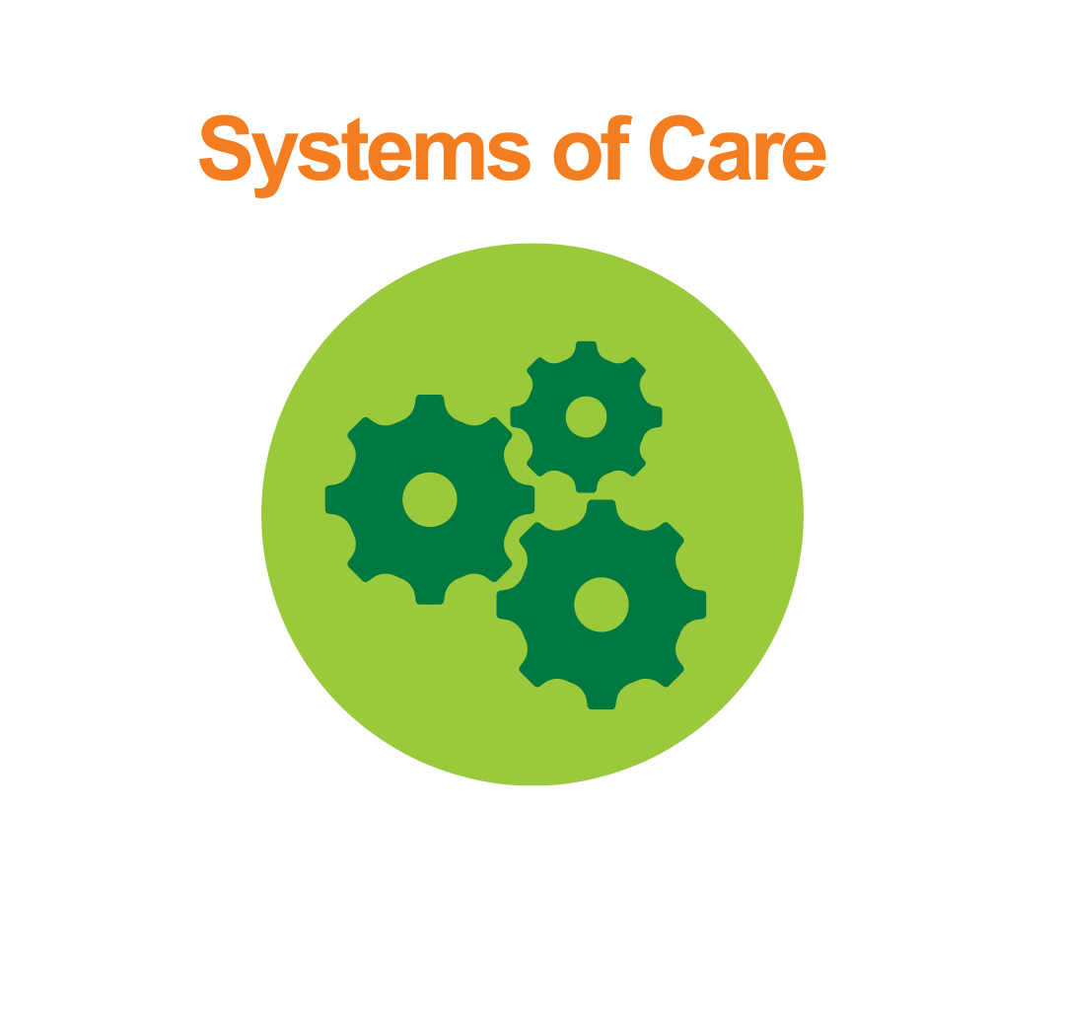

How Does It All Work?

CAHs provide rural patients with access to critical healthcare services close to home and then work within a system to address more complex patient needs.
System Anchor Hospital
- Berkshire Medical Center
Outpatient Services
- Provider Clinics
- Imaging/Lab
- Home Care
- Pharmacy
Critical Access Hospitals
- Fairview Hospital
- North Adams Regional Hospital

14

What Does a CAH Mean for Northern Berkshire County?

15

Impact on Northern Berkshire

Benefits of a CAH
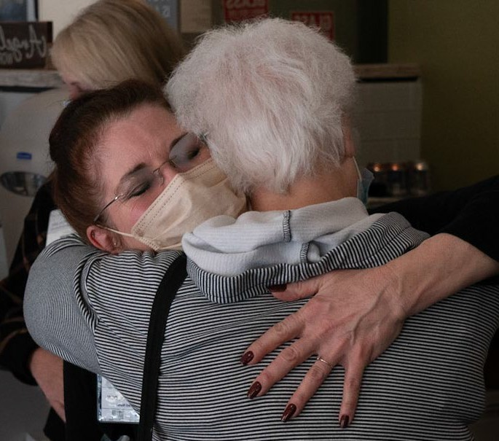

- Keeps essential patient care close to home
- Improves convenience and comfort-level of patients in North County
- Cuts down on transport times for Emergency Medical Services (EMS) and reduces common transportation issues
- Provides important stabilization and transfer services for complex patient needs
- Helps to ensure financial sustainability of healthcare services through enhanced reimbursement rates from federal government
- Expands eligibility for other types of government support like grants, technical assistance, and educational benefits

16

Impact on Northern Berkshire

Types of Health Conditions at a CAH
We expect to treat patients with similar conditions to those we see at Fairview CAH, while always relying on the resources and skills of BHS system of care to treat more advanced and complex cases.
For example:

  - Pneumonia
  - Heart Failure
  - COPD
  - Cardiac Arrythmia
  - Urinary Tract Infection
  - Respiratory Failure
- Chest Pain
- Weakness
- Syncope/Collapse/Fainting
- Hip-Replacement
- Post-Surgical Care

17

Next Steps in the Process

18

Next Steps/Process

Complex Local, State, and Federal Processes

Seek Approval for MA Determination of Need

Obtain MA State Hospital License

Apply to CMS for CAH through State Office of Rural Health

Complete Surveys for Medicare and Other Agencies

Target Opening Early 2024

19

How You Can Help
- Spread the word about the benefits of a CAH in our community

- Complete a Letter of Support to let Massachusetts Department of Public Health know that you support this project

- Contact us with questions at community@bhs1.org

20

August 3, 2023

Questions?
There are two microphones located at the front of the room near the stage.

Please:
- Form one line behind each mic,
- Introduce yourself and your town, and
- Ask your question.

21

Thank You!

22
1240\0177\2010136.v1

