August 2023
Joint Commission Health Equity Review

Addressing

Social Determinates of Health to Prevent Outcome Disparities and Promote Health Equity

Our commitment to diversity, equity, and inclusion is at the foundation of how we identify ourselves and who we strive to be.
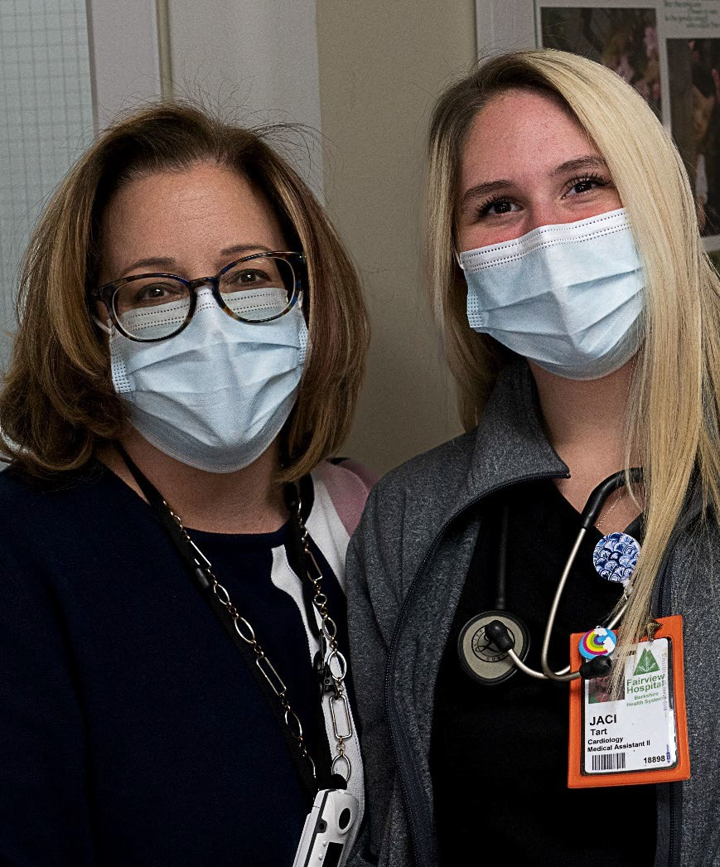
Our Mission
To advance health and wellness for everyone in our community in a welcoming, inclusive, and personalized environment
Our Vision
To be the region’s trusted healthcare partner and community advocate for improving overall quality of life.

Our Values: BHS CAREs
- Compassion  Accountability  Respect  Excellence

2

It’s embedded in how we approach our long-term goals….
2027
Destination Metrics
Patients
- BMC designated one of Healthgrades “America’s Best Hospitals” (Top 250; 95th percentile)
- BMC, FVH, the Medical Group, and BVNA all have achieved and maintained top quartile performance on
CMS Patient Experience measures (CAHPS)* (“rate this hospital, provider, or home health agency”)

People
- Top quartile performance on BHS employee engagement
- Top quartile performance on BHS provider engagement

Community
- Berkshire County has improved its ranking to no lower than 9th among the 14 Massachusetts counties for overall health factors
- Demonstrated reduction in health inequities impacting Berkshire populations that have been historically marginalized

3

Creating a Shared Vocabulary
Health Equity: The opportunity for everyone to attain their full health potential. No one is disadvantaged from achieving this potential because of their social position (class, socio-economic status) or socially assigned circumstance (race, ethnicity, gender identity, sexual orientation, geography, ability)

Health Inequities: Differences in health status and mortality rates across populations groups that are systemic, avoidable, unfair, and unjust. These differences are often attributable to the social, economic, environmental conditions in which people live, work, and play.

Health Disparities: measurable differences in health and wellness between populations
Populations can be organized according to shared characteristics such as:

RELD: Race, Ethnicity, Language, Disability SOGI: Sexual Orientation and Gender Identity
HRSN: Health Related Social Needs (such as food insecurity, housing instability, or lack of transportation)

Source 4

Health Disparities in our Community

Our Community

Who We Are
Berkshire County is ranked 13 of 14 Massachusetts counties for health outcomes according to the Robert Wood Johnson Foundation’s 2022 County Health Rankings.
- Population: about 126,000

- Median age: 47

- Socioeconomics: The median household income in Berkshire County is 30% lower than that of the state.

- Education: Only 19% of the population aged 25 and over in Berkshire County has a bachelor’s degree, compared to 45% statewide.

- Berkshire County primarily has White residents (91%).

- 12% of Berkshire residents are foreign-born.

Source: BHS Community Health Needs Assessment (CHNA), 2022

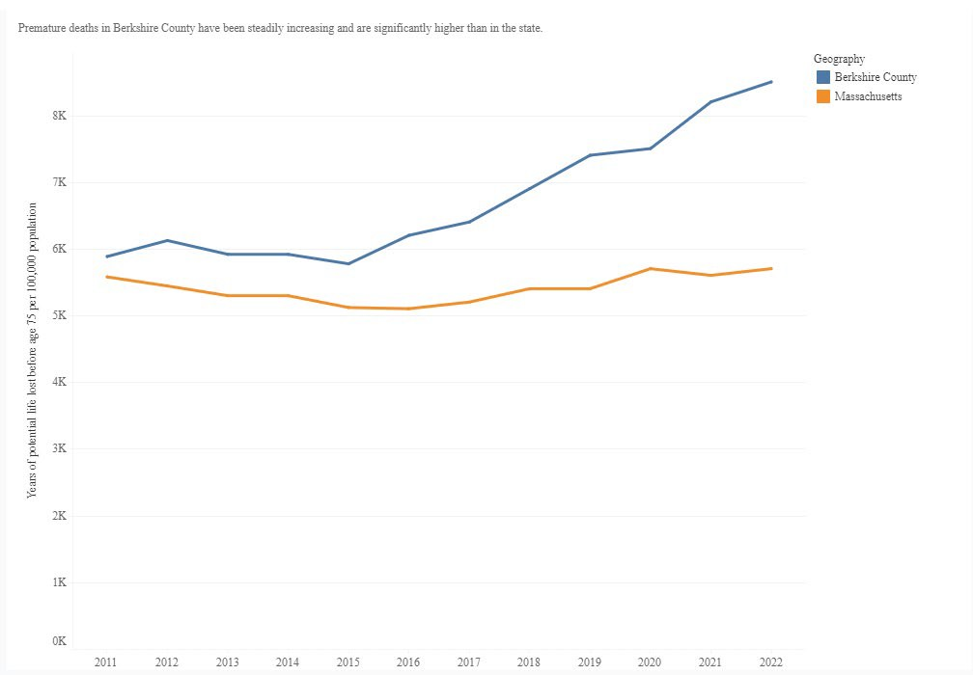
Our Community

Community Health Indicators

Rate of premature deaths in the County is at least 30% higher than the rest of the state.
“Measuring premature mortality, rather than overall mortality, focuses attention on deaths that might have been prevented.”

Source:

WHAT ARE WE DOING TO MAKE A DIFFERENCE?

Start Here:
Building a System-Wide Strategy to improve
Our Approach

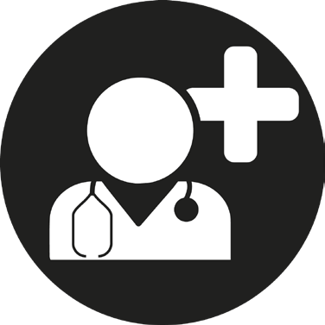
Information Relationships Education Action

Health Equity
Collecting and analyzing patient and population health data

Building new partnerships with patients, families and community partners
Health disparities education for providers and staff. Health literacy education for the community.
Partnering with patients and community resources to provide evidence- based practices to promote health equity

9

Start Here: Relationships/Partners

Building a System- Wide Strategy for DEI to improve Health Equity
2nd Street, Second Chances Project BASIC: Berkshire Alliance to Support Immigrant Community Berkshire Black Economic Council Berkshire Community College
Berkshire County District Attorney's Office Berkshire County Regional Housing Authority
Berkshire Harm Reduction
Berkshire Hills Regional School District Berkshire NAACP
Berkshire Perinatal Opioid Collaborative Berkshire Regional Planning Commission Berkshire Stonewall Community Coalition Berkshire United Way
Blackshires BRIDGE
Brien Center
City of Pittsfield Dalton Chief of Police
Greylock Federal Credit Union Habitat for Humanity
HEALing Communities Coalition LGBTQ+ Health Collaborative Manos Unidas Co-op
North Adams City Council
Northern Berkshire Community Coalition Roots & Dreams and Mustard Seeds Inc. Southern Berkshire Rural Health Network Volunteers in Medicine
Westside Legends Railroad Street Project Antidefamation League Jewish Federation BERK12

Start Here:
Building a System- Wide Strategy for DEI to improve Health Equity
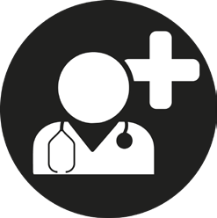 Action
- Appointed a system-wide Diversity, Equity, and Inclusion Officer
- Promoting workforce diversity by reducing barriers to access through employment training and pipeline programs
- Evaluating current status of RELD, SOGI, and HRSN data and develop actions to improve accuracy and completion
- Health Equity Committee comprised of stakeholders to develop and refine actions
- Evaluating patient experience and quality measures with DEI/Health Equity lens Contact Charles Redd with questions, concerns, ideas
Charles Redd
BHS Diversity, Equity, and Inclusion Officer credd@bhs1.org
413-447-2023

Process Improvement to Combat Health Disparities

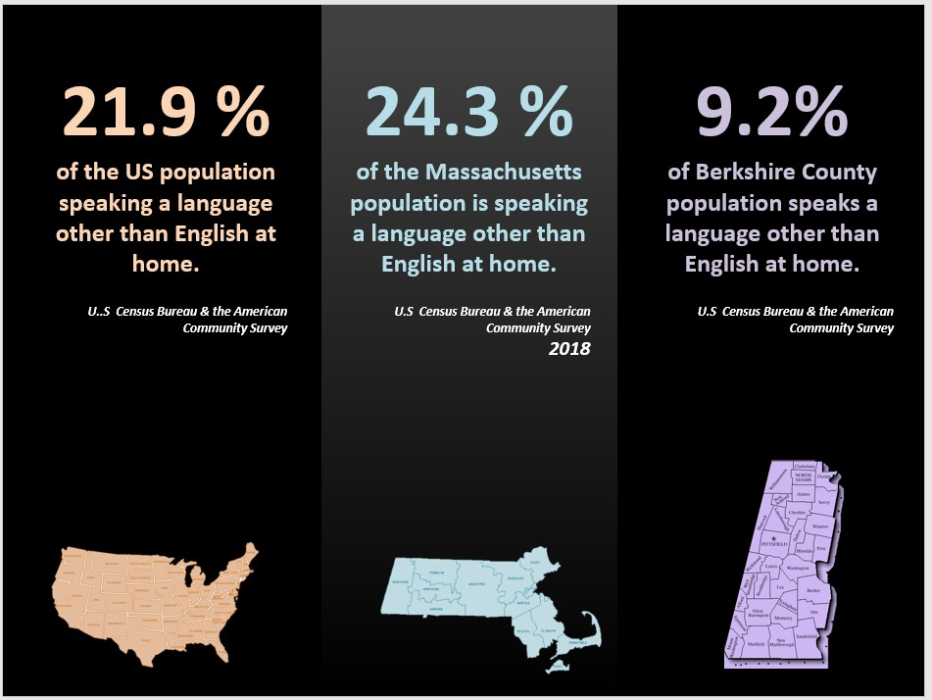

Language Services

Language Services
Language Services
- We provide Foreign Language and ASL (American Sign Language)
- We provide in-house, in-person, interpretation in Spanish and Russian
  - For other languages and ASL we contract with agencies
    - 24-hour telephone system interpretation in 200 languages
    - Provided services in 24 languages and ASL in 2022
    - Wireless Video interpreting for ASL
- We translate written materials by request
- We cover all Berkshire County

Language Services
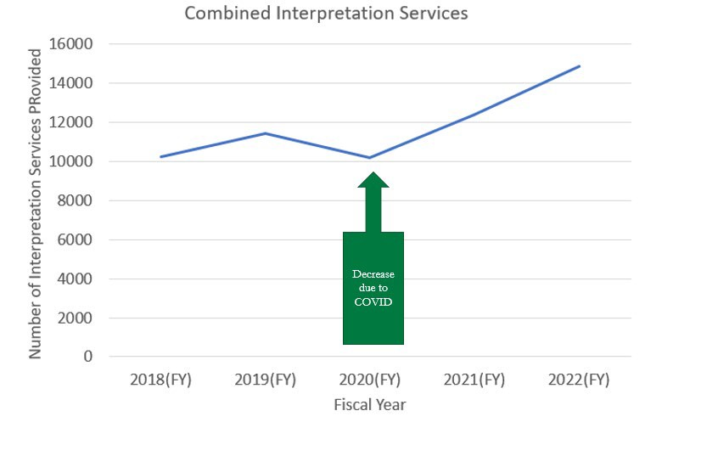
Language Services

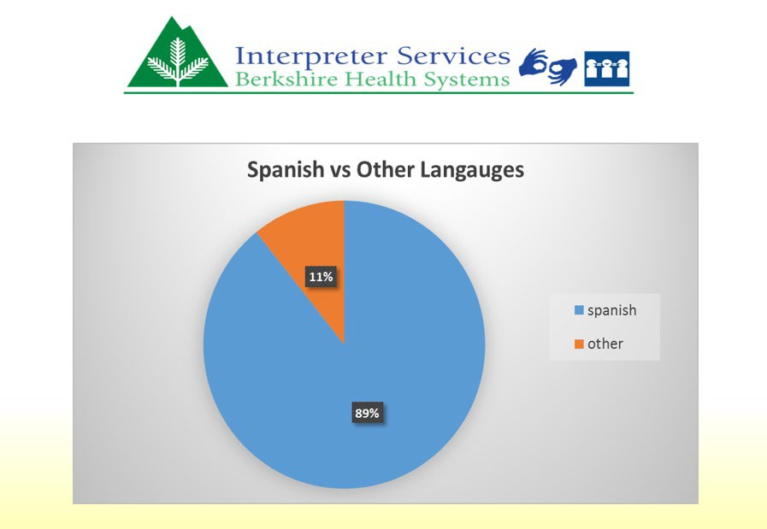

Language Services

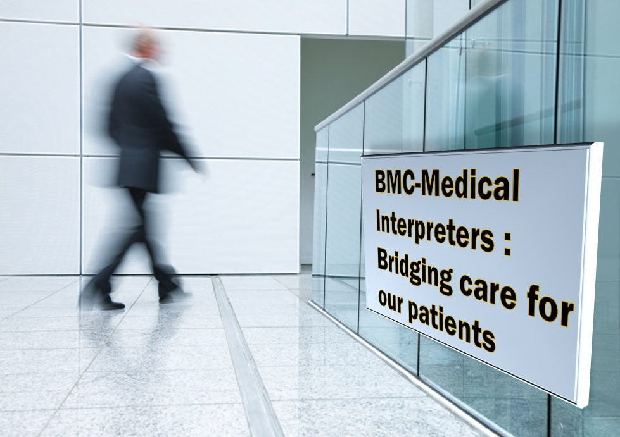
Language Services

Challenges & Opportunities

Age-Friendly Care

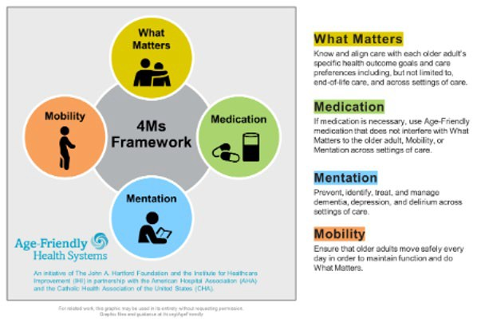
Age
- 25% of Berkshire County residents are 65 years or older
  - That is 1.5x the State and National Rate of 17%

- To meet the needs of these patients we have targeted initiatives:
  - The BMC Emergency Department has a Geriatric Emergency Department Accreditation from the American College of Emergency Physicians (ACEP)

  - BMC has a Geriatric Fracture Program

  - Participating in the Institute for Healthcare Improvement (IHI) Age-Friendly Care Collaborative

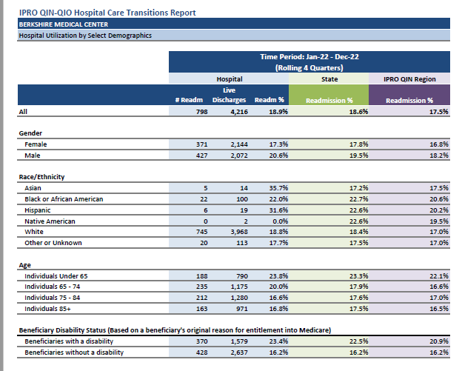
Overall BMC,
Readmission Data

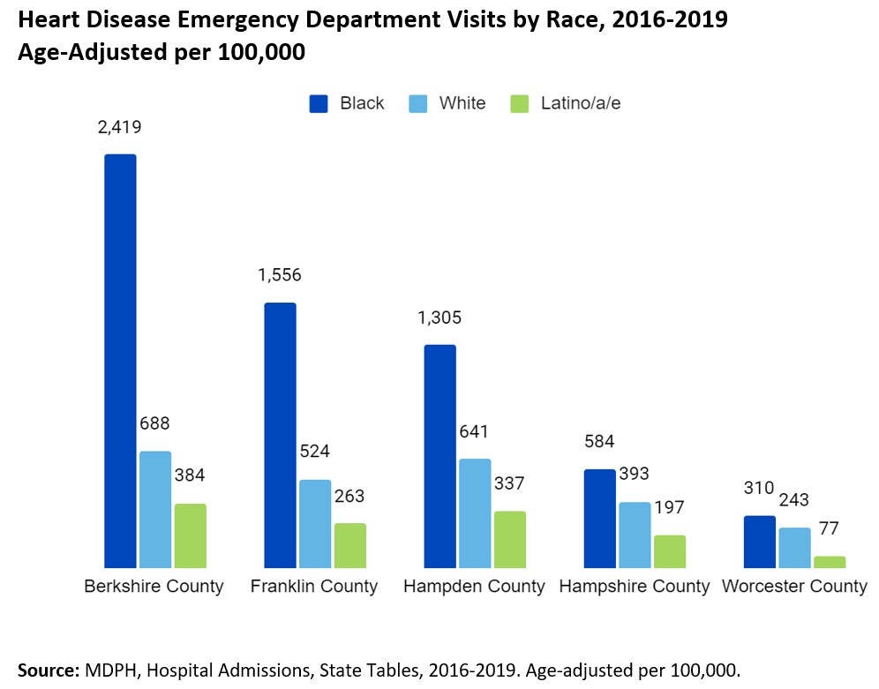
Our Community

Health Disparities
Some of the data currently available for our local populations shows that Black patients visit our emergency departments for heart disease at more than 3
½ times the rate of White patients.

Source: BHS Community Health Needs Assessment (CHNA), 2022

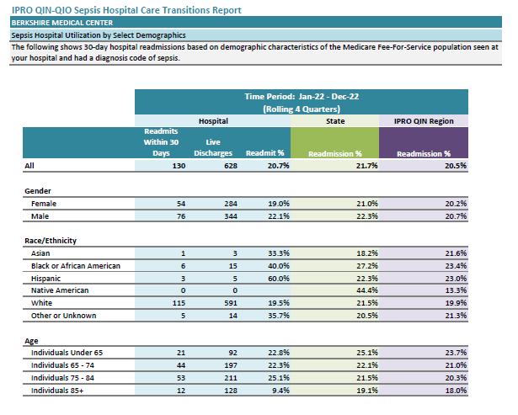
Challenges & Opportunities

Sepsis, Readmission Data

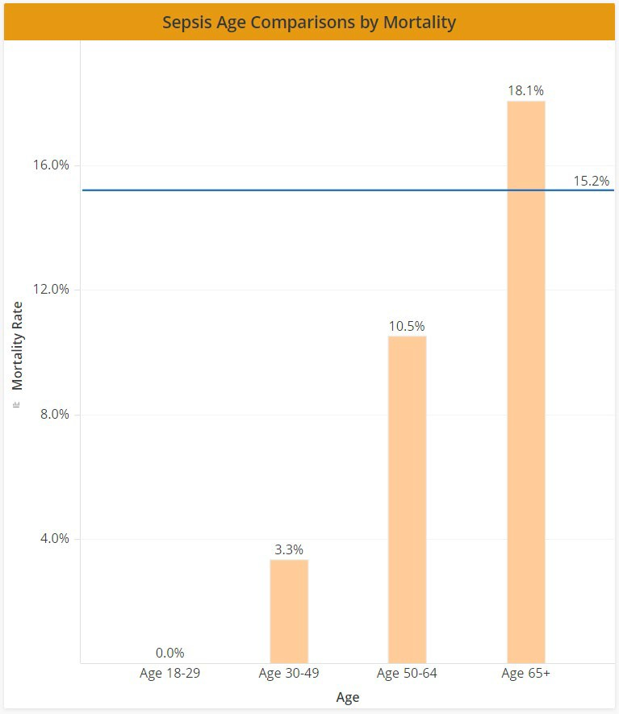
Challenges & Opportunities

Sepsis Mortality by Age, 7/1/2022 to
6/30/2023

WHAT ARE WE DOING TO MAKE A DIFFERENCE?
Social Determinants of Health (SDOH) Assessment

Social Determinant of Health Screening (SDOH)
Background
- Implemented SDOH screening in pilot practice beginning April 2022.
- Aligned Community Health Worker (CHW) to support patients with positive screen.
- Started in one practice for Medicaid only patients.
- Expanding to all BMC Primary Care Practices for all payers by end of August.
- Screening is done:
  - Pre-visit planning (call ahead of visit)
  - At registration (paper form)
  - At beginning of visit (verbally with Medical Assistant)
- Any patient with a positive screen is provided resource lists and/or referred to a CHW for additional assistance.

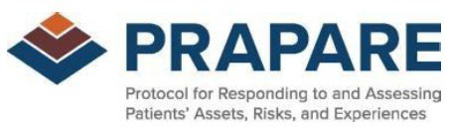

Social Determinant of Health Screening (SDOH)
Community Resources Available
- Barrier identified during pilot:
  - Providers concern about asking patients SDOH questions without aligned resources to provide support to patients.
- Action:
  - Comprehensive community resource lists created by category of need (i.e., food, transportation, housing, clothing, utilities).
  - This list is maintained and updates regularly by our care management team.
  - List is available to all staff electronically (shared resource sites) and on paper at inpatient care locations.
  - Provide referrals for identified needs, including assistance with with MassHealth (Medicaid) transportation forms, SNAP benefits for food insecurity, and utility assistance

Hillcrest Family to Start on 8/10/23
All Payer Adams Internists
All Payer Adams BOH

All Payer Berkshire Internists

Pilot
Medicaid Only Adams Internists
All Payer Lenox

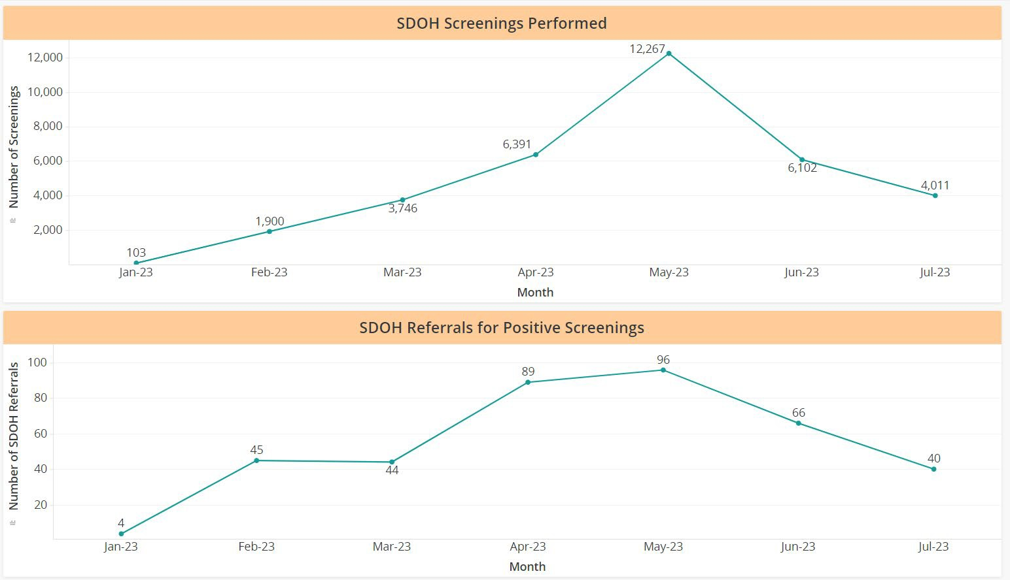
Decreases in June are related to provider vacations and once a new practice has screened their patients, they won’t need to be done again for another year. Berkshire Internists is the largest practice, which accounts for the spike in May.

Identified Needs
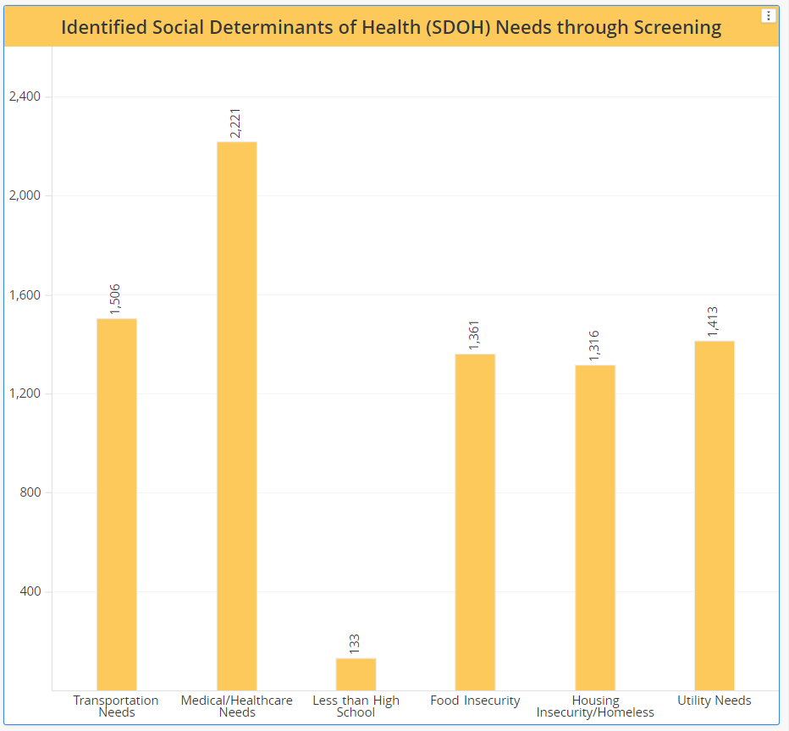
Social Determinant of Health Screening (SDOH)

January to July 2023

Social Determinant of Health Screening (SDOH)
Next Steps
- Finalize implementation of payer agnostic SDOH screening to all primary care practices by end of August.

- Incorporate formal SDOH screening for ED and Inpatient settings.

- Include processes for referral and resource distribution with implementation of new areas
  - Incorporate as part of patient discharge instructions

WHAT ARE WE DOING TO MAKE A DIFFERENCE?
Social Determinants of Health (SDOH) Initiatives

Flexible Services Program
Flexible Services
- Community Health Needs Assessments (CHNA) and analysis of our Medicaid ACO population identified housing, food, and transportation insecurity as three of our highest needs.
- We were able to use funding through the Flexible Services Program Grant from the Medicaid ACO to support additional resources for:
  - Housing
  - Food Insecurity
  - Transportation
- Patient’s qualified for program by having one of the following identified Health Needs Based Criteria (HNBC) and Risk Factor:
  - Risk Factor:
    - Homelessness
    - At risk for Homelessness
    - At risk for nutritional deficiency
  - HNBC:
    - BH need
    - Repeated ED use
    - High-risk or complicated pregnancy
    - Uncontrolled diabetes

Housing Insecurity:
Flexible Services
Flexible Services, Housing

- Services provided in collaboration with Community Partners including:
  - Berkshire County Regional Housing (BCRHA)
  - Service Net

- Services Available include:
  - Tenancy Preservation Program Services
  - Housing Search Intervention

Transportation
Flexible Services
Flexible Services, Transportation
- Programs provided home delivery of goods for patients with transportation needs.

- Also provided transportation support through bus and taxi vouchers as appropriate.

- MassHealth (Medicaid) transportation services

Food Insecurity:
Flexible Services
Flexible Services, Food Insecurity
  - Services provided in collaboration with Community Partners including:
    - Berkshire County Sheriff ’s Office (BCSO)
    - Community Health Programs (CHP)
    - Berkshire Fallon ACO
    - Big Y
    - Harry’s Grocery
    - Local Farmer’s Markets
    - Berkshire Bounty
  - Services Available include:
    - CSA Shares (partnership with local Farmers)
    - Food and Formula Vouchers
    - Education including cooking classes and meeting with nutritionist
    - Grocery Gift Cards
    - Grocery Home Delivery Program
    - Medically Tailored Meals
    - Nutrition Kitchen Supply Funds

Challenges & Opportunities

Food Insecurity:
Operation Better Start
Food Insecurity Actions
- Clinical Programming for infant through young adult
  - No co-pay, no balance billing
  - No limitation on visits
- Western Mass Growth and Nutrition Program (one of five in Mass. Partnership with MaDPH)
- Operation Better Start Feeding Clinic
- Berkshire County Head Start- 7 sites (nutrition and Nursing services)
- Community Education
  - Local Schools
  - YMCA
  - Boys & Girls Club
  - Televised Cooking Classes (on public television and BHS website)

Food Insecurity:
Berkshire North Women, Infants and Children’s Program (WIC)
Food Insecurity Actions
- Berkshire North WIC hosts:
  - Healthy eating
  - Food insecurity support
  - Breastfeeding support
  - Eating on a budget
  - Formula
  - Food Pantry (supported by staff and Berkshire Bounty, emergency food formula for participants and nonparticipants)
- Coordinates services with Family Birthplace (BMC Labor and Delivery Unit)
- Diapers distributor for the Berkshire diaper project (do not have to be a WIC participant)

WHAT ARE WE DOING TO MAKE A DIFFERENCE?
Phelps Cancer Center Care Navigation

Phelps Cancer Center
Care Navigation
Transportation
  - Collaborative Member with Dana Farber
    - Allows access to protocols, treatments, studies without travel to Boston

  - Virtual visits

  - MassHealth (Medicaid) PT-1 Transportation Forms, Taxi Vouchers, Bus passes

Phelps Cancer Center
Care Navigation
Screening
- Distress Screen for all new patients and those transitioning into Survivorship
  - Identify social challenges and barriers to care
- Integrated Health services provided free of charge to all patients/caregivers
  - Yoga
  - Health Coaching
  - Cooking Demonstrations
  - Exercise Therapy
  - Mindful Meditation
  - Reiki
  - Acupuncture

Phelps Cancer
Nurse Navigation
- Assist with access to primary care and specialist
- Assist with our identified barriers for care:
  - Transportation

Center
Care Navigation
- Sexuality/Body Image
- Access to restricted funds and supplies
  - Colonoscopy prep
  - Copays
- Arrange transportation:
  - Assist with volunteers
  - Taxi vouchers
  - Medicaid PT-1 forms

    - Provide Cancer Screening events in the community.
      - First Lutheran Church on 1st street
      - Pride Festival
      - Latino Festival
      - Relay for life

Phelps Cancer Center
Care Navigation
Social Worker
- Assess barriers to care and identify social determinants of health
- Referrals to available services
  - Transportation
    - Medicaid PT-1, Wheels for Wellness, BRTA Paratransit, Soldier On
  - Housing
    - Rent Assistance, RAFT, housing searches, tenant support
  - Utilities
    - Access grant money and restricted funds
    - Referrals to local support programs
  - Ability to pay for medical services and medications
    - Health Insurance: plan review, Advocacy for Access, SHINE
    - Assistance with: Paid Family Medical Leave, Social Security
    - Co-pay assistance
  - Food Insecurity
    - SNAP
  - Social Supports resources
    - Support groups
    - Mindful Meditation
    - Elder Services referrals
    - Integrative Health Program
  - Financial assistance
    - DTA/Emergency Cash assistance
    - Access to restricted funds

Phelps Cancer Center
Care Navigation
Nutritionist
- Utilizes the Distress screen and Nutrition screen to identify food insecurity
- Provides
  - Cooking Demonstrations
  - Nutritional Supplements for patients
  - Tube feeding education and support
  - SNAP benefits

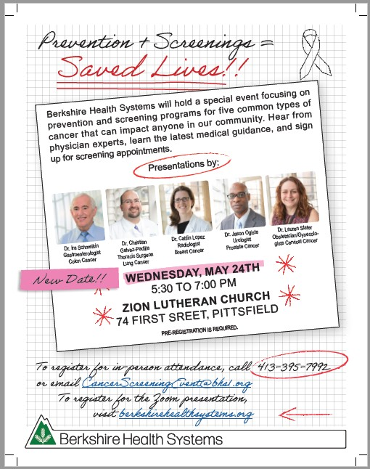

Phelps Cancer Center
Screening Programs

WHAT ARE WE DOING TO MAKE A DIFFERENCE?
Substance Use Supports Programs

Substance Use in Berkshire County
Overview
- Substance Use in Berkshire County is a top health condition – ranks in the top 10 list of most common conditions seen at Berkshire Health System

- Substance Use Deaths, for any reason results in a growing number of deaths each year

- We provide multiple referrals to aid community members with this issue

- We partner with community programs to support this population in addition to health system services

Maternal Opioid Use
- In 2022, Berkshire County has the second highest percentage of mothers who used opioids or benzodiazepines in MA
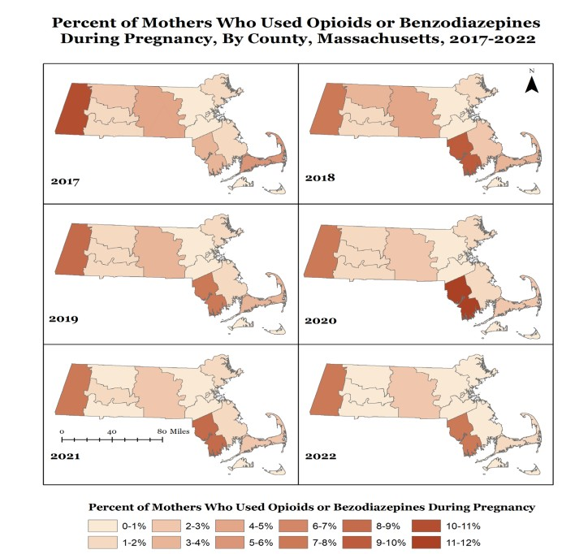
https://mass.gov/lists/current-opioid-statistics

Infants Exposed to Controlled Substances
- In 2022, Berkshire County tied for the highest percentage of infants exposed to controlled substances in MA
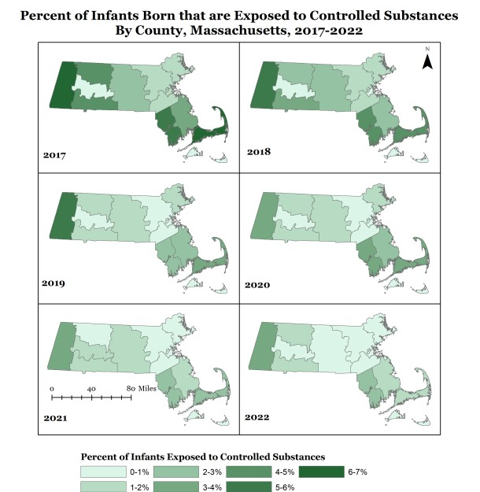
https://mass.gov/lists/current-opioid-statistics

Substance Use in Berkshire County
Overview
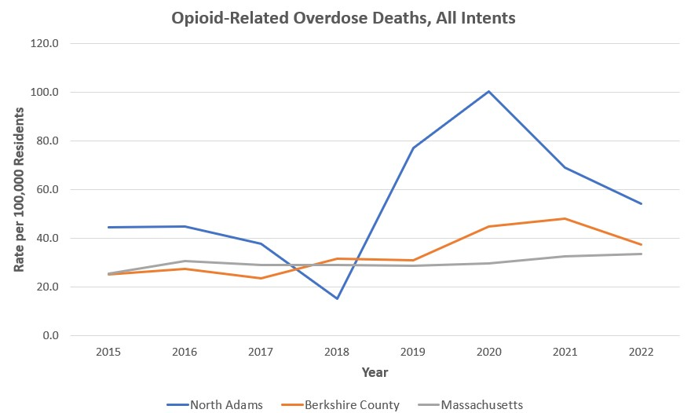
https://www.mass.gov/doc/opioid-related-overdose-deaths-by-county-June-2023/download https://www.mass.gov/doc/opioid-related-overdose-deaths-by-citytown-June-2023/download

Substance Use in Berkshire County
Overview
  - As a health system, many services are in place to aide in this crisis:
    - Acute Detoxification Unit
    - Clinical Stabilization Unit
    - Substance Use Disorder Team on the Acute Medicine Service
    - Bridge Program in the ED for Suboxone use to prevent the need for hospitalization
    - Partial Hospitalization Program, with a dual diagnosis tract
    - Adolescent Intensive Outpatient Program
    - Substance Use Treatment Clinic at Hillcrest Family Health
    - Harm Reduction Program
    - Berkshire Connections
    - Care Coordination Services that include Behavioral Health Care Coordinators and Community Health Workers

Primary Care Medical Home for Substance Use
Substance Use Treatment Clinic at Hillcrest Family Health
- Specializes in working with people with substance use disorders (SUD)
- Harm Reduction Model
- Mid-Level Provider treats patients with all forms of SUD
- Care includes support, medications including inductions, oral, sublingual, injectable and transdermal formulations
- Coordinates care with PCP and social services
- RN who does assessment, intake, and planning
- Recovery Coach Support
- Coordination with:
  - Primary Care
  - Social Services to meet identified needs

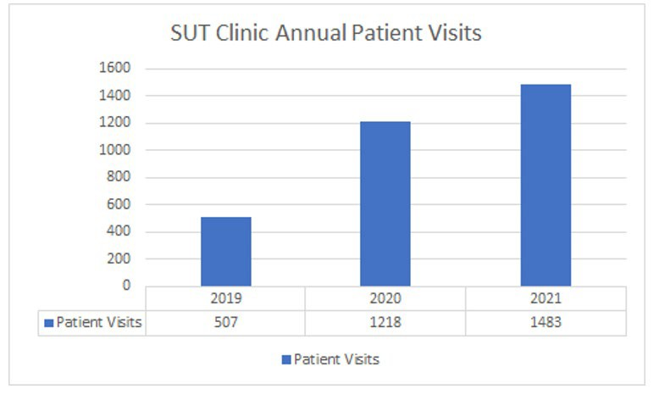
Primary Care Medical Home for Substance Use
Substance Use Treatment Program at Hillcrest Family Health

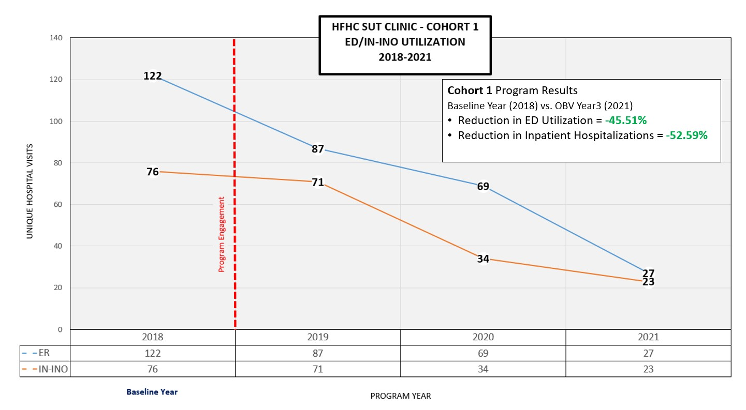
Primary Care Medical Home for Substance Use
Substance Use Treatment Program at Hillcrest Family Health – Reduction in ED and Inpatient Hospitalization

WHAT ARE WE DOING TO MAKE A DIFFERENCE?
Harm Reduction Programs

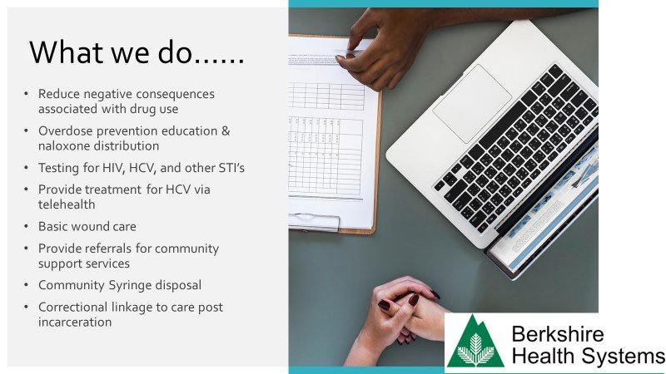
Harm Reduction Program

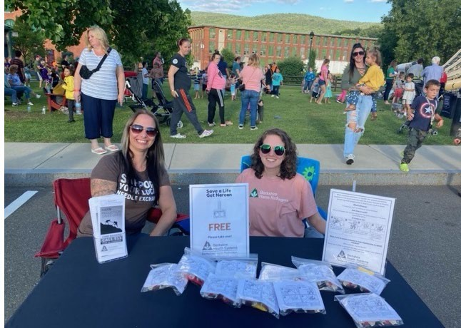
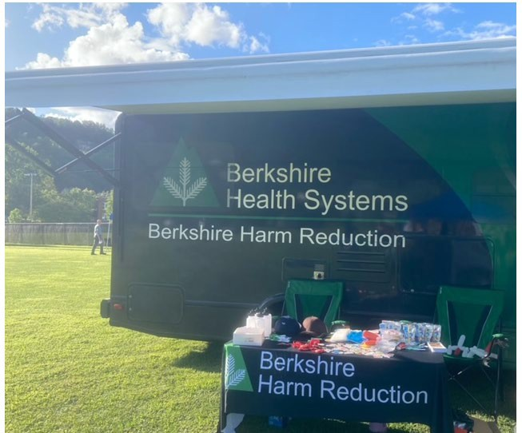

Harm Reduction Program

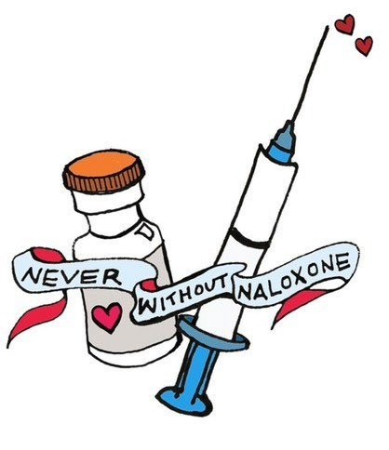
Our Program
- Berkshire County has seen a decrease in:
  - Overdose deaths (down 22%) in 2022
  - HCV+ rates (down 6.3%)
- Distributed over 4,200 dose of naloxone in the community

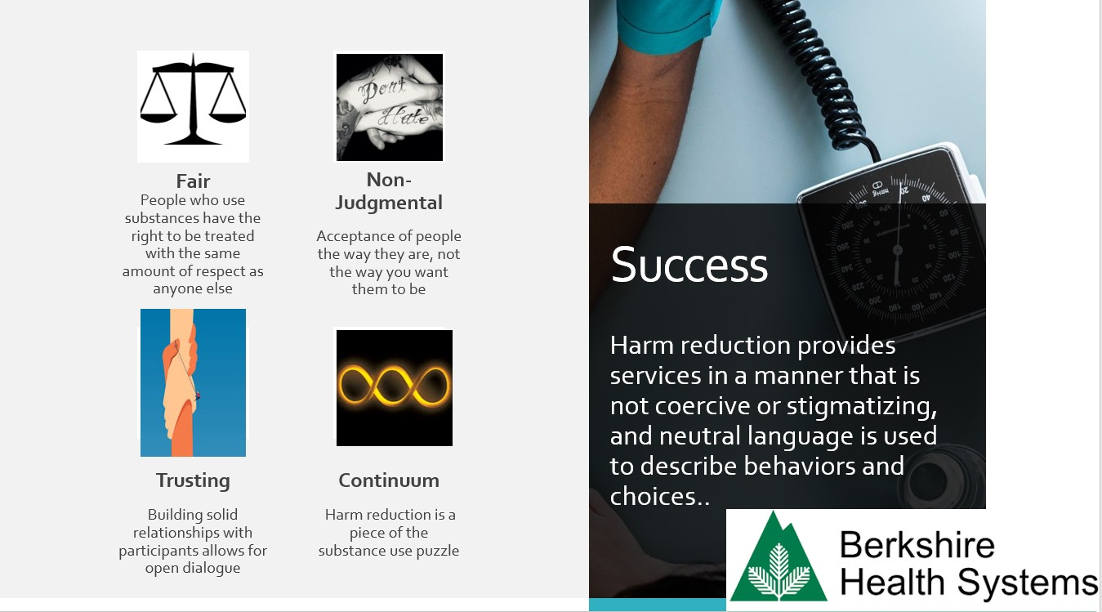
https://www.mass.gov/doc/opioid-related-overdose-deaths-by-county-June-2023/download

WHAT ARE WE DOING TO MAKE A DIFFERENCE?
Perinatal Support for SUD

Berkshire Connectio nBsegan March 2022
Overview
- Health Policy Commission, MA DPH initially funded a pilot project to design and implement wrap around services for pregnant and postpartum women with opioid use disorder (OUD)
- Criteria for enrollment: any active or history of OUD.
- In one year, 49 women were enrolled.
- Critical success factors included
  - Development of new roles: Outreach Coordinator
  - Embedding the program in the BMC OB practice
  - 40 community partnerships
  - Initiating care coordination mtgs with FBP, SUD team, MOUD provider
  - Initiation of a peer support group with strategies to reduce barriers to attendance

Berkshire County’s Wrap Around Services for

First Steps Together 18 Degrees
Berkshire Healthy Families Berkshire Nursing Families
Living in Recovery

4 Medications for Opioid Use Disorder
Programs DCF
Plan for Safe Care Juvenile Court Lawyers
Public Defenders office

Pregnant and Postpartum Women with SUD
(Wednesday Group)

2 Early Interventions
MA Hire and MA Rehab
Women served by Berkshire Connections OB Team
Family Birthplace

Foster Parents & Pediatricians
Kidding Around Consignment
2 Taxi Companies
Sheriff’s Office
(Tuesday Group)

2 Detox
2 CSS
1 TSS
3 Residential Programs

Berkshire Connections
Began March 2022
Evaluation of Effectiveness
- Monthly communication to OB providers and Family Birthplace Leadership on:
  - Enrollment, program changes, new partners and resources.
  - Continual awareness of stigma

- Coordination of OB care from incarceration

- Community referrals include:
  - OB providers
  - Harm reduction programs
  - Self-Referrals

Berkshire Connections
Evaluation of Effectiveness
Began March 2022

Referrals

Screening

Early Intervention
- 73% Enrollment

- 100% Social Determinants of Health
- 100% Depression

- 100% Enrollment

  - 96% Sustained enrollment in 1st year
Participation

Recovery • 71% Sustained Recovery in 1st year

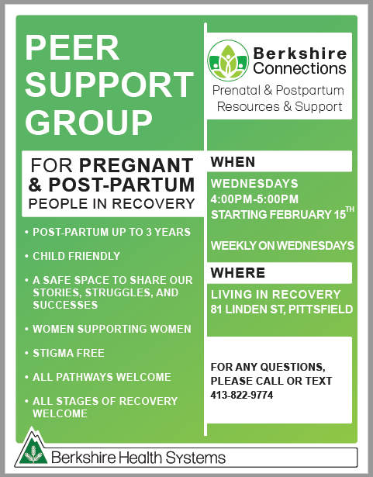

Berkshire Connections

Sustainable Funding from MA BSAS:
Moms Do Care Program through 2030
Berkshire Connections Program Enhancements with Sustainable Funding
- Eligibility expanded for all SUD, including nicotine

- Care out to 3 years postpartum

- Additional Staff Roles Being Implemented:
  - Certified Drug and Alcohol Counselor (Counseling on Drug Use Decisions)
  - Licensed Independent Certified Social Worker (Focus on Trauma Therapy for Both Parents)
  - Recovery Coach / Outreach Coordinator for Male Partners

MA Attorney Generals Office: Maternal Health Equity Award

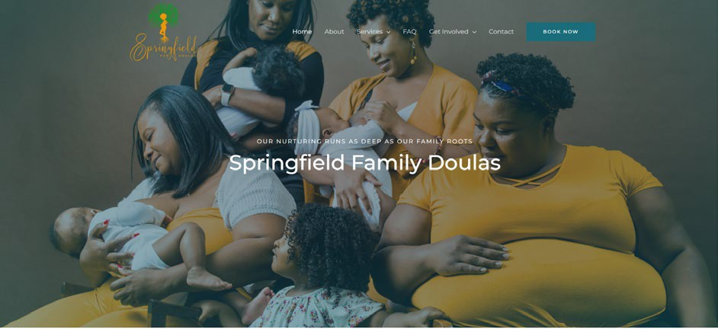
Berkshire Medical Center – Berkshire Nursing Families – Springfield Family Doulas Partnership
- Newly Awarded: August 2023
- Implement Continuous Perinatal Education and Support on Infant Nutrition, Benefits of Breast Feeding
- Implement Weekly Perinatal Support Groups Lead by Certified Perinatal Mental Health Professionals: In person and virtual
- Perinatal Support Groups for Women of Color Lead by Springfield Family Doulas: In person, Central County.
- Annual Education for Perinatal Professionals on Birth Equity Lead by Springfield Family Doulas

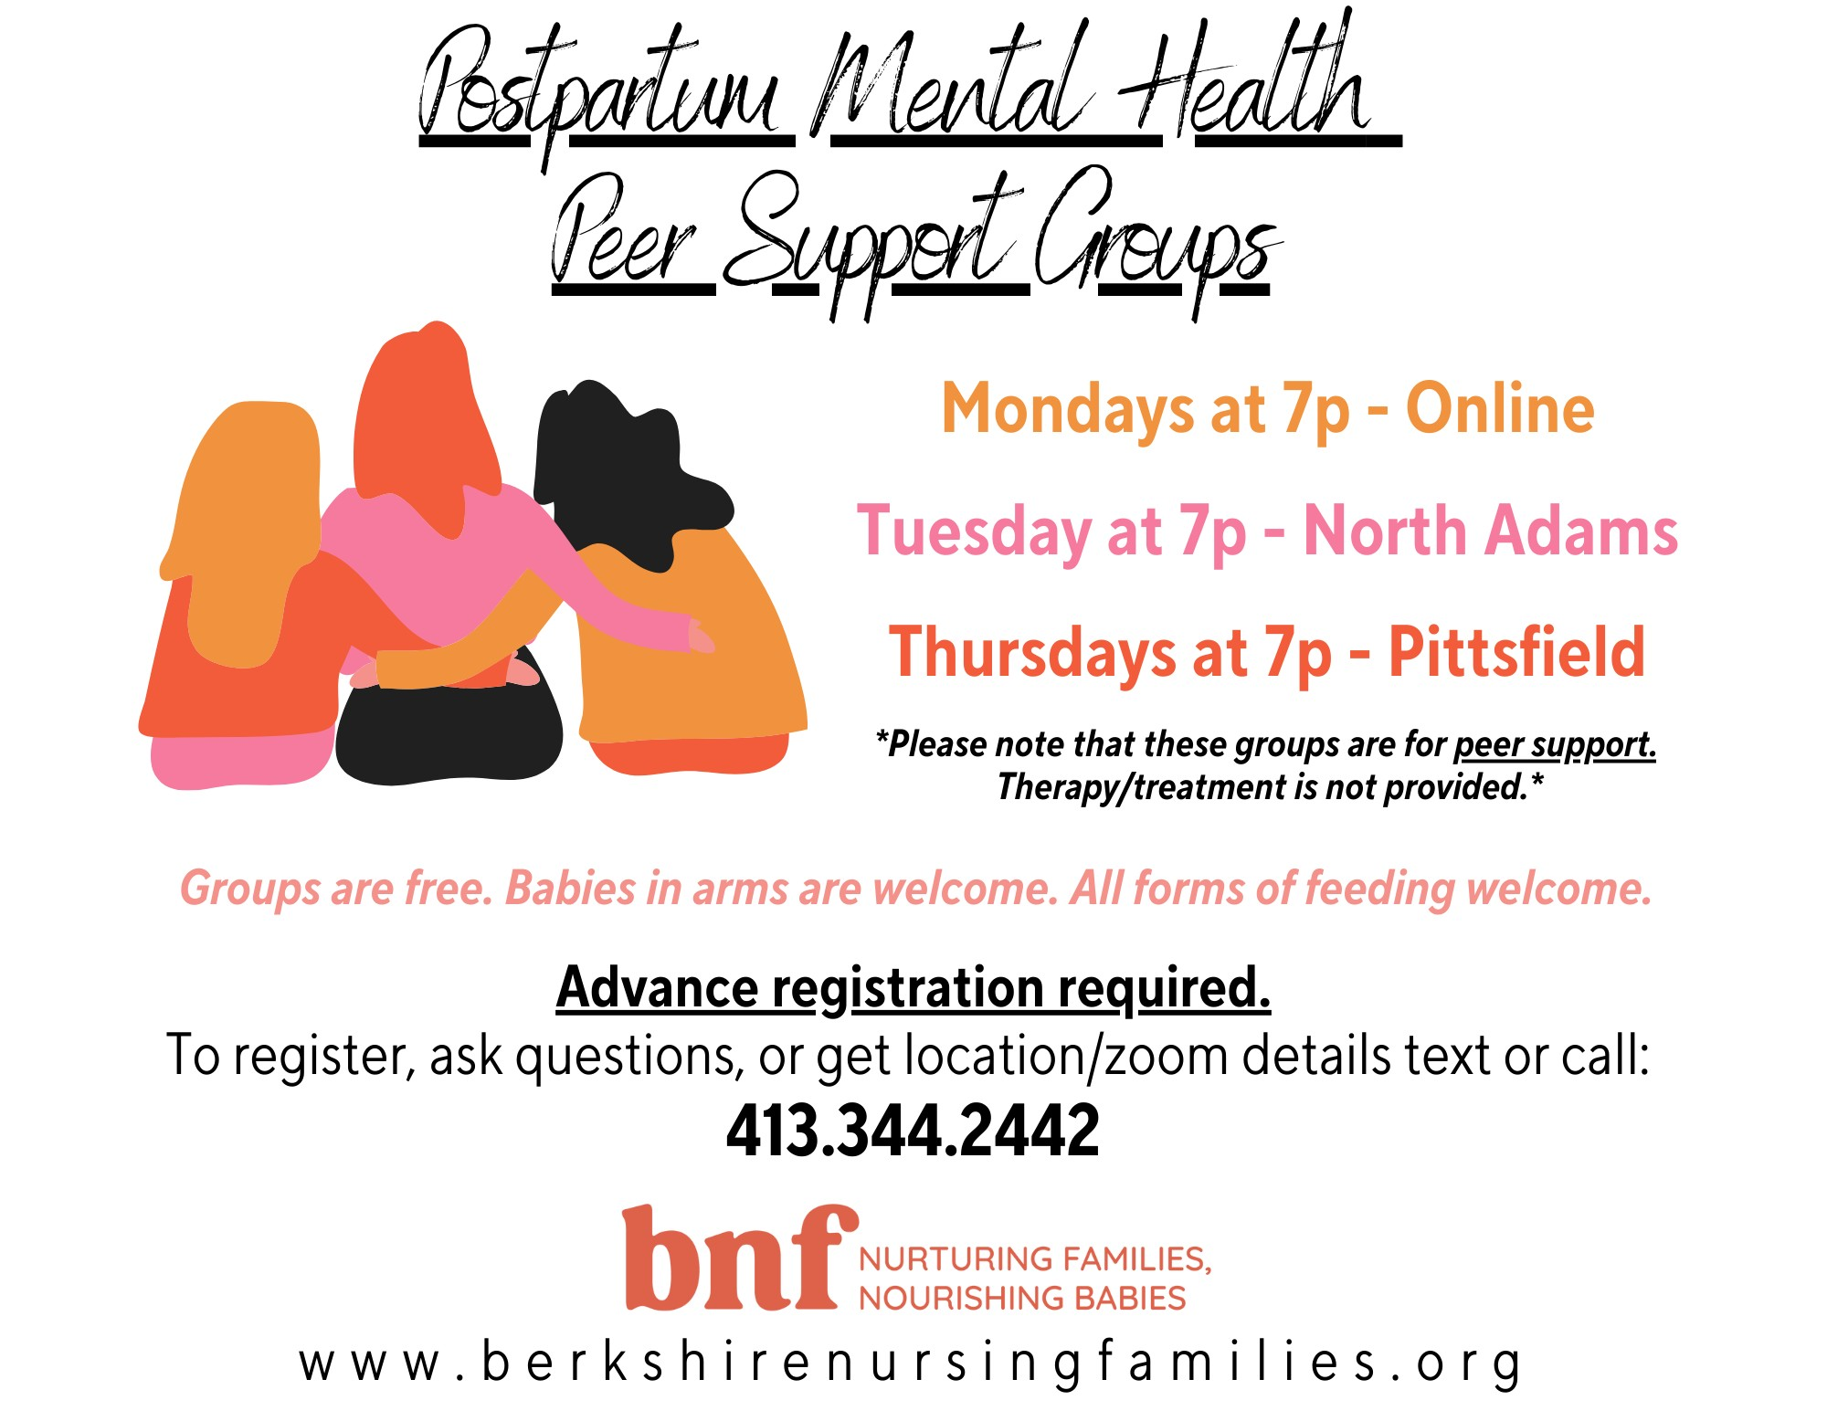

First Implemented

WHAT ARE WE DOING TO MAKE A DIFFERENCE?
Behavioral Health Programs

Behavioral Health Integration (BHI)
Program Scope
- Clinically focused, time-limited consultation service intended to increase access to behavioral health (BH) care for primary care patients who may be suffering from common mental health issues.
- BHI clinicians are embedded in primary care practices
  - Provide brief, evidence-based BH treatment to patients
  - Staff include:
    - Masters-prepared, independently licensed BH clinicians
    - Psychiatry residents
    - Advanced practice psychiatric nurses
    - Psychiatrists

Adolescent Intensive Outpatient Program (IOP)
Program Initiatives
- Short-term, structured ambulatory behavioral health treatment for Adolescents (age 12-17 years old)
- Evidence-based and trauma informed care
- Targeted care 3 times per week for 8 weeks
- Screenings and assessments are completed to ensure appropriate care coordination supports are put into place
- Groups focus on needs of participants and include but are not limited to:
  - Gender Identity
  - Body Image
  - Eating Disorders
  - How to cope
  - How to interact
  - Expressive Therapy
  - Building Trust
  - Emotion Regulation
  - Mindfulness

WHAT ARE WE DOING TO MAKE A DIFFERENCE?
Preventative Programs and Services

Programming to Help People Stay Healthy and Meet their Health Needs

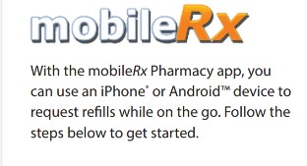
Berkshire Medical Center Community Pharmacy
- Medications for discharging patients (Meds to Beds)
  - Medications brought to the bedside
  - Helps patients lacking transportation
  - Ensure vital medications are not missed and makes a smoother transition home
- Co-Pays assistance
- Script Center (24/7 prescription pick-up kiosk)
- Medicine-On-Time:
  - Bundling of multiple medications into easy-to-use packets
- 90-day orders
- Delivery Services throughout Berkshire County
- Specialty Pharmacy
- Flexible spending account options
- Pet medications
- Immunizations

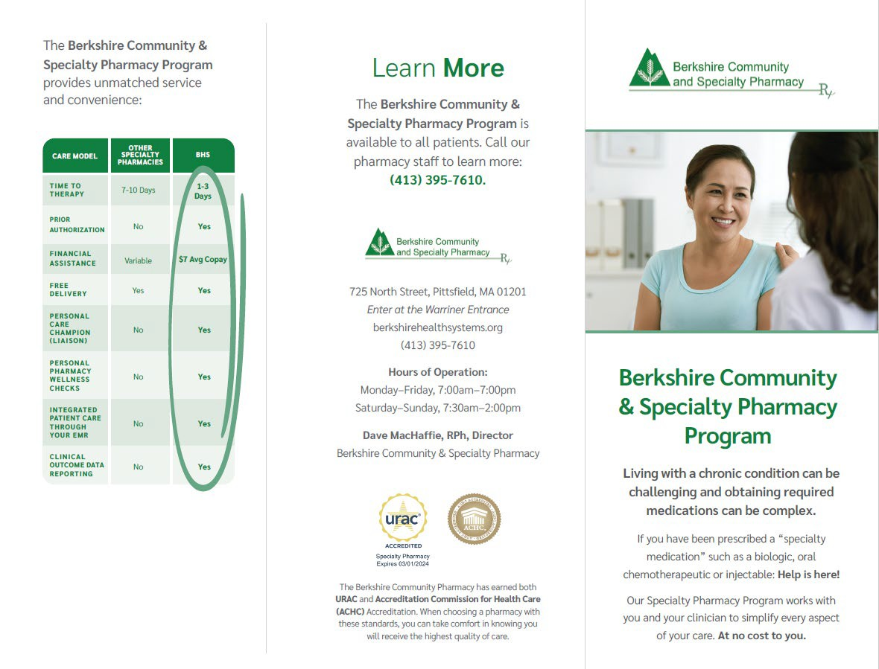

Programming to Help People Stay Healthy and Meet their Health Needs

Programming to Help People Stay Healthy and Meet their Health Needs
Wellness and Community Health
- Community Events bring health education awareness, fun, and referrals to local community events

- Connect with our neighbors to engage in conversations about their health, well-being, and needs

- Provide:
  - Provide resources: BP, Diabetes, age-appropriate screenings, schedule appointments
  - Health Care Proxy information
  - Offer fun games to engage all ages in discussions about health and well-being

Wellness and Community Health
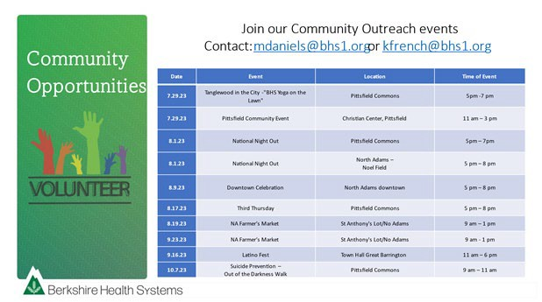
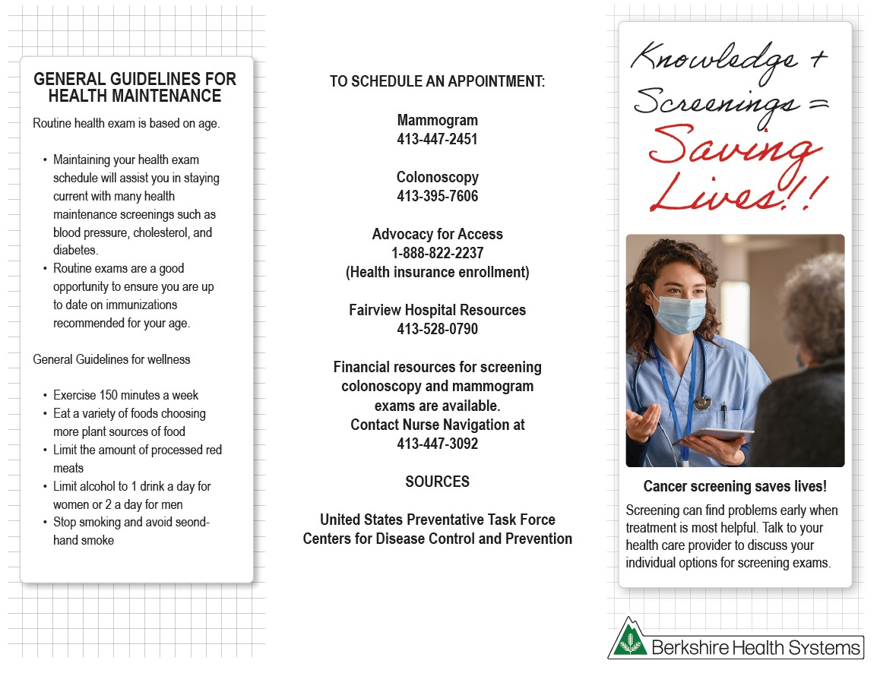
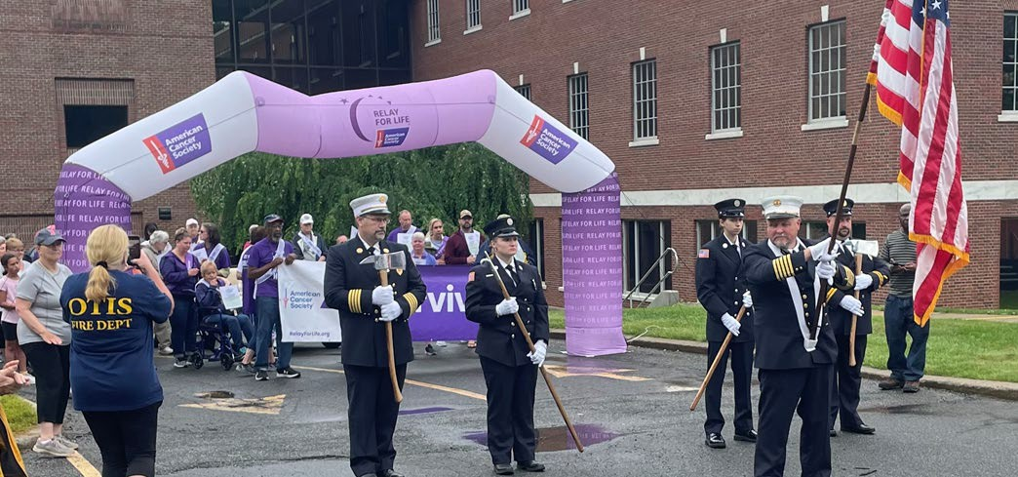
Programming to Help People Stay Healthy and Meet their Health Needs

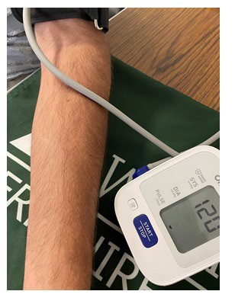
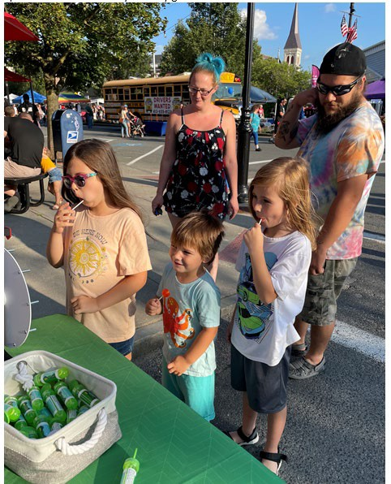
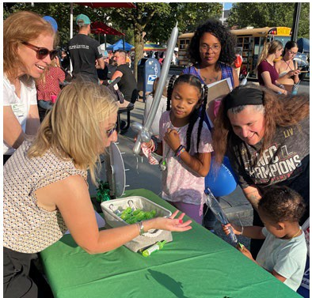
Programming to Help People Stay Healthy and Meet their Health Needs
Wellness and Community Health – North Adams Downtown Celebration

Wellness and Community Health
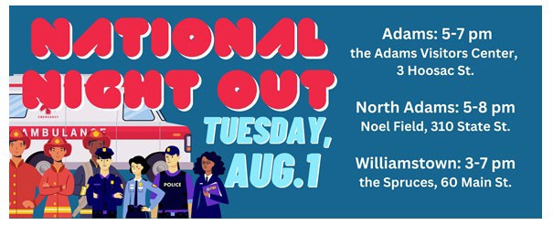
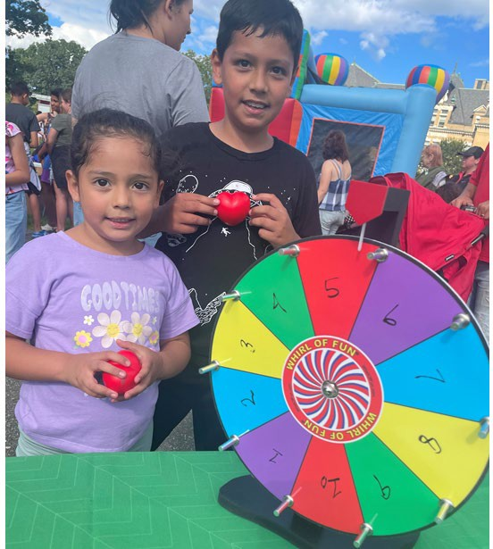
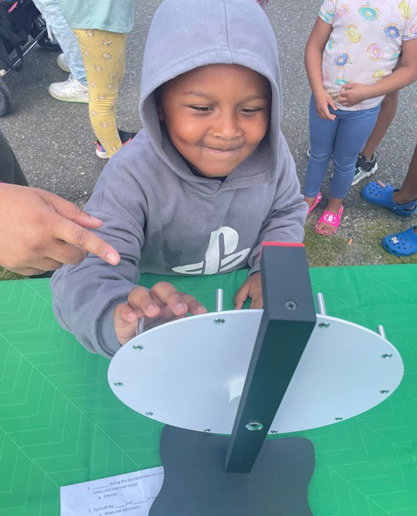
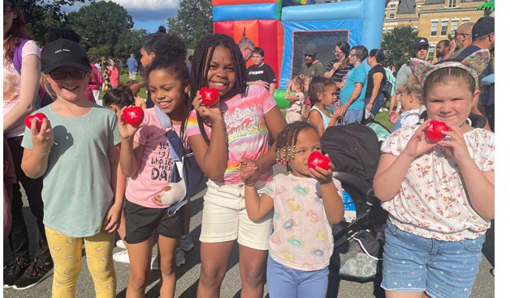
Programming to Help People Stay Healthy and Meet their Health Needs

Programming to Help People Stay Healthy and Meet their Health Needs
Talent Pipeline
- BHS initiative to provide training for people to gain careers in healthcare without prior experience or education
- Get paid full-time salary while going to school
  - BHS invests $7 million dollars annually to this program
- Programs include:
  - Medical Assistant
  - Nursing Assistant
  - Licensed Practical Nurse
  - Registered Nurse (Associate’s Degree)

Talent Pipeline
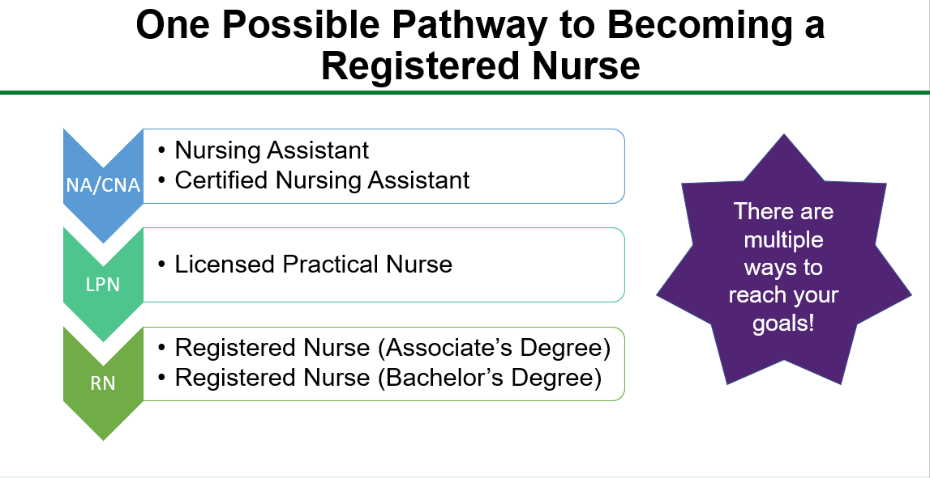
Programming to Help People Stay Healthy and Meet their Health Needs

Talent Pipeline
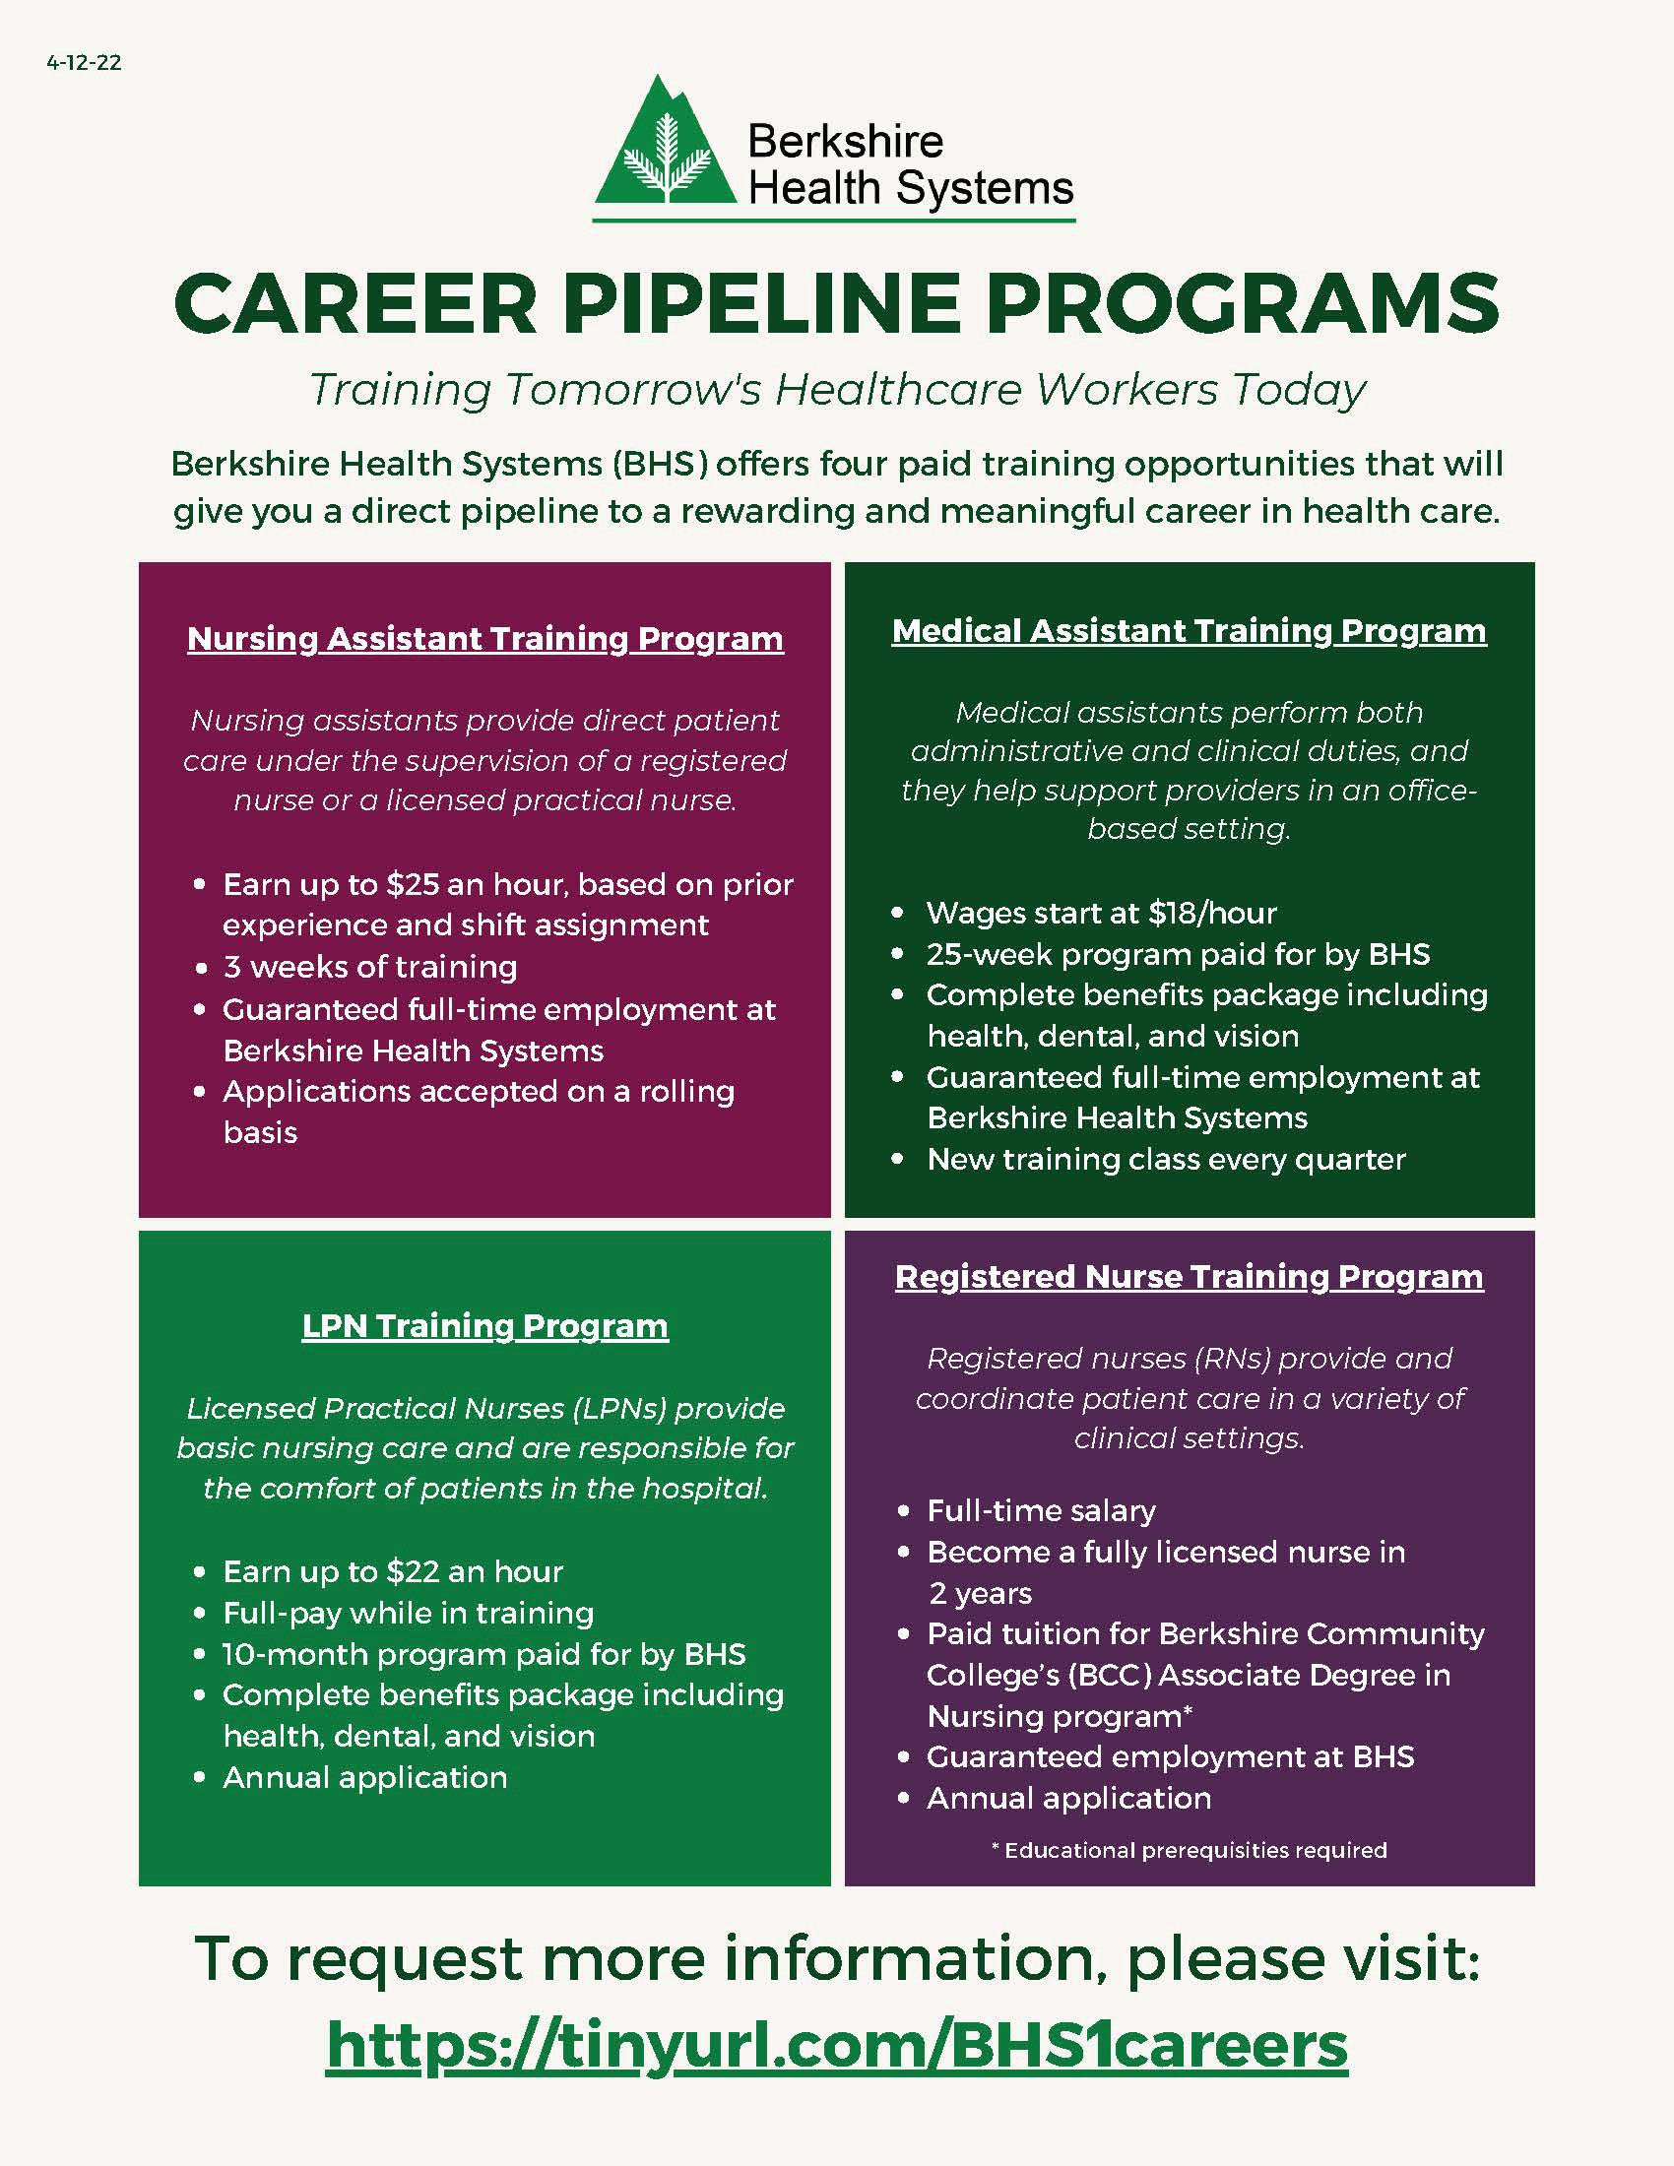
Programming to Help People Stay Healthy and Meet their Health Needs

Programming to Help
Initiatives
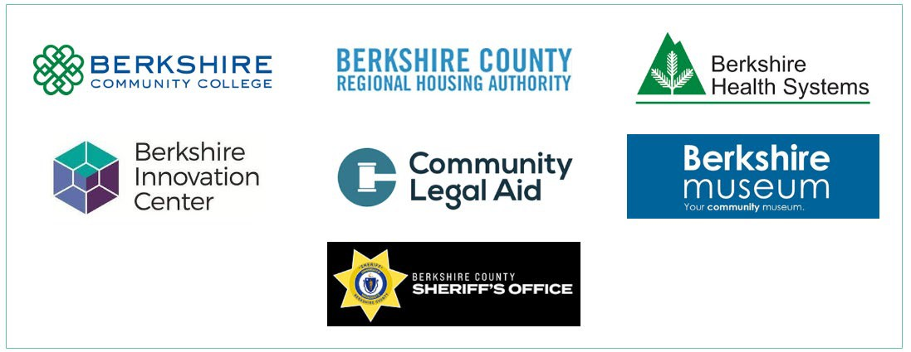
- 2nd Street, Second Chances
  - A collaborative program with local agencies to give formerly

People Stay Healthy and Meet their Health Needs
incarcerated individuals respect and encouragement
- Services provided include:
  - Medical
  - Mental Health
  - Substance use disorder services
  - Financial resources and literacy
  - Transportation
  - Housing
  - Family Reunification
  - Employment
  - Job Training
  - Legal Services
  - Support and Encouragement
1240\0177\2010138.v1

