CRITICAL ACCESS HOSPITAL FINANCIAL IMPACT ANALYSIS
North Adams Regional Hospital

Updated Final Report: August 16, 2023
Eric Shell, MBA, CPA
Wade Gallon, CPA, FHFMA

PROJECT OVERVIEW AND
PROJECT SCOPE

PROJECT OVERVIEW
- North Adams Regional Hospital (NARH) is a formerly freestanding Medicare Dependent hospital (MDH) that now operates as a department of Berkshire Medical Center (BMC), providing outpatient services to residents of North Adams, Massachusetts, and the surrounding communities
  - Services offered at the NARH campus include emergency care, surgical, endoscopy, renal dialysis, imaging, laboratory, specialty, and other community health services
- Effective January 1, 2023, CMS issued new regulations that redefined primary roads excluding from the definition of primary roads, US Highways with single lanes in each direction
  - With this change, Berkshire Health Systems (BHS) is interested in evaluating CAH designation from both a financial and operational perspective for the former NARH location as it now qualifies under distance criteria
- Stroudwater was engaged through the Massachusetts State Office of Rural Health to evaluate the financial and operational impact of reopening NARH as a Critical Access Hospital (CAH)

SCOPE
- Stroudwater performed a financial impact assessment of converting the North Adams (NA) campus from a department of BMC to a CAH
  - Stroudwater constructed a financial impact analysis utilizing the following information:
    - Revenues and expenses for the departments currently operating at the NA campus
    - Additional expense and revenue assumptions provided by BHS
    - Most recently filed Medicare hospital cost report, and PS&R for NARH prior to closure
    - Inpatient volume assumptions based on the proposed hospital bed count
    - Current outpatient utilization data
    - Staffing assumptions based on the proposed hospital structure
    - Detailed square footage for departments located on the NA campus
    - Payer mix and payer rate information
    - Applicable state laws and Centers for Medicare and Medicaid Services (CMS) regulations

CAH CONDITIONS OF PARTICIPATION

DEFINITIONS/REGULATIONS
- Critical Access Hospital (CAH)
  - A Critical Access Hospital (CAH) is a federal designation under the State Medicare Rural Hospital Flexibility Program (FLEX) that provides cost-based reimbursement for eligible Medicare services, and in some states Medicaid services
  - The purpose of the CAH designation is to ensure that people enrolled in Medicare and Medicaid have access to healthcare services in rural areas, particularly hospital care
  - Each CAH must comply with all conditions of participation (COPs), including the following:
    - Location:
      - Must be located in a rural area
    - Distance Criteria:
      - Meet the federal distance requirement that a CAH must be at least a 35-mile drive on primary roads or 15 miles on secondary roads to the nearest hospital or CAH
        - Prior to January 1, 2006, CAHs could be deemed Necessary Providers and qualify without meeting federal distance criteria
    - Emergency Services:
      - Offer 24-hour emergency department 7 days a week, laboratory, and diagnostic X-ray services
    - Inpatient Bed Limit:
      - Operate with 25 or fewer inpatient beds; does not include distinct part units (DPUs)
    - Average Length of Stay:
      - Maintain an average length of stay of 96 hours or less per patient for inpatient acute-care services
    - Comply with all federal, state, and local laws, including Commonwealth of Massachusetts hospital licensure regulations (see State Designation)

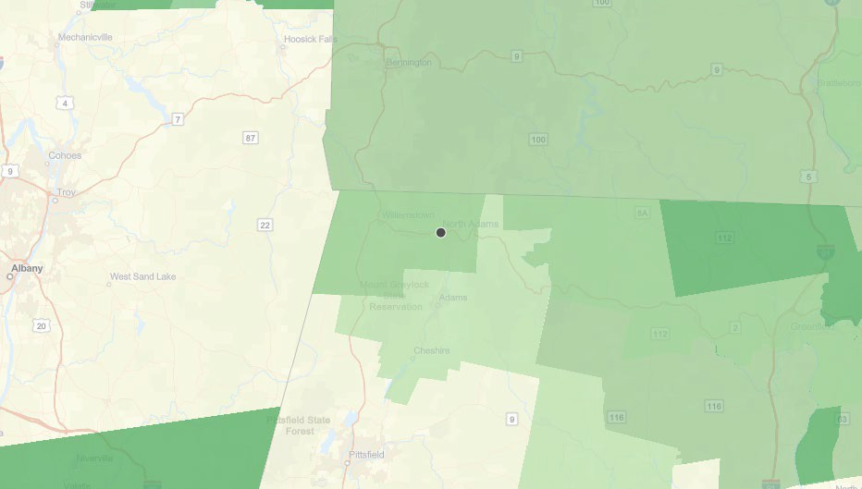
- Condition of Participation: §485.610 – Status and Location

North Adams Regional Hospital
  - Pursuant to 42 CFR 485.610(b), all CAH applicants and existing CAHs, including necessary provider CAHs, must be in one of the following to be eligible for CAH designation and certification:
    - Located in a rural area; or
    - Treated as rural in accordance with 42 CFR 412.103, which states the hospital is located in a rural census tract or designated as rural by any State law
  - NARH is located in an area defined as rural by the Health Resources & Services Administration (HRSA)
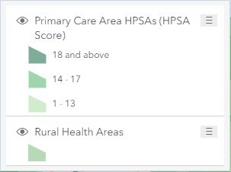
    - The green areas on the map to the right are designated as Rural Health Areas by HRSA
    - The CMS Regional Office will make the final determination as to whether a CAH applicant meets the rural location requirement

- Condition of Participation: §485.610 – Status and Location (cont.)
  - Pursuant to 42 CFR 485.610(c), all CAH applicants, including provider-based entities (PBE’s) of a CAH excluding rural-health clinics, must meet one of the following 2 distance requirements:
    - 35-Mile Distance: The CAH must be located more than a 35-mile drive from any hospital or other CAH on primary roads; or
    - 15-Mile Distance: In the case of mountainous terrain or areas with only secondary roads available, the CAH must be located more than a 15-mile drive from any hospital or another CAH
    - The definition of a primary road was recently refined and included in Federal regulations (see
§485.610(c)(2)) effective January 1, 2023; this change excluded US Highways with single lanes in each direction from the definition of a primary road; a primary road is now defined as one of the following
      - A numbered Federal highway, including interstates, intrastates, expressways, or any other numbered Federal highway with 2 or more lanes each way; or
      - A numbered State highway with 2 or more lanes each way
    - Given this definition of a primary road, a secondary road would be considered any road with less than 2 lanes each way, regardless of designation as a Federal or State highway
      - It is essential to note that, according to 42 CFR 485.610(e), provider-based entities (PBEs) excluding rural-health clinics (RHCs) must meet the distance criteria identified above in addition to the main hospital campus; therefore, any PBEs (including non-RHC clinics) serve as an extension of the main hospital campus
  - The closest hospitals to NARH are BMC (21.9 mi) and Southwestern Vermont Medical Center (18.0 mi)
    - Both hospitals are greater than 15 miles from NARH on secondary roads
      - Stroudwater has mapped out distances to various hospital locations on the following slides

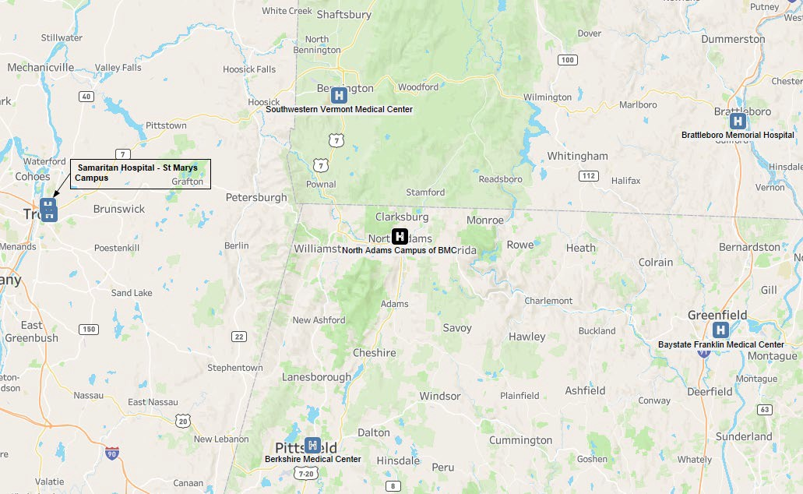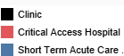

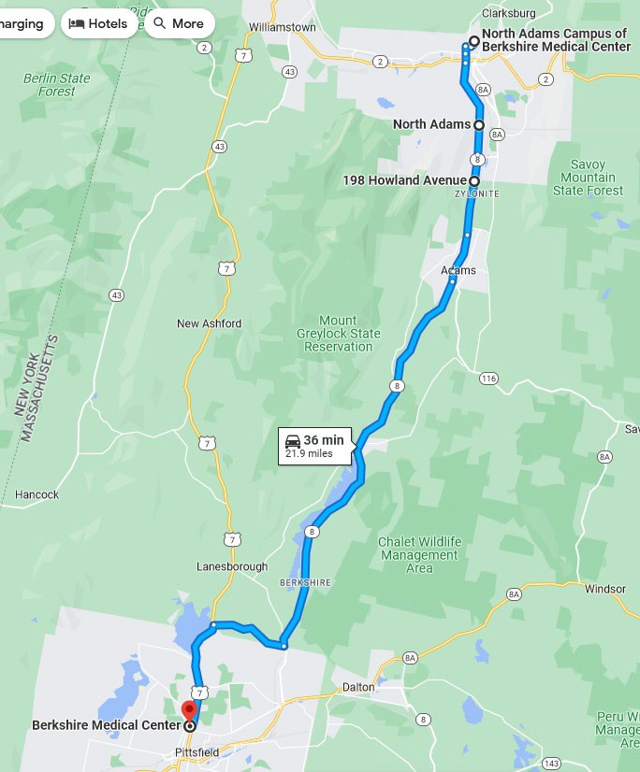

North Adams Campus to Berkshire Medical Center via US8 - APPEARS TO MEET
        - North Adams Campus of
Berkshire Medical Center is under the 35-mile limit for standard CAH conversion with 21.9 miles between the Campus and Berkshire Medical Center.
However, it does qualify for reduced distance with the new designation of primary and secondary roads, with 20.4 miles on “secondary” roads and 1.4 on “primary” roads.
        - A 1.4-mile section of Rt8 near North Adams is a divided road

Source: Google Maps 10

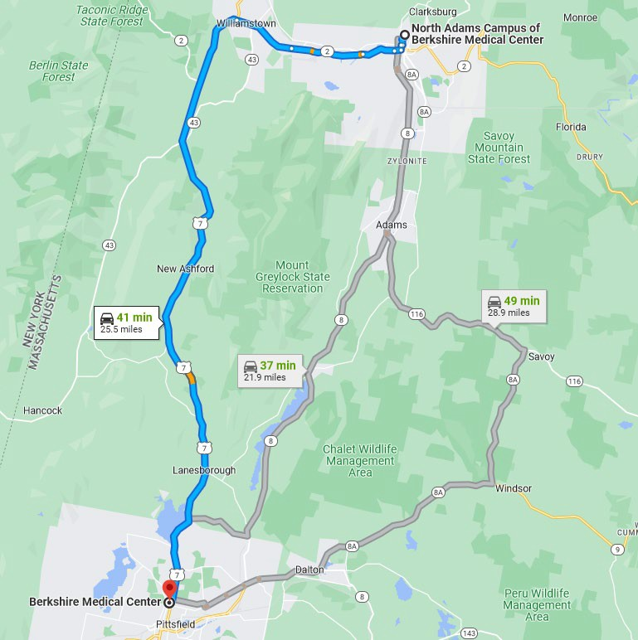
North Adams Campus of BMC to Berkshire Medical Center via US7 - APPEARS TO
•MEENTorth Adams Campus of Berkshire Medical Center is under the 35-mile limit for standard CAH conversion with a total of 25.5 miles between the Campus and Berkshire Medical Center. However, it does qualify for reduced distance with the new designation of primary and secondary roads, with all 25.5 miles on “secondary” roads.
          - US-7 is considered secondary because is it only 2 lanes from Williamstown to Pittsfield.

Source: Google Maps 11

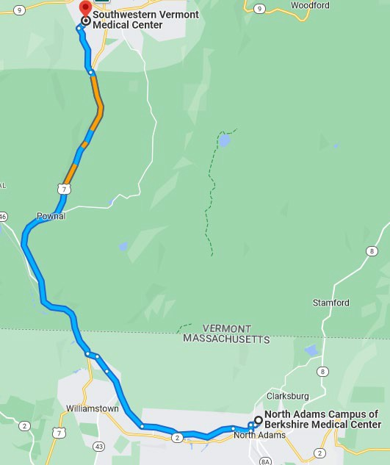
North Adams Campus to Southwestern Vermont Medical Center - APPEARS TO MEET
- North Adams Campus of Berkshire
Medical Center is under the 35- mile limit for standard CAH conversion with a total of 18 miles between the Campus and Southwestern Vermont Medical Center. However, it does qualify for reduced distance with the new designation of primary and secondary roads, with all 18 miles on “secondary.”
- Although Route 7 is designated as a US highway, it qualifies as a secondary road as it only has one lane in each direction

Source: Google Maps

Mileage between North Adams Campus of BMC and other Hospitals

Type | Location | Southwestern Vermont Medical Center | Berkshire Medical Center via US8 | Berkshire Medical Center via US7 | Baystate Franklin Medical Center | Samaritan Hospital – St. Marys Campus
 | North Adams Campus of BMC | 18.0 | 21.9 | 25.5 | 38.3 | 38.8
Mileages in blue [and bold] appear to meet the requirement by being over 15 miles between facilities with only secondary roads available
Source: Google Maps

DEFINITIONS/REGULATIONS: STATE DESIGNATION
- Massachusetts Rural Definition
  - The Commonwealth of Massachusetts (MA) defines a rural hospital as follows based on State law and Hospital licensure regulations:
    - State Law
    - Title XVI, Chapter 111, Section 52
    - Definitions applicable to Secs. 51 to 56
    - Section 52. In sections fifty-one to fifty-six, inclusive, the following words shall have the following meanings:—
    - ''Rural hospital'', an acute-care hospital as defined in section 25B and licensed under this chapter, which: (1) has been designated by the department as a rural hospital based on bed size, city or town population, and population density of the city, town, service area or county as determined by the department through regulation; or (2) a hospital currently designated as a critical access hospital by the United States Department of Health and Human Services in accordance with federal regulations and state requirements.
    - State Hospital Licensure Regulations
    - 105 CMR 130.00
    - Rural Hospital. An acute care hospital licensed under M.G.L. c. 111, § 51, which: (1) has 50 or fewer licensed beds and based on the published United States Census 2000 data of the US Census Bureau is in a city or town whose population is less than 20,000 and is located within a city, town, service area, or County whose population density is less than or equal to 500 people per square mile and which applies for such a designation; or (2) is a hospital designated as a Critical Access Hospital as of July 1, 2005 by the Federal Department of Health and Human Services in accordance with federal regulations and state requirements
  - NARH would be considered rural based on the definitions as outlined in state law and regulations

DEFINITIONS/REGULATIONS: EMERGENCY SERVICES

Condition of Participation: §485.618 – Emergency Services
  - The CAH provides emergency care necessary to meet the needs of its inpatients and outpatients
    - All emergency services must be provided as a direct service in the CAH and the ED cannot be a provider-based off-site location
  - Emergency Services are available on a 24-hour basis 7 days per week
    - The hospital must ensure that a doctor of medicine or osteopathy, a PA, a NP, or a clinical nurse specialist with training and experience in emergency care is on call and immediately available by telephone or radio, and available on-site within 30 minutes, 24 hours a day
  - The NA campus currently operates an ED which would become part of NARH; therefore, NARH should meet this CAH Condition of Participation

DEFINITIONS/REGULATIONS:
NUMBER OF BEDS AND LENGTH OF STAY

Condition of Participation: §485.620 – Number of Beds and Length of Stay
  - §485.620(a) Standard: Number of Beds - Except as permitted for CAHs having distinct part units under §485.647, the CAH maintains no more than 25 inpatient beds, which may be used for either inpatient, ICU, Labor and Delivery (LDRP) and or swing-bed services
    - NARH is anticipated to operate 18-beds, which is below the maximum 25-bed requirement
  - §485.620(a) Standard: Length of Stay - The CAH provides acute inpatient care for a period that does not exceed, on an annual average basis, 96 hours (or 4 days) per patient (ALOS calculation excludes Swing Bed, Observation and Nursery days)
    - NARH is anticipated to maintain an ALOS below 96 hours per regulation

DEFINITIONS/REGULATIONS: DISTINCT PART UNITS

Condition of Participation: §485.647 – Psychiatric and Rehabilitation Distinct Part Units
  - §485.647(b) Standard: To be eligible to receive Medicare payments for psychiatric or rehabilitation services as a distinct part unit, the facility provides no more than 10 beds in the distinct part unit of which the distinct part beds are excluded from the 25 inpatient-bed count limit specified in
§485.620(a)
    - NARH would not operate a distinct inpatient psychiatric facility (IPF) or inpatient rehabilitation facility (IRF)

DEFINITIONS/REGULATIONS: SUMMARY
- The following table summarizes each of the 6 COPs evaluated

Conditions of Participation | Meets Requiremen t? | Summary
Location | ✅ | Located in a Rural Area per HRSA
Distance Criteria | ✅ | The NA campus currently is greater than 15 miles on secondary roads from the nearest hospitals
Emergency Services | ✅ | The NA campus currently operates a 24/7 ED, which would become part of NARH
Average Daily Census (ADC) | ✅ | Though NARH’s average ADC is anticipated to be well below 25 based on current plan of 18 beds
Average Length of Stay (ALOS) | ✅ | ALOS anticipated to remain below the 96-hour threshold
Distinct Unit | ✅ | NARH does not anticipate operating a distinct unit

INPATIENT BED NEED

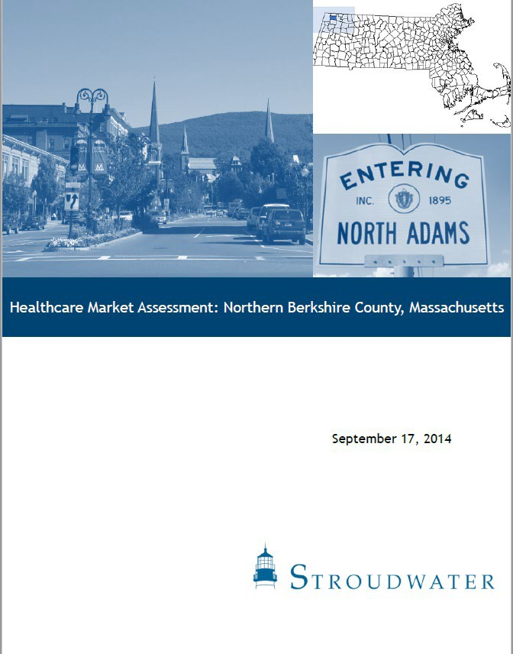
FINDINGS AND ANALYSIS
- In 2014 Stroudwater conducted a bed needs analysis for the North County service area
  - The primary service area consisted of eight zip codes including North Adams, Adams, Williamstown and Cheshire, among others, representing a total population of approximately 37,000 (see Market Assessment Report)
  - Analysis looked at projected population growth by age cohort, inpatient utilization rates, discharges by service line, market share, and other data to develop an estimated total bed need for the service area
- The results of this analysis showed a potential need of 18 – 21 inpatient Med/Surg beds for the North County service area
- The analysis also indicated that the only financially feasible way to provide inpatient services via inpatient beds within the service area was through CAH designation
  - CAH designation was not available given federal distance criteria at that time
- A copy of the report has been attached for reference
  - Though an updated inpatient bed assessment was not funded through this feasibility analysis, it is believed that there continues to be a significant need for inpatient care in the service area based on additional information collected in the CAH evaluation process

CONCLUSIONS
- Given the recent change in the road definitions, CAH designation is now available in North Adams
- 2014 market assessment suggested that 18 – 21 Med/Surg bed need could potentially be financially sustainable through inpatient beds within the service area if CAH designation was achieved
- This conclusion is supported by the results of this financial feasibility study, which indicates financial viability given the initial bed count of 18 (see Financial Impact Assessment)

FINANCIAL IMPACT ASSESSMENT

FINANCIAL IMPACT ASSESSMENT

Overview and Methodology
  - Stroudwater used BHS internal full-time equivalent (FTE) and cost projections, NA current expense and revenue data, NA current outpatient volume information, the as-filed NARH FY13 Medicare hospital cost report (the last full year NARH was in operation), and other BHS documentation as the basis for constructing a cost-finding model used to determine the net impact on reimbursements, and net income of the proposed NARH operating as a CAH
    - Stroudwater first developed a base case scenario to reflect NA’s current financial performance as a provider-based department of BMC
    - A pro forma was then developed to understand the financial impact and viability of re-opening NARH as a CAH
  - Medicare, including Medicare Advantage, and Medicaid (inc. MCO) reimbursement includes the following:
    - Acute care inpatient – 101% of allowable cost
    - Swing Beds – 101% of allowable cost
    - Observation – 101% of allowable cost
    - Most outpatient facility component of service – 101% of allowable cost

- Assumptions
  - The set of assumptions presented was applied to the cost- finding model
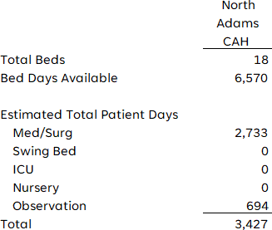
    - Inpatient Volume Assumptions
      - The model estimated 2,733 Med/Surg days, and 694 Observation bed days based on estimates provided by BHS
      - As the NA location has not had an inpatient unit since 2014, estimates regarding patient days were based on analysis of patient acuity for inpatients at BMC from the North County area (where NA resides), using experience with Fairview Hospital (FVH), another CAH within the BHS system to test for reasonableness
        - It is estimated that NARH will open with 18- beds; given the total bed days available, NARH is projected to initially operate at approximately 52% capacity given the total days reported above (inclusive of Observation days given the lack of a distinct Observation unit) although NARH and BHS will evaluate swing bed services in the future

Assumptions
  - Inpatient Volume Assumptions (cont.)
    - Patient days were broken out by payer (Medicare, Medicare Advantage, Medicaid, Medicaid Advantage, and Commercial) based on the payer mix of ED patients at the NA campus that were transferred to BMC for inpatient care; FVH payer mix was again utilized to test for reasonableness
    - Results of payer mix distribution for NARH are as follows:
Estimated Patient Days by Payor
Medicare | 1,539 | 56.3%
Medicare Advantage | 331 | 12.1%
Medicaid | 52 | 1.9%
Medicaid HMO | 478 | 17.5%
Commercial | 260 | 9.5%
Other | 74 | 2.7%
Total | 2,733 | 100%

ASSUMPTIONS: PATIENT SERVICE REVENUES
- Assumptions (cont.)
  - Revenue Assumptions
    - The Med/Surg charge per day was assumed to be approximately $1,500 (excluding Inpatient ancillary charges), which was then multiplied by total days to estimate routine gross charges
    - Ancillary charges were developed based on current FYTD charge information for the NA location; given the assumption that most ancillaries would remain in place once the location is converted to NARH, these charges were used for anticipated outpatient ancillary charges
      - Depending on the ancillary service, Stroudwater estimated ancillary charges for inpatients based on experience with other CAHs and estimated inpatient volumes (see Inpatient Volume Assumptions)
      - Stroudwater developed inpatient ancillary revenue assumptions for the following departments:
        - Operating Room
        - Radiology- Diagnostic
        - Laboratory
        - Physical Therapy
        - Medical Supplies Charged to Patients
        - Drugs Charged to Patients
        - Emergency Room

ASSUMPTIONS: DEDUCTIONS FROM REVENUE
- Assumptions (cont.)
  - Deductions from Revenue Assumptions
    - Stroudwater developed contractual allowance estimates based on the creation of a draft cost report, with estimates for expenses and revenues as discussed throughout this report
    - Cost-based reimbursement was estimated for cost-based payers (Medicare, Medicare Advantage, and Medicaid) based on per diems and cost-to-charge ratios (CCRs)
    - Contractual allowances for commercial payers were estimated based on historical rate information provided by BHS
      - Total NARH contractual allowances estimated at 50.4% of patient service revenue, or approximately $49.0M
    - Bad debts for NARH were estimated at 2% of patient service revenue (net of contractual allowances), or approximately $911K, based on BHS historical experience

- Assumptions (cont.)
  - Expense Assumptions
    - Most expense assumptions for the CAH were based on estimates provided by BHS; estimates were based on a review of services anticipated at NARH and historical cost data
      - Stroudwater performed some high-level tests of key expense assumptions provided by BHS, with a strong emphasis on projected inpatient costs
        - These tests included a review of overall nursing and support staff for the inpatient unit and hospitalist expense
        - To review these expenses, Stroudwater utilized Medical Group Management Association (MGMA) data, staffing benchmarks based on Stroudwater’s experience with other CAHs, and Bureau of Labor Statistics (BLS) information
          - Based on this review it was determined that inpatient unit costs as estimated by BHS are reasonable, although expenses may exceed estimates given current labor shortages
      - Stroudwater also compared expense projections for certain departments with NA campus-specific expense data via the Trial Balance for FY 2023
        - Stroudwater was able to tie expense projections back to NA campus expense accounts
        - Certain NA campus-specific expenses were not included in NARH expense projections, such as renal dialysis and certain clinics, which will remain as part of BMC
    - The following additional expenses were estimated based on conversations with BHS, systemwide cost data, and Stroudwater’s experience with other CAHs
      - Employee benefits: $5.1M (29% of total estimated NARH salaries)

- Assumptions (cont.)
  - Expense Assumptions (cont.)
    - Stroudwater developed a mockup of Worksheet A on the Medicare cost report (see Appendix A) based on expense projections provided by BHS, with some amounts estimated based on Stroudwater’s experience with other hospitals, and a review of FVH’s cost structure (see previous slide)
      - This mockup was then incorporated into the cost-finding model
      - Total Expenses were estimated as follows:
        - Total Salaries: $17.7M
          - Included in Salary expenses are $2.2M in costs allocated from BMC
        - Total Other: $23.2M
          - Included in Other expenses is $4.1M in costs allocated from the Home Office
          - $4.1M estimate of Home Office cost allocations was developed using FYTD
23 annualized Home Office costs, and historical cost allocation percentages from the BHS Home Office adjusted for the service mix anticipated at NARH

ASSUMPTIONS: REIMBURSEMENT
- Assumptions (continued)
  - Inpatient Reimbursement
    - The following tables show the projected payments from Medicare, Medicare Advantage, and Medicaid (including MCO) pertaining to Med/Surg services as a CAH, which are estimated at $8.3M
    - If NARH were a CAH, the hospital would experience a cost-based rate for inpatient services as shown below
Med/Surg*
CAH
Service Area | Per Diem | Days | CAH Payments
Medicare | $3,459.22 | 1,539 | $5,323,740
Medicare Advantage | $3,454.73 | 331 | $1,143,516
Medicaid (inc. MCO) | $3,441.13 | 530 | $1,823,799
Total Inpatient |  | 2,400 | $8,291,055

* per diem estimates relate to cost-based payers

      - Commercial rate for inpatient services estimated based on applicable rates for BMC and FVH for comparable services

Outpatient Reimbursement
  - The following tables show the estimated cost-to-charge ratios applied to outpatient charges for cost-based payers
  - Outpatient commercial rates estimated based on a review of current NA payment rates, using FVH to test for reasonableness
CC Line # | CC Description | NARH
50.00 | Operating Room | 0.574850
54.00 | Radiology- Diagnostic | 0.116249
60.00 | Laboratory | 0.265333
66.00 | Physical Therapy | 1.778107
69.00 | Electrocardiology | 0.070761
71.00 | Medical Supplies Charged to Patients | 0.673169
73.00 | Drugs Charged to Patients | 0.822190
75.00 | ASC | 0.446212
76.97 | Cardiac Rehabilitation | 0.682478
76.98 | Hyperbaric Oxygen Therapy | 0.613916
91.00 | Emergency Room | 0.529068

Outpatient Reimbursement
  - Current OP payments rates based on fee schedule were compared to estimated CCRs to establish an expectation around anticipated benefit in OP payment for cost-based payers given NARH’s designation as a CAH; a review of departments representing most outpatient gross charges revealed a significant positive differential as follows:
 | [Current] Medicare/MA | [Current] Medicaid/MCO | [Anticipated] CAH | [Differential] Medicare Diff | [Differential] Medicaid Diff
Imaging | 17.20% | 18.80% | 11.62% | -5.58% | -7.18%
Lab | 14.50% | 19.10% | 26.53% | 12.03% | 7.43%
Surgery | 34.80% | 37.50% | 57.49% | 22.69% | 19.99%
ASC | 25.10% | 19.50% | 44.62% | 19.52% | 25.12%
ER | 21.00% | 22.60% | 52.91% | 31.91% | 30.31%

- Medicare - Outpatient Reimbursement (cont.)
  - Optional Method II Election
    - In addition to the reimbursement gains seen under FFS and OPPS, CAHs may elect the All-Inclusive Method II Billing Option (Method II), which results in CAHs receiving payments for the outpatient, Part B, professional component of service equal to 112% of the Medicare professional service fee schedule
      - For NARH, the primary services to which Method II Billing could be applied are ED outpatient services
    - Based on charge data provided by BHS, ED outpatient facility component service charges were $20.1M, of which $5.3M was for services provided to Medicare beneficiaries
      - Since the cost report only provides facility charges, this analysis assumes the professional service component charges represent 24% of the total charges, resulting in estimated Medicare professional charges of $4.0M
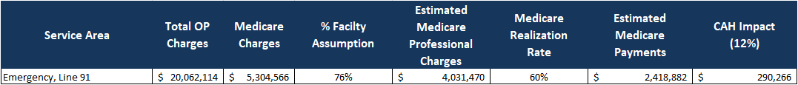
        - Assuming that NARH ED professional charges are established such that Medicare allowable fees represent 60% of the hospital’s charge, then the estimated Medicare professional component or the ED service fees would be approximately $2.4M

      - If NARH elected to implement Method II, the hospital would have realized an additional benefit of approximately $290K from Medicare

340B Program
  - The 340B program has proven highly beneficial to rural hospital peers with outpatient clinics
    - The 340B Drug Pricing Program allows CAHs to benefit from reduced drug costs and revenue from contracted retail pharmacy program arrangements
    - For CAHs, the 340B program is available to provider-based clinics (PBC) and provider-based Rural Health Clinics (PB-RHC)
  - The NA campus as an outpatient department of BMC currently participates in the 340B program
    - For a period of time after opening, NARH will not be eligible for drug cost savings through the 340B program, but this will be restored at a future date
    - No increase in cost has been assumed from current drug expense levels for this analysis

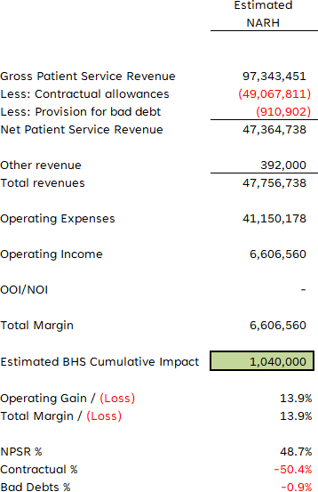
- Summary
  - The table to the right presents a summary of the financial impact of CAH status based on the assumptions and analysis described in this report
    - Applying the assumptions in this report, it is estimated that conversion to CAH status would result in an overall operating income of approximately $6.6M, and a potential operating margin of 13.9% for NARH, indicating financial viability
    - It is estimated that the total net benefit to BHS is approximately
$1M; the anticipated benefit is primarily impacted by the shift of inpatient volumes from BMC to NARH once NARH is opened and increased OP rates from cost-based payers for NARH as a CAH compared to current operations as an OP department of BMC

CONCLUSIONS & RECOMMENDATIONS

CONCLUSIONS
- 2014 market assessment projected an overall inpatient bed need of 18 – 21 in the North County service (see Inpatient Bed Need section)
  - 2014 study further suggested that meeting this inpatient bed need would only be financially feasible through CAH designation
- Due to estimated financial viability and potentially favorable systemwide reimbursement impact, BHS should consider reopening NARH as a CAH

RECOMMENDATIONS
- Assuming NARH obtains CAH designation, Stroudwater recommends that NARH do the following:
  - Monitor IP census to prevent ADC from exceeding limitations as a CAH
  - Implement systems to ensure the average length of stay for acute patients does not surpass the 96-hour (4-day) threshold
    - Document all patients with a LOS over 96 hours and the reason for keeping the patient over 96 hours
  - Elect Method II for ED services to leverage improved reimbursements for professional services
  - Evaluate the Medicare Cost Report to ensure the information reported is appropriate based on the CAH cost-based reimbursement methodology

APPENDIX

APPENDIX A: WORKSHEET A MOCKUP

North Adams Regional Hospital
Worksheet A (Mockup)
CC Line # | CC Description | Salaries | Other | Total
1.00 | Capital – Bldg & Fixt | - | 689,367 | 689,367
4.00 | Employee Benefits | 99,216 | 5,136,510 | 5,235,726
5.00 | A&G | 1,032,516 | 3,674,966 | 4,707,482
6.00 | Maint. & Repairs | 351,758 | 1,202,183 | 1,553,940
7.00 | Plant Ops | 474,331 | 15,117 | 489,448
8.00 | Laundry & Linen | - | 805,584 | 805,584
9.00 | Housekeeping | 446,067 | 286,892 | 732,959
10.00 | Dietary | 599,274 | 241,648 | 840,922
13.00 | Nursing Administration | 1,050,625 | 100,000 | 1,150,625
14.00 | Central Services & Supply | 231,110 | 55,200 | 286,310
15.00 | Pharmacy | 306,581 | 1,745,987 | 2,052,568
16.00 | Medical Records | 258,461 | 53,600 | 312,061
17.00 | Social Services | 237,580 | 15,000 | 252,580
30.00 | A&P | 3,199,334 | 205,000 | 3,404,334
50.00 | Operating Room | 581,120 | 180,464 | 761,583
53.00 | Anesthesiology | 831,764 | - | 831,764
54.00 | Radiology-Diagnostic | 1,208,004 | 316,118 | 1,524,121
60.00 | Lab | - | 3,296,498 | 3,296,498
66.00 | Physical Therapy | 327,818 | 75,000 | 402,818
69.00 | Electrocardiology | 48,426 | 915 | 49,341
75.00 | ASC | 524,889 | 288,453 | 813,342
76.97 | Cardiac Rehab | 244,410 | 10,719 | 255,129
76.98 | HBOT | 413,598 | 113,574 | 527,172
91.00 | Emergency Room | 5,245,224 | 629,275 | 5,874,499
 | Total | 17,712,105 | 19,138,067 | 36,850,172

40
1240\0177\2010275.v1

