Written Testimony of Congressman Richard E. Neal (MA-01),
Ranking Member of the U.S. House Committee on Ways and Means before the
Massachusetts Department of Public Health October 25, 2023
Thank you to the Massachusetts Department of Public Health for the opportunity to submit testimony for today’s proceedings regarding Berkshire Health Systems’ proposed new hospital facility.

I strongly support Berkshire Health System’s application to reopen a hospital in North Adams after closing more than a decade ago. The facility will include inpatient beds and, with its critical access hospital designation, will bring a much-needed healthcare access point and create job opportunities in Berkshire County.

The potential reopening of North Adams Regional Hospital is a pivotal step to ensure equitable access throughout the Commonwealth, addressing health disparities in the more rural regions of western Massachusetts. Federal support plays a crucial role in the strength and vitality of our local institutions. With Medicare’s critical access hospital designation, North Adams Regional Hospital will be able to reopen with additional funding so it can resume serving its community.

Our rural residents in western Massachusetts face unique challenges that are not apparent in other parts of the state. The single-lane highways, which are particularly treacherous during the winter months, underscore the urgency of having accessible healthcare within close proximity. It is not just about convenience; it is about safety, timely care, and the overall well-being of our residents.

Recognizing these challenges, I have worked with the Biden Administration to advocate for rule changes relative to the Critical Access Hospital designation. These changes are what paved the way for the project that Berkshire Health Systems is presenting to you this evening. I am proud that this designation allows for the additional resources that made this reopening possible, and I strongly support Berkshire Health Systems and their efforts to provide much-needed healthcare services to the people of North County. Thank you.

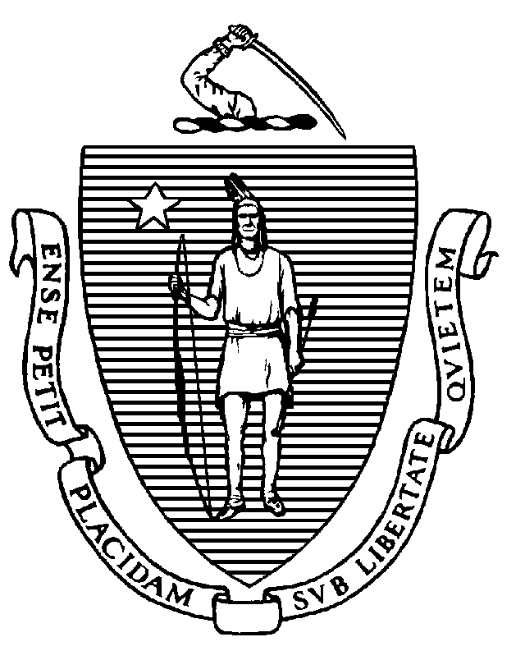The Commonwealth of Massachusetts
Massachusetts Senate

Senator Paul W. Mark
Berkshire, Hampden, Franklin and Hampshire District

State House
Boston, MA 02133-1053
Tel. (617) 722-1625
Fax. (617) 722-1523

Paul.Mark@MASenate.gov
www.MAsenate.gov

Dear Friends,

My name is Paul Mark and I am the State Senator for North Adams, northern Berkshire County, and a total of 57 cities and towns that make up the Berkshire, Hampden, Franklin and Hampshire Senate District. I’m pleased to be here tonight to support the proposed project to reintroduce inpatient care in North Adams.

I want to acknowledge Mayor Macksie, my colleague Representative John Barrett who is also here tonight and shares representation of North Adams and the surrounding communities with me at the State House and recognize his support, along with that of Massachusetts 1st District Congressman Richard Neal. I’m honored to be working with them every day to advocate for our constituents and highlight the issues that uniquely impact the rural communities of the Berkshires and Western Massachusetts.

We all know that the revitalization of a hospital in Northern Berkshire County will have many benefits for patients. But I want to emphasize the significant economic opportunities that it will offer for our residents—new jobs as doctors, nurses, clinicians, support service professionals, technicians, not to mention the multiplier effect that having a vibrant professional organization in the heart of North Adams will have on other businesses in the region.

I’m also particularly grateful that Berkshire Health Systems has committed to upholding the union agreements for bargaining unit positions at the new North Adams Regional Hospital campus—which is an important recognition of the rights of our dedicated healthcare workforce.

I am optimistic about the profound impact this project will have both on our community's health and its economic landscape, and I’m glad to be able to endorse the project here tonight. I will also be sending along my written comments, please feel free to follow up with me directly if there are any questions or if I can offer further guidance.

Sincerely,

[signature on file]

Senator Paul W. Mark
Berkshire, Hampden, Franklin and Hampshire District

From: John Lipa
To: DPH-DL - DoN Program
Subject: John Lipa-Testimony before the Massachusetts Department of Public Health – Virtual Public Hearing, Wednesday, October 25, 2023
Date: Wednesday, October 25, 2023 6:39:13 PM

CAUTION: This email originated from a sender outside of the Commonwealth of Massachusetts mail system. Do not click on links or open attachments unless you recognize the sender and know the content is safe.

My name is John Lipa. One month from today, 78 years ago, I was born at the North Adams Regional Hospital, The Reg. I was raised, grew up and have been active in North Adams.

I was chair of the following organizations: North Adams Redevelopment Authority, Northern Berkshire Industrial Parks Commission, Northern Berkshire United Way, Berkshire Regional Employment Board and the Massachusetts Workforce Board. I worked for General Dynamics for 31 years in Pittsfield and retired as Director of Human Resources.

I thank you for the opportunity to share my thoughts in support of Berkshire Health Systems’ Determination of Need and intent to reopen the North Adams Regional Hospital, known to locals as The Reg, through a critical access hospital designation.

It would be wonderful knowing that there is a hospital not only in my community, North Adams, but also in my neighborhood. It would mean I would not have to take a long, bumpy ride on a two-lane road to a hospital in Bennington VT or Pittsfield MA in an ambulance. It would then only be a 2-minute ride to the hospital from my house.

The reopening would mean a huge psychological boost to the community knowing a semblance of The Reg is back in operation
providing quality health care locally. It would mean the younger generation would be able to say, as I do: my wife, three sisters-in- laws, a mother-in-law, many cousins, and friends, worked there and had rewarding careers. It would mean that employers, including two local colleges, would have an easier time recruiting faculty, staff and students. It would be an additional vital and robust asset to help those who need medical and behavioral health treatment.
It would mean Northern Berkshire County would join Central Berkshire County, and Southern Berkshire County with their own local hospital. It would mean Berkshire County would have a seamlessly integrated hospital system. It would mean more opportunities for doctors, nurses, aides, and other health care specialties. It would mean Berkshire Community College; Massachusetts College of Liberal Arts and our outstanding vocational high school would be able to train students for real local jobs in the healthcare field.

It would mean more disposable income for residents to support local businesses, buy homes, and renovate. It would mean more young people would not have to relocate to find a good job. It would mean more young families wanting to have their children here and raise them in our community.

In short, only good things will happen when North Adams Regional Hospital, The Reg, is reopened as a critical access hospital under the guidance of Berkshire Health Systems.

Thank you for listening. Please make the decision to make the rebirth of the North Adams Regional Hospital, The Reg, a reality.

Thank you, John Lipa

From: John Meaney
To: DPH-DL - DoN Program
Subject: DON Testimony - North Adams Regional Hospital
Date: Thursday, October 26, 2023 8:10:18 AM
Attachments: image001.png
Importance: High

CAUTION: This email originated from a sender outside of the Commonwealth of Massachusetts mail system. Do not click on links or open attachments unless you recognize the sender and know the content is safe.

Hello,
My name is John Meaney. I am a resident of North Adams and I have the privilege of serving the community as the chief and general manager of Northern Berkshire EMS, the sole provider of emergency medical services to ten municipalities in the northern Berkshire, southern Vermont region. As someone who's dedicated his life to ensuring the timely and effective delivery of emergency care, I can't overstate the significance of having care resources close to home, both for our Emergency Medical Service providers and for our community as a whole.

In my role, I see firsthand how our EMS teams work tirelessly to respond to emergencies. Our goal is always to provide the best care as quickly as possible. With a Critical Access Hospital right here in North Adams, we can drastically reduce transport times, ensuring that patients receive care faster and more efficiently. This not only improves outcomes but also allows our EMS teams to be ready for the next call sooner, bolstering our community's overall safety and system status management of our resources.

The opportunity that a local inpatient hospital offers for increased efficiency of our operations has the potential to make a significant impact on Northern Berkshire EMS and our ability to serve the community. Fewer hour-and-a-half to two hour round trips to connect patients to inpatient care at Berkshire Medical Center in Pittsfield will reduce wear-and-tear on our vehicles and equipment, keep staff and patients safer during poor winter weather conditions, and allow us at Northern Berkshire EMS to instead direct our resources to ongoing system improvements.

We are also excited about how the availability of inpatient care at a Critical Access Hospital in North Adams would better support patients requiring IV therapy and other treatment. At present, we are responsible for transporting patients with certain diagnoses from their nursing home to a hospital facility by ambulance to receive their treatments. Being able to care for these patients in swing beds on-site at the hospital would be a game-changer, both for the patients and for Northern Berkshire EMS. Instead of transporting patients back and forth, they would receive continuous care in a single, familiar location and free up Northern Berkshire EMS to respond to acute emergencies more quickly.

I wholeheartedly support this project and urge everyone to recognize the immense benefits it will bring to our EMS services and the broader Northern Berkshire community.

Thank you for your time and consideration.

Sincerely,

John P. Meaney, Jr., NRP, I/C Chief / General Manager Northern Berkshire EMS
A Division of North Adams Ambulance Service, Inc.
P.O. Box 1045
10 Harris Street
North Adams, MA 01247 (413)664-6680 Office
(413)664-4051 Fax
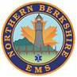
www.northernberkshireems.com
Confidentiality Notice: This electronic communication and any attachments may contain confidential and proprietary information of North Adams Ambulance Service, Inc. (NAAS). If you are not the intended recipient, or an agent or employee responsible for delivering this communication to the intended recipient, or if you have received this communication in error, please do not print, copy, retransmit, disseminate or otherwise use the information. Please indicate to the sender that you have received this communication in error, and delete the copy you received. NAAS reserves the right to monitor any electronic communication sent or received by its employees, agents or representatives.

Marie Harpin, [address redacted]

October 25, 2023

TO: Massachusetts Department of Public Health FROM: Marie Harpin
SUBJECT: BHS Determination of Need: Virtual Public Hearing, October 25, 2023 Dear Sir/Madam:
My name is Marie Harpin, and I am a resident of North Adams and a North Adams City Councilor. I would like to share some of my personal experiences with accessing healthcare in our area and emphasize how valuable it is to have healthcare close to home.

My mom, Mimi Harpin, is 85 years old. She is a native of North Adams and very involved in the community as a leader throughout her life. Over the years, she has had various health issues, and my siblings and I have taken on the role of caregivers.

North Adams Regional Hospital was the only hospital where my mom had ever received care, and when it closed in 2014, it felt like it was detrimental to her well-being. Over the past 1O years, she has experienced several emergencies that have required trips to the emergency room and hospital stays, and it has honestly been very difficult to get her to agree to go in for care since NARH closed. At first, she protested and said she was simply not going. She eventually agreed to getting the care she needed because she knew she had to. But it definitely took her time to adjust.

This past August, mom went to the emergency department on the North Adams campus. She received great care there but ended up needing to be admitted for a few days, so she was transferred to Berkshire Medical Center in Pittsfield. For my siblings and me, it's really difficult to get down to BMC. I work for Avangrid, the energy company, at two different sites in North Berkshire and Southern Vermont. To visit my mom in the hospital in Pittsfield, I typically need to take a day or half a day off from work, which is really challenging for me.

The prospect of having inpatient care right in North Adams would be amazing for me and my siblings. It would be a lot easier to visit my mom, bring her the things she needs, and coordinate with her doctors and her care team. Being in a familiar environment would also help to relieve some of the anxiety that she feels when dealing with her health challenges. It would be comforting both to her and to us to know that she was nearby.

My mom wants me to mention, having beds in North Adams will give better health access to the elderly because transportation to Pittsfield is a major problem for many of us in the northern Berkshires.
North Berkshire is an aging community and I strongly believe that our experience is not unique. There are a lot of people out there like me and a lot of people like my mom.
And for some, traveling to Pittsfield is not an accessible option due to transportation, winter weather, or other challenges.

Bringing inpatient beds back to North Adams means that more families like mine can be present, both physically and emotionally, during some of life's most challenging moments. Thank you for considering the deep impact this project will have on families throughout our community.

Respectfully,
[signature on file]

Marie Harpin

From: James Birge
To: DPH-DL - DoN Program
Subject: Testimony
Date: Friday, October 27, 2023 8:07:30 AM

CAUTION: This email originated from a sender outside of the Commonwealth of Massachusetts mail system. Do not click on links or open attachments unless you recognize the sender and know the content is safe.

Good Morning:

The following text is the testimony I offered at the Department of Public Health’s Virtual Public Hearing on Wednesday, October 25, 2023 at 6:00pm regarding Berkshire Health Systems.

Good evening, my name is James Birge, and I am a resident of North Adams, Massachusetts. I serve our community as President of the Massachusetts College of Liberal Arts, a nationally recognized, public, four-year college located in downtown North Adams. I am here to share more about our transformative partnership with Berkshire Health Systems and express our organization’s full approval for the proposed return of inpatient care and the opening of a new North Adams Regional Hospital.

As the nation experiences a healthcare staffing shortage on a wide scale, MCLA has intentionally worked to implement a comprehensive health sciences program with the capacity and the advanced technology necessary to train the next generation of healthcare workers in Berkshire County. We have been fortunate to be able to partner with BHS in this endeavor to help strengthen the college-to-career pipeline for healthcare professionals in Berkshire County. We are grateful for the health system’s support in everything from providing financial support, teaching space, clinical instructors, student lab space, clinical equipment, and even PPE.

We are incredibly proud of our new Bachelor of Science in Nursing program, the first of its kind in the region, which launched earlier this fall, with support from BHS. Rooted in the liberal arts tradition, we're training students to be not only adept clinicians but compassionate caregivers and informed community members. This integrated approach is made possible by the real-world training opportunities provided by BHS facilities, offering our students a direct bridge from classroom learning to practical application.
The reopening of North Adams Regional Hospital aligns perfectly with our mission. The facility would not only serve as an essential healthcare hub for the community, but also as a learning ground for our students. This hospital offers them real-life experiences, natural pathways for clinical training, and a promising avenue for future employment, right in their backyard.

Furthermore, the presence of a top-tier hospital in our community is a significant draw for prospective college students. For families considering MCLA, knowing that quality care is readily accessible brings invaluable peace of mind. The hospital's reopening would bolster our recruitment efforts, assuring families that their loved ones have
immediate access to comprehensive healthcare during their college journey.

In summary, MCLA wholeheartedly supports the project to reopen North Adams Regional Hospital. In partnership with BHS, we are not just shaping the healthcare leaders of tomorrow; we're ensuring the well-being of our students and the larger Northern Berkshires community for years to come.

Thank you.

JB

James F. Birge, Ph.D. President
Massachusetts College of Liberal Arts 413.662.5201
375 Church Street North Adams, MA 01247

National Top Ten
Public Liberal Arts College 2023 US News & World Report
MCLA

