Introduction
The Regional Workforce Skills Planning Initiative was launched in April 2017 with the aim of fostering strategic alignment between state and local programs, policies and resources to fuel job growth and address employer demand for talent across the Commonwealth.
The original Regional Labor Market Blueprints—developed through a comprehensive year-long planning process that involved local, regional, and state leadership from workforce development, education, and economic development, and input from business and community stakeholders—reflected a collective understanding of regional priorities and strategy for investments in seven regions across the Commonwealth: Berkshire, Pioneer Valley, Central, Southeast, Cape, Greater Boston, and Northeast.
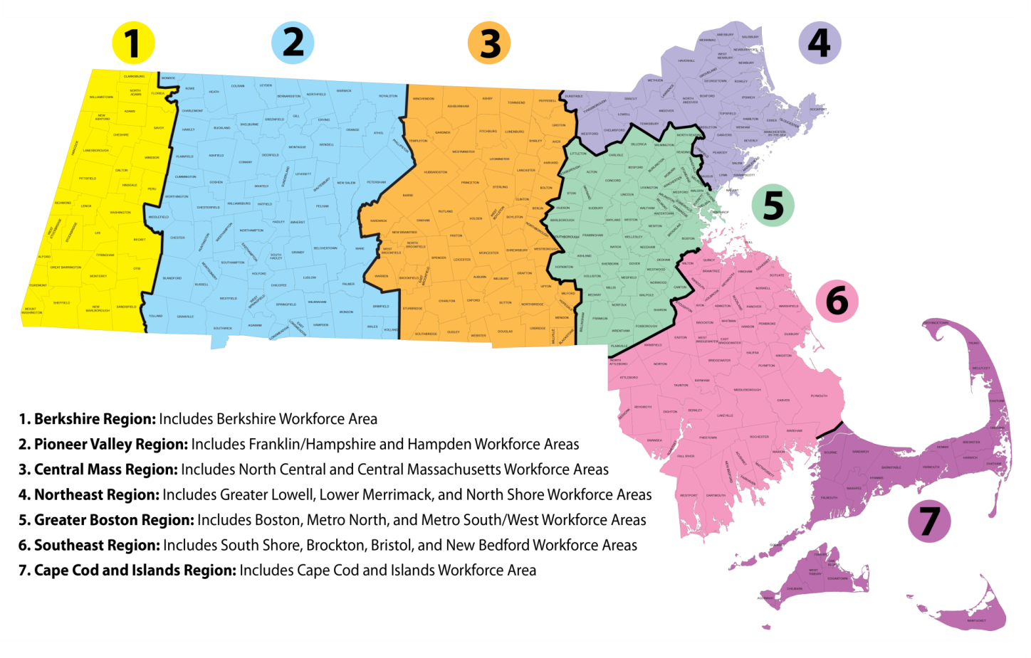
In order to promote a better understanding of the current and projected needs of the workforce system, a second round of regional labor market data packages was released in 2019.

Purpose
This document offers a guiding template for Regional Teams to provide an update to their Regional Labor Market Blueprint. Intended as a resource for external audiences, the update should illustrate how the Regional Team fosters strategic alignment and ensures that the workforce system is industry-relevant, responding to the changing economic conditions and workforce needs of the region.
- Where are we now?
Describe the current state of your region, including a summary of regional industry and occupational priorities, demographic shifts, and gaps between employer demand and employee supply.
Criteria for Priority Industries/Occupations
The regional kick-off meetings with the WSC suggested a number of foundational criteria to prioritize industries and occupations, including existing job openings, jobs with low barriers to entry, jobs that lead to career pathways, and occupations with high demand (current openings, short/long term projections), and self-sustaining wages.
STATE CRITERIA  - High employer demand  - High demand and wages (4+ star ranking)  - Talent gaps (supply-demand ratio)  - Career pathways | REGIONAL CRITERIA  What additional criteria did your Regional Planning Team elect to prioritize?  - Supply Gaps (more openings than qualified)  - Aligned with economic development strategies  - Support industry resilience
Priority Industries and Occupations
Describe the collectively developed industry and occupational priorities for your region.
List your 2-3 priority industries by 2-digit NAICS. Where you have prioritized an industry that does not fit neatly into a 2-digit NAICS code (i.e. creative economy), note where it would best fit (i.e. Arts and Recreation) and describe the portion of the 2-digit industry sector that you prioritized.
Healthcare and Social Assistance: NAICS 62
Manufacturing: NAICS 31-32
Hospitality and Management: NAICS 72
Trades occupations are falling under each of our priority industry sectors.
List 3 to 5 priority occupations or occupational groups by SOC code (4-8 digit, as necessary).
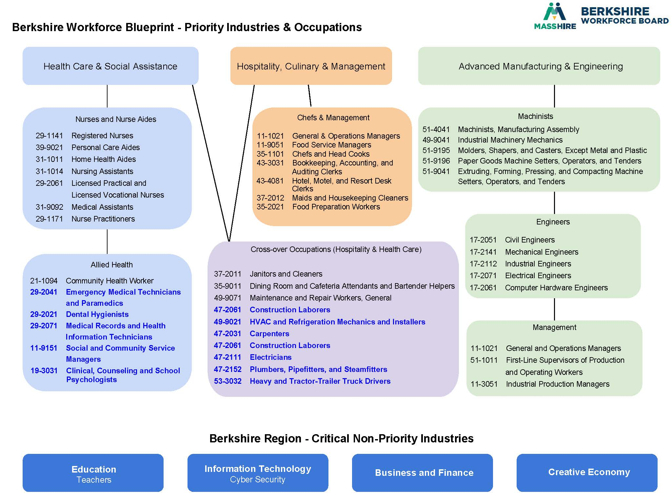

Regional Context
Use the information provided through state data sets (i.e. data packages and dynamic data tools) and additional local analysis to explore the following questions and develop consensus for each section.
Are there any new demographic, labor pool or talent pipeline considerations that will have an impact on labor supply in your region? Age, education, worker mobility, etc.
Berkshire County has the 2nd highest older population in the state. We are seeing an increase in services for those ages 55+, a 2nd home owner population that are moving to the region, and anticipate a spike in the number of people who want to move to a rural community. With the rise in unemployment due to COVID-19, we are also seeing a more skilled workforce looking for new positions.
Have there been any developments related to business and industry that will have an impact on workforce demand in your region? New employers, policies/regulations, etc.
Prior to the pandemic, Wayfair has brought a stronger customer service/retail presence and much higher wage/benefit packages to new employees. Companies are losing quality workers due to the wage disparity.
City of Pittsfield has implemented a strong Red Carpet Team to attract/retain companies in the region.
Berkshire Innovation Center has opened which will provide additional training opportunities and expansion to manufacturing and healthcare organizations.
New Priority Industries and Occupations (Optional)
If the team would like to propose any changes to the articulated list of priority industry sectors and occupations or occupational groups, please use this space to provide an updated list. Include a justification of any changes based on your regional context and mutually agreed upon regional criteria.
List your 2-3 priority industries by 2-digit NAICS. For any proposed changes, write a brief justification of your choice.
There are no proposed changes to priority industries, however we added additional occupations to our crossover occupations including more transportation, trades and construction occupations. There is a stronger need for workers and training in these occupations which fall under our identified critical sectors.
In addition, with a growing need in our region, we added several healthcare and mental health occupations to expand our capacity to help companies find the workforce needed. There have been continuous job postings for EMTs, hygienists, medical recorder, social/community service managers and school psychologists.
List 3 to 5 priority occupations or occupational groups by SOC code (4-8 digit, as necessary). Include a short description justifying any proposed changes. In building the list regions should consider:
- only occupations linked to one or more priority or critical industries;
- occupations ranked 4- or 5-stars;
- occupations that are part of a career pathway; and
- occupations with a restricted “supply” of qualified workers or skilled new graduates
Health Care and Social Assistance: We are proposing to expand the occupations in our Healthcare and Social Assistance priority sector to include the following:
- Behavioral Health and Social Service – As outlined by the Massachusetts Healthcare Collaborative, there is a statewide shortage in behavioral health specialists. There are currently more openings than qualified candidates for Mental Health Counselors and our advisory committees continuously stress the need for support staff within the behavioral health and social service sectors. As demands within behavioral and mental health rise, we need to ensure that this pathway is supported.

- Emergency Medical Technicians and Paramedics, Medical Records and Health Information Technicians, Dental Hygienists – These occupations each see a supply gap of less than 0.50, indicating a need for more qualified individuals. As 3+ star occupations only requiring a postsecondary non-degree award, some college, or an Associate’s degree, these are important pathways to open up to our community.
Cross-Over Occupations: We propose a reorganization of our cross-over occupations, placing previously found occupations into the Hospitality and Culinary sector and expanding the crossover occupations to include the trades.
- The Trades – There are currently few pathways into the trades in Berkshire County, with many training and apprenticeship programs requiring travel to other parts of the state. In the state as a whole, there is a shortage in apprenticeship programs to enter into these career pathways that provide high wages and are in high demand.

- Heavy and Tractor-Trailer Truck Drivers – Employers have shared an immediate need for CDL licensed professionals and monthly labor market analysis has shown an increase in available positions. Currently, interested individuals must travel to Springfield to participate in CDL licensing courses. As an occupation that allows for high wages and is in demand, pathway opportunities should be found within our region and are therefore a priority.

- How are we doing?
Evaluate the strategies you have jointly employed to align the work of multiple systems around your shared vision, mission and goals.
Focusing Resources
Summarize your efforts to align resources that support and meet training and employment needs of priority industry sectors and occupations in your region. (See Appendix D for additional detail.)
Resource Acquisition. Provide a summary of new resources secured to support priority industries and occupations (state, federal, private, etc.).
During FY20, we have secured resources within each of our critical sectors.
- WCTF to develop daytime and online nursing assistant programs (goal to train 70 un/underemployed) - $218K
- EOHED to implement intro to manufacturing, hoisting and welding training (goal to train 55 un/underemployed) - $168K
- TRAIN to implement front of the house, back of the house and hospitality managers (goal to train 25) - $125K
- Capital skills grants - $200K to improve equipment and infrastructures within our educational programs
- Career readiness programming - $200K for K-12 career readiness programming; $350K from private sector wage matches for internships
Resource Allocation. Provide a summary of existing resources re-allocated to support priority industries and occupations.
- Berkshire Taconic Foundation provided $37,500 towards career readiness in all critical sectors
- Berkshire United Way provided $75K towards connecting un/underemployed to employment opportunities
- Jobs4Youth generated $40K for summer programming for at-risk youth, mainly within the hospitality and healthcare sectors.
Expanding Pipelines
Identify your efforts to meet training and employment needs of priority industry sectors and occupations in your region. (See Appendix E for additional detail.)
Pipeline Expansion. Provide a summary of new seats added in programs related to priority industries and occupations.
Berkshire Community College, in an effort to align with our regional workforce blueprint, redesigned their Workforce Development Department to be structured into Healthcare, Manufacturing, and Hospitality. Each branch works to provide both for-credit and non-credit programs to match the needs of employers in Berkshire County. BCC has received TRAIN grants to provide training in hospitality, and partnered with the Berkshire Workforce Board to provide Manufacturing training as well as partnered with BWB and Berkshire Health Systems to provide training in healthcare.
Massachusetts College of Liberal Arts has also expanded their programming, building their healthcare offerings and are taking steps towards starting a new nursing program in the coming year.
The Berkshire Innovation Center was also opened in 2020, which will provide new opportunities for training in the manufacturing sector.
Lever’s Berkshire Interns program provided paid summer internship opportunities to 30 students in 2018 and 44 students in 2019. They have also pivoted to provide virtual internships during the summer of 2020. Many of these internships are in our priority sectors. The Berkshire Intern program aims to show college students the career opportunities that exist here in the Berkshires while also providing networking opportunities in an effort to retain talent.
Pipeline Improvement. Provide a summary of upgraded seats related to priority industries and occupations.
Berkshire Community College plans to add new seats to their Nursing program in the coming year and additional sections of CNA training have been added in a day slot to increase accessibility and number of seats.
MCLA has expanded their Health Sciences Major with programs which support pathway opportunities for Community Health Workers, Personal Care Aides, Medical Assistants, and Community Health Workers.
In addition to providing 383 high school internships; 1,656 K-12 career awareness activities; 1,309 grades 6-12 career exploration activities; and 17 teacher externships in a variety of industries/occupations through our Connecting Activities programming, Monument Mountain Reg. High School established Career Vocational Pathways for manufacturing and healthcare during FY20.
Shared Strategies
While each system may make changes in individual programming to align with the region’s priorities, all systems must commit to shared changes in the following areas, stated below. Describe how your region has worked collaboratively in the following two areas.
Continuous Communication. How often and in what way do you meet to review progress towards shared goals and make course corrections?
The Berkshire Regional Skills Cabinet meets quarterly to discuss our shared goals and to ensure that we are moving our blueprint forward. These meetings review the progress that has been made so far and includes thoughtful conversations on the next steps and goals. Quarterly meetings can also be used to discuss any new data made available to us to ensure that we are making the best decisions for our region. The work of the Cabinet is done through existing committees and task forces coordinated by the Berkshire Workforce Board, Berkshire Regional Planning Commission’s CEDS, 1Berkshire, Berkshire Innovation Center, and the Berkshire Leadership Impact Council in order to not duplicate efforts.
In addition to our quarterly meetings, the Berkshire Workforce Board also publishes a monthly labor market dashboard on our website that breaks down the job openings in the region by occupation family and outlines up-to-date labor market and unemployment information, and shares information with the quarterly Berkshire Practitioner’s Group.
Shared Measurement Systems. What data and measurement systems do you use to support shared understanding of how well you are meeting your goals and making progress towards a shared vision?
Describe specific indicators used to measure performance and effectiveness.
A metrics spreadsheet that contains our goals and strategies was developed and is updated at least annually. This metrics document is sent to the Skills Cabinet as needed. Baseline metrics were determined for each of our goals and strategies and each fiscal year is tracked to look for improvements and progress. Each strategy was approached with a different measurement system to ensure that we are capturing the information that is most useful. While some metrics look at numbers of people affected (i.e., training programs, career readiness, and job fairs), others track meeting convenings and program awareness.
Our career readiness activities are tracked through the DESE’s Connecting Activities database, job seeker information is tracked through EOLWD’s MOSES database, employer data is tracked through BWB’s Airtable database, and additional systems are tracked through Excel and GoogleDocs.
Other Shared Strategies. What other shared strategies do you employ to promote collaboration and strategic alignment among your region’s core partners?
Describe specific steps taken to coordinate workforce development, education, and economic development programs/initiatives.
The Berkshire Region has always seen strong collaboration among our regional partners. The Regional Skills Blueprint aligns with other economic development plans laid out by regional partners. Our Workforce Blueprint parallels with the regional economic 1Berkshire’s Berkshire Blueprint 2.0, which identifies our three priority industries as 3 of their five priority clusters. The Skills Cabinet goals also align with our regional Comprehensive Economic Development Strategy (CEDS) goals.
The Berkshire United Way has a number of initiatives that coordinate with and work towards the goals of the Skills Cabinet, including the Berkshire Leadership Impact Council, which brings together community leaders to strengthen communication and lessen duplication, as well as their Economic Prosperity Impact Council, whose goal is to increase the population living above the poverty line and has supported programming in both healthcare and trades career pathways.
Career readiness, one of the goals of our blueprint, is coordinated within the 12 public school systems in Berkshire County. Most K-12 schools have adopted career programming that aligns with our priorities and all schools have career readiness coordinators and access to career resources. “Career Tree” posters, outlining the pathways within an industry, were created for each priority industry outlined in our blueprint and were shared with each school as well as community youth organizations. In addition, 17 teacher externships occurred within our critical sectors which enhances our career readiness models.
Our Higher Education Institutions have aligned and expanded their programs with the needs of the region and the priorities of our Blueprint. Both MCLA and BCC are active members of the skills cabinet and meet with industry leaders to ensure that they are filling the needs in available career pathways.
Our industry sector partners are also actively engaged with the region’s employment and training Task Forces impacting the healthcare sector and manufacturing/STEM initiatives.
- Where do we want to go?
Summarize your upcoming plans to address the priority industries and occupations identified in the Blueprint.
Priorities. Describe your priorities for 2020. Note that the priorities listed here should be those that need participation of players from multiple entities and across two or three of the systems for accomplishment.
What new programs, initiatives, or policies would you like your team to enact or create related to your priority industries and occupations? What processes would you like to improve?
There were a number of new programs started since the creation of the original blueprint that we will continue to support and increase access to including the TRAIN grant, CNA Training (WCTF), Advanced Manufacturing (EOHED) Training, and expansion of career readiness. The Career Technical Initiative, which looks to expand offerings at vocational schools across the Commonwealth, will be important for the continued growth of our programs here in the Berkshires and is supported by the Skills Cabinet.
For new goals and occupational priorities, CDL licensing and expanded healthcare pathways will be important priorities within our Cabinet. CDL licensing and the heavy tractor trailer and truck driving occupation has a supply gap in Berkshire County according to Burning Glass projections. Employers look for experienced drivers so it will be important to have participation from new and existing partners to find effective pathways into the field. Establishing career opportunities within the Trades occupations will be another avenue that the Skills Cabinet continues to move forward.
In healthcare, both behavioral health and community health workers are a priority. The Berkshire Workforce Board applied for the Healthcare Hub grant to support the convening of our industry, community, and education partners to outline how we will build up our healthcare pathway opportunities as well as design and implement a new training program.
Partnerships. Describe your plans for developing additional strategic partnerships.
Where are you looking for partners to develop a particular pathway, program or initiative related to your priority industries and occupations? How do you plan to coordinate and invest in partnership infrastructure where key industry partnerships are not yet developed?
We have strong partnerships in the Berkshires due to our rural nature and the need to work together. Our goal is to continue to strengthen these existing partnerships, while welcoming any new players, to ensure that we have a cohesive, and non-duplicative pipeline strategy. While advisory committees have been established for each priority sector, we would like to strengthen these committees and empower them to become more action oriented.

Employer Engagement. Describe your plans for maintaining or strengthening employer engagement.
How have you continued to engage employers in the implementation of your region’s blueprint strategies?
We have maintained continuous communication with our business partners, ensuring that they are aware of the blueprint goals and programs results. The Berkshire Recruiter initiative has led to an increase in the number of employers that we meet with and ensured that employers are aware of the resources available as well as ensure that we are aware of the needs of our local employers. While we meet with companies from all industry sectors, we make sure that we are meeting with companies from our priority sectors regularly.
- Conclusion
Conclusion. Provide any closing remarks, next steps, or considerations.
The Berkshires are collaborative by nature due to our rural geography and consistent strategic planning and shared resources. With our strong partnerships and ability to work together towards common goals, we have been able to build and implement a strong workforce development plan for our region.
As we continue to move forward with this regional Labor Market Blueprint, we hope to guide the Skills Cabinet members into action focused goals that will continue to move our region forward. By focusing on our goals and strategies, we can make lasting steps towards a stronger workforce. Continuing to share our successes as a group will allow for better focus and less duplication among programming.
With an aging workforce, a continuous decline in population, and the recent affects of the pandemic, the Berkshire Region is facing unprecedented challenges. Time and time again, we have proven ourselves to be resilient. Unafraid of change, we will continue to adapt through collaboration and innovative thinking.

Appendix A. Regional Planning Team Organization

Regional Planning Team
Regional Planning Team. Describe the different partner organizations brought together to be a part of the Regional Planning Team (K-12 District, Vocational Technical School, Community College, State University, Workforce Development Board, Massachusetts Office of Business Development, Regional Economic Development Organization, and more) and provide contact information.
Individual Name | Organization Name | Individual Email
James Birge | Massachusetts College of Liberal Arts | James.Birge@MCLA.edu
Debra Boronski | MA Office of Business Development | debra.boronski@state.ma.us
Heather Boulger | MassHire Berkshire Workforce Board | heather@masshireberkshire.com
James Brosnan | McCann Technical School (vocational) | jbrosnan@mccanntech.org
Gerald Burke | Hillcrest Educational Centers | jburke@hillcrestec.org
Jonathon Butler | 1Berkshire | JButler@1berkshire.com
Tyler Fairbank | Jiminy Peak Resorts | tfairbank@eos-ventures.com
Melanie Gelaznik | MassHire Berkshire Career Center | MGelaznik@masshireberkshirecc.com
Linda Harrison | General Dynamics-Mission Systems | Linda.Harrison@gd-ms.com
Ellen Kennedy | Berkshire Community College | ekennedy@berkshirecc.edu
Stephanie Kinstle | Miraval | Stephanie.Kinstle@miravalresorts.com
Adam Klepetar | Berkshire Community College | aklepetar@berkshirecc.edu
Brenda Lepicier | Berkshire Health Systems | blepicier@bhs1.org
Tom Matuszko | Berkshire Regional Planning Commission | tmatuszko@berkshireplanning.org
Jason McCandless | Pittsfield Public Schools | jmccandless@pittsfield.net
Beth Mitchell | General Dynamics Mission Systems | beth.mitchell@gd-ms.com
Paul Petritis | Massachusetts College of Liberal Arts | Paul.Petritis@mcla.edu
Eva Sheridan | Main Street Hospitality | Eva.sheridan@mshgmail.com
Ben Sosne | Berkshire Innovation Center | Ben@the-bic.org
Peter Taylor | Berkshire Taconic Community Foundation | ptaylor@berkshiretaconic.org
Candace Winkler | Berkshire United Way | cwinkler@berkshireunitedway.org

Appendix B. Best Practice Documentation (1 of 2)
Note that compiled best practices will be shared across Regional Planning Teams.
Best Practice (BP) Documentation Tool
Using the following template, document two (2) proven processes or initiatives.
Best Practice Identification
Describe a best practice or achievement in support of your vision and strategic goals.
Title | Provide a title and/or brief summary of the best practice. | Career Readiness expansion in every middle/high school
Strategic Alignment | List the associated industry or occupation and Blueprint goal. | Hospitality, Healthcare and Manufacturing
Description | Describe the processes and steps involved. | BWB is leading the charge with school-based liaisons, administrators, and employers to establish college/career teams and centers in each school district. They are striving for every student to graduate with a completed College & Career Plan
Results | Report outcomes, including relevant next steps. | College/career teams created in each school district  Expanded teacher externships and career readiness programming.  Enhanced the number of career awareness, exploration, and immersion experiences for students.
Knowledge Management
Use the following fields as a guide to provide more information for other potential users.
Resources | What resources and skills are needed to apply the BP? | DESE Connecting Activities resources ($200K)  Local employers paid $250K in wages for internships and $250K in career readiness programming in-kind  The ability to convene, develop strategies and implement.
Barriers | Did you encounter any obstacles to applying the BP? How did you solve them? | Challenges with traditional educational ‘culture’ not prioritizing career readiness as an essential learning experience for all students  2012 State prioritization of College AND Career Readiness facilitated needed culture change  BWB provided teachers, administrators and school-based-staff with a series of professional development sessions (2012 – present)  BWB deepened partnerships with school districts to enhance their career readiness models in serving all students and developing College & Career Planning systems (2012-present)  Regional networks (e.g. Berkshire Compact For Education) promoting the importance of Career Readiness for all youth / students in K-12 (2015-current)
Timeline | How long did it take to introduce and implement the BP? | The region’s Career Readiness models within the public school districts (11 districts, 12 high schools) have been in existence since 1998. All districts are partnered with the BWB in offering career readiness experiences to youth in grades K-12
Measurement | Are there performance measures associated with this practice? | Data / performance tracking of all Career Readiness activities in the region is conducted through DESE’s School-to-Career Database. Performance measures include the number of students participating in internships and career awareness, exploration and immersion activities, number of teacher externships, number of host employers, number of students participating in critical sector & STEM experiences, etc.
Commentary | Additional advice, lessons learned, etc. | Through the BWB and the school districts’ longstanding partnerships, it has become widely understood and accepted throughout the community that Career Readiness is an essential component of the learning experience that ensures our young people’s career success and stability within our dynamic and challenging 21st century economy

Appendix C. Best Practice Documentation (2 of 2)
Note that compiled best practices will be shared across Regional Planning Teams.
Best Practice (BP) Documentation Tool
Using the following template, document two (2) proven processes or initiatives.
Best Practice Identification
Describe a best practice or achievement in support of your vision and strategic goals.
Title | Provide a title and/or brief summary of the best practice. | Alignment of Educational Providers with the Workforce Blueprint priorities.
Strategic Alignment | List the associated industry or occupation and Blueprint goal. | Hospitality, Healthcare and Manufacturing
Description | Describe the processes and steps involved. | Educational leaders convened with business leaders to discuss need and strategy, and established protocols and processes to be more aligned with career pathway development including new training opportunities.  BCC revamped their Business and Outreach Division and introduced a workforce development team that includes three directors: Director of Workforce Development: Advanced Manufacturing, Director of Workforce Development: Health Care, Director of Workforce Development: Hospitality. Each of the directors is working on developing educational and workforce development programs (webinars, workshops, certificate programs) aligned with each of the three Berkshire Blueprint areas.  Massachusetts College of Liberal Arts expanded their programming in each of the priority sectors and created solid career pathways in healthcare and manufacturing (STEM).
Results | Report outcomes, including relevant next steps. | Solid career pathway opportunities within each of the industry sectors.  In BCC’s health care workforce development, two profit generating non-credit certificate programs, one in phlebotomy and one in community health work, were established. Both programs are scheduled to start in fall 2020.  BCC’s Fast Track Hospitality enrolled 29 participants in its first year and 40 in its second year. For the 2020 cohort, they accepted 75 students into 4 certificate programs: Front of House, Back of House-Culinary, Beverage Service, and Hospitality Leadership.  Manufacturing trainings have also been established and expanded, with continued growth to programming and partnerships. FY20 results include training 35 un/under employed residents in intro to manufacturing, welding, and hoisting with a 70% entered employment rate.  MCLA added two new courses and enrolled 20 in its first year and 30 in its second year.
Knowledge Management
Use the following fields as a guide to provide more information for other potential users.
Resources | What resources and skills are needed to apply the BP? | Strong leadership and commitment to change. Ability to plan strategically and ensure policies, procedures, and standards are in place to streamline programs and make development of new programs more efficient.  Continued employer and education partnerships, as well as availability of funding for community partners who could be consultants and reviewers of the programs.
Barriers | Did you encounter any obstacles to applying the BP? How did you solve them? | Marketing the programs and recruiting for participants was an early obstacle which was overcome by strong communication efforts and outreach to key stakeholders within the community.  At BCC, one of main obstacles is that Business and Outreach Division and team is relatively new and is learning and fine-tuning programs and offerings. The Division is learning about the best practices at other colleges and discussing how to institute flexible and sustainable processes for Berkshire County.  Funding for new programming is always an obstacle, however, grants and private sector contributions were identified which assisted in implementing the programs.
Timeline | How long did it take to introduce and implement the BP? | There was a 6-month academic planning process followed by an outreach and marketing plan.  Building partnerships with local stakeholders is ongoing and will last a long time.
Measurement | Are there performance measures associated with this practice? | The number of people enrolled in each of the trainings that are offered and the number of trainees that continue within the career field and/or enter into a similar career sector employment opportunity.
Commentary | Additional advice, lessons learned, etc. | Learn from others who are doing similar work – locally, regionally, and nationally.  Have a strong, collaborative network of community partners who are interested in the region’s workforce development.  Both a focus on what is currently needed in the region as well opportunities for the workforce of the future.

Appendix D. Resource Tracker

Resource | Applying Entity | Occupation | Industry | Application Status
Resource #1 | [Name of lead applicant.] | [Associated occupation(s).] | [Associated industry.] | [e.g., Applied/Awarded.]
WCTF | Berkshire Workforce Board | Nursing assistant | Healthcare | Awarded $218K
EOHED | Berkshire Workforce Board | Manufacturing; production | Manufacturing | Awarded $170K
TRAIN | Berkshire Community College | Hospitality – waitstaff, culinary, service oriented | Hospitality | Awarded $125K
Capital Skills | McCann Tech  Berkshire Innovation Center  MCLA  BCC | Entry level manufacturing & STEM occupations | Manufacturing | Awarded $150K
Connecting Activities | Berkshire Workforce Board | All occupations | All sectors | Awarded $200K
Youth Works | MassHire Career Center | All | All | $120K
Berkshire Recruiter | Berkshire Workforce Board | All | All | $75K
Career Readiness | Berkshire Workforce Board | All | All | $37,500
Career Pathway | Monument Mountain Regional High Schools | Entry level healthcare and manufacturing occupations | Manufacturing, Healthcare | $50K
College Internships | Lever | All | All | $25K

Appendix E. Pipeline Capacity Tracker

Program | Provider | Occupation | Industry | Capacity Change
Mechatronics, A.S. (Under Development) | Berkshire Community College | 17-3024.00 - Electro-Mechanical Technicians | Advanced Manufacturing | No Change
Engineering, A.S. | Berkshire Community College | Data not available | Advanced Manufacturing & Engineering/Engineers | No Change
Health Information Management Certificate | Berkshire Community College | 29-2071 Medical Records and health Information Technicians | Health Care and Assistance/Allied Health | No Change
Health Information Management Option, A.S. | Berkshire Community College | 29-2071 Medical Records and health Information Technicians | Health Care and Assistance/Allied Health | No Change
Community Health Certificate | Berkshire Community College | Community Health Worker 21-1094 | Health Care and Social Assistance | No Change
Medical Assisting, A.S. | Berkshire Community College | 31-9092 Medical Assistants | Health Care and Social Assistance | No Change
Nursing, A.S. | Berkshire Community College | 29-1141 Registered Nurses | Health Care and Social Assistance | Additional 25 seats in spring 2021
Phlebotomy Technician Certificate | Berkshire Community College | Phlebotomist 31-9097 | Health Care and Social Assistance | No Change
Practical Nurse (Certificate) | Berkshire Community College | 29-2061 Licensed Practical and Licenses Vocational Nurses | Health Care and Social Assistance | 27 LPN Certificate FY20  57 Associate degree in nursing grades FY20
Culinary Arts Certificate | Berkshire Community College | 35-2021 Food Preparation Workers; Food Service Managers; 35-1101 Chefs and Head Cooks | Hospitality, Culinary & Management/Chefs and Management | No Change
Fast-Track Hospitality & Culinary Program (Non-Credit) | Berkshire Community College | 43-4081 Hotel, Motel, and Resort Desk Clerks; 43-3031 Bookkeeping, Accounting, and Auditing Clerks; 11-1021 General & Operations Managers; 11-9051 Food Service Managers; 35-9011Dining Room and Cafeteria Attendants and Bartender Helpers; 37-2012 Maids and Housekeeping Cleaners | Hospitality, Culinary & Management/Chefs and Management | 29 Certificates received
Hospitality Administration Career Option, A.S. | Berkshire Community College | 43-4081 Hotel, Motel, and Resort Desk Clerks; 43-3031 Bookkeeping, Accounting, and Auditing Clerks; 11-1021 General & Operations Managers | Hospitality, Culinary & Management/Chefs and Management | No Change
Hospitality Administration Transfer Option, A.S. | Berkshire Community College | 43-4081 Hotel, Motel, and Resort Desk Clerks; 43-3031 Bookkeeping, Accounting, and Auditing Clerks; 11-1021 General & Operations Managers | Hospitality, Culinary & Management/Chefs and Management | No Change
CNA | Berkshire Health Systems/Berkshire Community College | 31-1014 Nursing Assistants | Health Care and Social Assistance | Added day section (10 seats per cohort)
WCTF CNA Training – Online Program | Berkshire Healthcare Systems | Certified Nursing Assistants | Healthcare and Social Assistance | Newly developed online program. 3 cohorts of 10 planned.
Jobs4Youth | Berkshire Workforce Board | All | All | 65 youth FY19  42 youth FY20
Career Readiness | Berkshire Workforce Board in collaboration with 12 public high schools | All | All | 389 Internships; 172 STEM
College Internships | Lever, Inc. Berkshire Interns Program | All | All | 30 in 2018  44 in 2019
MACWIC Level 1 | MassHire/Berkshire Community College/Taconic High School | Machinists 51-4041 | Advanced Manufacturing | 8 completed training; 5 employed FY20
McCann/Berkshire Workforce Board Adv Manufacturing | McCann Technical School | Machinists 51-4041 | Advanced Manufacturing | 7 completed training FY19; 4 entered employment  14 completed training FY20; 10 entered employment
Dental Assisting Certificate | McCann Technical School | Dental Assistants 31-9091 | Health Care and Social Assistance | 10 completed training FY20
Medical Assisting Associates and Certificate programs | McCann Technical School | Medical Assistants 31-9092 | Health Care and Social Assistance | 4 completed training FY20
Practical Nursing Certificate | McCann Technical School | Licensed Practical and Licensed Vocational Nursing 29-2061 | Health Care and Social Assistance | 12 completed training FY20
Surgical Technology Certificate | McCann Technical School | Surgical Technologists  29-2055 | Health Care and Social Assistance | 8 completed training FY20
Electricians Program | McCann Technical School | Electricians 47-2111 | Manufacturing & Engineering | No Change
Business Administration General Business Concentration | MCLA | General and Operations Managers | Advanced Manufacturing & Engineering | No Change
Electrical Engineering Concentration | MCLA | Electrical Engineers | Advanced Manufacturing & Engineering | No Change
Community Health Major | MCLA | Community Health Worker | Health Care & Social Assistance | No Change
Health Sciences Major | MCLA | Personal Care Aides, Medical Assistants, Community Health Worker | Health Care & Social Assistance | No Change
Pre-Medical Professions Concentration | MCLA | Personal Care Aides, Medical Assistants, Community Health Worker | Health Care & Social Assistance | No Change
Sociology Major | MCLA | Social and Community Service  Managers | Health Care & Social Assistance | No Change
Business Administration Accounting Concentration | MCLA | Bookkeeping, Accounting, and  Auditing Clerks | Hospitality, Culinary & Management | No Change

Business Administration General Business Concentration | MCLA | General & Operations Managers | Hospitality, Culinary & Management | No Change
Clincal Medical Assisting | Mildred Elley | Medical Assistants 31-9092 | Health Care and Social Assistance | No Change
Practical Nursing | Mildred Elley | Licensed Practical and Licensed Vocational Nursing 29-2061 | Health Care and Social Assistance | No Change

Appendix F. 2020 Progress Report

Goal | Strategy | Progress
Conduct asset inventory of initiatives to identify partners, gaps, and duplications, and align stakeholders. | - Conduct Asset Inventory  - Identify and update metrics and develop a data gathering tool  - Identify a single point of contact for workforce development. | As asset inventory was conducted and the MassHire Berkshire Workforce Board was identified as the point of contact for Workforce Development in Berkshire County.  A metrics document was created and is continuously updated to track goals and strategies.
Increase Pipeline Activities | - Expand career readiness programming within the K-12 system  - Expand career readiness programming into middle schools  - Expand college internships  - Expand on-campus visits with employers  - Identify impacts of adult job/career fairs  - Educate parents and community members about career opportunities that exist in the region | We have seen an increase in CCR programming in both K-12 (2,373 students impacted in FY2018, up to 2,919 in FY19) as a whole and in middle schools (1,455 students impacted in FY2018, up to 1,634 in FY19).  A new volunteer network of professionals, Career Readiness Volunteers, was created and connected schools with professionals for a variety of volunteer opportunities, from mentoring to mock interviewing. 40 mentors have been engaged.  The Berkshire Interns (formally Berkshire Business Interns) program coordinates college internships in area business. They served 30 college students in 2018 and 44 in 2019.  A variety of local companies also host their own internship programs. Lever hosted a business-intern meet and greet for 50 students and 20 employers.  2 MassHire Career Fairs reached 300 job seekers and engaged 112 employers.  Q4 MassHire Career Fairs pivoted to virtual opportunities.  MassHire implemented 12 targeted job fairs for various industries including healthcare and manufacturing. These engaged 60 companies and hundreds of job seekers.  1Berkshires’ The Jobs Thing posted 300+ job opportunities.  Various community-based initiatives aimed at educating the community about job opportunities in our region.  The Berkshire United Way’s Economic Prosperity Impact Council spearheaded a marketing campaign that looks educate members of the community in the number of available positions and pipeline opportunities within the field of Healthcare.
Attract and retain skilled workers within critical industry sectors | - Expand Recruiter Initiative to connect millennials, experienced workers, and relocating families to workforce services  - Support 1Berkshire initiatives in attracting and retaining millennials  - Increase the number of on-the-job training opportunities and apprenticeships in priority occupations  - Change the narrative about employment in the Berkshires  - Establish short term and certificate programs and stackable credentials  - Create a user-friendly job opportunities webpage that connects initiatives | The Berkshire Recruiter hosted bi-weekly Career meet-ups targeted towards millennials and experienced workers, reaching 118 individuals during FY19 and 120 during FY20 with a job placement rate of 72%.  12 On-the-job training opportunities were provided through our manufacturing initiatives.  Our economic development partners and 1Berkshire are marketing the Berkshires outside the region and highlighting the strength of our cultural institutions, outdoor activities, and work-life balance.  1Berkshires also created a jobs portal that highlights full time jobs opportunities that pay more than $40k a year and market that outside the region as well.  Educational partners are working to expand short term certificate programs (see program tracker).
Develop and enhance the Advanced Manufacturing & Engineering career pathway | - Identify regional advisory task force  - Identify baseline industry sector employment statistics, including vacancy data  - Develop pilot training program  - Cross-reference trainees with local employment and college placement | Berkshire Workforce Board established and convened the manufacturing advisory twice during FY20 and FY19.  5 Manufacturing training programs were provided to 40 un/underemployed Berkshire individuals with continued tracking of those graduates as they enter the workforce  Stackable credentialing programs were also provided based on needs of employers. Examples include welding, hoisting, and waste treatment.
Develop and enhance the Healthcare & Social Assistance career pathway | - Identify regional advisory task force  - Identify baseline industry sector employment statistics, including vacancy data  - Develop pilot training program  - Cross-reference trainees with local employment and college placement | Berkshire Workforce Board’s healthcare advisory committee has continued to convene regularly.  Based on needs of this committee and the needs seen in vacancy data, the BWB applied for and was awarded a 2-year grant to train certified nursing assistants (goal of 70 by the end of grant cycle). Training was anticipated to begin in FY20 but was halted due to the pandemic. This program will include tracking of participants.
Develop and enhance the Hospitality, Culinary & Management career pathway | - Identify regional advisory task force  - Identify baseline industry sector employment statistics, including vacancy data  - Develop pilot training program  - Cross-reference trainees with local employment and college placement | 1Berkshire (a merger of the Berkshire Chamber of Commerce, Berkshire Visitor’s Bureau, and Berkshire Creative Economy) has been identified as the hospitality advisory committee and meets regularly.  Berkshire Community College received funds and ran a pilot TRAIN program for a fast track culinary and hospitality trainings.  This program received funding in FY20 as well and is working to adapt to new guidelines for education.
To improve inter-city and intra-regional public transportation | - Explore and asses public transportation system to meet needs of employers and workers  - Establish an inventory of public transit option in the region  - Be proactive with high-speed rail  - Explore cross-state-border synergy | The Berkshire Regional Planning Commission compiled results on a Transportation survey as well as compiled an inventory of transportation options in the region in FY19.  Key Berkshire stakeholders are involved with conversations surrounding a high-speed rail in Massachusetts that reaches the Berkshire region.  They have also been involved in starting the Berkshire Flyer train access from New York to Pittsfield to increase cross-border travel.
To become more intentionally connected to the Massachusetts and Tri-State Innovation Economy | - Create a cross-state border task force to identify options for partnering and training opportunities linked to critical sectors | The Berkshire Innovation Center was built and opened in FY20 which is a hub of cross-border innovation. They will be a resource for training opportunities in advanced manufacturing.  Connecting to the Tri-State Innovation Economy will be a priority during FY21.
To establish a communication plan for blueprint implementation | - Establish regular meetings of Workforce Skills Cabinet  - Establish regular meetings of voc-tech providers to guide programming and connect with key partners in industry  - Provide and annual update to the community  - Provide quarterly LMI updates on partner websites. | The Berkshire Regional Skills Cabinet meets quarterly to discuss progress, review projects, and future goals.  A Jobs Dashboard containing job vacancy data and employment figures is updated and distributed monthly from the BWB.  A FY20 Workforce Annual Update will be provided to our key stakeholders and posted on the Berkshire Workforce Board website.

Appendix G. 2022 Progress Report

Goal | Strategy | Progress
Goal #1 | - Goal #1 – Strategy  - Goal #1 – Strategy  - Goal #1 – Strategy | [Describe your achievements, as well as any noteworthy challenges or opportunities related to this goal.]
 | N/A

Appendix H. COvid-19 impacts

Initial thinking on Labor Market impacts in our region due to COVID-19
- How have your priority industries been impacted by COVID-19?
We anticipate that all of our critical sectors will remain priorities throughout FY21. Each of sectors in the Berkshires have been impacted by COVID-19 but in different ways.
The Healthcare/Social assistance industry saw a 15% drop in demand in services, however, are still recruiting for critical healthcare positions. There were more than 349 postings (6/20).
Although many of our small manufacturing companies were able to pivot their product and continue operations during the pandemic, there was an 8% drop in demand. Many others were forced to downsize and/or close due to limited orders and staffing needs. One major company in North Adams decided to close their operations impacting 230 jobs. There were more than 38 job postings (6/20).
Our accommodation and Food Service industry/hospitality sectors took a critical blow with a 51% drop in demand and 75% were forced to temporarily shut down impacting 4,400 jobs with an estimated payroll of $150M. These sectors are struggling with an estimated impact on the economy of $825M (Tanglewood, Jacobs Pillow, Kripalu, etc.). There are 131 job postings (6/20).
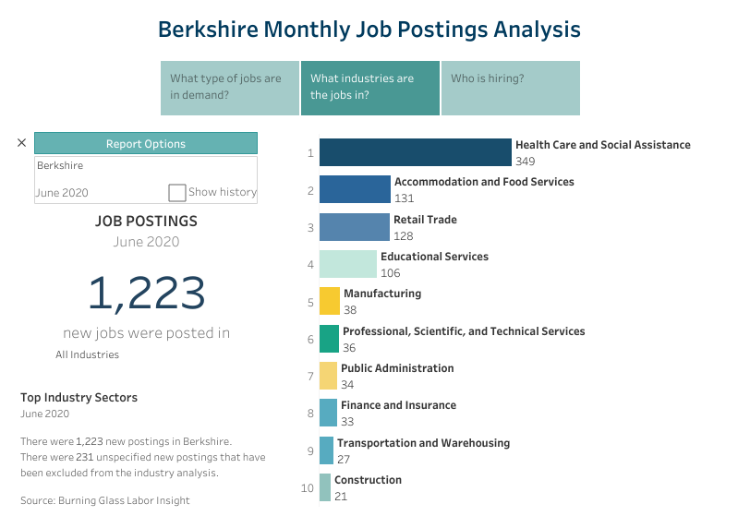
We will continue to utilize EOLWD and other data tools to monitor regional industry and occupational trends and modify our strategies throughout FY21.
Hundreds of our small businesses took advantage of PPP to keep their employees on board. The Berkshire Workforce Board assisted 224 companies access rapid response, WorkShare, furloughs and layoff information. The MassHire Career Center continues to post hundreds of job opportunities.
- At this time, what do you envision to be the top 3-5 priority occupations impacted by COVID 19?
Food preparation, nursing, construction, personal care and service, production, and truck drivers/transportation were all identified as occupations that will be the most impacted by the pandemic. A rise in the need for behavioral health specialists was identified, as well as educational occupations. Behavioral health was already facing a shortage and with the rise in mental health problems stemming from the pandemic, an increase in need is expected
- What education/training programs in your region are still available and able to retrain the unemployed population for job openings in your region?
Intro to Manufacturing trainings were halted at various stages of completion at the onset of the pandemic. Some participants have been able to return to finish the hands-on portion of their training while others were able to deploy a more virtual continuation of their instruction. Remaining funds from the shortened instruction were diverted into On-The-Job Training opportunities.
Nursing programs and CNA training programs have been established during FY20, and are currently pivoting to on-line training while figuring out classroom sizes available for social distancing for the clinical components.
Fast-Track Hospitality training will be deployed virtually.
The MassHire Berkshire Career Center continues to work virtually and provide online workshops and webinars and jobseekers still have access to Individual Training Accounts.
Summer Youth Programs are being held in a more virtual manner in agriculture and customer service.
The Berkshire Recruiter initiative pivoted its career meet ups to on-line workshops.
MassHire Career Center established several virtual job fairs to connect employers with potential talent.
- What are the overall top 3 challenges you anticipate facing in FY21 in deploying training solutions?
Finding and retaining qualified candidates to enroll and participate in the training.
Finding space that allows for social distancing and keeping class sizes small were discussed as challenges for any in-person trainings.
There is also a challenge in the inability to plan ahead, as there is uncertainty to how the COVID-19 pandemic will continue to develop.

- What are the largest challenges that you anticipate jobseekers in your region will face in attempting to return back to work?
A number of challenges exist including lack of childcare and the loss of summer and school programming, transportation limitations (especially for those who rely on public transportation, and concerns over health and safety.
As many trainings and opportunities move to a digital infrastructure, many jobseekers may have trouble with the rising dependence on technology. While some may face broadband and connection issues, others may not feel comfortable with technology or know how to use it. Equipment loan programs and support with technology will be crucial moving forward.
The Berkshires faced a large job vacancy rate prior to COVID-19 due to a decreasing and aging workforce, and we continue to have more than 1,200 jobs posted in the region. In addition to attracting/retaining skilled talent, we remain concerned that the Unemployment Assistance benefits will deter many job seekers from being motivated to return to work. It is interesting, however, as our region is seeing an increase of second home owners and people exiting the cities and coming to the Berkshires, so that might work in our favor.

