INDOOR AIR QUALITY ASSESSMENT

**Bernardston Elementary School**

37 School Road

Bernardston, MA

**July 2024**

Prepared by:

Massachusetts Department of Public Health

Bureau of Climate and Environmental Health

Indoor Air Quality Program

Contents

EXECUTIVE SUMMARY 3

BACKGROUND 5

RESULTS AND DISCUSSION 5

Ventilation 6

HVAC System Maintenance 6

HVAC Types and Specific Conditions 7

Water Damage and Moisture Concerns 8

Sources of Respiratory Irritants/Possible Asthma Triggers 9

Other IAQ Issues 10

[CONCLUSIONS AND RECOMMENDATIONS 11](https://massgov-my.sharepoint.com/personal/stefanie_santora_mass_gov/Documents/Desktop/bernardston-es-june-2024.docx#_Toc171676912)

REFERENCES 15

[FIGURES 16](https://massgov-my.sharepoint.com/personal/stefanie_santora_mass_gov/Documents/Desktop/bernardston-es-june-2024.docx#_Toc171676914)

PICTURES 17

Table 1 27

Table 2A 31

Table 2B 32

Table 2C 33

Table 3 34

Table 4 36

# EXECUTIVE SUMMARY

The Massachusetts Department of Public Health’s Indoor Air Quality Program (MDPH IAQ) conducted an IAQ assessment of Bernardston Elementary School located at 37 School Street in Bernardston on May 23, 2024. This assessment was requested by the Facilities Director of the Pioneer Valley School District.

Any building can have IAQ issues. These issues can be made worse through conditions common to marginalized communities (Environmental Justice communities or EJ) such as inequitable exposure to outdoor air pollution and a greater likelihood of poor building conditions leading to deterioration of IAQ resulting in higher asthma rates. Bernardston Elementary School is not within an EJ community. Note that the pediatric asthma rate for this school as of 2023 is 10.3%. While this rate is not statistically significantly different from the statewide pediatric asthma prevalence rate, it is, however, higher than the statewide rate of 9.9% (MAEPHT, 2024).

The assessment was conducted by evaluating several key elements within the school; a visual inspection of the heating, cooling, and ventilating (HVAC) systems, water/microbial damage, cleanliness, point sources of respiratory irritants such as chemicals, and electronic measurement of carbon dioxide (CO2), carbon monoxide (CO), temperature, relative humidity (RH), and small particulate matter (PM2.5) all taken with a Qtrak XP monitor. Data is collected in this manner to identify potential asthma triggers, allergens, and other environmental factors that can cause indoor air quality symptoms. Please refer to the [Indoor Air Quality Manual](https://www.mass.gov/lists/indoor-air-quality-manual-and-appendices#indoor-air-quality-manual-) on the MDPH website for methods, sampling procedures, and interpretation of results.

As a result of this assessment, there are several findings: while most conditions found in this school are typical of elementary schools of this age and type, this school building lacks operational mechanical ventilation in a majority of rooms. That means that it relies on open windows during all times of the year to provide fresh air. This represents a balancing act – while opening windows can bring in fresh air, it can also allow outdoor pollutants, such as vehicle exhaust, pollen, mold spores, wildfire smoke, pests, and noise into the building. Excess water vapor during hot, humid weather and/or heavy rain may also enter the building to cause water damage to building materials. In addition to this, univents and other heating, ventilation, and air conditioning (HVAC) components may be beyond their lifespan. Some water damage in the form of stained ceiling tiles was noted in the building. Univents and baseboard heaters were also found to be blocked by classroom materials, making air circulation and temperature control difficult. No obvious signs of mold, including visible mold growth, moldy or musty odors, were noted during the assessment. Materials used in construction of schools of this age, such as concrete, hard wood, plaster, vinyl floor tile, and brick, are resistant to mold growth. (Results and Discussion)

Upon review of these findings, a number of primary recommendations are made to optimize existing systems and improve air exchange (Conclusions)

* Have the HVAC system evaluated and balanced by a professional to ensure operability of mechanical ventilation, increase air exchange, lower humidity, and increase effectiveness of mini-split cooling systems in all rooms.
* Until the HVAC system becomes fully operational, keep at least some windows open in occupied classrooms without mechanical ventilation unless there are outdoor pollutant conditions causing odors or occupant discomfort.
* Use air purifiers in every occupied room that lacks mechanical ventilation. Facility staff should work with occupants to place air purifiers where they will be most effective including placing so the filtered airstream is in the breathing zone of occupants. Units that use HEPA filters with or without carbon filters are good choices for occupied areas; units that may produce ozone should not be used. Maintain all in accordance with manufacturer’s instructions.
* Move classroom materials away from univents and heating vents in all rooms to ensure proper air circulation and temperature control. (Conclusions and Recommendations)

Please note: this report contains a series of recommendations that should serve as Best Practices that apply to most public-school buildings across the Commonwealth and should be shared amongst other buildings in the school district.

# BACKGROUND

|  |  |
| --- | --- |
| Building: | Bernardston Elementary School (BES) |
| Address: | 37 School Street,  Bernardston, Massachusetts |
| Coordinated Via: | Facilities Director Gretchen Licata, Pioneer Valley Regional School District, Northfield, MA |
| Reason for Request: | General indoor air quality (IAQ) issues |
| Date of Assessment: | May 23, 2024 |
| Massachusetts Department of Public Health/Bureau of Climate and Environmental Health (MDPH/BCEH) Staff Conducting Assessment: | Stefanie Santora, Environmental Analyst, IAQ Program |
| Building Description: | The BES is a large brick faced one story building with an occupied basement. It was originally constructed in 1956 with a large renovation and addition in 1999. The school contains general classrooms, offices, and accessory rooms including a gymnasium, cafeteria, and kitchen. |
| Windows: | Some windows in the building are openable. |

# RESULTS AND DISCUSSION

The following is a summary of indoor air testing results (Table 1)

|  |  |  |
| --- | --- | --- |
| * ***Carbon dioxide (CO2)*** | *a measure of the adequacy of ventilation* | Levels were within/close to the MDPH guideline of 800 parts per million (ppm) in most of the areas surveyed with several areas above the guideline. This is due to the lack of operational mechanical ventilation in most areas of the school. |
| * ***Temperature*** | *a measure of comfort* | Was mostly within/close to the MDPH recommended range of 70°F to 78°F in occupied areas. |
| * ***Relative humidity*** | *a measure of comfort and, when in excess for an extended period, a way to reflect the potential for mold and fungal growth* | Was above the MDPH recommended range of 40 to 60% in most areas tested. This is reflective of outdoor conditions. Relative humidity would be expected to be higher during hot, humid weather, however this is mostly due to open windows in most classrooms during hot humid weather in conjunction with a non-operational mechanical ventilation system. |
| * ***Carbon monoxide***   ***(CO)*** | *a product of combustion that can result in acute and long term cardiovascular, respiratory, and neurological symptoms* | Levels were non-detect (ND) in most rooms, with the exception of 4 rooms with levels of 1.0 ppm. |
| * ***Particulate matter (PM2.5)*** | *a way to measure inhalable particle distribution in the air* | Concentrations were below the National Ambient Air Quality Standard (NAAQS) of 35 micrograms per cubic meter (μg/m3) in all areas tested. |

## Ventilation

Ventilation refers to both the supply of fresh air and the removal of stale air from a room. The introduction of fresh air into an occupied space will dilute normally occurring pollutants that are generated by occupancy and other activities. In addition, an HVAC system will remove pollutants from a building if operating appropriately. All ventilation systems throughout the building should operate continuously during periods of occupancy.

Most classrooms at BES have a combination of unit ventilators (univent, Picture 1) and air handling units (AHU). Univents bring in fresh air from a vent on the outside of the building (Picture 2), filter, heat it, and supply the air through a vent on the top. Some air is recirculated along with the fresh air through a vent at the bottom. AHUs supply fresh air through supply vents in the ceiling (Picture 3) and return vents return air to the AHU.

Most rooms in the BES do not have *operational* mechanical ventilation, due to the HVAC system not being serviced. It was reported that the BES does not have facilities personnel to manage the HVAC system and the only servicing that occurs is annual replacement of the Minimum Efficiency Rating Value (MERV) filters. The only current source of fresh air in most rooms is openable windows with the exception of a few rooms where the mechanical ventilation appears to be functional. (Table 2B).

Heat in rooms is provided by baseboard radiators in the original section of the school (Picture 4) and univents in the newer portion (Picture 5).

Cooling is provided in some rooms by wall-mounted mini-split/ductless air conditioners, and in others by portable air conditioners, all of which were operating at the time of the visit. Note that in one room, a portable air conditioner was vented through an openable window which was closed at the time of the assessment (Picture 6).

The various types of ventilation components as well as devices that can move/redirect airflow that were identified in the building are listed in Table 2A, Table 2B and Table 2C.

### HVAC System Maintenance

* As noted by the Facilities Director, the BES does not have facilities staff to maintain the HVAC system, and it is unclear when it was last serviced. Most rooms did not appear to have operational intake and exhaust vents.
* It was reported that MERV filters are replaced annually, however it is unclear what the MERV rating is on the filters.
* Many of the baseboard heaters and univents were blocked with classroom materials and furniture (Pictures 7 and 8).
* The air handling unit (AHU) equipment serving the original portion of the school may be >25 years old. These units, if they have not been replaced since installation, may be beyond their service life. According to the American Society of Heating, Refrigeration, and Air-Conditioning Engineering (ASHRAE), the service life of this type of unit is 15-20 years, assuming routine maintenance of the equipment (ASHRAE, 1991).

**Balancing**

To have proper ventilation with a mechanical supply and exhaust system, a system must be balanced to provide an adequate amount of fresh air to the interior of a room while also removing stale air from the room. It is recommended that HVAC systems be re-balanced every five years to ensure adequate air systems function (SMACNA, 1994).

### HVAC Types and Specific Conditions

(see HVAC pictures)

**Additional HVAC Conditions:**

* **In rooms without current operational mechanical ventilation, which is the majority of rooms, open windows are the only source of fresh air**. This means that windows should be opened during most occupied periods to provide some air exchange. It is difficult to maintain comfortable temperatures in all seasons while opening windows. In addition, open windows during heavy rain or hot, humid weather can bring in significant amounts of moisture which not only increases discomfort but can lead to water damage and mold growth.
* **The storage closet for books houses a desk and two chairs, indicating that it is occupied in some capacity.** Note that this storage area is not equipped with a fresh air supply or exhaust vent.
* **Nine rooms are equipped with mini-splits for cooling purposes.** It is important to ensure that all windows in these rooms remain closed while these units are in use. Filters should be cleaned/changed as per the manufacturer’s recommendation, or more frequently if needed. Note that mini-splits are not a source of fresh air.
* **Air purifiers were also found in classrooms (Picture 9).** Without an operational HVAC system, use of air purifiers is the only means by which indoor air can be filtered in classrooms. Air purifiers should be placed away from walls to ensure proper air intake. Note that many of BES’ air purifiers are placed in close proximity to classroom walls. This location may prohibit proper air intake and filtration.
* **A grilled vent was present in the wall between the kitchen and the cafeteria (Picture 10).** This vent likely serves as a make-up air vent for the kitchen exhaust and provides some exhaust ventilation for the cafeteria when the kitchen hoods are in operation. Kitchen exhaust ventilation should always be running when cooking is being performed to remove smoke and odors**.**
* **As most rooms in the building lack operational exhaust ventilation, it is even more vital to control airborne contaminants that may be brought in or generated inside classrooms.** This is discussed further in the sections below.

## Water Damage and Moisture Concerns

Please note that the IAQ Program does not recommend conducting mold testing in a typical water damage remediation. For details, please consult [Guidance Regarding Testing for Mold in Water-Damaged Public Buildings](https://www.mass.gov/info-details/guidance-regarding-testing-for-mold-in-water-damaged-public-buildings) | Mass.gov

The application of a mildewcide to moldy porous materials is not recommended.

Molds are found naturally in our environment both indoors and outdoors. Inside, mold growth may occur when items, particularly porous products such as paper or gypsum wallboard, are exposed to moisture. Typical water sources include leaks, floods, and condensation. To avoid mold growth, dry all water-damaged items and affected areas within 24-48 hours and reduce indoor humidity. Some people with chronic respiratory conditions, such as asthma, are more likely to experience health symptoms associated with molds, including allergic reactions and respiratory irritation. Controlling moisture is the key to preventing mold growth and potential health symptoms.

Hot humid summers are becoming more frequent due to climate change. Massachusetts has experienced hot, humid, and rainy summers in 2018, 2021, and 2023. July of 2021 was the wettest ever recorded in Massachusetts, and the three-month period from June through August, known as the meteorological summer, was the fourth wettest on record, according to the National Oceanic and Atmospheric Administration’s (NOAA) Centers for Environmental Information (NOAA, 2021). The summer of 2023 was also hot, and wet, being measured as the second rainiest on record (WBUR, 2023). These conditions are challenging for buildings, particularly those without air conditioning.

During these hot and wet summers, extended periods of outdoor relative humidity above 70% occurred. Under these weather periods, public buildings experienced extended periods of water vapor exposure from high relative humidity. When exposed to these conditions, porous materials such as gypsum wallboard, cardboard, and other materials may become prone to developing mold colonization, particularly if located in areas that are prone to developing condensation on floors and walls (e.g., below grade space).

* **Water-damaged ceiling tiles were found in a few locations (Pictures 10 and 11; Table 1),** which can indicate current/historic roof/plumbing leaks or other water infiltration. Water-damaged ceiling tiles can provide a source of mold and should be replaced after a water leak is discovered and repaired.
* **Bowed or sagging ceiling tiles were found in some locations (Picture 12).** This is likely the result of moisture exposure from elevated relative humidity conditions.
* **Plants were noted in some classrooms and offices (Pictures 13 and 14; Table 1).** Plants can be a source of pollen or mold especially if overwatered or not well maintained. Plants should also not be placed in the airstream of univents to prevent the aerosolization of pollen and mold.
* **Ductless mini-split air conditioners create condensation which needs to be drained.** Drain tubing and associated pumps should be checked periodically to prevent leaks due to clogs or malfunctions. Porous items should not be stored underneath these units.
* **A small tabletop water fountain was found in an office (Picture 15),** which can be a source of both odors and respiratory irritants.
* **Cardboard boxes and materials were stored against the basement wall (Picture 16).** Porous items should be elevated on shelves or pallets and not stored against walls or on the floor to prevent getting wet from condensation on the cool surface of the floor and wall.
* **An exterior double door was found to have a gap in-between the doors** which can be a source of drafts, moisture, and pest entry (Picture 17)**.**
* The exterior of the building was inspected for sources of water infiltration and related irritants. **Several trees were observed near the building where they can be a source of pollen, mold, and insects into the building (Picture 18).**

A list of water damage issues identified inside and outside the building is included as Table 3.

(see Water Damage and Moisture Concern Pictures)

**Mold Growth**

Porous materials (e.g., gypsum wallboard, ceiling tiles and carpeting) can be dried with fans and heating within 24 to 48 hours of becoming wet (US EPA, 2008).

If porous materials are not dried within this time frame, mold growth may occur.

## Sources of Respiratory Irritants/Possible Asthma Triggers

Asthma is a lung disease that can make breathing difficult. Without careful management of asthma, some people can have symptoms, like a tight feeling in the chest, shortness of breath, coughing, or wheezing. Although there is no cure for asthma, people with asthma can live healthy, active lives. A safe and healthy environment helps to reduce asthma symptoms.

**Comparison of Local and State-wide Asthma Rates (2023)**

10.3% of children

have asthma

**Bernardston ES**

9.9% of children

have asthma

**Massachusetts**

8.8% of children

have asthma

**Bernardston**

* **Sometimes, learning tools and personal items in a classroom can be a source of irritants.** For example, a bird or insect nest is a great learning tool for students but may harbor microbes and allergens, as does a fish tank which could be a source of odors, found in a BES classroom (Picture 19). Similarly, food-based projects can attract pests that carry disease or trigger allergies.
* **Dust, a common respiratory and eye irritant, can collect on surfaces and items.** Although janitorial and maintenance staff perform routine cleaning in classrooms, they may not be able to clean as effectively if classroom items are not picked up or surfaces are cluttered.
* Even with a properly functioning ventilation system, it is necessary to reduce the use of materials that can be a source of respiratory irritants to prevent symptoms in individuals who have sensitivity to such pollutants. **Without operational mechanical exhaust in most areas, irritants can linger.**

For guidance on maintaining an asthma-friendly healthy school environment, please consult the MDPH Asthma Prevention and Control Program’s [Clearing the Air: An Asthma Toolkit for Healthy Schools](https://www.maasthma.org/schooltoolkit).

Possible asthma triggers and/or airborne pollutants exist in the building. These are listed below as well as in (Table 4).

(see Sources of Respiratory Irritant Pictures)

* **Many classrooms had area rugs (Table 1), as most rooms were tiled.** Area rugs need to be cleaned regularly to remove dust, debris, and odors. Area rugs should be stored off the floor in a climate-controlled area during the summer to prevent moistening by condensation. Used area rugs should not be brought into the school as they may harbor allergens such as pet dander.

## Other IAQ Issues

*Radon*

Radon is a naturally occurring radioactive gas that seeps into buildings from the surrounding soil and at elevated levels can increase the risk of lung cancer.

The Environmental Protection Agency (EPA) conducted a National School Radon Survey “in which it discovered nearly one in five schools has at least one schoolroom with a short-term radon level above the action level of 4pCi/L (picocuries per liter) – the level at which the EPA recommends that schools take action to reduce the level” (US EPA, 1993).

**The MDPH IAQ Program therefore recommends that every school be tested for radon, and that this testing be conducted during the heating season while school is in session in a manner consistent with US EPA radon testing guidelines**. Radon measurement specialists and other information can be found at [www.nrsb.org](http://www.nrsb.org) and <http://aarst-nrpp.com/wp>, with additional information at: <https://www.mass.gov/radon>.

# CONCLUSIONS AND RECOMMENDATIONS

Please note: this report contains a series of recommendations that should serve as *Best Practices* that apply to most public-school buildings across the Commonwealth and should be shared amongst other buildings in the Somerville School District.

Issues typical to many schools were found in this building. However, the lack of operational mechanical ventilation in most classrooms makes controlling temperature, humidity, and airborne contaminants significantly more difficult. Facility staff and occupants need to remain aware of the limitations of the system, use open windows and portable air conditioners to the best that they can be used. If the HVAC system becomes operational, the age of the equipment will make controlling the temperature and airflow more difficult as time goes on.

**Short-term recommendations** can be implemented as soon as practicable, however **long-term measures** are more complex and will require planning and resources to adequately address overall indoor air quality issues within the building.

|  |  |  |  |
| --- | --- | --- | --- |
| **Short-term Recommendations** | | | |
|  | **HVAC System** | | **Helpful Links** |
|  | Have the HVAC system serviced and maintained by an HVAC professional. |  | |
| 1. If | If univents are made operational, ensure all univents are on and operating continuously during occupied periods. If univent fan operation is linked to thermostat, work with HVAC vendor to operate independently as to not cycle off/on during the school day. |  | |
|  | Keep at least some windows open in occupied classrooms without operational mechanical ventilation unless contraindicated by outdoor conditions or occupant concerns. Such conditions may include heavy precipitation, extreme cold, poor outdoor air quality, high pollen counts, idling vehicles, or excessive noise. | <https://www.airnow.gov/> | |
|  | Ensure windows are closed tightly at the end of the day. |  | |
|  | Air purifiers should be placed so the filtered airstream is in the breathing zone of occupants. |  | |
|  | Air purifiers that use HEPA filters, with or without carbon filters, are good choices for occupied areas. Units that may produce ozone should not be used. Maintain all in accordance with manufacturer’s instructions. | <https://www.epa.gov/indoor-air-quality-iaq/ozone-generators-are-sold-air-cleaners> | |
|  | Once the HVAC system is serviced, air handling units that serve those rooms with mechanical ventilation should have filters changed at least twice a year using the best Minimum Efficiency Rating Value (MERV) that can work with current equipment. | [ANSI/ASHRAE Standard 52.2-2017](https://www.ashrae.org/File%20Library/Technical%20Resources/COVID-19/52_2_2017_COVID-19_20200401.pdf) | |
|  | During filter changes, clean dust and debris from the inside of HVAC system cabinets. |  | |
|  | Clean dust and debris from radiators and from inside radiator cabinets periodically. |  | |
|  | Clean and maintain mini-splits in accordance with manufacturer’s instructions. |  | |
|  | When running portable ACs vented through windows, ensure that the windows are open. |  | |
|  | Remove blockages from univents and baseboard heaters. |  | |
|  | **Water Damage Sources** | | |
|  | Replace water-damaged ceiling tiles. Repeated water damage to ceiling tiles indicates leaks from the roof or plumbing/HVAC system which should be repaired. | <http://www.epa.gov/mold/mold-remediation-schools-and-commercial-buildings-guide> | |
|  | Do not store books, cardboard, or other porous items directly on ground-level floors or up against walls to prevent mold growth due to condensation on cool surfaces, Elevate items with pallets or store on shelving. |  | |
|  | Seal spaces in and around exterior doors with weatherstripping, to prevent drafts, moisture, and pest entry. |  | |
|  | Properly maintain plants to avoid mold and odors. Keep plants away from airflow. |  | |
|  | Use these guidelines to control for moisture and increase comfort in a non-air-conditioned school especially during heatwaves. | * Mold Growth Prevention During Hot, Humid Weather <https://www.mass.gov/service-details/preventing-mold-growth-in-massachusetts-schools-during-hot-humid-weather> * Remediation and Prevention of Mold Growth and Water Damage in Public Schools <https://www.mass.gov/service-details/remediation-and-prevention-of-mold-growth-and-water-damage-in-public-schools-and> * Methods for Increasing Comfort in Non-air-conditioned Schools <https://www.mass.gov/doc/methods-for-increasing-comfort-in-non-air-conditioned-schools/download> | |
|  | While bowed/sagging ceiling tiles are not a source of mold, this indicates extended exposure to high humidity. Therefore, care should be taken with storage of materials in these areas during hot, humid weather and over the summer. |  | |
|  | During summer months, pull furniture away (1 to 2 inches) from walls to prevent mold growth due to lack of airflow and remove impermeable wall coverings that can trap moisture such as laminated posters. |  | |
|  | Clean tabletop water fountains regularly to prevent odors and use water with low minerals such as deionized or distilled water so as not to leave mineral particles in the air. |  | |
|  | Trim trees at least 5 feet away from the building. |  | |
|  | **Respiratory Irritants/Possible Asthma Triggers** | | |
|  | Clean dust from surfaces, including chalk and dry erase dust, frequently using methods that do not aerosolize the dust, including HEPA-equipped vacuuming or wet wiping. Avoid using feather dusters or sweeping dust into the air. |  | |
|  | Reduce use of products and equipment that create irritating volatile organic compounds (VOCs) and only use in well-ventilated areas. Minimize the use of air fresheners (e.g., plug-ins), deodorizers and scented products. | <https://www.mass.gov/cleaner-greener-healthier-schools>  [Clean Air Is Odor Free](https://www.mass.gov/doc/clean-air-is-odor-free-removing-fragrances-to-improve-indoor-air-quality-in-schools-and-offices-0/download) | |
|  | Use only District-approved cleaning products. Keep spray bottles properly labeled and out of the reach of children. |  | |
|  | Clean area rugs frequently using a HEPA-equipped vacuum cleaner. Avoid bringing used area rugs into the school. |  | |
|  | Clean classroom learning tools like fish tanks regularly to prevent odors. |  | |
|  | **Other Recommendations to Improve Air Quality Conditions** | | |
|  | Test the school for radon by a certified radon measurement specialist during the heating season when school is in session. | Radon measurement specialists and other information can be found at: [www.nrsb.org](http://www.nrsb.org), and <http://aarst-nrpp.com/wp> | |
|  | To learn more about radon, review the MDPH’s Radon in Schools and Child Care Programs factsheet. | <https://www.mass.gov/radon>. | |
|  | Utilize the US EPA’s (2000), “Tools for Schools” as an instrument for maintaining a good IAQ environment in the building. | <https://www.epa.gov/iaq-schools>. | |
|  | For guidance on maintaining an asthma-friendly healthy school environment, please consult the MDPH Asthma Prevention and Control Program’s Clearing the Air: An Asthma Toolkit for Healthy Schools. | <https://www.maasthma.org/schooltoolkit> | |
|  | Include an IAQ component in the school’s Wellness Advisory Committee program. An IAQ plan should have an IAQ liaison/teacher representative, a member of maintenance/facilities and administration that conduct regular walk-throughs to identify on-going and/or potential environmental issues. |  | |
|  | **Long-term Recommendations** | | |
|  | Engage an HVAC or Engineering Management company to determine the feasibility of upgrading portions of the HVAC system that are no longer operable. |  | |

# REFERENCES

ASHRAE. 1991. ASHRAE Applications Handbook, Chapter 33 “Owning and Operating Costs”. American Society of Heating, Refrigeration and Air Conditioning Engineers, Atlanta, GA.

MAEPHT. 2024. Massachusetts Environmental Public Health Tracking. Massachusetts Department of Public Health - Bureau of Climate and Environmental Health. <https://matracking.ehs.state.ma.us/>

NOAA. 2021. Summer 2021 neck and neck with Dust Bowl summer for hottest on record. National Oceanic and Atmospheric Administration, 1401 Constitution Avenue NW, Room 5128, Washington, DC 20230 <https://www.noaa.gov/news/summer-2021-neck-and-neck-with-dust-bowl-summer-for-hottest-on-record>

SMACNA. 1994. HVAC Systems Commissioning Manual. 1st ed. Sheet Metal and Air Conditioning Contractors’ National Association, Inc., Chantilly, VA.

US EPA. 1993. Radon Measurement in Schools, Revised Edition. Office of Air and Radiation, Office of Radiation and Indoor Air, Indoor Environments Division (6609J). EPA 402-R-92-014.

US EPA. 2000. Tools for Schools. Office of Air and Radiation, Office of Radiation and Indoor Air, Indoor Environments Division (6609J). EPA 402-K-95-001, Second Edition. <https://www.epa.gov/iaq-schools>.

US EPA. 2008. Mold Remediation in Schools and Commercial Buildings. US Environmental Protection Agency, Office of Air and Radiation, Indoor Environments Division, Washington, D.C. EPA 402-K-01-001. <http://www.epa.gov/mold/mold-remediation-schools-and-commercial-buildings-guide>.

WBUR. 2023. “It's been a summer of rain and flooding misery in Mass.” WBUR local news. September 12, 2023. <https://www.wbur.org/news/2023/09/12/summer-flooding-rain-massachusetts>

(Click to link back to report)

# 

# R an FIGURES

**Figure 1**

**Unit Ventilator (Univent)**

Mixed Air

Air Diffuser

**Outdoors Indoors**

Fan

Heating/Cooling Coil

Air Mixing Plenum

Filter

Outdoor Return

Air Air

Air

Flow

Control

Louvers

**Air Flow**

= Fresh Air/Return Air

= Mixed Air

# PICTURES

Ventilation pictures

**Picture 1**

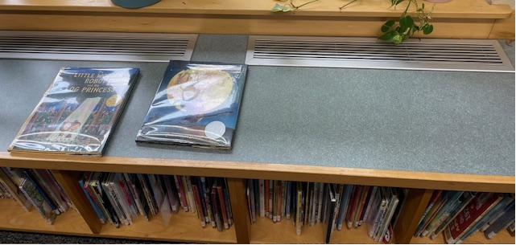

**Univent in classroom**

**Picture 2**

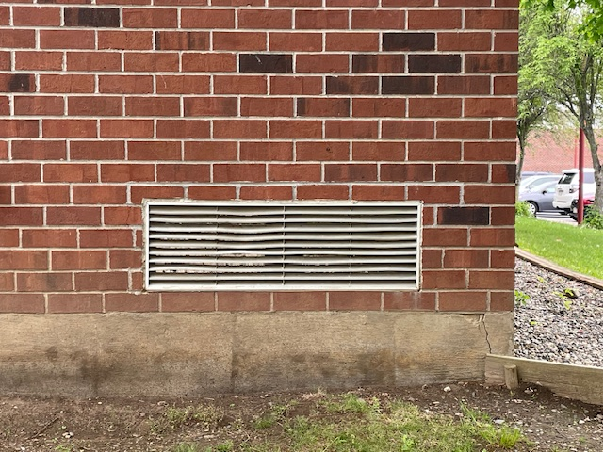

**Univent air intake vent on exterior of building**

**Picture 3**

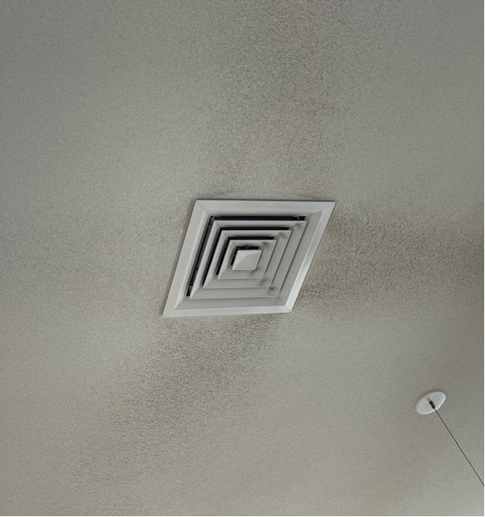

**Air supply vent in classroom**

**Picture 4**

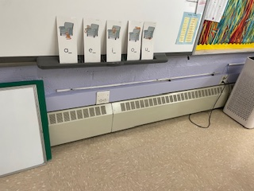

**Baseboard heaters in original section of BES**

**Picture 5**

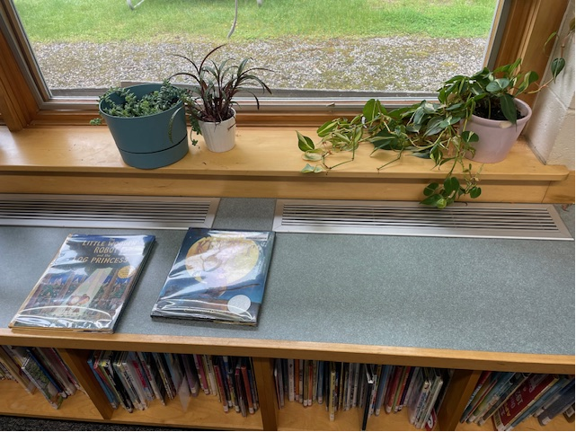

**Univent in newer section of BES**

**Picture 6**

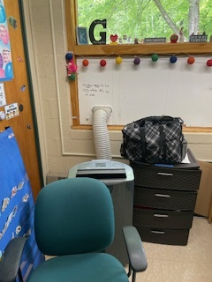

**Portable air-conditioner vented through closed window**

**Picture 7**

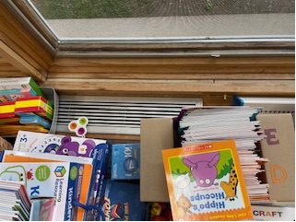

**Univent blocked by books**

**Picture 8**

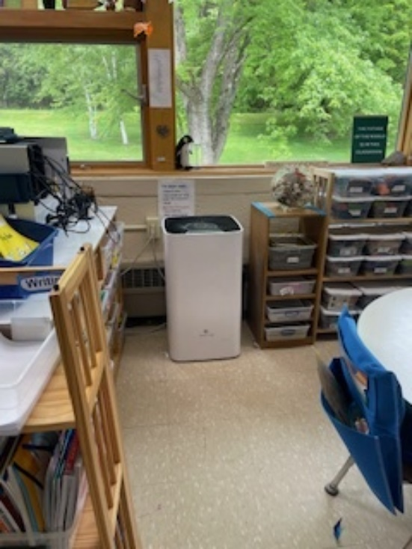

**Baseboard heaters blocked by classroom materials**

**Picture 9**

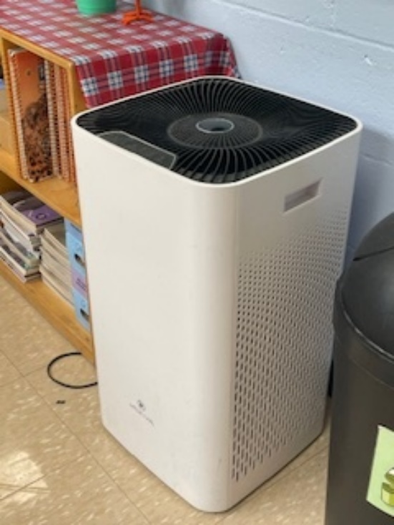

**Air purifier**

**Picture 10**

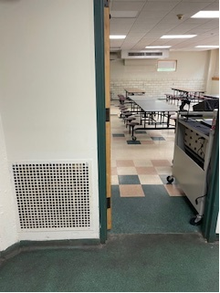

**Passive air vent in kitchen**

Water Damage pictures

**Picture 10**

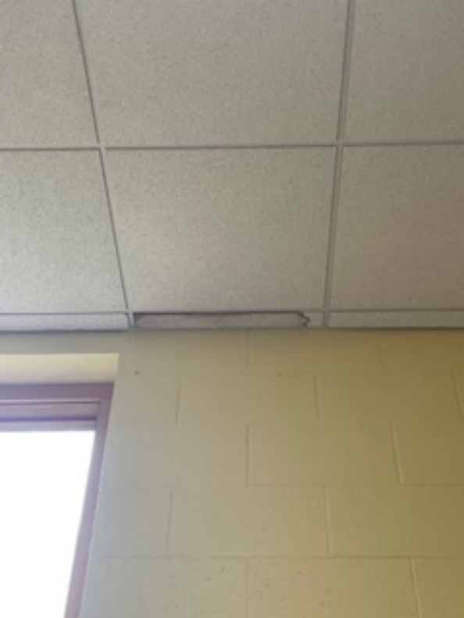

**Water-damaged ceiling tile**

**Picture 11**

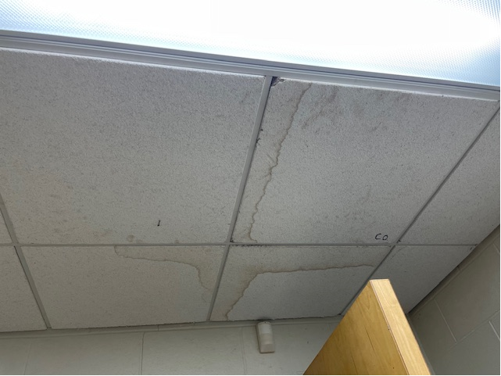

**Water-damaged ceiling tiles**

**Picture 12**

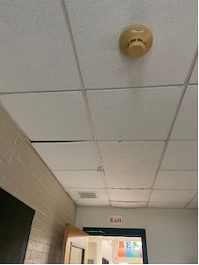

**Bowed ceiling tiles**

**Picture 13**

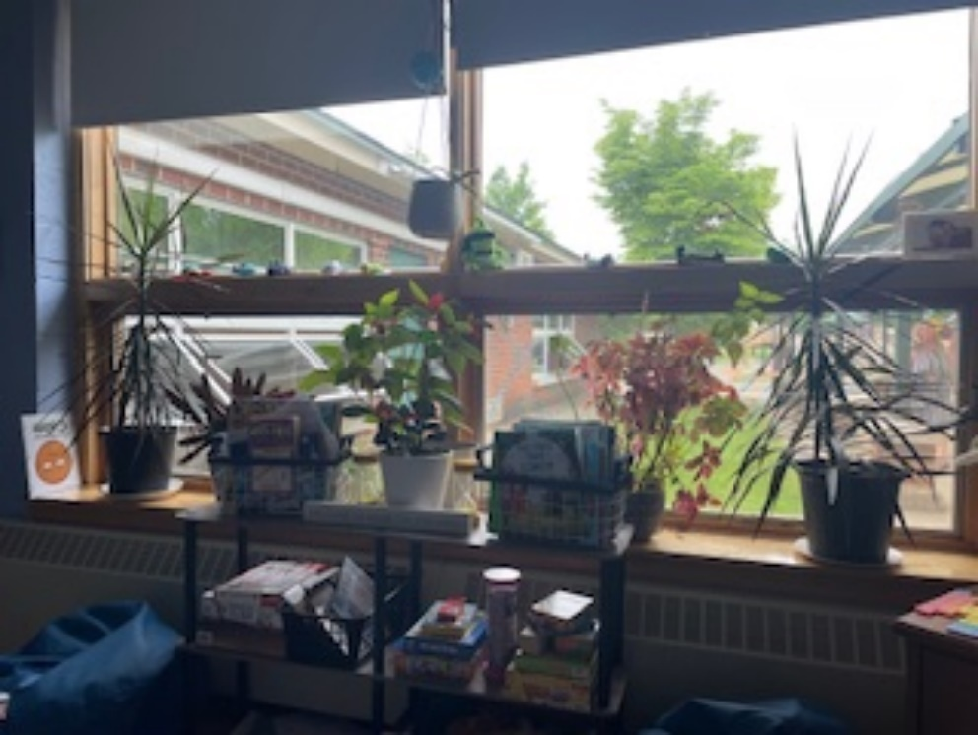

**Plants in classroom**

**Picture 14**



**Plants in classroom**

**Picture 15**

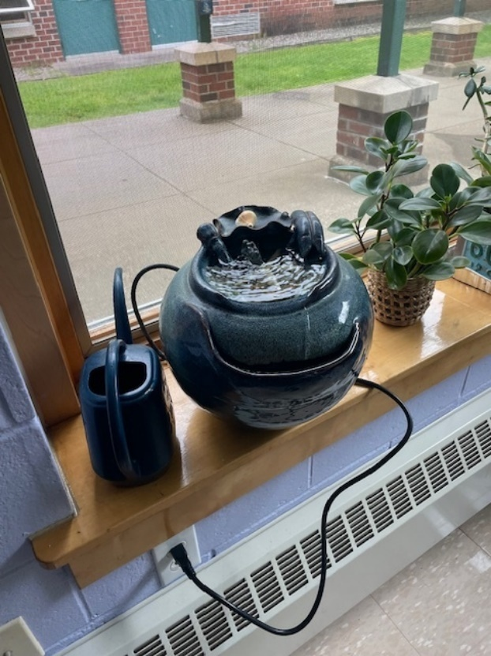

**Tabletop water fountain**

**Picture 16**

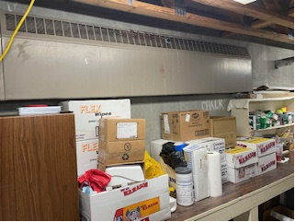

**Cardboard boxes and materials stored against basement wall**

**Picture 17**

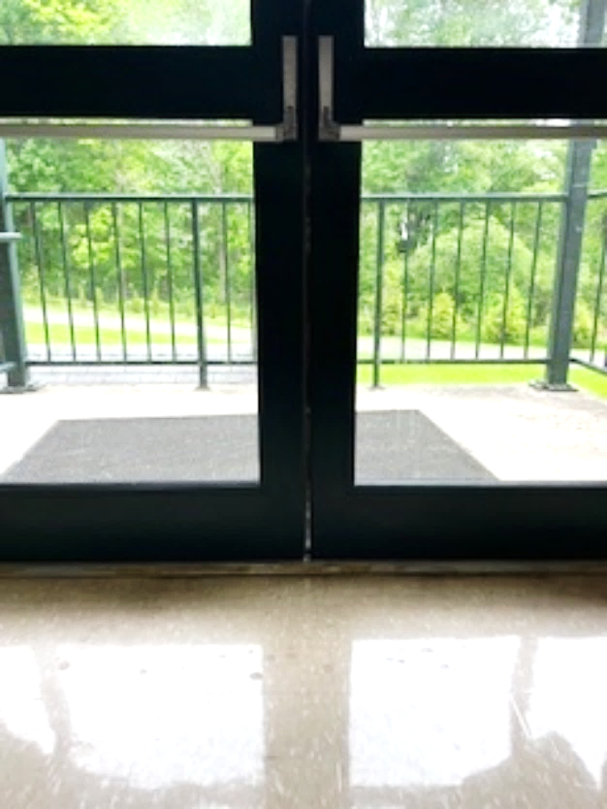

**Gap between exterior double doors**

**Picture 18**

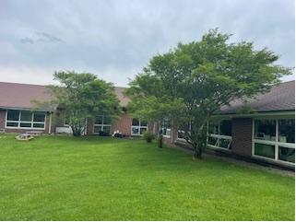

**Trees in close proximity to exterior of BES**

Respiratory Irritants pictures

**Picture 19**

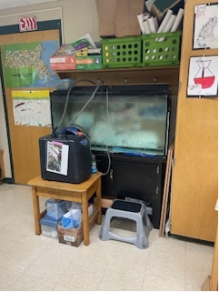

**Fish tank in classroom**

Click to link back to report

# Table 1

| **Location** | **Carbon**  **Dioxide**  **(ppm)** | **Carbon Monoxide**  **(ppm)** | **Temp**  **(°F)** | **Relative**  **Humidity**  **(%)** | **PM2.5**  **(µg/m3)** | **Occupants**  **in Room** | **Windows**  **Openable** | **Ventilation** | | **Remarks** |
| --- | --- | --- | --- | --- | --- | --- | --- | --- | --- | --- |
| **Supply** | **Exhaust** |
| Background (outside) | 421 | ND | 76 | 77 | 14 |  |  |  |  | Sunny and warm |
| Boiler Room | 480 | ND | 84 | 58 | 6 | 0 | Y 1 open | N | Y |  |
| Book Storage Closet | 589 | ND | 77 | 52 | 4 | 0 | N | N | N | Desk/chair |
| Cafeteria | 724 | ND | 70 | 70 | 8 | 0 | Y | Y  off | Y  off |  |
| Girls Bathroom | 713 | 1.0 | 84 | 57 | 4 | 0 | N/A | Y | N |  |
| Gym | 750 | ND | 71 | 78 | 11 | 25 | N | Y  off | Y  off |  |
| Kitchen | 769 | ND | 71 | 68 | 4 | 4 | N |  |  | Grill vent between kitchen/cafe |
| Kitchen Office | 714 | ND | 76 | 63 | 4 | 0 | N | N | N | 4 WD CT |
| Rm 119 A | 786 | ND | 74 | 62 | 1 | 3 | Y | N | N | WAC, AP |
| Room 101 | 527 | ND | 75 | 61 | 12 | 2 | Y | Y  off | Y  off | AR, heater blocked, mini-split on |
| Room 102 | 532 | ND | 77 | 74 | 11 | 15 | Y  open | Y  off | Y  off | AR, heater blocked |
| Room 103 | 1058 | ND | 76 | 74 | 7 | 20 | Y | Y | Y | AR, mini-split off, tennis balls on chair legs, plants |
| Room 104 | 648 | ND | 77 | 73 | 7 | 15 | Y  open | Y  off | Y  off | AR, plants PF, heater blocked |
| Room 106 |  | ND | 77 | 73 | 11 | 20 | Y  open | Y  off | Y  off | AR, refrigerator, microwave |
| Room 107 | 991 | ND | 78 | 71 | 11 | 15 | Y | Y | Y  off | AR, PF |
| Room 109 | 950 | ND | 77 | 68 | 12 | 15 | Y  open | Y | Y | AR, heater blocked |
| Room 110 | 765 | ND | 77 | 66 | 11 | 0 | Y | Y  off | Y  off | Wall-to-wall carpet, plants, copier/printer |
| Room 111 | 700 | ND | 75 | 71 | 10 | 0 | Y | N | N | AP, AR, mini-split on, heater blocked, fish tank, sink |
| Room 112 | 859 | ND | 76 | 76 | 12 | 20 | Y  open | N | N | PF, sink, AR, heater blocked |
| Room 113 | 735 | ND | 75 | 74 | 12 | 20 | Y  open | N | Y | 2-PF, AR, heater blocked, sink |
| Room 114 | 765 | ND | 75 | 74 | 10 | 0 | Y |  |  | PF, sink, AR, heater blocked |
| Room 115 | 533 | 1.0 | 80 | 53 | 8 | 4 | Y | Y  off | Y  off | 7 WD CT, W2W, blocked heater, mechanical AC running |
| Room 116 | 651 | 1.0 | 78 | 70 | 13 | 20 | Y  open | Y  off | Y  off | PF, blocked heater |
| Room 117 | 619 | ND | 77 | 65 | 8 | 2 | Y | Y  off | Y  off | 2 portable AC’s, 2 AP’s |
| Room 118 | 859 | 1.0 | 78 | 62 | 5 | 12 | Y | Y  off | Y  off | Portable AC, AR, blocked heater |
| Room 119 B | 603 | ND | 77 | 66 | 7 | 0 | Y | Y  off | Y  off | WAC |
| Room 120 | 853 | ND | 78 | 65 | 9 | 15 | Y | Y  off | Y  off | Portable AC, 2-AP, heater blocked w/objects, AR |
| Room 201  Office | 820 | ND | 73 | 71 | 4 | 2 | N | Y | Y | AP, WD CT, mini-split on |
| Room 202, Principal’s Office | 778 | ND | 73 | 76 | 7 | 2 | Y | Y | Y | AP |
| Room 203 | 530 | ND | 74 | 78 | 13 | 0 | Y | Y  off | Y  off | AR, mini-split on, heater blocked, plants |
| Room 204 | 599 | ND | 77 | 71 | 28 | 2 | Y | Y | Y | PF, AP, bowed CT |
| Room 205 | 650 | ND | 75 | 74 | 11 | 4 | N | Y | Y  off | PF, mechanical AC running |
| Room 206 | 626 | ND | 75 | 72 | 12 | 5 | Y | Y | Y | AP, stove, microwave, refrigerator |
| Stage | 664 | ND | 72 | 74 | 11 | 0 | N/A | N/A | N/A |  |
| Tech Closet | 787 | ND | 77 | 68 | 11 | 0 | N | Y | N | Vented door, carpeted |

(Click to link back to report)

# Table 2A

|  |  |  |  |  |  |
| --- | --- | --- | --- | --- | --- |
| **Equipment Present in Building**  **(X = Yes)** | **Type of Heating/Cooling Ventilation**  **Equipment** | **Fresh**  **Air**  **Supply**  **(X = Yes)** | **Type of Location(s)** | **Air Filters Installed**  **MERV Rating**  **(1-15, U*)**  **(X = Yes)** | **Comments** |
| X | Univents | X | Classrooms | X, U |  |
|  | Rooftop Air Handling Units |  |  |  |  |
|  | Outdoor, Ground-Installed Air Handling Units |  |  |  |  |
|  | Attic/Crawlspace Air Handling Units |  |  |  |  |
| X | Ceiling-Mounted Air Handling Units (including inside plenum) | X | Classrooms |  |  |
|  | Basement/Crawlspace-Installed Air Handling Units |  |  |  |  |
|  | Mechanical Room-installed Air Handling Units |  |  |  |  |
|  | Fan Coil Units |  |  |  |  |
|  | Window-Mounted Air Conditioners |  |  |  |  |
| X | Portable air conditioners | X | Classrooms |  |  |
|  | Wall Louver-Controlled Gravity Air Supply |  |  |  |  |
| X | Windows | X | Most rooms |  |  |
|  | Fan in window (blowing in) |  |  |  |  |
|  | Built in wall fan (switched) |  |  |  |  |
|  | Heat recovery ventilator unit |  |  |  |  |
|  | Energy recovery ventilator unit |  |  |  |  |
|  | Chilled Beam |  |  |  |  |
|  | Passive combustion supply vent in basement/boiler room |  |  |  |  |

*U = Filter Rating underdetermined due to inaccessibility during building visit

(Click to link back to report)

# Table 2B

|  |  |  |  |  |
| --- | --- | --- | --- | --- |
| **Equipment Present in Building**  **(X = Yes)** | **Type of Exhaust Ventilation**  **Equipment** | **Ducted**  **To Outdoors**  **(X = Yes)** | **Type of Location(s)** | **Comments** |
|  | Rooftop Motors/Fans |  |  |  |
|  | Unit Exhaust |  |  |  |
| X | Ceiling Return Vent |  |  |  |
|  | Ceiling Return Vent, Plenum |  |  |  |
|  | Wall Return Vent |  |  |  |
|  | Kitchen Stove Hood |  |  |  |
|  | Restroom Exhaust Vent |  |  |  |
|  | Photocopier Exhaust Vent |  |  |  |
|  | Garage |  |  |  |
|  | Chemical Hood(s) |  |  |  |
|  | Locker Rooms |  |  |  |
|  | Showers |  |  |  |
|  | Clothes Dryers |  |  |  |
|  | Gas Water Heaters |  |  |  |
|  | Furnace-Flue to Chimney |  |  |  |
|  | Furnace/Boiler direct vent or power vent (no combustion air supply) |  |  |  |
|  | Kiln, Pottery |  |  |  |
|  | Dark Room |  |  |  |
|  | Generator Room |  |  |  |
|  | Wood Shop Dust Collector |  |  |  |
|  | Spray Paint Booths |  |  |  |
|  | Fan in window (blowing out) |  |  |  |

# Table 2C

|  |  |  |  |
| --- | --- | --- | --- |
| **Equipment Present in Building**  **(X = Yes)** | **Type of Equipment** | **Type of Location(s)** | **Comments** |
| X | Floor Fans, pedestal | Classrooms, offices |  |
| X | Floor Fans, portable | Classrooms, offices |  |
| X | Air Purifier (HEPA, other) | Classrooms, offices |  |
|  | Floor heaters, portable |  |  |
| X | Refrigerators, Cold Beverage Vending Machines |  |  |
|  | Radiator, wall-mounted |  |  |
| X | Radiator, floor-mounted | Older classrooms |  |
|  | Passive Vents (Wall/Door) |  |  |

(Click to link back to report)

# Table 3

| **Found in Building**  **X = Yes** | **Water-Damaged Materials, Building Components or Stored Materials** | **Location** | **Visible Microbial Growth?**  **X = Yes** | **Musty odor detected?**  **X = Yes** | **Comments** |
| --- | --- | --- | --- | --- | --- |
|  | Books-other bound materials |  |  |  |  |
|  | Brick walls – broken, missing mortar |  |  |  |  |
|  | Brick walls – blocked weep holes |  |  |  |  |
|  | Cardboard boxes |  |  |  |  |
|  | Carpet tiles |  |  |  |  |
|  | Carpet - Area rugs |  |  |  |  |
|  | Carpet wall-to-wall |  |  |  |  |
|  | Ceiling tiles - affixed directly to ceiling surface |  |  |  |  |
| X | Ceiling tiles - bowing-in suspended ceiling | Some first floor rooms | No | No |  |
|  | Ceiling tiles - water-stained in splined ceiling |  |  |  |  |
| X | Ceiling tiles - water-stained in suspended ceiling | By windows in a few classrooms | No | No |  |
|  | Chairs - laminated |  |  |  |  |
|  | Cloth |  |  |  |  |
|  | Countertops (around sinks) |  |  |  |  |
|  | Curtains |  |  |  |  |
|  | Dust/debris within AHU, uninvent, HVAC, chilled beam units, etc. (WD through condensation, humidity, or leaks) |  |  |  |  |
|  | Efflorescence (i.e., mineral deposits) |  |  |  |  |
|  | Engineered woods - particleboard, plywood, Masonite |  |  |  |  |
|  | Flooring – loosened tiles |  |  |  |  |
|  | Flooring - wooden |  |  |  |  |
|  | Furniture - laminated |  |  |  |  |
|  | Furniture - upholstered |  |  |  |  |
|  | Gypsum wallboard - ceiling |  |  |  |  |
|  | Gypsum wallboard - restroom wall |  |  |  |  |
|  | Gypsum wallboard - interior wall |  |  |  |  |
|  | Gypsum wallboard – located on exterior wall |  |  |  |  |
|  | HVAC drain pan – lack of draining |  |  |  |  |
|  | HVAC filters |  |  |  |  |
|  | Insulation- attic (paper-backed) |  |  |  |  |
|  | Insulation - inside air handling unit |  |  |  |  |
|  | Insulation - on pipe(s) fiberglass |  |  |  |  |
|  | Insulation - on pipe(s) other/plaster-like material |  |  |  |  |
|  | Insulation - wall cavity |  |  |  |  |
|  | Insulation – ceiling plenum |  |  |  |  |
|  | Modular furniture – walls/cloth partitions |  |  |  |  |
|  | Musical instrument cases |  |  |  |  |
|  | Plaster ceilings |  |  |  |  |
|  | Records/files |  |  |  |  |
|  | Refrigerator - door gasket |  |  |  |  |
|  | Refrigerator - drip pan |  |  |  |  |
|  | Refrigerator - Interior surfaces |  |  |  |  |
|  | Room divider - ceiling-mounted, sliding |  |  |  |  |
|  | Sink backsplash |  |  |  |  |
|  | Tables – laminated |  |  |  |  |
|  | Wallpaper |  |  |  |  |
|  | Wood - attic/roof materials |  |  |  |  |
|  | Wood - floor joists in basement ceiling |  |  |  |  |
|  | Wood - wall framing |  |  |  |  |
|  | Wood - window sills |  |  |  |  |
|  | Wood - window-mounted air conditioner framing |  |  |  |  |
|  | OTHER |  |  |  |  |

WHAT ARE ENVIRONMENTAL ASTHMA TRIGGERS?

Asthma triggers are any chemical, pollutant, or allergen that can make your asthma worse. Asthma triggers can also be strong chemical smells, dust, or pets. Your asthma triggers may be different from those of other people. Not all asthma triggers affect people the same way. Environmental asthma triggers are found both indoors and outdoors. DPH link: [Asthma and Your Environment (mass.gov)](https://www.mass.gov/doc/asthma-and-your-environment-english/download)

(click to link back to report)

# Table 4

| **Condition Present**  **X = Yes** | **Possible asthma symptom-inducing environmental pollutant** | **Recommendation to reduce or eliminate the pollutant** |
| --- | --- | --- |
| X | Water Damage and/or Mold  (allergen) | Identify water source and repair to eliminate.  Clean non-porous materials.  Remove and replace porous materials susceptible to mold growth.  Perform regular water damage assessments as a tool to ensure timely mitigation as needed.  Use NIOSH water damage assessment protocol as a guide: [NIOSH water damage assessment guideline](https://www.cdc.gov/niosh/docs/2019-115/pdfs/2019-115.pdf?id=10.26616/NIOSHPUB2019115&inf_contact_key=241b5c2ed98c27d94b530dedc36f1623f651f238aa2edbb9c8b7cff03e0b16a0). |
|  | Moistening of building components during hot, humid weather (>2 days in length) (mold, allergen) | Remove materials not dried in <2 days in a manner consistent with [US EPA Mold Removal in Commercial Buildings guideline](https://www.epa.gov/mold/pdf-version-checklist-mold-remediation-mold-remediation-schools-and-commercial-buildings).  Use dehumidification in occupied basement areas and other areas with chronic dampness. |
| X | Vegetation against exterior of building (water damage-mold) | Remove all vegetation preventing building exterior drying.  Remove all vegetation capable of falling onto a building or depositing debris onto the roof. |
|  | Personal humidifiers (lack of proper maintenance)  (pollutant and allergen) | Clean and maintain properly.  Use distilled water to eliminate metal and water treatment odors.  Maintain hydration by increasing water consumption. |
|  | Drains: Floor drains, Sink drains (abandoned use)  Water bubblers (abandoned use) | If in use, pour water into drain at least twice a week.  If not in use, seal the drain with an appropriate material in accordance with Massachusetts Plumbing Code (248 CMR 10.00). |
|  | Live Animals (turtles, gerbils, birds, rabbits, etc.) | Ensure cleanliness or remove animals from the location. |
|  | Improperly maintained aquariums and terrariums (allergen) | Maintain such equipment properly to eliminate odor.  Discontinue use. |
| X | Plants and flowers  (allergen and mold) | Keep indoor plants well maintained and not overwatered. Monitor for signs of mold and pests.  Ensure water for cut flowers does not become stagnant.  Ensure dried plant material is free of odors, mold, and pests and handled carefully  If asthma risks are high, eliminate plants and flowers. |
| X | HVAC system moisture issues  (mold, allergen) | Consult ASHRAE’s minimum standards for HVAC maintenance and inspection of commercial HVAC systems (<https://www.ashrae.org/technical-resources/bookstore/standards-180-and-211>). |
|  | HVAC system contaminant issues (allergen) | Consult ASHRAE’s minimum standards for HVAC maintenance and inspection of commercial HVAC systems (<https://www.ashrae.org/technical-resources/bookstore/standards-180-and-211>). |
|  | Indoor swimming pool odors outside of swimming pool (mold, chemical) | Maintain and operate pool HVAC systems to vent odors from building.  Ensure locker room exhaust vents are operating during building hours.  All doors leading to pool should be rendered airtight and be closed. |
| X | Pollen (allergen) | Recommend installation of MERV 8 or better filters if HVAC engineer confirms HVAC system can be so equipped without adversely affecting function.  Cut grass after hours.  Cut grass in a pattern to direct clippings away from exterior wall.  Remove trees and shrubs from in front of windows and air intakes. |
|  | Dry air | Maintain hydration.  Avoid overheating of air. |
|  | Dust mites  (allergen) | Recommendation to remove non-official upholstered furniture, area rugs, pillows, cushions, etc.  Cleaning with use of HEPA-filtered vacuum cleaner.  Eliminating clutter, storing items in dust and moisture-proof containers, and regularly removing dust through wet wiping. |
|  | Pests, including rodents and cockroaches  (allergen) | Use of integrated pest management guidelines, including:   * Proper disposal of food containers * Proper storage of food products in airtight containers * Elimination of use of food as art projects * Remove pest harborages/clutter * Regular monitoring for pests   [EPA IPM guideline link](https://www.epa.gov/ipm/introduction-integrated-pest-management) |
|  | Latex-containing materials | Remove tennis balls from furniture legs. |
|  | Fragrances  (chemical) | Eliminate point sources, such as:   * Plug-in air fresheners * Aroma/oil reed diffusers * Scented sprays * Discontinue use of other scented materials * Consult DPH fragrance guideline: [*Clean air is odor-free*](https://www.mass.gov/doc/clean-air-is-odor-free-removing-fragrances-to-improve-indoor-air-quality-in-schools-and-0/download) |
|  | Strong smells from /use of Chemicals (such as cleaning products)  (chemical) | Use building-issued cleaning products.  Use products in accordance with manufacturer’s instructions including dilution, application, and ventilation.  Avoid using products that are stronger than needed for the situation. |
|  | Strong odors from new building materials (carpeting/furniture)  (chemical) | Use low VOC-emitting materials.  Air out materials (outside or in unoccupied area) prior to installation. |
|  | Tobacco smoke  Secondhand Smoke  (pollutant) | Eliminate tobacco smoking.  Seal all shared wall penetrations. |
|  | Products with a strong odor such as paint, perfume, hairspray, air fresheners, bug-spray, laminators, candles, wax melters, dry erase markers and other VOC-containing products  (chemical) | If essential:   * Provide proper exhaust ventilation to eject aerosolized product directly outdoors. * Avoid/reduce use during occupied hours.   If not necessary, remove and eliminate. |
|  | Vehicle exhaust  (pollutant) | Enforce anti-idling regulations and post signs to give notice.  Relocate vehicles away from fresh air intakes.  Require cars to park face-in at building walls.  [MA anti-idling law FAQs](https://www.mass.gov/files/documents/2018/02/20/idling-faq.pdf#:~:text=The%20Massachusetts%20Anti-Idling%20Law%20The%20goal%20of%20the,sometime%20wonder%20when%20idling%20might%20be%20considered%20necessary.) |
|  | Vapors and or fumes from gas, oil, or kerosene stoves  (pollutant) | Operate stove hood when stove in use.  Install stove hood if not present.  Ensure equipment is in good working order. |
|  | Ozone (pollutant) | Eliminate use of ozone generating equipment. |
|  | Window Air Conditioners (if not properly maintained) (allergen) | Equip with proper filter and clean periodically.  Clean drip pans.  Install in window with weathertight, non-mold-growth sustaining material. |
|  | Pottery (pollutant) | Do not operate kiln during occupied hours.  Operate kiln with exhaust system activated.  Seal all seams and holes in kiln vent.  Ensure kiln exhaust discharge terminates outdoors. |
| X | Carpeting (allergen) | Clean carpeting in a manner consistent with IICRC standards, including regular vacuuming with a high efficiency particulate air (HEPA) filtered vacuum in combination with annual cleaning or semi-annual cleaning in soiled high traffic areas. |
|  | Sweeping/dusting vs HEPA vacuuming/wet wiping  (allergen or pollutant) | Refrain from using feather dusters or brooms.  Utilize HEPA vacuums and wet wiping to minimize aerosolizing particulate matter. |
| X | Lack of adequate air exchange/mechanical ventilation | Make repairs as necessary and ensure all HVAC system components are operating continuously when building is occupied. |
|  | Lack of local exhaust at source of pollution (vocational shop activities, kitchen exhaust hood) (all) | Recommend installation of exhaust ventilation to direct pollutants directly outdoors. |
|  | Renovating buildings while occupied  (chemical) | Use all SMACNA guidelines for Renovation While Buildings Are Occupied. For information, visit <https://www.mass.gov/service-details/construction-and-renovation-generated-pollutants-in-occupied-buildings>. |
|  | Chemistry program chemical storage  (chemical) | Repair (if needed) and operate chemical storeroom vents appropriately.  Reduce or eliminate unneeded or overstocked chemicals.  Store all chemicals in a manner to separate incompatible chemicals.  Keep chemical storerooms clean. |
| X | Photocopiers/duplicating machines | All machines should have dedicated exhaust vents. |