MOLD Assessment

Charles A. Bernazzani Elementary School
701 Furnace Brook Parkway
Quincy, Massachusetts
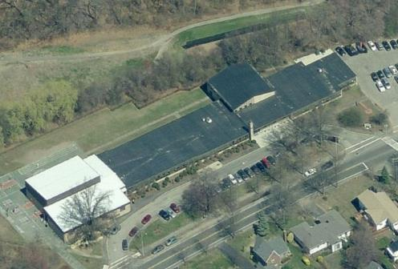

Prepared by:
Massachusetts Department of Public Health
Bureau of Environmental Health
Indoor Air Quality Program
January 2015

Background/Introduction
At the request of Kevin Segalla, Coordinator of Custodial Services, Quincy Public Schools (QPS), the Massachusetts Department of Public Health (MDPH), Bureau of Environmental Health (BEH) conducted an indoor air quality (IAQ) assessment at the Charles A. Bernazzani Elementary School (BES), located at 701 Furnace Brook Parkway, Quincy, Massachusetts. The request was prompted by concerns related to water damage and mold in the library/special education area as well as in a storage area located at the rear of the building. Odor concerns in the gymnasium were also reported. On November 12, 2014, a visit was made to the BES by Sharon Lee, an Environmental Analyst within BEH’s IAQ Program. Ms. Lee was accompanied by Mr. Segalla and Peter Dionne, Principal.
BEH/IAQ staff conducted a limited assessment of the building focusing on sources of water/moisture penetration in at the rear of the BES. The overall function of the heating, ventilating, and air-conditioning (HVAC) system was not assessed during this visit.
The BES is a one-story building constructed in 1955. The school is located downgradient from the Furnace Brook Golf Club. Windows throughout the building are openable.

Methods
Air tests for temperature and relative humidity were conducted with the TSI, Q-Trak, IAQ Monitor, Model 7565. Moisture content of wall materials was measured using a Delmhorst BD-2100 Moisture Meter. BEH/IAQ staff also performed a visual inspection of building materials for water damage and/or microbial growth.

Results
The BES serves approximately 350 pre-K to fifth grade students with approximately 40 staff. Measurements were taken while the school was occupied and appear in Table 1.

Discussion

Microbial/Moisture Concerns
Temperatures in the building were measured in a range of 69°F to 75°F (Table 1), which were all within or slightly below the MDPH comfort range. The MDPH recommends that indoor air temperatures be maintained in a range of 70ºF to 78ºF in order to provide for the comfort of building occupants.
On the day of the assessment, the outdoor relative humidity was measured at 62 percent (Table 1). Indoor relative humidity ranged from 51 to 66 percent. The MDPH recommends a comfort range of 40 to 60 percent for indoor air relative humidity. According to the American Society of Heating Refrigeration and Air-Conditioning Engineers (ASHRAE), relative humidity in excess of 70 percent for an extended period of time can provide an environment for mold and fungal growth in building materials (ASHRAE, 1989).
The elevated relative humidity indoors suggests that ventilation in the rear portion of the building may be inadequate. At the time of the assessment, BEH/IAQ staff examined the return vent for the media center, which is located under the stage (Picture 1). Draw of air could not be detected at this vent. Mr. Segalla indicated that the exhaust fan was not operating properly and a replacement was on order. Replacing the exhaust fan and thereby reestablishing exhaust ventilation is important to remove moisture from the building.
A dehumidifier was observed in the special education room (Picture 2). This dehumidifier does not appear to be sized appropriately for the room. A dehumidifier with a larger capacity may be needed to adequately remove moisture from the space. Consideration should be given to installing a drainage hose for the dehumidifier to allow the unit to operate continuously. If the hose is directed outdoors, measures should be taken to ensure water does not flow back towards the building. Dehumidifiers should be cleaned routinely and dried completely when not in use to prevent mold growth and associated unpleasant odors.
Please note, the library/special education areas reportedly experience uneven heating due to the erection of partition walls subdividing the space. Warmer temperatures were observed in the special education rooms where heating elements are located, while cooler temperatures were measured in the library. These partition walls do not extend the full ceiling to floor length. Consideration should be given to installing ceiling fans to create air movement and distribute heated air throughout the spaces during the heating season.
A number of conditions subject the rear portion of the building to chronic moisture. As mentioned, the rear portion of the building is downgradient from a golf course. This area is surrounded by trees, which reduces drying capacity. Furthermore, the building sits on a concrete slab foundation.
Temperature differences between the classroom air and the slab itself can result in the formation of condensation on the surface of the concrete foundation, resulting in moistening of building materials. Carpeting was also observed in the media/special education area. Carpet on slab is not recommended due to the potential for condensation generation and chronic moisture concerns. Mr. Dionne indicated that he has recommended that the carpeting be removed and the floors tiled. In the interim, until floor tiles can be installed, a high efficiency particulate air (HEPA) filtered vacuum should be used during regular cleaning to remove dirt/debris preventing materials trapped in carpet fibers from supporting mold growth. The Institute of Inspection, Cleaning and Restoration Certification (IICRC) recommends that carpeting be cleaned thoroughly on an annual (or semi-annual in soiled high traffic areas) (IICRC, 2012). Regular vacuuming in combination with an annual cleaning will help to reduce accumulation and potential aerosolization of materials from the carpeting.
Mr. Segalla and Mr. Dionne reported that previous to the BEH/IAQ visit, mold growth was observed on walls and school furniture (e.g. upholstered chairs) and educational materials (e.g. fabric-bound items, paper) in the special education area. Reportedly, at that time superficial mold growing on furniture was cleaned and the surfaces were disinfected, educational materials were reportedly discarded and replaced, and building surfaces were cleaned and disinfected. BEH/IAQ staff noted some replacement items were placed in plastic storage containers. Placing paper products in plastic containers allows these materials to be transported into alternate storage space during the summer and protects them from moisture and dust.
At the time of the assessment, MDPH/BEH staff noted boxes, papers and other items on flat surfaces and the floor. Flat surfaces (e.g., floors, windowsills, tabletops) provide a source for dusts to accumulate. Items (e.g., papers, folders, boxes) placed on flat surfaces make it difficult for areas to be cleaned. Items should be relocated to avoid excessive dust build up and allow for cleaning of the flat surfaces. In addition, dust and debris can accumulate on flat surfaces (e.g., desktops, shelving and carpets) in occupied areas and subsequently be re-aerosolized causing further irritation.
As mentioned, water damage was observed in the storage room. Paper products and other items in cardboard boxes were found placed against walls. During periods of hot, humid weather, condensation can be generated on the wall and floor surfaces. Items on the floor and next to walls can be moistened by condensation which may lead to water damage and microbial growth. At the time of the assessment, BEH/IAQ staff recommended that boxes be elevated off the floors and away from the walls to allow air to flow and moisture to dry. Operating a dehumidifier in this storage room is strongly recommended to prevent prolonged exposure of materials to moisture.
At the time of the assessment, BEH/IAQ staff also observed water-damaged ceiling tiles in the storage room (Picture 3). Staff reported that water penetrated the building during wind-driven rain events. Water-damaged ceiling tiles should be discarded and replaced after the source of moisture has been identified and remediated.
The US Environmental Protection Agency (US EPA) and the American Conference of Governmental Industrial Hygienists (ACGIH) recommends that porous materials be dried with fans and heating within 24 to 48 hours of becoming wet (US EPA, 2001; ACGIH, 1989). If porous materials are not dried within this time frame, mold growth may occur. Water-damaged porous materials cannot be adequately cleaned to remove mold growth. The application of a mildewcide to moldy porous materials is not recommended.
During an examination of the building exterior, BEH/IAQ staff noted that downspouts were missing elbows. In one instance, water was emptying directly against a crack in the foundation (Picture 4). Without proper drainage, water is funneled towards rather than directed away from the building. In additional, a patio at the rear of the building prevents adequate drainage of the outdoor space at the back of the building. Due to the slope and grade around the building, water drains towards the building. Continued moisture exposure can lead to deterioration of the foundation as well as water infiltrating into the building. Measures should be taken to direct water away from the building.
BEH/IAQ staff also noted breaches in the brick exterior due to missing mortar (Picture 5). Breaches in the building envelope can allow moisture and pests to penetrate the building. Measures should be taken to repoint the brick exterior and seal the building’s foundation to prevent further deterioration.

Other Concerns
At the time of the assessment, Mr. Dionne reported that the gymnasium is experiencing periodic odors, reportedly associated with spray polyurethane foam insulation (SPFI) installed to the ceiling of the gymnasium. According to one manufacturer, the SPFI should not produce odors once the foam “cures” (or sets), a process that occurs within seconds of product application, and lingering odors should dissipate in 24 hours (Icynene, 2014). According to the US EPA, “if SPF was not applied properly, chemical contaminants may have migrated to hard and/or soft surfaces elsewhere in the building and may be the source of residual odors” (US EPA, 2014). No odors were noted at the time of the assessment. Ceiling fans were reportedly installed to increase ventilation and dissipate odors (Picture 5); however, these fans were not operating at the time of the assessment.
Cleaning and deodorizing products were observed in a number of areas, some of the items were unlabeled (Picture 6). These products contain chemicals that can be irritating to the eyes, nose and throat of sensitive individuals. Cleaning products should be properly labeled and stored in an area inaccessible to children. In addition, a Material Safety Data Sheet (MSDS) should be available at a central location for each product in the event of an emergency.

Conclusions/Recommendations
As noted previously, this assessment was focused on identifying sources of moisture in the lowest level of the building. Upon request, the BEH IAQ Program can return to the building conduct a full IAQ evaluation. In view of the findings at the time of the visit, the following is recommended:
- Replace/repair the exhaust motor for ventilation servicing the library/special education areas. Reestablishing exhaust ventilation will remove normally occurring indoor air pollutants, including excess moisture, from the building
- Ensure dehumidifiers are sized appropriate for the space. Consider installing a hose to the unit to allow continuous operation. Ensure water drains away from the building.
- Clean and service dehumidifiers periodically to ensure proper function and reduce the chance of odors from the units.
- Ensure carpets are vacuumed regularly with a HEPA-filtered vacuum.
- Clean carpeting annually or semi-annually in high traffic areas as per the recommendations of the Institute of Inspection, Cleaning and Restoration Certification (IICRC, 2012).
- Consider replacing carpet with floor tiles or other material to allow for easier cleaning and prevent potential for mold growth from condensation on floors located on slab.
- Reduce the amount of items in classrooms to allow for thorough cleaning on a regular basis. Ensure flat surfaces remain free and clear of items to facilitate cleaning.
- Store paper products and other porous materials in plastic storage containers to allow for relocation to alternate locations during the summer and to protect from moisture and dust.
- Ensure boxes in the storage room are placed away from the walls and off the floors to allow ventilation and drying of moisture condensed on flat surfaces.
- Contact the SPFI installer and manufacturer if odors persist in the gymnasium. Removal of the insulation may be necessary to abate odors.
- Continue to operate fans in the gymnasium to dissipate odors.
- Replace water-damaged ceiling tiles.
- Install elbows to downspouts to direct water away from the building.
- Seal breaches in the building envelope (e.g. cracks in foundation, missing mortar) to prevent moisture and pest intrusion.
- Consider grading around the building to create a pitch that directs water away.
- Employ methods outlined in the document “Preventing Mold Growth in Massachusetts Schools During Hot, Humid Weather” (Appendix A) to prevent water damage from hot, humid weather.
- Consider adopting the US EPA (2000) document “Tools for Schools” to maintain a good indoor air quality environment in the building. This document can be downloaded from the Internet at http://www.epa.gov/iaq/schools/index.html.
- Refer to resource manuals and other related indoor air quality documents for further building-wide evaluations and advice on maintaining public buildings. Copies of these materials are located on the MDPH’s website: http://mass.gov/dph/iaq.

References
ASHRAE. 1989. ASHRAE Standard: Ventilation for Acceptable Indoor Air Quality. Sections 5.11, 5.12. American Society of Heating, Refrigerating and Air-Conditioning Engineers, Inc. Atlanta, GA.
ACGIH. 1989. Guidelines for the Assessment of Bioaerosols in the Indoor Environment. American Conference of Governmental Industrial Hygienists, Cincinnati, OH.
Icynene. 2014. Icynene FAQs. Retrieved 12/4/2014 from http://www.icynene.com/en-us/homeowners/resources/icynene-answers
IICRC. 2012. Carpet Cleaning FAQ 4 Institute of Inspection, Cleaning and Restoration Certification. Institute of Inspection Cleaning and Restoration, Vancouver, WA.
US EPA. 2000. Tools for Schools. Office of Air and Radiation, Office of Radiation and Indoor Air, Indoor Environments Division (6609J). EPA 402-K-95-001, Second Edition. http://www.epa.gov/iaq/schools/index.html.
US EPA. 2001. “Mold Remediation in Schools and Commercial Buildings”. Office of Air and Radiation, Indoor Environments Division, Washington, DC. EPA 402-K-01-001. March 2001. Available at: http://www.epa.gov/iaq/molds/mold_remediation.html.
US EPA. 2014. Spray Polyurethane Foam: Exposure Potential. Retrieved 12/4/2014 from http://www.epa.gov/dfe/pubs/projects/spf/exposure_potential.html

Picture 1
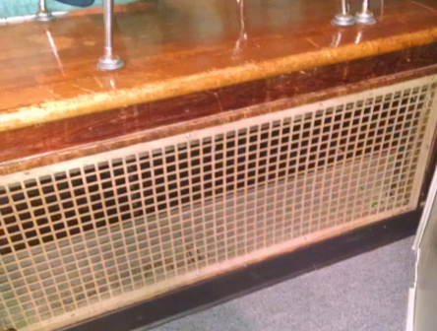
Exhaust vent located below stage
Picture 2
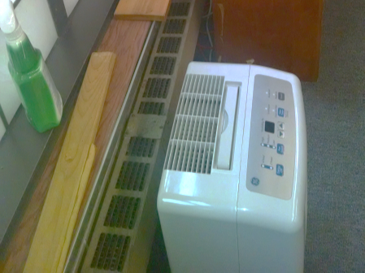
Dehumidifier in Special Education Area

Picture 3
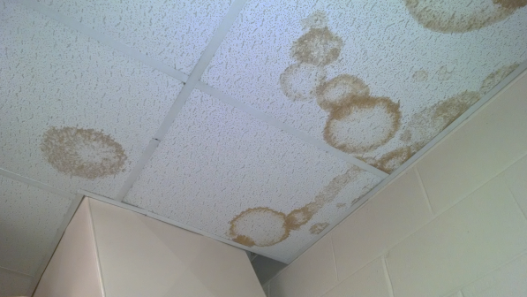
Water-damaged ceiling tiles
Picture 4
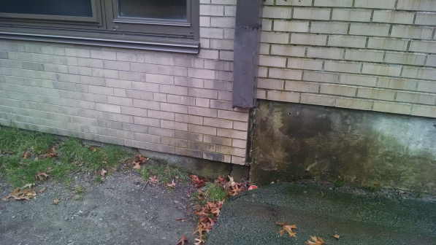
Downspout missing elbow, directing water to into cracked foundation
Picture 5
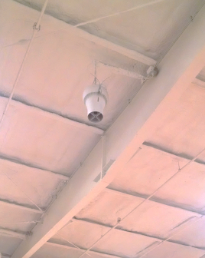
Ceiling fan hanging from insulated gymnasium ceiling
Picture 6
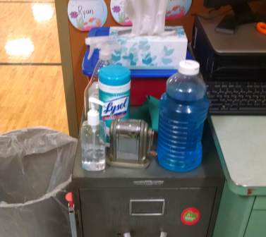
Unlabeled container

Location/ Room |  | Temp (°F) |  | Relative Humidity (%) |  | Occupants  in Room | Windows Openable | Ventilation |  | Remarks
 |  |  |  |  |  |  |  | Supply | Exhaust
 | Background |  | 61 |  | 62
 | Library storage |  | 70 |  | 66 | 0
 | Special education (left) |  | 75 |  | 59 | 0 | Y |  |  | Items
 | Special education (middle) |  | 75 |  | 61 | 5 | Y |  |  | Dehumidifier, cleaning products, items
 | Library |  | 69 |  | 51 | 20 | N
 | Gym |  | 71 |  | 54 | 15 | N | Y | Y
 | Gym office |  | 73 |  | 52 | 0 | N | Y | Passive | Chemical storage

