Best Management Practices for Beach Nourishment Projects in Massachusetts

Revised: January 2007

Table of Contents

Glossary of Terms

Summary

Overview

-Purpose
-Beach Nourishment
-Specifications and Best Management Practices for Beach Nourishment Projects
-Permit Requirements and Timelines

Attachment A: Beach Stability Determination

Attachment B: Receiving Beach Characterization

Attachment C: Source Material Characterization

Attachment D: Sample Problem: Beach and Borrow Site Sediment Analysis to Determine Stability of Nourishment Material For Shore Protection

Attachment E: Generic Beach Monitoring Plan

Attachment F: Sample Easement

Attachment G: References

GLOSSARY OF TERMS

Accretion – the gradual addition of land by deposition of water-borne sediment

Beach Fill – also called “artificial nourishment”, “beach nourishment”, “replenishment”, and “restoration,” comprises the placement of sediment within the nearshore sediment transport system (littoral zone). (paraphrased from Dean, 2002)

Beach Profile – the cross-sectional shape of a beach plotted perpendicular to the shoreline.

Cross-Shore Response – changes to the beach profile caused by the onshore and offshore movement of sediment after nourishment has taken place. It is the process by which a beach’s natural equilibrium profile is reached.

Depth of Closure – the seaward limit of sediment transport due to seasonal beach profile changes such as those caused by erosion and accretion. (Dean 2002)

Downdrift – the alongshore direction coincident with the dominant sediment transport direction. (Adapted from Dean and Dalrymple 2002)

Equilibrium Beach Profile – for the purpose of beach nourishment, equilibration of the on-offshore beach profile from the arbitrary shape created by placing sand on the beach to the natural equilibrium shape created by the environment. This process typically includes transfer of sand from the dry beach and the shallow constructed portions of the profile to the offshore. Wave/water level conditions and sediment size are the controlling factors that determine a beach’s equilibrium profile. (Adapted from Dean and Dalrymple 2002)

Fall Velocity – the maximum speed attained by a falling particle under the action of gravity in water (in other words, the terminal velocity). In general, large particles will have a higher fall velocity than small particles; therefore, large particles will be less likely to be suspended in the water column compared to finer particles.

Foreshore Beach – the intertidal portion of the beach. The foreshore, also called the intertidal or littoral zone, is that part of a beach that is exposed at low tides and submerged at high tides

Hot Spot or Erosional Hot Spot – area along a shoreline where coastal erosion is significantly greater than adjacent areas. Erosional hot spots can occur as a result of nonuniform wave conditions along the shoreline (e.g., offshore shoals redirecting wave energy), nonuniform sediment sizes along the shoreline, and sediment transport into a nearshore excavated area. (Adapted from Dean 2002)

Isolines – term for any graph or map on which some variable feature is contoured.

Lag Deposit – deposit consisting of coarser sediment (generally pebbles, cobbles, and boulders) that remains on a beach after finer particles are transported downdrift by waves, winds and currents. Lag deposits are usually more resistant to erosion than sand beaches.

Littoral Zone – the area of beach that lies between the high water line and the depth of closure. The littoral zone is where a majority of sediment transport processes occur along the shoreline. Also known as the foreshore beach and intertidal zone.

Longshore Transport – the amount of sediment moved along the coast through the combined effect of waves and currents. (Adapted from Dean and Dalrymple 2002)

Nomograph – a chart representing numerical relationships.

Subaerial Beach – the entire upper portion of a beach that is not under water at low tide.

Summary

Basic steps for Beach Nourishment Projects

Proponents of beach nourishment projects in Massachusetts are required to determine beach conditions and stability, characterize the physical and chemical properties of the material to be dredged, as well as the physical properties of the material on the receiving beach. Keep in mind that the most important factors for beach nourishment projects is the grain size distribution of the source material as compared to the native beach material, and the location of the project in relation to sensitive coastal receptors.

STEP 1. Determine if the project is near endangered species habitat and in or adjacent to: Shellfish Beds, Vegetated Shallows, Spawning Ares, or Rocky Sub-tidal Habitat. Detail the impacts of the proposed project on these areas.
If a beach or dune nourishment project is near endangered species habitat, proponents should consult with the Massachusetts Division of Fisheries and Wildlife, Natural Heritage and Endangered Species Program (www.mass.gov/dfwele/dfw/nhesp/nhesp.htm) concerning potential impacts to the habitat. Proposed beach and dune nourishment slopes can often be modified to avoid impacts to rare, threatened, or endangered species.

Species and plant density should be surveyed and extent of habitat mapped, particularly in shellfish beds, vegetated shallows, spawning areas, or rocky sub-tidal habitat. Time of Year (TOY) restrictions, along with other restrictions, may be necessary to minimize impacts to marine fisheries or other biological organisms, particularly during spawning season.

STEP 2. Determine Wetlands and Waterways Permits required from MassDEP or other agency approvals for the project and note application timelines.
The following Wetlands & Waterways permits may be required for beach nourishment and beneficial reuse projects.

The Public Waterfront Act (MGL Chapter 91) requires a Chapter 91 waterways license or permit for any activity located in, under, or over flowed tidelands, filled tidelands, Great Ponds and certain non-tidal rivers and streams located throughout the Commonwealth. In general, beach nourishment and the beneficial reuse of dredged sediment as beach fill qualify as Water-Dependent projects. Such projects fall in the category of MassDEP application # BRP WW 01.

The Massachusetts Wetlands Protection Act (MGL Chapter 131, § 40) prohibits the removal, dredging, filling, or altering of wetlands without a permit. To obtain a permit (called an Order of Conditions), a project proponent must submit a Notice of Intent to the municipal Conservation Commission and MassDEP.

A 401 Water Quality Certification from MassDEP is required under the federal Clean Water Act for any activity that results in a discharge of dredged material, dredging, or dredged material disposal greater than 100 cubic yards to waters subject to regulation by any federal agency. If no federal permit is needed for an activity, then no 401 Certification is required from MassDEP.

For a copy of these permit applications and for more information regarding the application process and timelines, refer to MassDEP’s permitting web page: www.mass.gov/dep/service/online/gettings.htm.

STEP 3. Determine the profile of the receiving beach.
The placement of dredged sediment should take into account the profile of the existing beach and the location of the dredging area. If the proposed nourishment profile varies significantly from the existing profile, then the material will adjust quickly as the beach system tries to re-establish a slope, resulting in less material on the beach, as material is shifted into the near-shore region of the beach. The adjustment of the beach profile could possibly harm adjacent coastal resources. Dredging material should be placed downdrift of the dredge site to minimize sediment returning to the area it was dredged, and to facilitate the movement of sediment alongshore. (See Attachment A for more details.)

STEP 4. Determine the grain size of receiving beach.
Characterization of the receiving beach material is vital for a successful beach nourishment project. The first step is to develop and implement a sediment sampling and analysis plan. Elements of the plan should include:
• Sampling locations,
• Sampling method,
• Number of samples to be collected,
• What method will be used to composite representative samples, and
• How grain-size distribution will be determined.

Typically, sediment samples are collected along survey profile-lines that run perpendicular to the shoreline, and should include all the features found in the project area (e.g. dune, dune base, mid-backshore, berm crest, mean high water, mid-tide, mean low water, trough, and bar crest.). In general, beach/dune systems having a narrow range of grain-sizes will require fewer samples to characterize them than will systems with a wide range of grain-sizes.

After all the locations along the profile-line are sampled, the individual samples should be combined. To create a combined sample, the samples collected at key locations along the profile-line must be dried before an equal-weight portion of each is measured out. Then the equal portions are combined together to create a single sample for grain-size distribution analysis. This process should be repeated for each profile-line established. Ultimately, there will be one combined sample for each profile-line. Then evaluate the grain size distribution for each sample. For detailed information on this process, refer to Attachment B.

STEP 5. Characterize source materials and determine best dredging source.
For each possible source material location, sediment samples will need to be collected and compared to the receiving beach sediment for compatibility. Obtain samples by taking cores from the entire depth of the dredging area. Generally, collect one core for each 5,000 cubic yards to be dredged. However, this can vary based on the homogeneity of the material – the less homogeneous, the more samples that need to be taken. Up to 3 cores may be combined to create a single sample for analysis, using the procedure outlined above in step 4. Then, evaluate the grain size distribution for each sample. (See Attachment B.) Additional chemical testing for contamination of the sediment may also be required. (See Attachment C.)

The physical properties of sediment that are the most important for determining its suitability as nourishment material are composition, grain size, mechanical strength, and resistance to abrasion. In most areas of New England, sediment is predominantly composed of quartz particles, so that borrow material will likely have adequate strength and high resistance to abrasion.

Ideally, the grain size of the source material should be the same size or larger than the native beach sand to minimize erosion. Material that has a smaller diameter than the native sand can remain in equilibrium only at slopes flatter than the existing beach. If smaller diameter sand is used, the volume of material required will be much greater and consequently, more costly.

STEP 6. Develop a beach monitoring/maintenance plan.
The primary objectives of monitoring a beach nourishment project are:
• To document and evaluate whether the project is performing as designed,
• To identify maintenance and re-nourishment requirements, and
• To evaluate project impacts.

Ideally, monitoring plans should include beach profile surveys to determine material stability. Generally, a number of surveys should be performed during the first year following construction preferably seasonally. After the first year, the beach nourishment transects can be monitored annually. Collection of post-storm profile information is also helpful in evaluating the cross-shore response of the project to storm waves and tides. Beach profile monitoring provides information on:
• The percent nourishment remaining within the project area compared to baseline conditions,
• The occurrence of downdrift accretion on beaches,
• Affected terrestrial and marine species,
• The presence of areas highly susceptible to erosion (i.e., “hot spots”) as indicated by variable
longshore beach widths, and
• The future nourishment volumes needed to maintain the sediment supply.

For all projects, monitor the material placed on the beach to determine shoreline changes and whether the beach fill is shifting. Monitoring requires measuring elevations along a series of shore perpendicular control transects along the length of the project area. The number of transects required to evaluate the nourishment depends on the size of the nourishment project, as well as the presence of shoreline features that may control sediment transport. Typically, transects should be spaced every 100 to 400 feet. Surveys are generally conducted landward of any expected long-term changes in beach/dune shape, to a water depth where changes between the equilibrated nourishment profile and the pre-construction profile are anticipated to be minimal.

Monitoring reports are typically prepared after the first year of complete data evaluation, and bi-annually thereafter. These reports should include general information regarding the wave climate and storm activity, changes in sand volume over time, and measured shoreline changes. The information is used to evaluate performance, assess any adverse environmental impacts, and estimate future re-nourishment requirements.

OVERVIEW

Purpose

The intent of establishing these best management practices is to: 1) provide guidance to those proposing beach nourishment projects on how to minimize erosion and maximize the time sand remains on the beach; 2) provide guidance to those designing the project on how to minimize potential adverse impacts to any natural resource areas; 3) promote the beneficial reuse of clean, compatible, dredge material and keep it in the longshore sediment transport system; and 4) expedite regulatory review. By following this guidance, proponents can expedite the permitting process.

Beach Nourishment

The term beach nourishment generally refers to the process of adding sediment, also known as “beach fill,” to a beach and/or dune system. Massachusetts has defined two types of beach nourishment projects. The most common is the beneficial re-use of clean, compatible sediment from a nearby dredging project to augment the volume of a beach or dune. This is done by directly placing sand either on the beach/dune, or in the nearshore where it can act as a source of sediment for the beach/dune system. Beach nourishment can also refer to a designed, engineered project where a specified volume of sand is added to a beach/dune system to provide a desired level of storm damage protection and flood control. The expectations and results associated with each type of nourishment are different; beneficial re-use projects are designed to keep the dredged sediment in the littoral system, but not necessarily to provide any specific level of protection, while engineered projects are designed to provide a specific level of storm damage protection.

Local, state, and federal regulatory agencies strongly encourage the use of non-structural measures such as beach nourishment to prevent storm damage and control flooding, because beach nourishment closely resembles natural processes and is the least disruptive to the littoral transport processes. Structural measures include seawalls and revetments which often have adverse effects on adjacent and nearby beaches by increasing erosion through wave reflection and by eliminating important sediment sources. However, site-specific conditions (e.g., erosion rate, grain size distribution, wave climate) and proximity of coastal resources (e.g., salt marsh, eelgrass, shellfish, rocky sub-tidal habitat) must be considered to minimize potential impacts to these sensitive resource areas as well as maximize protection of coastal development and infrastructure.

The most important factor for beach nourishment projects is the grain size distribution of the source material as compared to the native beach material, also referred to as sediment compatibility. For dredging projects, state policy requires that clean, compatible sediment be placed on adjacent beaches to keep the material in the littoral system. Note that location is important. If sediment is placed where it would not be stable due to its incompatibility, then unintended adverse impacts on eelgrass, shellfish beds, salt marshes, or the dredge channel could result.

For the purposes of this document it is assumed that the sand source is either a dredging project related to maintaining navigational channels, access to docks, piers, and boat ramps, or from a terrestrial location. The document does not address sand mining, where dredging is undertaken exclusively for obtaining sand for a nourishment project.

Local, state and federal permitting processes require biological and physical characterization of dredging sites and the proposed beach nourishment site. Applicants must compile information about shellfish resources, submerged aquatic vegetation, fisheries, and other natural coastal resources. Local, state, or federal government may impose conditions as part of the permit or certification process to protect those coastal resources. The extent of the physical characterization of the sediment depends on the size of the project, with larger projects requiring more characterization.

Beach nourishment in rare coastal shorebird habitat for such species as Piping Plovers and Roseate and Least Terns requires careful consideration, planning, design, and coordination with the Natural Heritage and Endangered Species Program. These species require specific feeding and nesting habitat features and are generally considered a benefit in the project review phase. Nourishment design should include specific plant species that provide the needed nesting and escape cover. Because these species nest and fledge during times of peak outdoor recreational season, fencing and resource management must address the competing use.

Specifications and Best Management Practices for Beach Nourishment Projects

Below are the recommended best management practices for beach nourishment projects. Proponents of beach nourishment projects in Massachusetts are required to determine beach stability, and characterize the physical and chemical properties of the material to be dredged, as well as the physical properties of the material on the receiving beach. Note that the extent to which a project may need to be modified based on these recommendations is a function of several elements: the design life and cost of the project, the potential adverse impacts on local natural resource areas, and the benefits of beach nourishment versus other alternatives, such as relocating coastal infrastructure or implementing structural or bio-engineering solutions.

General

- For publicly funded dredging projects, downdrift public beaches should take priority for placement of the dredge sediments.
- For projects involving beneficial re-use of clean, compatible dredge sediment, dredge material should generally be placed on a beach or dune downdrift of the dredge site to minimize the potential for material returning to the area where it was dredged, and to facilitate the movement of sediment alongshore through the littoral system. Exceptions to this rule are allowed and should be evaluated on a case-by-case basis.

Beach Stability and Characterization

- The proposed placement of dredged sediment should take into account the slope of the existing beach. If the proposed equilibrated nourishment profile varies significantly from the existing beach profile, then the nourishment will adjust relatively quickly as the beach system tries to re-establish an equilibrated slope, resulting in less material on the beach face, as material is shifted into the near-shore region of the beach profile. The adjustment of the beach profile could possibly harm adjacent coastal resources. Attachment A provides a step-by-step methodology for determining general beach nourishment stability. Attachment B provides a methodology for determining the biological and physical characteristics of the receiving beach.
- If a beach or dune nourishment project is near an endangered species habitat, then proponents should consult with the Massachusetts Division of Fisheries and Wildlife, Natural Heritage and Endangered Species Program (web site: www.mass.gov/dfwele/dfw/nhesp/nhesp.htm) concerning potential impacts to the habitat. Proposed beach and dune nourishment slopes can often be modified to avoid impacts to rare, threatened or endangered species. Time of Year (TOY) Restrictions may be necessary to minimize impacts to marine fisheries or other biological organisms.
- The use of vegetation and sand fencing on coastal dune enhancement projects and the landward portions of beach nourishment projects can reinforce the stability of the material placed at the site. Sand fencing and specific dune vegetation in coastal shorebird habitat should be designed to ensure the viability of the bird habitat and to reduce impacts from human disturbance during the nesting and fledgling times. Information on managing shorebird habitat, including rare species habitat, may be found in the Guidelines for Barrier Beach Management in Massachusetts (1994). Copies of this report are available from the Massachusetts Office of Coastal Zone Management.

Source Material Characterization

- The grain-size distribution of the dredge or source material should be compared to the grain size distribution at the proposed placement site to determine sediment compatibility. Attachment C presents a methodology for characterizing the source material. In general, source material that is similar to or coarser than the native sediment at the placement site is likely to be more stable after placement. If the grain size of the source material is finer than the grain size of the receiving beach, it will be more susceptible to erosion. If it is susceptible to an erosion rate greater than the historic rate, then beach fill could drift into adjacent coastal resources. The likelihood of eroded sediment drifting into these resources needs to be quantified as part of the regulatory review process. If there are no sensitive resource areas nearby, then incompatibility may not be as problematic, although it will still result in a shorter project life. Attachment A provides an approach to assess the stability of sediment placed on a beach for nourishment, and Attachment D provides an example on how to determine sediment compatibility for a nourishment project designed for shore protection.
- Sediment containing greater than 10% by weight of the material passing the No. 200 U.S. Standard Series Testing Sieve is generally unsuitable for beach or dune nourishment.
- The appropriateness of using source material coarser than the native sediment should be evaluated on a case-by-case basis. If the placement of the material will not adversely affect the natural function of the beach, dune, or near shore resources, or cause adverse changes in wave reflection or refraction, then there are unlikely to be significant environmental impacts. However, coarser material could affect recreational use and aesthetics.
- Regular monitoring of the beach nourishment project may be needed to evaluate the effectiveness of the project, document any effects on adjacent sensitive resources, or to understand changes in beach dynamics for future planning purposes. A sample beach-monitoring plan is included in Attachment E. Monitoring of rare coastal shorebird habitat may be required by the Natural Heritage and Endangered Species Program if the project is within their priority habitats or may be required to determine its potential use by such species.
- If material from a publicly funded dredge project will be placed on a private beach, it is likely that an easement for public access will be needed for the area where nourishment is placed in order to comply with 310 CMR 9.00, available online at www.mass.gov/dep/brp/ww/files/310cmr9.pdf. Attachment F provides a sample easement that can be used for beach nourishment projects.

Permit Requirements and Timelines

The following Wetlands & Waterways permits may be required for beach nourishment and beneficial reuse projects.

- The Public Waterfront Act MGL Chapter 91 and its regulations require a Chapter 91 waterways license or permit for any activity located in, under, or over flowed tidelands, filled tidelands, Great Ponds and certain non-tidal rivers and streams located throughout the Commonwealth. In general, beach nourishment and the beneficial reuse of dredged sediment as beach fill qualify as Water-Dependent projects. Such projects fall in the category of MassDEP application # BRP WW 01.

- The Massachusetts Wetlands Protection Act (General Law Chapter 131, Section 40) prohibits the removal, dredging, filling, or altering of wetlands without a permit. To obtain a permit (called an Order of Conditions), a project proponent must submit a Notice of Intent to the municipal Conservation Commission and MassDEP. The Conservation Commission issues a decision on the permit requests. Any appeals made to the Conservation Commission’s permit are subsequently submitted to MassDEP.

- A 401 Water Quality Certification from MassDEP is required under the federal Clean Water Act for any activity that results in a discharge of dredged material, dredging, or dredged material disposal greater than 100 cubic yards (c.y.) to waters subject to regulation by any federal agency. If no federal permit is needed for an activity, then no 401 Certification is required from MassDEP. Projects subject to 401 regulations may be classified as either major (BRP WW 07) or minor (BRP WW 08). Major projects involve the dredging of 5,000 c.y. or greater, while minor projects involve dredging less than 5,000 c.y.

To apply for any permit, proponents will need to send a transmittal form for permit application, application fee, and appropriate application. If you are applying for multiple permits related to the same project, MassDEP advises you to notify us. General timelines of the application review process for each of these three permits can be found on the next page. These timelines begin once DEP receives your payment and complete application. For a copy of these permit applications and for more information regarding the application process, please refer to the following website: http://www.mass.gov/dep/service/online/gettings.htm.

PERMITTING TIMELINES

Chapter 91 License Application

For Water-Dependent Projects (application type BRP WW01)

Time Period | MassDEP Action
 | Application received at MassDEP
30 to 60 days | Public Comment Period (includes Public Hearing if needed)
Within 60 days | Administrative Completeness review
Within 90 days | Technical Review and Issue Written Determination
21 days | Appeal Period
----- | Issue License
Maximum Application Time = 276 days

Wetlands Permitting Process

Time Period | Action
 | Notice of Intent application received at MassDEP
Within 21 days | Public Hearing (Hearing notice must be published in a public newspaper at least 5 days prior to hearing)
Within 21 days | Order of Conditions Permit
10 days | Appeal Period
Within 70 days | Superseding Order of Conditions if local Order is appealed.
10 days | Appeal Period
Within one year | Adjudicatory hearing and Final Agency Hearing
Maximum application time = 500 days (if adjudicatory hearing required)

401 Water Quality Certification
For Major projects (BRP WW07) and Minor projects (BRP WW08)

Time Period |  | Action
BRP WW07 | BRP WW08 | Action
30 days | 30 days | Review for Administrative Completeness
120 days | 90 days | Technical Review
120 days | 90 days | Second Technical Review*

* A second technical review will take place only if necessary.

Technical Attachments to Beach Nourishment: MassDEP’s Guide to Best management Practices for Projects in Massachusetts

ATTACHMENT A

BEACH STABILITY DETERMINATION

For beach nourishment projects where the primary goal is to increase the volume of sediment in the beach system to improve storm damage protection, the volume of proposed nourishment, grain size and design slope are three of the most important considerations. The stability of sediment placed on a beach is directly related to grain size. Material that is finer than what is presently on the receiving beach may move quickly off the beach and into other areas, possibly causing adverse impacts on nearby natural resource areas, and reducing the level of storm protection. If a specific volume of beach sediment is needed for storm damage protection and flood control, then using finer beach fill could make a project more costly to maintain. If placing coarser material will not adversely affect the natural function of the beach, dune, or near shore resources, or cause adverse changes in the wave reflection or refraction, then there are unlikely to be significant environmental impacts. On the other hand, coarser material could affect recreational use and aesthetics.

Some movement and drifting of sediment offshore and alongshore is unavoidable on any beach nourishment project. The grain size, slope, position on the beach relative to mean high tide and placement method will affect the amount and rate of shifting that occurs. The U.S. Army Corps of Engineers manual entitled Design of Beach Fills (http://www.usace.army.mil/publications/eng-manuals/em1110-2-1100/PartV/PartV.htm) includes four diagrams (see Figure A3) that illustrate the behavior of sediment placed on a given beach relative to grain size, as well as the equilibrated profile that would result from using four different grain sizes.

It is important to estimate where and how quickly beach fill will erode in order to assess if it meets the project goals and whether it will affect adjacent resource areas. If the material is placed at a slope that is steeper than the existing beach slope, then wind and wave action will eventually re-establish the natural flatter slope. Sediment can also result in unintended impacts if it rapidly drifts into adjacent resource areas. For nourishment projects where relatively small quantities of sediment from a dredging project are placed along relatively short stretches of a longer shoreline, sediment will tend to spread out, resulting in a relatively small net gain in volume to the intended and downdrift beaches.

The volume of material placed on a beach for a beach nourishment project designed to provide 100-year storm protection is generally about 100 cubic yards per linear foot; the design will vary depending on historic shoreline changes, wave sizes and storm frequencies, longshore transport rates, and the level of protection needed. For example, a project on Long Beach in Barnstable designed to provide flood protection for 10-year return frequency storms placed approximately 50 to 60 cubic yards of sediment per linear foot of beach.

One simple technique for quantitatively evaluating the relationship between mean grain size and beach slope for nourishment projects is based on the concept of equilibrium beach profiles (see Dean and Dalrymple, 2002). Simply put, the equilibrium profile is the profile a stretch of beach will tend toward after any disturbance (i.e., storms, nourishment). Equilibrium profile theory indicates that the beach profile shape will follow:

h = Ay^{2/3} (1)

where
h = water depth at distance y from the shoreline
A = profile scale factor
y = distance from shoreline

The nearly linear relationship between the profile scale factor, A, and the rate at which a particle of sediment settles out of the water column--also known as the fall velocity, w, was determined by Dean (1987) and is expressed by the following equation:

A = 0.067w^{0.44} (2)
The sediment fall velocity, w, can be expressed as a function of a material’s mean sediment diameter, D (Hallmeier, 1981):
w = 14D^{1.1} (3)

The relationship between the parameters A, w, and D is illustrated in Figure A1.

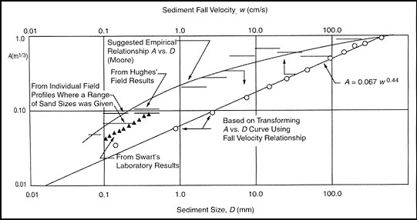
Figure A1. Profile scale factor A versus sediment diameter d and fall velocity w (from Dean, 1987; adapted in part from Moore, 1982).

Using equations (2) and (3), a value for A can be estimated and used to graphically depict offshore beach profiles. The following example demonstrates how to calculate the equilibrium beach profile scale factor, A, for nourishment material with a mean sediment diameter, D, of 0.2 mm.

Step One: Determine the Sediment Fall Velocity, w, by specifying a value for D into equation (3).

If D = 0.2 mm
Then w = 14(0.2)^{1.1} = 2.4

Step Two: Determine the Profile Scale factor, A, using the value obtained for w in Step One and equation (2).

If w = 2.4

Then A = 0.067(2.4)^{0.44} ≈ 0.1

Step Three: Use the determined value of A and equation (1) to graph water depth v. distance offshore. Figure A2 is a graph of the equation h = 0.1y^{2/3}. The result is a visual estimate of the beach’s offshore profile once equilibrium is reached.

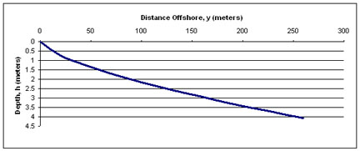
Figure A2. Equilibrium beach profile for sediment with a mean diameter, D, of 0.2 mm.

Depending on local wave action and storm frequency, it may take several months for a nourished beach to equilibrate in the cross-shore direction. Plotting beach profiles for both native and proposed beach sediment is useful in determining how nourishment material will be distributed over time, although note that equilibrium profile theory merely represents the overall concave shape of the offshore profile, and does not include the influence of tides or near shore sand bars.

Plotting beach profiles for multiple potential sediment sources and their corresponding grain size distributions (therefore, different A values) yields the results shown in Figure A3, where equation (1) is used to compute profile shape seaward of the shoreline. Figure A3 illustrates the reduced volume requirements needed to maintain a specific beach width, if the source material is coarser than the native beach, and vice versa. As a first approximation, plotting the equilibrium beach profile for the native beach with the anticipated equilibrium profile for the nourishment material will indicate the general depth of equilibrated fill in the near shore region.

This method of evaluating beach profiles for native and proposed beach sediment provides general information regarding the differences in profile shape; however, the method does not directly determine stability or potential longevity of the placed material. A more detailed methodology that compares several native beaches and borrow-site parameters is required to determine the potential stability of the nourishment material. This methodology, as well as calculations for a Massachusetts beach and two potential borrow sites are included in Attachment D. The detailed methodology is typically used when a beach nourishment project is engineered to provide a specific level of shore protection.

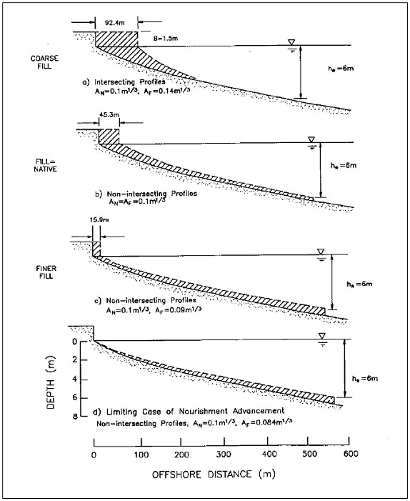
Figure A3. Behavior of beach profile with varying fill grain size (from U.S. Army Corps of Engineers, 1995).

ATTACHMENT B

RECEIVING BEACH CHARACTERIZATION

(Adapted from US Army Corps of Engineers, Design of Beach Fills, EM1110-2-3301 and Coastal Engineering Technical Note, Native Beach Assessment Techniques For Beach Fill Design, CETN II-29)

Biological Characterization

An important facet of any beach nourishment project is the evaluation of the potential effects on both terrestrial and aquatic species that may use the beach and adjacent inter- and sub-tidal areas for shelter, feeding, and reproduction. At a minimum, the following issues must be considered:

- Is the project area within or adjacent to any estimated habitat of rare wildlife or priority habitat of rare species as mapped by the Massachusetts Natural Heritage and Endangered Species Program? Similarly, are any federally listed and proposed, endangered or threatened species likely to use the project area or adjacent areas?

- Are there shellfish beds in or adjacent to the project area? If so, the species present and their density should be surveyed, and the extent of their habitat mapped.

- Are vegetated shallows (e.g., eelgrass, widgeon grass) present in or adjacent to the project area? If so, the species and plant density should be surveyed and the extent of the beds mapped.

- Is there rocky sub-tidal habitat in or adjacent to the project area? If so, this should be delineated on the project plans.

- It is important to consult with Massachusetts Division of Marine Fisheries and the National Marine Fisheries Service to determine if the project and adjacent areas are used by species that may not be readily observable during the field investigation, resulting in the destruction of animals or interference with their normal reproductive behaviors. A good example of the latter would be horseshoe crabs, which spawn on some beaches during spring and early summer. A poorly timed nourishment project could impede the horseshoe crabs’ ability to reproduce.

Physical Characterization

Accurate characterization of the native beach material is vital for a successful beach nourishment project. The first step is to develop and implement a sediment sampling and analysis plan. Elements of the plan should include:

- Sampling locations,
- Sampling method,
- Number of samples to be collected,
- What method will be used to composite representative samples, and
- How grain-size distribution will be determined.

Typically, sediment samples are collected along survey profile-lines within the project area. The profile-lines, which run perpendicular to the shoreline, should include all the morphological features found in the project area (See Figure B1). In general, beach/dune systems comprised of well-sorted sediment, or those having a narrow range of grain-sizes, will require fewer samples to accurately characterize them than will systems with poorly-sorted sediment, or those having a wide ranges of grain-sizes.

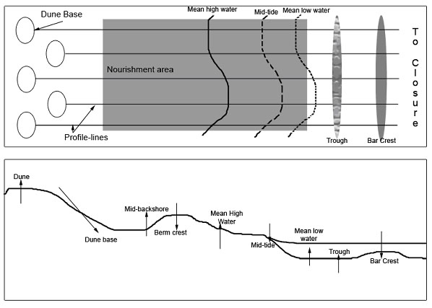
1
2

Figure B(1). Example of profile-lines for a nourishment project. (2). Characteristic zones and features of a beach profile.

Samples should be collected along the profile lines at locations that correspond to natural shore- parallel zones, distinct tidal elevations, and at specified elevation increments. Figure B2 outlines the characteristic zones and features of a typical beach profile. The arrows on Figure B2 show which zones usually result in sand deposition ( ↓ ) or uptake ( ↑ ).
Sample Collection

To characterize a native beach for beach nourishment, it is recommended that, at a minimum, samples be collected at mean high water (MHW), mid-tide (MT), and mean low water (MLW). If possible, include samples on the berm crest. If a well defined offshore bar system has been observed locally, collect additional samples in the trough and in the vicinity of the bar. These samples can be used to characterize the foreshore beach where the source material will be placed and re-sorted by wave action.

For beaches comprised primarily of sand, sampling consists of surface grabs of approximately 100 g of material from the surface layer (within 1 foot of surface) of the subaerial beach (above the mean high water line). Offshore samples can be collected with assistance divers or grab samplers. (Commonly used samplers include Ponar, Ekman clamshell, Van Veen, and Smith-MacIntire).

After all the locations along the profile-line are sampled, the individual samples should be composited (i.e., combined). To create a composite sample, the sub-samples (collected at key locations along the profile-line) must be thoroughly dried before an equal-weight portion of each is measured out. Then the equal portions are combined together to create a single sample for grain-size distribution analysis. This process should be repeated for each profile-line established. Ultimately there will be one composited sample for each profile-line.

Many beaches in Massachusetts consist of “reworked glacial sediments” ranging in grain size from fine sand to cobbles; for these beaches, significantly larger samples are required to develop grain size characteristics. Guidance for determining the appropriate sample size for analysis can be found in ASTM (American Society for Testing and Materials) Method D421 Standard Practice for Dry Preparation of Soil Samples for Particle-Size Analysis and Determination of Soil Constants (available online at www.astm.org).

Sample Evaluation

Determine the grain-size distribution of the sand samples in accordance with ASTM Method D422 Standard Test Method for Particle-Size Analysis of Soils, using, at a minimum, sieve numbers 4 (4.76 mm), 10 (2.0 mm), 14 (1.41 mm), 20 (0.84 mm), 40 (0.42 mm), 60 (0.25 mm), and 200 (0.074 mm). Submit the resulting data in both numeric and graphical formats. The data should be displayed with both a size (mm or mesh size) and grain size scale to facilitate review and interpretation. An example of the preferred graphical format is included below.
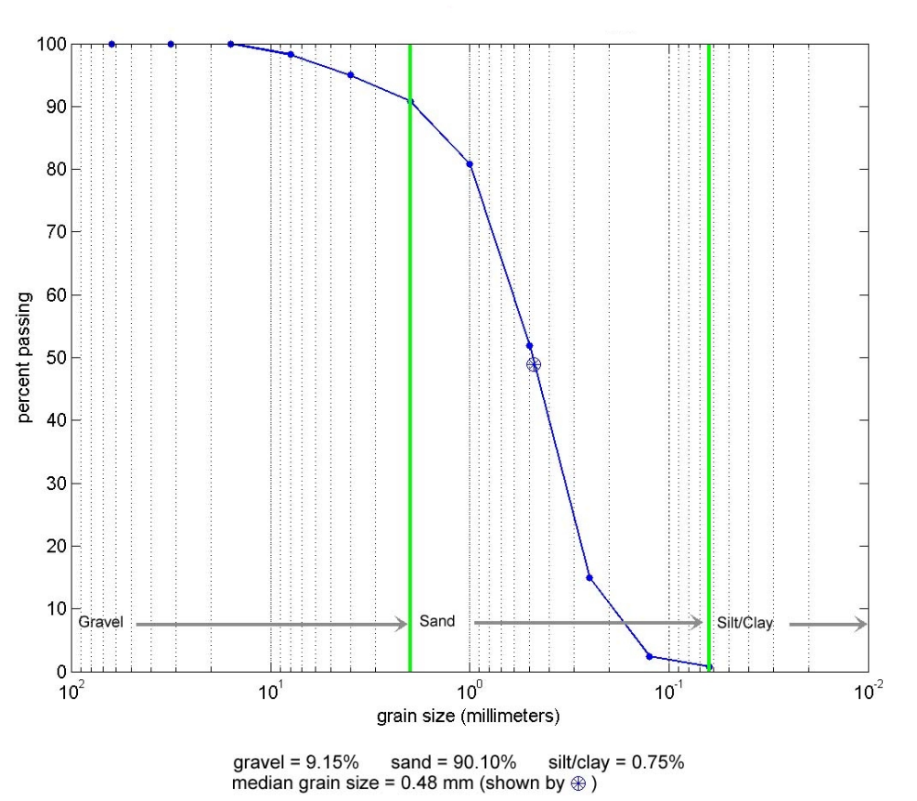
Figure B3. Example of a grain size analysis curve.

Due to the glacial origin of coastal sediment in Massachusetts, pebble, cobble, and boulder size material is common on beaches and tidal flats. Some beaches have naturally high percentages of cobble size material, such as Egypt Beach in Scituate (See example in photograph B1). In other cases, such as the Plymouth Shoreline near Manomet Beach, the finer sediment has eroded, leaving a lag deposit of pebble, cobble, and/or boulders on the surface. (See example in photograph B2).

The latter situation complicates both sampling and determining sediment compatibility. For beach nourishment projects, the grain size of potential sources should be based on many factors: the wave climate, exposure, characterization of the sediment across the existing beach profile, and projected stability of the proposed source material on the beach. For beach nourishment involving the beneficial re-use of dredge material intended to keep the sediment in the system, the stability is less critical if there are no sensitive resources that would be adversely affected by the transport of sediment alongshore or offshore. Several test pits may be helpful in determining the abundance of cobble relative to other sediment types.
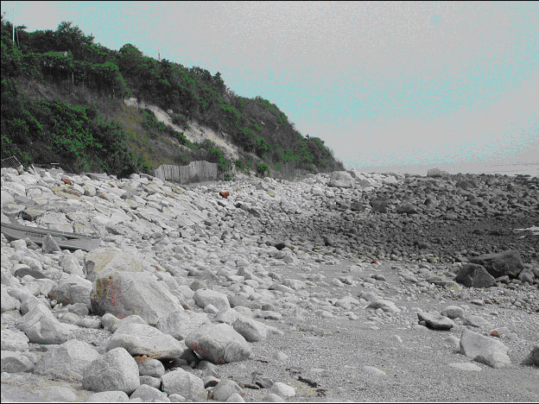
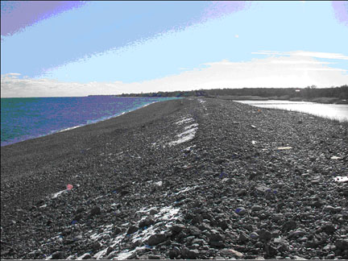

Photograph B1. Beach with high percent of cobbles (Photo courtesy of Rebecca Haney).

Photograph B2. Beach with lag deposits of sand, cobbles, and boulders (Photo courtesy of Jim Mahala).
ATTACHMENT C

SOURCE MATERIAL CHARACTERIZATION

Sediment samples will need to be collected for the grain-size distribution analysis. Collect samples from locations within the area to be dredged to accurately document the variability in grain-size distribution.

Obtain samples by coring to the full depth of the dredging area. For projects up to 10,000 cubic yards, collect one core per 5,000 cubic yards of sediment to be dredged; note, however, that the number of samples may vary depending upon the relative homogeneity or heterogeneity of the sediment. For larger dredging projects the number of cores should be determined by the extent of the dredging area and the homogeneity or heterogeneity of the material to be dredged. Up to three (3) cores (subsamples) may be composited, or combined together, to create a single sample for analysis provided that:

- Grain-size distributions are comparable,
- The likelihood of contamination is similar based on depositional characteristics, spill history, location of point source discharges, etc., and
- Samples were obtained from the same reach.

To create a composite sample, thoroughly dry the sub-samples before measuring equal-weight portions from each. Next, combine the equal portions to create a single sample for analysis. Repeat this process for each composite sample to be created.

Determine the grain-size distribution for each sample in accordance with ASTM Method D422 Standard Test Method for Particle-Size Analysis of Soils, using, at a minimum, sieve numbers 4 (4.76 mm), 10 (2.0 mm), 14 (1.41 mm), 20 (0.84 mm), 40 (0.42 mm), 60 (0.25 mm), and 200 (0.074 mm). Provide the resulting data in both numeric and graphical formats. As with the beach fill characterization (Attachment B), display the data with both a size (mm or mesh size) and grain scale size to facilitate review.
Generally, chemical testing of sediment containing less than 10% by weight of particles passing the No.200 U.S. Standard Series Testing Sieve is required unless exempted by the MassDEP. A “due diligence” review may demonstrate, to the Department’s satisfaction, that the area is unlikely to be contaminated with oil or hazardous materials. A “due diligence” review, may include, but is not limited to, a review of records of the local Board of Health, Fire Department, Harbormaster and/or Department of Public Works, the Department’s Bureau of Waste Site Cleanup, knowledge of historic land uses, information from prior dredging projects and discharges of pollutants in the project area watershed.

ATTACHMENT D

SAMPLE PROBLEM: BEACH AND BORROW SITE SEDIMENT ANALYSIS TO DETERMINE STABILITY OF NOURISHMENT MATERIAL FOR SHORE PROTECTION

Introduction

To determine the sediment characteristics of Town Beach for the proposed beach nourishment project, the project proponent conducted a sampling and sediment analysis program. The proponent evaluated samples of sediment from the beach and two possible borrow sites to determine compatibility. Both borrow sites are navigation channels proposed for maintenance dredging. Both are located within a mile of Town Beach.

Town Beach Sediment

To assess whether the potential borrow sites were compatible with the native beach sediment, the proponent collected a series of beach grab samples along cross-shore profiles. The proponent collected these samples near the high water line, the mid-tide line, the beach berm crest, and the low water line. A total of nineteen (19) samples were collected on Town Beach. The proponent collected the samples along eight (8) shore perpendicular transects, that were spaced at approximately 1,000 ft. to 1,500 ft. intervals to capture the natural variability of material along the beach.

Grain size analyses for the nineteen samples are presented in Figure D1. The analyses showed heterogeneous sediment ranging from fine sand to fine gravel. However, the majority of the material was relatively homogenous, containing primarily medium to coarse sand. On average the samples contained less than 10 percent gravel by weight. The grain size envelope is shown in the shaded region of Figure D1. The left border of the shaded area indicates the coarsest material (medium sand-to-gravel) and the right border indicates the finest material (fine-to-medium sand) found on the beach. To compare the native beach sediment to the proposed borrow material, the proponent developed a composite sample of the beach using a standard U.S. Army Corps of Engineers design methodology (USACE, 1995). The composite sample was generated by summing the percentage of sediment in each size interval for the nineteen samples. The total value in each size interval was then divided by the number of samples to obtain an average value. The blue/gray line bisecting the shaded area in Figure D1 represents the results of the composite grain size analysis for Town Beach, and shows the mean grain size of the native beach to be approximately 0.33 mm.

Sediment from Dredging Channel A

Channel A is a navigation channel that is also a potential source of suitable beach nourishment material for Town Beach. To test for compatibility, the proponent conducted grain size analyses on several cores from the site. The material was found to range from medium sand to gravel. Figure D2 shows the specific range of material found in Channel A.
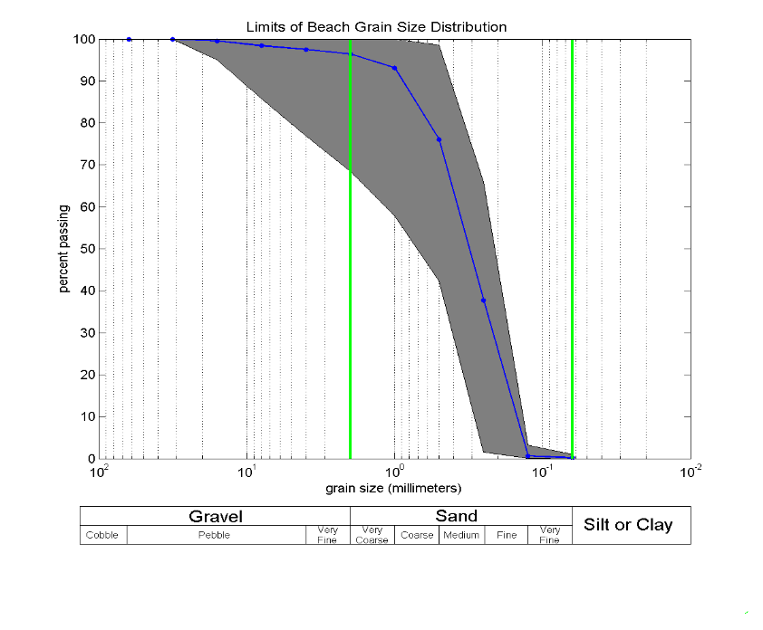
Figure D1. Grain size distribution of the native beach material found along Plymouth Beach, where the shaded area represents the grain size envelope and the curve bisecting the shaded area represents the composite grain size curve.

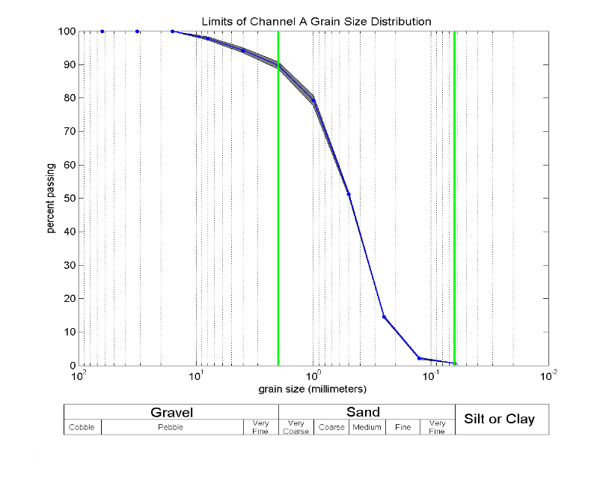
Figure D2. Grain size distribution of the material found in the Channel A borrow site, where the shaded area represents the grain size envelope and the curve bisecting the shaded area represents the composite grain size curve.

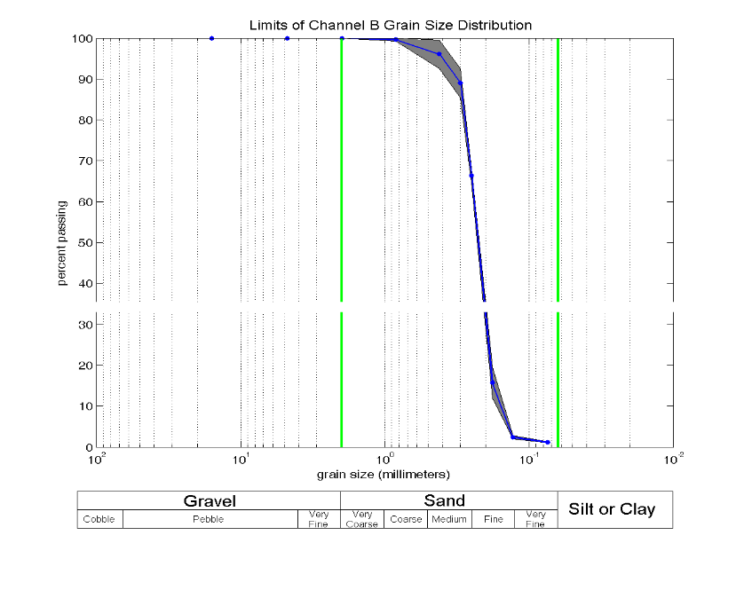
Figure D3. Grain size distribution of the material found in the Channel B borrow site, where the shaded area represents the grain size envelope and the curve bisecting the shaded area represents the composite grain size curve.

Navigation Channel B Sediment

The proponent also determined grain size from cores taken from Navigation Channel B. The material was found to have a very narrow range of medium to fine sand. Figure E3 shows the specific range of material found in the channel.

Sediment Characteristics

The two physical properties of sediment that are most important for determining its suitability as nourishment material are composition and grain size; desirable physical properties are mechanical strength and resistance to abrasion. In most regions of New England, sediment is predominantly composed of quartz particles, so that borrow material will likely have adequate strength and high resistance to abrasion.

Ideally, the grain size of the source material should be the same size or larger than the native beach sand to minimize erosion. Material that has a smaller diameter than the native sand can remain in equilibrium only at slopes flatter than the existing beach. If smaller diameter sand is used, the volume required to form an equilibrium offshore profile will be much greater and consequently, more costly. The mean grain size for the nourishment material on Town Beach should be equal or greater than the mean grain size observed on the native beach, or 0.33 mm.

In practice, nourishment material never exactly matches the native beach material in a project area. James (1975) developed an approach for indicating the behavior of a fill material having different characteristics than the native material. This approach uses a ratio indicating how much fill material is required as a result of the different sediment characteristics between the fill and native materials. The approach assumes:

- The native sediment is most compatible for creating a beach profile consistent with the existing beach
- Sorting of borrow material by coastal processes will achieve a similar grain size distribution as the native beach, given enough time
- Sorting of borrow material will winnow out a minimum amount of the original nourishment volume
- Both native and borrow material exhibit normal grain size distributions

Using the assumptions described above, James (1975) defined a factor for estimating the required nourishment volumes considering differences between the channel sediment and native materials. This overfill ratio, R_{A}, is the volume of borrow material required to produce a stable unit of usable nourishment material with the same grain size characteristics as the native material. R_{A} is determined by comparing the mean sediment diameter (φ) and sorting values of the native and proposed borrow sediment. The φ scale of sediment diameter is defined as:
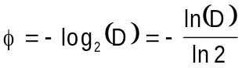

where D is the sediment grain size in millimeters. The adjusted overfill ratio is determined using the following relationships between the borrow and native material:

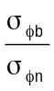
and
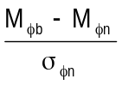
where

σ_{φb} = standard deviation or measure of sorting for borrow material
σ_{φn} = standard deviation or measure of sorting for native material
M_{φb} = mean sediment diameter for borrow material
M_{φn} = mean sediment diameter for native material

Plot the values from the above relationships on the appropriate U.S. Army Corp nomograph (see Figure E4), and determine R_{A} by interpolating between values represented by the isolines. (Note: A detailed description of this technique is described in the Shore Protection Manual, U.S. Army Corps of Engineers, 1984).

Results

Estimate the overfill ratio for the grain size distributions of the native beach material and the sediment in Navigation Channels A and B. The grain size distribution for these samples is shown in Figure E4. The results from the above analysis show that for Navigation Channel A, σ_{φb} = 1.24, σ_{φn} = 1.03, M_{φb} = 0.70, and M_{φn} = 1.47. The overfill ratio, R_{A}, is 1.02 (Figure E5), meaning 1.02 cubic yards of sediment will be required for every cubic yard of native material.

The low overfill ratio indicates that the material from Navigation Channel A closely matches the native material, and would be a good source of sediment for nourishment of Town Beach. The analysis results for Navigation Channel B are, σ_{φb} = 0.34, σ_{φn} = 1.03, M_{φb} = 2.13, and M_{φn} = 1.47. The overfill ratio, R_{A}, falls in the unstable range (Figure E5), indicating that sand from Navigation Channel B would quickly erode, causing the beach to return to its pre-construction condition. Because the goal of the project is to increase the volume of sediment in the beach system for shore protection, Navigation Channel B is not a good nourishment source for Town Beach.
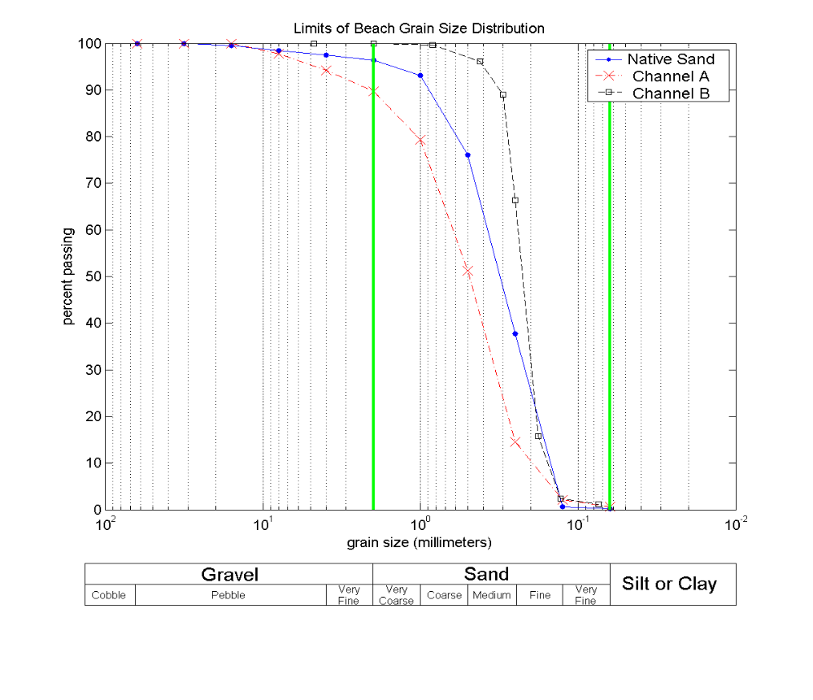
Figure D4. Comparison of grain size distribution curves for native beach material and material from proposed borrow site.

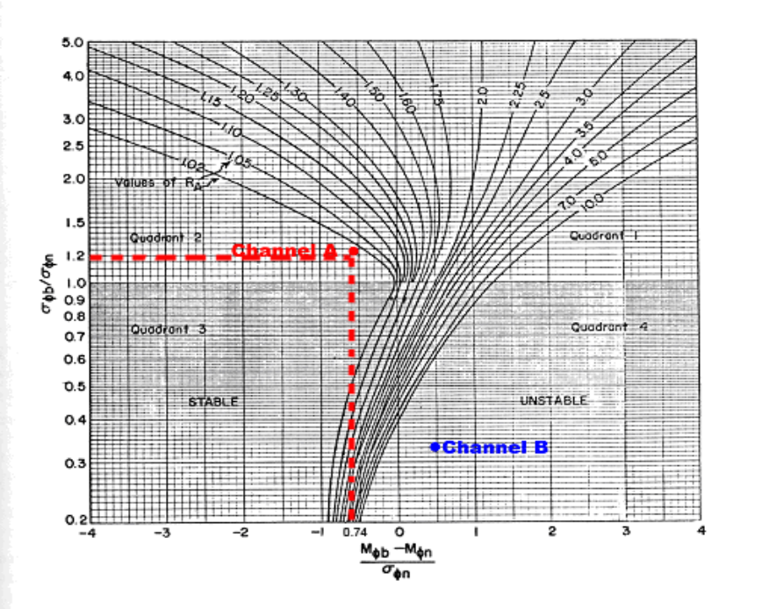
Figure D5. USACE nomograph represent the computed overfill factors (R_{A}) for Channel A and Channel B in relation to the native material on Town Beach.

ATTACHMENT E

GENERIC BEACH MONITORING PLAN

This attachment provides a general overview of the elements that make up a good monitoring program. More specific information and instructions can be found in the U.S. Army Corps of Engineers’ publications: Design of Beach Fills, EM 1110-2-3301 and Coastal Project Monitoring, EM 1110-2-1004. In general, the efforts described in the U.S. Army Corps Engineering Manuals refer to engineered beach nourishment projects. For smaller-scale beach nourishment projects, monitoring would likely be limited to an evaluation of potential adverse impacts to resource areas associated with sediment movement rates. Refer to CZM’s Beach Management Guidelines for information about monitoring for the presence of rare coastal shorebirds post-construction. Should their presence be observed, contact the NHESP for further information.

The primary objectives of monitoring a beach nourishment project are:

- to document and evaluate whether the project is performing as designed,
- to identify maintenance and re-nourishment requirements, and
- to evaluate project impacts.

Ideally, monitoring plans should include beach profile surveys and an evaluation of the survey data to determine nourishment stability. Monitoring should begin prior to material placement, so that baseline conditions can be documented, and continue at regular intervals thereafter. If possible, collect post-storm profile information because it is helpful in evaluating the cross-shore response of the project to storm waves and tides.

When the purposes of a beach nourishment program are shore protection and reestablishing the local sediment supply, an evaluation of long-term nourishment needs is necessary for planning future beach maintenance. Generally, the beach nourishment design life is determined during the design process; however, monitoring will show how well the actual nourishment performance compares to design performance. Beach profile monitoring provides information on:

- the percent nourishment remaining within the project area compared to baseline conditions,
- the occurrence of downdrift accretion on beaches,
- the presence of areas highly susceptible to erosion (i.e., “hot spots”) as indicated by variable longshore beach widths, and
- the future nourishment volumes needed to maintain the sediment supply.

For all projects, monitor the material placed on the beach to determine shoreline changes and whether the beach fill is shifting. Monitoring requires measuring elevations along a series of shore perpendicular control transects (or cross-sections) along the length of the project area. The number of transects required to evaluate the nourishment depends on the size of the nourishment project, as well as the presence of shoreline features that may control sediment transport in the longshore direction (e.g., natural headlands or groins). Typically, transects should be spaced every 100 to 400 feet. Surveys are generally conducted landward of any expected long-term changes in beach/dune shape, to a water depth where changes between the equilibrated nourishment profile and the pre-construction profile are anticipated to be minimal.

Contractors are usually required to measure profiles before, during and after construction to document the amount of sand placed so they can receive the appropriate amount of compensation. The monitoring plan should measure actual nourishment performance in the first three months of the project because the initial equilibration and longshore spreading occurs relatively quickly. A qualified surveyor or engineering contractor with experience in beach profile monitoring should undertake additional post-construction monitoring. Generally, a number of surveys should be performed during the first year following construction including, ideally, seasonally. After the first year, the beach nourishment transects can be monitored annually. For major beach nourishment programs (i.e., more than 2,000 feet long), the nourishment transects are measured within the original design template, as well as within approximately 1,000 feet updrift and downdrift of the project limits.

Monitoring reports are typically prepared after the first year of complete data evaluation, and bi-annually thereafter. These reports should summarize all data collected, including general information regarding the wave climate and storm activity, changes in sand volume over time, and measured shoreline changes. The information can then be used to evaluate performance, assess any adverse environmental impacts, and estimate future re-nourishment requirements.

Attachment F

Sample Easement
PUBLIC ACCESS EASEMENT
Said public on-foot right-of-passage shall not be exercised (a) later than one-half hour after sunset nor earlier than sunrise; (b) where the Commissioner of the Department of Conservation and Recreation for the purpose of protecting marine fisheries and wildlife or for controlling erosion, designates and posts natural area of critical ecological significance as areas in which, on either a regular or seasonal basis as circumstances in each situation require, the public not exercise the on-foot free right-of-passage; (c) where there exists a structure, enclosure, or other improvements made or allowed pursuant to any law or any license, permit, or other authority issued or granted under the General Laws or where exist agricultural fences for the purposes of enclosing livestock, provided that such area is clearly and conspicuously posted.
The Grantor(s), and the heirs, successors, and assigns of the Grantor(s) covenant and agree to reimburse the Grantee all reasonable cost and expenses (including without limitation counsel fees) incurred in enforcing this easement or in remedying or abating and violation thereof By its acceptance the Grantee does not undertake any liability or obligation relating to the condition of the Property.
The parties may execute this instrument in two or more counterparts, which shall, in the aggregate, be signed by both parties: each counterpart shall be deemed an original instrument as against any party who has signed it. In the event of any disparity between the counterparts produced, the recorded counterpart shall be controlling. The Grantor agrees to incorporate the terms of this Restriction in any deed or other legal instrument by which he divests himself of any interest in all or a portion of the Property.

The Grantor(s) shall record this instrument in timely fashion in the, _______________County Registry of Deeds.
NOW, THEREFORE, in consideration of the facts recited above and the mutual convents, terms, conditions, and restrictions contained herein, and pursuant to laws of the Commonwealth of Massachusetts, the Grantor hereby voluntarily grants and conveys to the Grantee an easement in perpetuity over the Property of the nature and character and to the extent hereinafter set forth: There is granted to the Grantee, the residents of __________and the public generally, a public on-foot right-of-passage along and across the shore of the coastline between the mean high water line and the entire “nourished area” subject to the following restrictions and limitations:
Executed under seal this ___________day of __________________________, 200__
WHEREAS, Grantor is sole owner in a fee simple of certain real property (the “Property”) in______________, more particularly described above; and
I (WE) _______________________________________of ____________________________________ the “Grantor(s),” which term shall, in perpetuity of the nature and character and to the extent hereinafter set forth, over a parcel (the “Property”) located in __________________, at the following address:______________________

WITNESSETH:
WHEREAS, the property possesses natural, scenic, and open space values of great importance to the people of Harwich and the people of the Commonwealth of Massachusetts; and WHEREAS, the value of the property has been (or will be) restored, enhanced, and protected (“The Nourished Area”) by a locally funded beach nourishment project more particularly described in the plans provided at Town Hall; and
WHEREAS, the Grantor has received a direct benefit from said publicly-funded beach nourishment project;

______________________________________________________________________________

ATTACHMENT G

REFERENCES

Dean, R.G., 1987. Coastal Sediment Processes: Toward Engineering Solutions, Proceedings of Coastal Sediments 1987, American Society of Civil Engineers, Reston, VA, pp. 1-24.

Dean, R.G., 2002. Beach Nourishment Theory and Practice, Advanced Series on Ocean Engineering – Volume 18, World Scientific Publishing, River Edge, NJ, 399 pp.

Dean, R.G., and Abramian, J., 1993. Rational Techniques for Evaluating the Potential of Sands for Beach Nourishment, U.S. Army Corps of Engineers, Waterways Experiment Station, Report DRP-93-2, Vicksburg, MS.

Dean, R.G., and Dalrymple, R.A., 2002. Coastal Processes with Engineering Applications, Cambridge University Press, New York, NY, 474 pp.

Hallermeier, R.J. 1981. Seaward Limit of Significant Sand Transport by Waves: An Annual Zonation for Seasonal Profiles, Coastal Engineering Technical Aid No. 81-2, U.S. Army Engineer Waterways Experiment Station, Vicksburg, MS.

James, J.R., 1975. Techniques in Evaluating Suitability of Borrow Material for Beach Nourishment, Technical Memorandum No. 60, Coastal Engineering Research Center, U.S. Army Corps of Engineers Waterways Experiment Station, Vicksburg, MS.

Kamphuis, J.W., 2000. Introduction to Coastal Engineering and Management, World Scientific Press, River Edge, NJ.

Massachusetts Office of Coastal Zone Management, 1994. Guidelines for Barrier Beach Management in Massachusetts, Boston, MA, 266 pp.

Moore, B.D., 1982. Beach Profile Evolution in Response to Changes in Water Level and Wave Height, MCE Thesis, Department of Civil Engineering, University of Delaware, Newark, DE, 164 pp.

National Research Council, 1995. Beach Nourishment and Protection, National Academy Press, 334 pp.

Natural Resources Conservation Service, 1992. Restoration of Sand Dunes Along the Mid-Atlantic Coast., Somerset NJ, 40 pp.

“Piping Plover (Charadrius melodus), Atlantic Coast Population, Revised Recovery Plan” Prepared by the Atlantic Coast Piping Plover Recovery Team for the U.S. Fish and Wildlife Service Region Five, Hadley, Massachusetts

Ramsey, J.S., and Cote, J.M., 2001. Winthrop Shores Reservation Restoration Program – Borrow Site Screening Process and Assessment of Physical Borrow Site Characteristics for Winthrop Beach, Applied Coastal Research and Engineering, Inc., Mashpee, MA.

Stauble, D.K., 1991b. Native Beach Assessment Techniques for Beach Fill Design, Coastal Engineering Technical Note II-29, U.S. Army Engineer Research and Development Center, Coastal and Hydraulics, Vicksburg, MS.

U.S. Army Corps of Engineers, 1984. Shore Protection Manual, Volume I, Washington, DC.

U.S. Army Corps of Engineers, 1995. Engineering and Design: Design of Beach Fills, Engineering Manual EM 1110-2-3301, Washington, DC.

