Massachusetts Department of Public Health

Peer-to-Peer Webinar:
Best Practices for Managing Medications for Residents with Opioid Use Disorder (OUD)

1

Welcome & Purpose

- To support long-term care facilities (LTCF) in effectively caring for residents diagnosed with opioid use disorder (OUD).
- As a result of today’s discussion, you will have an understanding of
  - Medications used to treat residents with OUD and
  - Policies and procedures for managing medication treatment.

Rules of Engagement

Let’s support each other!
- Share shamelessly
- Ask questions and make comments that stay on topic
- Actively listen
- Honor all experience and expertise equally
- Maintain confidentiality

Today’s Participants Include…

- Select one of the options that best describes the type of organization you represent.
Office-Based Addiction Treatment (OBAT)

Rest Home

Opioid Treatment Program (OTP)

Nursing Home

Community Resource

Other

Medications for Opioid Use Disorder (MOUD)
Margherita Giuliano, RPh

Short-Term
How Opioids Effect The Brain
  - Fatigue
  - Numbness (absence of pain)
  - Euphoria
  - Drowsiness
  - Lethargy
  - Nausea

Long-Term
  - Irritability
  - Hallucinations
  - Hypoxia
  - Anxiety
  - Depression
  - Possible Hyperalgesia

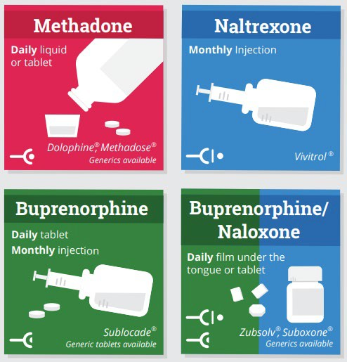
Medications for Opioid Use Disorder

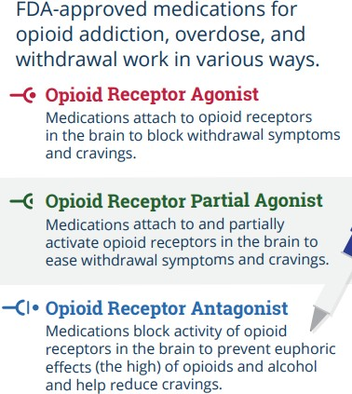

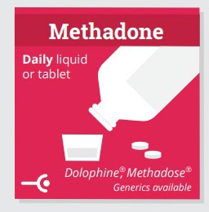
Methadone
- Synthetic opioid
  - Used to treat pain
  - Used as a MOUD
- Administered by licensed & certified OTP

- Must be dispensed at OTP clinic for the treatment of OUD
- Managed and monitored by OTP - typically daily
- Long-acting
- Full agonist - full activation of opioid receptors in the brain

Methadone - Benefits

- First line of treatment for MOUD; reduces desire for other opioids (full agonist)
- Eliminates withdrawal symptoms from discontinuation of opioid (anxiety, nausea/vomiting/abdominal pain, etc.)
- Administered in controlled setting by OTP (reduces risk of overdose)
- Helps individuals achieve and sustain recovery
- Various dosage forms and options to choose from in consultation with medical provider
SAMHSA: Methadone

Chain of Custody for Methadone

- If residents in LTCFs can and do receive methadone as part of their
care, who is in charge of handling methadone from OTP to patient’s hands?
- Assign the role to someone (e.g. a registered nurse) who is responsible for overseeing the chain of custody of methadone: – OTP manage pre-poured doses administration destruction

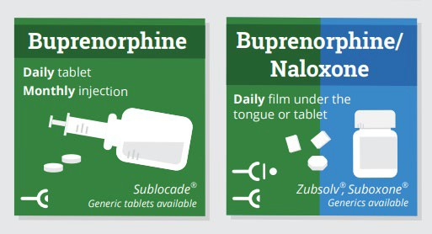
Buprenorphine (and Buprenorphine/ Naloxone Combination)

- Semi-synthetic opioid
- Used for treatment of OUD
- Can be used for pain
- Long-acting
- Partial agonist
– Binds to opioid receptors in brain but only causes limited or partial opioid effect in body relative to full agonist
- Community pharmacists CAN dispense this medication with a prescription
- Comes in many forms:
– Sublingual tablet, sublingual film, buccal film, transdermal patch (pain only), injectable (sub-cutaneous)

Buprenorphine Benefits

- Available at the community pharmacy and OTP
- Lower misuse potential than full agonist
- Lower opioid overdose symptom risk
- Various dosage forms and options to choose from in consultation with medical provider

SAMHSA: Buprenorphine

DATA 2000 Waiver

- Licensed independent practitioners in LTCF can receive waiver to prescribe buprenorphine
- To apply, practitioner must submit intent to SAMHSA Center for Substance Abuse Treatment (CSAT)
– Complete online waiver request form
- This could potentially open doors and opportunities for practitioners in LTCF to directly treat residents with MOUD
– Can potentially lead the way for future similar advances for medications such as methadone/naltrexone
SAMHSA: Become a Buprenorphine Waivered Practitioner

X-Waiver Training (Part 1 of 2)
- April 23, 2022 (8 am – 12 pm)

X-Waiver Training (Part 2 of 2)
- April 30, 2022 (8 am – 12 pm)

Upcoming DATA Waiver Training Sessions
This two-part training is intended to provide 8 hours of required training for providers seeking their buprenorphine waivers.

Waiver Trained: Now What? The Nuts and Bolts of Addiction Treatment This training will prepare prescribers to handle practical considerations when treating patients with OUD in office settings.
OBAT TTA+ Boston Medical Upcoming Trainings

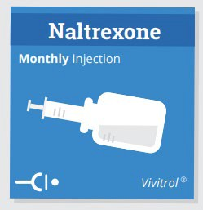

Naltrexone

- Approved for OUD and alcohol use disorder
- Long acting
- Not an opioid but is an opioid antagonist - blocks
activation of opioid receptor
- Prevents opioid-like effects
- Reduces desire to take opioids
- Currently available as tablet or injectable
- Before starting naltrexone, a resident needs to be opioid free for a minimum of 7-10 days due to risk of withdrawal symptom exacerbation

Naltrexone Benefits

- Blocks the effects of opioids
- Can reduce cravings for residents with OUD
- Can be dispensed at a community pharmacy
- Low diversion risk
- Low/no overdose risk

SAMHSA: Naltrexone

Discussion

How has your LTCF trained staff
on medication options for OUD?

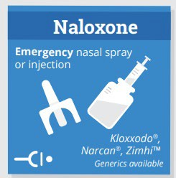

Naloxone
- It is an opioid antagonist that attaches to opioid receptors and reverses and blocks the effects of other opioids.
- This is not an opioid and can be dispensed by community pharmacies
- It is used for the complete or partial reversal of opioid overdose, including respiratory depression
- Staff members should be trained on recognizing opioid overdose and naloxone administration to address overdose.
Naloxone Training

Polling Question

  - Has your LTCF used naloxone for an opioid overdose emergency in the last year?

Discussion

- How has your LTCF trained staff on recognizing symptoms of overdose?

- How has your LTCF trained staff on naloxone administration?

- Are there any challenges or barriers your facility faces its ability to respond to an opioid overdose emergency? How have you navigated them in the past, if at all?

Policies and Procedures for
MOUD

Navigating care for those affected by OUD

Methadone Take-Home at a Long Term Care Facility

  - Resident will receive methadone take-home (TH) if appropriate per the OTP Medical Director.
  - Create a Chain of custody form
  - Ensure the security of the methadone on site
  - Document self-administration of TH methadone
  - Maintain accountability for all bottles; return empties to the clinic
  - Plan for destruction of methadone when the resident leaves facility if appropriate.
  - Facility needs to be in consistent communication with OTP, (e.g. if the resident leaves against medical advice facility need to alert OTP).

OTP Medical Director approves methadone TH for resident OTP and LTCF create a Chain of Custody Form
Ensure the security of the methadone on site at the LTCF Document self-administration of TH methadone
Develop a plan between the LTCF and OPT regarding what will done with methadone once the resident is discharged

Consistent communication between the LTCF and OTP is necessary (e.g., if the resident leaves against medical advice facility need to alert OTP).

Coronavirus Disease 2019 (COVID-19) Blanket Exception

  - Up to 28 days TH medication - stable patients
  - Up to 14 days TH medication - less stable patients who can safely handle this level.
  - For COVID-19 TH medication, dispensing of THs is based on individualized assessment by the OTP medical team.
  - Decisions r/t TH medications are made by OTP’s medical director in consultation with the clinical team.
  - The LTCF must consult with the OTP when a resident has a change in mediation or is being discharged and/or experiencing a medical emergency.
Source: BSAS Practice Guidance: Integrating Opioid Overdose Prevention Strategies into Treatment https://www.samhsa.gov/medication-assisted-treatment/statutes-regulations-guidelines/methadone-guidance

Discussion

Share one challenge from implementing policies/procedures around methadone accessibility and storage.
How did you mitigate the challenge?

Effective Communication

  - Qualified Service Organization Agreement (QSOA)
  - Individual Release of Information (ROI)
  - HIPAA Regulations
  - 42CFR
  - Record of Justification for Exemptions

Sample: Record of Justification

  - Per agreement between this OTP and [Name of LTCF], the resident will pick up six (6) TH's on [Specify Day of Week] in the company of staff from [Name of LTCF]. On [Specify Day of Week], the resident will be dosed at [Name of OTP]. Six methadone doses will be placed in a locked box and will be sent back with staff from [Name of LTCF] and the resident. The resident and the staff member from [Name of LTCF] will sign a chain of custody for these THs.

Sample: Record of Justification (cont. 1)

  - The resident will self-administer daily methadone doses dispensed by the LTCF nurse. After being handed the daily dose, the resident will ingest in the presence of the LTCF nurse. Both the nurse and resident will sign receipt of the dose on a chain of custody administration record. On [Specify Day of Week] the resident will return to the OTP with the locked box containing empty methadone bottles and chain of custody form.

Sample: Record of Justification (cont. 2)

  - The LTCF and the resident have been made aware that if the resident leaves the program at any point in time (whether for voluntary or administrative) all THs can be taken with them if the resident is deemed stable by the OTP physician.
  - Any remaining doses will be disposed of in accordance with the LTCF’s policy on disposal of medication left behind and regulations for destruction of medication.

Payment Methodologies for New and Existing Nursing Facility Payments Substance Use Disorder (SUD) Rate Add-on

101 CMR 206.00: Standard Payments to Nursing Facilities | Mass.gov

Criteria for the Rate Add-On

Eligibility for $30 per member per day SUD Rate Add-on requires meeting the three following criteria:
  - July 1, 2020 - June 30, 2021: 30% of MassHealth fee-for-service members residing in the facility had an SUD diagnosis (diagnosed w/in previous five years) that falls under eligible diagnosis group;
  - July 1, 2020 - June 30, 2021: at least 30 MassHealth fee-for service members residing in the facility had an SUD diagnosis (diagnosed w/in previous five years) that falls under eligible diagnosis group;
  - The facility certifies that it will complete the SUD training offered to nursing facilities by the MDPH no later than June 30, 2022

Self-Paced Training: The Care of Residents with OUD and Stimulant Use Disorder (StUD) in LTC Settings

  - Satisfies the required training for the SUD rate add-on.
  - Training designed to help staff understand the care needs of residents with OUD and StUD.
  - Six educational modules
    - Holistic approach grounded in person-centered care and standards for Culturally and Linguistically Appropriate Services (CLAS).
    - Taken at your own pace; start, stop, and restart at your convenience.
  - Optional for facilities with experience caring for residents with OUD/StUD; required for those with little or no experience.

Discussion

  - Today we covered MOUD and related policies.
  - What other questions do you have regarding caring for residents with OUD and those receiving MOUD?
  - Does anyone have anything to share that impacts the care of residents receiving MOUD?
  - Although this webinar did not touch on StUD, our training and toolkit does. Do you have any questions or comments regarding StUD or co-occurring OUD and StUD?

Polling Question

What would be helpful in future sharing sessions?

- OUD and StUD general education
- Implicit Bias and Stigma
- Motivational Interviewing
- Community resources for residents after discharge
- Other

Massachusetts Department of Public Health

Thank you!

35

Connect with DPH
36

@MassDPH
Massachusetts Department of Public Health DPH blog
https://blog.mass.gov/publichealth

www.mass.gov/dph

