Best Practices for Feeding Breast Milk or Formula to Babies

***Relationships are the***

***Heart of Quality Care***

Use feeding time to develop your relationship with the baby.

***Health & Safety Information***

**It’s important to follow safe food handling, preparation and storage practices in child care programs.**

* Always wash your hands before handling bottles or feeding a baby.
* Use BPA-free plastic, labeled #1, 2, 4 or 5 or glass.

***Tips for Supporting Breast Fed Infants***

* Discuss the infant’s usual feeding schedule with parents.
* Ask if the mother wishes to time the child’s last feeding of the day so they are ready to be breast fed when she arrives.
* If mom wishes to feed the infant at the program, create a quiet, comfortable, private place: sink for mom to wash her hands, comfortable chair, pillow, footstool, glass of water for Mom to drink.
* It is a good idea to have a supply of extra breast milk on hand. Keep the breast milk in the freezer or refrigerator so it won’t spoil.

***Storing Breast Milk***

* Label the bottles with the baby’s name and the date and time the milk was collected.
* Store milk in plastic bottles. Glass bottles can break.
* Each bottle should hold just enough for one feeding.
* Freeze small bottles with one or two ounces of breast milk for extra meals.
* Use a cooler and ice packs to bring the fresh or frozen milk to the child care program.

***How to Thaw Frozen***

***Breast Milk***

* Thaw milk in the refrigerator. Don’t thaw at room temperature as bacteria may develop,(for example, on the kitchen counter).
* Hold it under cool (not cold) running water.
* Frozen breast milk can be stored in an air-tight container in the freezer for up to 3 months but it must always be at 0°  F or below.
* Refrigerate thawed milk at 40° F or below and use within 24 hours.
* Always use the oldest milk first
* Don’t refreeze milk.

It is normal for breast milk to separate when stored, just swirl it **gently** to remix.

***Warming Breast Milk***

***and Formula***

You don’t have to warm breast milk or formula. It can be safely fed to an infant cold right from the refrigerator. However, you may wish to warm the milk if the family or child prefers. Be *very careful* when warming bottles. Overheated milk can seriously burn the baby.

* Hold the bottle under warm (never hot) running tap water.
* Set the bottle in a pan of warm water.
* Warm only as much breast milk or formula as you will use for a feeding.
* Test the temperature.
* Don’t heat breast milk on a stove or in a microwave. Stoves and microwaves also damage special substances in breast milk that protect the baby’s health.

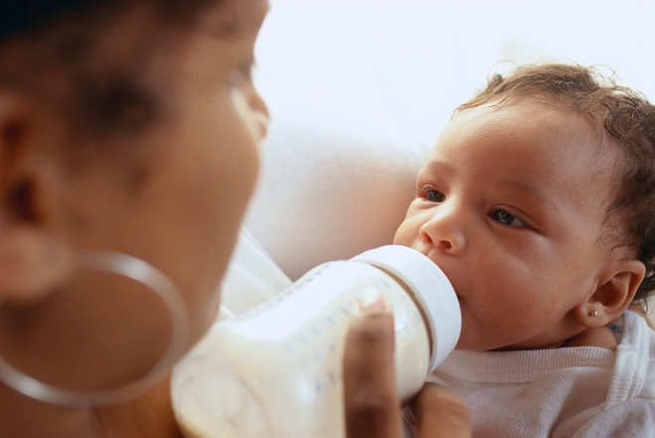

**Microwaves, Electric Bottle Warmers and Crock Pots**

* + **A Special Warning**

**Microwave ovens are not safe for warming breast milk or formula. They can cause hot spots that can burn the child.**

**Slow cookers, (crock pots), and bottle warmers contain hot water which can place children at risk of burn injuries. Formula or breast milk stored in warm water for an extended period of time provides an ideal medium for bacteria to grow.**

**These practices are prohibited per EEC licensing policy.**

***Infant* *Formula***

* Always use infant formula before the “use before” or expiration date on the container.
* Don’t freeze formula because it can separate.
* You can keep open liquid concentrate or ready-to-use formula in the refrigerator for up to two days if the cans are tightly covered.
* Label the bottles with the baby’s name and the date.

***Never Prop A Bottle Or Leave A Bottle In The Crib With A Baby.***

* This creates a choking risk.
* Bottle propping promotes tooth decay.
* Licensing regulations require that infants are held while they are bottle fed.

***After the Baby is Fed***

* Use prepared formula within two days after mixing.
* Throw milk, formula, or food away if it has been out of the refrigerator for more than two hours.
* Discard any formula or milk the baby hasn’t finished after feeding. The milk is no longer sanitary, even if it’s placed back into the refrigerator.

***Sources***

“National Resource Center for Health and Safety in Child Care and Early Education, Caring for Our Children 3rd edition”

http://nckids.org/CFOC3

“Infant Nutrition and Health: WIC Works Resource System”

<http://www.nal.usda.gov>

“Children’s National Medical Center – Department of Trauma and Burn Services

EEC regulations 606 CMR 7.00

EEC licensing policy, Bottle Warming Safety

Best Practices for

Bottle Feeding

In An

Early Education and Care

Setting

