Department of Public Health
Bureau of Substance Abuse Services
Service and Practice
Hilary Jacobs, LICSW, LADC I
Director
hilary.jacobs@state.ma.us
AGENDA
Introduction to BSAS
Descriptive data on persons served
Inventory of current programs and services
Best treatment practices

BSAS History
Key Dates

1950 Division of Alcoholism established within DPH
1970 Division of Drug Rehabilitation established within DMH
1986 two divisions merged within DPH as the Bureau of Substance Abuse Services

BSAS Major Responsibilities
Single State Authority
Overall responsibility for system development
Overall responsibility for quality of care
Fund prevention, intervention, treatment and recovery support services
License treatment facilities
License addiction counselors

What BSAS funds
Prevention services
Licensed treatment services
BSAS is the payer of last resort for clients with no other resources or where there is no other payer
Non licensed services
Case management
Recovery High Schools
Recovery Support Centers
Narcan distribution
Workforce development
Training
Free materials for providers and clients
Pilot programs (via federal grants)

BSAS Enrollments
FY 2013
104,143 new enrollments

153,289 total enrollments served

Notes: Enrollment totals on all slides are primary enrollments only
Data is as of 10/22/13
Characteristics of
FY 13 enrollments served
N=153,289
Client Gender
69% male
31% female
< 1% transgender

Primary Drug of Choice
46% heroin
9% other opiate drugs
32% alcohol

Other Characteristics
59% report opiates as their primary or secondary drug of choice
40% between the ages of 16 and 29
64% unemployed
14% homeless

Characteristics
Transitional Age Youth (TAY)
FY13 Enrollments Served
(16-24 years old)
30,387 enrollments served
Client Gender
66% male
34% female
< 1% transgender
Primary Drug of Choice
49% heroin
12% other opiate drugs
21% alcohol
Other Characteristics
65% report opiates as their primary or secondary drug of choice
65% unemployed
11% homeless
20% had children under 6 years old
Health Concerns in Transitional Age Youth (TAY)
(16-24 years old)
National Data:
Less likely to be insured or have a PCP and more likely to use ED
Highest rate of drug use, including prescription misuse (NIDA)
Accounted for 40% of 2010 ED visits related to club drugs (SAMHSA)
Highest HIV incidence rates in 20-24 year olds (CDC)
Emerging mental illness
MA Data TAY represent:
24% of all ED visits for opioid poisoning (2011)
11% of all in-patient hospitalizations for opioid poisonings (2011)
10% of all opioid poisoning deaths (2011 preliminary data)
CDC estimates for every opioid death in 2011 there were:
9 abuse treatment admissions
35 emergency room visits
161 who are abuse/are dependent
761 non-medical users

Fatal and Non-Fatal Opioid-related Poisoning Overdoses
for Boston and Massachusetts

City of Boston
Massachusetts
Non-fatal Overdoses, 2009-2011
Number
Total Number
1,439
10,990
Relative City/Town Rank
1
NA
Rate
per 100,000 population
Rate
77.6
55.9
City/Town Rank of rate
47
NA
Fatal Overdoses, 2008-2010
Number
Total Number
164
1,686
Relative City/Town Rank
1
NA
Rate
per 100,000 population
Rate
8.9
8.6
City/Town Rank of rate
107
NA
Opioid-related Overdoses
Prevent substance abuse across the life span

Target various communities in the Commonwealth, focusing on high-risk groups,

supporting coalitions that work with multiple systems in a community

Prevent Alcohol and Other Drug Abuse through Social Marketing

Massachusetts Technical Assistance Partnership for Prevention

Prevention

Licensed Acute Treatment Programs
(detoxification)
ACUTE TREATMENT SERVICES
Medical
Detoxification
All Drugs
Methadone
Outpatient
Acupuncture
Detoxification
Inpatient
Medically Managed
Clinically
Monitored
Medically
Monitored
Adult
Youth
Adult
Youth
Licensed Residential Treatment Programs
RESIDENTIAL REHABILITATION SERVICES
Adults
with families
OUI
Second
Offenders
Youth
Adults Only
Short - Term
Transitional
Support
Services
Long - Term
Recovery
Home
Social
Model
Therapeutic
Community
Licensed Outpatient Programs and Services
Adult
OUTPATIENT TREATMENT SERVICES
Day
Treatment
OUI
First
Offender
Opioid Treatment
(Methadone Maintenance)
Counseling
Youth
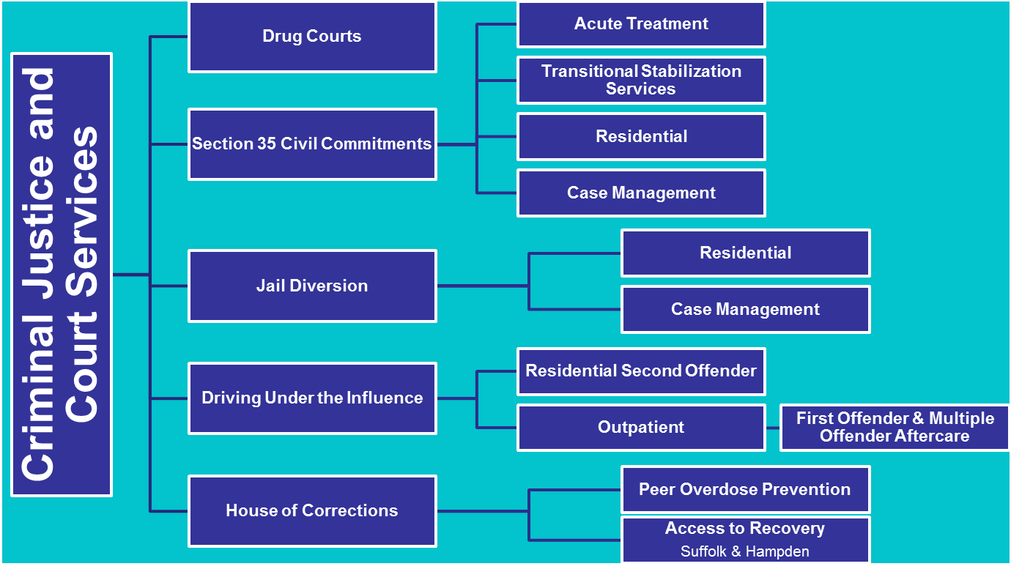
Criminal Justice and
Court Services
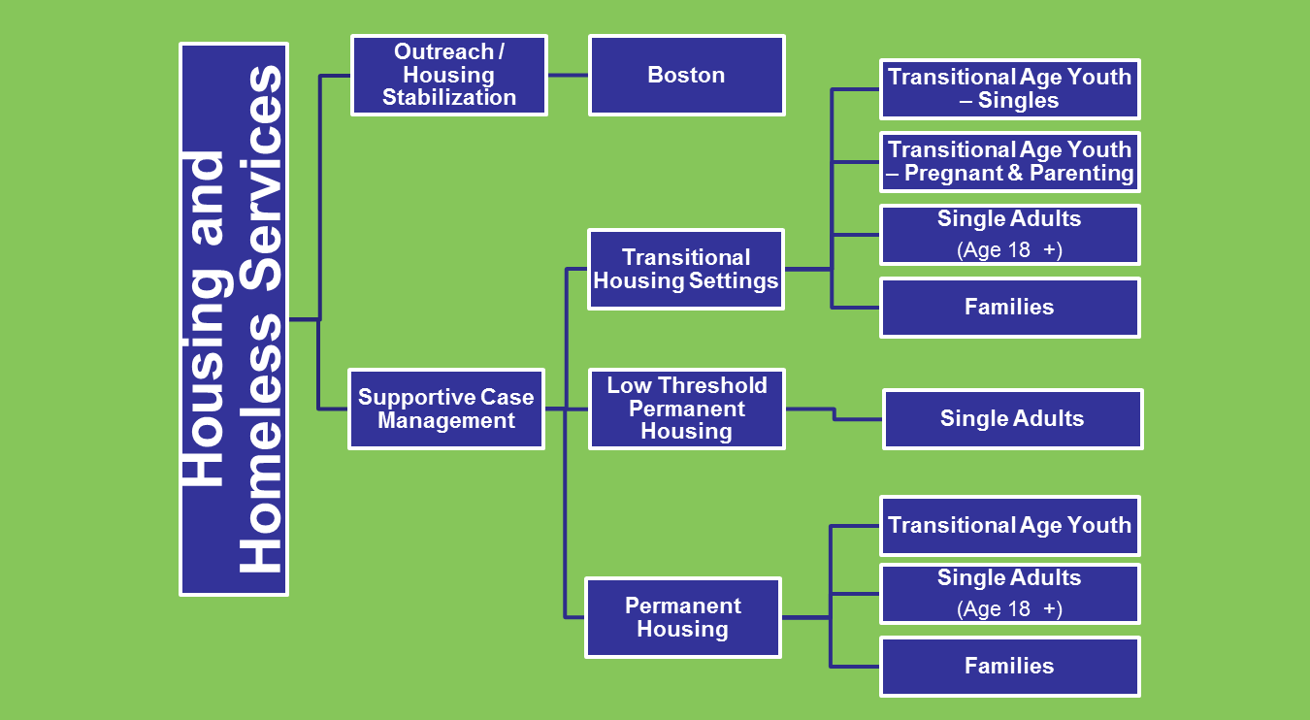
Non-licensed Services to Support Community Tenure
Housing & Homeless
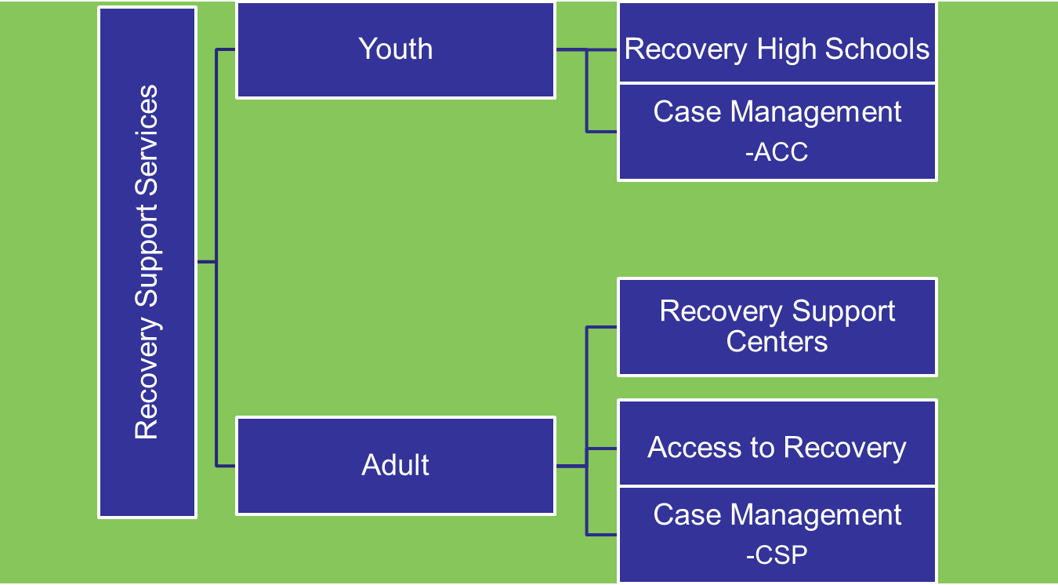
Non-licensed Services to Support Community Tenure

ACC = Assertive Continuing Care
CSP = Community Support Program

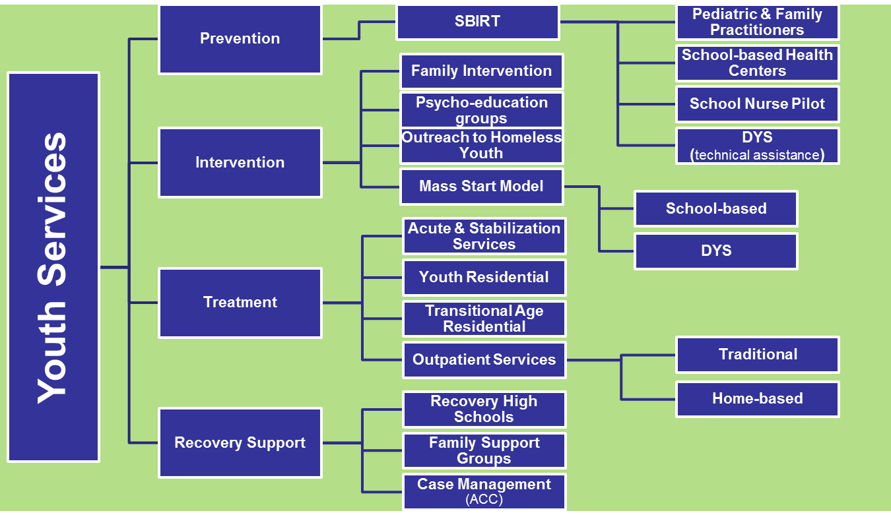
Youth Services
SBRIT = Screening, Brief Intervention & Referral to Treatment
DYS = Department of Youth Services
ACC = Assertive Continuing Care

BSAS Guiding Principles
Addiction is a chronic, progressive, relapsing disorder

Cannot be cured, but managed effectively with long term, ongoing support

Adherence to prescribed treatment regimens are on par with other chronic conditions such as asthma, diabetes and hypertension

Effective treatment attends to the multiple needs of the individual, not just substance use

Paradigm shift away from acute and episodic care to a more holistic approach over the life cycle

Screening and Early Intervention
Brief motivational conversations with patients can promote significant, lasting reductions in unhealthy alcohol and drug use.

SBIRT - low intensity, low cost, public health approach to identify and intervene with people with unhealthy substance use.
Screening: Universal, brief screen that identifies unhealthy substance use and Assessment: additional questions to determine severity and consequences of use
Brief Intervention: Brief conversation to raise awareness of risks and build motivation to change
Referral to Treatment: Referral for those with more serious problems, when appropriate

