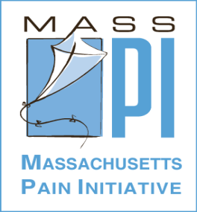
Cindy Steinberg BA, BS
Policy Council Chair
Massachusetts Pain Initiative
National Director of Policy & Advocacy
US Pain Foundation
&
Ann Marie Harootunian RN,MS,FNP-c
Steering Council Co-Chair
Massachusetts Pain Initiative

Massachusetts Pain Initiative
Statewide non-profit organization
Dedicated to ending needless suffering from pain &
Improving the quality of life for those affected by pain
Founded in 1989
Membership h/c providers & others interested in pain
Educate h/c professionals about pain
Raise community awareness about pain
Work with government officials to improve pain care through policy change
IOM reports 100 million Americans living with pain
More than afflicted with heart disease, diabetes & cancer combined – 1 in 3 Americans
10 million considered severe – disabled by pain
Pain is the number one reason Americans seek medical care
Chronic pain costs the US economy between $560 - $630B per year in healthcare costs & lost productivity
MassPI commissioned a survey reported in the Globe found that one out of four adults in Massachusetts suffers from serious, persistent pain that interferes with
daily life and work

Chronic Pain: A Problem of Staggering Proportions & a Major Threat to Public Health

Multitude of Diseases & Injuries Result in Chronic Pain

Diseases- Cancer, Diabetic Neuropathy, Osteoarthritis, Rheumatoid Arthritis, Sickle Cell, MS, AIDS, Lupus
Conditions – Fibromyalgia, Vulvodynia, Migraine, TMJ,
Trigeminal Neuralgia, Interstitial Cystitis, Endometriosis, Shingles, Post-herpetic Neuralgia
Injuries– Back pain, other joint/musculosketal injuries, chronic postoperative pain, Phantom Limb pain, Thoracic Outlet Syndrome, Carpal Tunnel, RSD/CRPS
Once chronic, (>3 -6 mos) pain becomes disease itself changing CNS, spinal cord & brain & amplifying
nerve signals that self-stimulate & worsen over time

Pain Devastates Lives

Chronic pain destroys ability to work & earn a living, relationships, families, self-esteem, participation in social activities, ability to sleep
Robs victims of joys in life – both large and small & leads to social isolation
Described by people with pain as being a prisoner in your own body subjected to torture 24/7 without a way to escape
Extremely difficult to treat
One study found a quarter of respondents saw more than saw 4 doctors until they found help

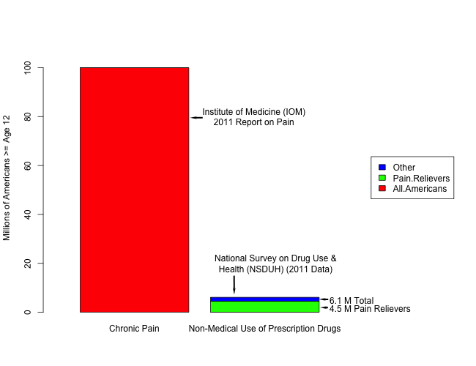
Chronic Pain > 10 X Abuse
Two Public Health Problems: Chronic Pain & Prescription Medication Abuse

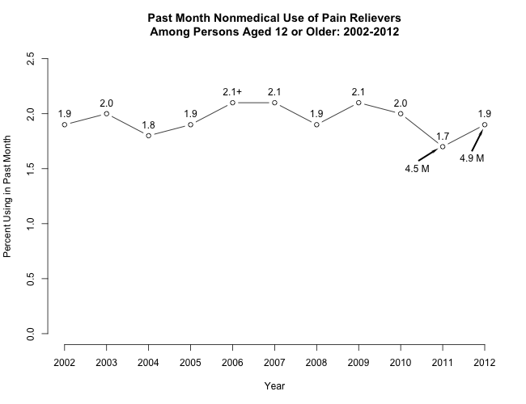
2012 National Survey on Drug Use & Health (SAMHSA)
The percentage of non-medical users of pain relievers has varied little in a decade
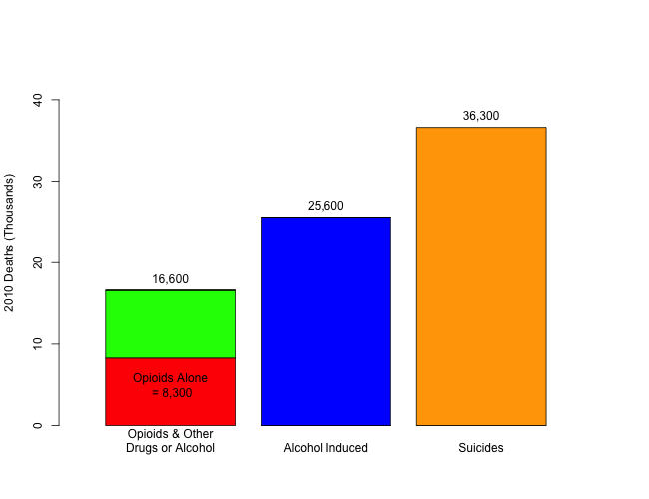
Are Opioid Overdose Deaths an “Epidemic”?
2010 Deaths – CDC National Vital Statistics Report 5/13
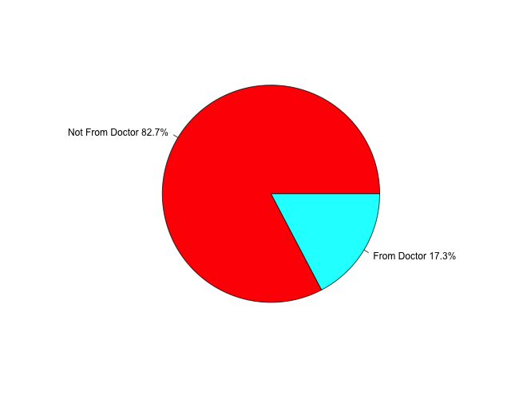
Where are Abusers Getting Medications?
82% Did Not Get Them from a Doctor (CDC, 2011)
Opioid Analgesics & Pain
There is no cure for chronic pain but can be managed & reduced
A combination of treatments (multi-modal) approach works best
Opioids are just one option, but a vital & essential treatment component that allows pain sufferers to be functional
Vast majority of people with pain take them safely & legally with no “high”, nor abuse or addiction (98.1% of US population)
Pharmacotherapy – OTC, Opioids, Tricyclic Antidepressants, Anticonvulsants, Corticosteroids, Muscle Relaxants, Topical Analgesics
Rehabilitation Techniques (ie. PT, exercise)
Psychosocial Interventions (ie. meditation)
Complementary and Alternative Medicine (acupuncture)
Injection & Infusion Therapies (ie. nerve blocks)
Implantable devices & Surgical Interventions

It will likely shift abuse to other potentially illicit substances
It will have huge, negative unintended consequences such as:
Doctors hesitant to prescribe even for long-term patients
Pharmacists hesitant to dispense
People with pain cannot get necessary medication & being discharged
Increase in patient suffering
Decrease in productivity
Increase in h/c utilization (ie. Rescheduling will require 4 to 12 X the number of doctor visits)
Increase in h/c costs

Policy That Severely Restricts Supply Will Not Solve the Abuse Problem
MassPI Recommendations for BPWG Report
Improving Pain Care & Reducing Abuse in MA
Education
Adoption of 2013 FSMB Model Policy by MA Board of Registration in Medicine
Policy Rulings on Management of Pain in 2009 by BORN, BORPh, BORPA, BORD to be disseminated widely along with training in pain management
CE requirements in pain management & opioid prescribing for all MA prescribers and dispensers
Public education about pain including prevalence, importance of getting proper, timely assessment and securing medications
Mandatory curriculum for middle & high school students on dangers of abusing prescription medication.
Specialized healthcare teams trained to consult or care for complex cases (ie. Co-occurring pain & addictive disorders.)

Prevention
Promote sale of lockboxes for medication; consider discounts or coupons with pharmacies/chains
Require use of abuse deterrent formulations, especially when prescriber writes for it
Establish permanent drug disposal locations & promote their use
Encourage passage of H2002 an amendment to patient’s rights law to require pain assessment and management when entering an MA H/C facility

Screening
Use a published reliable and valid screening/risk assessment tool at the initiation of opioid therapy (ORT, COMM, SBIRT, SOAPP-R)
Consider pharmacogenetic testing
Psychiatric screening; not to rule out treatment but to be certain patient getting needed support & counseling

Treatment

Develop multimodal treatment plan including non-pharmacologic and complementary treatments
Establish treatment goals collaboratively with patient including opioid agreements
Do not regulate/require dose limits, thresholds or restrictions on med combinations; each patient needs individual plan
Do not require consults w/pain specialists as we do not have enough to fulfill a mandate
Reimburse range of treatment options to encourage their use
Improve substance abuse treatment programs in local communities

Monitoring & Tracking
Use of PMP; give new required use a chance to work
Set PMP thresholds to capture most egregious cases > 4 doctors & > 4 pharmacies
Contact prescribers that are flagged to understand context before initiating a Board investigation
Ongoing functional assessment of patient toward goals
Reassess and use urine drug screens and pill counts randomly
Use prescription paper that cannot be replicated
DPH to collect & report data on pain: incidence, prevalence, utilization of services, costs, effectiveness of treatments so can ID those most likely to benefit from specific treatments

Thank You for listening!

Questions?

