Slide 1
Best Practices Working Group
Chapter 244 Acts of 2012
Joint Policy Working Group
Bureau of Health Care Safety and Quality
Director
Madeleine Biondolillo, M.D.
November 8, 2013
Agenda
I. Review October 9, 2013 Meeting Minutes

II. Best Practices Working Group – Review Mandate

III. Best Practices for Monitoring and Tracking
Speaker Presentation
SCOPE Video screening

IV. Review Focus of Past Meetings

V. Discussion of Best Practices Work Group Deliverable – Report of Findings

VI. Next steps

Slide 2
From Acts of 2012 Chapter 244
Details From Acts of 2012 Chapter 244

…..a joint policy working group to investigate and study best practices, including those in education, prevention, screening, tracking, monitoring and treatment, to promote safe and responsible opioid prescribing and dispensing practices for acute and chronic pain with the goal of reducing diversion, abuse and addiction and protecting access for patients suffering from acute and chronic pain.

The policy working group shall submit a report of its findings, along with recommendations, if any, to the commissioner and shall submit a copy of the report to the general court………
…….not later than 6 months after the effective date of this act.

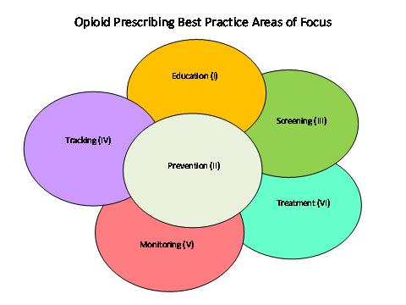

Slide 3
CDC’s four focus areas:

1) Improve systems to track prescriptions and identify misuse

2) Identify prevention policies and programs that work / best practices

3) Increase health care provider accountability

4) Educate health care providers, policy makers, and the public
CDC. Saving Lives and Protecting People: Preventing Prescription Painkiller Overdoses. Available at http://www.cdc.gov/injury/about/focus-rx.html Last viewed on September 30, 2013.

Align with three focus topics for BPWG set out by legislature
Slide 6

Best Practices for Monitoring and Tracking

▪John Eadie, M.S., Director, PDMP Center of Excellence,
Brandeis University
Presentation: “Utilizing a Prescription Monitoring Program for Tracking and Monitoring”

▪Review health care provider/ patient education from SCOPE of Pain.
Safe and Competent Opioid Prescribing Education (SCOPE)¹ is an educational program that provides resources to safely and competently manage patients with chronic pain.

1.Boston University School of Medicine, Continuing Medical Education,
Federation of State medical Boards, and
Council of Medical Specialty Societies

John Eadie
PDMP Center for Excellence

Utilizing a
Prescription Monitoring Program
for
Tracking and Monitoring

Len Young, MDPH

Discussion of MA PMP Data
Looking at Practitioners Who Have Patients With Questionable Activity

Doctor/Pharmacy Shopping
by Practitioner¹ in MA during CY 2012
¹ Practitioners comprise the following provider categories: MDs, DDSs, DMDs, DOs, and DPMs
*Includes all practitioners who are current (i.e., MA Controlled Substance Registration is not expired or otherwise inactive) during CY 2012 (n = 34,211)
**Practitioners who prescribed at least one Schedule II or III opioid prescription during 2012 (n = 22,941)
Note: Excludes prescription records where the reported DEA number is a hospital DEA (i.e., only includes records where an individual prescriber can be identified.)

Review Focus of Past Meetings:
April
Discussion and feedback regarding statute and
pending regulations

July
Discuss amendment and regulations relating to mandatory utilization of PMP and best practices for prescribing and dispensing

September Education and Treatment

Review of national and state data relating to prescription drug abuse.
DPH Epidemiology

Presentation by MA Department of Industrial Accidents Treatment Guideline 27 – Chronic Pain

Slide 31

OctoberPrevention and Screening

Review data on opioid overdose, relative to milligram morphine equivalents,
DPH epidemiology
Presentation of community level MA PMP data
- How PMP data can be used to help communities
Brandeis University PMP Center of Excellence

BPWG Deliverables:
Report of findings and recommendations

Six focus areas:
Education
Screening
Prevention
Monitoring
Tracking
Treatment

Education

Reviewed: Guidelines from WA, UT and NM

ED specific guidelines from NY and OH

Considered for Recommendation:

Best practices guidelines for different sites of care and providers

Screening
Reviewed: SAMHSA chart of SBIRT effectiveness CAGE-AID CAGE that includes drugs
ORT-9 Opioid Risk Tool

Considered for Recommendation:
DPH research SBIRT tools for drugs
DPH link death data and PMP data

Prevention

Reviewed: Presentation Peter Kreiner
BSAS Grantees for Partnerships for Success
How PDMP Data Might Be Useful for Assessment and Evaluation

