Best Practices Working Group
Chapter 244 Acts of 2012
Joint Policy Working Group
Bureau of Health Care Safety and Quality
Director
Madeleine Biondolillo, M.D.
October 9, 2013
Agenda
Pre-Meeting Matters
Summary of discussion from September 9, 2013
Review September 9, 2013 Meeting Minutes
C. Best Practices Working Group Legislative Report
National Recommendations
Best Practices for Screening
Opioid Overdose High Risk Populations
Screening Tools
Best Practices for Prevention
Data Measures for Risk of Opioid Overdose
Strategies for Prevention of Opioid Overdose
Best Practices Guidelines
Comparison of State Guidelines
WA State Guidelines and Decrease in Doctor Shopping Rates
MA Information Resources
BSAS Partnerships for Success
Presenter: Peter Kreiner, Ph.D., Principal Investigator, PDMP Center of Excellence
VII. Next Steps and Discussion

Pre-Meeting Matters

September 9 Meeting Summary
Key points
The leading mechanism of injury deaths is associated with poisoning or drug overdose, mostly from opiates

Best Practices Working Group (BPWG) is tasked with studying best practices in education, treatment, prevention, screening, monitoring and tracking for promoting safe and responsible opioid prescribing in the setting of reducing diversion, abuse of and addiction to opioid medications while protecting access for patients with acute and chronic pain

Different professional organizations have developed best practices guidelines and educational materials for the treatment of acute and chronic pain

MA PMP is in the process of developing unsolicited reports and electronic alerts to inform prescribers of patients who meet specified doctor shopping thresholds

Next BPWG meeting session will focus on discussing WA state guidelines as a starting point for developing recommendations that will be included in the report to the legislature.
Proposed Legislative Report Outline
Scope of the Epidemic
National data on prescription drug abuse epidemic
MA data on prescription drug abuse epidemic
Education Recommendations
Best practices and treatment education
Online tools
Screening Recommendations
WA state recommended tools for primary care and emergency departments
Implementation in MA
Prevention Recommendations
Best Practices Guidelines
MA Educational Resources
Tracking and Monitoring
Regulatory/Enforcement
Treatment/Interventions
References
Workgroup Participants

Question of the Day:

What can be done to mitigate prescription drug diversion and misuse through screening and prevention?


Four focus areas:

1) Improve systems to track prescriptions and identify misuse

2) Identify prevention policies and programs that work

3) Increase health care provider accountability

4) Educate health care providers, policy makers, and the public
CDC. Saving Lives and Protecting People: Preventing Prescription Painkiller Overdoses. Available at http://www.cdc.gov/injury/about/focus-rx.html Last viewed on September 30, 2013.

Slide 1
Four focus areas:

1) Education

2) Prescription Drug Monitoring
Programs

3) Proper medication disposal

4) Enforcement
R. Gil Kerlikowske. Prescription Drug Abuse: the National Perspective, September 2013. Available at: http://www.astho.org/Annual-Meeting-2013/Presentations/R-Gil-Kerlikowske-Prescription-Drug-Presidents-Challenge-Session Last viewed on September 30, 2013.

Best Practices for Screening

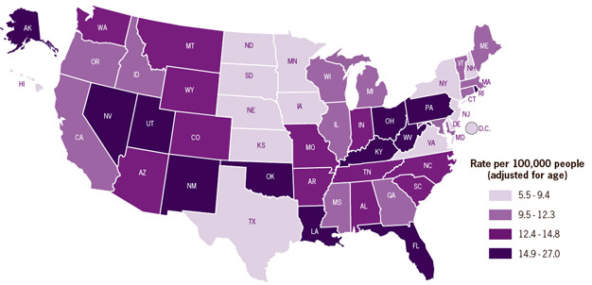
Drug overdose epidemic is most severe in the Southwest and Appalachian region.

SOURCE: National Vital Statistics
System, 2008

Rates vary substantially between states.

Where overdose deaths are the highest
Who is most at risk for opioid prescription overdose?

Doctor shoppers-people who obtain
multiple controlled substance
prescriptions from multiple providers.

People who take high daily dosages
of prescription painkillers.

Those who misuse multiple abuse-prone prescription drugs.

CDC. Saving Lives and Protecting People: Preventing Prescription Painkiller Overdoses. Available at http://www.cdc.gov/injury/about/focus-rx.html Last viewed on September 30, 2013.

Screening Tools

Screening, Brief Intervention and Referral to Treatment
SBIRT Requirements (SAMHSA Model)
Brief, initial screening is accomplished within 5-10 minutes;
Screening is universal, part of the intake process;
Addresses a specific behavioral characteristic deemed to be problematic, or pre-conditional to substance dependence or other diagnoses;
The services occur in a public health, or other non-substance abuse treatment setting;
The program includes a seamless transition between brief universal screening, intervention or treatment and referral to specialty substance abuse care; and
Strong research or substantial experiential evidence supports the model.

Source: Substance Abuse and Mental Health Services Administration (SAMHSA). White Paper on Screening, Brief Intervention and Referral to Treatment (SBIRT) in Behavioral Healthcare. Available at: http://www.samhsa.gov/prevention/SBIRT/SBIRTwhitepaper.pdf

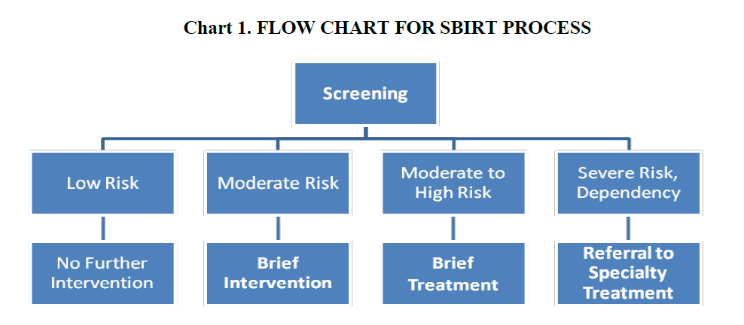
SBIRT Process
Slide 1
Source: Substance Abuse and Mental Health Services Administration (SAMHSA). White Paper on Screening, Brief Intervention and Referral to Treatment (SBIRT) in Behavioral Healthcare. Available at: http://www.samhsa.gov/prevention/SBIRT/SBIRTwhitepaper.pdf

SBIRT Effectiveness
Slide 1
Source: Substance Abuse and Mental Health Services Administration (SAMHSA). White Paper on Screening, Brief Intervention and Referral to Treatment (SBIRT) in Behavioral Healthcare. Available at: http://www.samhsa.gov/prevention/SBIRT/SBIRTwhitepaper.pdf

Key:

✓ Evidence for effectiveness/utility of component

* Component Demonstrated to show Promising Results

— Not Demonstrated and/or Not Utilized

Family history of substance abuse
Personal history of substance abuse
Age (mark box if 16-45 years)
History of preadolescent sexual abuse
Psychological disease
WA State Guidelines Screening Tools
ORT-9 (Opioid Risk Tool)
CAGE-AID Questionnaire
Available at: http://www.painknowledge.org/physiciantools/ORT/ORT%20Patient%20Form.pdf
Have you ever felt that you ought to cut down on your drinking or drug use?
Have people annoyed you by criticizing your drinking or drug use?
Have you ever felt bad or guilty about your drinking or drug use?
Have you ever had a drink or used drugs first thing in the morning to steady your nerves or get rid of a hangover?
Risky use: 1 or less
Substance use disorder: 2 or more

Richard L. Brown, et.al., A Two-Item Conjoint Screen for Alcohol and Other Drug Problems. Journal of the American Board of Family Medicine, 25 July 2000, p. 95-106.

Comparison of ScreeningTools WA State Guidelines
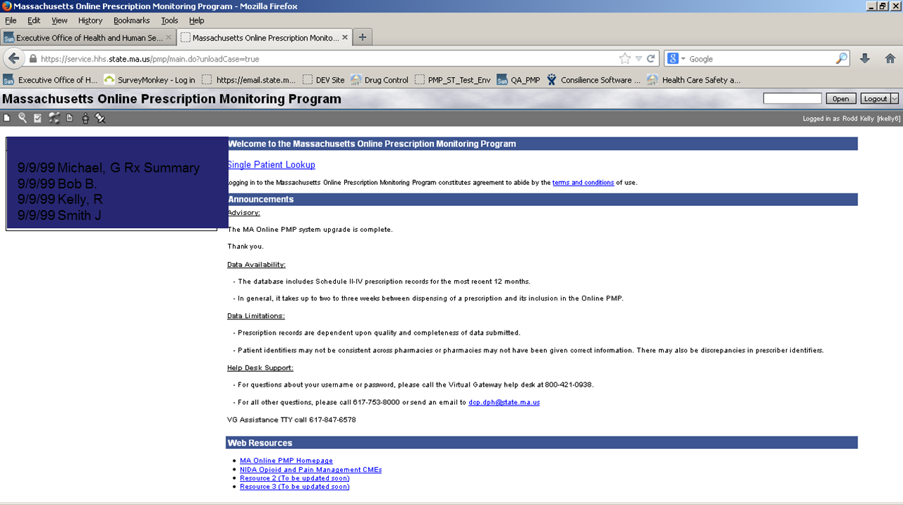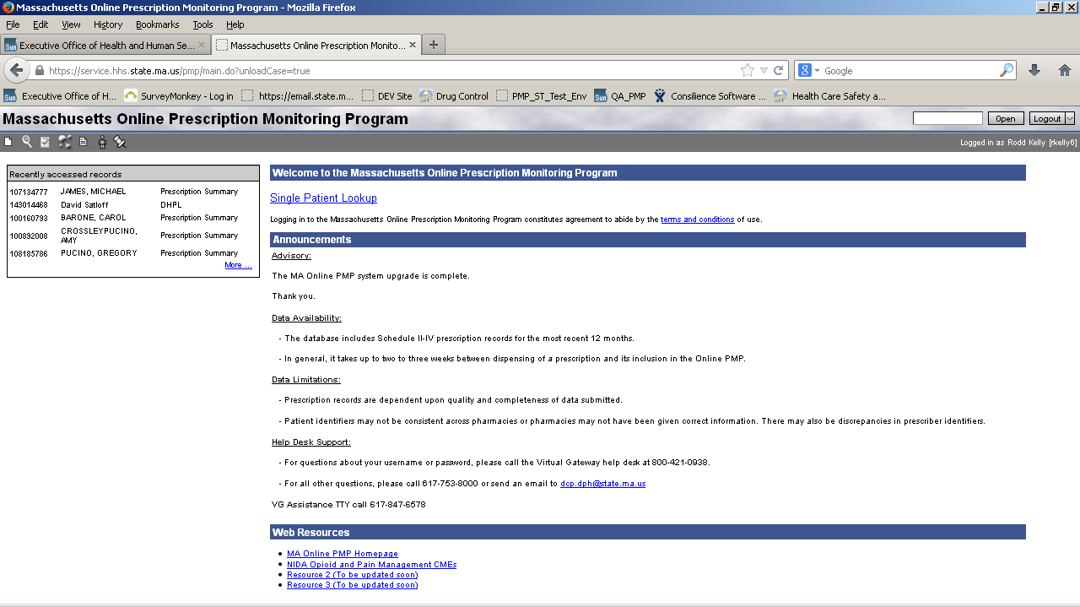
MA Online PMP Screening
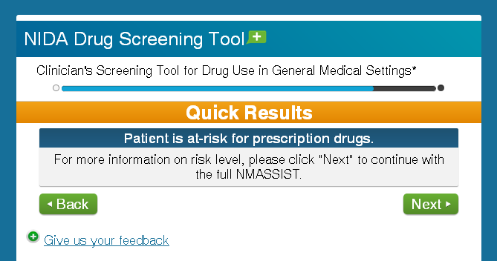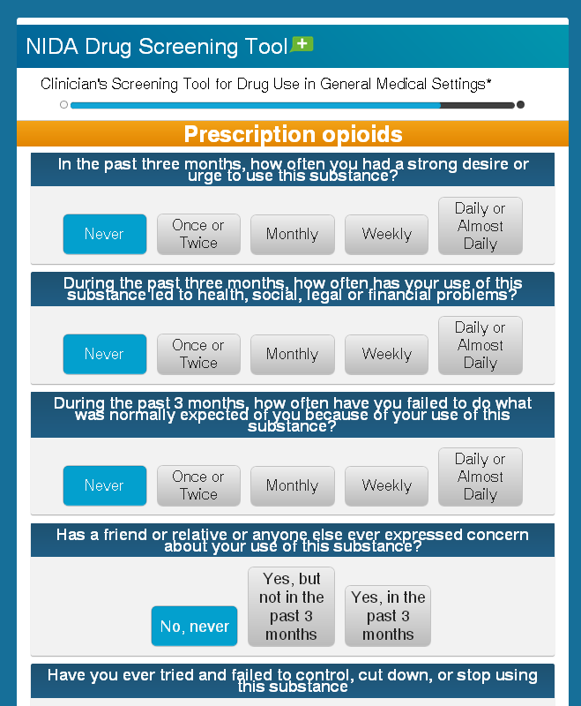
Slide 1
National Institute on Drug Abuse (NIDA) Screening Tool

An online interactive Web site that guides clinicians through a short series of questions and, based on the patient’s responses, generates a substance involvement score that suggests the level of intervention needed.
Available at: http://www.drugabuse.gov/nmassist/
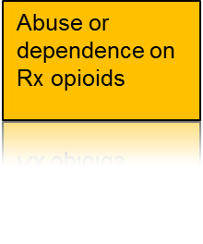
Fatal Overdose
Substance abuse treatment admission
ED visit for misuse or abuse of Rx opioids
Non-medical use of Rx opioids
How to measure risk for overdose
Daily dose for opioids
(High, e.g., > 100 MME/day)
Prescription drug combinations
Additive sedating effects
Opioids overlapping with benzodiazepines or muscle relaxants or both
Large distances
Patient residence to prescriber office compared with nearest prescriber
Patient residence to pharmacy compared with nearest pharmacy
Multiples
Prescriptions from the same class
Classes of scheduled drugs
Prescribers or pharmacies or both
Source: Presentation by Len Palauzzi, MD, MPH. National Center for Injury Prevention and Control, Centers for Disease Control and Prevention. Prescription Behavior Surveillance Using PDMP Data. April, 2013.
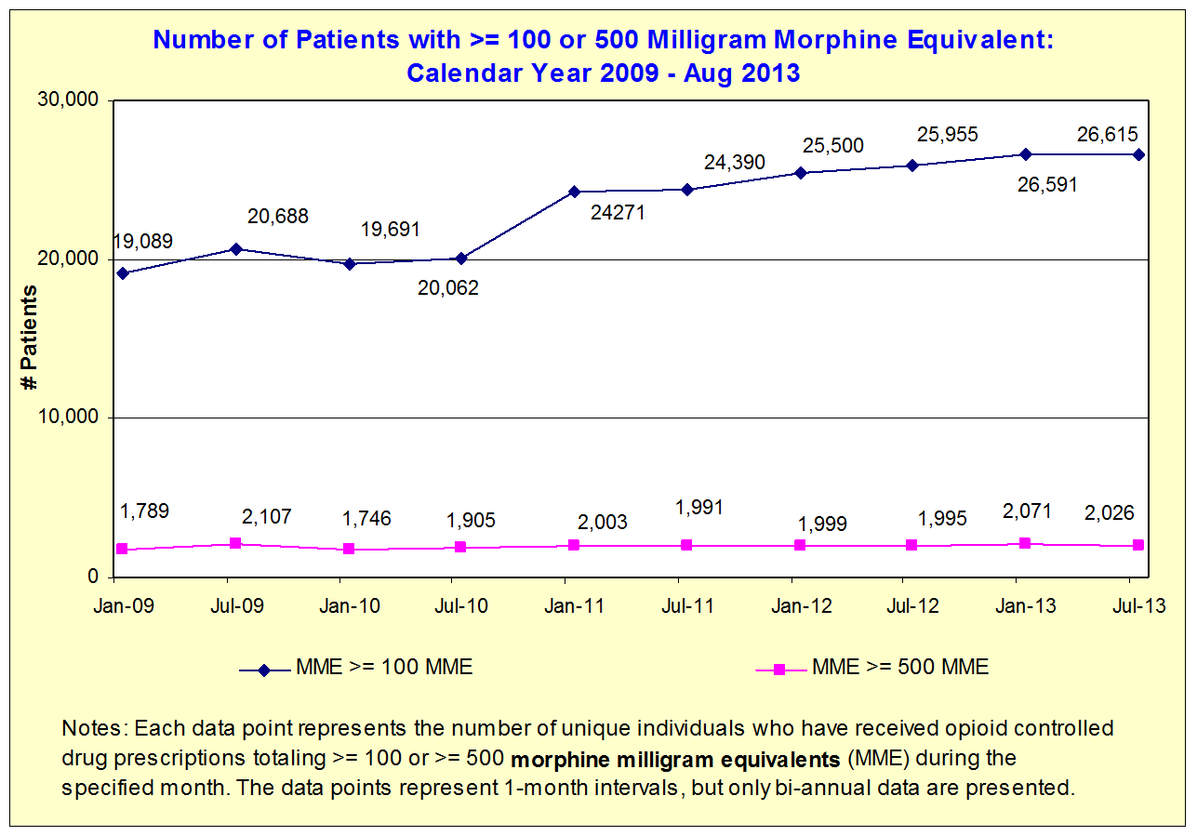
Number of Patients with >= 100 or 500 Milligram Morphine Equivalent:
MA PMP CY 2009 - Aug 2013
WA State Guidelines Dosing Threshold
CDC Recommendations for Overdose Prevention
Prescription Drug Monitoring Programs: focus resources on patients at highest risk and prescribers who clearly deviate from accepted medical practice.
Patient review and restriction programs.
Health care provider accountability.
Laws to prevent prescription drug abuse and diversion.
Better access to substance abuse treatment.

Source: Presentation by the National Center for Injury Prevention and Control, Division of Unintentional Injury Prevention of the Centers for Disease Control and Prevention. Policy Impact: Prescription Painkiller Overdoses. April 2013.
Top 10 Proposed Legislation for Opioid Overdose Prevention
Legislation
Immunity from prosecution laws and/or naloxone
Required use/registration of PDMP
PDMP enhancements (access, reporting time, delegates)
Creation of Commission or Working Group
Mandatory provider education on pain addiction
Abuse-deterrent formulation substitution restrictions
Opioid prescribing standards/rules
PDMP funding
OTP standards
Quantity/dose limits

Number of states
21
13
11
9
7
6
5
4
4
2
Source: Presentation by Christopher M. Jones, PharmD, MPH. National Center for Injury Prevention and Control, Centers for Disease Control and Prevention. State of the States: Prescription Drug Abuse and Overdose Policy. April, 2013.

Prevent Opioid Abuse, Addiction and Overdose Through Education

Sample Methods
Tie together medical doctor and pharmacy training programs in school so that they view one another as a prevention and treatment team
SBIRT programs in multiple settings
Best practices guidelines
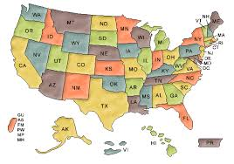
States with Prescribing Guidelines
General guidelines
Emergency Department
guidelines
Source: Presentation by Christopher M. Jones, PharmD, MPH. National Center for Injury Prevention and Control, Centers for Disease Control and Prevention. State of the States: Prescription Drug Abuse and Overdose Policy. April, 2013.
State Comparisons of Best Practices Recommendations

Recommendation
WA
UT
NM
NY (ED)
OH (ED)
Develop a written treatment plan for the patient (that includes measurable goals for opioid therapy and frequently reevaluate efficacy of opioid therapy against goals with patient.)
✓
✓
✓

✓
Physicians should send patient pain agreements to local EDs
✓

For exacerbations of chronic pain, the ER provider should contact the patient’s primary opioid prescriber or pharmacy and prescribe enough until next appointment
✓

ER/acute care facilities should have an updated list of clinics that provide primary care and/or pain management services for patients
✓

✓
Use available EMR to coordinate care of patients who frequently visit the facility

✓
Maintain patient records documenting opioid treatment evaluations for patients using opioid therapy to treat chronic pain.
✓
✓

Patients should be provided a handout or display signage that reflect the guidelines and the facility’s position on prescribing opioids

✓
Perform comprehensive evaluation before starting treatment for chronic pain

✓
✓

Screen for risk of abuse before starting treatment
✓
✓

Monitor for medication misuse
✓

Baseline risk assessment should be performed (ORT, CAGE-AID, PHQ-9, baseline urine drug test, baseline assessment of function and pain)

Discontinue opioid therapy if treatment goals are not met.
✓
✓
✓

Initiate opioid treatment as a treatment trial.
✓
✓
✓

Schedule regular visits with evaluation of progress against goals

✓

Use of methadone in treatment plan is discouraged.
✓
✓
✓

✓
(IV) Meperidine for acute or chronic pain is discouraged
✓

✓
State Comparisons of Best Practices Recommendations

State Comparisons of Best Practices Recommendations

Recommendation
WA
UT
NM
NY (ED)
OH (ED)
Avoid prescribing replacement doses of suboxone, subutec for patients in a treatment program

✓
A decrease by 10% of original dose per week
✓

Discontinue opioids or refer for addiction management if drug-seeking behaviors or diversion is noted.
✓

If opioid abstinence syndrome then treat with clonidine; anti-depressants for irritability
✓

Refer patients to other specialists if needed (WA esp if the dose has increased to 120 MED)
✓
✓

✓

Washington State Data

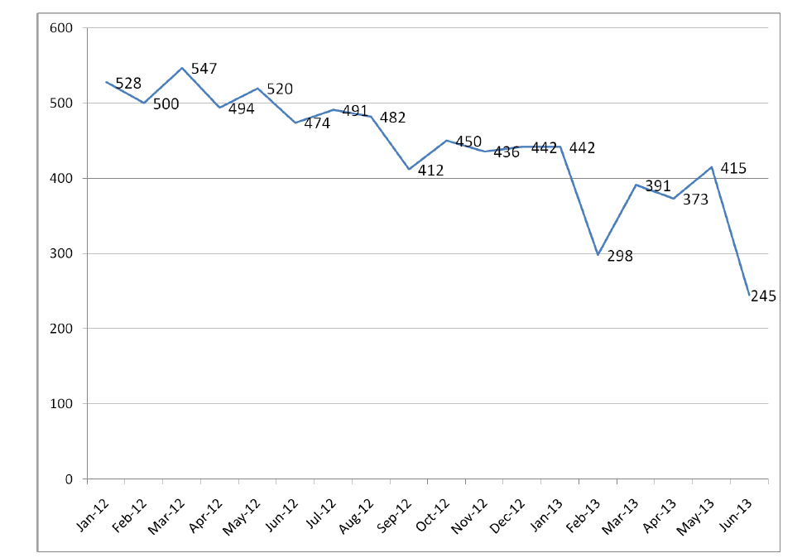
Patients with 5 or More Prescribers

Slide 1
Source: WA State Department of Public Health, PMP Implementation Forum Presentation, July 29, 2013.
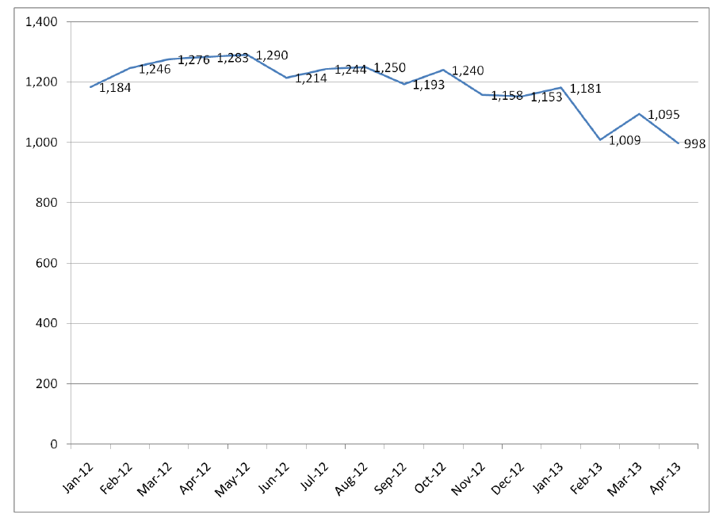
Number of Prescribers with at Least 1 Patient Seeing More than 1 Prescriber
Slide 1
Source: WA State Department of Public Health, PMP Implementation Forum Presentation, July 29, 2013.
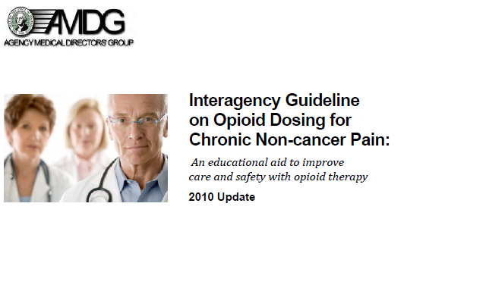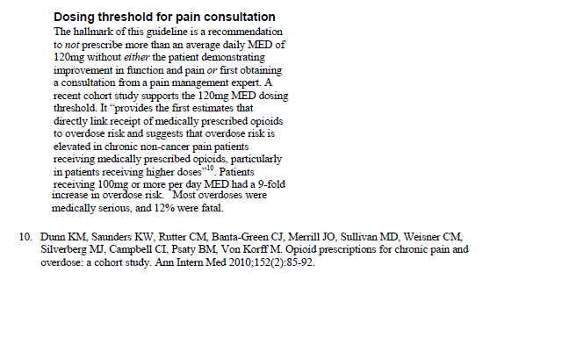
WA State Guidelines
Includes:
Tools for calculating dosages of opioids during treatment while tapering
Validated screening tools
Urine drug testing guidelines
New patient educational materials and resources

Massachusetts

Slide 1
Number of MA Prescribers with at Least 1 Patient Receiving a Schedule II-V Controlled Drug from >= 5 Different Prescribers
Jan 2009 - July 2013
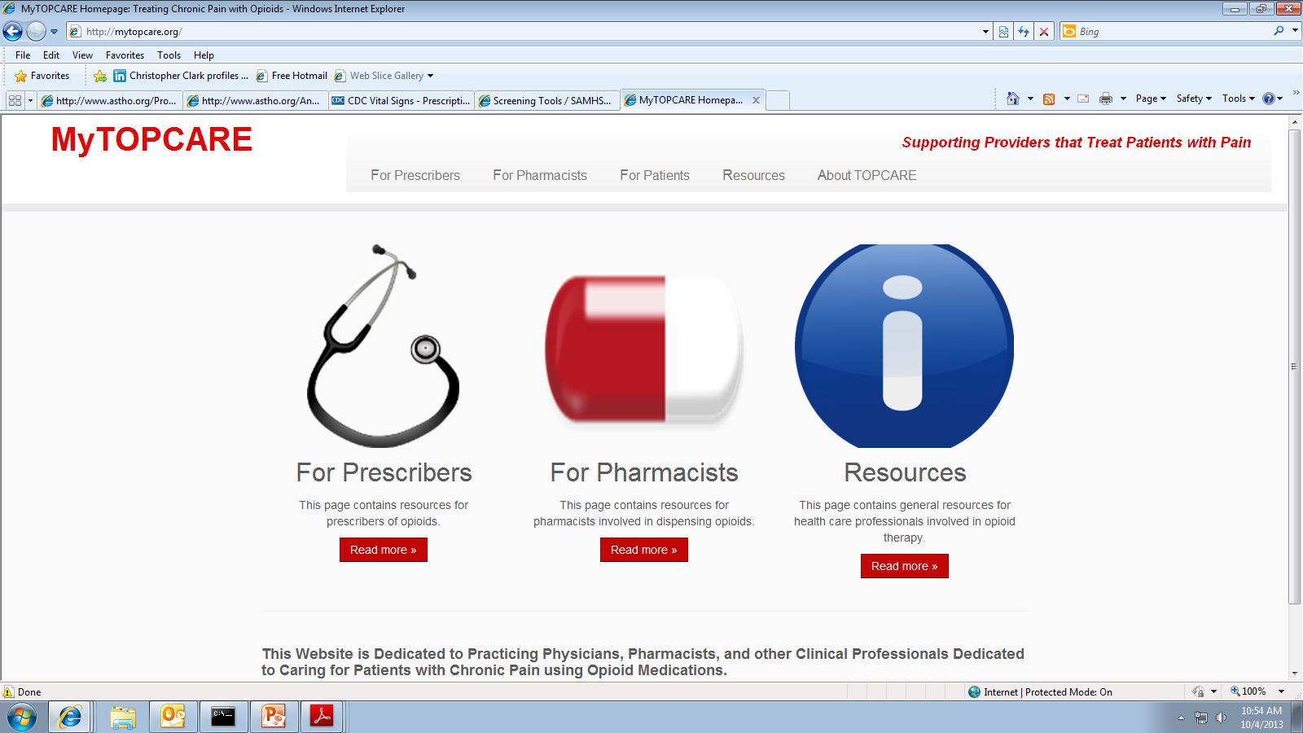
MA Resource
BMC Topcare Project
Slide 1
Available at: http://mytopcare.org/

Examples of Guidelines Available on Topcare
For Prescribers: Information for clinical scenarios that commonly arise while treating patients on opioids.

Starting Opioids
Continuing Opioids
Stopping Opioids
Screening and Assessment Tools
Opioid Equivalency Calculator: A tool that interconverts a variety of opioid medications.
Pill Count Calculator
A Guide to State Opioid Prescribing Policies
Interpreting Urine Tests
About Urine Drug Tests
Pain/Opioid-Related CME Courses
Talking to Patients About Opioid Therapy
Other Resources

For Pharmacists

When to Call the Prescriber
Message Board?
Talking to Patients About Opioid Therapy
Pharmacist’s Manual from U.S. Drug Enforcement Agency
Other Resources

http://mytopcare.org/

BSAS Grantees for Partnerships for Success
Peter Kreiner, Ph.D.

