Best Practices Work Group
Chapter 244 Acts of 2012
Joint Policy Working Group
Bureau of Health Care Safety and Quality
Cheryl Campbell, M.S.,J.D.
Adele Audet, R.Ph.
Len Young, M.S., M.A.
September 9, 2013
Chapter 244 Acts of 2012 Section 21

“The commissioner of public health shall convene a joint policy working group to investigate and study best practices, including those in education, prevention, screening, tracking, monitoring and treatment, to promote safe and responsible opioid prescribing and dispensing practices for acute and chronic pain with the goal of reducing diversion, abuse and addiction and protecting access for patients suffering from acute and chronic pain.”

Agenda

I. Review meeting minutes from July 26, 2013
II. Prescription Drug Abuse Epidemic – Data Review
National trends in Prescription Drug Abuse
Prescription Drug Abuse in Massachusetts
III. Purpose of the Best Practices Workgroup
IV. Example: Treatment Guideline (Number 27) – Chronic Pain
the Department of Industrial Accidents. Diane Neelon, B.S., R.N., J.D. Director of the Office of Health Policy (OHP) - Executive Director of the Health Care Services Board (HCSB)
V. Discussion, Feedback and Next Steps

Overview

Meeting Minutes

Meeting of July 26, 2013 Agenda
Agenda
1. Review Minutes from April 25, 2013 Meeting
2. Discuss the Amendment to Chapter 244 of the Actsof 20123.
3. Discuss Best Practices for Promoting Safe and Responsible Opioid Prescribing
4. Regulations Development Timeline
5. Discuss Next Steps
Prescription Drug Abuse Epidemic: Brief Review of National Data

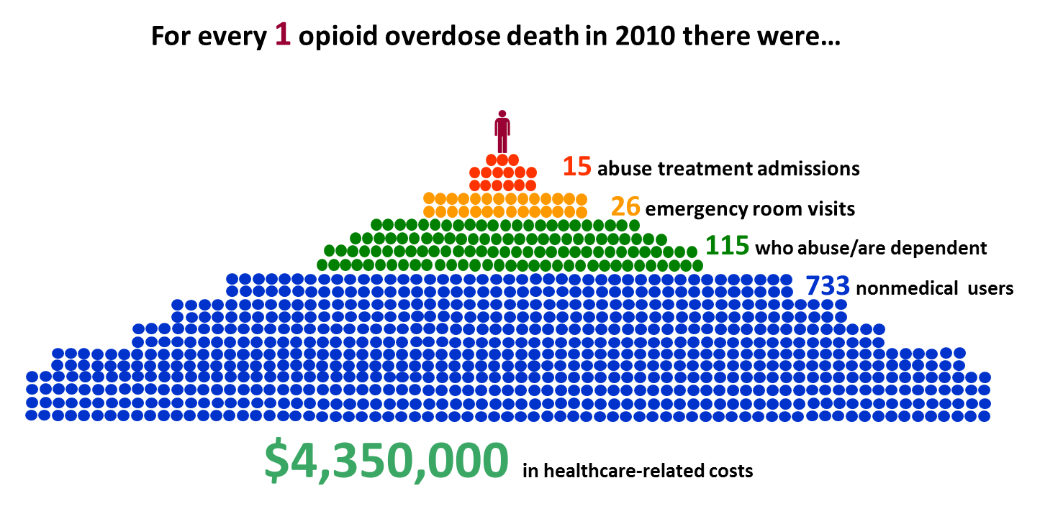

Deaths are the tip of the iceberg
National Center for Injury Prevention and Control, Centers for Disease Control and Prevention

National Data: ED Visits Related to Nonmedical Use of Narcotic Pain Relievers (2004 and 2011)
Data Source: Drug Abuse Warning Network (DAWN) Report 2013 (Only includes data up to 2011)

Massachusetts Data
MA Death Data
Coded according to WHO International Classification of Diseases, Tenth Revision
Based on text that is written on death certificates
Data shown here is not directly based on toxicology reports

Nearly all overdose deaths in MA are reviewed and certified by MA Office of the Chief Medical Examiner
Standardized policies and protocols (quality data)
Determine the manner and cause of death – written on death cert.
2005 policy change regarding assignment of manner of death in overdose deaths where no evidence of suicide from “undetermined intent” to “unintentional.”

Leading Mechanisms of Injury Deaths,
MA Residents, 2010 (Total N= 3,066)
*Includes occupants, motorcyclists, and unspecified persons
Sources: Registry of Vital Records and Statistics, MA Department of Public Health; CDC, WISQARS
Age Adjusted Rate: 43.3 per 100,00 (vs. 57.0 per 100,00 in U.S.)

14
Muscle relaxants
11
Anticonvulsants
24
Misc. analgesics/combinations
432
– All other opiates/opioids
94
– Methadone
90
– Heroin (specified)
592 **(72% of all drugs)
Opiates/opioids
30
Misc. anxiolytics, sedatives, and hypnotics
86
Benzodiazepines
25
Antipsychotics
90
Antidepressants
216
Alcohol
822
ALL DRUGS
NOTES: Alcohol row includes alcohol in combination
with other drugs (all ages) and alcohol alone
in decedents under age 21.
Massachusetts - Drug-related deaths by drug category, 2009-2010
Source: Substance Abuse and Mental Health Services Administration, Drug Abuse Warning Network, 2010: Area Profiles of Drug-Related Mortality.
HHS Publication No. (SMA) 12-4699, DAWN Series D-36. Rockville, MD: Substance
Abuse and Mental Health Services Administration, 2012.

Co-Occurrences of Select Agents among Poisoning/Overdose Deaths, MA Residents 2000-2010
Source: Registry of Vital Records and Statistics, MDPH

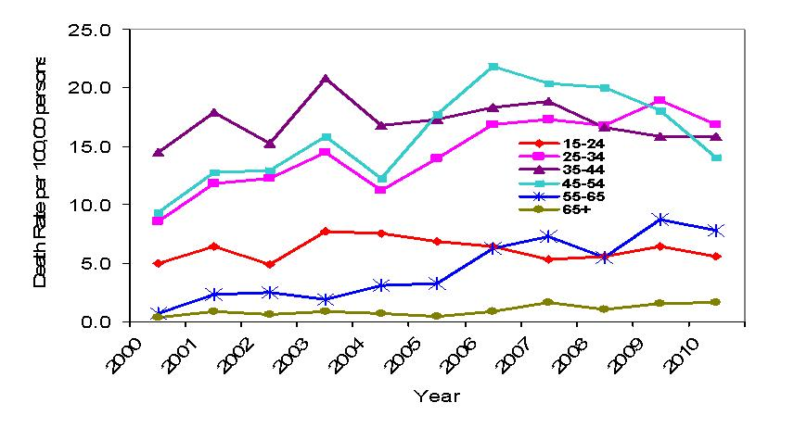
Opioid-related Poisoning Deaths by Selected Age Subgroups, MA Residents 2000-2010
Source: Registry of Vital Records and Statistics, MA Department of Public Health
Rates among individuals 65+ for all years and among individuals 55-64 for years 2000-2003 are based on counts <20 and considered unstable.
2010: Highest rates among individuals 25-54 years of age.
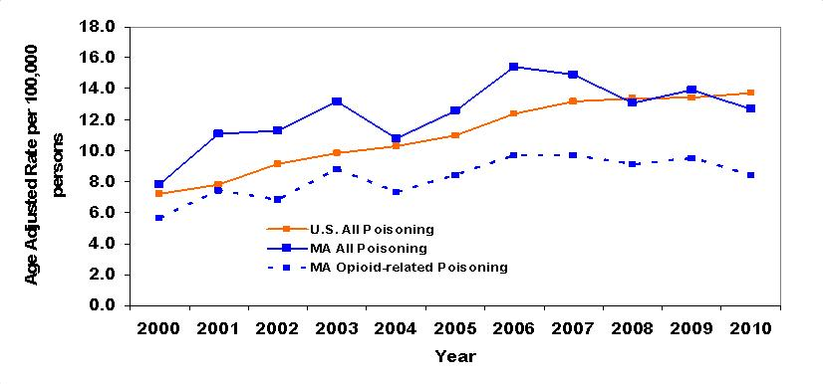
US and MA Age-Adjusted All Poisoning and MA Opioid-related Death Rates, 2000-2010
Sources: All- poisoning rates from CDC, WISQARS web-based query (Accessed 2/19/2013)
Opioid-related poisoning from Registry of Vital Records, MDPH.
99% increase in all poisoning death rate in MA from 2000-2006; 18% decrease in rate from 2006 to 2010.
73% increase in opioid-related poison death rate in MA from 2000-2006; 13% decrease in rate from 2006 to 2010.
Key Data Points
National:
Opioid deaths are just the tip of the iceberg.
There is a need for different strategies for early intervention.

Statewide:
The leading mechanism of injury deaths in MA is associated with poisoning/drug overdose.
Opiates and opioids accounted for 72% of all drug-related deaths in 2009-2010.
Overdose deaths related to co-occurrences of opioid among benzodiazepines is on the rise.
2010: Highest rates among individuals 25-54 years of age.
99% increase in all poisoning death rate in MA from 2000-2006; 18% decrease in rate from 2006 to 2010.
73% increase in opioid-related poison death rate in MA from 2000-2006; 13% decrease in rate from 2006 to 2010.

Purpose of the Best Practices Work Group
Statutory Approach to Address the Prescription Drug Abuse Epidemic in Massachusetts

Adele Audet, R.Ph.
Assistant Director of the Drug Control Program

Adele.Audet@State.MA.US

Best Practices Workgroup
Goals:

Develop recommendations for:
reducing diversion,
abuse of opioid prescription medications,
and addiction to opioid prescription medications
while protecting access for patients with acute and chronic pain.

Study findings and workgroup recommendations will be submitted in a report to the legislature.

Task
Investigate and study best practices for promoting safe and responsible opioid prescribing and dispensing practices for acute and chronic pain.

What are the best practices in:

Education
Monitoring
Tracking
Screening
Prevention
Treatment
Question 1

Educate whom?

Health Care Providers
Patients/Care Givers
Insurance Companies
Drug Companies
Professional Schools
Regulators
Law Enforcement

Question 2

Treatment of Acute/Chronic Pain in the Setting of Reducing Diversion, Abuse and Addiction

Treatment Specialists
Emergency Services
Patients/Care Givers
Professional Schools
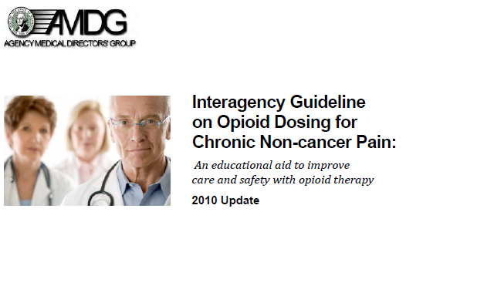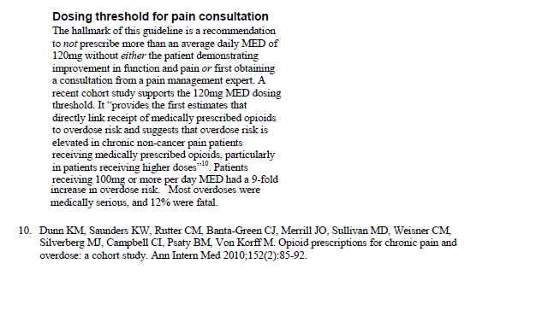
Morphine Equivalent Dose
Treatment of Chronic Pain
: Guideline Number 27
Workers’ Compensation Claims
Department of Industrial Accidents

Diane Neelon; BS, RN, JD
Director of the Office of Health Policy (OHP) - Executive Director of the Health Care Services Board (HCSB)
Discussion and Feedback

Screen for depression, history of substance use disorder and other mental health disorders.
Psychosocial evaluation, as well as, concomitant interdisciplinary rehabilitation treatment whenever appropriate. Initial exam to be performed by a psychologist with a PhD, PsyD, EdD credential, or Psychiatric MD/DO may perform the initial comprehensive evaluations.
Psychological risk factors screening
Social and vocational assessment, personal and family history of alcohol or drug abuse
Psychosocial history, mechanism of injury, pain history, medical management history, substance use/abuse, and other factors that may affect treatment outcome.
Additional factors to consider
Systems review, physical exam, laboratory investigations as indicated.
Physical exam and baseline initial drug screen.
Initial workup should include
"Physicians must understand the relevant pharmacologic and clinical issues in the use of such analgesics, and carefully structure a treatment plan that reflects the particular benefits and risks of opioid use for each individual patient."
"It is recommended that use of opioid analgesic and sedative hypnotic medications in chronic pain patients be used in a very limited manner, with total elimination desirable whenever clinically feasible."
Topics
Federation of State Medical Boards Model Policy on the Use of Opioid Analgesics in the
Treatment of Chronic Pain
Guidelines from the MA Department of Industrial Accidents
Side by Side Comparison of Guidelines and Federation of State Guidelines and Federation of StateMedical Boards Model Policy

Opioid therapy should be presented to the patient as a therapeutic
trial or test for a defined period of time (usually no more than 90 days) and with specified evaluation points.
Consultation or referral to a pain specialist should be considered when the pain persists beyond the expected time for tissue healing of the injury.
Initiating Opioid Treatment
Use of a written informed consent and treatment agreement (sometimes referred to as a “treatment contract”)
is recommended.
Patient Physician Agreement – All patients on long term opioids must have a written, informed agreement. The agreement should discuss side effects of opioids, results of use in pregnancy, inability to refill lost or missing medication/prescription, withdrawal symptoms, requirement for drug testing, necessity of tapering, and reasons for termination of prescription.
Treatment Agreement
Reasonably attainable improvement
in pain and function; improvement in pain-associated symptoms such as sleep disturbance, depression,
and anxiety; and avoidance of unnecessary or excessive use of medications.
Ongoing effort to gain improvement in activities of daily living, and social and physical function as a result of pain relief should be a primary goal with the use of any medication.
Goal of pain treatment
Federation of State Medical Boards Model Policy on the Use of Opioid Analgesics in the
Treatment of Chronic Pain
Guidelines from the MA Division of Industrial Accidents
Side by Side Comparison of Guidelines and Federation of State Medical Boards Model Policy (cont’d.)

Evidence of misuse of prescribed opioids demands prompt intervention by the physician. If opioid therapy is discontinued, the patient who has become physically dependent should be provided with a safely structured tapering regimen.
The total daily dose of opioids should not be increased above 120 mg of oral morphine or its equivalent. If more than two opioids are prescribed for long-term use; and/or the total daily dose of opioids is above 120 mg of oral morphine or its equivalent; and/or opioids with central nervous system depressants are prescribed, then a second opinion from a Pain Medicine Specialist
(i.e. Board Certified) is strongly recommended.
Addiction and diversion prevention measures
Periodic drug testing and pill counting.
Use of random drug screening at least twice and up to 4 times per year for the purpose of improving patient care.
Testing for Adherence to Treatment Plan
Apply the “5As” of chronic pain management when monitoring patient on chronic opioid therapy; these involve a determination of whether the patient is experiencing a reduction
in pain (Analgesia), has demonstrated an improvement in level of function (Activity), whether there are
significant Adverse effects, whether there is evidence of Aberrant substance-related behaviors, and mood of the
individual (Affect).
Ongoing review and documentation of pain relief, functional status, appropriate medication use, and side effects. Visits initially at least every 2-4 weeks for the first 2-4 months of the trial, then At least once every 6-8 weeks while receiving opioids. If there has not been an overall improvement in function, opioids should be tapered and discontinued.
Ongoing Monitoring and Adapting the Treatment Plan
Federation of State Medical Boards Model Policy on the Use of Opioid Analgesics in the
Treatment of Chronic Pain
Guidelines from the MA Division of Industrial Accidents
Side by Side Comparison of Guidelines and Federation of State Medical Boards Model Policy (cont’d.)

Prescription Monitoring Program (PMP) and patient prescription histories:
use in promoting safe and responsible opioid prescribing
Len Young, M.S., M.A.
Epidemiologist for the Prescription Monitoring Program

Leonard.Young@State.MA.US
3
Prescription Monitoring Program
Prescriber Survey: Preliminary Findings
336 baseline surveys received as of 1/23/2012
72% of respondents said Unsolicited Reports (both electronic and hard copy) “very” or “somewhat helpful”
Only 8% said they were “aware of all or most of other prescribers” in report
Only 9% said “based on current knowledge, including report, patient appears to have legitimate medical reason for rxs from multiple prescribers”
Source: MDPH and P. Kreiner et al., Brandeis University
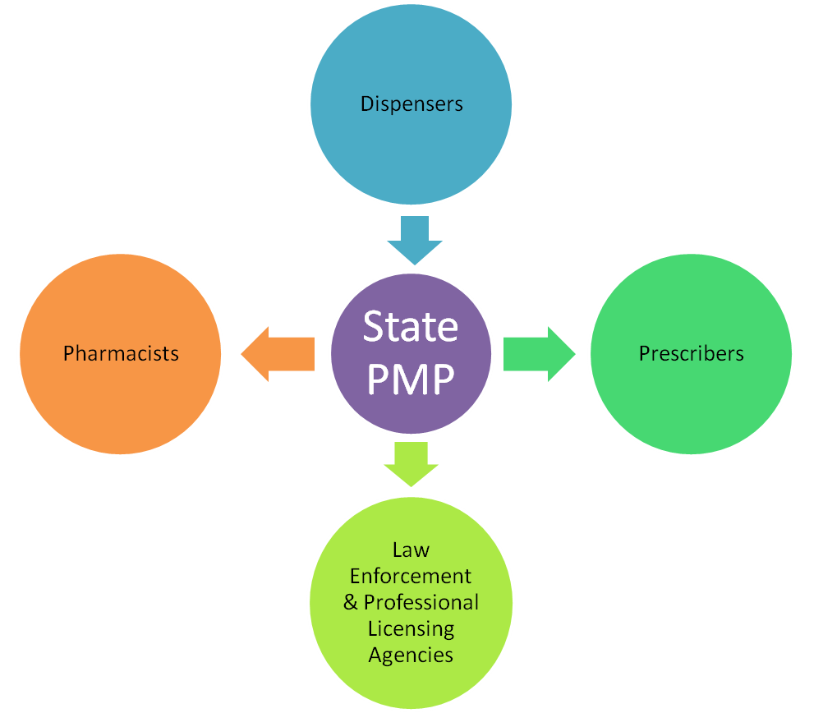
PMP System Overview
Data Submitted
Reports
Sent
Reports
Sent
Reports
Sent
*Other groups may also receive reports other than those listed
PMP System Overview

What is doctor shopping?
Patient seeks prescription without informing a prescriber that he/she has obtained prescriptions from other prescribers

How can PMP data be used to measure it?
Patients with prescriptions from multiple prescribers, filled at multiple pharmacies, can be identified in PMP data

States use different thresholds

PMP and Doctor Shopping
Prescription Information Collected
Patient identification:
Name & Address
DOB & Gender
Prescriber Information
Dispensing Pharmacy Information
Drug Information, e.g.
NDC # = name, type, strength, manufacturer
Quantity & date dispensed

Comparison of Doctor Shopping Thresholds

Percent Difference from 2009 - 2012
Declining Rates of Doctor/Pharmacy Shopping in MA

Comparison of PMP
Requirements

Next Steps

Best Practices Work Group Report: Recommendations for
MA Department of Public Health Epidemiology to Policy Group

Background
From Epidemiology to Policy: Prescription Drug Overdose Meeting, Centers for Disease Control and Prevention, April 22-23, 2013
Using epidemiology data to develop educational programs
MA Department of Public Health Representatives and Collaborators in this Initiative:
Madeleine Biondolillo, M.D., Director of the Bureau of Health Care Safety and Quality
Holly Hackman, M.D., M.P.H., Epidemiologist, Injury Prevention and Control Program
Hilary Jacobs, LICSW, LADC I, Director of the Bureau of Substance Abuse Services
Epi to Policy Group: Current/Future Initiatives
Identify a best practice training program for opioid prescribing for prescribers and pharmacists.
Provide a catalogue of educational opportunities for Prescription Monitoring Program use and best practices.
Develop principles of care guidelines published by describing best practices and how practice in specific areas can be improved.
Provide guidance on how to talk to patients suspected of abuse and how to say no to prescribing opioids.
Next Meeting Topics
Investigate and study best practices for promoting safe and responsible opioid prescribing and dispensing practices for acute and chronic pain.

What are the best practices in:

Education
Monitoring
Tracking
Screening
Prevention
Treatment
Thank you
Next meeting:
Wednesday
October 9, 2013
9:30 AM – 11 AM
99 Chauncy St., 11th Floor
Boston, MA

