INDOOR AIR QUALITY ASSESSMENT
MOLD INVESTIGATION

Betsey B. Winslow Elementary School
561 Allen Street
New Bedford, MA 02740

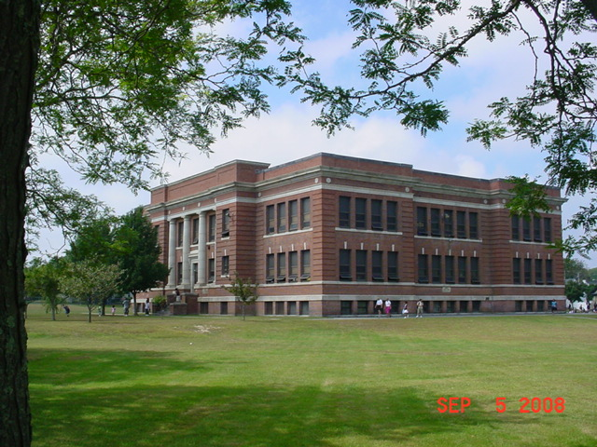

Prepared by:
Massachusetts Department of Public Health
Bureau of Environmental Health
Indoor Air Quality Program
October 2008

Background/Introduction
At the request of Mayor Scott Lang, the Massachusetts Department of Public Health (MDPH), Bureau of Environmental Health (BEH) provided assistance and consultation regarding indoor air quality concerns at the Betty B. Winslow Elementary School (BBWES) located at 561 Allen Street, New Bedford, Massachusetts. Concerns related to water damage as a result of flooding and potential mold growth prompted the request. The assessment was coordinated with the Mayor’s Office, the New Bedford Health Department, and the New Bedford Public Schools (NBPS).
On September 5, 2008, a visit was made to this building by Michael Feeney, Director of BEH’s Indoor Air Quality (IAQ) Program. As reported to BEH staff, the New Bedford area experienced a substantial amount of rainfall in a short period of time on Monday August 11, 2008. The rain event resulted in overflow from the toilets in the basement level restrooms of the BBWES.
Prior to the BEH assessment, remediation efforts had been completed and the floors of the restrooms had also been cleaned. This preliminary report focuses on water damage/mold remediation. A report regarding general indoor air quality conditions will follow.

Methods
MDPH staff performed a visual inspection of building materials for water damage and/or microbial growth.

Microbial/Moisture Concerns
In order for building materials to support mold growth, a source of water exposure is necessary. Repeated water damage to porous building materials (e.g., gypsum wallboard, ceiling tiles, and insulation) can result in microbial growth. The US Environmental Protection Agency (US EPA) and the American Conference of Governmental Industrial Hygienists (ACGIH) recommend that porous materials be dried with fans and heating within 24 to 48 hours of becoming wet (US EPA, 2001; ACGIH, 1989). If not dried within this time frame, mold growth may occur. Once mold has colonized porous materials, they are difficult to clean and should be removed.
As discussed previously, a rain event caused toilet backflow in the basement level restrooms. The floor of the restroom consists of ceramic tile and cement (Pictures 1 and 2), which can be readily cleaned and disinfected. No porous materials (i.e. carpeting, gypsum wallboard) or other school materials (i.e. books) were moistened as a result of this event.

Conclusions/Recommendations
In view of findings at the time of assessment, the following recommendations are made:
- In order to prevent future sewage back-up in the basement restrooms, consideration should be given to installing a backflow preventer on the school sewage line.
- Consult “Mold Remediation in Schools and Commercial Buildings” published by the US Environmental Protection Agency (US EPA, 2001) for more information on mold. This document can be downloaded from the US EPA website at: http://www.epa.gov/iaq/molds/mold_remediation.html.
- Refer to resource manuals and other related indoor air quality documents for further building-wide evaluations and advice on maintaining public buildings. These materials are located on the MDPH’s website at http://mass.gov/dph/indoor_air.

References
ACGIH. 1989. Guidelines for the Assessment of Bioaerosols in the Indoor Environment. American Conference of Governmental Industrial Hygienists, Cincinnati, OH.
US EPA. 2001. “Mold Remediation in Schools and Commercial Buildings”. Office of Air and Radiation, Indoor Environments Division, Washington, DC. EPA 402-K-01-001. March 2001. Available at: http://www.epa.gov/iaq/molds/mold_remediation.html

Picture 1
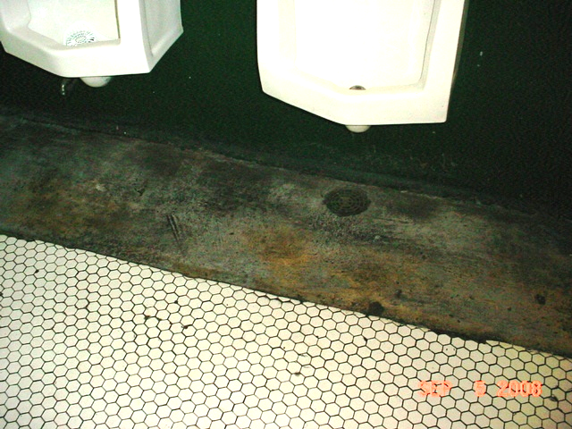

Floor and Wall of Basement Restroom

Picture 2
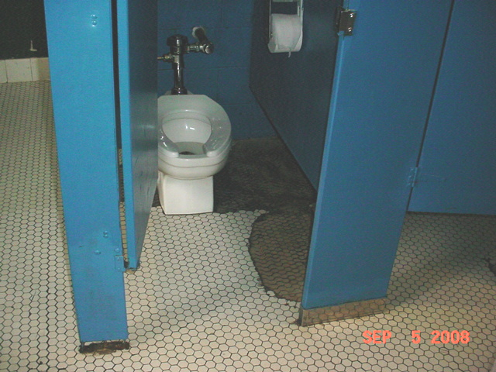

Floor and Wall of Basement Restroom

