Bi-Monthly Electronic Visit Verification PCA Public Listening Session, Executive Office of Health and Human Services, April 2021

Slide 2: Agenda

Logistics

Intent of Public Listening Sessions

Program Updates

EVV Policy Decisions

Open Discussion

Thank You

Slide 3: Joining from a Mobile Device

If you are joining this meeting from a mobile device, you have two options: Join by calling in or Join via the WebEx mobile application

Listening session details, including call in information and the meeting password, can be found online at mass.gov by searching “Notice Bi-Monthly Public Listening Session” and opening the search result for April 2021.

If you are having difficulty joining via the mobile application, please call in using the information provided in the communications sent for this listening session.

If you call in, the deck we are reviewing will be posted on mass.gov and can be found by searching “April Bi-Monthly Public Listening Session”.

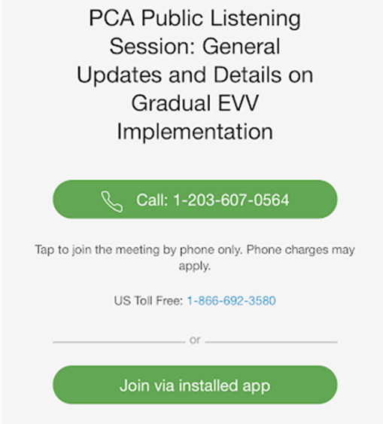

Slide 4: Muting and Unmuting Your Line

MassHealth requests that all attendees keep their phone muted if they are not talking to minimize background noise. MassHealth may mute your line if there is background noise.

If you need to unmute your line, you can do so by following these instructions:

If you are connected to audio on your computer: Click the Mute icon at the bottom of the screen.

If you are connected to audio on your phone: Press *6 on your phone.

You can also get MassHealth’s attention by “raising your hand” in the participant pane by clicking on the hand icon.

If we run out of time and you are unable to share your feedback, written responses will be accepted at any time at PCAfeedback@massmail.state.ma.us

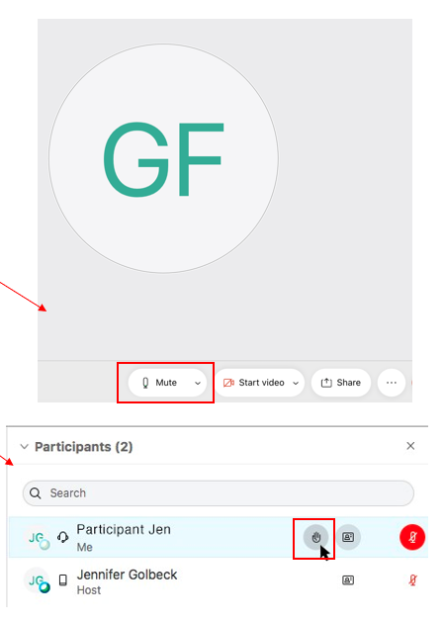

Slide 5: Closed Captioning

Closed captions are available during this session for those using their computer.

To see the closed captions, you must open the “Multimedia Viewer” panel in the bottom right-hand side of your screen (see the image below).

Step 1: Select the three vertical dots to the right of “Chat” to open additional panel options

Step 2: When Closed Caption is highlighted in blue, the panel should be visible on your screen

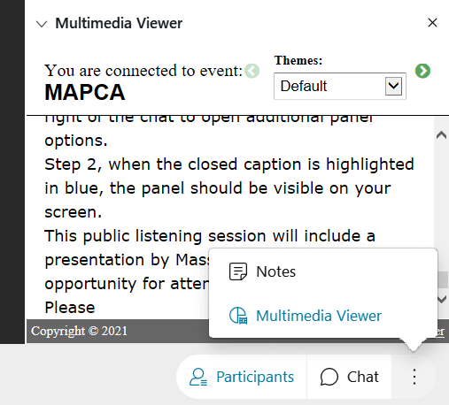

Slide 6: Providing Input

This Public Listening Session will include a presentation by MassHealth followed by an opportunity for attendees to provide input. Please hold all comments until the end of MassHealth’s presentation.

Attendees can provide input by either typing their comment into the comment section of WebEx or by unmuting and verbally giving their comments.

MassHealth asks that individuals providing comments indicate their role as a stakeholder. For example, identifying if you are a consumer, a PCA, a PCM employee, etc.

Feedback will be prioritized in the following order:

A MassHealth representative will read any comments submitted to the comments section.

A MassHealth representative will call on anyone using the “raise hand” feature.

Attendees will have the opportunity to unmute and provide feedback.

MassHealth anticipates that many individuals will want to provide feedback. We ask that you be as concise as possible to ensure that all attendees who want to provide input have time to do so.

During Public Listening Sessions, MassHealth does not respond to feedback. MassHealth asks that when the time for comments comes, participants frame their feedback in the form of a comment as questions cannot be answered.

If we run out of time and you are unable to share your feedback, written responses will be accepted at any time at PCAfeedback@massmail.state.ma.us

Slide 7: Agenda

Intent of Public Listening Sessions

Slide 8: Intent of Public Listening Sessions

Public Listening Sessions are voluntary. PCAs are not required to attend.

MassHealth is holding bi-monthly Public Listening Sessions specific to the implementation of Electronic Visit Verification (EVV) within consumer-directed programs.

The intention of these Public Listening Sessions is to share updates about MassHealth policy decisions related to EVV implementation in the PCA and MFP Waiver programs and seek stakeholder feedback as it relates to key focus areas of the implementation.

This Public Listening Session is not a training.

Each session will include a presentation by MassHealth with updates related to EVV implementation within the PCA and MFP Waiver programs, followed by an opportunity for attendees to provide input.

During Public Listening Sessions, MassHealth does not respond to feedback or answer questions. The purpose of this session is for MassHealth to share updates and for stakeholders to provide feedback that will help inform ongoing policy development.

Slide 9: Agenda

Program Updates

Slide 10: Fiscal Intermediary (FI) Procurement Update

MassHealth procured a group of PCA Program stakeholders, known as the FI Procurement Advisory Council (FIPAC), to help evaluate FI proposals.

MassHealth, with feedback from the FIPAC, selected Tempus Unlimited (Tempus) to serve as the single FI for consumer-directed programs.

Tempus will assume FI responsibilities for all PCA Consumers in January 2022.

In addition to payroll and administrative functions, Tempus will be responsible for implementing an Electronic Visit Verification (EVV) system for the PCA Program.

EVV will be implemented in phases throughout calendar year 2022.

Over the next 9 months, MassHealth will be working with Tempus to prepare consumers who need to transition from their current FI.

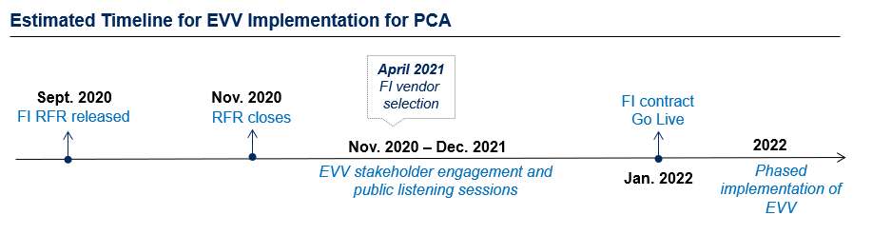

Slide 11: FI Transition Next Steps

MassHealth will be working with Tempus to ensure as seamless and efficient a transition as possible for Consumers and PCAs, including with the implementation of EVV.

Over the coming months, Consumers and PCAs will hear from Tempus regarding piloting certain features of the EVV system.

MassHealth will work with Tempus on the configuration of the EVV system to meet the PCA Program’s specific needs.

MassHealth will continue to engage stakeholders through the PCA EVV Workgroup and these bi-monthly EVV Public Listening Sessions to gather feedback on EVV policy and operational issues.

There will be opportunities for stakeholders to view the EVV system at a future date.

Stakeholder training for using EVV will begin in early 2022.

EVV will be implemented in the program gradually throughout calendar year 2022.

Slide 12: PCA EVV Stakeholder Workgroup

MassHealth had originally planned to solicit feedback on EVV implementation through a small procured workgroup (SPEAC).

MassHealth decided to shift from a procured model to a workgroup model. The workgroup model helps to ensure that:

A diverse set of voices and perspectives are heard;

Changes in membership are allowed, as needed; and

Tempus is given the opportunity to hear feedback on system functions as the system is being developed.

MassHealth is facilitating bi-weekly meetings with the PCA EVV Stakeholder Workgroup.

The PCA EVV Stakeholder Workgroup will provide feedback on topics that include but are not limited to:

EVV compliance considerations

Technology considerations

Guidelines and rules to ensure EVV use and avoid non-utilization

Functionality to promote appropriate utilization of hours and EVV

Training processes and materials

Updates from the PCA EVV Workgroup will be provided at the subsequent Public Listening Session.

Slide 13: Agenda

EVV Policy Decisions

Slide 14: EVV Implementation Feedback Strategy

Beginning in the Fall of 2020, MassHealth has hosted bi-monthly EVV Public Listening Sessions specific to EVV implementation in the PCA and MFP Waiver programs.

MassHealth documented feedback and questions posed by stakeholders during these sessions and continues to use this feedback to inform the development of EVV guidance and policy decisions

MassHealth is still making decisions about many topics related to EVV implementation.

Decisions will take into consideration input from the PCA EVV Stakeholder Workgroup and these Public Listening Sessions on key topics.

Slide 15: Electronic Visit Verification (EVV) Background

EVV is required by federal law for certain in-home Medicaid services.

MassHealth must implement EVV. Not implementing EVV will result in financial penalties for MassHealth from the federal government.

Once it is implemented, EVV will replace your timesheet.

The PCA will “check in” and “check out” at the beginning and end of their visit using EVV technology.

The consumer will have the ability to review and approve the EVV recorded time.

EVV will not impact how services are provided within the PCA Program.

MassHealth will implement EVV gradually over calendar year 2022.

As a reminder, many questions about how EVV will be implemented are still under consideration by MassHealth. As policy decisions are made, MassHealth will use these Public Listening Sessions to provide clarification.

Note: The California model, as originally proposed and implemented, is specifically identified by CMS as a non-compliant EVV system in the CMCS Informational Bulletin dated August 8, 2019. California is working to revise their approach to EVV implementation for its self-directed personal care programs. Its first proposed model developed toward the end of 2020 is to provide a mobile-based application with a check-in and check-out procedure.

Slide 16: An Introduction to the EVV System

Tempus will be working with MassHealth to configure an EVV system for the PCA Program.

The EVV system will be an application that is downloaded on a mobile device.

A worker will “check in” and “check out” of each service appointment.

The EVV system will capture the data elements required by federal law:

Name of the worker

Name of the consumer

Name of the service (i.e., personal care)

Date of the service

Visit start and end time

Visit start and end location

A consumer, surrogate, or administrative proxy will be able to log into the EVV system and approve or edit the time reported.

Slide 17: Privacy in the EVV System

The EVV system will only verify location at check-in and check-out, which is the minimum required by the federal government.
- MassHealth is aware that many stakeholders are concerned about their privacy as users of the EVV system.
- CMS guidance requires that location is electronically captured at check-in and check-out for each service visit.
- In bargaining with 1199SEIU, the state has proposed that check-ins and check-outs outside of the Consumer’s home will be recorded by the EVV system as “Community,” not actual GPS coordinates. For services provided in the Consumer’s home, MassHealth intends to have the EVV system record “Home”.
- Under no circumstance will the EVV system capture location data outside of the worker’s check-in and check-out times. This requirement will be written into the FI contract.
- MassHealth will continue to balance federal rules against the valid needs and concerns of our program stakeholders.

Slide 18: Live-in Caregivers

MassHealth has heard feedback from stakeholders about various challenges and considerations with implementing EVV for PCAs who live with their consumers.

This is a subject over which the state is actively bargaining with 1199SEIU. At bargaining, the state proposed that PCAs who live with their Consumers full-time be exempt from using EVV.

MassHealth is still bargaining about this, and is still determining how to operationalize a live-in exemption, such as:

How to verify live-in status

What alternative method will be permitted to enter and approve time for Consumers and PCAs who live together

Slide 19: Allowable Exemptions

MassHealth will offer some workers and consumers exemptions from using EVV.

MassHealth is anticipating that there may be some limited reasons to exempt Consumers or PCAs from using EVV.

One exemption MassHealth will likely implement is for Consumers or PCAs who have a concern of a safety risk related to using location services due to stalking, harassment, domestic violence, or other factors.

MassHealth is still determining how exemptions will be operationalized, including:

Whether to permit other exemptions

How the reasons for exemptions will be verified

What alternative method will be permitted to enter and approve time for Consumers and PCAs who have an exemption

What CMS will consider as acceptable exceptions

Slide 20: Ongoing Policy and Technology Development

In addition to the policy items discussed in previous slides, MassHealth recognizes that the following EVV focus areas are a high priority for stakeholders. At this time, MassHealth is still developing responses to the following priority areas:
- Training. Training on the EVV system will be made available to all Consumers and PCAs. Training will begin in early calendar year 2022.
- Access to a personal device. What if a consumer or PCA does not have access to a personal device that supports the use of the EVV application or to internet?
- Working for multiple consumers. How will a PCA use EVV if they are doing work for multiple consumers at the same time (for example: grocery shopping)?
- Compliance. What if a consumer or PCA refuses to use EVV.

Slide 21: MassHealth Wants to Hear From You!

What do you consider to be the key impacts of EVV implementation and do you have suggestions for MassHealth to consider as we address those impacts?

Feedback Reminders

Feedback will be prioritized in the following order:

A MassHealth representative will read any comments submitted to the comments section.

A MassHealth representative will call on anyone using the “raise hand” feature.

Attendees will have the opportunity to unmute and provide feedback.

During Public Listening Sessions, MassHealth does not respond to feedback. MassHealth asks that you frame your feedback in the form of a comment as questions cannot be answered.

If we run out of time and do not get to your question, MassHealth accepts feedback at anytime at PCAfeedback@massmail.state.ma.us

Slide 22: Thank you!

Additional feedback can be submitted to MassHealth by emailing: PCAfeedback@massmail.state.ma.us

