Bi-Monthly Electronic Visit Verification PCA Public Listening Session, Executive Office of Health and Human Services, April 2022

Slide 2: Agenda

Logistics

Intent of Public Listening Sessions

Recap of EVV

EVV Rollout Timelines

Open Discussion

Thank You

Slide 3: Joining from a Mobile Device
    - If you are joining this meeting from a mobile device, you have two options:
      - Join by calling in
      - Join via the Zoom mobile application
    - Listening session details, including call in information and the meeting password, can be found online at mass.gov by searching “Notice Bi-Monthly Public Listening Session” and opening the search result for April 2022.
    - If you are having difficulty joining via the mobile application, please call in using the information provided in the communications sent for this listening session.
    - If you call in, the deck we are reviewing will be posted on mass.gov and can be found by searching “April Bi-Monthly Public Listening Session”.

Slide 4: Muting and Unmuting Your Line
- MassHealth requests that all attendees keep their phone muted if they are not talking to minimize background noise. MassHealth may mute your line if there is background noise.
- If you need to unmute your line, you can do so by following these instructions:
  - If you are connected to audio on your computer or via the Zoom app: Click the Mute icon at the bottom of the screen.
  - If you are connected to audio on your phone: Press *6 on your phone.
- You can also get MassHealth’s attention by” raising your hand” by clicking the Reactions button and choosing Raise a Hand.
- If we run out of time and you are unable to share your feedback, written responses will be accepted at any time at PCAfeedback@massmail.state.ma.us
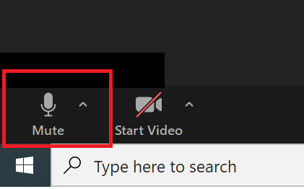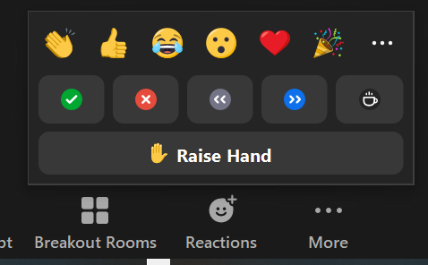

Slide 5: Closed Captioning
- Closed captions are available during this session for those using their computer.
- To see the closed captions, you must use the following links:
  - English - https://www.streamtext.net/player?event=MassHealth
  - Spanish - https://www.streamtext.net/player?event=MassHealth-Spanish
- These links will be placed in the Chat section of Zoom.

Slide 6: Providing Input

This Public Listening Session will include a presentation by MassHealth followed by an opportunity for attendees to provide input. Please hold all comments until the end of MassHealth’s presentation.

Attendees can provide input by either typing their comment into the chat section of Zoom or by unmuting and verbally giving their comments.

MassHealth asks that individuals providing comments indicate their role as a stakeholder. For example, identifying if you are a consumer, a PCA, a PCM employee, etc.

Feedback will be prioritized in the following order:

A MassHealth representative will read any comments submitted to the comments section.

A MassHealth representative will call on anyone using the “raise hand” feature.

Attendees will have the opportunity to unmute and provide feedback.

MassHealth anticipates that many individuals will want to provide feedback. We ask that you be as concise as possible to ensure that all attendees who want to provide input have time to do so.

During Public Listening Sessions, MassHealth does not respond to feedback. MassHealth asks that when the time for comments comes, participants frame their feedback in the form of a comment as questions cannot be answered.

If we run out of time and you are unable to share your feedback, written responses will be accepted at any time at PCAfeedback@mass.gov

Slide 7: Agenda

Intent of Public Listening Sessions

Slide 8: Intent of Public Listening Sessions

Public Listening Sessions are voluntary. PCAs are not required to attend.

MassHealth is holding bi-monthly Public Listening Sessions specific to the implementation of Electronic Visit Verification (EVV) within consumer-directed programs.

The intention of these Public Listening Sessions is to share updates about MassHealth policy decisions related to EVV implementation in the PCA and HCBS MFP Self-Directed Waiver programs and seek stakeholder feedback as it relates to key focus areas of the implementation.

This Public Listening Session is not a training.

Each session includes a presentation by MassHealth with updates related to EVV implementation within the PCA and HCBS MFP Self-Directed Waiver programs, followed by an opportunity for attendees to provide input.

During Public Listening Sessions, MassHealth does not respond to feedback or answer questions. The purpose of this session is for MassHealth to share updates and for stakeholders to provide feedback that will help inform ongoing policy development.

The deck being reviewed is available at mass.gov by searching “Bi-Monthly Public Listening Session”. The deck will also be available in Spanish, however, it is not yet posted.

Slide 9: Agenda

Recap of EVV

Slide 10: Electronic Visit Verification (EVV) Background

EVV is required by Federal law for in-home personal care services.

MassHealth must implement EVV. Not implementing EVV will result in financial penalties for MassHealth from the federal government.
- Once it is implemented, EVV will replace your timesheet.
  - The PCA will “check in” and “check out” at the beginning and end of their visit using EVV technology.
  - The consumer will have the ability to review and approve the EVV recorded time.
  - Consumers or PCAs exempt from using EVV (live-in caregivers and those with a potential safety risk) will have an alternate method of submitting time.
- EVV will not impact how services are allowed to be provided within the PCA program.
- MassHealth will implement EVV gradually over calendar years 2023 and 2024 (we will discuss this further in a later slide).
- Many questions about how EVV will be implemented are still being considered. As policy decisions are made, updates and clarifications will be provided through these Public Listening Sessions.

Slide 11: An Introduction to the EVV System

MassHealth is working with Tempus to configure an EVV system for the PCA Program.

The EVV system will be an application that is downloaded on a smartphone device.

A worker will “check in” and “check out” of each service appointment.

The EVV system will capture the data elements required by federal law:

Name of the worker

Name of the consumer

Name of the service (i.e., personal care)

Date of the service

Visit start and end time

Visit start and end location

A consumer, surrogate, or administrative proxy will be able to log into the EVV system and approve or edit, if needed, the time reported.

Once implemented, EVV will replace your existing timesheet.

Slide 12: The EVV Web Portal

In addition to the mobile application that PCAs will download on a mobile device, there will be a web portal that can be accessed by both Consumers and PCAs.
- Consumers or their Surrogates/Administrative Proxies will be responsible for using the web portal to review and approve time that has been submitted by PCAs.
- Consumers will be able to use the web portal to access historical visit information.
- Consumers and PCAs will have the ability to add and edit time in the web portal that was not captured by the mobile application or captured incorrectly. The web portal can be used when:

There is an emergency when the PCA arrives at the Consumer’s home

The PCA forgets to check in or out of a visit

The PCA’s phone dies during a visit
- Note that time submitted manually in the web portal is not considered EVV compliant and therefore policies will be established to minimize manual entries.

Slide 13: Access to Personal Devices
- PCAs and Consumers will be given one-time “vouchers”, which will be redeemable for an EVV-compatible device.
- The PCA Quality Homecare Workforce Council and 1199SEIU have agreed to provide all PCAs who are unable or unwilling to use their own device with a one-time “voucher” or similar method for redeeming a device that can be used for EVV.
  - Please note that impact bargaining is still underway and terms are not yet final
- MassHealth intends to implement a similar voucher program for Consumers who do not have access to the technology they need to review and approve time electronically.
- MassHealth, in partnership with Tempus, is working to define how vouchers will be distributed.

Slide 14: Privacy and EVV
- The EVV System will only verify location at the time of check-in and check-out, which is the minimum required by the federal government.
- The PCA Quality Homecare Workforce Council and 1199SEIU have tentatively agreed that check-ins and check-outs outside of the Consumer’s home will be recorded by the EVV system as “Community,” not actual GPS coordinates. For services provided in the Consumer’s home, MassHealth intends to have the EVV system record “Home”.
- MassHealth is aware that many stakeholders are concerned about their privacy as users of the EVV system.
- CMS guidance requires that location is electronically captured at check-in and check-out for each service visit.
- MassHealth will not have access to GPS coordinates. Only “Home” and “Community” markers, as described above.
- Under no circumstance will the EVV system capture location data outside of the worker’s check-in and check-out times. This requirement will be written into the FI contract.
- MassHealth will continue to balance federal rules against the valid needs and concerns of our program stakeholders.

Slide 15: Allowable Exemptions

Some Consumers and PCAs will have exemptions from using EVV.
- MassHealth anticipates that there will be reasons to exempt some Consumers and PCAs from using EVV. Those anticipated exemptions will be:
  - Live-in caregivers
  - Consumers or PCAs who have a concern of a safety risk related to using location services due to stalking, harassment, domestic violence, or other factors.
- MassHealth is still determining how exemptions will be operationalized. MassHealth is working to determine:
  - How live-in caregiver will be defined
  - How exemptions will be verified
  - How stakeholders who are exempt from using EVV will submit time

Slide 16: Using EVV When Note Connected to Data/Internet

The EVV mobile application will not require that the PCA be connected to the internet or that the PCA have a data plan.
- MassHealth recognizes that many Consumers live in areas in the state where cellphone coverage is limited and that some PCAs may not have access to data on their device.
- PCAs who do not have access to a data plan, or who are providing services in an area where there is not data coverage, will be able to use EVV offline and upload the information from their visit by connecting to internet at a later time.
- Consumers who do not have access to internet to access the web-portal and are unable to access internet in their community will have alternate methods of reviewing and approving time, as necessary.

Slide 17: Agenda

EVV Roll Out Timelines

Slide 18: Phased Implementation Strategy

EVV is a federal requirement. All non-exempt Consumers and PCAs participating in the PCA Program will need to use EVV.

The first phase of EVV implementation will be with Consumers who are not authorized for night hours. This is subject to finalizing bargaining with 1199SEIU (the PCA Union).

Within each phase, MassHealth intends to implement with small groups to ensure there are the resources necessary available to support all users starting to use the system.

For example, MassHealth may roll EVV out to Consumers alphabetically to ensure geographic spread allowing for easier management of the transition by the FI and PCMs.

All users will have access to training before they are expected to use EVV.

Slide 19: EVV Implementation Timeline Update

MassHealth will implement EVV in phases

A visual representation of EVV Implementation Timeline Update
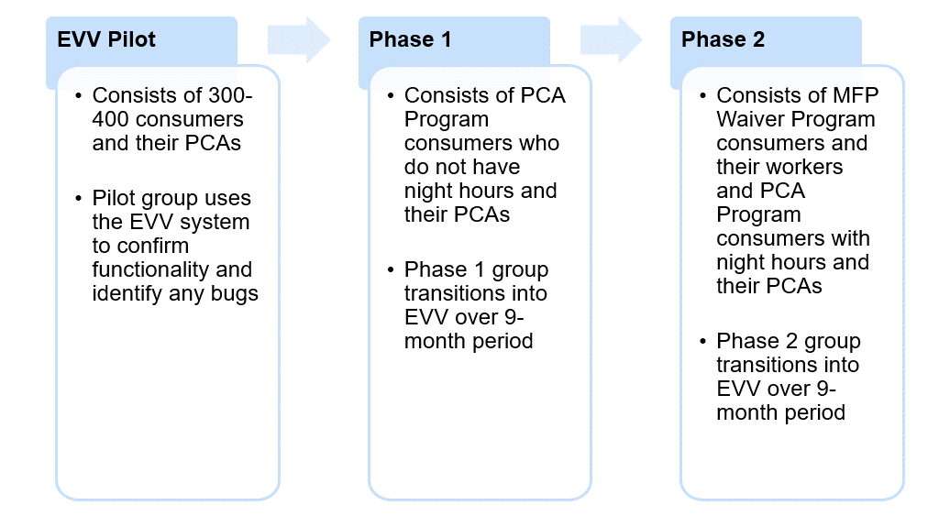

Image Summary:
- EVV Pilot
  - Consists of 300-400 consumers and their PCAs
  - Pilot group uses the EVV system to confirm functionality and identify any bugs
- Phase 1
  - Consists of PCA Program consumers who do not have night hours and their PCAs
  - Phase 1 group transitions into EVV over 9-month period
- Phase 2
  - Consists of MFP Waiver Program consumers and their workers and PCA Program consumers with night hours and their PCAs
  - Phase 2 group transitions into EVV over 9-month period

Slide 20: EVV Implementation Timeline Update
- MassHealth will implement EVV in phases, beginning with a Pilot in the fall of 2022 and followed by groups of Consumers and PCAs throughout calendar years 2023 and 2024.
- This timeframe allows for a longer pilot to ensure proper functionality and a smooth roll out.
A visual representation of EVV Timeline Update
Image Summary:
- Spring/Summer 2022: EVV system development
- Fall 2022: Pilot and Training
- 2023 and 2024: Phased Implementation and Training

Slide 21: Agenda
- Open Discussion

Slide 22: MassHealth wants to hear from you!
- What do you consider to be the key impacts of EVV implementation, and do you have suggestions for MassHealth to consider as we address those impacts?
- Feedback Reminders
- Feedback will be prioritized in the following order:
  - A MassHealth representative will read any comments submitted to the comments section.
  - A MassHealth representative will call on anyone using the “raise hand” feature.
  - Attendees will have the opportunity to unmute and provide feedback.
- During Public Listening Sessions, MassHealth does not respond to feedback. MassHealth asks that you frame your feedback in the form of a comment as questions cannot be answered.
- If we run out of time and do not get to your question, MassHealth accepts feedback at any time at PCAfeedback@massmail.state.ma.us

Slide 23: Agenda

Thank you!

Slide 24: Thank you!

Additional feedback can be submitted to MassHealth by emailing: PCAfeedback@massmail.state.ma.us

