Bi-Monthly Electronic Visit Verification PCA Public Listening Session, Executive Office of Health and Human Services, December 2020

Slide 1: Agenda

Logistics

Intent of Public Listening Sessions

Electronic Visit Verification Updates

EVV Frequently Asked Questions

Open Discussion

Slide 2: Joining from a Mobile Device

If you are joining this meeting from a mobile device, you have two options: Join by calling in or Join via the WebEx mobile application

Listening session details, including call in information and the meeting password, can be found online at mass.gov by searching “Gradual EVV Implementation” and opening the first search result.

If you are having difficulty joining via the mobile application, please call in using the information provided in the communications sent for this listening session.

If you call in, the deck we are reviewing will be posted on mass.gov and can be found by searching “December EVV PCA Public Listening Session”.

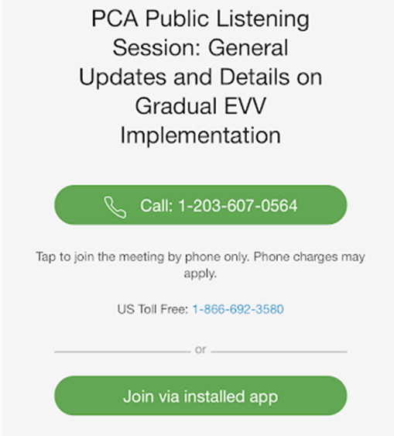

Slide 3: Muting and Unmuting Your Line

MassHealth requests that all attendees keep their phone muted if they are not talking to minimize background noise. MassHealth may mute your line if there is background noise.

If you need to unmute your line, you can do so by following these instructions:

If you are connected to audio on your computer: Click the Mute icon at the bottom of the screen.

If you are connected to audio on your phone: Press *6 on your phone.

You can also get MassHealth’s attention by ”raising your hand” in the participant pane by clicking on the hand icon.

If we run out of time and you are unable to share your feedback, written responses will be accepted at any time at PCAfeedback@massmail.state.ma.us

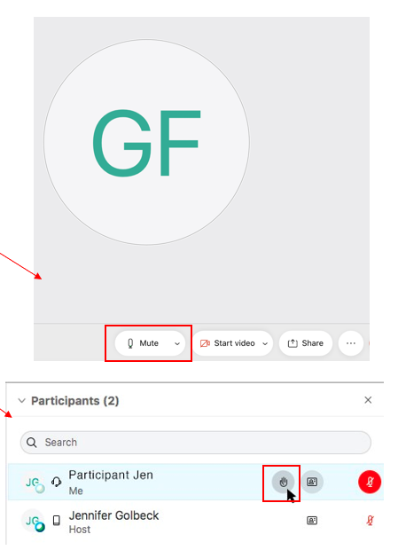

Slide 4: Closed Captioning

Closed captions are available during this session for those using their computer.

To see the closed captions, you must open the “Closed Captions” panel in the bottom right-hand side of your screen (see the image below).

Step 1: Select the three vertical dots to the right of “Chat” to open additional panel options

Step 2: When Closed Caption is highlighted in blue, the panel should be visible on your screen

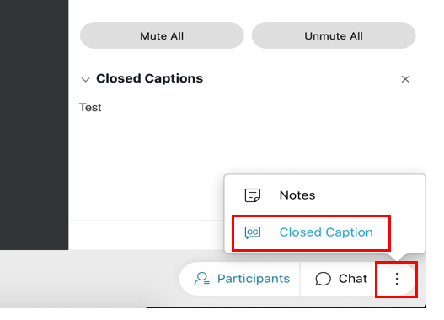

Slide 5: Providing Input

This Public Listening Session will include a presentation by MassHealth followed by an opportunity for attendees to provide input. Please hold all comments until the end of MassHealth’s presentation.

Attendees can provide input by either typing their comment into the comment section of WebEx or by unmuting and verbally giving their comments.

MassHealth asks that individuals providing comments indicate their role as a stakeholder. For example, identifying if you are a consumer, a PCA, a PCM employee, etc.

Feedback will be prioritized in the following order:

A MassHealth representative will read any comments submitted to the comments section.

A MassHealth representative will call on anyone using the “raise hand” feature.

Attendees will have the opportunity to unmute and provide feedback.

MassHealth anticipates that many individuals will want to provide feedback. We ask that you be as concise as possible to ensure that all attendees who want to provide input have time to do so.

During Public Listening Sessions, MassHealth does not respond to feedback. MassHealth asks that when the time for comments comes, participants frame their feedback in the form of a comment as questions cannot be answered.

If we run out of time and you are unable to share your feedback, written responses will be accepted at any time at PCAfeedback@massmail.state.ma.us

Slide 6: Intent of Public Listening Sessions

MassHealth will be holding bi-monthly Public Listening Sessions specific to the implementation of Electronic Visit Verification (EVV) within consumer-directed programs.

The intention of these Public Listening Sessions will be to share updates about MassHealth policy decisions related to EVV implementation in the PCA and MFP Waiver programs and seek stakeholder feedback as it relates to key focus areas of the implementation.

This Public Listening Session is not a training.

Each session will include a presentation by MassHealth with updates related to EVV implementation within the PCA and MFP Waiver programs, followed by an opportunity for attendees to provide input.

During Public Listening Sessions, MassHealth will not respond to feedback or answer questions. The purpose of this session is for MassHealth to share updates and for stakeholders to provide feedback that will help inform ongoing policy development.

Slide 7: Definition of Terms Used in this Presentation

Request for Response (RFR)

An RFR is how state agencies like MassHealth select outside companies to help with certain projects

You will hear MassHealth refer to an RFR as a “procurement”

The RFR is a fair and competitive process in which any company that meets the general project requirements can apply to provide the services

Electronic Visit Verification (EVV)

EVV refers to an electronic way of collecting timesheet information.

EVV is different than electronic timesheets because it collects information about the service automatically rather than the worker or employer entering the information manually.

When a worker “checks in” and “checks out” using EVV, the EVV system automatically collects information such as the start and stop time of the service and the location of where the service begins and ends.

Slide 8: Fiscal Intermediary Procurement Update

In September of 2020, MassHealth released an RFR to procure a single Fiscal Intermediary (FI) for the PCA and MFP Waiver programs.

In addition to traditional payroll-related administrative activities, the selected FI vendor will be responsible for implementing EVV for the PCA and MFP Waiver programs.

Responses are being reviewed with the support of the FI Procurement Advisory Council (FIPAC), a procured advisory council of PCA program consumers and stakeholders.

MassHealth will announce the selected FI in April of 2021.

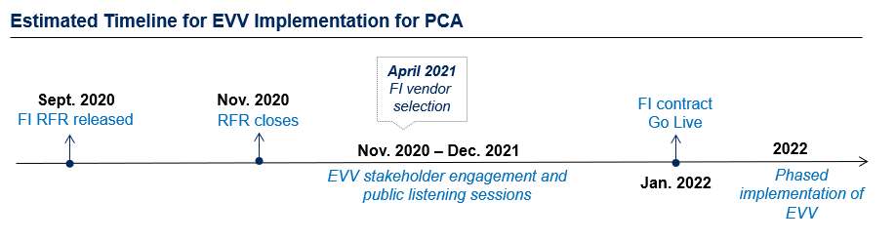

Slide 9: Electronic Visit Verification (EVV) Background

EVV is required by federal law for certain in-home Medicaid services.

MassHealth must implement EVV. Not implementing EVV will result in financial penalties for MassHealth from the federal government.

Once it is implemented, EVV will replace your timesheet.

The PCA will “check in” and “check out” at the beginning and end of their visit using EVV technology.

The consumer will have the ability to review and approve the EVV recorded time.

EVV will not impact how services are provided within the PCA program.

MassHealth will implement EVV gradually over calendar year 2022.

MassHealth will not know which EVV system is going to be implemented until an FI vendor has been selected in April of 2021.

As a reminder, many questions about how EVV will be implemented are still under consideration by MassHealth. As policy decisions are made, MassHealth will use these Public Listening Sessions to provide clarification.

Slide 10: EVV Implementation Feedback Strategy

As we move toward EVV implementation in calendar year 2022, MassHealth will gather regular stakeholder feedback.

1. Fiscal Intermediary Procurement Advisory Council (FIPAC)

This is a procured advisory council that will consist of program stakeholders that may include some combination of Consumers, PCAs, Surrogates, family members, advocates, or others. FIPAC will support MassHealth in reviewing certain parts of the FI procurement responses, including EVV system proposals.

2. Stakeholder PCA EVV Advisory Council (SPEAC)

This is a procured advisory council that will consist of program stakeholders that may include some combination of Consumers, PCAs, Surrogates, family members, advocates, or others.​ SPEAC will advise and inform MassHealth policy decisions related to EVV implementation for the PCA and self-directed MFP Waiver programs.

3. Bi-Monthly Public Listening Sessions

These sessions, open to all stakeholders, will be used as a time for MassHealth to update stakeholders on EVV implementation status, key policy decisions, and seek feedback on outstanding implementation focus areas.

Slide 11: EVV Frequently Asked Questions

In September and October 2020, MassHealth held Public Listening Sessions specific to EVV implementation in the PCA and MFP Waiver programs.

MassHealth documented the feedback and questions posed by stakeholders during these sessions and used this feedback to inform the development of EVV guidance and policy decisions.

There are many questions that MassHealth does not have answers to yet.

Some questions will be answered when an EVV system has been selected as part of the Fiscal Intermediary (FI) procurement.

The remaining questions will be answered over time as we meet with you, meet with the EVV stakeholder group and complete policy development.

Slide 12: I am a consumer. How will I use EVV?

What MassHealth Knows:

Consumers and/or their surrogates/administrative proxies will be responsible for approving time reported by workers in the EVV system.

Time may be approved at the end of every pay period or at any time during the pay period.

Consumers and/or their surrogates/administrative proxies will be able to add time if no time was captured or edit time if the time captured was inaccurate.

Surrogates/administrative proxies will have access to the EVV system so they will not need to be present at the time of the visit.

What MassHealth Does Not Know

What the consumer and/or surrogate/administrative proxy portal of the EVV system will look like.

Slide 13: I am a PCA. How will I use EVV?

What MassHealth Knows

EVV will serve as the primary method of timekeeping for the PCA and MFP Waiver programs.

Once it is implemented, EVV will replace your existing timesheet.

PCAs will use an application on a mobile device to “check in” and “check out” of a visit.

The system will capture the check in time as the start time and the check out time as the end time for your visit.

There will be limited exemptions from using EVV

What MassHealth Does Not Know

If there will be alternatives to the mobile application. Some EVV solutions offer “backup” technology options (i.e. telephone option).

What the mobile application will look like.

What the EVV exemptions are.

Slide 14: What if I forget to check in or check out of a visit using EVV?

What MassHealth Knows

There will be situations where a PCA does not use EVV to check in or check out of a visit. This may be because the PCA forgot or because of an emergency.

Consumers and/or their surrogates/administrative proxies will have the ability to enter or edit time to account for situations where a PCA forgets to check in or check out.

PCAs will be able to see if the time reported for a visit in the EVV system has been changed by the consumer and/or their surrogate/administrative proxy.

What MassHealth Does Not Know

If the EVV system will notify the PCA that their timesheet has been edited.

What the EVV “timesheet” will look like.

Slide 15: How can I be sure that EVV is not tracking me all the time?

What MassHealth Knows

CMS requires independent capture of location. This means that location cannot be reported by the consumer and/or PCA; it must be collected by an independent source.

MassHealth will only record location at the time that the PCA checks into a visit and the time that a PCA checks out of a visit. The system will not capture your location at any other time.

What MassHealth Does Not Know

The system may have the ability to only capture “home” and “community” markers, rather than actual GPS coordinates.

Slide 16: I am a PCA and I live with my consumer. Will I be required to use EVV?

What MassHealth Knows

EVV will replace the existing timesheet process.

Because EVV will be used for timekeeping, live-in caregivers will be required to use EVV.

Consumers should adapt the schedule for live-in PCAs as needed to ensure the PCA checks in and out using EVV.

Slide 17: What do I do if my visit does not begin or end in my consumer’s home?

What MassHealth Knows

Services are provided both in the community and the home. MassHealth does not want this to change.

EVV will be required in both the home and the community.

EVV will serve as the primary method of timekeeping for the PCA and MFP Waiver programs.

PCAs will only have to check in once at the beginning of a visit and once at the end of a visit.

If your visit starts in the community, you will NOT need to check in again when you arrive at the consumer’s home.

What MassHealth Does Not Know

How policy will address situations in which a PCA is running errands for multiple consumers at the same time.

Slide 18: What if I live in an area without cellphone or internet coverage?

What MassHealth Knows

The EVV system will have the ability to capture EVV data when the system is offline. That data will automatically sync when the user returns to an area with cellphone coverage.

What MassHealth Does Not Know

How will a consumer approve time if they do not have cellphone coverage or internet in their home?

Slide 19: Will there be training available to consumers, PCAs, and surrogates/administrative proxies before we are expected to start using EVV?

YES!

This Public Listening Session is not a training.

Part of the FI procurement includes specific requirements about the types of training that must be available for all EVV users.

Training will be available in different formats: including video, web-based, and print materials.

MassHealth will work with the selected FI to communicate information about training opportunities as we get closer to EVV implementation.

Slide 20: I have heard a lot about the “California model”. Why are we not implementing EVV in the same way?

California proposed the use of an electronic timesheet to meet EVV requirements.

This model was very popular among national stakeholder groups.

The Centers for Medicare and Medicaid Services (CMS), the federal agency that is requiring states to implement EVV, has indicated that the “California model” as it was originally proposed does not comply with EVV requirements.

Slide 21: Ongoing Policy Development

In addition to the policy items discussed in previous slides, MassHealth recognizes that the following EVV focus areas are a high priority for stakeholders. At this time, MassHealth does not have answers to how EVV will impact these current program policies.

Technology

What if a consumer or PCA does not have access to a smartphone or internet?

How will a PCA use EVV if they are doing work for multiple consumers at the same time (for example: grocery shopping)?

Policy

How will EVV be used during night hours?

What will the allowable exemptions from using EVV be?

What if a consumer or PCA refuses to use EVV?

Slide 22: MassHealth Wants to Hear From You!

What do you consider to be the key impacts of EVV implementation and do you have suggestions for MassHealth to consider as we address those impacts?

Feedback Reminders

Feedback will be prioritized in the following order:

A MassHealth representative will read any comments submitted to the comments section.

A MassHealth representative will call on anyone using the “raise hand” feature.

Attendees will have the opportunity to unmute and provide feedback.

During Public Listening Sessions, MassHealth does not respond to feedback. MassHealth asks that you frame your feedback in the form of a comment as questions cannot be answered.

If we run out of time and do not get to your question, MassHealth accepts feedback at anytime at PCAfeedback@massmail.state.ma.us

Slide 23: Thank you!

Additional feedback can be submitted to MassHealth by emailing: PCAfeedback@massmail.state.ma.us

