Bi-Monthly Electronic Visit Verification PCA Public Listening Session, Executive Office of Health and Human Services, July 2021

Slide 1: Agenda

Logistics

Intent of Public Listening Sessions

Program Updates

EVV Policy Decisions

Open Discussion

Thank you

Slide 2: Joining from a Mobile Device

If you are joining this meeting from a mobile device, you have two options: Join by calling in or Join via the WebEx mobile application

Listening session details, including call in information and the meeting password, can be found online at mass.gov by searching “Notice Bi-Monthly Public Listening Session” and opening the search result for July 2021.

If you are having difficulty joining via the mobile application, please call in using the information provided in the communications sent for this listening session.

If you call in, the deck we are reviewing will be posted on mass.gov and can be found by searching “July Bi-Monthly Public Listening Session”.

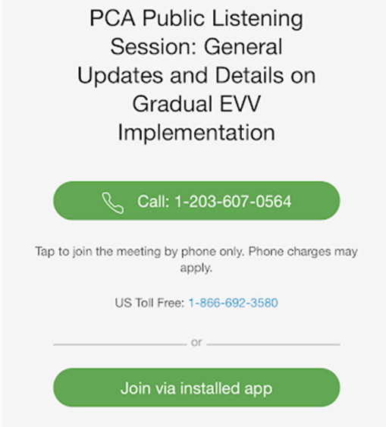

Slide 3: Muting and Unmuting Your Line

MassHealth requests that all attendees keep their phone muted if they are not talking to minimize background noise. MassHealth may mute your line if there is background noise.

If you need to unmute your line, you can do so by following these instructions:

If you are connected to audio on your computer: Click the Mute icon at the bottom of the screen.

If you are connected to audio on your phone: Press *6 on your phone.

You can also get MassHealth’s attention by “raising your hand” in the participant pane by clicking on the hand icon.

If we run out of time and you are unable to share your feedback, written responses will be accepted at any time at PCAfeedback@massmail.state.ma.us

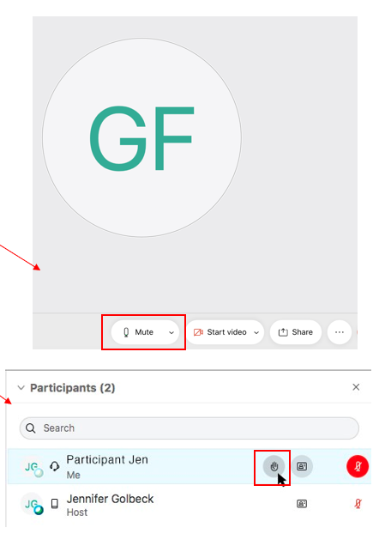

Slide 4: Closed Captioning

Closed captions are available during this session for those using their computer.

To see the closed captions, you must open the “Multimedia Viewer” panel in the bottom right-hand side of your screen (see the image below).

Step 1: Select the three vertical dots to the right of “Chat” to open additional panel options

Step 2: When Multimedia Viewer is highlighted in blue, the panel should be visible on your screen

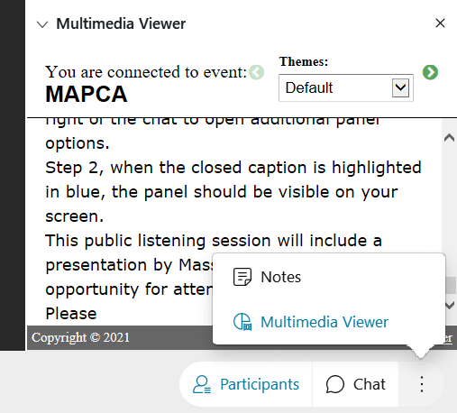

Slide 5: Providing Input

This Public Listening Session will include a presentation by MassHealth followed by an opportunity for attendees to provide input. Please hold all comments until the end of MassHealth’s presentation.

Attendees can provide input by either typing their comment into the comment section of WebEx or by unmuting and verbally giving their comments.

MassHealth asks that individuals providing comments indicate their role as a stakeholder. For example, identifying if you are a consumer, a PCA, a PCM employee, etc.

Feedback will be prioritized in the following order:

A MassHealth representative will read any comments submitted to the comments section.

A MassHealth representative will call on anyone using the “raise hand” feature.

Attendees will have the opportunity to unmute and provide feedback.

MassHealth anticipates that many individuals will want to provide feedback. We ask that you be as concise as possible to ensure that all attendees who want to provide input have time to do so.

During Public Listening Sessions, MassHealth does not respond to feedback. MassHealth asks that when the time for comments comes, participants frame their feedback in the form of a comment as questions cannot be answered.

If we run out of time and you are unable to share your feedback, written responses will be accepted at any time at PCAfeedback@mass.gov

Slide 6: Agenda

Intent of Public Listening Sessions

Slide 7: Intent of Public Listening Sessions

Public Listening Sessions are voluntary. PCAs are not required to attend.

MassHealth is holding bi-monthly Public Listening Sessions specific to the implementation of Electronic Visit Verification (EVV) within consumer-directed programs.

The intention of these Public Listening Sessions is to share updates about MassHealth policy decisions related to EVV implementation in the PCA and HCBS MFP Self-Directed Waiver programs and seek stakeholder feedback as it relates to key focus areas of the implementation.

This Public Listening Session is not a training.

Each session includes a presentation by MassHealth with updates related to EVV implementation within the PCA and HCBS MFP Self-Directed Waiver programs, followed by an opportunity for attendees to provide input.

During Public Listening Sessions, MassHealth does not respond to feedback or answer questions. The purpose of this session is for MassHealth to share updates and for stakeholders to provide feedback that will help inform ongoing policy development.

Slide 8: Agenda

Program Updates

Slide 9: Fiscal Intermediary (FI) Transition Update

MassHealth selected Tempus Unlimited to serve as the single FI for the PCA program, starting on January 1, 2022.

MassHealth will be working with Tempus to ensure as seamless and efficient a transition as possible for Consumers and PCAs, including with implementation of EVV.

Although Tempus has been contracted, EVV implementation is not scheduled to begin until 2022.

MassHealth will work with Tempus on the configuration of the EVV system to meet the PCA Program’s specific needs.

MassHealth will continue to engage stakeholders through the PCA EVV Workgroup and these bi-monthly EVV Public Listening Sessions to gather feedback on EVV policy and operational issues.

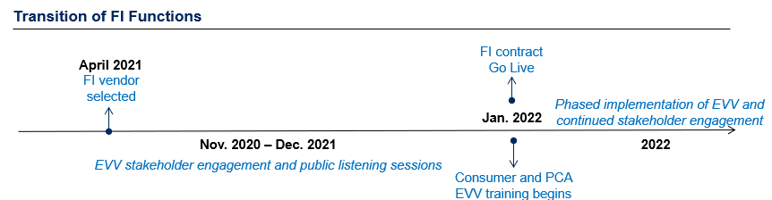

Slide 10: Agenda

EVV Policy Decisions

Slide 11: Electronic Visit Verification (EVV) Background

EVV is required by federal law for in-home personal care services.

MassHealth must implement EVV. Not implementing EVV will result in financial penalties for MassHealth from the federal government.

Once it is implemented, EVV will replace your timesheet.

The PCA will “check in” and “check out” at the beginning and end of their visit using EVV technology.

The consumer will have the ability to review and approve the EVV recorded time.

Consumers or PCAs exempt from using EVV (live-in caregivers and those with a potential safety risk) will have an alternate method of submitting time.

EVV will not impact how services are provided within the PCA program.

MassHealth will implement EVV gradually over calendar year 2022.

Many questions about how EVV will be implemented are still under consideration by MassHealth. As policy decisions are made, MassHealth will use these Public Listening Sessions to provide clarification.

NOTE: The California model, as originally proposed and implemented, is specifically identified by CMS as a non-compliant EVV system*. California is working to revise their approach to EVV implementation for its self-directed personal care programs.

Slide 12: EVV Implementation Feedback Strategy

Bi-monthly Public Listening Sessions

Started in December 2020

Available to all

Specific to EVV implementation in PCA and MFP Waiver programs.

Feedback used to inform development of EVV guidance and policy decisions

Bi-weekly PCA EVV Workgroup Meetings

Convened in April 2021

Consists of Consumers, PCAs, PCMs agencies, Union representatives and other stakeholders

Discusses specific EVV policy items, communication about EVV-related topics, opportunities for training, etc.

Impact bargaining with 1199SEIU

Initiated in February 2021

Conducted between the PCA Quality Home Care Workforce Council and 1199SEIU

Topics related to EVV implementation that impact PCAs

MassHealth is still making decisions about many topics related to EVV implementation.

Decisions will take into consideration input from the PCA EVV Stakeholder Workgroup and these Public Listening Sessions on key topics.

Slide 13: An Introduction to the EVV System

MassHealth is working with Tempus to configure an EVV system for the PCA Program.

The EVV system will be an application that is downloaded on a smartphone device.

A worker will “check-in” and “check-out” of each service appointment.

The EVV system will capture the data elements required by federal law:

Name of the worker

Name of the consumer

Name of the service (i.e., personal care)

Date of the service

Visit start and end time

Visit start and end location

A consumer, surrogate, or administrative proxy will log into the EVV system and approve or edit the time reported.

Once implemented, EVV will replace your existing timesheet.

Slide 14: Summary of Prior Public Listening Sessions

In December 2020, MassHealth began holding Bi-Monthly Public Listening Sessions to provide PCA Program stakeholders with updates on EVV implementation in Massachusetts.

In prior Public Listening Sessions, MassHealth has covered the following topics:

PCAs will check in and check out of visits using a mobile application;

Consumers, surrogates, or administrative proxies will review and approve time through the EVV web-portal

In bargaining with 1199SEIU, the state has proposed an exemption for live-in caregivers;

If a PCA forgets to check in or out of their visit, the Consumer will have the ability to enter the worker’s time manually in the web-portal;

Training will start in calendar year 2022 and include a variety of training methods.

MassHealth will offer an exemption from using EVV for anyone whose use of EVV presents a potential safety risk due to harassment, stalking, or domestic violence

For more information on these topics and what was presented by MassHealth, please search for the Bi-Monthly Public Listening Session decks on www.mass.gov and review deck content.

Slide 15: Privacy and EVV

The EVV system will ONLY verify location at the time of check-in and check-out, which is the minimum required by the federal government.

The PCA Quality Homecare Workforce Council and 1199SEIU have tentatively agreed that check-ins and check-outs outside of the Consumer’s home will be recorded by the EVV system as “Community,” not actual GPS coordinates. For services provided in the Consumer’s home, MassHealth intends to have the EVV system record “Home”.

MassHealth is aware that many stakeholders are concerned about their privacy as users of the EVV system.

CMS guidance requires that location is electronically captured at check-in and check-out for each service visit.

MassHealth will not have access to GPS coordinates. Only “Home” and “Community” markers, as described above.

Under no circumstance will the EVV system capture location data outside of the worker’s check-in and check-out times. This requirement will be written into the FI contract.

MassHealth will continue to balance federal rules against the valid needs and concerns of our program stakeholders.

Slide 16: Access to Personal Devices

PCAs and Consumers will be given one-time “vouchers”, which will be redeemable for an EVV-compatible device.

The PCA Quality Homecare Workforce Council and 1199SEIU have tentatively agreed to provide all PCAs who are unable or unwilling to use their own device with a one-time “voucher” or similar method for redeeming a device that can be used for EVV.

Please note that impact bargaining is still underway and terms are not yet final

MassHealth intends to implement a similar voucher program for Consumers who do not have access to the technology they need to review and approve time electronically.

MassHealth, in partnership with Tempus, is working to define how vouchers will be distributed.

Slide 17: Using EVV When Not Connected to Data/Internet

The EVV mobile application will NOT require that the PCA be connected to the internet or that the PCA have a data plan.

MassHealth recognizes that many Consumers live in areas in the state where cellphone coverage is limited and that some PCAs may not have access to data on their device.

PCAs who do not have access to a data plan, or who are providing services in an area where there is not data coverage, will be able to use EVV offline and upload the information from their visit by connecting to internet at a later time.

Consumers who do not have access to internet to access the web-portal and are unable to access internet in their community will have alternate methods of reviewing and approving time, as necessary.

Slide 18: Backup Methods for Submitting Time

MassHealth recognizes that there will be instances where a PCA does not or cannot use EVV.

These instances might include:

If there is an emergency when the PCA arrives at the Consumer’s home

The PCA forgets to check in or check out of a visit

The PCA’s phone dies during the visit

In these instances, the PCA or the Consumer will have the ability to enter time manually in the EVV system via the web-based portal.

Time that is manually entered is not EVV compliant, therefore policies will be established to minimize manual entries.

In unique circumstances, a PCA or Consumer will be able to use a paper timesheet to submit time.

Consumers who do not have access to internet to access the web-portal and are unable to access internet in their community will have alternate methods of reviewing and approving time, as necessary.

Slide 19: Other Frequently Asked Questions

Question: I am a PCA Consumer and I am planning to bring my PCA on vacation with me for two weeks. How will my PCA use EVV?

Answer: EVV will have no impact on how PCA services are delivered. The PCA would check in and out using the EVV system when they are providing hands-on assistance. The EVV system will record this as a “community” visit.

Question: I am a Consumer surrogate. Do I have to be in the home during the visit to approve time for a visit?

Answer: No, but surrogates will be expected to verify the time of the visit. Consumers, surrogates, and administrative proxies will have access to a web-based portal that will allow them to review, edit, and approve time at any time during the pay period.

Question: How will EVV work if there are multiple PCAs working for the same Consumer at the same time?

Answer: The EVV system will not limit the number of PCAs who can work for one Consumer at the same time. However, the system will not allow one PCA to work for multiple Consumers at the same time. Consumers will still be required to schedule their PCAs to work in accordance with their authorized PCA hours.

Slide 20: Other Questions that MassHealth is Working Through

MassHealth, with the support of the PCA EVV Workgroup, is still working through answers to many issues related to EVV implementation, including:

Working for multiple consumers. How will a PCA use EVV if they are doing work for multiple consumers at the same time (for example: grocery shopping)?

Using EVV during night hours. How will a PCA use EVV during night hours visits?

Compliance. What if a Consumer or PCA required to use EVV does not use it?

Slide 21: MassHealth wants to hear from you!

What do you consider to be the key impacts of EVV implementation and do you have suggestions for MassHealth to consider as we address those impacts?

Feedback Reminders

Feedback will be prioritized in the following order:

A MassHealth representative will read any comments submitted to the comments section.

A MassHealth representative will call on anyone using the “raise hand” feature.

Attendees will have the opportunity to unmute and provide feedback.

During Public Listening Sessions, MassHealth does not respond to feedback. MassHealth asks that you frame your feedback in the form of a comment as questions cannot be answered.

If we run out of time and do not get to your question, MassHealth accepts feedback at anytime at PCAfeedback@massmail.state.ma.us

Slide 22: Thank you!

Additional feedback can be submitted to MassHealth by emailing: PCAfeedback@massmail.state.ma.us

