# Bi-Monthly Electronic Visit Verification PCA Public Listening Session, Executive Office of Health and Human Services, September 2021

## Slide 2: Agenda

### Logistics

### Intent of Public Listening Sessions

### Program Updates

### EVV Policy Decisions

### Open Discussion

### Thank You

## Slide 3: Joining from a Mobile Device

### If you are joining this meeting from a mobile device, you have two options: Join by calling in or Join via the WebEx mobile application

### Listening session details, including call in information and the meeting password, can be found online at mass.gov by searching “Notice Bi-Monthly Public Listening Session” and opening the search result for September 2021.

### If you are having difficulty joining via the mobile application, please call in using the information provided in the communications sent for this listening session.

### If you call in, the deck we are reviewing will be posted on mass.gov and can be found by searching “September Bi-Monthly Public Listening Session”.

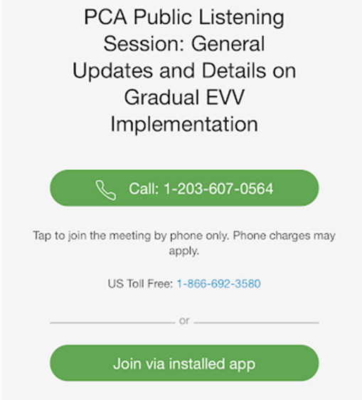

## Slide 4: Muting and Unmuting Your Line

### MassHealth requests that all attendees keep their phone muted if they are not talking to minimize background noise. MassHealth may mute your line if there is background noise.

### If you need to unmute your line, you can do so by following these instructions:

### If you are connected to audio on your computer: Click the Mute icon at the bottom of the screen.

### If you are connected to audio on your phone: Press *6 on your phone.

### You can also get MassHealth’s attention by “raising your hand” in the participant pane by clicking on the hand icon.

### If we run out of time and you are unable to share your feedback, written responses will be accepted at any time at [PCAfeedback@massmail.state.ma.us](mailto:PCAfeedback@massmail.state.ma.us)

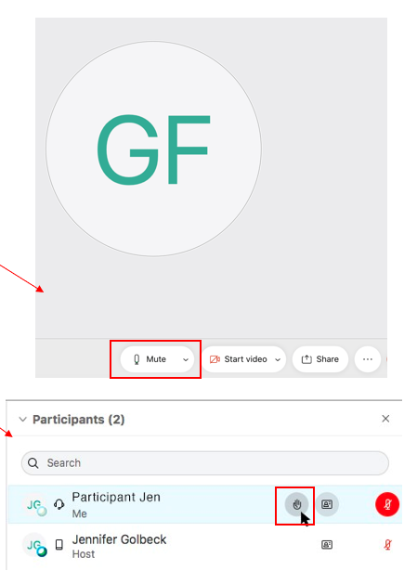

## Slide 5: Closed Captioning

### Closed captions are available during this session for those using their computer.

### To see the closed captions, you must open the “Multimedia Viewer” panel in the bottom right-hand side of your screen (see the image below).

### Step 1: Select the three vertical dots to the right of “Chat” to open additional panel options

### Step 2: When Closed Caption is highlighted in blue, the panel should be visible on your screen

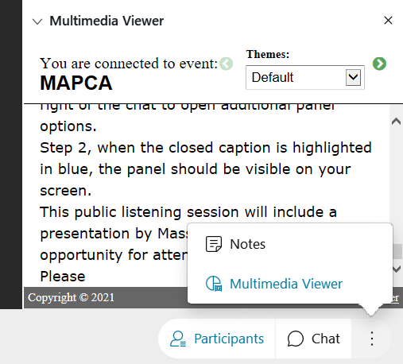

## Slide 6: Providing Input

### This Public Listening Session will include a presentation by MassHealth followed by an opportunity for attendees to provide input. Please hold all comments until the end of MassHealth’s presentation.

### Attendees can provide input by either typing their comment into the comment section of WebEx or by unmuting and verbally giving their comments.

### MassHealth asks that individuals providing comments indicate their role as a stakeholder. For example, identifying if you are a consumer, a PCA, a PCM employee, etc.

### Feedback will be prioritized in the following order:

#### A MassHealth representative will read any comments submitted to the comments section.

#### A MassHealth representative will call on anyone using the “raise hand” feature.

#### Attendees will have the opportunity to unmute and provide feedback.

### MassHealth anticipates that many individuals will want to provide feedback. We ask that you be as concise as possible to ensure that all attendees who want to provide input have time to do so.

### During Public Listening Sessions, MassHealth does not respond to feedback. MassHealth asks that when the time for comments comes, participants frame their feedback in the form of a comment as questions cannot be answered.

### If we run out of time and you are unable to share your feedback, written responses will be accepted at any time at [PCAfeedback@massmail.state.ma.us](mailto:PCAfeedback@massmail.state.ma.us)

## Slide 7: Agenda

### Intent of Public Listening Sessions

## Slide 8: Intent of Public Listening Sessions

### Public Listening Sessions are voluntary. PCAs are not required to attend.

### MassHealth is holding bi-monthly Public Listening Sessions specific to the implementation of Electronic Visit Verification (EVV) within consumer-directed programs.

### The intention of these Public Listening Sessions is to share updates about MassHealth policy decisions related to EVV implementation in the PCA and MFP Waiver programs and seek stakeholder feedback as it relates to key focus areas of the implementation.

### This Public Listening Session is not a training.

### Each session will include a presentation by MassHealth with updates related to EVV implementation within the PCA and MFP Waiver programs, followed by an opportunity for attendees to provide input.

### During Public Listening Sessions, MassHealth does not respond to feedback or answer questions. The purpose of this session is for MassHealth to share updates and for stakeholders to provide feedback that will help inform ongoing policy development.

### The deck being reviewed is available at mass.gov by searching “Bi-Monthly Public Listening Session”. The deck will also be available in Spanish, however, it is not yet posted.

## Slide 9: Agenda

### Program Updates

## Slide 10: Agency-Directed EVV Implementation Update

### For informational purposes only. This decision does not impact the consumer-directed PCA or MFP Waiver programs.

### The 21st Century Cures Act requires states to implement EVV for personal care and home health care services in both consumer-directed and agency-based services.

### For **agency-based services** *(i.e., not the PCA Program)*, MassHealth used an existing contract with Optum Government Solutions (Optum) to build the EVV system.

### Rather than continue EVV implementation work with Optum, EOHHS will be issuing an RFR to procure a different EVV system for agency-directed providers. Note: The existing LTSS TPA contract remains in place and Optum will continue with non-EVV functions.

### For **consumer-directed PCA and MFP Waiver services**, MassHealth required the Fiscal Intermediary to build the EVV system.

### Tempus, the Fiscal Intermediary responsible for EVV implementation for the consumer-directed PCA and MFP Waiver programs, will continue to move forward with EVV implementation as planned.

### EVV for the PCA and MFP Waiver programs is expected to be implemented gradually over calendar year 2022.

## Slide 11: EVV Implementation Timeline Update

### MassHealth is currently working with Tempus on finalizing the requirements that will be used to develop the EVV system for the PCA and MFP Waiver programs.

* Tempus will be providing initial EVV training to Personal Care Management Agencies (PCMs), Consumers, and PCAs.
* Training will be offered throughout EVV implementation and beyond. Trainings will include in-person, web-based, and e-learning options and be provided in multiple languages.
* MassHealth will implement EVV in phases, beginning with a Pilot in early 2022 and followed by small groups of Consumers and PCAs throughout calendar year 2022.

Tenative timeline for EVV implementation. EVV system development will be from September through December, EVV training will begin in December 2021 and continue being offered all the way throughout implementation, the EVV pilot will be held in March 2022, and the phased EVV implementation will begin in April 2022. All dates are tentative and subject to change.

## Slide 12: FI Transition Update

* Tempus communications have been sent to all transitioning consumers.
* Throughout the month of September, Tempus will be distributing forms to be completed by both Consumers and PCAs-it is extremely important that these forms are returned as quickly as possible to ensure a smooth transition and avoid any payroll disruptions.
* Physical spaces across the Commonwealth are being identified for walk in FI access.

## Slide 13: Agenda

### EVV Policy Decisions

## Slide 14: Electronic Visit Verification (EVV) Background

### EVV is required by federal law for in-home personal care services.

### MassHealth must implement EVV. Not implementing EVV will result in financial penalties for MassHealth from the federal government.

### Once it is implemented, EVV will replace your timesheet.

#### The PCA will “check in” and “check out” at the beginning and end of their visit using EVV technology.

#### The consumer will have the ability to review and approve the EVV recorded time.

#### Consumers or PCAs exempt from using EVV (live-in caregivers and those with a potential safety risk) will have an alternate method of submitting time.

### EVV will not impact how services are allowed to be provided within the PCA Program.

### MassHealth will implement EVV gradually over calendar year 2022.

### Many questions about how EVV will be implemented are still being considered. As policy decisions are made, updates and clarifications will be provided through these Public Listening Sessions.

## Slide 15: An Introduction to the EVV System

### MassHealth is working with Tempus to configure an EVV system for the PCA Program.

### The EVV system will be an application that is downloaded on a smartphone device.

### A worker will “check in” and “check out” of each service appointment.

### The EVV system will capture the data elements required by federal law:

#### Name of the worker

#### Name of the consumer

#### Name of the service (i.e., personal care)

#### Date of the service

#### Visit start and end time

#### Visit start and end location

### A consumer, surrogate, or administrative proxy will be able to log into the EVV system and approve or edit, if needed, the time reported.

### Once implemented, EVV will replace your existing timesheet.

## Slide 16: The EVV Web Portal

### In addition to the mobile application that PCAs will download on a mobile device, there will be a web portal that can be accessed by both Consumers and PCAs.

* The EVV system will have a web portal that can be accessed by both Consumers and PCAs.
* Consumers or their Surrogates/Administrative Proxies will be responsible for using the web portal to review and approve time that has been submitted by PCAs.
* Consumers will be able to use the web portal to access historical visit information.
* Consumers and PCAs will have the ability to add and edit time in the web portal that was not captured by the mobile application or captured incorrectly. The web portal can be used when:

#### There is an emergency when the PCA arrives at the Consumer’s home

#### The PCA forgets to check in or out of a visit

#### The PCA’s phone dies during a visit

* Note that time submitted manually in the web portal **is not** considered EVV compliant and therefore policies will be established to minimize manual entries.

## Slide 17: Access to Personal Devices

### PCAs and Consumers will be given one-time “vouchers”, which will be redeemable for an EVV-compatible device.

### The PCA Quality Homecare Workforce Council and 1199SEIU have tentatively agreed to provide all PCAs who are unable or unwilling to use their own device with a one-time “voucher” or similar method for redeeming a device that can be used for EVV.

* + *Please note that impact bargaining is still underway and terms are not yet final*

#### MassHealth intends to implement a similar voucher program for Consumers who do not have access to the technology they need to review and approve time electronically.

* *MassHealth, in partnership with Tempus, is working to define how vouchers will be distributed.*

## Slide 18: Phased Implementation Strategy

### EVV will be implemented in phases throughout calendar year 2022.

### EVV is a federal requirement. All non-exempt Consumers and PCAs participating in the PCA Program will need to use EVV.

### The first phase of EVV implementation will be with Consumers who are not authorized for night hours. This is subject to finalizing bargaining with 1199SEIU (the PCA Union).

#### Within each phase, MassHealth intends to implement with small groups to ensure there are the resources necessary available to support all users starting to use the system.

#### For example, MassHealth may roll EVV out to Consumers alphabetically to ensure geographic spread allowing for easier management of the transition by the FI and PCMs.

* All users will have access to training before they are expected to use EVV.

## Slide 19: Privacy and EVV

### The EVV system will only verify location at check-in and check-out, which is the minimum required by the federal government.

* The PCA Quality Homecare Workforce Council and 1199SEIU have tentatively agreed that check-ins and check-outs outside of the Consumer’s home will be recorded by the EVV system as “Community,” not actual GPS coordinates. For services provided in the Consumer’s home, MassHealth intends to have the EVV system record “Home”.
* MassHealth is aware that many stakeholders are concerned about their privacy as users of the EVV system.
* CMS guidance requires that location is electronically captured at check-in and check-out for each service visit.
* MassHealth will not have access to GPS coordinates. Only “Home” and “Community” markers, as described above.
* Under **no** circumstance will the EVV system capture location data outside of the worker’s check-in and check-out times. This requirement will be written into the FI contract.
* MassHealth will continue to balance federal rules against the valid needs and concerns of our program stakeholders.

## Slide 20: Allowable Exemptions

### Some Consumers and PCAs will have exemptions from using EVV.

* MassHealth anticipates that there will be reasons to exempt some Consumers and PCAs from using EVV. Those anticipated exemptions will be:

#### Live-in caregivers

#### Consumers or PCAs who have a concern of a safety risk related to using location services due to stalking, harassment, domestic violence, or other factors.

* MassHealth is still determining how exemptions will be operationalized. MassHealth is working to determine:

#### How live-in caregiver will be defined

#### How exemptions will be verified

#### How stakeholders who are exempt from using EVV will submit time

## Slide 21: Using EVV When Not Connected to Data/Internet

* The EVV mobile application will not require that the PCA be connected to the internet or that the PCA have a data plan.
* MassHealth recognizes that many Consumers live in areas in the state where cellphone coverage is limited and that some PCAs may not have access to data on their device.
* PCAs who do not have access to a data plan, or who are providing services in an area where there is not data coverage, will be able to use EVV offline and upload the information from their visit by connecting to internet at a later time.
* Consumers who do not have access to internet to access the web-portal and are unable to access internet in their community will have alternate methods of reviewing and approving time, as necessary.

## Slide 22: MassHealth Wants to Hear From You!

### What do you consider to be the key impacts of EVV implementation and do you have suggestions for MassHealth to consider as we address those impacts?

#### Feedback Reminders

#### Feedback will be prioritized in the following order:

#### A MassHealth representative will read any comments submitted to the comments section.

#### A MassHealth representative will call on anyone using the “raise hand” feature.

#### Attendees will have the opportunity to unmute and provide feedback.

#### During Public Listening Sessions, MassHealth does not respond to feedback. MassHealth asks that you frame your feedback in the form of a comment as questions cannot be answered.

#### If we run out of time and do not get to your question, MassHealth accepts feedback at anytime at PCAfeedback@massmail.state.ma.us

## Slide 23: Thank you!

### Additional feedback can be submitted to MassHealth by emailing: **PCAfeedback@massmail.state.ma.us**