Slide 1
Electronic Visit Verification Phase II Implementation for SCO/One Care Contracted Providers
Executive Office of Health and Human Services
July 23, 2021

Slide 2
Meeting Agenda
  - Today we will discuss
  - High Level Overview of EVV
  - Options for EVV Compliance
  - Incremental Steps to Implementing EVV
  - Update EVV Website
  - EVV Communication
  - Q & A
Please write your questions in the chat box. We will go through any questions in the chat box first during the Q & A period and then open it up for additional questions.

Slide 3
High-Level Overview of EVV
- Electronic Visit Verification (EVV) refers to the technology used to capture timesheet and location information of a worker providing in-home services
- EVV systems can vary but, instead of a timesheet, the worker uses the EVV system to check in and check out.
- The most common types of EVV systems are:
  - Mobile (using a personal device, usually a phone)
  - Telephony (using a landline)
  - Fixed device (acquiring a code from a device that is “fixed” in the consumer’s home)

Slide 4
High-Level Overview of EVV
- EVV is a federal requirement based on the 21st Century Cures Act (Cures Act)
- Massachusetts is federally required to implement EVV for personal care services provided to Medicaid recipients.
    - Since personal care is often provided along with homemaking and companion services, EOHHS decided to implement EVV for those services too.
- Because EVV requirements extend to many providers, EOHHS decided to implement in phases
- This phase (Phase II) impacts providers that contract directly with SCO and/or One Care Plans to provide personal care, homemaking and companion services
- Many providers in Phase II are required to implement EVV for Phase I (ASAP-contracted providers) Requirements in Phase II will be similar to Phase I

Slide 5
High-Level Overview of EVV
- The Cures Act requires EVV for all Medicaid funded, in-home personal care services by January 1, 2020 and for all home health services by January 1, 2023
- The Commonwealth of Massachusetts got a Good Faith Effort extension that extended our personal care implementation deadline to January 1, 2021
- CMS will issue financial penalties to states that miss the federal deadline
- Because of COVID-related delays, the Commonwealth did not meet the January 2021 deadline
  - Providers will not be held responsible for penalties associated with COVID-related delay
Slide 6
Options for EVV Compliance
EOHHS offers providers that directly contract with SCO and One Care Plans two options for achieving EVV compliance:
Alternate EVV System
Any system purchased by a provider that meets Cures Act and EOHHS requirements
- Providers can use a variety of technologies to meet EVV requirements
- Systems are generally customized for the provider’s specific use
- Cost of system and devices, if applicable, is borne by the provider
- Providers upload a standard file to EOHHS’ Data Aggregator (a data warehouse of EVV visit data) on at least a monthly basis

MyTimesheet
State-sponsored EVV system
- Mobile-based system offered by Optum and configured for the State’s use
- Integrated with Plans’ systems. Consumer, provider, and service plan data will be uploaded nightly to simplify creation of appointments
- Use of MyTimesheet system is free of charge but does not include the cost of devices
- EVV data will be automatically uploaded to EOHHS’ Data Aggregator

Slide 7
Incremental Steps to Implementing EVV
- If you have not yet implemented EVV, EOHHS recommends completing the following steps
- These steps are relevant if you select an Alt-EVV system or the MyTimesheet system

A visual representation of the Incremental Steps to Implementing EVV.
Image summary:
- Step 1
  - Select your method for EVV Compliance
- Step 2
  - Complete internal EVV implementation planning
- Step 3
  - Attend EVV System Trainings
- Step 4
  - Begin EVV Implementation
Slide 8
Incremental Steps to Implementing EVV
A visual representation of the Incremental Steps to Implementing EVV.
Image summary:
Step 1. Select your method for EVV Compliance
- Identify the Key People in your Organization for EVV Decision-Making
- Review the EOHHS Cost Considerations Document
- Schedule Demonstrations with Alt-EVV Vendor
- Attend State-Sponsored EVV Meetings
- Attend the MyTimesheet Demonstration
Slide 9
Incremental Steps to Implementing EVV

A visual representation of the Incremental Steps to Implementing EVV.
Image summary:
Step 2. Complete internal EVV Implementation Planning
- Identify Key EVV Users
  - Primary trainer(s)
  - Primary “tech” support
  - EVV “HR”
- Identify EVV Users by User Group
  - Workers
  - Schedulers
  - Other Staff
- Execute Alt-EVV Contract and Install System*
  - For Alt-EVV Providers only
- Develop Plans for Devices/Check-In Process
  - Update/create policy & procedures
  - Communicate policy to staff
Slide 10
Incremental Steps to Implementing EVV
A visual representation of the Incremental Steps to Implementing EVV.
Image summary:
Step 3. Attend EVV System Training
- Consider Who Needs to Attend Training
- Identify you Goals for Training Prior to Attending
- Actively Participate in Trainings
- Complete Post-Training “Tests”
- If Necessary, Retake Training

Slide 11
Incremental Steps to Implementing EVV
A visual representation of the Incremental Steps to Implementing EVV.
Image summary:
Step 4. Initiate System Set-Up and Implementation
- Complete System Set-up Tasks
  - Add users
  - Add other organization data (i.e. worker lists)
  - Have workers download app
- Update Policies and Procedures
  - Identify and update those policies and procedures impacted by EVV implementation
  - Distribute to staff
- Develop Internal Training Plan
  - Identify users needing training
  - Determine order of training by user group
  - Set schedule for initial training
  - Plan and schedule for follow-up training

Slide 12
Updated EVV Website
- EOHHS updated its website for information on Electronic Visit Verification
- The website has a new address: https://www.mass.gov/topics/electronic-visit-verification-evv
- If you select the old address, it will redirect you to the new website
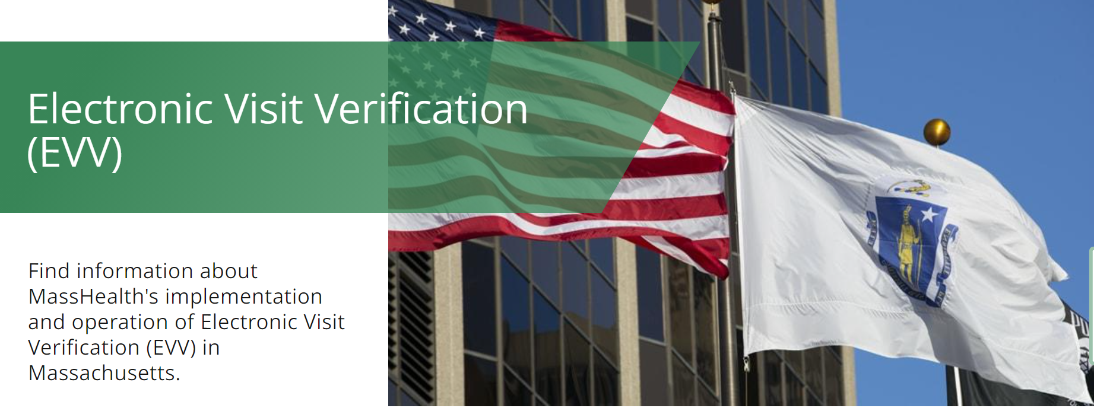

A visual representation of Updated EVV Website
Image summary:
- Electronic Visit Verification
- Find information about MassHealth implementation and operation of Electronic Visit Verification (EVV) in Massachusetts.

Slide 13
Updated EVV Website
Users are directed to pages specific to the programs and providers impacted by EVV
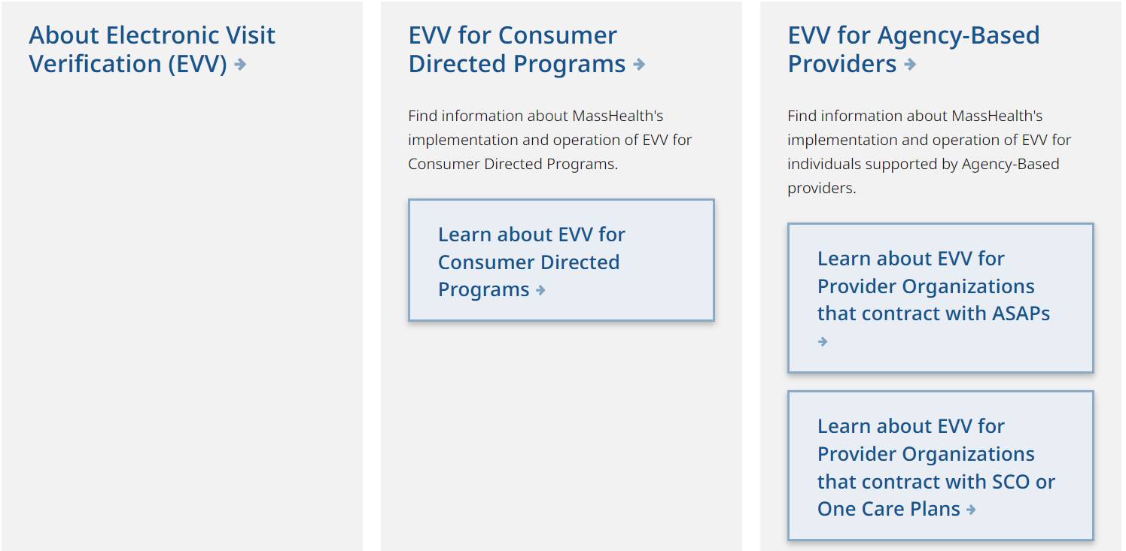
A visual representation of Updated EVV Website
Image summary:
- About Electronic Visit Verification (EVV)
- EVV for Consumer Directed Programs
- Find information about MassHealth’s implementation and operation of EVV for Consumer Directed Programs.
- Learn about EVV for Consumer Directed Programs
- EVV for Agency-Based Providers
- Find information about MassHealth’s implementation and operation of EVV for individuals supported by Agency-Based providers
- Learn about EVV for Provider Organizations that contract with ASAPs
- Learn about EVV for Provider Organizations that contract with SCO or One Care Plans

Slide 14
Updated EVV Website
Program-specific information sorted into functional categories
A visual representation of Updated EVV Website
Image summary:
Learn about EVV for Provider Organizations that contract with ASAPs
- Find information about MassHealth’s implementation and operation of Electronic Visit Verification (EVV) for individuals supported by ASAP-contracted Providers in Massachusetts
- Table of Contents
  - General Information
  - EVV Implementation Plan for Provider Organizations that contract with ASAPs
    - Designated area that illustrates the implementation timeline
  - Options for EVV Compliance
    - ASAP provider-specific instructions for Data Aggregator and MyTimesheet users
  - Stakeholder Engagement
    - ASAP provider-specific documentation
  - Contact

Slide 15
Update EVV Website
- Collated resources in the Options for EVV Compliance section to aid providers in EVV implementation. Includes the following documentation:
    - Cost Considerations Document
    - Steps to Using MyTimesheet
    - Steps to Using the Data Aggregator
    - Data Aggregator and MyTimesheet Documentation
- Data Aggregator User Guide
- Data Aggregator API Guide
    - Updated Frequently Asked Questions

Slide 16
Website available in many languages
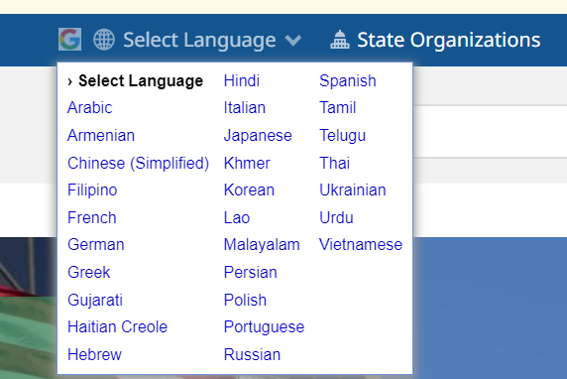

A visual representation of Updated EVV Website
Image summary:
Select Language
List of available languages

Link to EVV email provided on all pages specific to each provider implementation group

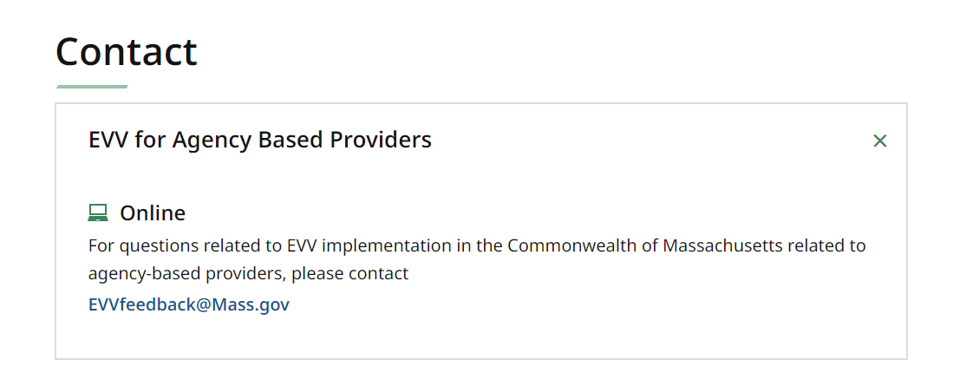
A visual representation of Updated EVV Website
Image summary:
Contact
- EVV for Agency-Based Providers
- Online
  - For questions related to EVV Implementation in the Commonwealth of Massachusetts related to agency-based providers, please contact EVVfeedback@mass.gov
Slide 17
EVV Communication
- EOHHS has developed multiple channels for communication
- Mass.gov website. EOHHS posts provider resources, EVV documents and general EVV information on our EVV website: https://www.mass.gov/topics/electronic-visit-verification-evv. This website has recently been updated to make information about specific implementations easier to find.
- Email communication. EOHHS has an email distribution group for SCO and One Care C-contracted providers that we use to provide information about EVV implementation. If you would like to be added to this distribution list, please email us at evvfeedback@state.ma.us.
- Dedicated EVV email. The evvfeedback@state.ma.us email account is monitored by the EOHHS EVV team. Feel free to contact us if you have a question about EVV implementation.
- Bi-weekly WebEx sessions. We will hold WebEx sessions every other Friday from 1:00pm to 2:00pm. We will present on an EVV-related topic and answer questions from attendees.
- EOHHS will be communicating with providers on EVV requirements, not EVV software vendors. Since the federal requirements impact you, we want you to understand how we will work with you to meet them. Our intent is to provide documentation that you can provide to your vendors that is self-explanatory and user friendly. We welcome feedback on areas where we can improve our documentation to meet that standard.

