Instructions:

You can use this Template Bid Request to solicit engineering services for the initial phase of a culvert replacement project, including field data collection, site survey, and replacement structure recommendations. Replace red text below with relevant project information for your project.

Use the graphic below to complete Table 1: Project Information, Existing Structure Type.

Graphic: North Atlantic Aquatic Connectivity Collaborative’s (NAACC), May 2016, “Structure Shapes and Dimensions Field Data Form”, Amherst, MA. The full field data form is available at http://streamcontinuity.org/naacc/assessments/naacc-documents

Bid Request
Enter Project Name
Enter Town Name, MA

TO: Enter Bidder’s Name

FROM: Enter Town Contact

RE: Culvert Replacement Field Data Collection Request for Proposals

DATE: Enter Date

The Enter Department and Town is requesting bids for technical services as described below under section III, Project Specifications for Enter Project Name in Enter Town Name, MA.

This Bid Request presents a general proposed sequence of work with an expectation that responding firms will express their own project approaches. Bidders will be evaluated based upon their demonstrated experience with scientific river assessments and data collection and engineering culvert replacements that meet the MA River and Stream Crossing Standards, project examples, technical and management approach to this project, timeline for completed work, and cost effectiveness.

Enter Town Name anticipates execution of a contract in Enter Month of Enter Year for services through Enter Contract End Date.

- PROJECT LOCATION

Table 1: Project Information
Site # | Location | Existing Structure Type ^ | GPS Coordinate | Desired technical service
1 | Enter Stream Name, Road Name, Town Name | Enter Crossing Structure Type | Lat: XX.XXXX  Long: -XX.XXXX | Field data collection for culvert replacement
^ For a list of structure crossing types, see NAACC’s Field Data Form above. Include the structure type (ex: round culvert) and material (ex: concrete).

Site #1
Describe general location of the project including the town, road and stream name. Describe the watershed, (forested/developed, steep/flat, Area (acres)). Provide other identifying information useful for bidders to locate the location of the project and understand the location.

Provide a photo and locus map of the site. SEE EXAMPLE BELOW
Locus Map 1- Site #1 on Clark Road east of Chickering Road.

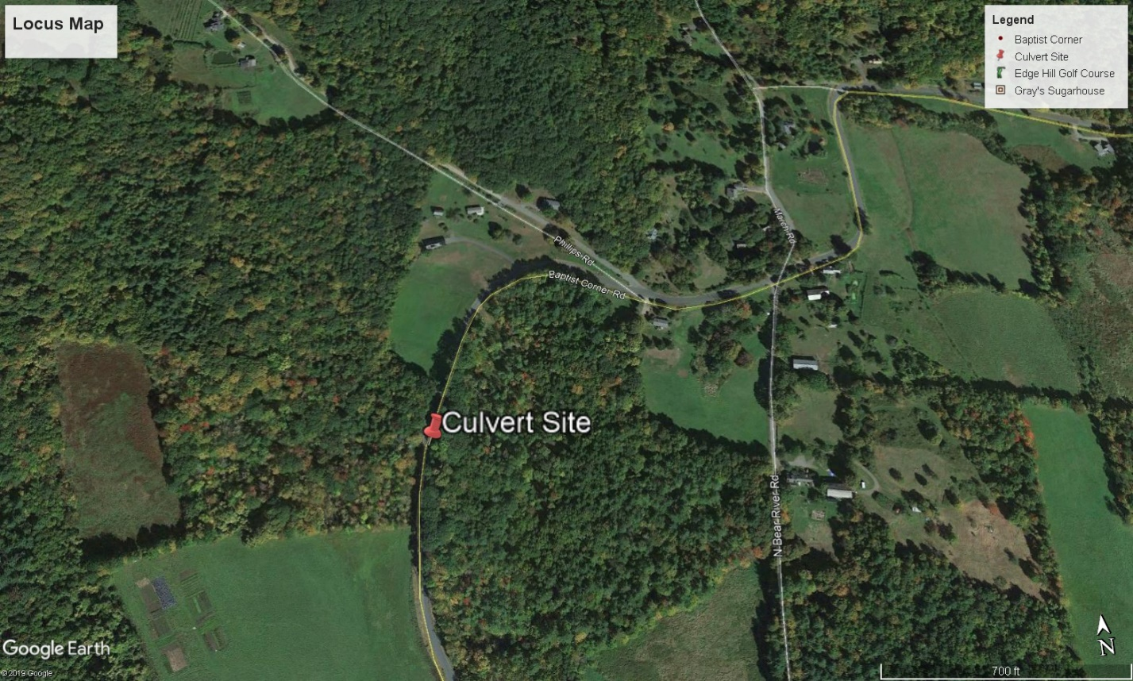
Locus Map - Culvert site on Baptist corner Road southwest of Phillips Road.

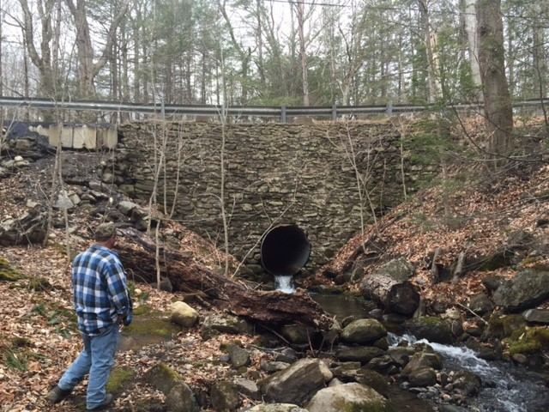
Culvert site looking west at the outlet.

- PROJECT PURPOSE AND BACKGROUND

Enter Project Goal, Road type, General description of what you are hoping to achieve. Provide any history to the site, known site conditions and site constraints. Explain your expectations of the project and the consultant. If necessary, outline deadlines and milestones for the project.

PROJECT SPECIFICATIONS

Scope of Services
Below is a general outline of tasks thought to be required at this time to support the above referenced goal. Enter Town Name welcomes variations on this approach from prospective Bidders. Enter Town Name reserves the right to not execute certain tasks. Bidders are encouraged to submit succinct proposals; Enter Town Name will be an active technical partner with the selected Bidder. The Bidders shall expect full access to the site and adjacent properties necessary to perform the below tasks. Deliverables should be clearly identified under each task by Bidders. The proposed scope must, at minimum, include the following tasks for each site:

Task 1) Project Management
Throughout the course of this project, the selected bidder will coordinate tasks, schedule work, maintain project records and be available for project inquiries through the duration of the contract by phone or e-mail. If specific meetings are envisioned as part of work flow, bidders should propose the location, number, and purpose.

Task 1) Deliverables
- E-mails, Conference Calls, Meetings and Site Visits (as applicable)

Task 2) Site reconnaissance and resource delineation
- Perform a wetland resource area delineation of the project area within the vicinity of the culvert (USACE Determination forms and associated materials required).
- Perform a riverbed substrate analysis, i.e. pebble-count, to understand the existing riverbed substrate and provide data to calculate the design stream bed material.
- Identify the type and integrity of upstream and downstream streambed features expected to control the streambed elevation (grade controls) through the crossing when the existing structure is replaced. These should be located on a field sketch for future survey and should generally extend a minimum distance of 20-30 times the average bankfull width of the stream both upstream and downstream of the crossing.
- Identify and flag appropriate reference reaches (1-2), outside of the influence of the culvert hydraulics, with similar slope to the road-stream crossing location. This is normally several hundred feet away from the existing crossing location. For additional information on identifying reference reaches, see Gubernick et al (2008).
- Identify and flag a minimum of 3 bankfull width measurement locations and representative cross-sections both upstream and downstream of the structure (6 total) so these locations can be surveyed during Task 4. If possible, these cross section measurements should be located within the reference reach(es) identified in Task 2.D.
- Identify and flag any additional representative cross sections (including extending through the floodplain where applicable) that will be needed for modeling as part of the hydraulic analysis (Task 5.B.).
- Identify key site features and existing infrastructure that may act as a constraint to replacing the crossing, such as utilities. Describe and photograph significant features.

Task 2) Deliverable:
- USACE Determination forms
- Copies of field notes
- Photos detailing the crossing site, stream, stream features, and reference reach.
- All data in native formats

Task 3) Geotechnical Evaluation
- Perform a subsurface investigation and soils analysis, including at least 2 borings adjacent to the culvert within the limits of the roadway. Borings should be located in the approximate location of the proposed road-stream crossing.
- Provide a geotechnical analysis to illustrate the material gradations and engineering properties such as bearing capacity.

Task 3) Deliverable:
- A detailed analysis regarding the subsurface findings including engineering properties of the subsurface material included in a Technical Memo.
- Boring logs and notes.

Task 4) Survey the road-stream crossing
This task shall occur in consultation and coordination with water resource engineer or scientist who specializes in river form and processes.
- Perform a topographic survey and include other relevant features; including, but not limited to resource areas, adjacent areas for the potential use of stormwater features, headwall/wingwall locations and elevations, centerline elevation of the road, site topography at least 50 feet from the edge of the road, key site features that may act as constraints to replacing the crossing, and geotechnical boring locations.
- Survey longitudinal profile of the river upstream and downstream of the crossing (a minimum distance of 20-30 times the average bankfull width of the stream in each direction). This profile should include, but not be limited to streambed features (steps, pools, riffles, glides), grade control locations and elevations, culvert invert elevations, top of culvert elevation, locations of bankfull width measurements, representative cross-sections above and below each culvert, and large wood deposits.
- Survey riverine cross sections flagged in Tasks 2.E. and 2.F.
- Prepare an existing conditions topographic plan including reference reach location and plot the streambed longitudinal profile, cross sections and key grade control features for each crossing as well as approximate property lines and roadway rights of way. The profile plot should include the full reach (500 to 2,000 feet) and a zoom of the structure (50 to 200 feet).

Task 4) Deliverable:
- Survey data and full size existing conditions plans, including a plotted and labeled longitudinal profile and cross-sections in CAD and pdf format.

Task 5) Hydrologic / Hydraulic Studies:
- Conduct a hydrologic study of the project site, using appropriate methods. Evaluate and select a minimum of two applicable hydrologic models to develop flow estimations at the crossing location. Identify typical low flows, the bankfull discharge, 5-year, 10-year, 25-year, 50-year and 100-year discharges, or other flows essential to the engineering and design process.
- Conduct a hydraulic analysis to predict water depths, velocities, and water surface profiles for existing and proposed conditions. Identify any existing scour and erosion concerns adjacent to the existing culvert.

Task 5) Deliverable:
- A detailed summary of the hydrologic and hydraulic studies in the Technical Memo.
- Input and output files for the hydrology and hydraulic models in native format.

Task 6) Recommended Replacement Structure Type & Technical Memo
- Prepare Technical Memo with a recommended replacement structure type for the stream crossing site. The Technical Memo shall include information from Tasks 2-5 and the following information:
  - Summary of results from previous tasks.
  - A detailed evaluation of the structure types considered and the recommended structure including cost estimates for each structure considered. Considerations may include (but are not limited to): site constraints, ease of construction, structure lifespan, potential for scour, stream stability and risk of stream channel adjustment, benefits to stream habitat and ability to meet the Massachusetts Stream Crossing Standards, storm flow conveyance, potential to affect adjacent property or infrastructure, and design and construction costs for replacement.
  - A description of the required additional engineering studies and phases that will be needed to complete the engineering design.
  - Outline of permits and approvals needed prior to construction and any recommendations for the design and/or the permit approval processes.

Task 6) Deliverable:
- A Technical Memo (draft and final) including information described above for each stream crossing in MS Office format and 3 color paper copies with full size site plans. Draft memo will be reviewed by municipal staff and potential project partners or funders.

IV. BID

Please provide a bid including a Scope of Services to meet the project purpose, description and requirements as outlined above. Include municipal procurement language.

The bid must include the following:

- Project scope including deliverables for each task
- Specific budget, broken down by task, personnel, etc.
- Project schedule by task and week
- List of personnel and their rate category who will specifically be working on this project
- Project examples of experience with culvert replacement projects that meet MA River and Stream Crossing Standards.

Note that Enter Town Name reserves the right to reject any and all bids, including specific tasks and solicit additional proposals from other vendors to ensure the best value is obtained for the services requested. The decision to request additional proposals will be made after evaluating the submitted proposals for overall value, including:

- Demonstrated understanding of, and proper approach to, the scope of work;
- Demonstrated experience with scientific river assessments and data collection;
- Demonstrated experience engineering culvert replacements that meet the MA River and Stream Crossing Standards;
- Appropriate allocation of qualified staff and level of effort to scope tasks;
- Timeline for completed work and;
- Competitive total cost to complete the scope of work.

Duration of Contract:

We anticipate contract beginning Enter Date. Initial contracting is expected to be directly with Enter Town Name, with associated work completed by Enter contract end date. Enter Town Name reserves the right to re-negotiate the Scope of Work related to any tasks under any subsequent contract.

Q/A
All questions related to the bid must be submitted in writing by 5 PM, Enter Date to Enter Email Address. Enter Town Name will email responses to questions to all bidders by 5 PM, Enter Date.

Submissions:

Deadline: Enter Proposal Deadline.

Provide information about how to and where to submit proposals. Provide them with any electronic links they may need. Remind them of any attachments or contracting documents they need to provide.

Gubernick, Robert, Danniel Cenderelli, Kozmo Bates, David Johanson, and Scott Jackson. 2008. “Stream Simulation : An Ecological Approach to Providing Passage for Aquatic Organisms at Road-Stream Crossings.” San Dimas, CA. https://www.fs.fed.us/eng/pubs/pdf/StreamSimulation/hi_res/%20FullDoc.pdf.

