**Care Group Public Notice Posting**

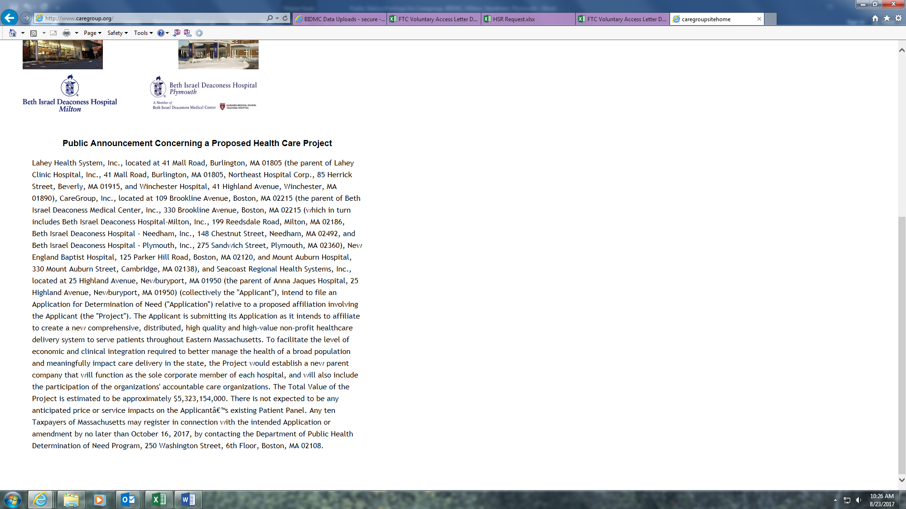**BIDMC Public Notice Posting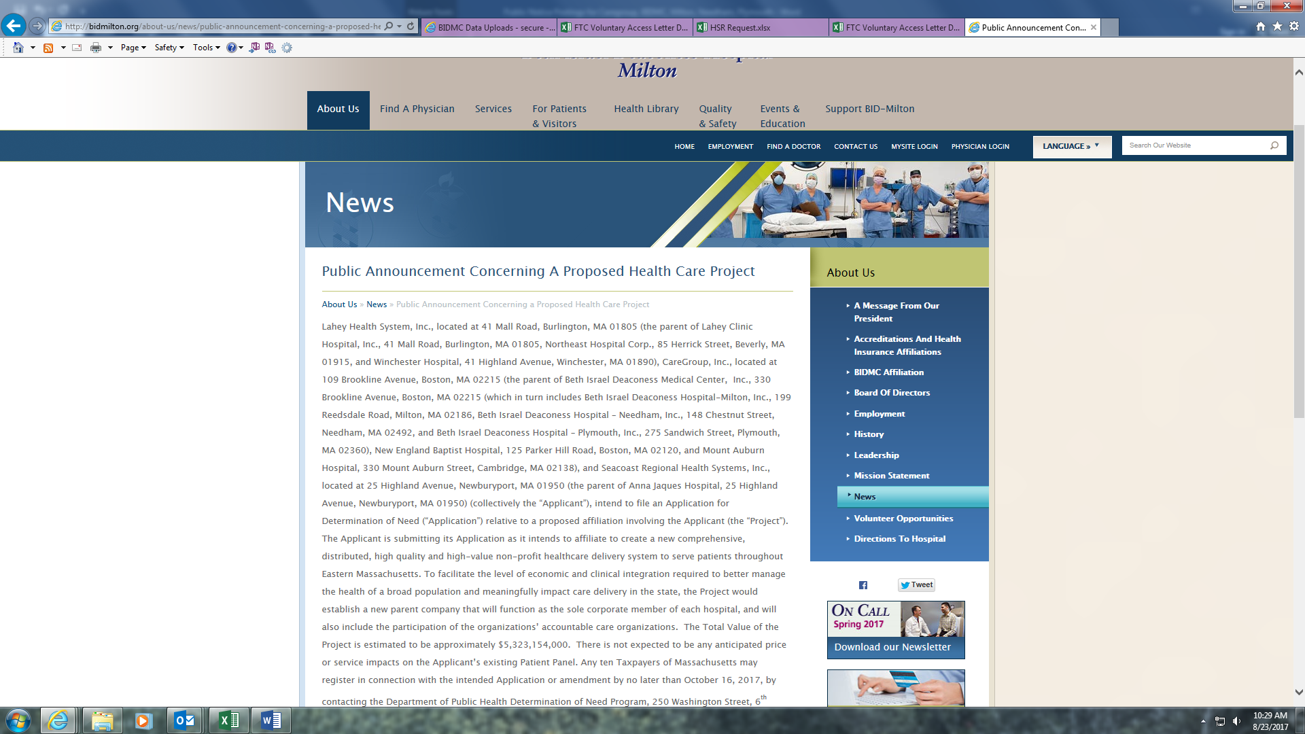BID-Milton Public Notice Posting** 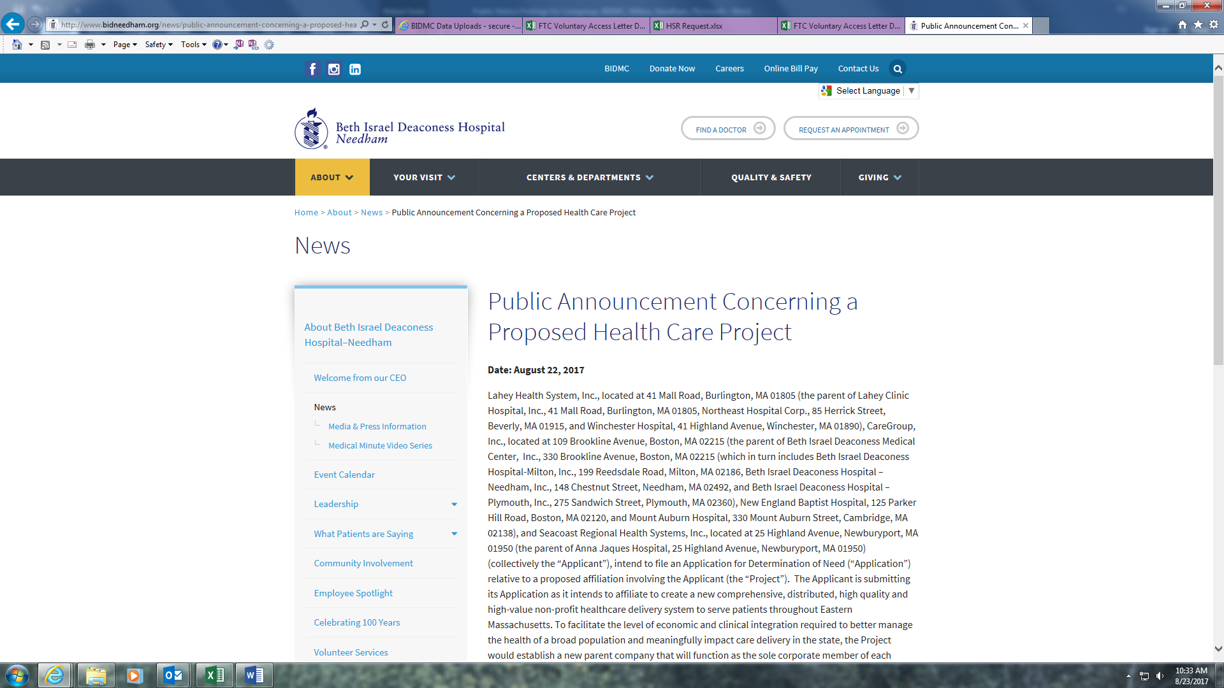

**BID-Needham Public Notice Posting** 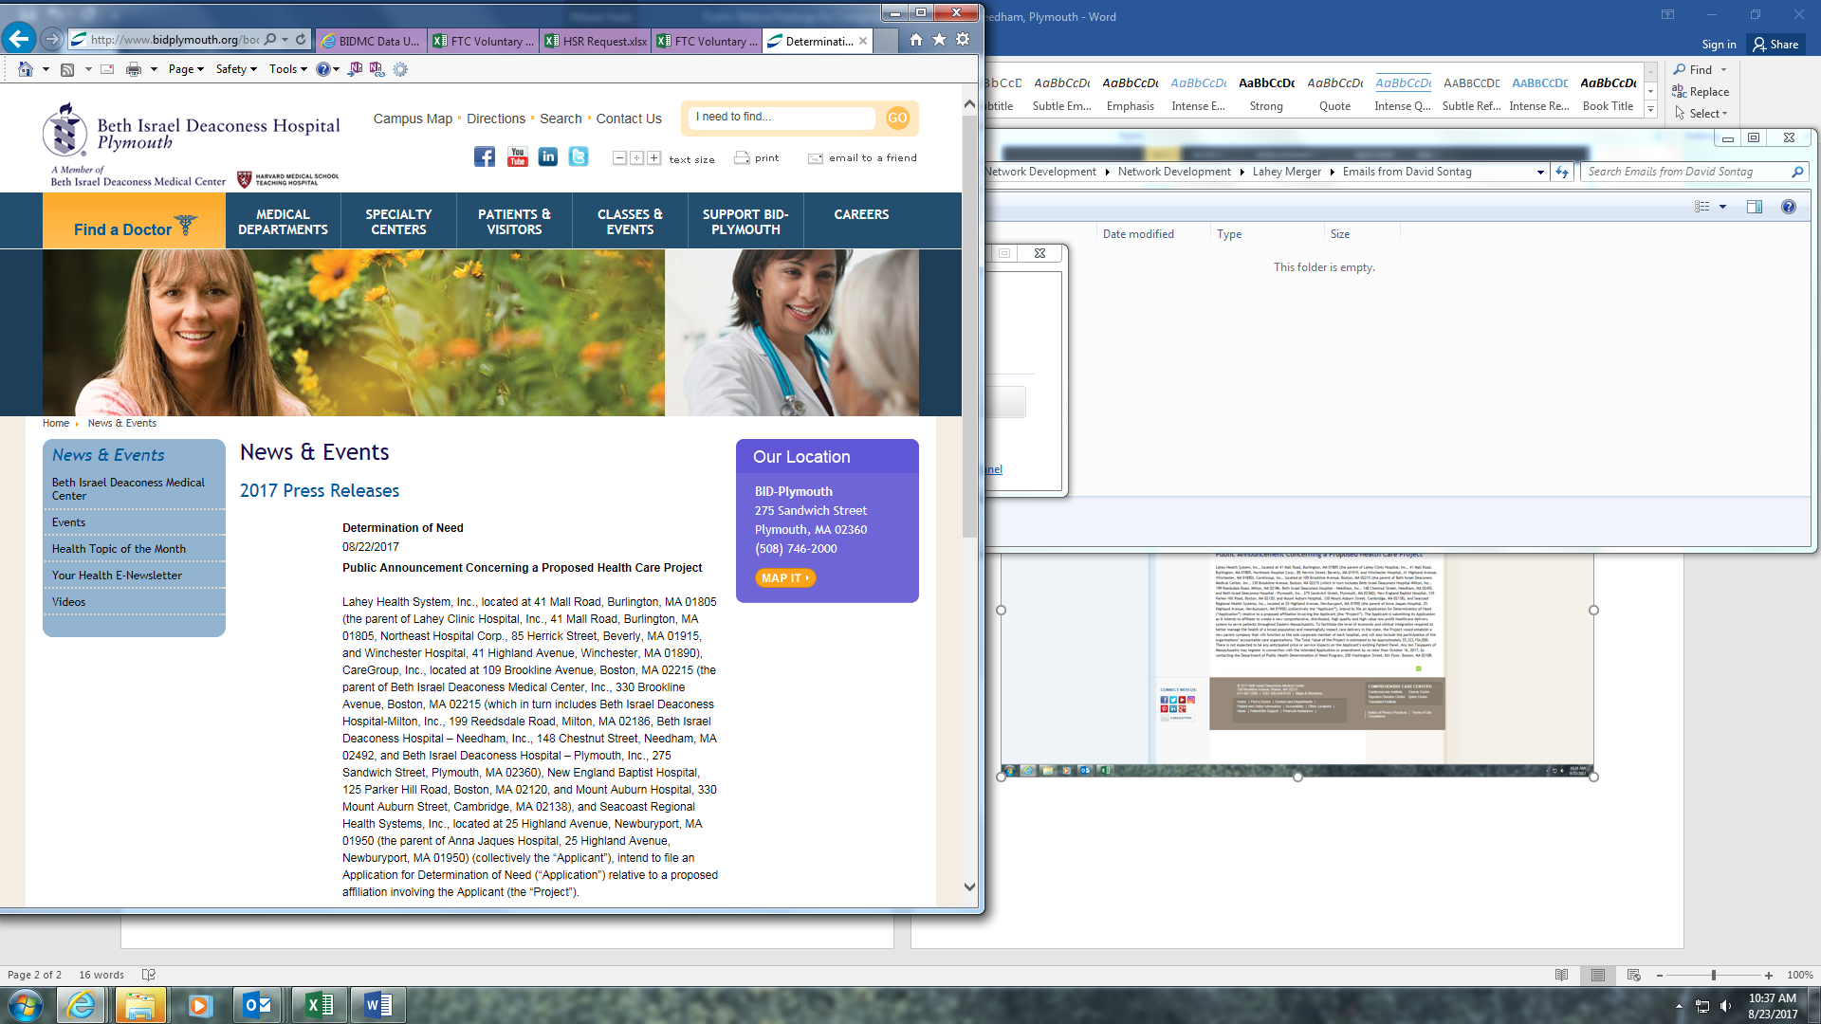

**BID-Plymouth Public Notice Posting**