INDOOR AIR QUALITY ASSESSMENT

Bigelow Public Library
54 Walnut Street
Clinton, MA

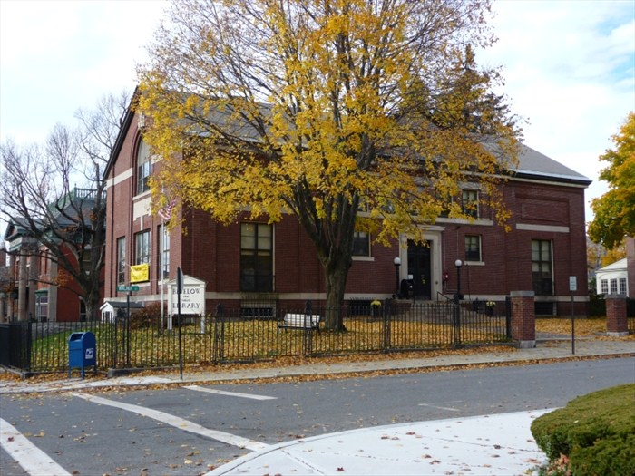

Prepared by:
The Massachusetts Department of Public Health
Bureau of Environmental Health
Indoor Air Quality Program
December 2014

Background/Introduction
At the request of Marie Letarte Mueller, Library Director, the Massachusetts Department of Public Health (MDPH), Bureau of Environmental Health (BEH) conducted an indoor air quality (IAQ) assessment at the Bigelow Public Library (BPL) located at 54 Walnut Street, Clinton, Massachusetts. On July 3, 2014, a visit was made to the BPL by Michael Feeney, Director of BEH’s IAQ Program to investigate mold/water damage concerns and conduct general IAQ testing. Mr. Feeney returned to the building on July 11, 2014 for further evaluations.
The BPL was constructed in 1902 as a two-story, brick building. The addition of an elevator shaft and renovation of the restrooms in the lower level/basement occurred in the early 2000’s (Picture 1). Windows are openable throughout the building.

Methods
Air tests for carbon monoxide, carbon dioxide, temperature and relative humidity were conducted with the TSI, Q-Trak, IAQ Monitor, Model 7565. Air tests for airborne particle matter with a diameter less than 2.5 micrometers were taken with the TSI, DUSTTRAK™ Aerosol Monitor, Model 8520. BEH/IAQ staff also performed visual inspection of building materials for water damage and/or microbial growth. Test results are listed in Table 1.

Results
The BPL has approximately 6 employees with up to several hundred visitors on a daily basis. The tests were taken under normal operating conditions. Test results appear in Table 1.

Discussion

Ventilation
It can be seen from Table 1 that carbon dioxide levels were below 800 parts per million (ppm) in all areas surveyed indicating adequate air exchange on the day of the assessment. It is important to note that the BPL does not have mechanical means to introduce outside air/exhaust. The building was originally designed to use a natural/gravity feed ventilation system to provide heated fresh air (Picture 2); however, this system appears to have been abandoned for some time. The sole source of fresh air in the building is openable windows. Restrooms in the lowest level of the building have mechanical exhaust ventilation.
Minimum design ventilation rates are mandated by the Massachusetts State Building Code (MSBC). Until 2011, the minimum ventilation rate in Massachusetts was higher for both occupied office spaces and general classrooms, with similar requirements for other occupied spaces (BOCA, 1993). The current version of the MSBC, promulgated in 2011 by the State Board of Building Regulations and Standards (SBBRS), adopted the 2009 International Mechanical Code (IMC) to set minimum ventilation rates. Please note that the MSBC is a minimum standard that is not health-based. At lower rates of cubic feet per minute (cfm) per occupant of fresh air, carbon dioxide levels would be expected to rise significantly. A ventilation rate of 20 cfm per occupant of fresh air provides optimal air exchange resulting in carbon dioxide levels at or below 800 ppm in the indoor environment in each area measured. MDPH recommends that carbon dioxide levels be maintained at 800 ppm or below. This is because most environmental and occupational health scientists involved with research on IAQ and health effects have documented significant increases in indoor air quality complaints and/or health effects when carbon dioxide levels rise above the MDPH guidelines of 800 ppm for schools, office buildings and other occupied spaces (Sundell et al., 2011). The ventilation must be on at all times that the room is occupied. Providing adequate fresh air ventilation with open windows and maintaining the temperature in the comfort range during the cold weather season is impractical. Mechanical ventilation is usually required to provide adequate fresh air ventilation.
Carbon dioxide is not a problem in and of itself. It is used as an indicator of the adequacy of the fresh air ventilation. As carbon dioxide levels rise, it indicates that the ventilating system is malfunctioning or the design occupancy of the room is being exceeded. When this happens, a buildup of common indoor air pollutants can occur, leading to discomfort or health complaints. The Occupational Safety and Health Administration (OSHA) standard for carbon dioxide is 5,000 ppm. Workers may be exposed to this level for 40 hours/week, based on a time-weighted average (OSHA, 1997).
The MDPH uses a guideline of 800 ppm for publicly occupied buildings. A guideline of 600 ppm or less is preferred in schools due to the fact that the majority of occupants are young and considered to be a more sensitive population in the evaluation of environmental health status. Inadequate ventilation and/or elevated temperatures are major causes of complaints such as respiratory, eye, nose and throat irritation, lethargy and headaches. For more information concerning carbon dioxide, consult Appendix A.
Temperatures measured during the assessment ranged from 73°F to 79°F, which were within the MDPH recommended comfort range in most areas (Table 1). The MDPH recommends that indoor air temperatures be maintained in a range of 70°F to 78°F in order to provide for the comfort of building occupants. In many cases concerning indoor air quality, fluctuations of temperature in occupied spaces are typically experienced, even in a building with an adequate fresh air supply.
The relative humidity measured ranged from 44 to 64 percent, which was within the MDPH recommended comfort range (Table 1) in most areas with the exception of the lowest levels of the building. The MDPH recommends a comfort range of 40 to 60 percent for indoor air relative humidity. Relative humidity levels in the building would be expected to drop during the winter months due to heating. The sensation of dryness and irritation is common in a low relative humidity environment. Low relative humidity is a very common problem during the heating season in the northeast part of the United States.

Microbial/Moisture Concerns
In order for building materials to support mold growth, a source of water exposure is necessary. Identification and elimination of the source of water moistening porous materials is necessary to control mold growth. Of note is the basement level closed stacks area used for storage of books and other materials. The detection of a musty odor was noted upon entering the closed stacks area. Upon further inspection, BEH/IAQ staff noted that numerous books in the closed stack room had visible mold growth on the outside of book spines and edges (Picture 3). It is likely that the closed stack area is periodically subject to relative humidity levels in excess of 70 percent due to chronic water penetration. Prolonged indoor relative humidity levels above 70 percent can foster mold growth in susceptible, porous materials such as cardboard, paper, books, cloth and other materials, which are all present in the closed stack. Three sources appear to be contributing to water damage of books: (1) a burst pipe, which was reportedly repaired months prior to the visit, (2) chronic water penetration through the exterior wall of the closed stack area and (3) condensation on metal shelving.
The exterior wall in the lowest level of the closed stack area showed signs of efflorescence (Picture 4). Efflorescence is a characteristic sign of water intrusion. As moisture penetrates through mortar and around brick, it leaves behind characteristic mineral deposits. The likely source of water penetration is melt from snow banks that accumulate on a strip of lawn that is adjacent to this wall (Picture 5). Snow is likely piled against this wall as a result of plowing which contributes to water accumulation against the foundation wall during the spring thaw.
While the pipe leak and increased humidity due to chronic moisture may contribute to mold growth on these books, the generation of condensation on the metal shelving can result in direct moistening of the books. At the time of the assessment, MDPH/BEH staff observed books stored on metal shelves in the basement closed stack area. The lowest shelves of the shelving units are likely in contact with the cement slab of the basement floor. Considering the age of the building, it is unlikely that the cement slab is insulated. Since the air in the space is likely a different temperature than the uninsulated cement slab, the metal shelving acts as a thermal bridge. Where a thermal bridge exists, condensation is likely to form on the warm air side of the cold object. Metal shelving in direct contact with the uninsulated cement slab likely takes on the temperature of the slab. In this instance, it is likely that the warm, moist air is condensing when in contact with the cool metal shelving, resulting in the books becoming wet.
The basement also contains a periodical room with a stand-up piano. IAQ staff noted a number of conditions that indicate that this location is routinely subject to moisture exposure.
- A number of desiccant bags in this area had accumulated water (Picture 6).
- Moisture samples along the exterior wall of this room ranged from non-detectable (ND) in most wall plaster to 20 percent saturated in plaster beneath windows, indicating routine water exposure through the window frames. Each of the windows in this area is located in brick and cement pits. The floor of each pit was covered with debris, which limits drainage during rainstorms.
- The west wall window showed signs of efflorescence (Picture 7).
- The floor has a hatchway, which likely covers a pit that contains various drain and sewer utilities. Spaces around this hatch may allow moisture to enter the basement.
Wall-to-wall carpeting was observed in the periodicals room, which is below grade area. Due to these signs of chronic moisture, it is not advisable for wall-to-wall carpeting to be installed in this below grade space. The US Environmental Protection Agency (US EPA) and the American Conference of Governmental Industrial Hygienists (ACGIH) recommend that porous materials be dried with fans and heating within 24 to 48 hours of becoming wet (US EPA, 2006; ACGIH, 1989). If not dried within this time frame, mold growth may occur. Once mold has colonized porous materials, they are difficult to clean and should be removed/discarded.
The hallway wall adjacent to the elevator shaft in the basement level of the new addition has water-damaged gypsum wallboard (GW) (Picture 8). Repeated moisture to GW can lead to mold growth. Damage to the GW is likely due to a lack of a gutter/downspout system/roof drains for the flat section of the new addition roof. BEH/IAQ staff observed conditions of the exterior wall of the new addition directly above where the damaged GW was noted. Water at the edge of the roof appears to be drained by a scupper (Picture 9), which directs water to the ground at the base of the new addition. The velocity of the water emptying onto the ground likely increases water penetration into the subsoil against the foundation. In addition, a number of utility installations were observed penetrating through the exterior wall of the new addition (Picture 10). It is likely that breaches around the utility conduit holes are not properly sealed and that water is migrating through the wall. Over time, these two conditions can undermine the integrity of the building envelope and provide a means of water entry into the building via capillary action through foundation concrete and masonry (Lstiburek & Brennan, 2001).

Other Indoor Air Evaluations
Indoor air quality can be negatively influenced by the presence of respiratory irritants, such as products of combustion. The process of combustion produces a number of pollutants. Common combustion emissions include carbon monoxide, carbon dioxide, water vapor and smoke (fine airborne particle material). Of these materials, exposure to carbon monoxide and particulate matter with a diameter of 2.5 micrometers (μm) or less (PM2.5) can produce immediate, acute health effects upon exposure. To determine whether combustion products were present in the indoor environment, BEH/IAQ staff obtained measurements for carbon monoxide and PM2.5.

Carbon Monoxide
Carbon monoxide is a by-product of incomplete combustion of organic matter (e.g., gasoline, wood and tobacco). Exposure to carbon monoxide can produce immediate and acute health effects. Several air quality standards have been established to address carbon monoxide and prevent symptoms from exposure to these substances. The MDPH established a corrective action level concerning carbon monoxide in ice skating rinks that use fossil-fueled ice resurfacing equipment. If an operator of an indoor ice rink measures a carbon monoxide level over 30 ppm, taken 20 minutes after resurfacing within a rink, that operator must take actions to reduce carbon monoxide levels (MDPH, 1997).
The American Society of Heating Refrigeration and Air-Conditioning Engineers (ASHRAE) has adopted the National Ambient Air Quality Standards (NAAQS) as one set of criteria for assessing indoor air quality and monitoring of fresh air introduced by HVAC systems (ASHRAE, 1989). The NAAQS are standards established by the US EPA to protect the public health from six criteria pollutants, including carbon monoxide and particulate matter (US EPA, 2006). As recommended by ASHRAE, pollutant levels of fresh air introduced to a building should not exceed the NAAQS levels (ASHRAE, 1989). The NAAQS were adopted by reference in the Building Officials & Code Administrators (BOCA) National Mechanical Code of 1993 (BOCA, 1993), which is now an HVAC standard included in the MSBC (SBBRS, 2011). According to the NAAQS, carbon monoxide levels in outdoor air should not exceed 9 ppm in an eight-hour average (US EPA, 2006).
Carbon monoxide should not be present in a typical, indoor environment. If it is present, indoor carbon monoxide levels should be less than or equal to outdoor levels. Outdoor carbon monoxide concentrations were non-detect (ND) at the time of the assessment (Table 1). No measureable levels of carbon monoxide were detected inside the building during the assessment (Table 1).

Particulate Matter
The US EPA has established NAAQS limits for exposure to particulate matter. Particulate matter is airborne solids that can be irritating to the eyes, nose and throat. The NAAQS originally established exposure limits to particulate matter with a diameter of 10 μm or less (PM10). According to the NAAQS, PM10 levels should not exceed 150 micrograms per cubic meter (μg/m³) in a 24-hour average (US EPA, 2006). These standards were adopted by both ASHRAE and BOCA. Since the issuance of the ASHRAE standard and BOCA Code, US EPA established a more protective standard for fine airborne particles. This more stringent PM2.5 standard requires outdoor air particle levels be maintained below 35 μg/m³ over a 24-hour average (US EPA, 2006). Although both the ASHRAE standard and BOCA Code adopted the PM10 standard for evaluating air quality, MDPH uses the more protective PM2.5 standard for evaluating airborne particulate matter concentrations in the indoor environment.
Outdoor PM2.5 concentrations the day of the assessment were measured at 16 μg/m³. PM2.5 levels measured inside the building ranged from 10 to 15 μg/m³ (Table 1), which were below the NAAQS PM2.5 level of 35 μg/m³. Frequently, indoor air levels of particulate matter (including PM2.5) can be at higher levels than those measured outdoors. A number of activities that occur indoors and/or mechanical devices can generate particulate matter during normal operations. Sources of indoor airborne particulate matter may include but are not limited to particles generated during the operation of fan belts in the HVAC system, use of stoves and/or microwave ovens in kitchen areas; use of photocopiers, fax machines and computer printing devices; operation of an ordinary vacuum cleaner and heavy foot traffic indoors.

Other Concerns
BEH staff noted damage to the brick of the support pillar for the new edition (Picture 11). Repeated exposure to driving rain will accelerate the deterioration of this pillar.

Conclusions/Recommendations
The conditions observed in the BPL are somewhat complicated. Water leakage into the closed stacks is resulting in mold growth in the book collection; lack of mechanical ventilation prevents removal of moisture in this area. In addition, water penetrating the lower levels of the building is resulting in water damage to GW in new addition. Wall-to-wall carpeting in the periodicals room may also be chronically exposed to moisture.
A decision should be made concerning the mold-contaminated materials stored in the closed stack area. These books, boxes, documents and other stored materials will continue to be a source for mold growth. In this case, the application of mechanical ventilation alone cannot serve to reduce or eliminate mold growth in these materials. As an initial step, options concerning the preservation of materials stored in this area should be considered. Since most of these materials appear to be historical records, an evaluation concerning disposition of these materials must be made. Porous materials that are judged not worthy of preservation, restoration or transfer to another media (e.g., microfiche or computer scanning) should be discarded. Where stored materials are to be preserved, restored or otherwise handled, an evaluation should be done by a professional book/records conservator. This process can be rather expensive, and may be considered for conservation of irreplaceable documents that are colonized with mold. Due to the cost of book conservation, disposal or replacement of moldy materials may be the most economically feasible option.
In order to address the conditions described in this assessment, the recommendations for improving indoor air quality in this building are divided into short-term and long-term corrective measures. The short-term recommendations can be implemented as soon as practicable. Long-term measures are more complex and will require planning and resources to adequately address the overall indoor air quality concerns within the building. In view of the findings at the time of the visit, the following recommendations are made:

Short Term Recommendations
- Place fans in windows at the lowest level of the closed stack area to provide exhaust ventilation on a temporary basis during warm weather.
- Remove any mold-contaminated materials (including stored items) in the closed stacks.
- Remove and replace any water-damaged/mold-colonized building materials (e.g., GW). This measure will remove actively growing mold colonies that may be present. Remove mold contaminated materials in a manner consistent with recommendations found in “Mold Remediation in Schools and Commercial Buildings” published by the US Environmental Protection Agency, Office of Air and Radiation, Indoor Environments Division, Washington, DC. This document can be downloaded from the US EPA website at: http://www.epa.gov/iaq/molds/mold_remediation.html.
- Use dehumidifiers in below grade areas to reduce relative humidity. Ensure dehumidifiers are cleaned and maintained as per the manufacturer’s instruction to prevent microbial growth.
- Seal utility holes and other potential pathways to eliminate pollutant paths of migration from the basement to the first floor.
- Install gutters and downspouts on the new edition roof to direct rainwater at least 5 feet away from the foundation. Remove foliage to no less than five feet from the foundation.
- Clean debris from window pits and drains.
- Examine the walls beneath the scupper of the new edition for degrading seals and repair as needed.
- Refrain from creating snow banks against the exterior wall during plowing of parking lot and driveway.
- Repoint and repair the support column shown in Picture 11.
- For buildings in New England, periods of low relative humidity during the winter are often unavoidable. Therefore, scrupulous cleaning practices should be adopted to minimize common indoor air contaminants whose irritant effects can be enhanced when the relative humidity is low. To control for dusts, a high efficiency particulate arrestance (HEPA) filter equipped vacuum cleaner in conjunction with wet wiping of all surfaces is recommended. Drinking water during the day can help ease some symptoms associated with a dry environment (throat and sinus irritations).
- Refer to resource manual and other related indoor air quality documents located on the MDPH’s website for further building-wide evaluations and advice on maintaining public buildings. These documents are available at: http://mass.gov/dph/iaq.

Long Term Recommendations
- Consider installing a mechanical exhaust system for the closed stack area.
- Consider paving over the grassy area along the exterior wall of the closed stack to aid the draining of rainwater away from the exterior wall.
- Consider replacing carpeting in the periodical room with a non-porous floor covering.

References
ASHRAE. 1989. Ventilation for Acceptable Indoor Air Quality. American Society of Heating, Refrigeration and Air Conditioning Engineers. ANSI/ASHRAE 62-1989.
BOCA. 1993. The BOCA National Mechanical Code/1993. 8th ed. Building Officials and Code Administrators International, Inc., Country Club Hill, IL.
Lstiburek, J. & Brennan, T. 2001. Read This Before You Design, Build or Renovate. Building Science Corporation, Westford, MA. U.S. Department of Housing and Urban Development, Region I, Boston, MA
MDPH. 1997. Requirements to Maintain Air Quality in Indoor Skating Rinks (State Sanitary Code, Chapter XI). 105 CMR 675.000. Massachusetts Department of Public Health, Boston, MA.
MDPH. 2003. Indoor Air Quality Assessment. Mold/Water Damage Investigation. Dighton Public Library, Dighton, MA. Massachusetts Department of Public Health, Center for Environmental Health, Boston, MA. October 2003.
OSHA. 1997. Limits for Air Contaminants. Occupational Safety and Health Administration. Code of Federal Regulations. 29 C.F.R 1910.1000 Table Z-1-A.
SBBRS. 2011. Mechanical Ventilation. State Board of Building Regulations and Standards. Code of Massachusetts Regulations, 8th edition. 780 CMR 1209.0
Sundell, J., H. Levin, W. W. Nazaroff, W. S. Cain, W. J. Fisk, D. T. Grimsrud, F. Gyntelberg, Y. Li, A. K. Persily, A. C. Pickering, J. M. Samet, J. D. Spengler, S. T. Taylor, and C. J. Weschler. 2011. Ventilation rates and health: multidisciplinary review of the scientific literature. Indoor Air, Volume 21: pp 191–204.
US EPA. 2006. National Ambient Air Quality Standards (NAAQS). US Environmental Protection Agency, Office of Air Quality Planning and Standards, Washington, DC. http://www.epa.gov/air/criteria.html.
Picture 1
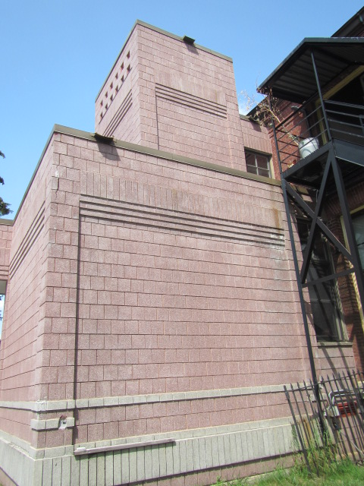
Addition containing elevator
Picture 2
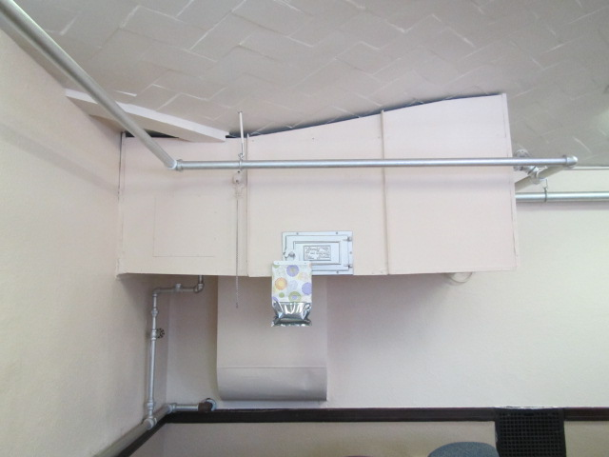
Abandoned HVAC system
Picture 3

Example of a mold-colonized book
Picture 4
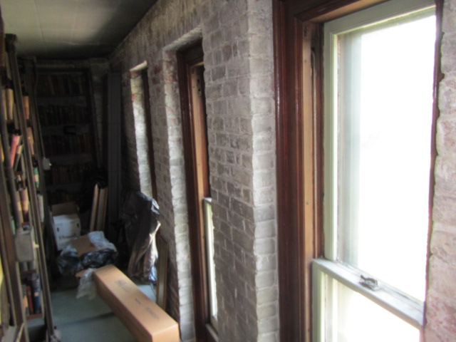
Efflorescence on closed stack exterior walls

Picture 5
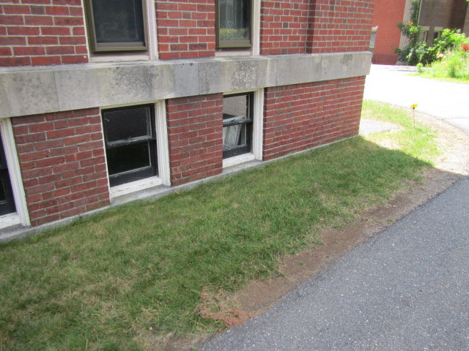
Strip of grass adjacent to the closed stack exterior wall
Picture 6
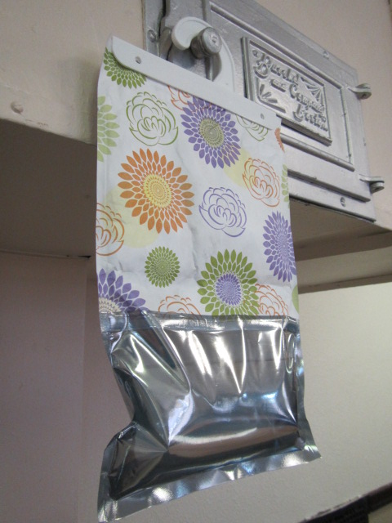
Desiccant bag filled with accumulated water in the periodical room
Picture 7
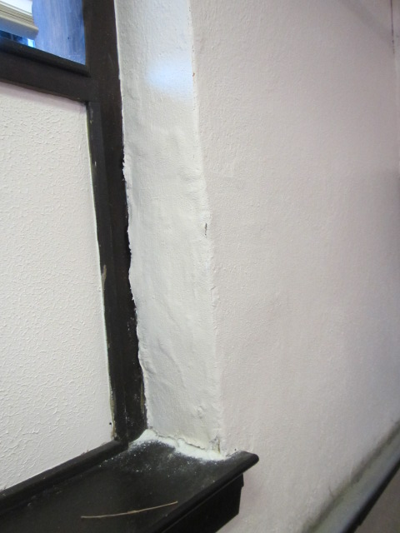
West wall window has signs of efflorescence (note bubbled paint)
Picture 8
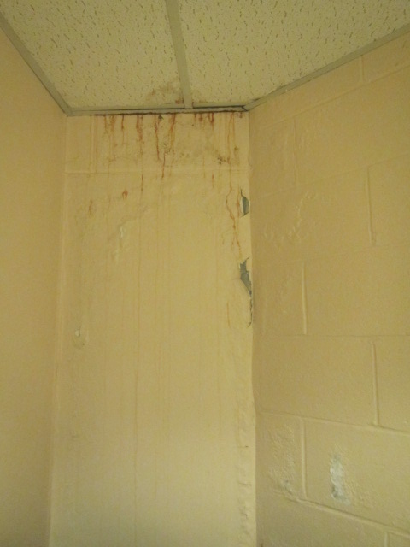
Hallway wall adjacent to the elevator shaft in the basement
has water-damaged gypsum wallboard (GW)

Picture 9
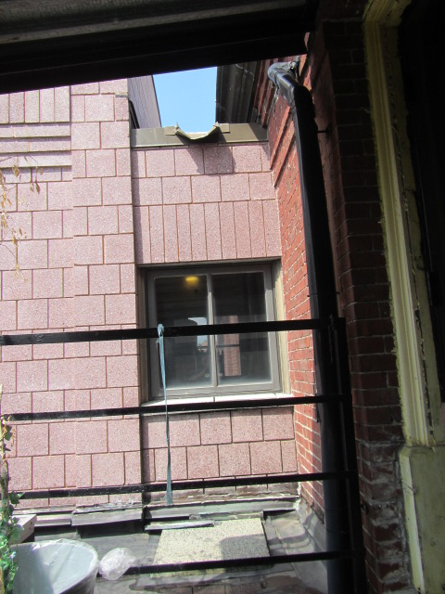
Scupper (Note wall damage)
Picture 10
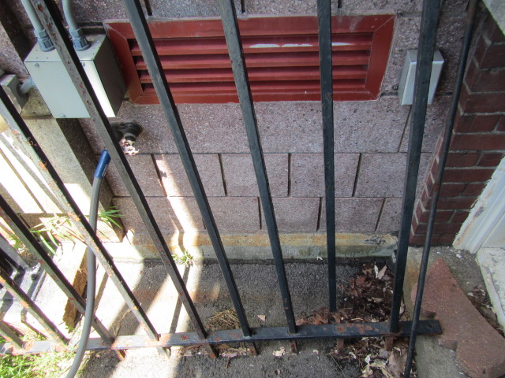
Wall penetration in new addition wall
Picture 11
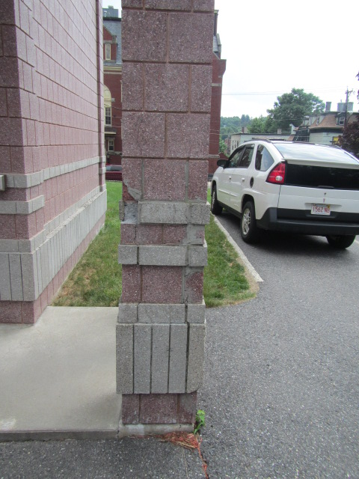
Damaged support pillar of new addition

Location | Carbon  Dioxide  (ppm) | Carbon Monoxide  (ppm) | Temp  (°F) | Relative  Humidity  (%) | PM2.5  (µg/m³) | Occupants  in Room | Windows  Openable | Ventilation |  | Remarks
 |  |  |  |  |  |  |  | Supply | Exhaust | Remarks
Outdoor (Background) | 389 | ND | 80 | 46 | 16
Juvenile desk | 701 | ND | 77 | `51 | 12 | 5 | Y | N | N | AC, WD window sill, DO
Director’s office | 747 | ND | 79 | 51 | 11 | 2 | Y | N | N
Juvenile stack | 771 | ND | 73 | 44 | 10 | 0 | Y | N | N | AC, peeling paint, DO
Juvenile hall/balcony | 537 | ND | 75 | 58 | 11 | 0 | Y | N | N | PF, WD window panel, DO
Elevator lobby 2nd floor | 651 | ND | 76 | 55 | 12 | 0 | Y | N | N | DO
Front door lobby | 657 | ND | 78 | 52 | 12 | 1 | N | N | N | DO
Main stack | 681 | ND | 76 | 47 | 13 | 5 | Y | N | N | AC
Main desk | 693 | ND | 77 | 48 | 12 | 5 | Y | N | N | PF DO
Elevator lobby 1st floor | 659 | ND | 77 | 47 | 12 | 0 | Y | N | N | WD GW
Kitchen | 687 | ND | 77 | 47 | 13 | 0 | N | N | N | AC
Basement periodical room | 551 | ND | 75 | 64 | 13 | 0 | Y | N | N | WD plaster under windows
Elevator lobby basement | 548 | ND | 75 | 64 | 13 | 0 | N | N | N | WD GW
2nd level closed stack | 613 | ND | 77 | 60 | 11 | 0 | Y | N | N | WD wall, books
1st level closed stack | 531 | ND | 78 | 55 | 10 | 0 | Y | N | N | WD wall, books
Basement level closed stack | 536 | ND | 76 | 56 | 15 | 0 | Y | N | N | WD wall, mold colonized books

Condensation is the collection of moisture on a surface with a temperature below the dew point. The dew point is a temperature determined by air temperature and relative humidity. For example, at a temperature of 73º F and relative humidity of 57 percent indoors, the dew point for water to collect on a surface is approximately 57 º F (IICRC, 2000).

