

CCFA End to End Billing: Providers with Contract and Voucher Agreements



# Billing Overview

* **Step by step billing process**
* **Submitted Invoices**
* **View Monthly Billing History**

# 1. Generate Ledgers once your attendance has been entered and is complete

– Requires you to agree attendance is accurate

|  |  |  |
| --- | --- | --- |
| **2.** | **Go to Pending Invoices** |  |
| **3.** | **Review Pending Invoice and** | **approve/reject** |
| **4.** | **Click Review Submission** |  |
| **5.** | **Review Submission** |  |
| **6.** | **Submit and Confirm** |  |

When you agree to the attendance, your billing status will

change to “in progress”. You must refresh the page in order to view the status to ”billed”.

* + As billing is processing you can continue to do other functions in CCFA.

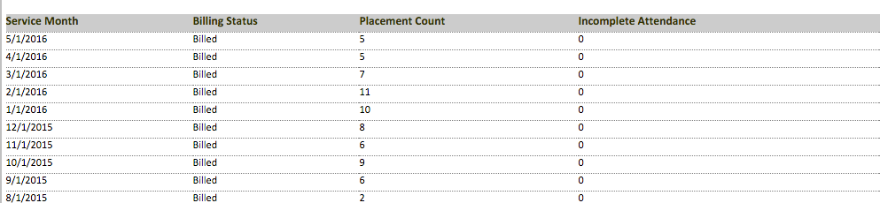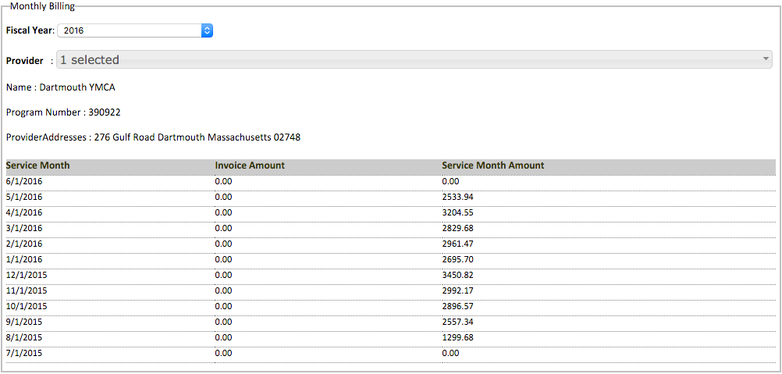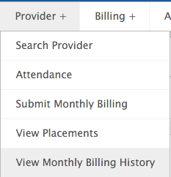

# The View Monthly Billing History page allows you to see your invoice amounts by location from a monthly perspective

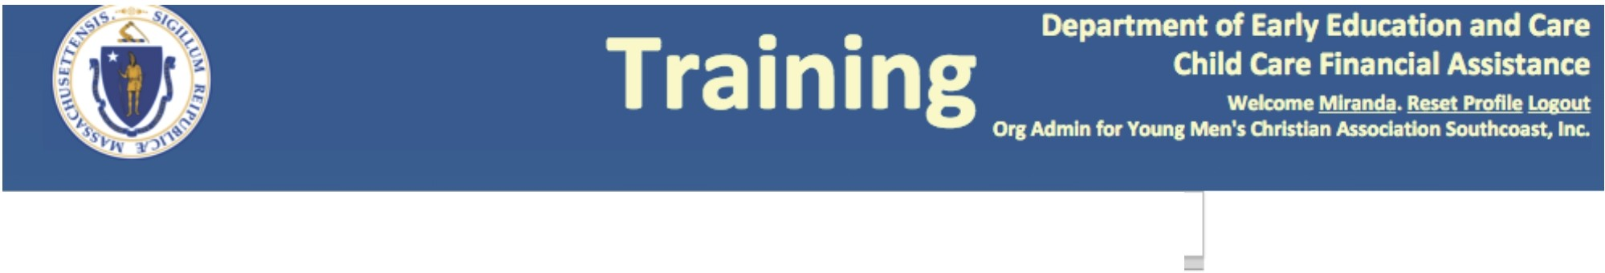

Home

Intake +

Provider +

Billing +

Admin +

Reports +

Help +

Invoice Summary

Pending Invoices

Monthly Billing

Submitted Invoices

Provider : 1selected + Adjustments

J

Reconciliation

Name :YMCA Sippican Child Care Program

Program Number :290988

ProviderAdd resses : 16 Spring Street Marion Massachusetts 02738

Service Month Billing Status Placement Count Incomplete Attendance

5/1/2016 Billed 5 0 --------- --------'

4/1/2016 Billed 5 0

3/1/2016

2/1/lOi6

iiiho'ff

12/1/2015

11/1/2015

1011ho15

9/1/i.01s

Billed 7 0

Billed 11 0

Billed 10 0

Billed 8 0

Billed 6 0

Billed 9 0

Billed 6 0

8/1/2015 Billed 2 0

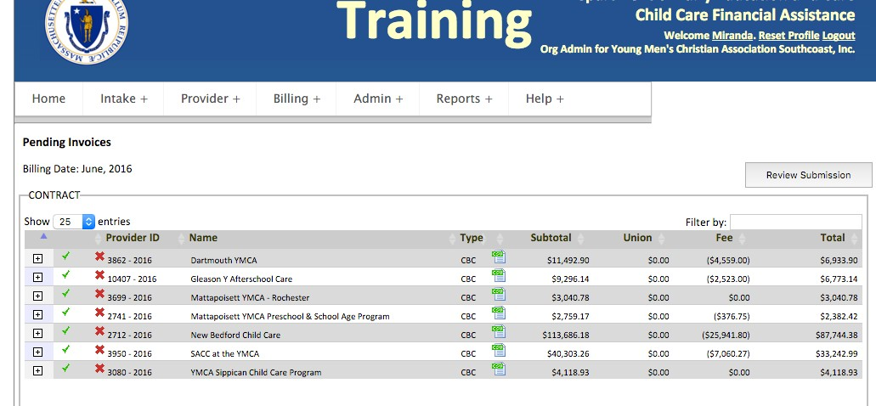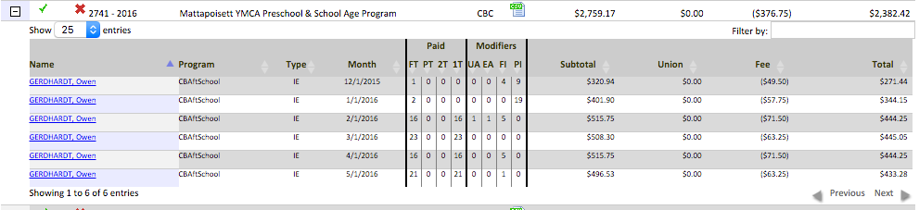

Approve the invoice by clicking the green check. Reject the invoice by clicking the red X.

Clicking the “+” sign will expand the invoice and provide details for each child by each month billed

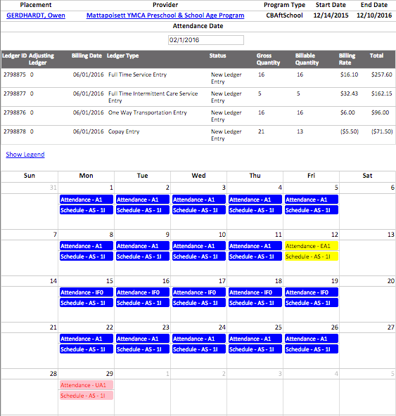

# Clicking the child’s name will open a separate tab with the Monthly View and the ledger

**entries for that month.**

* Service entries
* Copay
* Transportation
* Intermittent entries (if applicable)
* Union dues (if applicable)
* Rejecting an invoice will change the provider’s attendance status to “rejected” and allow him or her to make changes.
* Approving an invoice will change the check mark to gray. After approval, click ”Review Submission”

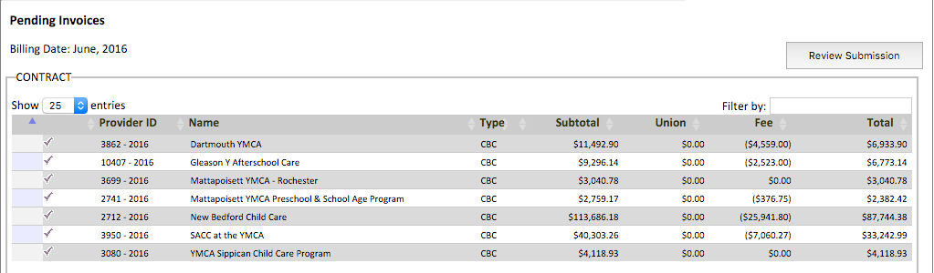

* **The black rewind button is your last chance to reject billing before submitting.**
* **You will see a ”Denied” tab if you have rejected any invoices AND have not re-generated ledgers within the current billing month.**
* **You will see a “missing Attendance” tab if you have providers with missing attendance for the current billing cycle.**

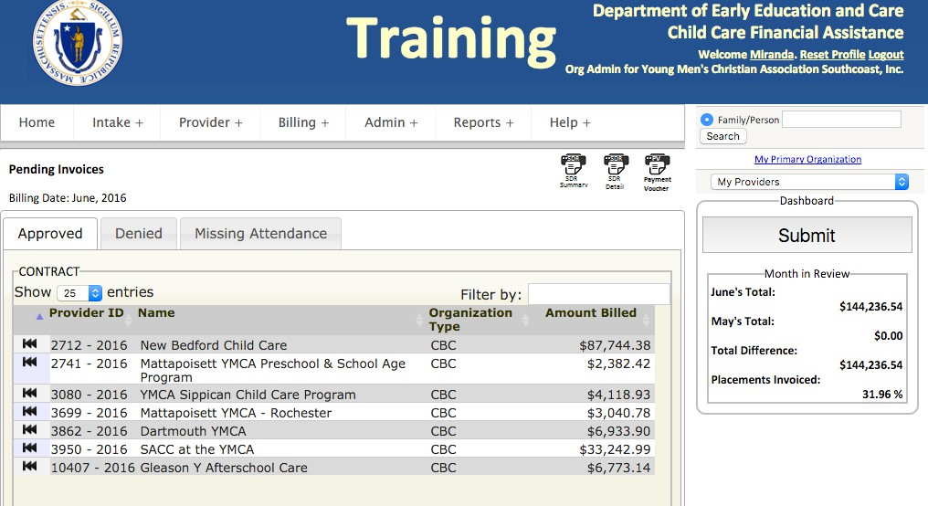

# The SDR Summary, SDR Detail, and Payment Voucher are available for download in draft form

* **The SDR Summary shows a breakdown of your invoice from a monthly perspective**
* **The SDR Detail report provides a more detailed look at your invoice, broken down by child and the attendance entered against that child**
* **The Payment voucher will show the monthly totals by contract line**

Service Delivery Report (SOR) - Summary

Report Print Date: 08/22/2018 10:38:37AM Bllllng Date: 08/01/2018

PrognimType:

"*

Commune

ActgUne

Pal'llftt ..

LIM Totlil Biiied

|  |  |  |
| --- | --- | --- |
| 23A MOULTON ST |  | |
| CHARLESTOWN,MA 02129  (617)241-8866 |  |  |
| Contrect/AgrMmlnt | R9glon | Contract Type |

600010.

411E

6

IE

Connet

IWt O...

09/01/2009

Contnlct

!nd O...

08131/2016

Connet Amount

227,880.37

|  |  |  |  |  |  |
| --- | --- | --- | --- | --- | --- |
| Cantor-Based After SchoolOnl |  | 18.48 AS / 34.48 SA | 7 | ·1 738.50 | 4 807.82 |
| Service Date: 0110112015 |  |  | Fee Total | Total Biiied |  |
| Regul1r | Rite: 18.48 AS / 34.48 SA | Unite: 184.00 | FH: 1,738.50 | Total: 4,807.82 |  |
| PrognimType: "* Commune ActgUne Pal'llftt FM LIM Totlil Biiied | | | | | |
| Center-Based PreSchool |  | 38.76 | 7 | -4 338.00 | 24 892.84 |
| Service Date: 0110112015 |  |  | Fee Total | TotaIBllled |  |
| Regular  QRIS Add On | Rate:38.76  Rate:1.16•.03 • Provider Rate | Units: 754.00  Units: 5.00 | Fee: -4,338.00  Fee: 0.00 | Total: 24,887.04  Total: 5.80 |  |

Service Delivery Report (SOR) - Detail Print Date:ae/22120111 10:311:00AM

Billlna Data:08/01120111

23A MOULTON ST CHARLESTOWN,MA 02129

(617)241-8866

.....,.,,.....Diie:71112111

'-TOlll: l(t,1JUll

TOlll .._

.....111.a

-....

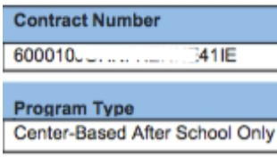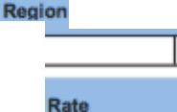

IE

6

09J01f2009

08f.)1/20,6

$227,U0.37

AclllU..•

18.48 AS / 34.48 SA

7

$31,880.113

|  |  |  |  |  |  |  |  |  |  |  |  |  |  |  |  |  |  |  |  |  |  |  |  |  |  |  |  |  |  |
| --- | --- | --- | --- | --- | --- | --- | --- | --- | --- | --- | --- | --- | --- | --- | --- | --- | --- | --- | --- | --- | --- | --- | --- | --- | --- | --- | --- | --- | --- |
|  | |  | | | | | | | | | | | | | | | | | | | | | | | | | | | |
| $IOI No | Child *H•me* | Start Date | EndD... | Unlbl | FT | l'T | BS | AS | BA | lllS | PR | UA | UAP | EA | EAi' | *HA* | CF | CP | UC | x | v -.. | | ..,. |  |  | ...... | -.. | rce | T- |
|  | E | 711/2015 | 8/31/2015 | 2300 | 23 | 0 | 0 | 0 | 0 | 0 | 0 | 0 | 0 | 0 | 0 | 0 | 0 | 0 | 0 | 0 | 0 | 0 | 0 | 0 | 0 | 0 | 0 | $(52900) | S:I&< 04 |
|  | J | 7/1/2015 | 10/8/2015 | 2300 | 23 | 0 | 0 | 0 | 0 | 0 | 0 | 0 | 0 | 0 | 0 | 0 | 0 | 0 | 0 | " | 0 | 0 | 0 | 0 | 0 | 0 | 0 | $1207 00) | $5111104 |
|  | J | 711/2015 | 91"'2015 | 2300 | 23 | 0 | 0 | 0 | 0 | 0 | 0 | 0 | 0 | 0 | 0 | 0 | 0 | 0 | 0 | 0 | 0 | 0 | 0 | 0 | 0 | 0 | 0 | $(19550) | *1!>4* |
|  | K | 7/112015 | J/3112016 | 2300 | 23 | 0 | 0 | 0 | 0 | 0 | 0 | 0 | 0 | 0 | 0 | 0 | 0 | 0 | 0 | *0* | 0 | 0 | 0 | 0 | 0 | 0 | 0 | $('600) | 57•704 |
|  | t | 711/2015 | 311312016 | 2300 | 23 | 0 | 0 | Q | 0 | 0 | 0 | 0 | Q | 0 | Q | 0 | 0 | 0 | 0 | 0 | 0 | 0 | 0 | 0 | 0 | 0 | 0 | $()'500) | $<48 04 |
|  | "' | 711/2015 | 111"2015 | 2300 | 23 | 0 | 0 | 0 | 0 | 0 | 0 | 0 | 0 | 0 | n | 0 | 0 | 0 | 0 | " | 0 | 0 | 0 | 0 | 0 | 0 | 0 | S:>.00 | 5793 04 |
|  | R. | 711/2015 | 8/3112015 | 2300 | 23 | 0 | 0 | 0 | 0 | 0 | 0 | 0 | Q | 0 | 0 | 0 | 0 | 0 | 0 | 0 | 0 | 0 | 0 | 0 | 0 | 0 | 0 | $()'500) | $<48 04 |
|  | RJ | 7/1/2015 | 1& | 2300 | 23 | 0 | 0 | 0 | 0 | 0 | 0 | 0 | 0 | 0 | n | 0 | 0 | 0 | 0 | *0* | 0 | 0 | 0 | 0 | 0 | 0 | 0 | $.;6900) | 572, 04 |

**Payment Voucher Input Form**

Department/Organization Name:

Department of Early Education and Care (EEC)

Commonwealth of Massachusetts Executive Officeof Education Early Educationand Care

Office of the Comptroller



June 22, 2016

|  |  |  |  |  |  |  |
| --- | --- | --- | --- | --- | --- | --- |
| PV DATE 7/1/2015 | VENDOR' S CERTIFICATION  I certify that the goods l\'ere shipped or the service rendered as set forth below  (Plc:isc Sign In Ink) | | | Vendors Name and Address  --··· - .. . - -  · ,  23A MOULTON ST  CHARLESTOWN, MA, 02129 | | |
| Document Total: | $29,494.86 | I | Vendor | | Customer Code: | VC6000159732 |

|  |  |  |  |  |  |
| --- | --- | --- | --- | --- | --- |
| Encumbrance JD | Quantity | Description | Unit Price | Amount | Fot Al!encv Use |
| 60001L- ..... · -····-411E | 1 | c:·_ ·_ _:_ . . - .. ,- .. - .: _-20090901  ,-- | $29,494.86 | $29,494.86 |  |
| n.,••*n(* , rvlr••: 7/1/2015 to 7/3112015 |
| Prepared By: Title: Date:  Entered By: Title: Date: | | | | | |
| *The undersigned authorized signatory approving this document Cl!rtifics that this document and any attachments arc accurate and complete and comply with all applicable general*  ***nnrl nprfnl lnwC' nn,/ """"lntinn'f'***  Approved By: Tille: Date: | | | | | |

* **Click Submit to submit your voucher invoices to the CCRR and your contract invoices to EEC.**
* **When you click ”Submit,” you will be asked to confirm the submission**
  + **You will be notified of any providers that haven’t been approved.**
  + **If you click “yes”, these providers will be excluded from the current billing cycle.**

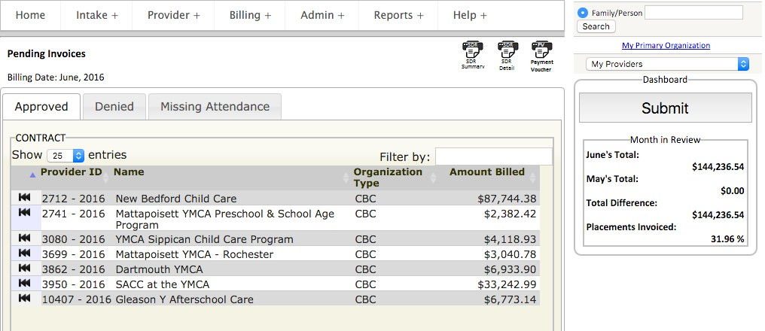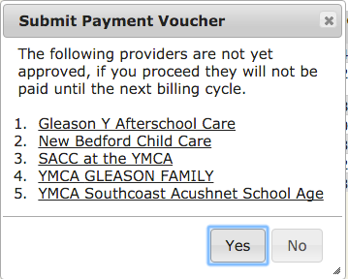

# After you submit to the CCRR and EEC, you can see all of your past submissions and payments.

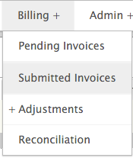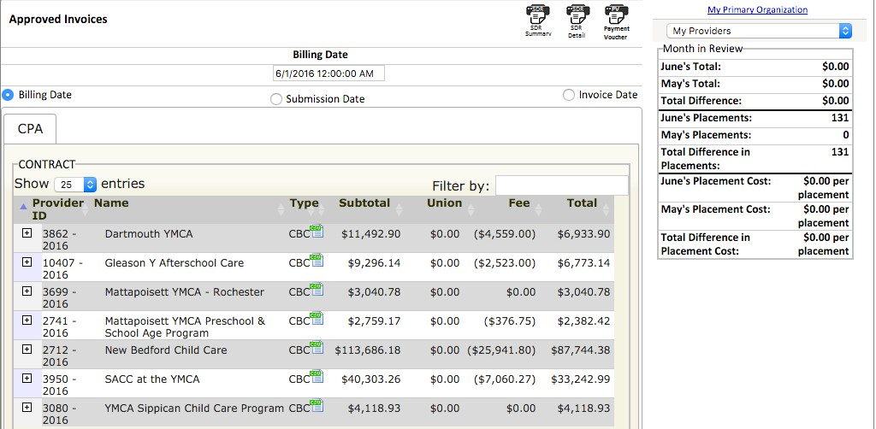

* The billing date is the date you submitted your invoice to the CCRR/EEC
* The Submission date is the date the CCRR submitted to EEC
* The Invoice date is the date EEC approved
* You will not see any totals

populated under the Month in Review until your invoices are approved.