**Massachusetts Department of Public Health | Bureau of Environmental Health**

**BJAT SUPERFUND SITE ADVISORY**

300 Fisher Street, Franklin, MA

**The Department of Public Health urges all residents NOT to trespass in or around the BJAT site**

**WHERE IS BJAT?**

BJAT is located off of an old access road at the end of Fisher Street. The property is bordered by the Town of Franklin Department of Public Works and I-495.

**WHO IS AT RISK?**

Anyone who visits the property without proper protection is at risk. Individuals are especially at risk if they inhale dust, touch contaminated debris, or track home soil from contaminated areas.

**WHY IS THE BJAT SITE HAZARDOUS?**

The BJAT site was listed in September 2015 by the United States Environmental Protection Agency on the National Priorities List (NPL). Sites on the NPL have known or potential releases of hazardous substances and are federally funded for cleanup. However, the BJAT Superfund site is in the early stage of the process; therefore hazardous contaminants are still located on the property.

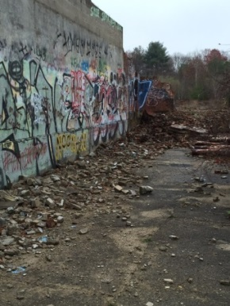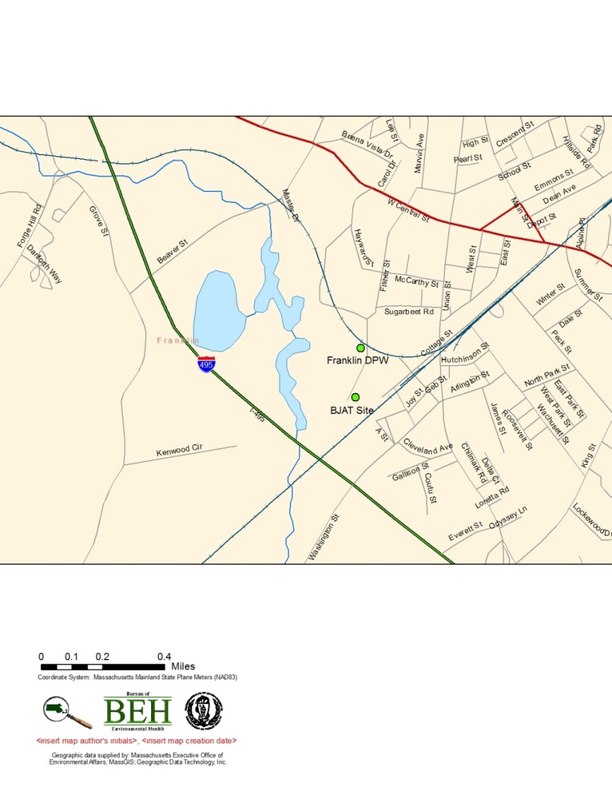

**WHERE IS BJAT?**

BJAT is located off of an old access road at the end of Fisher Street. The property is bordered by the Town of Franklin Department of Public Works and I-495.

**WHAT IS THE BJAT SITE?**

The BJAT site, located at 300 Fisher Street, is an   
18.3-acre property with one large, dilapidated building which was used for rubber and plastic manufacturing. The last manufacturing business ended production in 1985. **The building is currently vacant, but frequent trespassing is occurring.**

**WHAT ARE THE CONCERNS?**

|  |  |
| --- | --- |
| **HAZARD EXPOSURE** | **POSSIBLE HEALTH EFFECTS** |
| Physical Hazards symbol  **Physical** | Caving ceilings and unsecured  building materials.  ▪ Falling or slipping hazards  ▪ Entrapment by falling building debris |
| **Chemical** | Potential health effects could occur from long-term exposure to unsafe levels of lead, mercury, or zinc such as lowered IQ, memory problems, muscle weakness and behavioral changes.  Soil and sediment at the BJAT site  contains elevated levels of **LEAD, ZINC, AND MERCURY**  Exposed building materials and debris  contain hazardous materials, including **Asbestos, Lead and PCBs** |



**Bureau of Environmental Health**

**Massachusetts Department of Public Health**

250 Washington Street, 7th Floor

Boston, MA 02108

Phone: 617-624-5757 | Fax: 617-624-5183 | TTY: 617-624-5286

[www.mass.gov/dph/environmental health](http://www.mass.gov/dph/environmental%20health)

Revised XXXXX