Data Update: Bladder Cancer and Hodgkin Lymphoma in Westfield, Massachusetts

Massachusetts Department of Public Health March 2019

T
he Bureau of Environmental Health within the Massachusetts Department of Public Health (MDPH/BEH) conducted a screening-level review of the incidence of two cancer types in Westfield to follow up on a previous public health assessment (PHA) released in 2007 on the Barnes Aquifer – an aquifer that provides drinking water for some of Westfield and other surrounding communities. The PHA indicated that bladder cancer and Hodgkin lymphoma were statistically significantly elevated in one area of Westfield. MDPH/BEH reviewed the most recent incidence data for these two cancer types in response to a resident’s request. This bulletin summarizes the earlier PHA findings and results of this latest evaluation.

Summary of Earlier Findings

The PHA, Evaluation of Environmental Concerns Related to the Barnes Aquifer and Cancer Incidence, 1982 – 2000, was initiated in response to community concerns about possible environmental exposures to trichloroethylene (TCE) in municipal drinking water (Easthampton and Holyoke only) and/or private drinking water wells (in Southampton, Holyoke, Westfield, and Easthampton) that draw from the Barnes Aquifer. It evaluated incidence data for eight types of cancer for Easthampton, Holyoke, Southampton, and Westfield during the 19-year time period of 1982-2000, as well as three shorter time periods (1982-1987, 1988-1993, and 1994-2000). These cancer types were selected based on potential associations with TCE and residents’ concerns about particular types.

No statistically significant elevations were observed during 1982 to 2000 and each of the three shorter time periods for any of the eight cancer types in any of the four communities as a whole. (Statistically significant means there is less than a 5% chance that the difference between the number of observed and expected diagnoses is the result of random fluctuation).

The PHA also evaluated cancer incidence in census tracts (CT) where some of the residents may have been exposed to TCE-contaminated drinking water from the Barnes Aquifer. A CT is the smallest geographic area for which cancer rates can be accurately calculated. Within Westfield, CT 8125 covers the northeast section of the city (Figure 1). This is the part of Westfield where some residents with private wells were at risk of exposure to TCE in drinking water from the Barnes Aquifer. According to the PHA, most residents of Westfield CT 8125 were not at risk of exposure to TCE prior to 1997.

Figure 1: Census Tract (CT) boundaries in Westfield
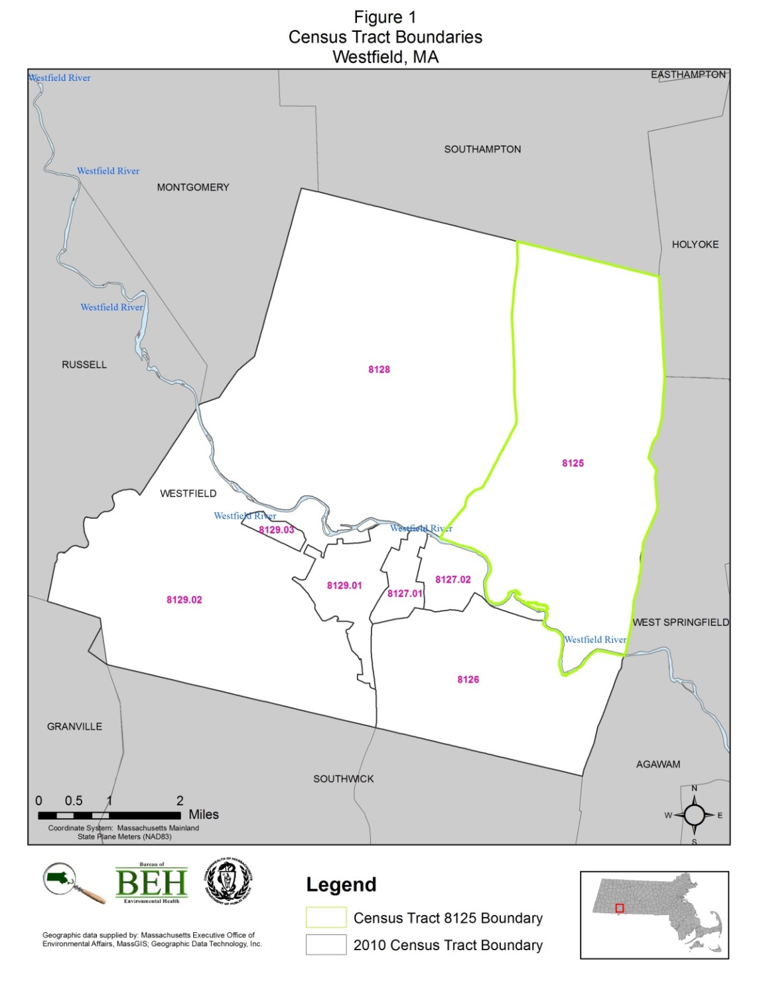
Table 1 summarizes the cancer incidence data for the 19-year time period of 1982-2000 for CT 8125. The number of diagnoses observed for six of the cancer types was not statistically significantly different from the number that would be expected based on the statewide experience. Hodgkin lymphoma was statistically significantly elevated among females and bladder cancer was statistically significantly elevated among males and females combined. The supplemental data tables that follow provide the number of observed and expected diagnoses, standardized incidence ratios (SIRs), and confidence intervals for each of the eight cancer types during 1982-2000 and the three shorter time periods within the 19-year period. These data were presented in the 2007 PHA.

Table 1: Summary of Cancer Incidence Data for Westfield CT 8125 during 1982 to 2000
Cancer Type | Statistical Significance of Cancer Incidence Compared to Statewide
 | Total | Males | Females
Bladder (includes in situ) | Higher | No difference (borderline) | No difference
Esophageal | No difference | No difference | No difference
Hodgkin lymphoma | No difference | No difference | Higher
Kidney | No difference | No difference | No difference
Leukemia | No difference | No difference | No difference
Liver | No difference | No difference | No difference
NHL | No difference | No difference | No difference
Pancreatic | No difference | No difference | No difference
Source: Massachusetts Cancer Registry (MCR), Office of Data Management and Outcomes Assessment, MPDH.

Hodgkin lymphoma was statistically significantly elevated among females (6 observed compared to 2 expected) over the 19-year time period. This elevation was due to small differences (1-2 diagnoses) during each of the three shorter time periods. It is important to point out that exposure to chemicals in the workplace or environment has not been established as a risk factor for Hodgkin lymphoma. Established risk factors for this cancer type include exposure to the Epstein-Barr virus and hereditary conditions. More information on risk factors for Hodgkin lymphoma can be found at https://matracking.ehs.state.ma.us/Health-Data/Cancer/factsheets/Hodgkin.pdf.

Bladder cancer was statistically significantly elevated among males and females during 1982 to 2000 in Westfield CT 8125. This was largely due to a borderline elevation among males. Based on the residential address at the time of diagnosis, 96% of the individuals diagnosed with bladder cancer (n=28) were not at risk of exposure to TCE from the Barnes Aquifer. Since tobacco use is an established risk factor for bladder cancer, tobacco use history was reviewed for each individual diagnosed with this type of cancer. Of those individuals diagnosed with bladder cancer in CT 8125 during 1982-2000 and for whom tobacco history was reported, 86% reported to be current or former smokers at the time of diagnosis (n=18). It should be noted that due to the specific nature of the diagnostic techniques and treatment patterns, urinary bladder cancer as reported here includes invasive cancers (i.e., cancers have spread beyond the layer of cells where they started) and in situ cancers (i.e., cancers diagnosed at the earliest stage when they are limited to a small number of cells and have not invaded the organ itself.)

The PHA concluded that it did not appear that a common factor (environmental or non-environmental) played a major role in the overall incidence of cancer during 1982-2000 in the communities where some residents were at risk of exposure to TCE from the Barnes Aquifer.

Update of Incidence Data for Bladder Cancer and Hodgkin Lymphoma

In response to a request from a resident to follow up on the statistically significant elevations in bladder cancer and Hodgkin lymphoma in Westfield CT 8125 during 1982-2000, MDPH/BEH reviewed recent incidence data on these two cancer types for the City of Westfield and Westfield CT 8125 during 2004-2008 and 2009-2013. The latter constitutes the period for which the most recent and complete cancer incidence data were available at the initiation of this evaluation.

For both bladder cancer and Hodgkin lymphoma, the number of observed diagnoses was either less than or about (within 1 or 2 diagnoses) expected based on the statewide experience (Table 2). None of the differences were statistically significant. The supplemental data tables include the numbers of observed and expected diagnoses, SIRs, and confidence intervals.

In addition, an analysis of the residential addresses at the time of diagnosis did not reveal any unusual spatial or temporal patterns for those diagnosed with either bladder cancer or Hodgkin lymphoma during 2004-2013. The geographic distribution of diagnoses generally followed the pattern of population density with no unusual spatial clustering.

Table 2: Incidence of Bladder Cancer and Hodgkin Lymphoma in Westfield and CT 8125

City of Westfield
2004-2008
Cancer Type | Males |  |  |  |  |  |  |  |  |  | Females
 | Obs | Exp |  |  | SIR |  |  | 95% CI |  |  | Obs | Exp |  | SIR |  |  | 95% CI
Bladder (includes in situ) | 40 | 42.4 |  |  | 94 |  |  | 67--129 |  |  | 11 | 16.2 |  | 68 |  |  | 34--121
Hodgkin Lymphoma | 4 | 3.9 |  |  | NC |  |  | NC--NC |  |  | 5 | 3.2 |  | 158 |  |  | 51--368
2009-2013
Bladder (includes in situ) | 44 |  | 41.8 |  |  | 105 |  |  | 77--141 |  | 14 | 15 |  | 93 |  |  |  | 501--156
Hodgkin Lymphoma | 6 |  |  | 3.5 |  |  | 174 |  |  | 63--378 | 1 |  | 3 |  | NC |  |  | NC--NC
Westfield CT 8125
2004-2008
Cancer Type | Males |  |  |  |  |  |  |  |  |  | Females
 | Obs |  |  | Exp |  |  | SIR |  |  | 95% CI | Obs |  | Exp |  |  | SIR |  | 95% CI
Bladder (includes in situ) | 4 |  |  | 2.9 |  |  | 138 |  |  | 37--354 | 2 |  | 1.2 |  |  | 173 |  | 19--623
Hodgkin Lymphoma | 0 |  |  | 0.7 |  |  | NC |  |  | NC--NC | 0 |  | 0.6 |  |  | NC |  | NC--NC
2009-2013
Bladder (includes in situ) | 4 |  |  | 3.3 |  |  | 123 |  |  | 33--315 | 0 |  | 1.2 |  |  | NC |  | NC--NC
Hodgkin Lymphoma | 1 |  |  | 0.6 |  |  | 165 |  |  | 2--917 | 0 |  | 0.5 |  |  | NC |  | NC--NC

Obs = Observed number of diagnosis  Exp = Expected number of diagnosis  SIR = Standardized Incidence Ratio | 95% CI = 95% Confidence Interval  NC = Not calculated  * = Statistically significant

CONCLUSIONS

This review of the incidence of bladder cancer and Hodgkin lymphoma in the City of Westfield and Westfield CT 8128 during 2004-2008 and 2009-2013 did not reveal any unusual patterns.

DATA SOURCES AND METHOD NOTES

Data Source:
Massachusetts Cancer Registry, Office of Data Management and Outcomes Assessment, MDPH.

Method Notes:
All new diagnoses of invasive cancer, as well as certain in situ (localized) cancers, are required by law to be reported to the MCR within six months of the date of diagnosis (M.G.L. c.111. s 111b).
Individuals diagnosed with cancer were selected for inclusion based on the residential address provided to the hospital or reporting medical facility at the time of diagnosis.
An SIR is the ratio of the observed number of cancer diagnoses in an area to the expected number of diagnoses multiplied by 100. Age-specific statewide incidence rates were applied to the population distribution of each geographic area to calculate the number of expected cancer diagnoses.
It is standard MCR policy not to calculate rates with fewer than five observed diagnoses due to the instability of the rate.
The statistical significance of an SIR is assessed by calculating a 95% confidence interval (CI) to determine if the observed number of diagnoses is “statistically significantly different” from the expected number or if the difference may be due solely to chance. If the 95% CI range does not include the value 100, then the study population is significantly different from the comparison or “normal” population. An SIR greater or less than 100 indicates that more or fewer cancer diagnoses occurred than expected and an SIR less than 100 indicates that fewer cancer diagnoses occurred than expected.
The MDPH is bound by state and federal patient privacy and research laws not to make public the names or any other information (e.g., place of residence) that could personally identify individuals with cancer whose diagnoses have been reported to the MCR (M.G.L. c.111. s. 24A).

RESOURCES

For additional cancer incidence data:  Massachusetts Environmental Public Health Tracking  250 Washington Street, 7th Floor  Boston MA, 02108  Tel. (800) 319-3042  www.mass.gov/dph/matracking | For more information on cancer data:  Massachusetts Cancer Registry  250 Washington Street, 6th Floor  Boston MA, 02108  Tel. (617) 624-5642  www.mass.gov/dph/mcr
For information on this bulletin or other cancer concerns:  MDPH Bureau of Environmental Health  250 Washington Street, 7th Floor  Boston MA, 02108  Tel. (617) 624-5757  www.mass.gov/dph/environmental_health | For more information about quitting smoking:  Massachusetts Smokers’ Helpline  1-800-QuitNow or 1-800-784-8669.  For Spanish call 1-800-8-Déjalo or 1-800-833-5256.

SUPPLEMENTAL DATA

Incidence of Eight Cancer Types in Westfield CT 8125
1982-2000

Cancer Type | Total |  |  |  | Males |  |  |  | Females
 | Obs | Exp | SIR | 95% CI | Obs | Exp | SIR | 95% CI | Obs | Exp | SIR | 95% CI
Bladder (includes in situ) | 28 | 18.1 | 155* | 103--223 | 22 | 13.8 | 160 | 100--242 | 6 | 4.4 | 137 | 50--299
Esophageal | 6 | 5.8 | 103 | 38--224 | 5 | 4.5 | 111 | 36--260 | 1 | 1.3 | NC | NC--NC
Hodgkin Lymphoma | 8 | 4.6 | 174 | 75--342 | 2 | 2.5 | NC | NC--NC | 6 | 2.1 | 287* | 105--624
Kidney | 9 | 11.7 | 77 | 35--146 | 6 | 7.5 | 80 | 29--175 | 3 | 4.3 | NC | NC--NC
Leukemia | 15 | 10.3 | 146 | 82--241 | 9 | 6 | 150 | 68--284 | 6 | 4.2 | 141 | 52--308
Liver | 2 | 2.9 | NC | NC--NC | 1 | 2.2 | NC | NC--NC | 1 | 0.7 | NC | NC--NC
NHL | 12 | 17.6 | 68 | 35--119 | 3 | 9.9 | NC | NC--NC | 9 | 7.8 | 116 | 53--220
Pancreatic | 9 | 9.9 | 91 | 41--172 | 8 | 5.2 | 152 | 66--300 | 1 | 4.7 | NC | NC--NC

Obs = Observed number of diagnosis  Exp = Expected number of diagnosis  SIR = Standardized Incidence Ratio | 95% CI = 95% Confidence Interval  NC = Not calculated  * = Statistically significant

Incidence of Eight Cancer Types in Westfield CT 8125
1982-1987

Cancer Type | Total |  |  |  | Males |  |  |  | Females
 | Obs | Exp | SIR | 95% CI | Obs | Exp | SIR | 95% CI | Obs | Exp | SIR | 95% CI
Bladder (includes in situ) | 10 | 5.6 | 179 | 86--329 | 8 | 4.3 | 187 | 81--369 | 2 | 1.3 | NC | NC--NC
Esophageal | 0 | 1.5 | NC | NC--NC | 0 | 1.1 | NC | NC--NC | 0 | 0.4 | NC | NC--NC
Hodgkin Lymphoma | 3 | 1.4 | NC | NC--NC | 0 | 0.8 | NC | NC--NC | 3 | 0.7 | NC | NC--NC
Kidney | 2 | 2.6 | NC | NC--NC | 1 | 1.6 | NC | NC--NC | 1 | 1 | NC | NC--NC
Leukemia | 4 | 2.7 | NC | NC--NC | 2 | 1.6 | NC | NC--NC | 2 | 1.1 | NC | NC--NC
Liver | 0 | 0.6 | NC | NC--NC | 0 | 0.4 | NC | NC--NC | 0 | 0.2 | NC | NC--NC
NHL | 5 | 4.1 | 123 | 40--287 | 1 | 2.3 | NC | NC--NC | 4 | 1.8 | NC | NC--NC
Pancreatic | 0 | 2.7 | NC | NC--NC | 0 | 1.4 | NC | NC--NC | 0 | 1.2 | NC | NC--NC

Obs = Observed number of diagnosis  Exp = Expected number of diagnosis  SIR = Standardized Incidence Ratio | 95% CI = 95% Confidence Interval  NC = Not calculated  * = Statistically significant

Incidence of Eight Cancer Types in Westfield CT 8125
1988-1993

Cancer Type | Total |  |  |  | Males |  |  |  | Females
 | Obs | Exp | SIR | 95% CI | Obs | Exp | SIR | 95% CI | Obs | Exp | SIR | 95% CI
Bladder (includes in situ) | 9 | 5.6 | 161 | 73--305 | 7 | 4.3 | 164 | 66--339 | 2 | 1.3 | NC | NC--NC
Esophageal | 3 | 1.7 | NC | NC--NC | 2 | 1.3 | NC | NC--NC | 1 | 0.4 | NC | NC--NC
Hodgkin Lymphoma | 2 | 1.5 | NC | NC--NC | 1 | 0.8 | NC | NC--NC | 1 | 0.7 | NC | NC--NC
Kidney | 2 | 3.8 | NC | NC--NC | 1 | 2.5 | NC | NC--NC | 1 | 1.4 | NC | NC--NC
Leukemia | 2 | 2.9 | NC | NC--NC | 1 | 1.7 | NC | NC--NC | 1 | 1.2 | NC | NC--NC
Liver | 0 | 0.8 | NC | NC--NC | 0 | 0.6 | NC | NC--NC | 0 | 0.2 | NC | NC--NC
NHL | 3 | 5.4 | NC | NC--NC | 1 | 3.1 | NC | NC--NC | 2 | 2.4 | NC | NC--NC
Pancreatic | 5 | 2.9 | 172 | 55--400 | 4 | 1.6 | NC | NC--NC | 1 | 1.4 | NC | NC--NC

Obs = Observed number of diagnosis  Exp = Expected number of diagnosis  SIR = Standardized Incidence Ratio | 95% CI = 95% Confidence Interval  NC = Not calculated  * = Statistically significant

Incidence of Eight Cancer Types in Westfield CT 8125
1994-2000

Cancer Type | Total |  |  |  | Males |  |  |  | Total
 | Obs | Exp | SIR | 95% CI | Obs | Exp | SIR | 95% CI | Obs | Exp | SIR | 95% CI
Bladder (includes in situ) | 9 | 7.0 | 128 | 59--243 | 7 | 5.2 | 133 | 53--275 | 2 | 1.8 | NC | NC--NC
Esophageal | 3 | 2.7 | NC | NC--NC | 3 | 2.1 | NC | NC--NC | 0 | 0.6 | NC | NC--NC
Hodgkin Lymphoma | 3 | 1.7 | NC | NC--NC | 1 | 0.9 | NC | NC--NC | 2 | 0.8 | NC | NC--NC
Kidney | 5 | 5.4 | 92 | 30--214 | 4 | 3.4 | NC | NC--NC | 1 | 2 | NC | NC--NC
Leukemia | 9 | 4.8 | 186 | 85--353 | 6 | 2.7 | 218 | 80--475 | 3 | 2.1 | NC | NC--NC
Liver | 2 | 1.6 | NC | NC--NC | 1 | 1.2 | NC | NC--NC | 1 | 0.4 | NC | NC--NC
NHL | 4 | 8.4 | NC | NC--NC | 1 | 4.6 | NC | NC--NC | 3 | 3.8 | NC | NC--NC
Pancreatic | 4 | 4.5 | NC | NC--NC | 4 | 2.3 | NC | NC--NC | 0 | 2.2 | NC | NC--NC

Obs = Observed number of diagnosis  Exp = Expected number of diagnosis  SIR = Standardized Incidence Ratio | 95% CI = 95% Confidence Interval  NC = Not calculated  * = Statistically significant

ATSDR. 2007. Evaluation of Environmental Concerns Related to the Barnes Aquifer and Cancer Incidence, 1982 – 2000. Available at: https://www.atsdr.cdc.gov/HAC/pha/BarnesAquifer/BarnesAquiferFinalPHA101707.pdf
Based on recent research by the MCR (MCR 2013), which included an evaluation of the reliability of the tobacco use history information reported to the MCR, it appears that the category of “never smoker” is less reliable than other reporting categories (such as current or former smoker). Many individuals are reported as never having smoked when, based on medical record reviews, they are individuals who are not current smokers but whose past tobacco use is unknown. These individuals should more accurately be reported as having an unknown tobacco use history rather than being categorized as never having used tobacco products. This misclassification is expected to result in an overestimate of those categorized as “never smokers” and an underestimate of those categorized as “former smokers.”

