
THE COMMONWEALTH OF MASSACHUSETTS
EXECUTIVE OFFICE FOR ADMINISTRATION AND FINANCE
HUMAN RESOURCES DIVISION
ONE ASHBURTON PLACE, BOSTON, MA 02108
DEVAL L. PATRICK
Governor

TIMOTHY P. MURRAY
Lieutenant Governor

LESLIE A. KIRWAN
Secretary

PAUL DIETL
Chief Human Resources Officer

M E M O R A N D U M

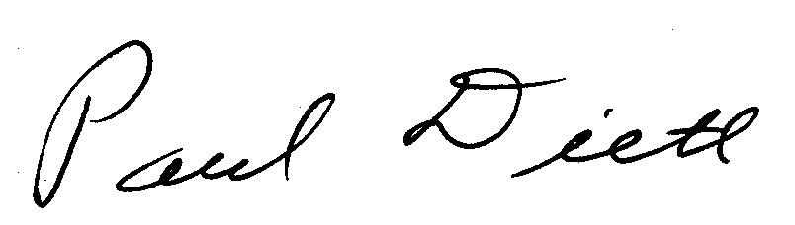
TO: Cabinet Secretaries, Department Heads, Division Directors, and Human Resource Directors

FROM: Paul Dietl, Chief Human Resources Officer

DATE: April 7, 2009

RE: Blood Donation Leave Program

This memorandum is a reminder of the benefit available to state employees who participate in the Massachusetts State Employees Blood Program (MSEBP). It applies to all employees, whether they are managerial, confidential, or covered by a collective bargaining contract.

Employees may take up to four hours leave of absence with pay, subject to advance approval by their supervisors, for the purpose of donating blood at any blood collection site or hospital in Massachusetts. The leave must be taken on the day that the blood donation occurs and covers the travel time, donation time, and recovery time. Employees will not accrue compensatory time in lieu of such leave. This leave may be allowed for a maximum of up to five times annually, during the period of October 1 through September 30 each year. This leave is designated on HR/CMS using the payroll exception code of “BLD”.

Employees who donate blood five times or more between October 1 and September 30 at the American Red Cross, Massachusetts General Hospital, or UMass Memorial Medical Center are also allowed to take up to four hours leave of absence with pay (BLD), subject to approval by their supervisors, to attend the annual MSEBP award ceremonies, which are usually held in November.

The attached revised form is provided by the employee as evidence of having donated blood and should be filed in the employee’s personnel file. Please note the revised form includes arrival and departure time at the blood collection site.

Any questions concerning this leave policy may be directed to the MassHR Employee Service Center (ESC). The ESC contact information is: Main number 617-979-8500, Toll Free 1-855-447-7776, TTY 617-447-7778 and email MassHRESC@MassMail.State.MA.US. You may also visit the ESC website at https://www.mass.gov/employee-self-service.

