INDOOR AIR QUALITY ASSESSMENT

Board of Health
1 Turner Lane
Randolph, Massachusetts 02368

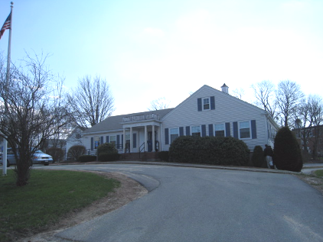

Prepared by:
Massachusetts Department of Public Health
Bureau of Environmental Health
Indoor Air Quality Program
July 2009

Background/Introduction
At the request of John McVeigh, Director of the Randolph Board of Health (RBOH), the Massachusetts Department of Public Health (MDPH), Bureau of Environmental Health (BEH) provided assistance and consultation regarding indoor air quality concerns at the RBOH office located at 1 Turner Lane, Randolph, Massachusetts. The request was prompted due to concerns relative to chronic water damage and mold growth. On April 10, 2009, a visit to the RBOH to conduct an indoor air quality assessment was made by Mike Feeney, Director and Cory Holmes, Environmental Analyst/Inspector for BEH’s Indoor Air Quality (IAQ) Program.
The RBOH office is located in a one-story, vinyl-sided building with an occupied basement. It was reportedly constructed in 1961 and has undergone interior renovations over the years. Windows are openable throughout the building. The RBOH occupies half of the 1st floor; the other half was recently vacated by the Randolph Recreation Department (RRD) and is currently unoccupied. The Randolph Building Department (RBD) is located in the basement. The building contains offices, common areas and meeting rooms. At the time of the assessment no one from the RBD was available, therefore the assessment was limited to accessible areas, (RBOH offices, common areas and space formerly occupied by the RRD).
Methods
Air tests for carbon monoxide, carbon dioxide, temperature and relative humidity were conducted with the TSI, Q-Trak, IAQ Monitor, Model 8551. Air tests for airborne particle matter with a diameter less than 2.5 micrometers were taken with the TSI, DUSTTRAK™ Aerosol Monitor Model 8520. MDPH staff also performed visual inspection of building materials for water damage and/or microbial growth.
Results
The RBOH has an employee population of approximately 7 and can be visited by up to 50 individuals daily. Tests were taken during normal operations and results appear in Table 1.
Discussion
Ventilation
It can be seen from Table 1 that carbon dioxide levels were above 800 parts per million (ppm) in four of eight areas indicating poor air exchange in half of the areas surveyed the day of the assessment. It is important to note, however, that the RBOH does not have mechanical ventilation to introduce fresh air. It appears that the heating, ventilation and air conditioning (HVAC) system is limited to circulating air. The system consist of an air-handling unit (AHU) located in the attic (Picture 1). Conditioned air is distributed to ceiling-mounted air diffusers (Picture 2), and ducted back to the AHU via return vents (Picture 3). The system is controlled by a digital thermostat (Picture 4). Airflow is controlled using a fan switch that has two settings, on and auto. When the fan is set to on, the system provides a continuous source of air circulation and filtration. The automatic setting on the thermostat activates the HVAC system at a preset temperature. Once the preset temperature is reached, the HVAC system is deactivated. Therefore, no mechanical ventilation is provided until the thermostat re-activates the system.
The Massachusetts Building Code requires that each room have a minimum ventilation rate of 20 cubic feet per minute (cfm) per occupant of fresh outside air or openable windows (SBBRS, 1997; BOCA, 1993). The ventilation must be on at all times that the room is occupied. Providing adequate fresh air ventilation with open windows and maintaining the temperature in the comfort range during the cold weather season is impractical. Mechanical ventilation is usually required to provide adequate fresh air ventilation.
Carbon dioxide is not a problem in and of itself. It is used as an indicator of the adequacy of the fresh air ventilation. As carbon dioxide levels rise, it indicates that the ventilating system is malfunctioning or the design occupancy of the room is being exceeded. When this happens, a buildup of common indoor air pollutants can occur, leading to discomfort or health complaints. The Occupational Safety and Health Administration (OSHA) standard for carbon dioxide is 5,000 parts per million parts of air (ppm). Workers may be exposed to this level for 40 hours/week, based on a time-weighted average (OSHA, 1997).
The MDPH uses a guideline of 800 ppm for publicly occupied buildings. A guideline of 600 ppm or less is preferred in schools due to the fact that the majority of occupants are young and considered to be a more sensitive population in the evaluation of environmental health status. Inadequate ventilation and/or elevated temperatures are major causes of complaints such as respiratory, eye, nose and throat irritation, lethargy and headaches. For more information concerning carbon dioxide, please see Appendix A.
Temperature readings in the building ranged from 71º F to 72 º F, which were within the MDPH recommended comfort guidelines. The MDPH recommends that indoor air temperatures be maintained in a range of 70 º F to 78 º F in order to provide for the comfort of building occupants. In many cases concerning indoor air quality, fluctuations of temperature in occupied spaces are typically experienced, even in a building with an adequate fresh air supply.
The relative humidity measured in the building ranged from 26 to 30 percent, which was below the MDPH recommended comfort range in all areas surveyed. The MDPH recommends a comfort range of 40 to 60 percent for indoor air relative humidity. Relative humidity levels in the building would be expected to drop during the winter months due to heating. The sensation of dryness and irritation is common in a low relative humidity environment. Low relative humidity is a very common problem during the heating season in the northeast part of the United States.
Microbial/Moisture Concerns
In order for building materials to support mold growth, a source of water exposure is necessary. IAQ staff examined the roof, exterior walls and basement of the RBOH building in an effort to identify various sources of moisture wetting building materials. Water damaged/mold colonized ceiling tiles were observed in the office formerly occupied by the RRD (Pictures 5 and 6). The US Environmental Protection Agency (US EPA) and the American Conference of Governmental Industrial Hygienists (ACGIH) recommend that porous materials be dried with fans and heating within 24 to 48 hours of becoming wet (US EPA, 2001; ACGIH, 1989). If not dried within this time frame, mold growth may occur. Once mold has colonized porous materials, they are difficult to clean and should be removed/discarded.
Repeated water damage to ceiling tiles, gypsum wallboard and wall-to-wall carpeting can result in mold colonization. In order to prevent mold growth, the source of the water wetting building materials must be identified and remediated. The following likely sources of moisture were noted:
- Water penetration through the exterior walls via penetrations;
- Water penetration through exterior walls due to water impingement;
- Ice dams; and
- Condensation from air conditioning (AC) components.

Water Penetration through Exterior Walls
Water damage in the RRD office is most likely the result of water penetration through the building envelope via an opening in the exterior wall for a portable AC installed directly above this office (Picture 7). The exterior portion of the AC casing projects outward through the exterior wall to form a shelf (Picture 8). Flashing to prevent water penetration around this unit appears to be absent. In easterly winds, rain may be driven through the seams around the AC to force water into the attic. Installation of flashing around ACs installed through exterior walls can prevent moisture penetration (Picture 8A).

Water Penetration through the Exterior Walls Due to Water Impingement
A number of exterior sources for potential moisture penetration due to water impingement were identified:
- Damaged/dislodged gutters and downspouts (Pictures 9 through 12);
- Clinging plants on exterior walls/foundation (Picture 13);
- Trees, vines and shrubbery growing on or in close proximity to the building’s exterior (Pictures 14 through 16); and
- Water trapped between the foundation and handicapped access ramp (Picture 17).
These conditions can undermine the integrity of the building envelope and provide a means of water entry by capillary action into the building through exterior walls, foundation concrete and masonry (Lstiburek & Brennan, 2001).

Ice Dams
RBOH staff, reported the formation of large sections of icicles in the winter, indicating the building is prone to ice dams. Ice dams occur when snow (in contact with the roof) melts to form water on the upper section of the roof and refreezes on the lower portion of the roof to form ice. Heated air from occupied spaces moves upwards and gathers in the peak of the roof, warming the roofing material above water’s melting point (32º F). As water rolls down the sloped roof, it freezes into ice when it comes into contact with roof materials on the lower section of the roof that is below 32º F. This ice creates a dam, which then collects and holds melting snow or rainwater against the roof shingles. Pooling water can subsequently penetrate through the roofing materials via cracks and crevices, resulting in wetting of the interior of the building, usually ceiling tiles that are located near exterior walls of the building where ice dams are occurring (Picture 18).
In order to prevent ice dams, a combination of methods are often used. At the Randolph BOH building, gable vents are located in the east and south walls (Pictures 8 and 8A). The purpose of the gable vents is to allow for cold air to enter the attic space to cool the roof. A cupola exists in the roof (Picture 19), which was likely installed to provide an opening like a ridge vent, allowing free exhaust of heat from the attic space. The floor of the attic space is insulated to prevent air movement and heat loss from the occupied space. This configuration of vents can allow heat to escape so that the attic space has a temperature roughly equal to the outdoor temperature. Installation of insulation will prevent warm air from penetrating the attic and cool air from penetrating the occupied spaces below. In that way, the attic space is maintained at a temperature which reduces the potential for roof materials to melt snow in contact with the roof. If attic insulation is inadequate, or the cupola opening is closed/not installed, then heat can accumulate in the roof peak and start the cycle of ice dam creation. Due to limited access, BEH staff were unable to determine if the cupola was present/open.
An indication of whether ice dams are prone to occur is the temperature of the attic crawlspace. If an attic has a temperature that is close to the outdoor temperature, then it is unlikely that ice dams would form on the roof. Conversely, if the attic is closer to the temperature of the rooms below the attic, then the roof would be prone to developing ice dams. On the day of the assessment, outdoor temperature was 63º F. The temperature of the attic was 71º F which roughly matched the temperature of the occupied space below it (Table 1). This temperature indicates that heat is escaping into the attic from the occupied space. The primary source of heat is most likely ductwork that exists in the attic and is not insulated (Picture 20). In addition other spaces in insulation, around pipes/utilities and around the attic hatch can serve as pathways for heat to enter the attic.

Condensation
As ACs operate, water droplets form on cooling coils called condensation. Condensation is the collection of moisture on a surface at or below the dew point. The dew point is the temperature that air must reach for saturation to occur. Over time, condensation can collect and form water droplets. For this reason, AC units have drip pans and drains installed to remove accumulated moisture from the AC cabinet. Of note is the exterior of the drain for the AC unit in the east wall. This drain appears to be pointed upwards, which may indicate that the drain pan is not emptying. Without proper drainage the drip pan can overflow and cause leakage back into the building. Properly draining drip pans are needed to prevent mold growth indoors. In addition, if the drain pan is not insulated and is continuously chilled by water from the AC, condensation can form on the underside of the pan, which would then drip onto the ceiling tiles above the RRD office.
Another possible source of moisture in the building was from a portable AC that was installed in an interior wall in the basement (Picture 21). Normally, ACs are mounted in windows or through exterior walls, in order to drain condensate outside the building. No obvious sings of drainage for condensate were observed for this AC. The metal base of the AC unit was rusted from pooling water and the wooden surface around it was water damaged (Picture 22). Without proper drainage, pooling water from condensation can damage materials and create mold growth.

Other IAQ Evaluations
Indoor air quality can be negatively influenced by the presence of respiratory irritants, such as products of combustion. The process of combustion produces a number of pollutants. Common combustion emissions include carbon monoxide, carbon dioxide, water vapor and smoke (fine airborne particle material). Of these materials, exposure to carbon monoxide and particulate matter with a diameter of 2.5 micrometers (μm) or less (PM2.5) can produce immediate, acute health effects upon exposure. To determine whether combustion products were present in the building environment, BEH staff obtained measurements for carbon monoxide and PM2.5.
Carbon Monoxide
Carbon monoxide is a by-product of incomplete combustion of organic matter (e.g., gasoline, wood and tobacco). Exposure to carbon monoxide can produce immediate and acute health affects. Several air quality standards have been established to address carbon monoxide and prevent symptoms from exposure to these substances. The MDPH established a corrective action level concerning carbon monoxide in ice skating rinks that use fossil-fueled ice resurfacing equipment. If an operator of an indoor ice rink measures a carbon monoxide level over 30 ppm, taken 20 minutes after resurfacing within a rink, that operator must take actions to reduce carbon monoxide levels (MDPH, 1997).
The American Society of Heating Refrigeration and Air-Conditioning Engineers (ASHRAE) has adopted the National Ambient Air Quality Standards (NAAQS) as one set of criteria for assessing indoor air quality and monitoring of fresh air introduced by HVAC systems (ASHRAE, 1989). The NAAQS are standards established by the US EPA to protect the public health from six criteria pollutants, including carbon monoxide and particulate matter (US EPA, 2006). As recommended by ASHRAE, pollutant levels of fresh air introduced to a building should not exceed the NAAQS levels (ASHRAE, 1989). The NAAQS were adopted by reference in the Building Officials & Code Administrators (BOCA) National Mechanical Code of 1993 (BOCA, 1993), which is now an HVAC standard included in the Massachusetts State Building Code (SBBRS, 1997). According to the NAAQS, carbon monoxide levels in outdoor air should not exceed 9 ppm in an eight-hour average (US EPA, 2006).
Carbon monoxide should not be present in a typical, indoor environment. If it is present, indoor carbon monoxide levels should be less than or equal to outdoor levels. On the day of assessment, outdoor carbon monoxide concentrations were non-detect (ND) (Table 1). Carbon monoxide levels measured in the building were also ND.
Particulate Matter (PM2.5)
The US EPA has established NAAQS limits for exposure to particulate matter. Particulate matter is airborne solids that can be irritating to the eyes, nose and throat. The NAAQS originally established exposure limits to particulate matter with a diameter of 10 μm or less (PM10). According to the NAAQS, PM10 levels should not exceed 150 microgram per cubic meter (μg/m³) in a 24-hour average (US EPA, 2006). These standards were adopted by both ASHRAE and BOCA. Since the issuance of the ASHRAE standard and BOCA Code, US EPA established a more protective standard for fine airborne particles. This more stringent PM2.5 standard requires outdoor air particle levels be maintained below 35 μg/m³ over a 24-hour average (US EPA, 2006). Although both the ASHRAE standard and BOCA Code adopted the PM10 standard for evaluating air quality, MDPH uses the more protective PM2.5 standard for evaluating airborne particulate matter concentrations in the indoor environment.
Outdoor PM2.5 concentrations were measured at 16 μg/m³ (Table 1). PM2.5 levels measured in the building ranged from 10 to 14 μg/m³ (Table 1), which were below the NAAQS of 35 μg/m³ (Table 1). Frequently, indoor air levels of particulates (including PM2.5) can be at higher levels than those measured outdoors. A number of mechanical devices and/or activities that occur in buildings can generate particulate matter during normal operations. Sources of indoor airborne particulates may include but are not limited to particles generated during the operation of fan belts in the HVAC system, cooking in the cafeteria stoves and microwave ovens; use of photocopiers, fax machines and computer printing devices; operation of an ordinary vacuum cleaner and heavy foot traffic indoors.
Other Conditions
Several other conditions that can potentially affect indoor air quality were identified during the assessment. In a number of areas, items were observed on the floor, windowsills, tabletops, counters, bookcases and desks. The large number of items stored provides a source for dusts to accumulate. These items (e.g., papers, folders, boxes) make it difficult for custodial staff to clean. Items should be relocated and/or be cleaned periodically to avoid excessive dust build up. In addition, these materials can accumulate on flat surfaces (e.g., desktops, windowsills and carpets) in occupied areas and subsequently be re-aerosolized causing further irritation.
Several supply, exhaust and return vents were observed to have accumulated dust/debris. If exhaust vents are not functioning, backdrafting can occur, which can re-aerosolize accumulated dust particles. Re-activated supply vent can aerosolize accumulated dust.
Finally, fluorescent light fixtures were missing covers in a number of areas (Picture 23). Fixtures should be equipped with access covers installed with bulbs fully secured in their sockets. Breakage of glass can cause injuries and may release mercury and/or other hazardous compounds.
Conclusions/Recommendations
In view of the findings at the time of the visit, the following recommendations are made to improve indoor air quality:
- Enhance air exchange by using openable windows to control for comfort. Care should be taken to ensure windows are properly closed as needed to avoid the freezing of pipes and potential flooding during the winter season.
- Operate the HVAC system continuously in the fan “on” mode during periods of occupancy to maximize air circulation and filtration.
- Work with town officials to develop a preventive maintenance program for all HVAC equipment.
- For buildings in New England, periods of low relative humidity during the winter are often unavoidable. Therefore, scrupulous cleaning practices should be adopted to minimize common indoor air contaminants whose irritant effects can be enhanced when the relative humidity is low. To control for dusts, a HEPA filter equipped vacuum cleaner in conjunction with wet wiping of all surfaces is recommended. Drinking water during the day can help ease some symptoms associated with a dry environment (throat and sinus irritations).
- Ensure that the cupola on the roof (Picture 19) is open in order to vent heat from the roof.
- Consider insulating all attic ductwork.
- Ensure that insulation in the attic floor is complete; install insulation as needed.
- Insulate the attic hatch and install weather-stripping around the hatchway opening and any pipes or other utility penetrations through the attic floor.
- Install flashing around wall-mounted air conditioners.
- Ensure the wall-mounted AC unit drip pans drain properly and have an insulated underside.
- Seal breaches in the building exterior to prevent further water penetration, particulary around the AC outside of former RRD area.
- Install drainage hose/pump for portable AC in basement.
- Remove/replace water damaged/mold colonized ceiling tiles. Examine the area above and around these areas for mold growth. Disinfect areas of water leaks with an appropriate antimicrobial.
- Repair gutters and downspouts to drain water away from the building.
- Remove clinging plants and vegetation/overhanging branches from building exterior.
- Clean carpeting annually or semi-annually in soiled high traffic areas as per the recommendations of the Institute of Inspection, Cleaning and Restoration Certification (IICRC). Copies of the IICRC fact sheet can be downloaded at: http://www.cleancareseminars.com/carpet_cleaning_faq4.htm (IICRC, 2005)
- Relocate or consider reducing the amount of materials stored in common areas to allow for more thorough cleaning. Clean items regularly with a wet cloth or sponge to prevent excessive dust build-up.
- Clean supply, exhaust and return vents periodically of accumulated dust.
- Replace all covers for fluorescent light fixtures.
- For more information on mold consult as “Mold Remediation in Schools and Commercial Buildings” published by the US Environmental Protection Agency (US EPA, 2001). Copies of this document can be downloaded from the US EPA website at: http://www.epa.gov/iaq/molds/mold_remediation.html
- Refer to resource manuals and other related indoor air quality documents for further building-wide evaluations and advice on maintaining public buildings. Copies of these materials are located on the MDPH’s website: http://mass.gov/dph/indoor_air
References
ACGIH. 1989. Guidelines for the Assessment of Bioaerosols in the Indoor Environment. American Conference of Governmental Industrial Hygienists, Cincinnati, OH.
ASHRAE. 1989. Ventilation for Acceptable Indoor Air Quality. American Society of Heating, Refrigeration and Air Conditioning Engineers. ANSI/ASHRAE 62-1989
BOCA. 1993. The BOCA National Mechanical Code-1993. 8th ed. Building Officials & Code Administrators International, Inc., Country Club Hills, IL.
IICRC. 2005. Carpet Cleaning FAQ 4 Institute of Inspection, Cleaning and Restoration Certification. Institute of Inspection Cleaning and Restoration, Vancouver, WA.

Lstiburek, J. & Brennan, T. 2001. Read This Before You Design, Build or Renovate. Building Science Corporation, Westford, MA. U.S. Department of Housing and Urban Development, Region I, Boston, MA
MDPH. 1997. Requirements to Maintain Air Quality in Indoor Skating Rinks (State Sanitary Code, Chapter XI). 105 CMR 675.000. Massachusetts Department of Public Health, Boston, MA.
OSHA. 1997. Limits for Air Contaminants. Occupational Safety and Health Administration. Code of Federal Regulations. 29 C.F.R 1910.1000 Table Z-1-A.

SBBRS. 1997. Mechanical Ventilation. State Board of Building Regulations and Standards. Code of Massachusetts Regulations. 780 CMR 1209.0
US EPA. 2001. “Mold Remediation in Schools and Commercial Buildings”. Office of Air and Radiation, Indoor Environments Division, Washington, DC. EPA 402-K-01-001. March 2001. Available at: http://www.epa.gov/iaq/molds/mold_remediation.html
US EPA. 2006. National Ambient Air Quality Standards (NAAQS). US Environmental Protection Agency, Office of Air Quality Planning and Standards, Washington, DC. http://www.epa.gov/air/criteria.html
Picture 1

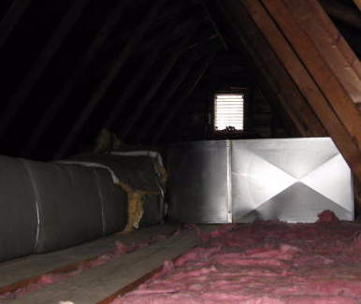

AHU in Attic Crawlspace

Picture 2

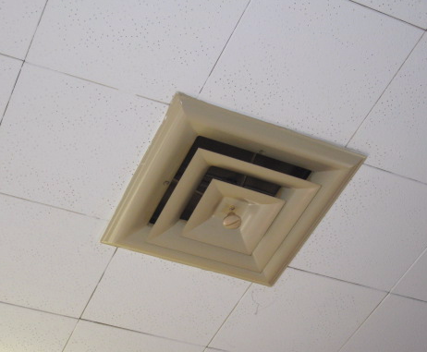

Ceiling-Mounted Air Diffuser

Picture 3

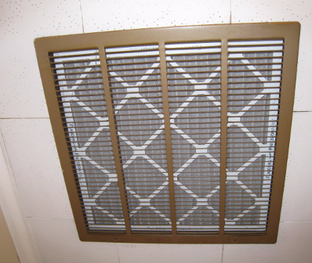

Ceiling-Mounted Return Vent

Picture 4

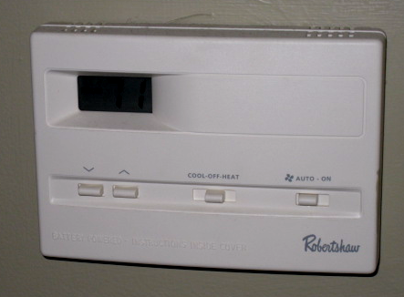

Digital Thermostat, Note Fan in “Auto” Position

Picture 5

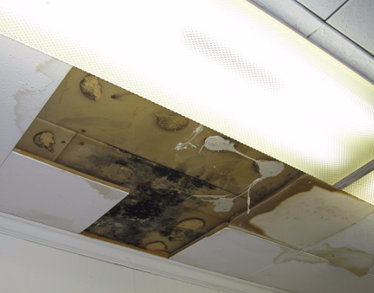

Water Damaged/Mold Colonized Ceiling Tiles/Panels in former RRD Office

Picture 6

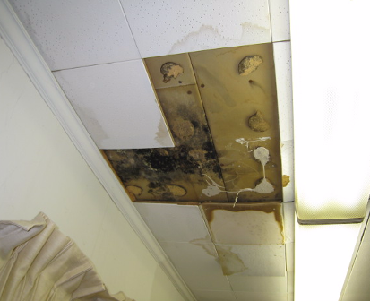

Water Damaged/Mold Colonized Ceiling Tiles/Panels in former RRD Office

Picture 7

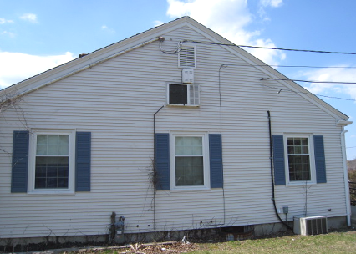

Note Air Conditioner Installed Through Exterior Wall over Center Window of Former Randolph Recreation Department

Picture 7A

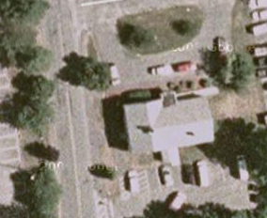

Aerial View of RBOH Building, East Wall Contains Attic Wall-Mounted Air Conditioner Shown in Picture 7

Picture 8
Ledge Gable Vent
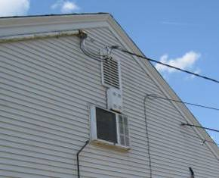

East Wall AC, Note Ledge

Picture 8A
AC Unit Gable Vent
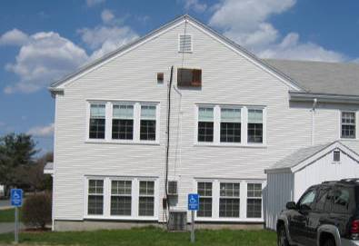

Wall-mounted AC in South Exterior Wall

Picture 9

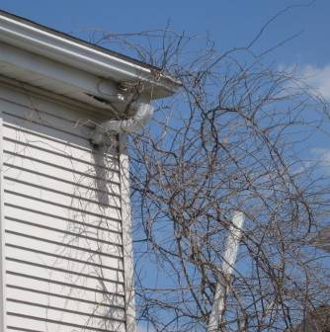

Disconnected Gutter/Downspout

Picture 10

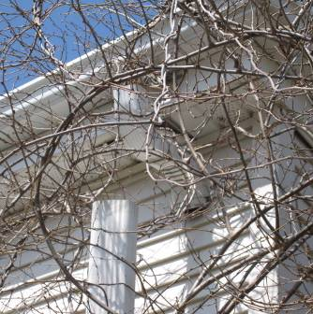

Disconnected Gutter/Downspout

Picture 11

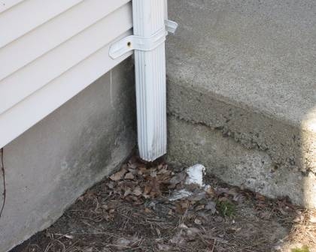

Missing Elbow Extension on Downspout, Which Empties against Foundation

Picture 12

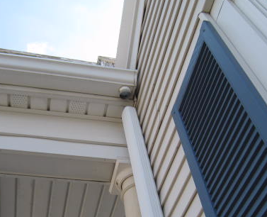

Disconnected Gutter/Downspout

Picture 13

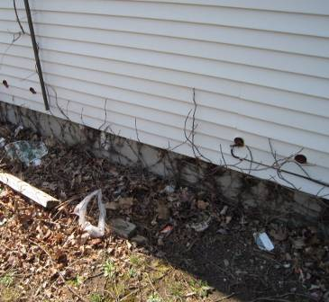

Clinging Plants Growing on Exterior Wall

Picture 14

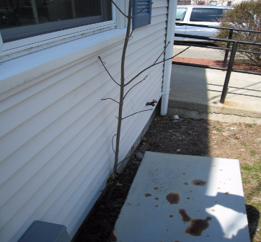

Small Tree Growing against Foundation

Picture 15

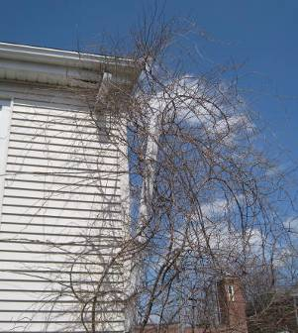

Tree/Vines Growing in Close Proximity to Building Exterior

Picture 16

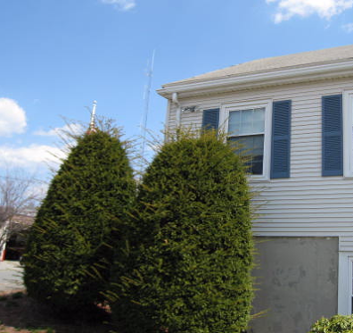

Shrubbery in Close Proximity to Exterior Walls

Picture 17

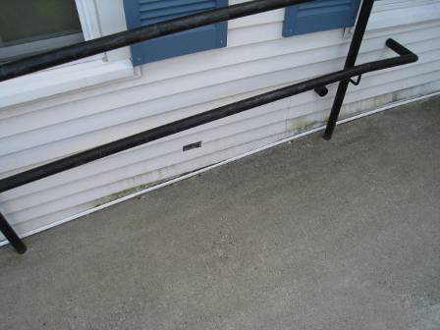

Seam between Foundation and Retrofitted Access Ramp
(Note Moss Growth on Vinyl Siding)
Picture 18

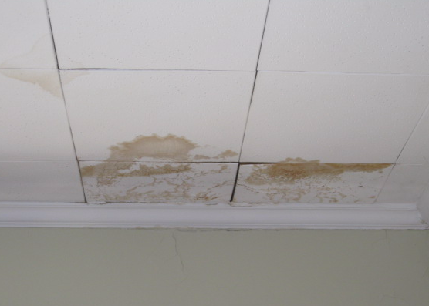

Water Damaged Ceiling Tiles in BOH Office

Picture 19

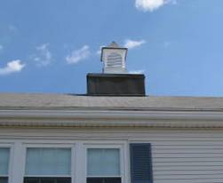

Roof Cupola

Picture 20

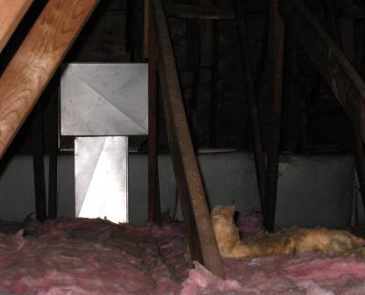

Uninsulated Ductwork in Attic That Would be a Source of Heat

Picture 21

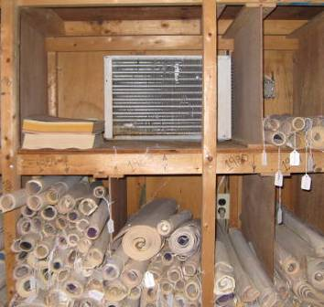

AC Unit Installed through Interior Wall in Basement

Picture 22

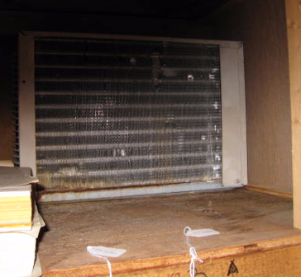

AC Unit, Note Rust along Bottom of Unit and Water Damaged Wood

Picture 23

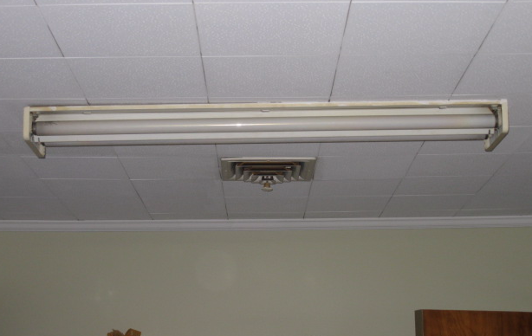

Missing Cover on Fluorescent Light Fixture
Location/ Room | Occupants  in Room | Temp  (°F) | Relative  Humidity  (%) | Carbon  Dioxide  (ppm) | Carbon Monoxide  (ppm) | PM2.5  (µg/m3) | Windows  Openable | Ventilation |  | Remarks
 |  |  |  |  |  |  |  | Supply | Exhaust | Remarks
background |  | 63 | 19 | 376 | ND | 16 |  |  |  | Sunny, cool
BOH meeting room | 3 | 71 | 29 | 920 | ND | 14 | Y | N | N
Director Office | 0 | 71 | 28 | 841 | ND | 11 | Y | N | N | Carpet loose/dirty
Admin | 1 | 72 | 27 | 838 | ND | 11 | Y | N | N | Dust accumulation on vents, no cover fluorescent lights
Nurse’s Office | 0 | 71 | 26 | 756 | ND | 11 | Y | N | N | WD CT
Exam Room | 0 | 71 | 27 | 838 | ND | 10 | Y | N | N | WD CT, dust/cobwebs
Attic Crawlspace | 0 | 71 | 30 | 796 | ND
Kitchen/  Breakroom | 0 | 71 | 26 | 600 | ND | 11 | Y | N | N
Recreation Dept | 0 | 66 | 29 | 581 | ND | 10 | Y | N | N | Water damage/roof leak, visible mold growth on ceiling material

Building envelope is the roof, exterior walls, fenestrations, door systems and the foundation.

