INDOOR AIR QUALITY ASSESSMENT

Board of Registration in Medicine
200 Harvard Mill Square, Suite 330
Wakefield, Massachusetts

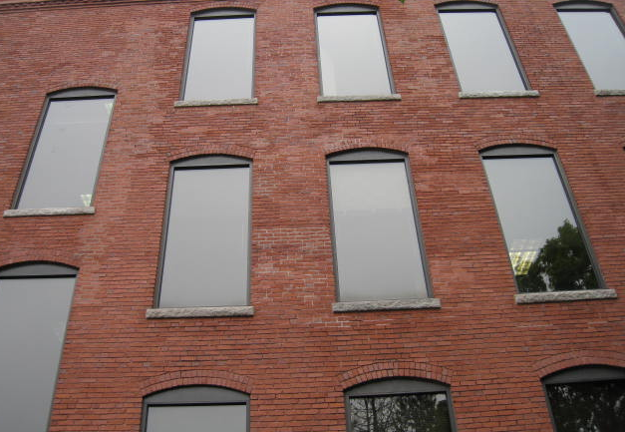

Prepared by:
Massachusetts Department of Public Health
Bureau of Environmental Health
Indoor Air Quality Program
July 2019

Background

Building: | Board of Registration in Medicine (BORIM)
Address: | 200 Harvard Mill Square, Suite 330 Wakefield, MA
DCAMM Project Manager: | Debbie Russell, Senior Project Manager, Division of Capital Asset Management and Maintenance (DCAMM)
Reason for Request: | Follow up assessment due to construction on floor above BORIM office suite
Date of Assessment: | April 23, 2019
Massachusetts Department of Public Health/Bureau of Environmental Health (MDPH/BEH) Staff Conducting Assessment: | Jason Dustin, Environmental Analyst/Inspector, Indoor Air Quality (IAQ) Program
Building Description: | The BORIM space is located on the third floor of a large, brick four-story former mill building. The space is composed of private offices, open work areas, and conference rooms. Most areas have carpeting.
Windows: | Windows are not openable.

Methods
Please refer to the IAQ Manual for methods, sampling procedures, and interpretation of results (MDPH, 2015).

Results and Discussion
This building was previously visited by the BEH/IAQ program in 2010 and again in early April 2019. The link to the reports from the visits can be found on the BEH/IAQ website at https://www.mass.gov/info-details/indoor-air-quality-reports-cities-and-towns-w
The following is a summary of indoor air testing results (Table 1).
- Carbon dioxide levels were below the MDPH guideline of 800 parts per million (ppm) in the majority of areas assessed.
- Temperature was within the MDPH recommended range of 70°F to 78°F in all areas.
- Relative humidity was within the MDPH recommended range of 40% to 60% in all areas assessed.
- Carbon monoxide levels were non-detectable (ND) in all indoor areas assessed.
- Fine particulate matter (PM2.5) concentrations measured were below the National Ambient Air Quality Standard (NAAQS) level of 35 micrograms per cubic meter (μg/m³) in all occupied areas.
- Total Volatile Organic Compounds (TVOCs) were ND in all areas assessed.

Ventilation
A heating, ventilating, and air conditioning (HVAC) system has several functions. First it provides heating and, if equipped, cooling. Second, it is a source of fresh air. Finally, an HVAC system will dilute and remove normally occurring indoor environmental pollutants by not only introducing fresh air, but by filtering the airstream and ejecting stale air to the outdoors via exhaust ventilation. Even if an HVAC system is operating as designed, point sources of respiratory irritation may exist and cause symptoms in sensitive individuals.
The HVAC system in the BORIM space consists of large rooftop air handling units (AHUs) that draw in fresh air from intakes on the roof and supply fresh air to two mechanical rooms through round supply ducts. These ducts are not connected to the AHUs so the mechanical rooms act as a mixing room. Return air is brought back to the AHUs through a combination of return vents, partial ceiling plenums, and passive vents.
BEH/IAQ staff noted that some thermostat controls were still set to “Fan Auto” instead of the recommended “Fan On” setting. This will turn off the supply of fresh air/exhaust ventilation when the thermostat settings are reached which can lead to the buildup of commonly found indoor air pollutants. This will occur more frequently in temperate weather.
To maximize air exchange, the MDPH recommends that both supply and exhaust ventilation operate continuously during periods of occupancy. In order to have proper ventilation with a mechanical supply and exhaust system, the systems must be balanced to provide an adequate amount of fresh air to the interior of a room while removing stale air from the room. It is recommended that HVAC systems be re-balanced every five years to ensure adequate air systems function (SMACNA, 1994).

Microbial/Moisture Concerns
Occupants near a window outside open cubicle area 322 reported that there is an active water leak in this area (Picture 1). Property managers were aware of this leak and have been seeking remedies. Chronic water leaks can cause microbial colonization of porous building materials if the porous materials are not dried properly.
Plants were noted in some occupied areas. Plants can be a source of odors, pollen and mold. Plants should be kept in good condition, not overwatered, and not placed on porous materials.

Construction Activity Concerns
The fourth floor (above the BORIM space) was actively being renovated in the evening prior to this assessment. Many pathways between the BORIM-occupied space and the area under construction noted in the previous report were observed to be sealed (Picture 2).
Some occupied areas in the BORIM space had a layer of dust on flat surfaces (Picture 3). This dust may or may not have been in place prior to the construction. However, flat surfaces should be thoroughly wet-wiped and floors vacuumed with a high efficiency particulate arrestance (HEPA) filter-equipped vacuum cleaner prior to occupants returning to work in the morning following construction activities.

Other Issues
Hand sanitizers, scented cleaning products, and air fresheners were noted in some areas of the office space. These products can cause irritation of the eyes, nose, and respiratory system of some people.
Most flooring is covered with carpet. The Institute of Inspection, Cleaning and Restoration Certification (IICRC), recommends that carpeting be cleaned annually (or semi-annually in soiled high traffic areas) (IICRC, 2012).

Conclusions/Recommendations
Based on the observations made during the visit, the following is recommended:
- Continue performing construction during unoccupied hours.
- Seal any remaining pathways between occupied and unoccupied/construction areas to prevent infiltration of dust and odors.
- Cover BORIM workstations with plastic drop cloths in areas below active construction prior to evening renovations/demolition.
- Occupants should keep workstations free from accumulated items so that custodial staff can have better access.
- During the active construction project, perform daily wet wiping of surfaces and HEPA vacuuming of carpeting prior to occupants returning to work.
- Property managers and contractors should continue to consult the MDPH guideline: “Construction and renovation generated pollutants in occupied buildings” as well as the SMACNA 2007 guideline referenced in the previous report.
- Continue to ensure that occupants are made aware of construction scheduling and have a system to report any construction-related concerns.
- Operate the HVAC system to provide for continuous fresh air ventilation during occupied hours. Inspect all thermostats to ensure that they are set for “fan on” instead of the “fan auto” setting.
- Ensure the mixing rooms are kept clean to prevent entrainment of dust, debris or odors into supply air.
- Continue to change filters for HVAC equipment 2-4 times a year. Use pleated filters with a Minimum Efficiency Reporting Value (MERV) 8 (or higher), which are adequate in filtering out pollen and mold spores (ASHRAE, 2012), if these can be used with current equipment.
- Consider adopting a balancing schedule of every 5 years for all mechanical ventilation systems, as recommended by ventilation industrial standards (SMACNA, 1994).
- Repair any known active water leaks. Monitor any areas of suspected water infiltration and ensure porous building materials are dried within 24-48 hours. Discard any water-damaged porous materials that have not been properly dried.
- Properly maintain plants, including drip pans, to prevent water damage to porous materials. Plants should also be located away from air diffusers to prevent the aerosolization of dirt, pollen, and mold.
- Reduce or eliminate the use of scented cleaners, hand sanitizers, and personal air fresheners.
- Follow any remaining recommendations from the April 2019 report.
- Clean carpeting at least once per year according to IICRC recommendations (IICRC 2012). Regularly vacuum carpeting with a HEPA-filtered vacuum cleaner even after construction is completed.
- Refer to resource manuals and other related IAQ documents for further building-wide evaluations and advice on maintaining public buildings. Copies of these materials are located on the MDPH’s website: http://mass.gov/dph/iaq.

References
ASHRAE. 2012. American Society of Heating, Refrigeration and Air Conditioning Engineers (ASHRAE) Standard 52.2-2012 -- Method of Testing General Ventilation Air-Cleaning Devices for Removal Efficiency by Particle Size (ANSI Approved).
IICRC. 2012. Institute of Inspection Cleaning and Restoration Certification. Institute of Inspection, Cleaning and Restoration Certification. Carpet Cleaning: FAQ.
MDPH. 2015. Massachusetts Department of Public Health. “Indoor Air Quality Manual: Chapters I-III”. Available at: http://www.mass.gov/eohhs/gov/departments/dph/programs/environmental-health/exposure-topics/iaq/iaq-manual/.
SMACNA. 1994. HVAC Systems Commissioning Manual. 1st ed. Sheet Metal and Air Conditioning Contractors’ National Association, Inc., Chantilly, VA.
SMACNA. 2007. IAQ Guidelines for Occupied Buildings Under Construction. Sheet Metal and Air Conditioning Contractors National Association, Inc. Chantilly, VA.
Picture 1
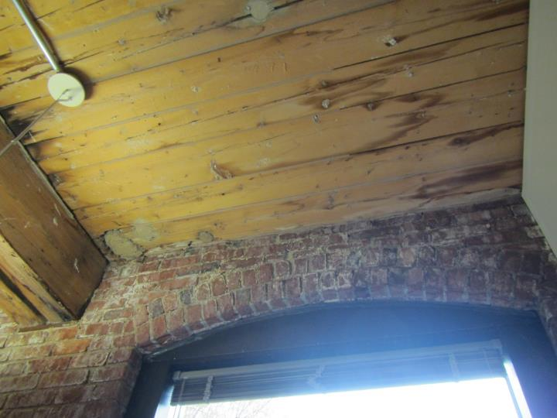
Area of reported active water leak
Picture 2
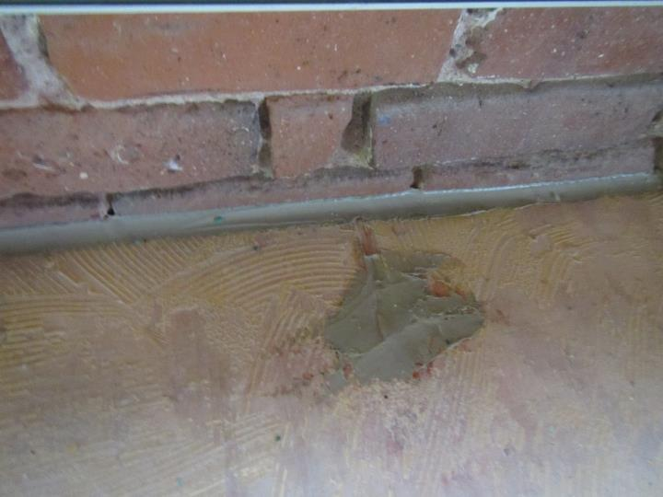
Holes and seam along brick wall (pathways) have been sealed
Picture 3
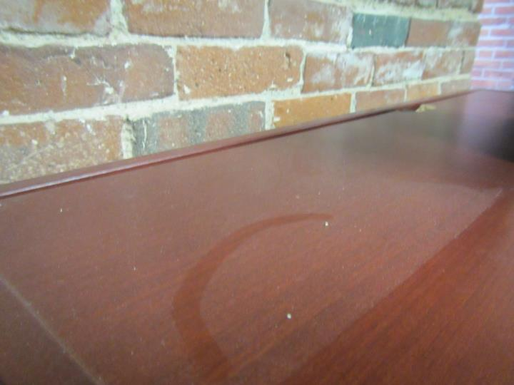
Dust on flat surface in BORIM space

Location | Carbon  Dioxide  (ppm) | Carbon Monoxide  (ppm) | Temp  (°F) | Relative  Humidity  (%) | PM2.5  (µg/m³) | TVOCs  (ppm) | Occupants  in Room | Windows  Openable | Ventilation |  | Remarks
 |  |  |  |  |  |  |  |  | Supply | Exhaust
Background | 382 | ND | 58 | 72 | 13 | ND | - | - | - | - | Overcast, drizzle
Conference 305 | 576 | ND | 70 | 54 | 3 | ND | 2 | N | Y | Y
306 | 593 | ND | 72 | 51 | 2 | ND | 1 | N | Y | Y | Carpet
307 | 525 | ND | 73 | 49 | 2 | ND | 1 | N | Y | Y | Carpet
Outside 311 | 557 | ND | 73 | 47 | 2 | ND | 2 | N | Y | Y
322 open cubes | 657 | ND | 73 | 47 | 3 | ND | 2 | N | Y | Y | Active water leak reported
333 | 681 | ND | 73 | 47 | 5 | ND | 2 | N | Y | Y
Library | 625 | ND | 72 | 46 | 6 | ND | 2 | N | Y | Y
Break | 644 | ND | 72 | 47 | 4 | ND | 2 | N | Y | Y | Vinyl flooring
Conference G | 675 | ND | 72 | 47 | 6 | ND | 1 | N | Y | Y
367 | 820 | ND | 72 | 49 | 4 | ND | 3 | N | Y | Y
368 | 907 | ND | 73 | 50 | 7 | ND | 4 | N | Y | Y | Carpet, plants
369 | 869 | ND | 74 | 47 | 6 | ND | 3 | N | Y | Y | Carpet
Conference H | 788 | ND | 73 | 48 | 7 | ND | 1 | N | Y | Y
376 open | 811 | ND | 73 | 47 | 8 | ND | 2 | N | Y | Y
384 open | 818 | ND | 73 | 49 | 9 | ND | 2 | N | Y | Y
394 open | 817 | ND | 73 | 46 | 8 | ND | 2 | N | Y | Y
400 open | 745 | ND | 73 | 46 | 9 | ND | 0 | N | Y | Y
408 | 737 | ND | 73 | 47 | 6 | ND | 1 | N | Y | Y
402 open | 795 | ND | 73 | 46 | 6 | ND | 1 | N | Y | Y
409 | 790 | ND | 73 | 46 | 8 | ND | 1 | N | Y | Y
411 open | 723 | ND | 73 | 45 | 7 | ND | 1 | N | Y | Y
417 | 667 | ND | 73 | 46 | 8 | ND | 0 | N | Y | Y
418 | 657 | ND | 72 | 46 | 9 | ND | 0 | N | Y | Y
422 open | 660 | ND | 73 | 46 | 11 | ND | 0 | N | Y | Y
Gen counsel | 760 | ND | 73 | 47 | 7 | ND | 1 | N | Y | Y | Accumulated items, dry erase materials
4258 open | 676 | ND | 73 | 47 | 9 | ND | 3 | N | Y | Y
317 | 647 | ND | 74 | 45 | 10 | ND | 1 | N | Y | Y
328 | 672 | ND | 74 | 45 | 7 | ND | 1 | N | Y | Y
351 | 681 | ND | 74 | 44 | 6 | ND | 1 | N | Y | Y

