The Commonwealth of Massachusetts
Executive Office of Health and Human Services
Department of Public Health
Bureau of Health Professions Licensure
250 Washington Street, Boston, MA 02108-4619
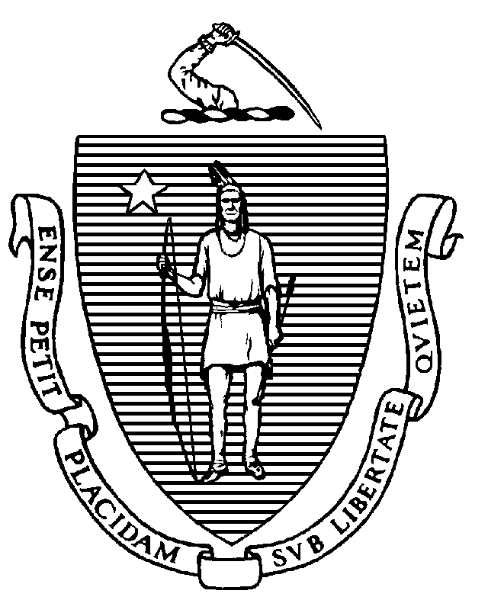

CHARLES D. BAKER
Governor
KARYN E. POLITO
Lieutenant Governor

MARYLOU SUDDERS
Secretary
MARGRET R. COOKE Commissioner

⁂ Microsoft Teams Meeting ⁂
Join on your computer or mobile app
Click here to join the meeting
Or call in (audio only)
Phone: 857-327-9245
Phone Conference ID: 924 547 256#

December 2, 2022, Location: Virtual Meeting Time: 9:00 a.m.

Housekeeping and Meeting Procedures (Ms. Lewis)

Call Meeting to Order (Lisa Brown)
- Attendance roll call
- Approval of agenda

General Business:
- Conflict of Interest and Open Meeting Law Requirements (Sheila York, Esq.)
- Minutes from Public Meeting of September 9, 2022
- Executive Director Report (Eboni Lewis)
  - MoveIT
  - PACE Trainings
  - Webex Meeting Platform/Recorded Meetings
  - eLX Licensing System
- 2023 Board Meeting Dates

Discussion:
- Board’s transition to Department of Public Health
- Data verification project
- Pending Exam Applications

Application Review
- LDNNE2022-000018 (KV)
https://nteducationcommission.org.uk/trainers/

New Business:
- Open Session for Topics not reasonably anticipated by the Chair 48 hours before meeting

Public Comment
Investigative Case Conference [Closed Session: G.L. c. 112, § 65C]

