INDOOR AIR QUALITY ASSESSMENT

Massachusetts Board of Registration in Medicine
200 Harvard Mill Square, Suite 330
Wakefield, MA



Prepared by:
Massachusetts Department of Public Health
Bureau of Environmental Health
Indoor Air Quality Program
September 2010

Background/Introduction
At the request of Mr. Russell Aims, Special Assistant to the Board, Massachusetts Board of Registration in Medicine (MBRM), the Massachusetts Department of Public Health (MDPH), Bureau of Environmental Health (BEH) conducted an indoor air quality assessment at the MBRM office located at 200 Harvard Mill Square, Suite 330, Wakefield, Massachusetts. The request was prompted by concerns related to building materials damaged as a result of water infiltration through exterior walls during heavy, wind-driven rains that occurred over the winter/spring of 2010. On May 18, 2010, a visit to conduct an indoor air quality assessment was made by Michael Feeney, Director of BEH’s Indoor Air Quality (IAQ) Program.
The Harvard Mill Square Complex is a four-story office building, originally constructed as a mill in the 1880s. The building was renovated into office space in the mid-1980s. The MBRM moved into renovated space on the 3rd floor of the building in 2008. Windows are not openable in the MBRM offices.
In response to concerns regarding water infiltration, the MBRM office was evaluated in April 2010, by an environmental consultant [Covino Environmental Associate, Inc. (CEA)]. CEA conducted a limited microbial assessment and made the following recommendations based on their evaluation:
The carpeting in the Board of Medicine office suite should be cleaned using the following three-step protocol: (1) thoroughly clean using vacuum cleaners equipped with high-efficiency particle air (sic) (HEPA) filters; (2) steam clean using effective extraction methods to minimize the potential for over-wetting the carpeting and (3) HEPA vacuum. After the thorough cleaning, the carpeting should be cleaned regularly using HEPA-filtered vacuum cleaners (CEA, 2010).
No other recommendations were made in this report.

Methods
Air tests for carbon monoxide, carbon dioxide, temperature and relative humidity were conducted with the TSI, Q-Trak, IAQ Monitor, Model 8551. Air tests for airborne particle matter with a diameter less than 2.5 micrometers were taken with the TSI, DUSTTRAK™ Aerosol Monitor Model 8520. BEH staff also performed visual inspection of building materials for water damage and/or microbial growth.

Results
The MBRM offices have an employee population of approximately 80. Tests were taken during normal operations and appear in Table 1.

Discussion

Ventilation
It can be seen from Table 1 that carbon dioxide levels were below 800 parts per million (ppm) in all areas surveyed, indicating adequate air exchange. It is important to note that at the time of assessment a number of areas were unoccupied or sparsely populated, which can greatly reduce carbon dioxide levels. Carbon dioxide levels would be expected to increase with higher occupancy.
The configuration of the mechanical supply system is atypical of those generally observed by BEH staff. A rooftop air-handling unit (AHU) delivers fresh air to two mechanical rooms on the MBRM floor as well as other floors of the building through ductwork (Pictures 1 and 2); ductwork branching from the main trunk provides air to smaller AHUs within each of the two mechanical rooms on the third floor. However, the round ductwork branching from the main trunk is not connected directly to the mechanical room AHUs, but rather these round ducts empty air in front of the AHU intake vents (Pictures 3 and 4). Fresh, tempered air drawn into the AHUs is distributed to occupied areas via ceiling and wall-mounted air diffusers (Pictures 5 and 6).
The return air system uses an unusual method of partial duct ceiling plenum to return air back to the mechanical rooms. Offices along the southern exterior wall have wall-mounted passive return vents connected to ducts that traverse the interior wall and terminate in the walkway in a 90º angled vent (Pictures 5 and 6; Figure 1). A partially suspended ceiling installed over cubicles appears to act like a duct, creating a space through which return air can be drawn into wall-mounted return vents on the wall opposite from the 90º angled vents for offices along the south wall (Picture 7; Figure 1). Based on HVAC plans provided to BEH staff, it appears that a full ceiling plenum in offices near the mechanical room serves as a conduit for air to enter mechanical rooms through the aforementioned wall-mounted return vents (Figure 1). Each mechanical room essentially functions as an air mixing room that contributes to the overall HVAC system. In this configuration, there appears to be minimal control over the ratio of fresh air to return air.
Of note is the passive exhaust vent for room 315. As discussed, ductwork for passive exhaust vents of offices exit out the office wall and terminate at a 90º angle. A similar vent exists for room 315; however, the duct work vent is oriented in a manner that results in decreased draw of air from this room (Picture 8).
Absent from this design is an obvious means for air to be exhausted from the building. In Mechanical Room A (Figure 2), a small fan was operating intermittently. The size of this fan does not appear to be sufficient to exhaust air from the mechanical room and the area serviced by the system in Mechanical Room A. For areas serviced by mechanical room B, no means to exhaust air was observed. It is possible that exhaust ventilation in this area was intended to be provided by the restroom exhaust vents. However, the restroom exhaust was not operating at the time of assessment; therefore, no exhaust ventilation was being provided. Based on the current configuration, it does not appear that the HVAC system provides even minimum exhaust ventilation to remove normally occurring pollutants from the indoor environment. Without appropriate exhaust ventilation, normally occurring environmental pollutants can accumulate, which may cause eye, nose and respiratory irritation.
To maximize air exchange, the MDPH recommends that both supply and exhaust ventilation operate continuously during periods of occupancy. In order to have proper ventilation with a mechanical supply and exhaust system, the systems must be balanced to provide an adequate amount of fresh air to the interior of a room while removing stale air from the room. It is recommended that HVAC systems be re-balanced every five years to ensure adequate air systems function (SMACNA, 1994). The date of the last balancing of these systems was July 17, 2008, by Milharmer Associates, Inc. (MAI, 2008).
The Massachusetts Building Code requires that each area have a minimum ventilation rate of 20 cubic feet per minute (cfm) per occupant of fresh outside air or openable windows (SBBRS, 1997; BOCA, 1993). The ventilation must be on at all times that the room is occupied. Providing adequate fresh air ventilation with open windows and maintaining the temperature in the comfort range during the cold weather season is impractical. Mechanical ventilation is usually required to provide adequate fresh air ventilation.
Carbon dioxide is not a problem in and of itself. It is used as an indicator of the adequacy of the fresh air ventilation. As carbon dioxide levels rise, it indicates that the ventilating system is malfunctioning or the design occupancy of the room is being exceeded. When this happens, a buildup of common indoor air pollutants can occur, leading to discomfort or health complaints. The Occupational Safety and Health Administration (OSHA) standard for carbon dioxide is 5,000 parts per million parts of air (ppm). Workers may be exposed to this level for 40 hours/week, based on a time-weighted average (OSHA, 1997).
The MDPH uses a guideline of 800 ppm for publicly occupied buildings. A guideline of 600 ppm or less is preferred in schools due to the fact that the majority of occupants are young and considered to be a more sensitive population in the evaluation of environmental health status. Inadequate ventilation and/or elevated temperatures are major causes of complaints such as respiratory, eye, nose and throat irritation, lethargy and headaches. For information concerning carbon dioxide, please see Appendix A.
Temperature readings ranged from 69º F to 75 º F, which were within or very close to the lower end of the MDPH recommended comfort guidelines (Table 1). The MDPH recommends that indoor air temperatures be maintained in a range of 70 º F to 78 º F in order to provide for the comfort of building occupants. In many cases concerning indoor air quality, fluctuations of temperature in occupied spaces are typically experienced, even in a building with an adequate fresh air supply.
The relative humidity measured ranged from 39 to 45 percent, which was also within or very close to the lower end of the MDPH recommended comfort range (Table 1). The MDPH recommends a comfort range of 40 to 60 percent for indoor air relative humidity. Relative humidity levels in the building would be expected to drop during the winter months due to heating. The sensation of dryness and irritation is common in a low relative humidity environment.

Microbial/Moisture Concerns
The office space appears to be experiencing water penetration through the exterior walls and/or window system. The brick exterior wall system appears to lack a curtain wall, which is typical of mill buildings of this sort. Without a curtain wall, the building is prone to water penetration, causing moistening of carpeting and creating associated musty odors and/or mold growth.
Evidence of water penetration was observed on the exterior walls in the form of efflorescence (Picture 9). Efflorescence is a characteristic sign of water damage to brick and mortar, but it is not mold growth. As moisture penetrates and works its way through mortar, brick or plaster, water-soluble compounds dissolve, creating a solution. As the solution moves to the surface of the material, the water evaporates, leaving behind white, powdery mineral deposits.
As discussed, water penetrating the building has resulted in carpet damage and musty odors. During the winter/spring of 2010, the New England area experienced record rainfall, marked by several wind-driven rainstorms. Wind-driven rain likely penetrated through exterior walls, subsequently moistening perimeter carpeting in these areas.
Another point of water penetration is through seams around windows. Energy-efficient windows (Picture 10) were installed in the openings the original windows, which appear unaltered from the original construction of the building. Each window is rendered weather-tight by the application of caulking around three sides of the frame (Pictures 11 and 12). An opening exists at the bottom of the window frame, a feature likely designed to aid in draining rainwater away from the frame (Pictures 13 and 14). Since the underside of the frame in contact with the windowsill does not appear to have sealant, driving rain can penetrate the building through this space.
The windowsill consists of two materials; the exterior is a single slab of granite and the interior is brick (Pictures 13 and 14). The seam formed by the granite and brick is located beneath the window frame, where accumulating rainwater can enter and subsequently moisten building materials.
In several areas windows panes were removed and the space was filled with brick. These areas also show signs of significant water penetration and efflorescence (Picture 15). In this current state, any porous material (e.g., carpeting) in direct contact with exterior walls is likely to become chronically dampened, creating a source of mold colonization.
The US Environmental Protection Agency (US EPA) and the American Conference of Governmental Industrial Hygienists (ACGIH) recommends that porous materials be dried with fans and heating within 24 to 48 hours of becoming wet (US EPA, 2001; ACGIH, 1989). If porous materials are not dried within this time frame, mold growth may occur. Water-damaged porous materials cannot be adequately cleaned to remove mold growth. The application of a mildewcide to moldy porous materials is not recommended.

Other IAQ Evaluations
Indoor air quality can be negatively influenced by the presence of respiratory irritants, such as products of combustion. The process of combustion produces a number of pollutants. Common combustion emissions include carbon monoxide, carbon dioxide, water vapor, and smoke (fine airborne particle material). Of these materials, exposure to carbon monoxide and particulate matter with a diameter of 2.5 micrometers (μm) or less (PM2.5) can produce immediate, acute health effects upon exposure. To determine whether combustion products were present in the indoor environment, BEH staff obtained measurements for carbon monoxide and PM2.5.

Carbon Monoxide
Carbon monoxide is a by-product of incomplete combustion of organic matter (e.g., gasoline, wood and tobacco). Exposure to carbon monoxide can produce immediate and acute health effects. Several air quality standards have been established to address carbon monoxide and prevent symptoms from exposure to these substances. The MDPH established a corrective action level concerning carbon monoxide in ice skating rinks that use fossil-fueled ice resurfacing equipment. If an operator of an indoor ice rink measures a carbon monoxide level over 30 ppm, taken 20 minutes after resurfacing within a rink, that operator must take actions to reduce carbon monoxide levels (MDPH, 1997).
The American Society of Heating Refrigeration and Air-Conditioning Engineers (ASHRAE) has adopted the National Ambient Air Quality Standards (NAAQS) as one set of criteria for assessing indoor air quality and monitoring of fresh air introduced by HVAC systems (ASHRAE, 1989). The NAAQS are standards established by the US EPA to protect the public health from six criteria pollutants, including carbon monoxide and particulate matter (US EPA, 2006). As recommended by ASHRAE, pollutant levels of fresh air introduced to a building should not exceed the NAAQS levels (ASHRAE, 1989). The NAAQS were adopted by reference in the Building Officials & Code Administrators (BOCA) National Mechanical Code of 1993 (BOCA, 1993), which is now an HVAC standard included in the Massachusetts State Building Code (SBBRS, 1997). According to the NAAQS, carbon monoxide levels in outdoor air should not exceed 9 ppm in an eight-hour average (US EPA, 2006).
Carbon monoxide should not be present in a typical, indoor environment. If it is present, indoor carbon monoxide levels should be less than or equal to outdoor levels. Outdoor carbon monoxide concentrations were non-detect (ND) the day of the assessment (Tables 1). No measureable levels of carbon monoxide were detected in the building during the assessment (Table 1).

Particulate Matter
The US EPA has established NAAQS limits for exposure to particulate matter. Particulate matter is airborne solids that can be irritating to the eyes, nose and throat. The NAAQS originally established exposure limits to particulate matter with a diameter of 10 μm or less (PM10). According to the NAAQS, PM10 levels should not exceed 150 micrograms per cubic meter (μg/m3) in a 24-hour average (US EPA, 2006). These standards were adopted by both ASHRAE and BOCA. Since the issuance of the ASHRAE standard and BOCA Code, US EPA established a more protective standard for fine airborne particles. This more stringent PM2.5 standard requires outdoor air particle levels be maintained below 35 μg/m3 over a 24-hour average (US EPA, 2006). Although both the ASHRAE standard and BOCA Code adopted the PM10 standard for evaluating air quality, MDPH uses the more protective PM2.5 standard for evaluating airborne particulate matter concentrations in the indoor environment.
Outdoor PM2.5 concentrations were measured at 8 μg/m3 (Table 1). PM2.5 levels measured indoors ranged from 3 to 5 μg/m3 (Table 1), which were below the NAAQS PM2.5 level of 35 μg/m3. Frequently, indoor air levels of particulates (including PM2.5) can be at higher levels than those measured outdoors. A number of mechanical devices and/or activities that occur in indoors can generate particulate during normal operations. Sources of indoor airborne particulates may include but are not limited to particles generated during the operation of fan belts in the HVAC system, use of stoves and/or microwave ovens in kitchen areas; use of photocopiers, fax machines and computer printing devices; operation of an ordinary vacuum cleaner and heavy foot traffic indoors.

Other Conditions
Of note was a visible, yellowish dust that had accumulated on the mechanical room floors to an extent that this dust produced visible footprints on hallway carpet (Picture 16). The color of the dust appears to match that of dust on the fourth floor, which is an unoccupied floor where wall-to-wall carpeting had been removed (Pictures 17 and 18). This dust seems to have been drawn into the mechanical rooms through spaces around the original wooden floorboards that serve as the ceiling for the MBRM occupied third floor. No similar type of dust was observed in occupied areas, indicating that the HVAC filters were removing this particulate from the airstream.

Conclusions/Recommendations
In view of the findings at the time of the visit, the following is recommended:
- Remove carpeting approximately 1 to 2 feet from exterior walls. Disinfect floor beneath carpet with an appropriate antimicrobial agent, clean and dry. Consider replacing carpet with tile or other non-porous floor material. Carpeting should be removed in a manner consistent with recommendations in “Mold Remediation in Schools and Commercial Buildings” published by the US EPA (2001), which is available from their website: http://www.epa.gov/iaq/molds/mold_remediation.html.
- Refrain from hanging pictures or placing materials capable of supporting mold growth (e.g., paper, cardboard, etc.) in contact with the exterior walls of office space.
- Move furniture and book shelves away from exterior walls to allow airflow/drying.
- Consult a building engineer concerning the best method for rendering the window frames and windowsill water-tight to prevent moisture penetration.
- Consult a building engineer concerning the best method for reducing water penetration through exterior walls, particularly in areas with bricked-in windows.
- Operate restroom vents continuously during business hours to provide exhaust ventilation.
- Examine the feasibility of increasing the exhaust ventilation capabilities of the HVAC system.
- Re-orient the exhaust vent for room 315 to be on the same wall as rooms 316-318.
- Clean dust from mechanical rooms and the fourth floor.
- Refer to resource manuals and other related indoor air quality documents for further building-wide evaluations and advice on maintaining public buildings. Copies of these materials are located on the MDPH’s website: http://mass.gov/dph/indoor_air.

References
ACGIH. 1989. Guidelines for the Assessment of Bioaerosols in the Indoor Environment. American Conference of Governmental Industrial Hygienists, Cincinnati, OH.
ASHRAE. 1989. Ventilation for Acceptable Indoor Air Quality. American Society of Heating, Refrigeration and Air Conditioning Engineers. ANSI/ASHRAE 62-1989
BOCA. 1993. The BOCA National Mechanical Code/1993. 8th ed. Building Officials and Code Administrators International, Inc., Country Club Hill, IL. Section M-308.1.1.
CEA. 2010. Letter to Mark Donohoe, Harvard Mills Limited Partnership from Peter G. von Au, CEA, concerning Limited Microbial Assessment, Massachusetts Board of Registration in Medicine, 200 Harvard Mill Square, Wakefield, MA. Covino Project 10.00522. Covino Environmental Associates, Inc., Woburn, MA.
MAI. Milharmer Associates, Inc. Test and Balance Report, Board of Registration in Medicine-1st & 3rd Floor, 200 Harvard Mills, Wakefield, MA. July 17, 2008. Project No.:08-235.
MDPH. 1997. Requirements to Maintain Air Quality in Indoor Skating Rinks (State Sanitary Code, Chapter XI). 105 CMR 675.000. Massachusetts Department of Public Health, Boston, MA.
OSHA. 1997. Limits for Air Contaminants. Occupational Safety and Health Administration. Code of Federal Regulations. 29 C.F.R 1910.1000 Table Z-1-A.
SBBRS. 1997. Mechanical Ventilation. State Board of Building Regulations and Standards. Code of Massachusetts Regulations. 780 CMR 1209.0
SMACNA. 1994. HVAC Systems Commissioning Manual. 1st ed. Sheet Metal and Air Conditioning Contractors’ National Association, Inc., Chantilly, VA.
US EPA. 2001. Mold Remediation in Schools and Commercial Buildings. US Environmental Protection Agency, Office of Air and Radiation, Indoor Environments Division, Washington, D.C. EPA 402-K-01-001. March 2001.
US EPA. 2006. National Ambient Air Quality Standards (NAAQS). US Environmental Protection Agency, Office of Air Quality Planning and Standards, Washington, DC. http://www.epa.gov/air/criteria.html.
Figure 1: Return Airflow for Cubicles and Private Offices
Partial Suspended Ceiling Tile System
Return Vent
Airflow to Return Vent
Cubicle
Private Office
Airflow to Return Vent
Hall/Walkway
Passive Duct

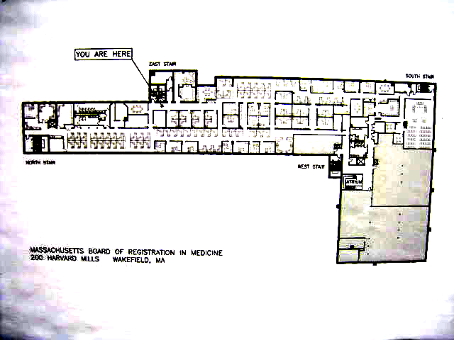
Picture 1

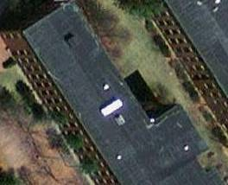

Rooftop Air Handling Unit (AHU)

Picture 2

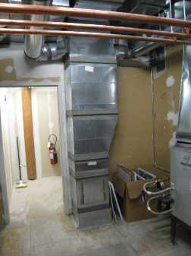

Ductwork Connected To Rooftop AHU That Distributes Fresh Air to All Floors
Picture 3

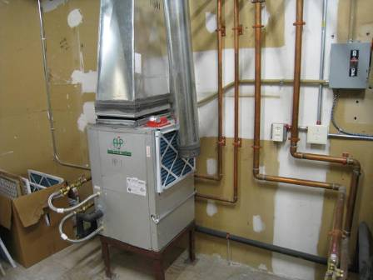

Fresh Air Supply Vent Duct (Arrow) That Deposits Air In Front Of the Intake of the AHU

Picture 4

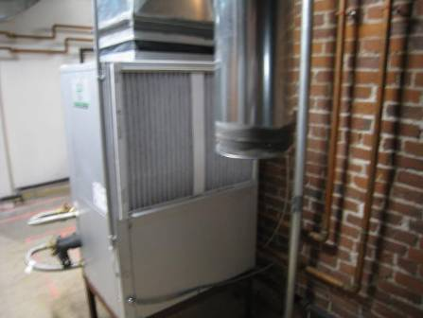

Fresh Air Supply Vent Duct That Deposits Air In Front Of the Intake of the AHU

Picture 5

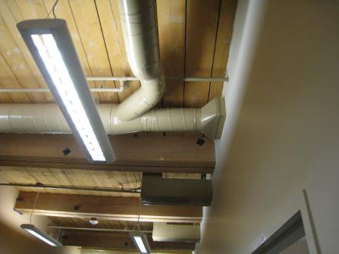
Fresh air supply ductwork for offices
Office passive exhaust ductwork

Office Supply and Passive Exhaust Ductwork

Picture 6

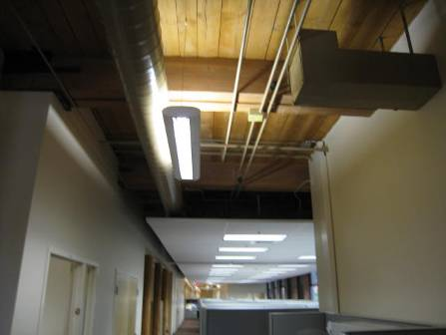
Office passive exhaust ductwork

Office Passive Exhaust Ductwork Terminating At 90° and Partial Drop Ceiling Plenum

Picture 7

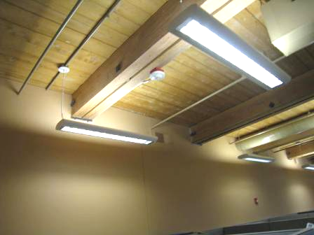

Wall-Mounted Return Vent

Picture 8

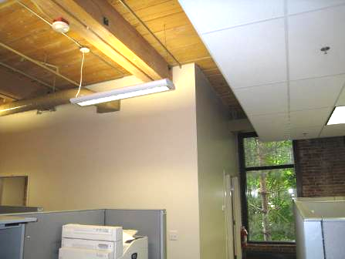

Wall-Mounted Return Vent for Room 315

Picture 9

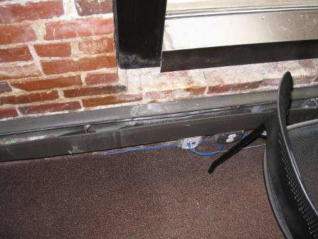

Efflorescence and Brick Dust

Picture 10

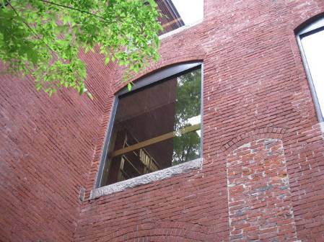

Energy-Efficient Window System

Picture 11

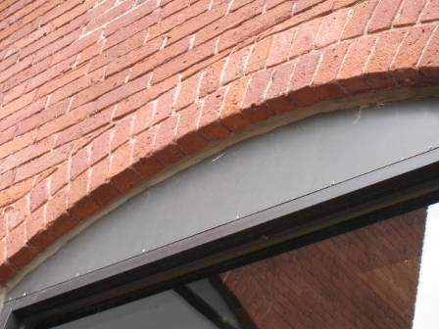

Window Caulking

Picture 12

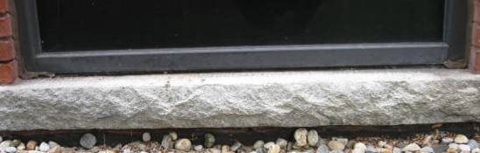

Window Caulking, Note That It Does Not Extend Across the Frame/Sill Junction

Picture 13

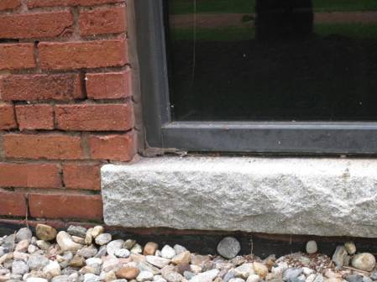

Opening Below Window Frame to Drain Water, Note Lack of Sealant
Between Flange and Sill

Picture 14

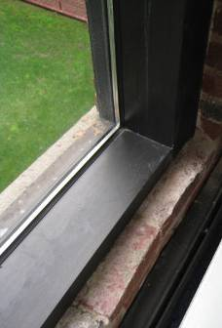

Window Sill Consists Of Granite Slab (Outside) and Brick (Inside)

Picture 15

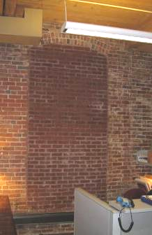

Bricked-In Window with Heavy Efflorescence

Picture 16

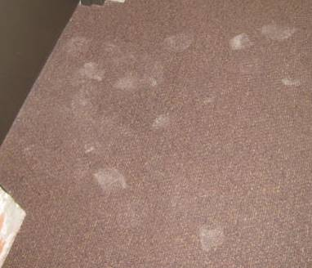

Visible Footprints from Dust on Carpet

Picture 17

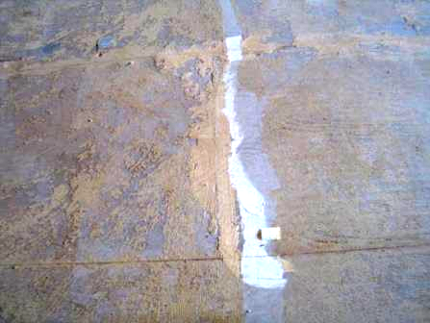

Accumulated Dust on Fourth Floor from Carpet Removal

Picture 18

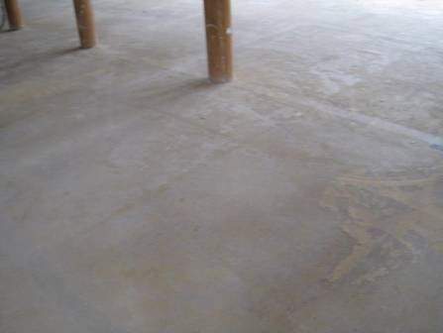

Accumulated Dust on Fourth Floor from Carpet Removal
Location | Occupants  in Room | Temp  (°F) | Relative  Humidity  (%) | Carbon  Dioxide  (ppm) | Carbon Monoxide  (ppm) | PM2.5 (ug/m3) | Windows  Openable | Ventilation |  | Remarks
 |  |  |  |  |  |  |  | Supply | Exhaust | Remarks
Outside  (Background) |  | 58 | 65 | 368 | ND | 8
Recycling | 0 | 70 | 39 | 556 | ND | 5 | N | Y | Y | DO
Lunchroom | 4 | 71 | 42 | 664 | ND | 4 | N | Y | Y | Efflorescence  DO
Library | 0 | 74 | 40 | 577 | ND | 3 | N | Y | Y | Efflorescence
301 | 1 | 73 | 45 | 623 | ND | 5 | N | Y | Y | Efflorescence
305 | 0 | 73 | 45 | 633 | ND | 5 | N | Y | Y | Efflorescence
306 | 0 | 72 | 43 | 537 | ND | 5 | N | Y | Y
307 | 0 | 72 | 43 | 613 | ND | 5 | N | Y | Y | Efflorescence
308 | 0 | 72 | 43 | 605 | ND | 5 | N | Y | Y
309 storage | 0 | 72 | 43 | 647 | ND | 5 | N | Y | Y | Photocopier
310 | 0 | 71 | 42 | 645 | ND | 5 | N | Y | Y | Efflorescence
311 | 0 | 71 | 42 | 620 | ND | 5 | N | Y | Y | Efflorescence
312 | 1 | 69 | 41 | 626 | ND | 5 | N | Y | Y
315 | 0 | 70 | 40 | 604 | ND | 5 | N | Y | Y
316 | 0 | 70 | 40 | 579 | ND | 5 | N | Y | Y | DO
317 | 0 | 69 | 39 | 579 | ND | 5 | N | Y | Y
318 | 0 | 69 | 39 | 577 | ND | 5 | N | Y | Y
321 | 0 | 70 | 40 | 569 | ND | 5 | N | Y | Y | Efflorescence
323 | 1 | 70 | 41 | 688 | ND | 5 | N | Y | Y
325 | 0 | 70 | 39 | 607 | ND | 4 | N | Y | Y | Personal fan
326 | 0 | 71 | 39 | 590 | ND | 5 | N | Y | Y
327 | 0 | 71 | 39 | 576 | ND | 5 | N | Y | Y
334 | 2 | 71 | 39 | 624 | ND | 5 | N | Y | Y | Efflorescence
340 | 1 | 73 | 42 | 601 | ND | 4 | N | Y | Y
343 | 1 | 74 | 45 | 654 | ND | 3 | N | Y | Y
345 | 2 | 72 | 41 | 591 | ND | 4 | N | Y | Y | Efflorescence
350 | 2 | 74 | 40 | 653 | ND | 4 | N | Y | Y
355 | 0 | 75 | 41 | 587 | ND | 3 | N | Y | Y
356 | 1 | 72 | 42 | 582 | ND | 4 | N | Y | Y
357 | 0 | 72 | 42 | 582 | ND | 4 | N | Y | Y
367 | 0 | 72 | 42 | 588 | ND | 3 | N | Y | Y
368 | 2 | 73 | 43 | 588 | ND | 4 | N | Y | Y
373 | 0 | 73 | 42 | 563 | ND | 3 | N | Y | Y
376 | 1 | 72 | 42 | 581 | ND | 3 | N | Y | Y
384 | 2 | 73 | 41 | 584 | ND | 3 | N | Y | Y
390 | 2 | 72 | 41 | 551 | ND | 3 | N | Y | Y
395 | 2 | 73 | 41 | 604 | ND | 3 | N | Y | Y
398 | 1 | 70 | 42 | 593 | ND | 3 | N | Y | Y | Air purifier  DO
409 | 0 | 74 | 41 | 578 | ND | 4 | N | Y | Y | Efflorescence
418 | 0 | 74 | 42 | 579 | ND | 4 | N | Y | Y | Efflorescence
419 | 0 | 73 | 41 | 545 | ND | 4 | N | Y | Y | Efflorescence
422 | 0 | 74 | 41 | 573 | ND | 4 | N | Y | Y
425 | 1 | 69 | 40 | 537 | ND | 5 | N | Y | Y

