The Commonwealth of Massachusetts
Executive Office of Health and Human Services
Department of Public Health
250 Washington Street, Boston, MA 02108-4619
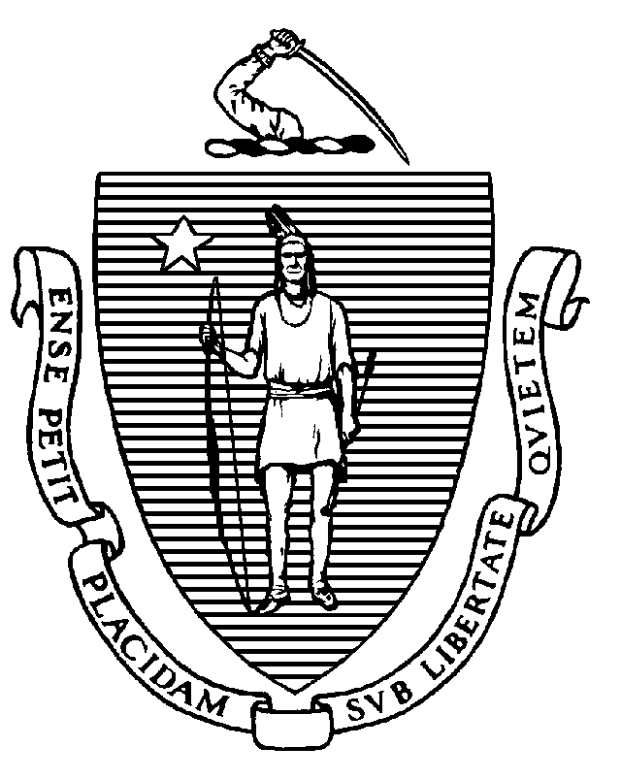

KATHLEEN E. WALSH
Secretary
ROBERT GOLDSTEIN, MD, PhD Commissioner

Tel: 617-624-6000
www.mass.gov/dph

MAURA T. HEALEY
Governor
KIMBERLEY DRISCOLL
Lieutenant Governor

Board of Social Workers
Public Session Meeting Minutes
May 23, 2023

TIME: 9:30 a.m.

ATTENDANCE: Quanesha Fuller
Scune Carrington
Charlene Zuffante
Marie Pierre-Victor
Carrie Kelley

STAFF: Brian Bialas, Executive Director
Sheila York, Board Counsel

All board members and staff appeared by videoconference.

The meeting was called to order at approximately 9:30 a.m.

Board Business

- Roll Call Vote for Attendance: Mr. Bialas called the roll of board members. Quanesha Fuller, Scune Carrington, Charlene Zuffante, Marie Pierre-Victor, and Carrie Kelley all present by videoconference.

- Public Meeting Minutes of April 25, 2023: After a brief discussion, a motion was made by Ms. Fuller, seconded by Ms. Kelley, to approve the Public Meeting Minutes of April 25, 2023. The motion passed unanimously by a roll call vote.

- Executive Session Minutes of April 25, 2023: After a brief discussion, a motion was made by Ms. Zuffante, seconded by Ms. Kelley, to approve the Executive Session Minutes of April 25, 2023. The motion passed unanimously by a roll call vote.

- Complaint Subcommittee Minutes of May 8, 2023: After a brief discussion, a motion was made by Ms. Fuller, seconded by Ms. Kelley, to approve the Complaint Subcommittee Minutes of May 8, 2023. The motion passed unanimously by a roll call vote.
Discussion

- Delegated Authority to Resolve Continuing Education (CE) Violations: Ms. York explained that the Board retains the ability to fine licensees as discipline after the transition from the Division of Occupational Licensure to the Department of Public Health and asked the Board whether it would like to renew its delegation of authority to investigators to resolve CE violations for a $200 fine and the make-up of deficient CEs.

After a brief discussion, a motion was made by Ms. Carrington, seconded by Ms. Pierre-Victor, to delegate authority to investigators to resolve CE violations for a $200 fine and the make-up of deficient CEs. The motion passed unanimously by a roll call vote.

Application Review Interview – Discipline in Another Jurisdiction

- Michael Galvin, Applicant for LICSW: Mr. Galvin appeared to discuss his failure to disclose discipline on his license in Louisiana for unlicensed practice. He explained that the agency he was working for at the time paid the fine, and he did not think it was “discipline.” By his agreement with the Louisiana Board, had to pay a fine, complete CEs, and take an ethics examination. Mr. Galvin has done work in ethics and research in the past and currently is working in a post-doctoral position at Boston Medical Center. He would like to have his LICSW license while completing his work there.

After a brief discussion, a motion was made by Ms. Fuller, seconded by Ms. Kelley, to allow Mr. Galvin to continue with the licensing process. The motion passed unanimously by a roll call vote, with Ms. Pierre-Victor abstaining.

Executive Session (Closed Session under G.L. c. 30A, § 21(a)(1), individual character rather than competence, and G.L. c. 30A, § 21(a)(7) to comply with G.L. c. 4, § 7, para. 26(c) and G.L. c. 214, § 1B, to review sensitive medical information)

At 10:41 a.m., a motion was made by Ms. Pierre-Victor, seconded by Ms. Carrington, to exit the public meeting and enter into a closed executive session under G.L. c. 30A, § 21(a)(1), individual character rather than competence, and under G.L. c. 30A, § 21(a)(7) to comply with G.L. c. 4, § 7, para. 26(c) and G.L. c. 214, § 1B, to review sensitive medical information in a request for reinstatement and a monitoring report. The motion passed unanimously by a roll call vote.

The Board entered executive session at 10:41 a.m. The Chair announced that the Board would not resume public session after closed session.

Board maintains separate minutes of executive session.

Adjournment

The Board exited executive session and the meeting adjourned at 11:59 a.m.

The above Minutes were approved at the public meeting held on June 27, 2023.

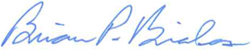
____________________________________
Brian Bialas, Executive Director

List of Documents Used During the Public Meeting:

- Agenda for Meeting of May 23, 2023
- Public Meeting Minutes of April 25, 2023
- Executive Session Minutes of April 25, 2023
- Complaint Subcommittee Minutes of May 8, 2023
- LICSW Application of Michael Galvin

